Supplementary materials

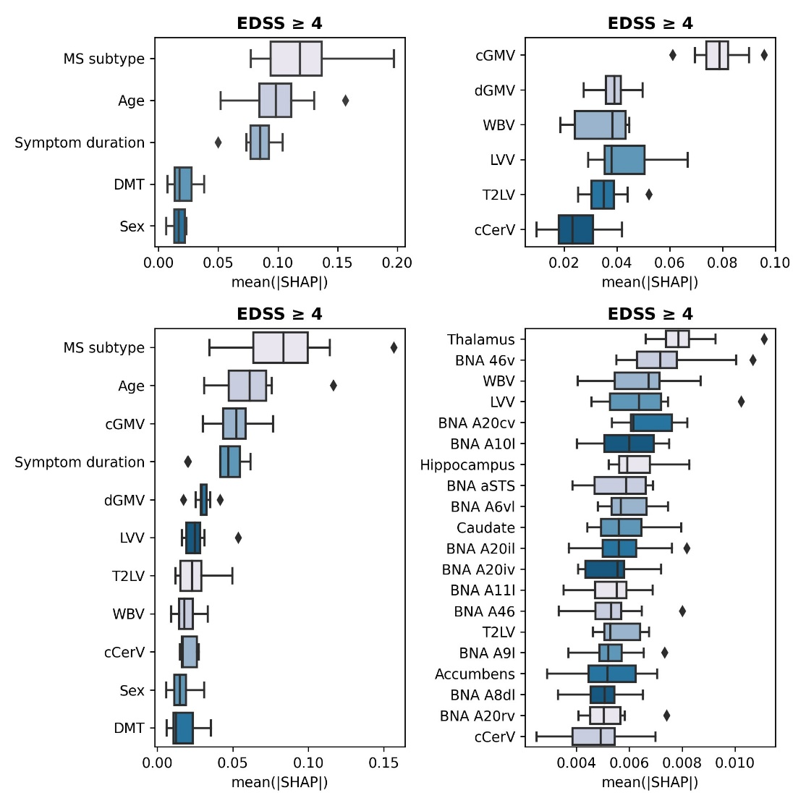
Figure 1. Prediction high disability using SVM-rbf. Distributions of SHAP feature importances for each feature set: 1) Clinical (AUC=0.81±0.07, p=0.018) 2) global MRI (AUC=0.75±0.06, p=0.043) 3) clinical + global MRI (AUC=0.83±0.06, p=0.036) 4) regional MRI (AUC=0.76±0.05, p=0.035).

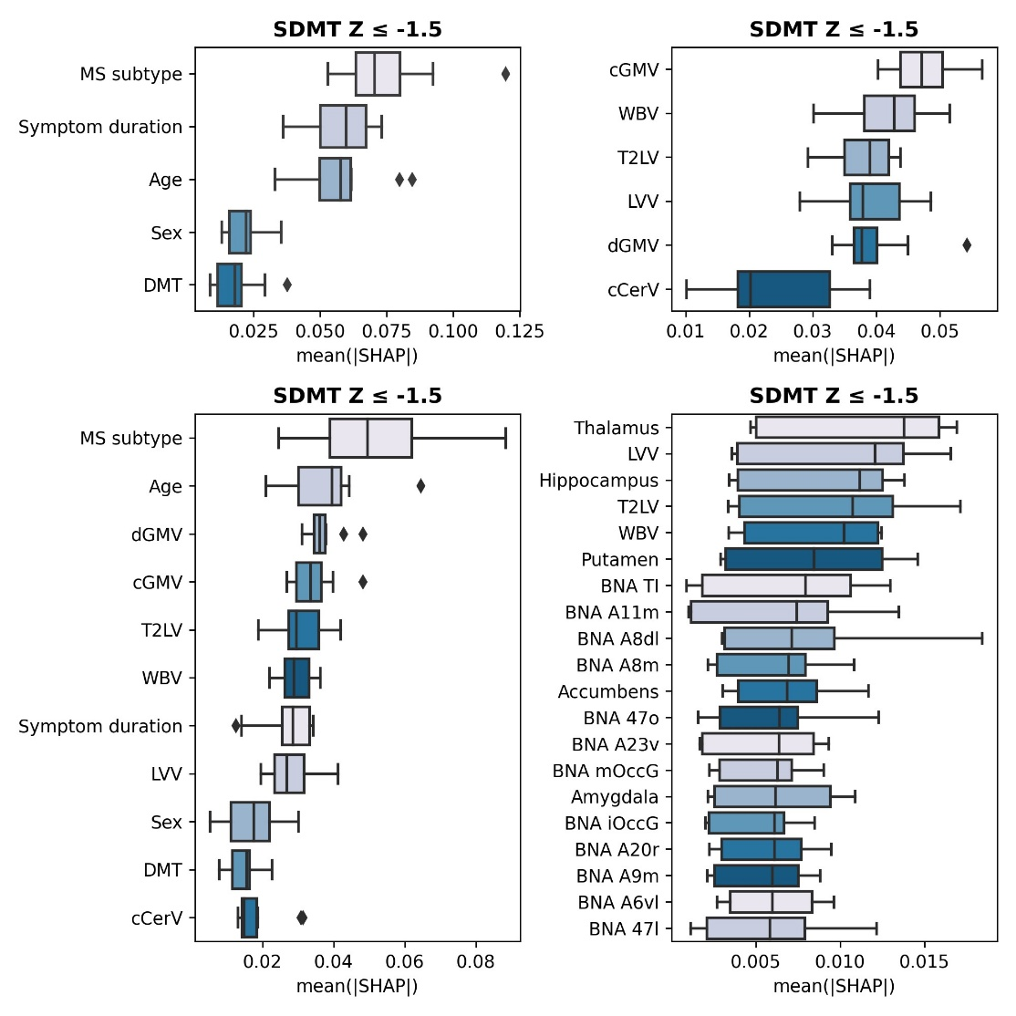
Figure 2. Prediction cognitive impairment using SVM-rbf. Distributions of SHAP feature importances for each feature set: 1) Clinical (AUC=0.55±0.05, p=0.27) 2) global MRI (AUC=0.69±0.04, p=0.057) 3) clinical + global MRI (AUC=0.69±0.04, p=0.041) 4) regional MRI (AUC=0.72±0.04, p=0.008).

