Supplementary materials.
- Supplementary Tables
Supplementary Table 1. Overview of the characteristics for CVID and controls

 | CVID (n=72) | HD (n=26) | P value
Age in years mean (SD),  [range] | 48,6 (12,7)  [19-77] | 47,7 (11,9)  [27-61] | 0.759
Sex, female n (%) | 34 (47.2) | 13 (50) | 0.059
Smokers n (%) | 4 (5.0) | 2 (7,7) | 0.086

Abbreviations: CVID, common variable immunodeficiency; HD healthy donors

Supplementary Table 2. Contribution of demographic, clinical, and immunological data on alpha diversity (Chao and Shannon).

 | Chao1 index  mean (SD) | R2 | P value
Sex
Females | 116.3 (39.1) | – | 0.199
Males | 104.2 (40.2) | –
Age
>45 years | 114.3 (45.4) | – | 0.016
<=45 years | 137.4 (38.7) | –
Smokers
Yes | 151.8 (41.9) | – | 0.085
No | 118.7 (45.2) | –
Immunological data
IgG Trough level
>= 0.6 g/L | 115.2 (39.2) | – | 0.078
<0.6 g/L | 96.9 (39.8) | –
IgA serum levels
> = 0.01 g/L | 116.1 (42.4) | – | 0.011
< 0.01 g/L | 93.9 (27.1) | –
IgM serum levels
> 0.20 g/L | 126,6 (35.4) | – | 0.018
<= 0.20 g/L | 102.6 (39.8) | –
Switched MBC
<=2% of B cells | 112.3 (42.4) | – | 0.827
> 2% of B cells | 109.7 (41.0) | –
Clinical manifestations
Bronchiectasis
Yes | 113.1 (36.5) | – | 0.457
No | 106.4 (41.8) | –
Complicated phenotype
Yes | 103.3 (37.4) | – | 0.107
No | 118.6 (42.0) | –
COPD
No/Yes mild | 89.2 (38.8) | – | 0.010
Yes, moderate/severe | 116.8 (38.1) | –
Granulomatous lung diseases (GLILD)
Yes | 118.5 (40.51) | – | 0.354
No | 107.7 (39.4) | –
Concomitant treatment (T0-T5)
Steroids (inhalers)
Yes | 97.3 (31.3) | – | 0.151
No | 113.3 (41.9) | –
Antibiotic prophylaxis
Yes | 90.7 (24.2) | – | 0.182
No | 112.0 (40.8) | –
Antibiotic use, days |  | 0.001 | 0.843

Abbreviations, CVID common variable immunodeficiency, COPD chronic obstructive pulmonary disease, IQR interquartile range.

Supplementary Table 3. Bacterial taxa with different abundance in CVID and controls.
Taxon | Increased in | LDA Effect size | LEfSe  P value | t test  P value
Bacteria.Bacteroidetes | HD | 4.63 | 8.7x10⁻⁵ | 8.5 x10⁻⁴
Bacteria.Bacteroidetes.Bacteroidia | HD | 4.63 | 8.7x10⁻⁵ | 8.5 x10⁻⁴
Bacteria.Bacteroidetes.Bacteroidia.Bacteroidales | HD | 4.58 | 1.8 x10⁻⁵ | 0.0010
Bacteria.Bacteroidetes.Bacteroidia.Bacteroidales.Prevotellaceae | HD | 4.50 | 5.1 x10⁻⁴ | 0.0011
Bacteria.Bacteroidetes.Bacteroidia.Bacteroidales.Prevotellaceae.Alloprevotella | HD | 4.14 | 1.9 x10⁻⁴ | 4.1 x10⁻⁵
Bacteria.Bacteroidetes.Bacteroidia.Bacteroidales.Prevotellaceae.Prevotella | HD | 3.68 | 2.0 x10⁻⁴ | 0.0273
Bacteria.Bacteroidetes.Bacteroidia.Flavobacteriales | HD | 3.69 | 0.0046 | 0.0178
Bacteria.Bacteroidetes.Bacteroidia.Flavobacteriales.Flavobacteriaceae | HD | 3.58 | 0.0109 | 0.0326
Bacteria.Fusobacteria | HD | 4.26 | 0.0183 | 0.0062
Bacteria.Fusobacteria.Fusobacteriia | HD | 4.26 | 0.0183 | 0.0062
Bacteria.Fusobacteria.Fusobacteriia.Fusobacteriales | HD | 4.26 | 0.0183 | 0.0062
Bacteria.Fusobacteria.Fusobacteriia.Fusobacteriales.Fusobacteriaceae | HD | 3.99 | 0.0355 | 0.0042
Bacteria.Fusobacteria.Fusobacteriia.Fusobacteriales.Fusobacteriaceae.Fusobacterium | HD | 3.99 | 0.0355 | 0.0042
Bacteria.Firmicutes.Negativicutes | HD | 4.20 | 0.0402 | 0.0035
Bacteria.Firmicutes.Negativicutes.Selenomonadales | HD | 4.20 | 0.0402 | 0.0035
Bacteria.Firmicutes.Negativicutes.Selenomonadales.Veillonellaceae | HD | 4.20 | 0.0402 | 0.0035
Bacteria.Epsilonbacteraeota | HD | 3.54 | 0.0219 | 0.0284
Bacteria.Epsilonbacteraeota.Campylobacteria | HD | 3.54 | 0.0219 | 0.0284
Bacteria.Epsilonbacteraeota.Campylobacteria.Campylobacterales | HD | 3.54 | 0.0219 | 0.0250
Bacteria.Epsilonbacteraeota.Campylobacteria.Campylobacterales.Campylobacteraceae | HD | 3.54 | 0.0231 | 0.0293
Bacteria.Epsilonbacteraeota.Campylobacteria.Campylobacterales.Campylobacteraceae.Campylobacter | HD | 3.54 | 0.0231 | 0.0293
Bacteria.Firmicutes.Bacilli.Lactobacillales | CVID | 4.97 | 2.8x10⁻⁶ | 0.0042
Bacteria.Firmicutes.Bacilli.Lactobacillales.Streptococcaceae | CVID | 4.94 | 5.5x10⁻⁶ | 0.0050
Bacteria.Firmicutes.Bacilli.Lactobacillales.Streptococcaceae.Streptococcus | CVID | 4.95 | 9.3x10⁻⁵ | 0.0045

Supplementary Table 4. Linear logistic model using a stepwise selection procedure to assess the impact of CVID-related characteristics collected during the study on dysbiosis index. The variable antibiotic prophylaxis has been here removed.
 | OR | P value
Final Model
Sex (female) | -18.5 | 0.019
COPD (moderate/severe) | 18.7 | 0.036
Excluded variables:
Age ≥45 years | 0.0 | 0.829
Smokers | -0.2 | 0.179
IgA < 0.01 g/L | 0.1 | 0.388
IgM ≥0.20 g/L | -0.1 | 0.332
IgG TL g/L | 0.0 | 0.695
SwMBC ≤ 2% of B cells | 0.0 | 0.664
Complicated phenotype | -0.1 | 0.654
Bronchiectasis | -0.1 | 0.855.
Systemic autoimmunity | 0.0 | 0.795
Antibiotic use (T0-T5) | -0.1 | 0.348
Days of antibiotic therapy | -0.2 | 0.167
Amoxicillin/clavulanate (days) | -0.2 | 0.134
Trimethoprim/sulfamethoxazole (days) | -0.1 | 0.735
Macrolides (days) | 0.10 | 0.511
Cephalosporin (days) | -0.2 | 0.112
Quinolones (days) | -0.1 | 0.528
Lincomycin (days) | 0.2 | 0.272
Corticosteroids treatment by inhaler (T0-T6) | 0.1 | 0.652
Abbreviations: COPD chronic obstructive pulmonary diseases, OR odds ratio, CI confidence intervals, SwMBC switched memory B cells.

Supplementary Table 5. Binomial logistic model using a stepwise selection procedure to assess the risk for respiratory tract exacerbation within 60 days (T6-T8). Odds ratios (OR) and 95% confidence intervals (CI) of multivariate models are reported.

Final Model | OR | P value
Haemophilus | 20.4 | 0.017
Excluded variables: | OR | P value
Anoxybacillus | -0.1 | 0.213
Rothia | 0.1 | 0.435
Alloprevotella | 0.1 | 0.877
Prevotella | 0.1 | 0.279
Gemella | -0.1 | 0.400
Streptococcus | -0.1 | 0.685
Veilonella | 0.2 | 0.060
Neisseria | -0.1 | 0.890

Supplementary Table 6. Binomial logistic model using a stepwise selection procedure to assess the risk for respiratory tract exacerbation within 6 months (T6-T12). Odds ratios (OR) and 95% confidence intervals (CI) of multivariate models are reported.

 | OR | P value
Final Model
Anoxybacillus | 10.5 | 0.026
Excluded variables: | OR | P value
Rothia | 0.1 | 0.612
Alloprevotella | 0.1 | 0.554
Prevotella | 0.0 | 0.949
Gemella | 0.1 | 0.647
Streptococcus | 0.0 | 0.775
Veilonella | 0.0 | 0.950
Neisseria | 0.1 | 0.352
Haemophilus | 0.2 | 0.335

2. Supplementary Figures
Supplementary Figure 1. Colour-coded bar plots show bacterial taxa's average distribution at phylum0. class0. order0. families0. and genus levels in HD and CVID. Only taxa with a mean relative abundance ≥1% are shown. Taxa were sorted by decreasing mean relative abundances in the HD group.
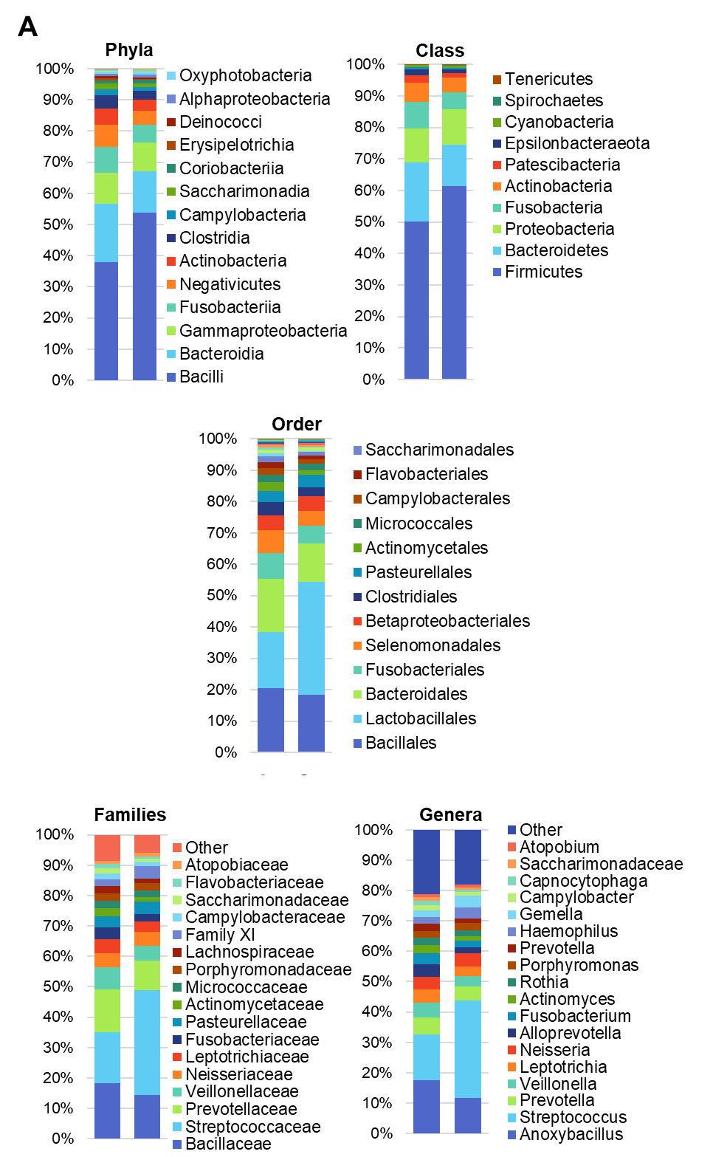
Supplementary Figure 2. Beta diversity by Principal Component Analysis (PCA) between controls and CVID with/without IgA undetectable serum levels is shown

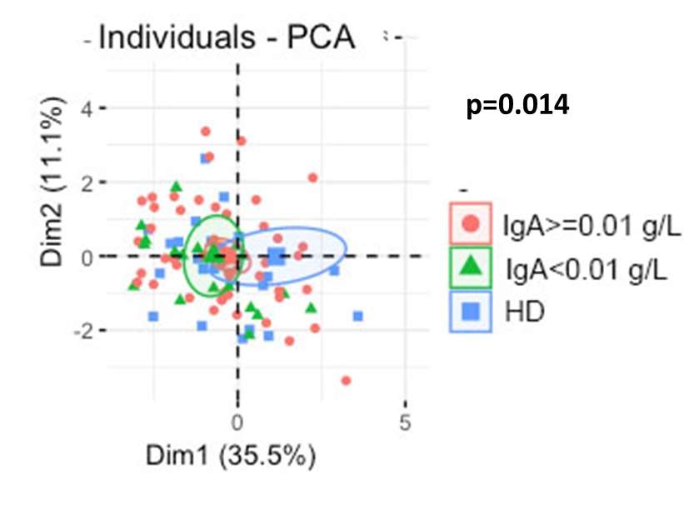
Supplementary Figure 3. Bacterial community composition of the oropharynx in CVID patients grouped by their age and controls. The first six most frequently identified genera in CVID patients are shown. Lines represent the median. The whiskers represent the 10 and 90 percentiles. The non-parametric Mann–Whitney test was used to evaluate statistical significance. Two-tailed P value significances are shown as *p<0.050. **p < 0.010. ***p < 0.0010. ****p<0.0001. Abbreviations: HD healthy donors

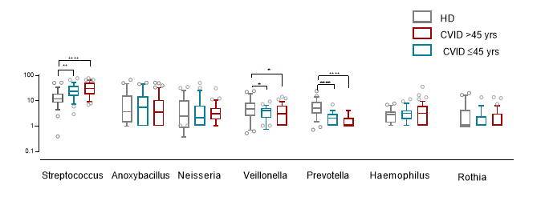
Supplementary Figure 4. CVID-dysbiosis index. The relative abundance of the 11 main taxa in CVID patients and controls (CVID-dysbiosis index). The dysbiosis index was higher in CVID patients than in HD (OR 30.00. 95%CI 19.8 to 40.20. panel A) and inversely related to the alpha diversity (OR -1.10. 95%CI -1.3 to -0.80. panel B). Levels of significance: ****p<0.0001
