ONLINE ONLY SUPPLEMENTS:
Number of supplements: 3 figures and 2 tables.
Supplementary Figure 1: Flow diagram describing patient selection for the MRI analysis. Number of patients available for the analysis are shown.
Supplementary Figure 2: Differences in grey matter (GM) volumes, when only patients with white matter (WM) lesions were considered, between myelin oligodendrocyte glycoprotein antibody-associated disease (MOGAD), aquaporin-4-antibody positive neuromyelitis optica spectrum disorder (AQP4+NMOSD), relapsing remitting MS (RRMS), and healthy controls (HC) using a Voxel-wise analysis.
Supplementary Figure 3: Differences in grey matter (GM) volumes, when only patients without white matter (WM) lesions were considered, between myelin oligodendrocyte glycoprotein antibody-associated disease (MOGAD), aquaporin-4-antibody positive neuromyelitis optica spectrum disorder (AQP4+NMOSD), relapsing remitting MS (RRMS), and healthy controls (HC) using a Voxel-wise analysis.
Supplementary Table 1: Grey matter (GM) regions whose volume is significantly different between myelin oligodendrocyte glycoprotein antibody-associated disease (MOGAD), aquaporin-4-antibody positive neuromyelitis optica spectrum disorder (AQP4+NMOSD), relapsing remitting MS (RRMS), and healthy controls (HC) groups and their corresponding total volume in cm³ and total number of voxels (nV).
Supplementary Table 2: Volumes in cm³ and corresponding number of voxels (nV) of GM areas significantly different between groups when disease duration and time to last attack were independently added as covariates to the Voxel-wise analysis.

Supplementary Figure 1: ﻿ Flow diagram describing patient selection for the MRI analysis. Number of patients available for the analysis are shown.
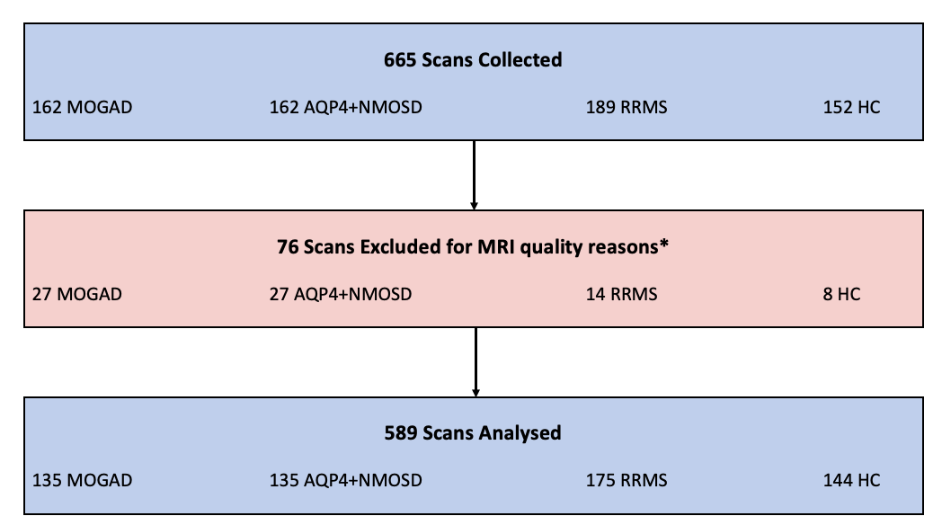

﻿*Reasons for exclusion were: acquisition artifacts, poor GM/WM intensity contrast, no full brain MRI coverage

Supplementary Figure 2: Differences in grey matter (GM) volumes, when only patients with white matter (WM) lesions were considered, between myelin oligodendrocyte glycoprotein antibody-associated disease (MOGAD), aquaporin-4-antibody positive neuromyelitis optica spectrum disorder (AQP4+NMOSD), relapsing remitting MS (RRMS), and healthy controls (HC) using a Voxel-wise analysis.
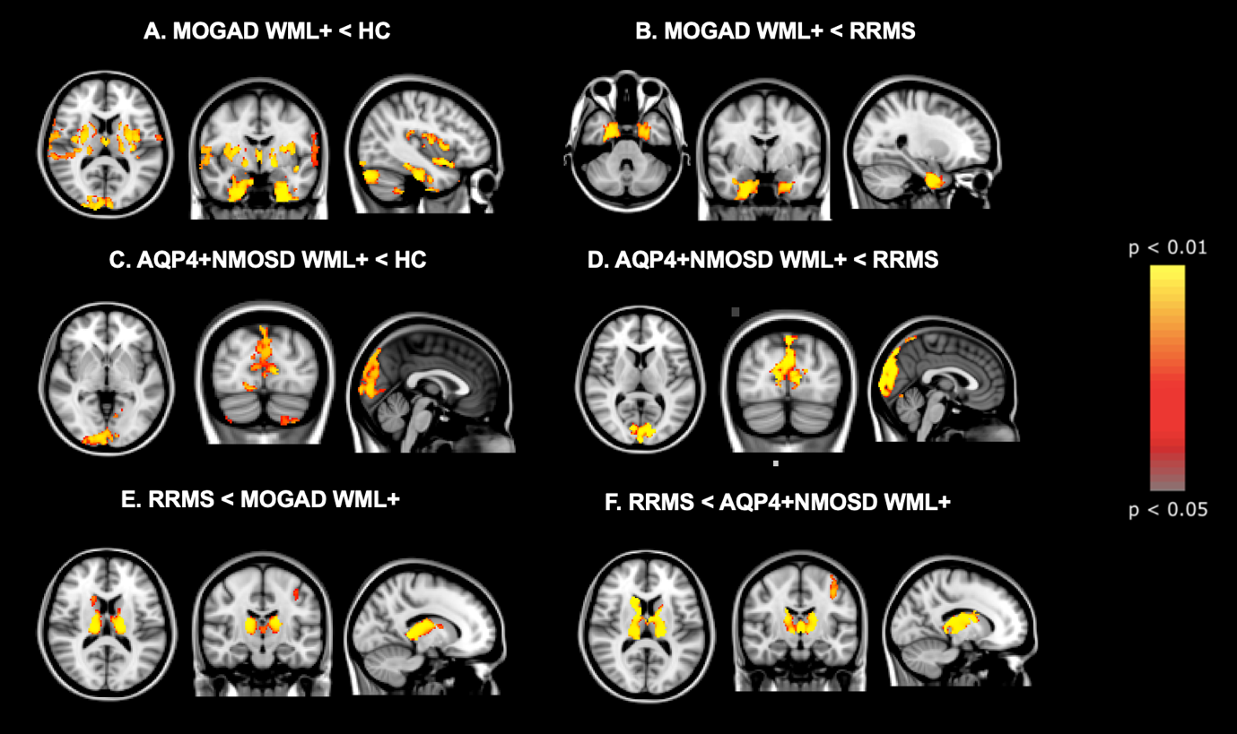
Topographical distribution of group differences in GM atrophy. Atrophied voxels are shown in a colour scale from yellow to red, from the most to the less significant, respectively.
When considering only patients with WM lesions, MOGAD showed lower temporal cortex, deep GM, insula, cingulate cortex and cerebellum volumes than HC (total volume of atrophic voxels: 135.82 cm³) (A) and lower temporal cortex volumes than RRMS (26.04 cm³) (B). AQP4+NMOSD showed lower occipital cortex volume than HC (44.88 cm³) (C) and RRMS (16.35 cm³) (D). RRMS showed lower deep GM and left sensory-motor cortex volumes than MOGAD (total volume of atrophic voxels: 16.63 cm³) (E) and AQP4+NMOSD (total volume of atrophic voxels: 30.06 cm³) (F). No differences were detected between MOGAD and AQP4+NMOSD.
Supplementary Figure 3: Differences in grey matter (GM) volumes, when only patients without white matter (WM) lesions were considered, between myelin oligodendrocyte glycoprotein antibody-associated disease (MOGAD), aquaporin-4-antibody positive neuromyelitis optica spectrum disorder (AQP4+NMOSD), relapsing remitting MS (RRMS), and healthy controls (HC) using a Voxel-wise analysis. 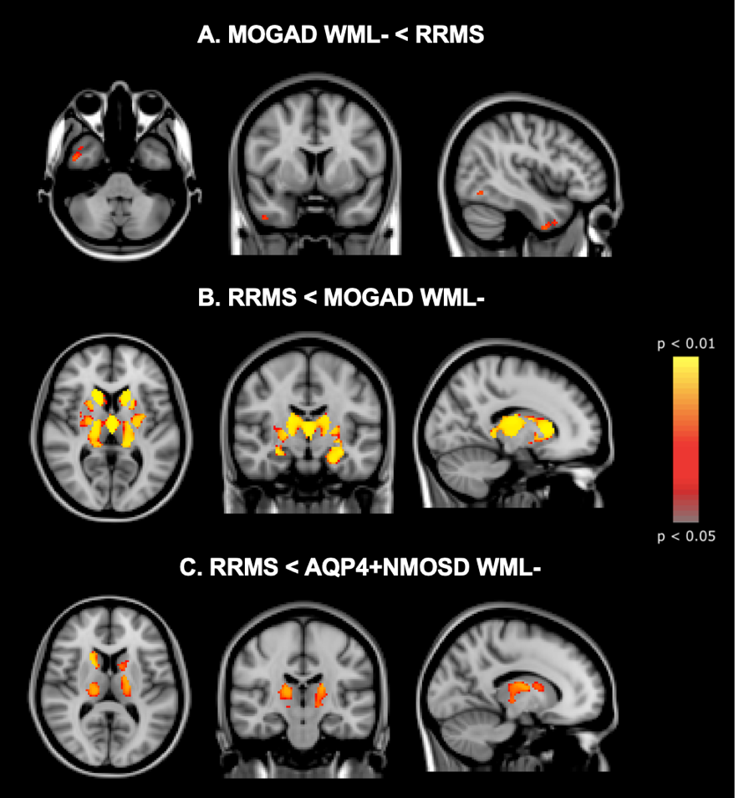
Topographical distribution of group differences in GM atrophy. Atrophied voxels are shown in a colour scale from yellow to red, from the most to the less significant, respectively.
When considering only patients without WM lesions, MOGAD showed a mild lower right temporal cortex volume than MS (2.81 cm³) (A), while did not show differences in GM volumes when compared to HC and AQP4+NMOSD. RRMS showed lower deep GM volumes compared to both MOGAD (37.70 cm³) (B) and AQP4+NMOSD (6.86 cm³) (C). AQP4+NMOSD did not show reduced GM volumes compared to the other groups.
Supplementary Table 1: Grey matter (GM) regions whose volume is significantly different between myelin oligodendrocyte glycoprotein antibody-associated disease (MOGAD), aquaporin-4-antibody positive neuromyelitis optica spectrum disorder (AQP4+NMOSD), relapsing remitting MS (RRMS), and healthy controls (HC) groups and their corresponding total volume in cm³ and total number of voxels (nV).
 | GM regions whose volume is significantly different between groups and their corresponding total volume in cm³ and total number of voxels
MOGAD < HC | Temporal cortex, deep GM, insula, cingulate cortex and cerebellum  (tot. volume: 75.79 cm³)  (tot. nV: 9474)
MOGAD with WM lesions < HC | Temporal cortex, deep GM, insula, cingulate cortex and cerebellum  (tot. volume: 135.82 cm³)  (tot. nV: 16978)
AQP4+NMOSD < HC | Occipital cortex  (tot. volume: 32.83 cm³)  (tot. nV: 4104)
AQP4+NMOSD with WM lesions < HC | Occipital cortex  (tot. volume: 44.88 cm³)  (tot. nV: 5610)
RRMS < HC | Widespread involvement of cortex, deep GM and cerebellum  (tot. volume: 260.61 cm³)  (tot. nV: 32576)
MOGAD < RRMS | Temporal cortex  (6.71 cm³)  (nV: 839)
MOGAD with WM lesions < RRMS | Temporal cortex  (26.04 cm³)  (nV: 3255)
AQP4+NMOSD < RRMS | Occipital cortex  (19.82 cm³)  (nV: 2478)
AQP4+NMOSD with WM lesions < RRMS | Occipital cortex  (16.35 cm³)  (nV: 2044)
RRMS < MOGAD | Deep GM  (27.90 cm³)  (nV: 3487)
RRMS < MOGAD with WM lesions | Deep GM and left sensory-motor cortex  (tot. volume: 16.63 cm³)  (tot. nV: 2079)
RRMS < AQP4+NMOSD | Deep GM  (47.04 cm³)  (nV: 5880)
RRMS < AQP4+NMOSD with WM lesions | Deep GM and left sensory-motor cortex  (tot. volume: 30.06 cm³)  (tot. nV: 3757)
Abbreviations: AQP4+NMOSD=aquaporin-4-antibody-positive neuromyelitis optica spectrum disorder, HC=healthy controls, MOGAD=myelin oligodendrocyte glycoprotein antibody associated disease, RRMS=relapsing-remitting multiple sclerosis, WM=white matter.

Supplementary Table 2: Volumes in cm³ and corresponding number of voxels (nV) of GM areas significantly different between groups when disease duration and time to last attack were independently added as covariates to the Voxel-wise analysis.
 | When using disease duration* as covariate  (cm³, nV) | When using time from last attack to MRI as covariate  (cm³, nV)
MOGAD < HC | 26.65; 3331 | 29.92; 3740
AQP4+NMOSD < HC | 43.04; 5380 | 45.76; 5720
RRMS <HC | 142.98; 17872 | 223.86; 27983
MOGAD < AQP4+NMOSD | NS | NS
MOGAD < RRMS | 3.03; 379 | 2.6; 325
AQP4+NMOSD < MOGAD | NS | NS
AQP4+NMOSD <RRMS | 17.62; 2203 | 19.83; 2479
RRMS < MOGAD | 22; 2750 | 24.14; 3018
RRMS < AQP4+NMOSD | 46.18; 5772 | 47.14; 5893
MOGAD WML+ < HC | 79.43; 9929 | 93.94; 11743
AQP4+NMOSD with WM lesions < HC | 59.76; 7470 | 16.37; 2046
MOGAD with WM lesions < RRMS | 14.66; 1833 | 16.36; 2045
AQP4+NMOSD with WM lesions < RRMS | 14.15; 1769 | 16.37; 2046
MOGAD with WM lesions < AQP4+NMOSD with WM lesions | NS | NS
AQP4+NMOSD with WM lesions < MOGAD with WM lesions | NS | NS
RRMS < MOGAD with WM lesions | 9.21; 1151 | 11.78; 1472
RRMS < AQP4+NMOSD with WM lesions | 29.15; 3644 | 30; 3750
*The reasons for the delay between disease onset and the MRI used in the analysis were as follows: (i) the selected MRI was the closest MRI to patients clinical onset which fulfilled the inclusion criteria, such as the absence of artifacts and the availability of concomitant 3DT1 and FLAIR/PDT2 in the non-attack phase (i.e., at least 6 months from an acute event); (ii) some patients were initially diagnosed elsewhere and later referred to a specialist clinic in a highly specialised centre, which was the MAGNIMS site which took part into the study; (iii) Some MOGAD patients (n.4: <10 years, n.10: 10-17 years) had a paediatric onset but were included in the study only upon reaching adulthood, when they were seen in the adult services, as per inclusion criteria.
Abbreviations: AQP4+NMOSD=aquaporin-4-antibody-positive neuromyelitis optica spectrum disorder, HC=healthy controls, MOGAD=myelin oligodendrocyte glycoprotein antibody associated disease, NS=not significant, RRMS=relapsing-remitting multiple sclerosis, WM=white matter.

