Appendix
Table 7 Mean and incremental costs (2020 euros) for insufficiently vs. sufficiently active people (based on leisure-time physical activity only) from the NAKO baseline examination sample. Indirect costs (productivity losses) monetarily valued using the friction cost approach.
 |  | By age group
 | Total sample | 20-39 | 40-59 | 60+
 | Mean (95% CI)
Healthcare + indirect costs
Model 1
Insufficient PA | 4135 (4051, 4219) | 2548 (2420, 2675) | 3850 (3744, 3956) | 6526 (6293, 6759)
Sufficient PA | 3681 (3616, 3746) | 2246 (2140, 2352) | 3520 (3435, 3606) | 5405 (5256, 5555)
Δ | 454 (345, 563) | 302 (144, 460) | 330 (194, 466) | 1121 (841, 1400)
Model 2
Insufficient PA | 4113 (4029, 4197) | 2533 (2409, 2658) | 3820 (3715, 3925) | 6396 (6167, 6625)
Sufficient PA | 3774 (3706, 3842) | 2252 (2145, 2359) | 3610 (3521, 3699) | 5628 (5467, 5788)
Δ | 339 (229, 449) | 281 (125, 438) | 210 (74, 345) | 768 (484, 1053)
Model 1: adjusted for age, sex, study site, migration background, marital status, socioeconomic status, risky alcohol consumption, and smoking status. Model 2: adjusted for the covariates in Model 1 plus the number of comorbidities.

Table 8 Mean costs (2020 euros) for different physical activity levels and by activity domain of people from the NAKO baseline examination sample. Indirect costs (productivity losses) monetarily valued using the friction cost approach.
 | By PA domain
 | Leisure | Work | Transport
 | Mean (95% CI)
Healthcare + indirect costs
Model 1
Very low | 4494 (4374, 4614) | 3618 (3551, 3685) | 4014 (3903, 4124)
Low | 3700 (3584, 3817) | 3722 (3454, 3990) | 3491 (3373, 3608)
Medium | 3705 (3578, 3831) | 4132 (3814, 4451) | 3658 (3540, 3776)
High | 3654 (3578, 3730) | 4174 (4081, 4268) | 3976 (3896, 4057)
Model 2
Very low | 4367 (4250, 4484) | 3699 (3630, 3769) | 4007 (3900, 4115)
Low | 3794 (3674, 3913) | 3824 (3538, 4110) | 3594 (3470, 3718)
Medium | 3794 (3666, 3922) | 4193 (3840, 4547) | 3737 (3615, 3859)
High | 3747 (3668, 3826) | 4166 (4072, 4259) | 4027 (3945, 4110)
Model 1: adjusted for age, sex, study site, migration background, marital status, socioeconomic status, risky alcohol consumption, and smoking status. Model 2: adjusted for the covariates in Model 1 plus the number of comorbidities.

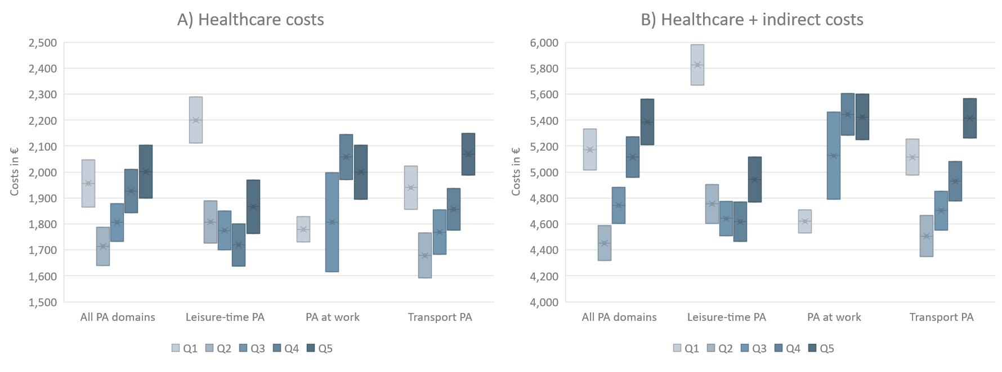
Figure 2 Confidence intervals of costs (2020 euros) for different physical activity levels (in quintiles) and by activity domain of people from the NAKO baseline examination sample. Adjusted for age, sex, study site, migration background, marital status, socioeconomic status, risky alcohol consumption, and smoking status (Model 1). Crossed centerlines indicate group means.

