Immediate reuse of patch-clamp pipettes after ultrasonic cleaning
Kevin Jehasse^{1,*}, Jean-Sebastien Johanneau^{5,6}, Sophie Wetz^{1,4}, Alexander Schwedt², James Poulet^{5,6}, Peter Neumann-Raizel^{7,#}, Björn M. Kampa^{1,3,4,#,*}
Supplementary informations
*Correspondence: Kevin Jehasse: jehasse@bio2.rwth-aachen.de; Björn M. Kampa: kampa@brain.rwth-aachen.de
# equal contribution

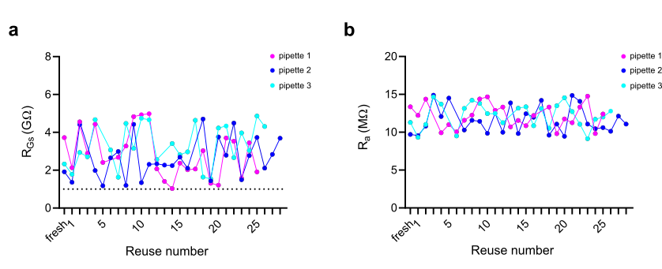
Supplementary Figure 1: Ultrasonic cleaning allows the reuse of patch-clamp pipettes over 25 times. (a) shows the reuse of 3 pipettes for which R_{GS} was successfully reached over multiple cleaning procedures. Success rate is 23/25 trials for pipette 1, 27/28 for pipette 2 and 24/26 for pipette 3. (b) shows that R_{a} is not affected by ultrasonic cleaning, in favor of indefinite reuse of the pipette. Success for whole-cell achievement is the same as (a).

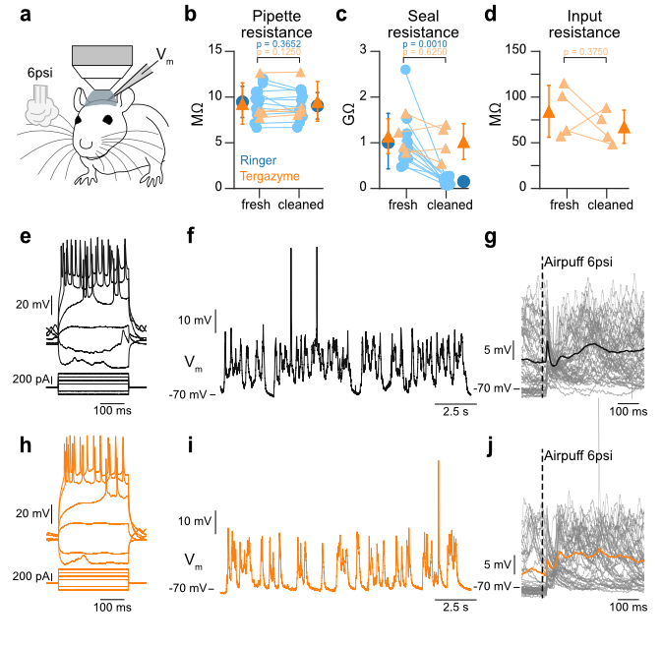

Supplementary Figure 2: In vivo whole-cell membrane potential recordings. (a) Cartoon schematic showing in vivo whole-cell recording setup with airpuff stimulus delivered to the whiskers and whole cell pipette in primary somatosensory barrel cortex. (b) Resistance of pipette in the bath before entering the brain (fresh) and after having been used to record neuronal activity and followed the LN-PCS cleaning procedure (cleaned). Blue shows data from pipettes cleaned in Ringer’s solution (N = 6 mice, n = 9 cells) or external Ringer’s (N = 2 mice, n = 2 cells) or external double distilled water (N = 1 mouse, n = 1 cell), orange shows data from pipettes cleaned using the LN-PCS system in 1% Tergazyme in double distilled water (N = 4 mice, n = 4 cells). Light colored circles and triangles connected by lines represent data from a single pipette before and after cleaning, dark color circles and triangles with error bars show mean +/- SD for each condition (Ringer’s fresh vs. cleaned: 9.40 +/- 1.62 MΩ vs 8.98 +/- 1.38 MΩ, n = 11, p = 0.3652; Tergazyme fresh vs. cleaned: 9.23 +/- 1.95 MΩ vs 9.46 +/- 1.87 MΩ, n = 4, p =0.1250). (c) Same plot as (b) but for seal resistance (Ringer’s fresh vs cleaned: 1.03 +/- 0.57 GΩ vs 0.15 +/- 0.08 GΩ, n = 11, p = 0.0010; Tergazyme fresh vs cleaned: 1.13 +/- 0.33 GΩ vs 1.02 +/- 0.34 GΩ, n = 4, p = 0.6250). (d) Comparison of input resistance for successful recording in Tergazyme cleaned pipettes. Light color triangles connected by lines represent data from a single pipette before and after cleaning, dark colored triangles with error bars show mean +/- SD for each condition (Tergazyme fresh vs cleaned: 83.84 +/- 24.44 MΩ vs 66.99 +/- 15.59 MΩ, n = 4, p = 0.3750). (e) Firing pattern from example neuron recorded with a fresh pipette. Upper panel shows the membrane potential (V_{m}) of the recorded neuron responding to the 6 current steps shown on the lower panel. (f) Spontaneous membrane potential fluctuations from the recorded neuron shown in (e). (g) Airpuff evoked response from recorded neuron shown in (e) and (f) with single trials shown in grey and mean response in black. (h), (i), and (j) same as (e), (f), and (g) but after cleaning with Tergazyme.

Supplementary Video 1: Resonance effect during ultrasonic cleaning. The resonance effect is observed on the tip of the pipette (left) during the ultrasonic cleaning of a second pipette (right) at 1 mm from it. White line shows when the cleaning starts.
Supplementary Video 2: Absence of resonance effect during ultrasonic cleaning. The resonance effect on the tip of the pipette (left) is absent when the ultrasonic cleaning of a second pipette (right) occurs at 5 mm from it. White line shows when the cleaning starts

