Supplemental material

Supplemental table 1: Genes included in the NanoString panel.
SMTN | UBE2J1 | UBA7 | ALDH3A1 | KCTD12 | SLC2A1
IGF2BP2 | CD2 | OSMR | IL33 | SLA | RPA2
HRAS | ARL6IP5 | PTPRC | CIITA | DPT | GCHFR
COL13A1 | COL17A1 | SLAMF7 | YIF1A | TNFRSF1A | CD247
PECAM1 | F2RL1 | SASH1 | PPP1R16B | ZDHHC11 | CXCL12
LAMC2 | TLR7 | MAD1L1 | ZAK | FADS3 | IL11
C16ORF57 | SPRR3 | IL17A | MT2A | PANX1 | MFAP4
TUBB3 | GALNT6 | GPR171 | TRAF3IP3 | TGFBI | PCDH7
NCF4 | PDPN | CA9 | SEMA4D | CDC7 | CBS
FKBP14 | FLNA | KCNS3 | MCM2 | GZMK | PLEK2
GIMAP6 | CDKN2A | FBLN1 | ZBED2 | LRIG1 | SPARCL1
CD74 | IFNG | MMP10 | EVI2B | AREG | TNFAIP2
KRT1 | HLADPB1 | STAT1 | PIM2 | KRT17 | ICOS
PLAU | MYC | S100A4 | TGFBR2 | IL10RA | ECHDC2
PYGL | VEGFC | PPAP2B | ITGB1 | MEF2C | ACTN1
ALDH1A1 | HIF1A | MAN1C1 | HLADMA | E6 (HPV16) | VNN2
DBI | SLC2A9 | GIMAP5 | CXCL10 | ST6GAL1 | MCCC1
SUSD4 | ITGA3 | NTRK2 | F3 | CAMK2N1 | KRT13
SELL | FBXO2 | ACTL6A | REPIN1 | TSPAN5 | FUCA1
EYA2 | CTSL2 | EGFR | CD8A | PROCR | POSB(32)
FST | PXN | KRT16 | HK2 | SEMA3C | POSC(8)
SLC16A1 | HOMER3 | CAV2 | NRG1 | CYORF15B | POSE(0.5)
PAPPA | AKR1C3 | TPBG | AMMECR1L | HLADPA1 | POSD(2)
TNFRSF12A | E2F2 | IL1B | LMO4 | CYP27B1 | POSF(0.125)
HLADOB | KRT9 | CECR1 | BPGM | GIMAP4 | POSA(128)
CAV1 | CCR7 | SNAI2 | ITGA5 | LIMA1 | NEGC(0)
KRT19 | CDA | HLADRA | CSPG4 | CD79A | NEGD(0)
AKR1C1 | ITGAL | CYBB | MMP9 | IRS1 | NEGB(0)
CD3G | MCM10 | C20ORF20 | P4HA2 | C19ORF21 | NEGF(0)
CSF1R | TMUB2 | LAG3 | GATM | TACC1 | NEGE(0)
VIM | NME7 | GLTSCR2 | FOSL1 | VEGF | NEGA(0)
IRF8 | PRPF38A | SELENBP1 | PTGDS | PBX1
PTGS1 | TNFRSF17 | ITGB7 | CCL19 | PPFIBP2
LRMP | CORO1A | TMEM176A | CDH3 | ARTN
MYO5C | EHD2 | FAM46C | IGJ | FCGRT
GZMH | NKG7 | SLAMF6 | STAB1 | IDO1
RGS20 | ABCC5 | NT5E | RASSF2 | RRAS2
KRT75 | CD69 | HLADMB | ICAM3 | KLRB1
PTHLH | ICAM2 | DOCK10 | ACSL5 | MYO1B
ITM2A | FHL2 | CXCL9 | LAMA3 | DDX50

Supplemental table 2: Clinicopathologic characteristics of all histologically analyzed samples.
Patient  Number | Used for  survival analysis | Subtype | Histotype | Grading (WHO) | Tumor cell  budding (2 tier) | Cell nest  size (2 tier) | Mitotic count  (2 tier) | Nuclear size  (2 tier) | Stroma content  (2 tier) | Necrosis  (2 tier) | Inflammatory infiltrate  (2 tier) | Lymphvessel  invasion | Perineural  invasion | Sex | Age at  randomisation | Localization  sample | Tumor  stadium
2 | yes | CL | non-keratinizing | G2 | high | small | high | big | low | low | low | present | absent | male | 64 | Oropharynx | 4
3 | yes | BA | keratinizing | G2 | high | small | high | small | low | low | high | absent | absent | male | 62 | Hypopharynx | 4
4 | yes | BA | keratinizing | G3 | high | small | high | small | low | low | low | absent | absent | male | 57 | Oropharynx | 4
5 | yes | MS | keratinizing | G3 | high | small | low | small | high | high | low | absent | present | male | 62 | Hypopharynx | 4
5 | no | MS | non-keratinizing | G2 | high | small | low | big | low | low | low | absent | absent | male | 62 | Hypopharynx | 4
5 | no | BA | non-keratinizing | G3 | high | small | high | big | low | low | high | absent | absent | male | 62 | Hypopharynx | 4
6 | yes | BA | keratinizing | G2 | high | small | low | big | low | high | high | absent | absent | male | 52 | Hypopharynx | 3
6 | no | MS | non-keratinizing | G2 | high | small | high | small | low | high | low | present | absent | male | 52 | Hypopharynx | 3
7 | yes | MS | non-keratinizing | G3 | high | small | low | big | low | low | high | absent | absent | male | 66 | Oropharynx | 4
8 | yes | MS | NA | NA | NA | NA | NA | NA | NA | NA | NA | NA | NA | NA | 62 | NA | NA
11 | yes | CL | non-keratinizing | G3 | high | small | low | small | low | high | low | absent | absent | female | 64 | Hypopharynx | 4
16 | yes | BA | keratinizing | G2 | high | small | low | small | low | low | high | absent | absent | male | 58 | Tongue | 4
17 | yes | BA | non-keratinizing | G2 | high | small | low | small | high | low | low | absent | absent | male | 40 | Hypopharynx | 4
18 | yes | BA | keratinizing | G2 | high | small | low | small | high | low | high | absent | absent | male | 67 | Larynx | 4
18 | no | BA | non-keratinizing | G2 | high | small | low | small | low | low | low | absent | absent | male | 67 | Larynx | 4
18 | no | BA | keratinizing | G3 | high | small | low | small | low | high | low | present | present | male | 67 | Larynx | 4
18 | no | BA | non-keratinizing | G2 | high | small | low | small | low | low | high | absent | absent | male | 67 | Larynx | 4
19 | yes | MS | basaloid | G3 | high | small | high | small | high | high | low | absent | absent | male | 72 | Hypopharynx | 4
19 | no | CL | keratinizing | G2 | low | big | low | small | low | low | high | absent | absent | male | 72 | Hypopharynx | 4
21 | no | BA | non-keratinizing | G2 | high | small | low | small | low | low | high | absent | absent | male | 69 | Tongue | 4
22 | yes | CL | keratinizing | G3 | high | small | high | small | low | high | low | absent | absent | male | 61 | Tonsil | 3
22 | no | MS | keratinizing | G2 | high | small | high | big | low | high | high | absent | absent | male | 61 | Tonsil | 3
22 | no | MS | keratinizing | G2 | high | small | high | small | low | high | high | absent | present | male | 61 | Tonsil | 3
22 | no | MS | basaloid | G3 | high | small | low | small | low | high | high | present | absent | male | 61 | Tonsil | 3
23 | yes | BA | keratinizing | G3 | high | small | low | small | low | high | low | absent | absent | male | 57 | Tongue | 4
25 | yes | CL | basaloid | G3 | high | small | high | small | low | high | low | present | absent | male | 55 | Oropharynx | 4
26 | yes | BA | keratinizing | G2 | high | small | high | big | low | high | high | present | absent | male | 58 | Hypopharynx | 4
30 | yes | MS | non-keratinizing | G2 | high | big | low | small | low | low | high | present | absent | male | 70 | Tonsil | 3
145 | yes | CL | NA | NA | NA | NA | NA | NA | NA | NA | NA | NA | NA | NA | NA | NA | NA
146 | yes | MS | non-keratinizing | G2 | high | small | high | big | low | high | high | absent | absent | male | 54 | Tongue | 4
147 | yes | CL | non-keratinizing | G2 | low | big | low | small | low | low | high | absent | absent | male | 63 | Tongue | 4
217 | yes | BA | NA | NA | NA | NA | NA | NA | NA | NA | NA | NA | NA | female | NA | NA | NA
218 | yes | CL | keratinizing | G2 | high | big | low | small | high | low | high | present | absent | male | 58 | Oropharynx | 4
219 | yes | CL | non-keratinizing | G2 | low | big | low | small | low | low | low | absent | absent | male | 59 | Oropharynx | 4
253 | yes | BA | non-keratinizing | G2 | low | big | high | small | low | low | low | absent | absent | female | 46 | Oral cavity | 4
254 | yes | MS | non-keratinizing | G2 | low | big | low | small | low | low | high | absent | absent | male | 65 | Larynx | 4
255 | yes | MS | basaloid | G3 | high | big | high | small | low | high | high | absent | absent | male | 61 | Oropharynx | 4
256 | no | CL | basaloid | G3 | high | small | high | small | low | high | high | present | absent | male | 59 | Oral cavity | 4
256 | yes | CL | keratinizing | G2 | high | small | high | small | low | low | high | absent | absent | male | 59 | Oral cavity | 4
265 | yes | MS | keratinizing | G2 | high | small | high | small | high | high | high | absent | absent | male | 59 | Larynx | 4
268 | yes | MS | non-keratinizing | G3 | high | big | low | small | low | low | high | absent | absent | male | 67 | Hypopharynx | 4
362 | yes | BA | keratinizing | G2 | high | small | low | small | low | low | low | absent | absent | male | 57 | Tongue | 4
363 | yes | BA | NA | NA | NA | NA | NA | NA | NA | NA | NA | NA | NA | female | 42 | Oral cavity | 3
364 | yes | BA | keratinizing | G2 | low | big | high | small | low | low | low | absent | absent | female | 54 | Tonsil | 4
365 | yes | BA | keratinizing | G2 | high | small | high | small | low | low | high | present | absent | male | 60 | Larynx | 3
369 | yes | CL | keratinizing | G2 | low | big | low | small | high | high | high | absent | absent | male | 52 | Oropharynx | 4
372 | yes | BA | keratinizing | G3 | high | small | low | small | high | low | low | absent | absent | male | 56 | Larynx | 3
373 | yes | MS | NA | NA | NA | NA | NA | NA | NA | NA | NA | NA | NA | male | 66 | Oropharynx | 4
375 | yes | MS | NA | NA | NA | NA | NA | NA | NA | NA | NA | NA | NA | male | 69 | Hypopharynx | 4
383 | yes | MS | non-keratinizing | G2 | high | small | high | small | high | high | high | absent | absent | male | 62 | Oropharynx | 4
384 | yes | BA | keratinizing | G2 | high | big | high | big | low | high | high | absent | present | female | 53 | Hypopharynx | 4
387 | yes | CL | non-keratinizing | G3 | high | small | low | big | low | high | high | absent | absent | male | 67 | Larynx | 4
397 | no | CL | keratinizing | G2 | high | small | high | small | high | low | high | absent | absent | male | 47 | Oral cavity | 4
397 | yes | CL | keratinizing | G2 | high | small | high | small | high | low | high | absent | absent | male | 47 | Oral cavity | 4
399 | yes | BA | NA | NA | NA | NA | NA | NA | NA | NA | NA | NA | NA | male | 61 | Hypopharynx | 4
578 | yes | MS | non-keratinizing | G2 | low | big | high | small | high | high | high | absent | absent | male | 74 | Tongue | 4
615 | yes | CL | NA | NA | NA | NA | NA | NA | NA | NA | NA | NA | NA | female | 52 | Tongue | 4
617 | yes | BA | non-keratinizing | G2 | low | small | low | small | low | low | high | present | absent | male | 46 | Hypopharynx | 4
619 | yes | BA | non-keratinizing | G2 | low | big | low | small | low | low | high | present | absent | male | 58 | Larynx | 4
620 | yes | MS | keratinizing | G2 | high | small | low | small | high | low | high | absent | absent | female | 72 | Oropharynx | 4
621 | yes | BA | keratinizing | G2 | high | small | low | small | low | high | low | absent | absent | male | 59 | Oral cavity | 4
624 | yes | BA | keratinizing | G2 | high | small | low | small | low | high | high | absent | present | male | 76 | Larynx | 4
632 | yes | CL | keratinizing | G3 | high | small | low | small | low | low | high | present | absent | male | 53 | Hypopharynx | 3
633 | yes | BA | keratinizing | G2 | high | big | low | small | low | high | high | absent | absent | male | 53 | Oropharynx | 4
634 | yes | CL | non-keratinizing | G2 | high | small | low | small | low | low | high | absent | absent | male | 59 | Oropharynx | 4
635 | yes | BA | non-keratinizing | G3 | high | small | low | small | low | low | low | absent | absent | male | 56 | Oral cavity | 4
636 | yes | MS | non-keratinizing | G2 | high | small | low | small | high | low | high | present | absent | male | 62 | Larynx | 4
637 | yes | MS | basaloid | G3 | high | small | low | big | low | high | low | absent | absent | male | 66 | Hypopharynx | 4
638 | yes | CL | keratinizing | G2 | high | small | high | small | high | low | high | absent | absent | male | 47 | Hypopharynx | 4
641 | yes | BA | NA | NA | NA | NA | NA | NA | NA | NA | NA | NA | NA | male | 58 | Tonsil | 4
642 | yes | CL | non-keratinizing | G2 | low | big | low | small | low | high | high | absent | absent | male | 68 | Oral cavity | 4
643 | yes | BA | non-keratinizing | G3 | high | small | low | big | high | low | high | absent | absent | male | 53 | Larynx | 4
644 | yes | BA | keratinizing | G2 | high | small | low | big | low | low | high | absent | absent | male | 63 | Larynx | 4
652 | yes | CL | non-keratinizing | G2 | low | big | low | big | low | low | high | absent | absent | male | 57 | Tonsil | 4
652 | no | CL | NA | NA | NA | NA | NA | NA | NA | NA | NA | NA | NA | NA | NA | NA | NA
655 | yes | MS | keratinizing | G2 | low | big | low | big | high | high | high | absent | absent | male | 54 | Oropharynx | 4
685 | yes | BA | keratinizing | G2 | high | small | high | small | low | low | high | absent | absent | male | 46 | Tongue | 4
686 | yes | BA | keratinizing | G1 | high | small | low | small | high | low | high | absent | absent | female | 73 | Oral cavity | 4
687 | yes | BA | non-keratinizing | G2 | high | small | high | small | low | high | high | absent | absent | male | 62 | Oropharynx | 4
688 | yes | MS | non-keratinizing | G2 | high | small | low | big | low | low | low | absent | absent | male | 60 | Oral cavity | 4

Supplemental table 3: Metrics of the histological parameters.

 | median | interquartile range | mean | standard deviation | min | max
Tumor budding | 3.0 | 4.0 | 4.7 | 4.7 | 0 | 25
Mitotic activity | 2.0 | 3.8 | 3.1 | 2.4 | 1 | 12
Stroma content | 20.0 | 23.8 | 24.4 | 16.7 | 1 | 65
Necrosis | 0.0 | 7.8 | 7.4 | 14.0 | 0 | 50
Lymphocytic infiltrate | 3.0 | 7.0 | 5.0 | 5.3 | 0.5 | 30
Minimal cell nest size | 1.0 | 0.8 | 5.6 | 13.3 | 1 | 60
Nuclear size | 2.0 | 1.0 | 1.8 | 0.8 | 1 | 3

Supplemental table 4: Distribution of the samples according to the cutoffs identified by “Cutoff Finder”.
 | TB low | TB high | Mitotic activity low | Mitotic activity high | Stroma content low | Stroma content high | Necrosis low | Necrosis high | Lymphocytic infiltrate low | Lymphocytic infiltrate high
Cutoffs | 0-1 | ≥ 2 | 0-3 | ≥ 4 | 0-32 | ≥ 33 | 0 | ≥ 1 | 0-1 | ≥ 2
Number of samples with available data | 57 | 13 | 27 | 43 | 18 | 52 | 29 | 41 | 48 | 22
% | 81.4 | 18.6 | 38.6 | 61.4 | 25.7 | 74.3 | 41.4 | 58.6 | 68.6 | 31.4
 | Minimal cell nest size small | Minimal cell nest size big | Nuclear size small | Nuclear size big | Lymphovascular invasion | Lymphovascular invasion | Perineural invasion | Perineural invasion | Keratinization | Keratinization
Cutoffs | 1 | ≥ 2 | 1-2 | ≥ 3 | absent | present | absent | present | absent | present
Number of samples with available data | 18 | 52 | 16 | 54 | 56 | 14 | 65 | 5 | 33 | 37
% | 25.7 | 74.3 | 22.9 | 77.1 | 80.0 | 20.0 | 92.9 | 7.1 | 47.1 | 52.9

Supplemental table 5: Clinical and histological correlations of the CeFCiD cohort.
 | Number of samples with available data | Minimal cell nest size |  |  | Mitoses |  |  | Nuclear size |  |  | Stroma content |  |  | Necrosis |  |  | Inflammation
 |  | small | big | p | low | high | p | small | high | p | low | high | p | low | high | p | low | high | p
Age (median; IQR) | 70 | 60.5 (8) | 58.5 (12.5) | 0.984 | 62 (10) | 59 (8) | 0.052 | 59.5 (10.5) | 60.5 (9.25) | 0.785 | 60.5 (7.25) | 58.5 (13.5) | 0.572 | 59 (9) | 61 (9) | 0.672 | 59 (7.5) | 61 (12.25) | 0.455
Sex
male | 64 | 49 (94.2) | 15 (83.3) | 0.172 | 40 (93.0) | 24 (88.9) | 0.670 | 49 (90.7) | 15 (93.8) | >0.999 | 48 (92.3) | 16 (88.9) | 0.643 | 37 (90.2) | 27 (93.1) | >0.999 | 19 (86.4) | 45 (93.8) | 0.370
female | 6 | 3 (5.8) | 3 (16.7) |  | 3 (7.0) | 3 (11.1) |  | 5 (9.3) | 1 (6.2) |  | 4 (7.7) | 2 (11.1) |  | 4 (9.8) | 2 (6.9) |  | 3 (13.6) | 3 (6.2)
Tumor stage
3 | 10 | 9 (17.3) | 1 (5.6) | 0.435 | 5 (11.6) | 5 (18.5) | 0.493 | 8 (14.8) | 2 (12.5) | >0.999 | 9 (17.3) | 1 (5.6) | 0.435 | 4 (9.8) | 6 (20.7) | 0.299 | 3 (13.6) | 7 (14.6) | >0.999
4 | 60 | 43 (82.7) | 17 (94.4) |  | 38 (88.4) | 22 (81.5) |  | 46 (85.2) | 14 (87.5) |  | 43 (82.7) | 17 (94.4) |  | 37 (90.2) | 23 (79.3) |  | 19 (86.4) | 41 (85.4)
Grading
G1/G2 | 50 | 34 (65.4) | 16 (88.9) | 0.073 | 30 (69.8) | 20 (74.1) | 0.790 | 39 (72.2) | 11 (68.8) | 0.763 | 36 (69.2) | 14 (77.8) | 0.560 | 33 (80.5) | 17 (58.6) | 0.062 | 11 (50.0) | 39 (81.2) | 0.011
G3 | 20 | 18 (34.6) | 2 (11.1) |  | 13 (30.2) | 7 (25.9) |  | 15 (27.8) | 5 (31.2) |  | 16 (30.8) | 4 (22.2) |  | 8 (19.5) | 12 (41.4) |  | 11 (50.0) | 9 (18.8)
Histotype
basaloid | 6 | 5 (9.6) | 1 (5.6) | 0.503 | 2 (4.7) | 4 (14.8) | 0.137 | 5 (9.3) | 1 (6.2) | 0.580 | 5 (9.6) | 1 (5.6) | 0.208 | 0 (0.0) | 6 (20.7) | 0.002 | 3 (13.6) | 3 (6.2) | 0.468
conventional (keratinizing) | 34 | 27 (51.9) | 7 (38.9) |  | 19 (44.2) | 15 (55.6) |  | 28 (51.9) | 6 (37.5) |  | 22 (42.3) | 12 (66.7) |  | 19 (46.3) | 15 (51.7) |  | 9 (40.9) | 25 (52.1)
conventional (non-keratinizing) | 30 | 20 (38.5) | 10 (55.6) |  | 22 (51.2) | 8 (29.6) |  | 21 (38.9) | 9 (56.2) |  | 25 (48.1) | 5 (27.8) |  | 22 (53.7) | 8 (27.6) |  | 10 (45.5) | 20 (41.7)
Localization
Hypopharynx | 17 | 14 (26.9) | 3 (16.7) | 0.458 | 10 (23.3) | 7 (25.9) | 0.366 | 11 (20.4) | 6 (37.5) | 0.748 | 13 (25.0) | 4 (22.2) | 0.486 | 9 (22.0) | 8 (27.6) | 0.733 | 7 (31.8) | 10 (20.8) | 0.871
Larynx | 14 | 12 (23.1) | 2 (11.1) |  | 12 (27.9) | 2 (7.4) |  | 11 (20.4) | 3 (18.8) |  | 9 (17.3) | 5 (27.8) |  | 10 (24.4) | 4 (13.8) |  | 3 (13.6) | 11 (22.9)
Oral cavity | 10 | 8 (15.4) | 2 (11.1) |  | 5 (11.6) | 5 (18.5) |  | 9 (16.7) | 1 (6.2) |  | 7 (13.5) | 3 (16.7) |  | 7 (17.1) | 3 (10.3) |  | 4 (18.2) | 6 (12.5)
Oropharynx | 14 | 8 (15.4) | 6 (33.3) |  | 8 (18.6) | 6 (22.2) |  | 11 (20.4) | 3 (18.8) |  | 9 (17.3) | 5 (27.8) |  | 7 (17.1) | 7 (24.1) |  | 4 (18.2) | 10 (20.8)
Tongue | 8 | 6 (11.5) | 2 (11.1) |  | 5 (11.6) | 3 (11.1) |  | 7 (13.0) | 1 (6.2) |  | 7 (13.5) | 1 (5.6) |  | 5 (12.2) | 3 (10.3) |  | 2 (9.1) | 6 (12.5)
Tonsil | 7 | 4 (7.7) | 3 (16.7) |  | 3 (7.0) | 4 (14.8) |  | 5 (9.3) | 2 (12.5) |  | 7 (13.5) | 0 (0.0) |  | 3 (7.3) | 4 (13.8) |  | 2 (9.1) | 5 (10.4)
Lymphangiosis
absent | 56 | 41 (78.8) | 15 (83.3) | >0.999 | 35 (81.4) | 21 (77.8) | 0.764 | 42 (77.8) | 14 (87.5) | 0.497 | 40 (76.9) | 16 (88.9) | 0.494 | 33 (80.5) | 23 (79.3) | >0.999 | 18 (81.8) | 38 (79.2) | >0.999
present | 14 | 11 (21.2) | 3 (16.7) |  | 8 (18.6) | 6 (22.2) |  | 12 (22.2) | 2 (12.5) |  | 12 (23.1) | 2 (11.1) |  | 8 (19.5) | 6 (20.7) |  | 4 (18.2) | 10 (20.8)
Perineural invasion
absent | 65 | 48 (92.3) | 17 (94.4) | >0.999 | 40 (93.0) | 25 (92.6) | >0.999 | 50 (92.6) | 15 (93.8) | >0.999 | 48 (92.3) | 17 (94.4) | >0.999 | 41 (100.0) | 24 (82.8) | 0.010 | 20 (90.9) | 45 (93.8) | 0.646
present | 5 | 4 (7.7) | 1 (5.6) |  | 3 (7.0) | 2 (7.4) |  | 4 (7.4) | 1 (6.2) |  | 4 (7.7) | 1 (5.6) |  | 0 (0.0) | 5 (17.2) |  | 2 (9.1) | 3 (6.2)
Subtype
basal | 30 | 25 (48.1) | 5 (27.8) | 0.254 | 20 (46.5) | 10 (37.0) | 0.743 | 24 (44.4) | 6 (37.5) | 0.391 | 25 (48.1) | 5 (27.8) | 0.237 | 21 (51.2) | 9 (31.0) | 0.066 | 11 (50.0) | 19 (39.6) | 0.803
classical | 19 | 12 (23.1) | 7 (38.9) |  | 11 (25.6) | 8 (29.6) |  | 16 (29.6) | 3 (18.8) |  | 14 (26.9) | 5 (27.8) |  | 12 (29.3) | 7 (24.1) |  | 5 (22.7) | 14 (29.2)
mesenchymal/ inflamed | 21 | 15 (28.8) | 6 (33.3) |  | 12 (27.9) | 9 (33.3) |  | 14 (25.9) | 7 (43.8) |  | 13 (25.0) | 8 (44.4) |  | 8 (19.5) | 13 (44.8) |  | 6 (27.3) | 15 (31.2)

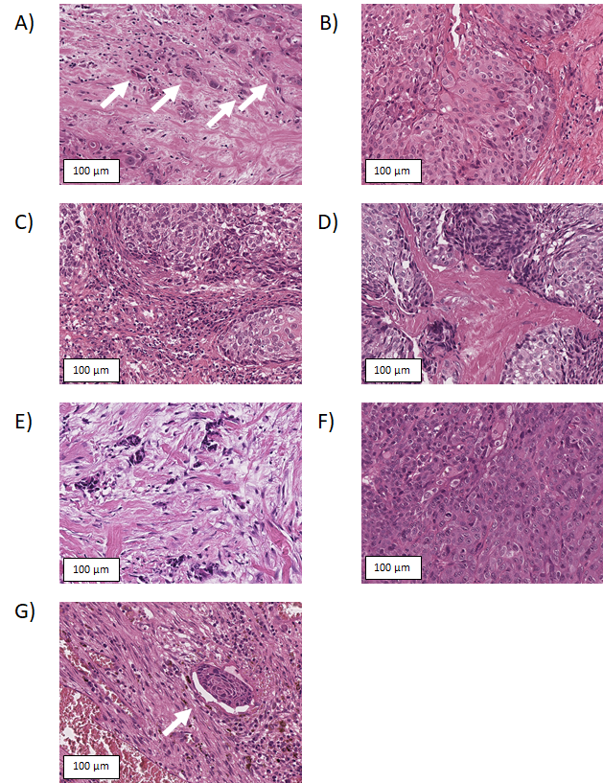Supplemental figure 1: Photomicrographs of histological parameters. Tumors show high (A, arrows) and low (B) tumor budding, high (C) and low (D) lymphocytic infiltrate, high (E) and low (F) stroma content and lymphovascular invasion (G, arrow)

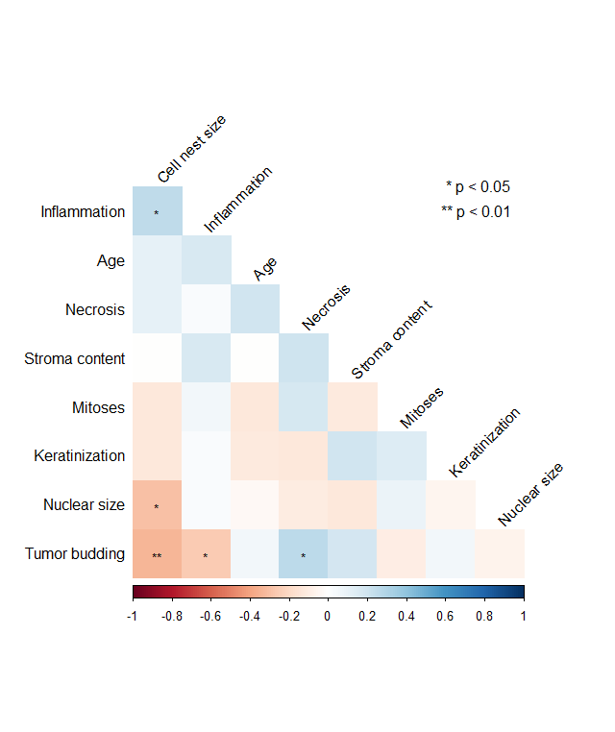Supplemental figure 2: Clinicopathological correlations of the study cohort. For continuous variables, the Pearson-correlation was applied to obtain p-values.

