Figure S1
Figure S1 Pathway analysis of B cells across the compartments. (A) Reactome biological process enrichment of DEGs of blood B cells from NMOSD and HCs. (B, C) Reactome biological process enrichment of DEGs of B cells from different tissue of NMOSD patients.

Figure S2
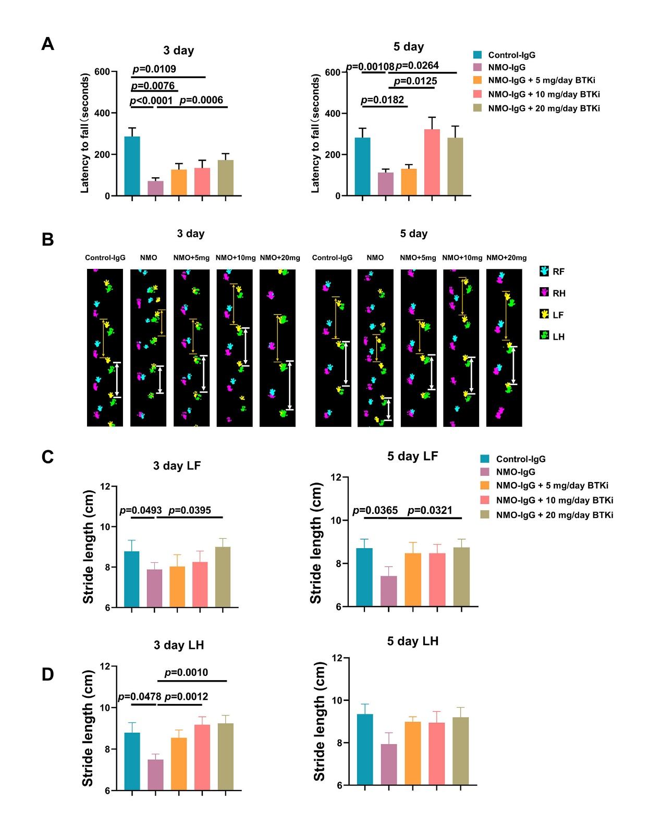
Figure S2 Zanubrutinib mitigated the motor impairment induced by NMO-IgG intrathecal infusion A Rotarod tests showed motor impairment (measured as fall latency) with injection of NMO-IgG (n = 6 for each group), but BTK inhibitor-zanubrutinib can attenuated the impairment and this effect seemed dose-dependent. B Gait illustrated by representative paw print images after 3 days of NMO-IgG injection with or without zanubrutinib. C, D Stride length of NMO-IgG recipients (n = 6 for each group) was shorter than that of wild type (WT) (n = 6), indicating significant gait impairment，but zanubrutinib can attenuated the impairment and this effect seemed dose-dependent. Right forelimb, RF; Right hindlimb, RH; Left forelimb, LF; Left hindlimb LH.

Figure S3
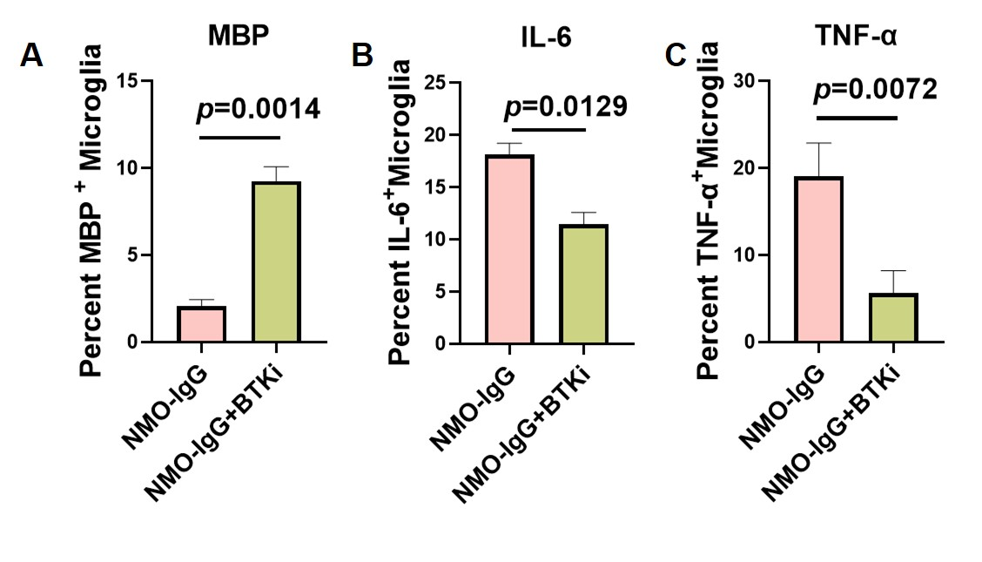
Figure S3 Zanubrutinib enhanced the phagocytosis of microglia but reduced intracranial injection-induced increases in pro-inflammatory cytokine levels in microglial cells
Quantification of percent myelin basic protein (MBP) positive (A), IL-6 positive (B) and TNF-α positive (C) microglia from NMO model with or without BTK inhibitor treatment. Data analyzed by unpaired t test with Welch's correction from representative experiment. (n = 3)
Methods
MBP staining. Microglia were first incubated with Fc-block at 4oC and then stained with fluorochrome conjugated antibody for CD11b, CD45 as well as 7-AAD to gate on live cells. After surface staining, Microglia were fixed with 2% PFA. For intracellular MBP staining, cells were permeabilized in biolegend 1x permeabilization buffer and then incubated with anti-MBP or IgG2a isotype control for 1 hr at room temp, followed by 30 min incubation with anti-rat IgG. The stained samples were assessed by flow cytometry using a FACS Aria III flow cytometer (BD Biosciences, San Jose, CA, USA). The results were analyzed using FlowJo software (version 10).

