Supplementary materials
Supplementary Figure 1 Representative micrographs of H4K20me, H3K9me3 and H3K4me4 staining for IHC scores of 8, 12, and 16.
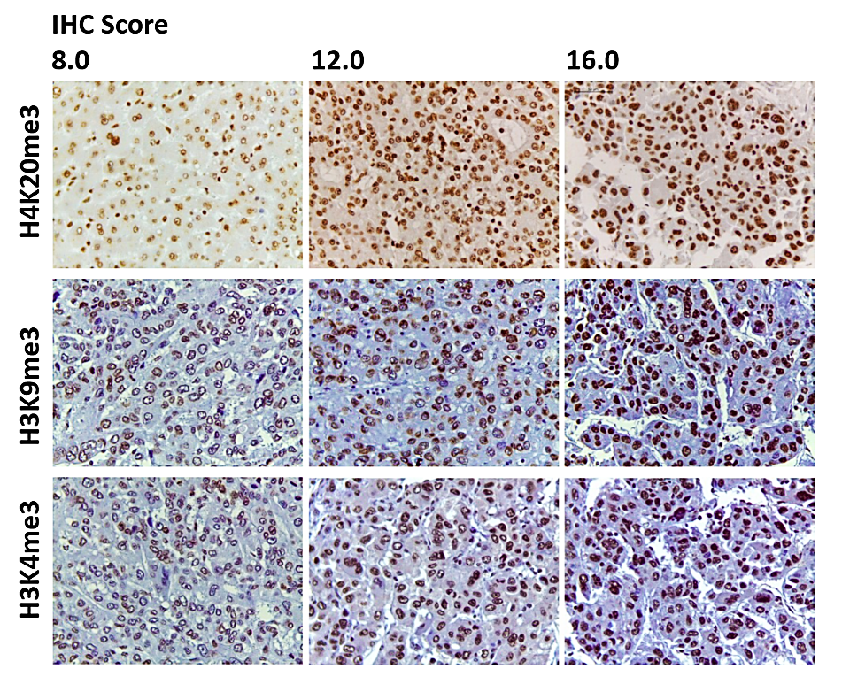

Supplementary Figure 2 Cell viability following H₂O₂ treatment (10 – 200 µM) in HepG2 (A) and Huh7 (B) cells determined by MTT assay. *P < 0.05 vs. untreated control (0 µM).
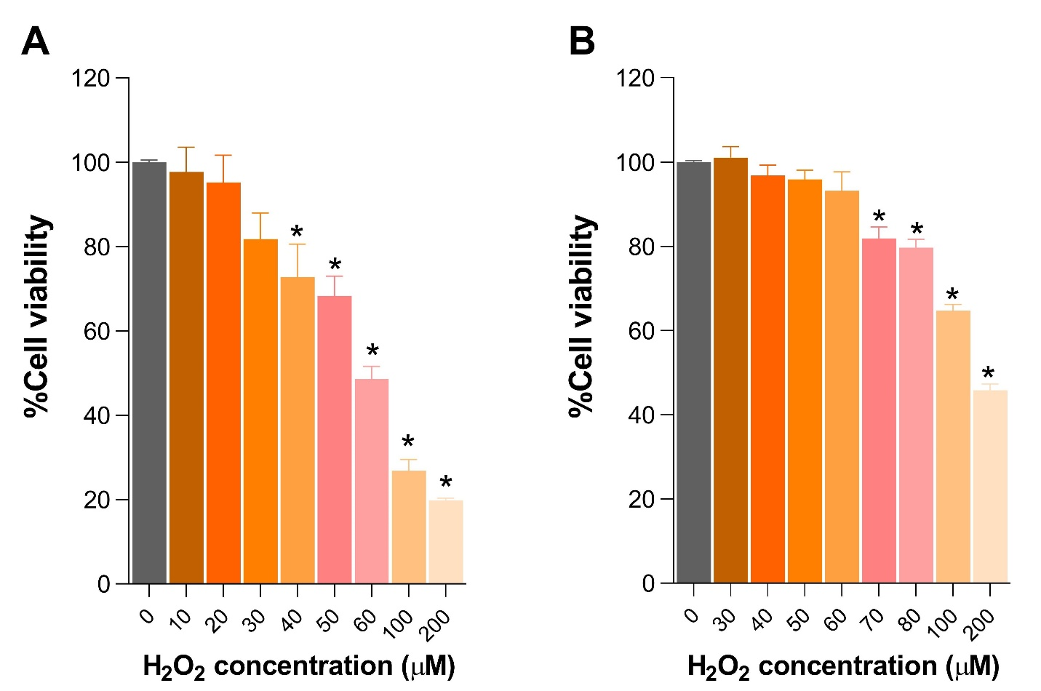

Supplementary Table 1 List of specific primers used for qRT-PCR
Primers | Sequences | Annealing temperature (°C)
NRF2 | F: 5’-ACACGGTCCACAGCTCATC-3’  R: 5’-TGCCTCCAAGTATGTCAATA-3’ | 60ª
NQO1 | F: 5’-GAAGAGCACTGATCGTACTGGC-3’  R: 5’-GGATACTGAAAGTTCGCAGGG-3’ | 60ª
SUV420H2 | F: 5’-GGCCCGCTACTTCCAGAG-3’  R: 5’-GCAGGATGGTAAAGCCACTT-3’ | 58^{b}
SUV39H1 | F: 5’-GTCATGGAGTACGTGGGAGAG-3’  R: 5’-CCTGACGGTCGTAGATCTGG-3’ | 60^{c}
SMYD3 | F: 5’-TTCCCGATATCAACATCTACCAG-'3  R: 5’-AGTGTGTGACCTCAATAAGGCAT-'3 | 60^{d}
E-cadherin | F: 5’-TGAGTGTCCCCCGGTATCTT-3’  R: 5’-GAATCATAAGGCGGGGCTGT-3’ | 60e
α-SMA | F: 5’-CCCTTGAGAAGAGTTACGAGTTG-3’  R: 5’-ATGATGCTGTTGTAGGTGGTTTC-3’ | 60e
SNAIL | F: 5’-CACTATGCCGCGCTCTTC-3’  R: 5’-GGTCGTAGGGCTGCTGGAA-3’ | 58
GAPDH | F: 5’- CAAGGTCACCATGACAACTTTG-3’  R: 5’- GTCCACCACCCTGTTGCTGTAG-3’ | 58
References for primers
a. Chen J, Yu Y, Ji T, Ma R, Chen M, Li G, et al. Clinical implication of Keap1 and phosphorylated NRF2 expression in hepatocellular carcinoma. Cancer Medicine. 2016;5(10):2678-87.
b. Yokoyama Y, Matsumoto A, Hieda M, Shinchi Y, Ogihara E, Hamada M, et al. Loss of histone H4K20 trimethylation predicts poor prognosis in breast cancer and is associated with invasive activity. Breast Cancer Research. 2014;16(3):R66.
c. Chiba T, Saito T, Yuki K, Zen Y, Koide S, Kanogawa N, et al. Histone lysine methyltransferase SUV39H1 is a potent target for epigenetic therapy of hepatocellular carcinoma. International Journal of Cancer. 2015;136(2):289-98.
d. Hamamoto R, Silva FP, Tsuge M, Nishidate T, Katagiri T, Nakamura Y, et al. Enhanced SMYD3 expression is essential for the growth of breast cancer cells. Cancer Science. 2006;97(2):113-8.
e. Mahalingaiah PKS, Ponnusamy L, Singh KP. Chronic oxidative stress leads to malignant transformation along with acquisition of stem cell characteristics, and epithelial to mesenchymal transition in human renal epithelial cells. Journal of Cellular Physiology. 2015;230(8):1916-28.

Supplementary Figure 3 Representative micrographs of the H&E-stained HCC tissues.
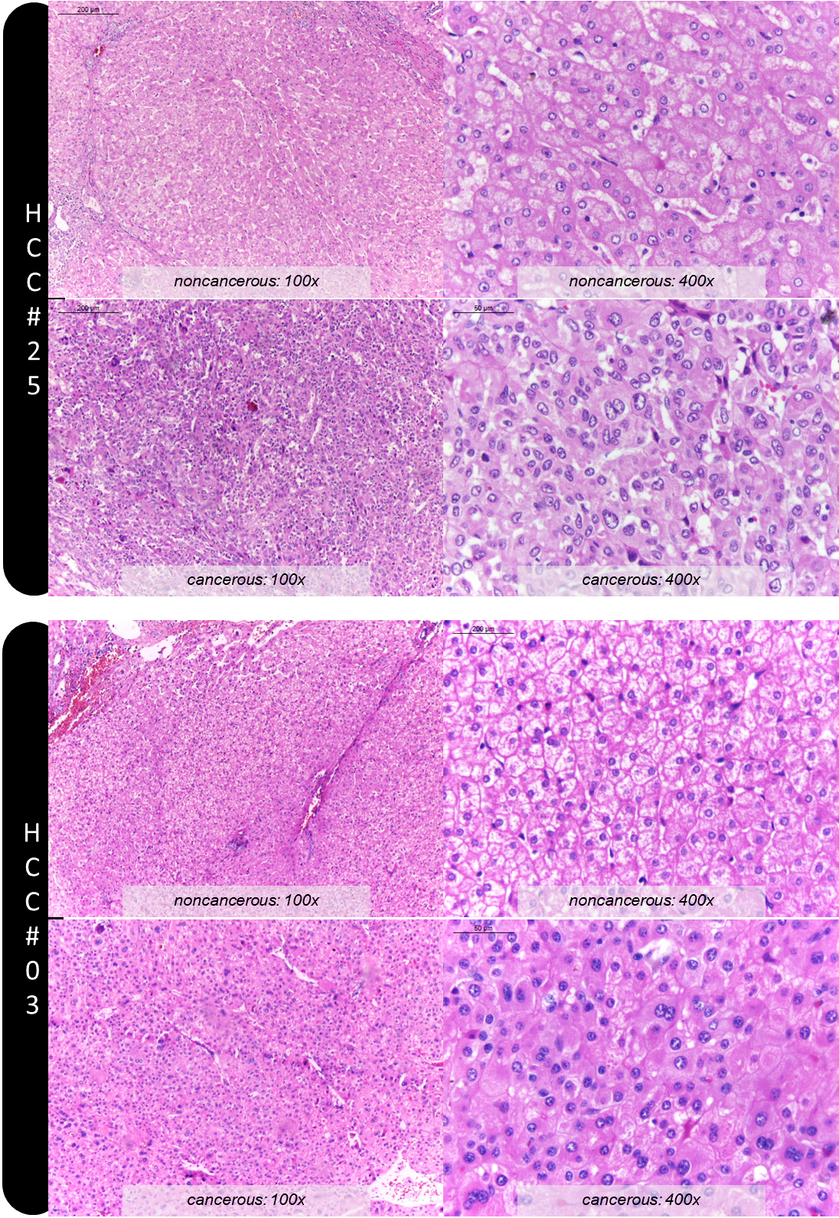

Supplementary Figure 4 Level of H4K20me3 expression in human HCC liver tissues compared among different etiologies, hepatitis B infection (n = 50, median (IQR): 9.6 (3.7)), hepatitis C infection (n = 12, median (IQR): 8.4 (3.3)), alcoholic disease (n = 5, median (IQR): 8.8 (3.1)), nonalcoholic steatohepatitis (NASH, n = 2, median (IQR): 7.4 (0.4)) and other causes (n = 31, median (IQR): 8.8 (4.4)). We found no significant difference of H4K20me3 expression level among HCC patients with different etiologies.

Supplementary Figure 5 The full non-adjusted western blot images for H3K9me3 and H3K4me3 detection in HepG2 and Huh7 cells.

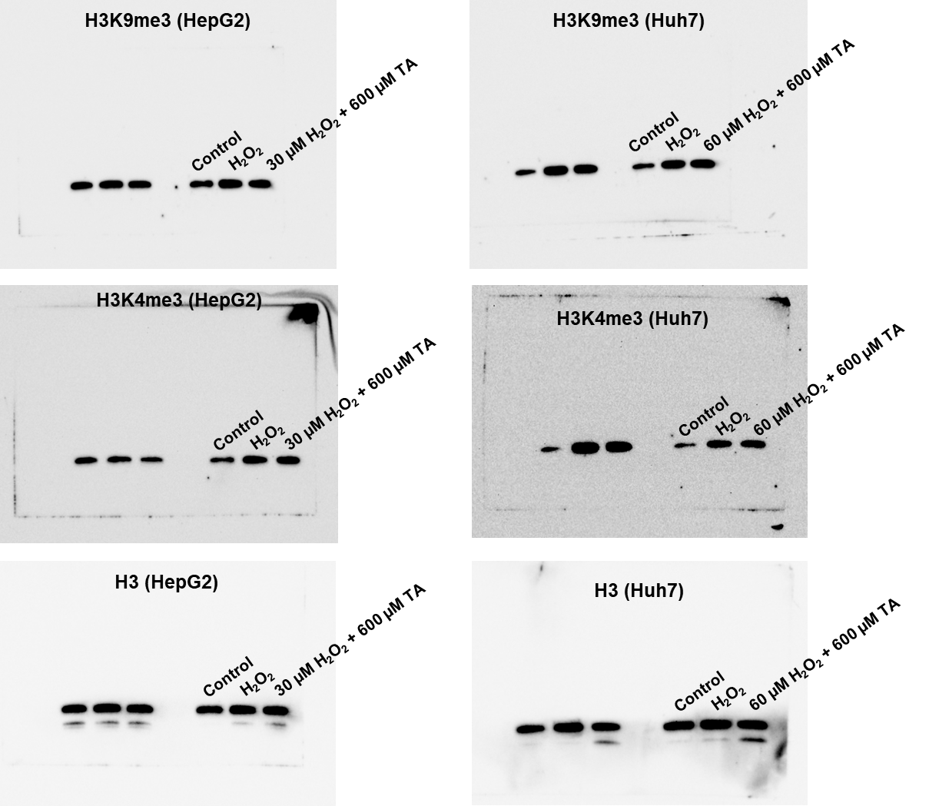

Supplementary Figure 6 The full non-adjusted western blot images for H4K20me3 detection in HepG2 and Huh7 cells.

