Supplemental Appendix

Supplemental Methods

Human endothelial cell culture
For cell culture studies, PEA specimens were cut into small pieces, placed in 10 cm Petri dishes pre-coated with 0.2% gelatin and cultured in Endothelial Cell Growth medium MV2 Kit (PromoCell) until confluency (up to 7 days) at 37 °C and 5% CO₂ (Supplemental Figure 1A), similar to published protocols (1-4). Cells were trypsinized using 1 mL of 0.25% Trypsin-EDTA, plated on glass borosilicate coverslips and fixed using 4% paraformaldehyde (PFA; for immunofluorescence analysis) or lysed using Trizol® (Ambion; for RNA isolation). Endothelial cells outgrown from PEA specimens (CTEPH-ECs) were compared to Human Pulmonary Artery Endothelial Cells (HPAECs; PromoCell and and ATCC) isolated from human pulmonary arteries (the main pulmonary artery, left and right branches) by enzymatic digestion and regularly tested for endothelial cell morphology and expression of endothelial specific markers, according to the company (PromoCell and ATCC). HPAECs used in this studies were isolated from three donors (a 84-year old Caucasian male, a 51-year old Caucasian female and a 20-year old Caucasian male). For some experiments, CTEPH-ECs were also compared to Human Umbilical Vein Endothelial Cells (HUVECs: PromoCell). Human Pulmonary Vein Endothelial Cells (HPVECs; CellBiologics) were also studied; however, they did not express pan-endothelial markers and did not grow beyond passage 1 and were therefore excluded from further analysis. HPAECs and CTEPH-ECs were cultivated in Endothelial Cell Growth Medium MV2 Kit and HUVECs in Endothelial Cell Growth Medium, according to the manufacturer’s recommendations. To avoid changes in genes expression profile as a result of culture conditions, control HPAECs were used at two different time-points (passage 3 and passage 6). CTEPH-ECs were used at passage 3.

Immunofluorescence and confocal microscopy
Endothelial cells cultured on glass coverslips pre-coated with 0.2% gelatin were fixed using freshly prepared 4% PFA for 10 min at room temperature, followed by permeabilization using 0.25% Triton X-100 for 5 min at room temperature. Blocking of unspecific binding sites was performed using 5% normal goat serum. Primary antibodies (all used at dilution 1:100) against transforming growth factor beta-induced (TGFBI; abcam; ab99562), CD31 (Dako; M0823), VE-cadherin (Cdh5; abcam; ab33168), Ki67 (abcam; ab15580) and stanniocalcin-2 (STC2; atlas antibodies; HPA045372) were incubated for 45 min at room temperature, followed by fluorescence-conjugated secondary antibodies (AlexaFluor 488, 555 or AlexaFluor 647, as indicated; Invitrogen). Cells nuclei were detected using 4′,6-diamidino-2-phenylindole (DAPI; Roth). Images were collected using a Leica LSM710 confocal microscope or a Keyence BZ-X800 microscope, respectively. The mean fluorescent intensity of endothelial cells overexpressing TGFBI was determined per microscopic area using ImageJ software.

Quantitative real time polymerase chain reaction
To validate the expression of 45 selected genes, a list containing the gene symbol, alias, official full name and reference sequence from NCBI Reference Sequence Database was prepared and sent to Qiagen for technical evaluation and RT² ProfilerTM PCR array optimization. To perform custom-designed RT² ProfilerTM PCR arrays, one µg of RNA was treated with DNase I to eliminate genomic DNA, reverse transcribed into cDNA using RT² First Strand Synthesis Kit (Qiagen) followed by quantitative, custom-designed RT² SYBR Green QPCR analysis (Qiagen) using Applied Biosystems Real-Time PCR Instrument (ThermoFisher Scientific). To validate the mRNA expression of ADAMTS13, FSTL3, PAI-1, PROCR, STC2, VWF, TAGLN, TFPI, TGFBI, TPA, SNAI2, TWIST and ZEB1, ‘standard’ real-time qPCR using SYBR Green (Bio-Rad Laboratories) and primers was used. For primer sequences, please see Supplemental Table 2. All qPCR data were normalized to the housekeeping gene HPRT1 and are reported as normalized expression or -fold change vs. HPAECs, as indicated.

Laser microdissection and gene expression analysis
To simultaneously examine the expression of multiple genes on the tissue level, nCounter® (nanoString) technology was employed. Serial, five µm-thick cross-sections of cryo-preserved PEA specimens were prepared on RNase-free, steel frame slides equipped with a polyethylene (POL)-based, UV-absorbing membrane (Leica). The modified Carstairs protocol was used to identify specific areas-of-interest, as described (5), and laser microdissection was performed using the Leica LMD7000 system under RNase-free conditions. Afterwards, RNA was isolated from the laser microdissected material using RNeasy FFPE Kit (Qiagen), and RNA quality was analyzed using Fragment Analyzer. Multiplexed target enrichment (MTE) primers (Eurofins) are shown in Supplemental Table 3. Primers were designed using Primer3* software with specific requirements, such as amplicon size 170 to 230 nucleotides, melting temperature (Tm) 60 °C and optimal primer size 18 nucleotides (6). Following amplification of the RNA using MTE primers, mRNA expression analysis was executed using nCounter® primers (Integrated DNA Technologies). As control, and to establish the baseline expression of the examined genes, 100 ng of RNA from each sample was hybridized following standard protocols provided by the manufacturer (nanoString), but without pre-amplification.

Immunohistochemistry
Paraffin-embedded PEA, IPAH and IPF specimens were cut into five µm-thick serial cross sections and examined using immunohistochemistry. To ensure comparable experimental conditions and to enable co-localisation studies, Tissue MicroArrays (TMA) were prepared, as published (5). Expression patterns of selected antigens were detected using human polyclonal antibodies against TGFBI (abcam, ab99562; dilution, 1:100), FSTL3 (Biozol, OAAB19560; dilution, 1:100), and STC2 (atlas antibodies, HPA045372; dilution, 1:500), or monoclonal antibodies against α-smooth muscle actin (SMA; clone 1A4; Sigma-Aldrich; dilution 1:500), transgelin (TAGLN; clone: OT18C8; OriGene, TA503092; dilution, 1:150) and PDGFRα (ThermoFischer Scientific; PA516742; dilution 1:100). All antibodies were incubated overnight at 4 °C in a humid chamber. The next day, secondary antibodies (MoBiTec) were incubated for 1 hour followed by incubation with avidin-biotin peroxidase link (Vector Laboratories) and peroxidase substrate (3,3’-diaminobenzidine) until color development. Sections were briefly counterstained with Gill’s hematoxylin (Sigma) and mounted with ImmuMount (ThermoScientific).

In vitro endothelial clot resolution assay
To determine the role of endothelial cells for thrombus resolution, we prepared human whole blood clots in vitro containing human endothelial cells, modifying a published protocol (7). One day before, confluent HPAECs were transduced with lentiviral particles containing human TGFBI ORF tagged with GFP (OriGene; RC200411L2V; Lot 134156E) at 5 Multiplicity Of Infection (5 MOI) using polybrene (Tocris Bioscience). Twenty-four hours later, cells were washed with PBS and trypsinized using 500 µL of Trypsin-EDTA (per well of a 6-well plate) and suspended in full endothelial medium (MV2; C-22121; PromoCell) to a final volume of 2 mL. Peripheral venous blood was collected from healthy subjects (n=3 biological repeats and n=2 experimental repeats) in 15 mL falcon tubes without anticoagulants. Then, 150 µL of whole blood and 150 µL of the cell suspension (1.8 x 10⁵ of total cells) were mixed in disposable plastic cuvettes (Plastibrand) and allowed to clot for 120 min at room temperature. Whole blood clots were picked, placed in non-suspension 96-well plates (Corning) and 100 µL of endothelial growth medium (MV2 kit) was added. Alternatively, recombinant human TGFBI (50 ng/µL; Biozol, USB-157133) was added to untreated HPAECs. After cultivation for one week at 37 °C in 5% CO₂, the medium was changed and incubation continued for another week. At the end of the experiment, clots were transferred to 4% zinc-formalin solution and incubated overnight at 4 °C, before being embedded in paraffin wax. Five µm-thick serial sections were cut on a Leica microtome, dewaxed and stained using immunohistochemical protocols to visualize Ve-cadherin (CDH5; abcam, ab33168) or SMA (clone 1A4; Sigma-Aldrich, A2547).

Inferior vena cava ligation and osmotic pump implantation
Male C57BL/6J mice were subjected to inferior vena cava ligation, as published (5,8). Two days after surgery, non-invasive vascular ultrasound was performed, and only mice that developed a venous thrombus (> 3 mm²) were implanted with osmotic pumps (mini-osmotic pump, Model 2002, Alzet; pump rate: 0.5 µL per hour) containing either recombinant TGFBI protein (Biozol, USB-157133; 0.1 µg/g of BW) or vehicle (NaCl; control). Following a small incision, loaded pumps were placed on the back of anaesthetized animals. The wound was closed using sutures (6.0 prolene; Ethicon), and animals were inspected every day. Two weeks after surgery animals were sacrificed, whole blood was collected in sodium citrate anticoagulant, thrombi were isolated and fixed in 4% zinc-formalin overnight at 4 °C, before being embedded in paraffin wax. Five µm-thick serial sections were cut on Leica microtome, dewaxed and stained to visualize CDH5 (abcam, ab33168), SMA (clone 1A4; Sigma-Aldrich, A2547), Mac-2 (clone M3/38; Biozol, CL8942AP) and PDGFRα (ThermoFischer Scientific, PA516742) as described above. Plasma levels of endogenous and recombinant TGFBI were determined using ELISA (ThermoFisher Scientific; EMTGFBI; detection range, 4.1-1,000 pg/mL).

Supplemental Table 1. Baseline characteristics, medical history and medication of 27 CTEPH patients whose plasma was analyzed using ELISA
Parameter | CTEPH patients (n=27)
Age (years), mean ± SD | 59.3 ± 14.5
Sex (male), n (%) | 15 (55.6%)
BMI (kg/m²), mean ± SD | 27.5 ±4.1
Medical history and risk factors
Previous pulmonary embolism | 26 (96.3%)
Thrombophilia | 8 (29.6%)
Splenectomy | 2 (74.1%)
Systemic inflammatory disease | 3 (9.7%)
Cancer | 1 (3.7%)
Coronary artery disease | 3 (11.1%)
Pulmonary disease | 4 (14.8%)
Renal insufficiency | 14 (51.9%)
Medication
Vitamin K antagonist, n (%) | 14 (51.9%)
Non-vitamin K-dependent oral anticoagulant (NOAC), n (%) | 13 (48.1%)
Platelet aggregation inhibitors, n (%) | 6 (22.2%)
Riociguat, n (%) | 3 (11.1%)
Phosphodiesterase-5 inhibitor, n (%) | 1 (3.7%)
Endothelin receptor antagonist, n (%) | 1 (3.7%)

Supplemental Table 2. List of human primers used in real-time qPCR analysis
Gene | Primer sequences  (in 5′–3′ direction) | T_{m}  (°C) | cycles | ref
ADAMTS13 | F: CCTCACATTGGGCGTTATTG  R: CACTGTAGTTGGCTGAGAAAC | 60 | 35 | Primer Bank
FSTL3 | F: CTACATCTCCTCGTGCCACA  R: TCTTCTGCAGACTCACCACCT | 60 | 35 | (9)
HPRT1 | F: GTAATTGGTGGAGATGATCTCTCAACT  R: TGTTTTGCCAGTGTCAATTATATCTTC | 60 | 35 | (10)
PAI-1 | F: GTCTGCTGTGCACCATCCCCCATC  R: TTGTCATCAATCTTGAATCCCATA | 60 | 35 | (11)
PROCR | F: GGCAGTTTCATCATTGCTGG  R: TTGAACGCCTCAGGTGATTC | 60 | 35 | (12)
SNAI2 | F: TCGGACCCACACATTACCTTG  R: AAAAGGCTTCTCCCCCGTGT | 58 | 35 | (13)
STC2 | F: GGGTGTGGCGTGTTTGAATG  R: CTTGAGGTAGCATTCCCGCT | 60 | 35 | (14)
VWF | F: TGC TGA CAC CAG AAA AGT GC  R: AGT CCC CAA TGG ACT CAC AG | 60 | 35 | (15)
TAGLN | F: AGTGCAGTCCAAAATCGAGAAG  R: CTTGCTCAGAATCACGCCAT | 60 | 35 | (16)
TFPI | F:GGAAGAAGATCCTGGAATATGTCGAGG  R: CTTGGTTGATTGCGGAGTCAGGGAG | 60 | 35 | (17)
TGFBI | F: TCATGGCCACAAATGGCGTGGT  R: AGCCCTGGAAAACGCTGATGCT | 60 | 35 | Primer Bank
TPA | F: CTGCAGCTGAAATCGGATTCGT  R: CTGATGATGCCCACCAAAGTC | 60 | 35 | (18)
TWIST | F: CTCAAGAGGTCGTGCCAATC  R: CCCAGTATTTTTATTTCTAAAGGTGTT | 60 | 35 | (19)
ZEB1 | F: TTCAAACCCATAGTGGTTGCT  R: TGGGAGATACCAAACCAACTG | 60 | 35 | (20)

Supplemental Table 3. List of human primers used in nCounter gene expression studies
Gene Name | Accession Number | Position | Forward Primer Sequence (5′–3′) | Reverse Primer Sequence (5′–3′) | Tm A | Tm B
CD44 | NM_001001392.1 | 430-529 | CAGGGATCCTCCAGCTCC | CCGTCCGAGAGATGCTGT | 85 | 85
COL1A1 | NM_000088.3 | 5211-5310 | CACTGGGTTCGGAGGAGA | TAAAATGGGGAGCCGCTT | 82 | 81
COL1A2 | NM_000089.3 | 2636-2735 | GTGGTGAGGTCGGTCCTG | GCCTCCATCACCACGACT | 83 | 81
COL3A1 | NM_000090.3 | 181-280 | TTTGTGCAAAAGGGGAGC | TGGGTTGGGGCAGTCTAA | 81 | 80
FSTL3 | NM_005860.2 | 246-345 | GCAACATTGACACCGCCT | GGAGCCCCGAGCAGTC | 82 | 82
HPRT1 | NM_000194.1 | 241-340 | GGACTGAACGTCTTGCTCG | TCCCCTGTTGACTGGTCATT | 87 | 80
NOTCH3 | NM_000435.2 | 1966-2065 | CCACAGGTGTGAACTGCG | CCCATCCACACAGGAACC | 81 | 82
SERPING1 | NM_000062.2 | 306-405 | AGCTCCAGCTCCCAGGAT | GTGGGTTGTGTGGTGGGT | 80 | 78
STC2 | NM_003714.2 | 2826-2925 | AGGGTGGAGGGAGGAGTG | CCCCCTTTGAGCTGGTTT | 82 | 79
TAGLN | NM_003186.3 | 261-360 | CAGTGTGGCCCTGATGTG | CCACCTGCTCCATCTGCT | 82 | 82
TGFBI | NM_000358.2 | 2031-2130 | CCTGACATCATGGCCACA | ACAGGGGCTAGTCGCACA | 82 | 80
TGFB1 | NM_000660.3 | 1261-1360 | GGTGGAAACCCACAACGA | GCTGAGGTATCGCCAGGA | 79 | 82
THBS2 | NM_003247.2 | 4461-4560 | TGAAAGCCCTCATGTGCAG | GGTTCCTCTCAGGCAGCA | 82 | 79

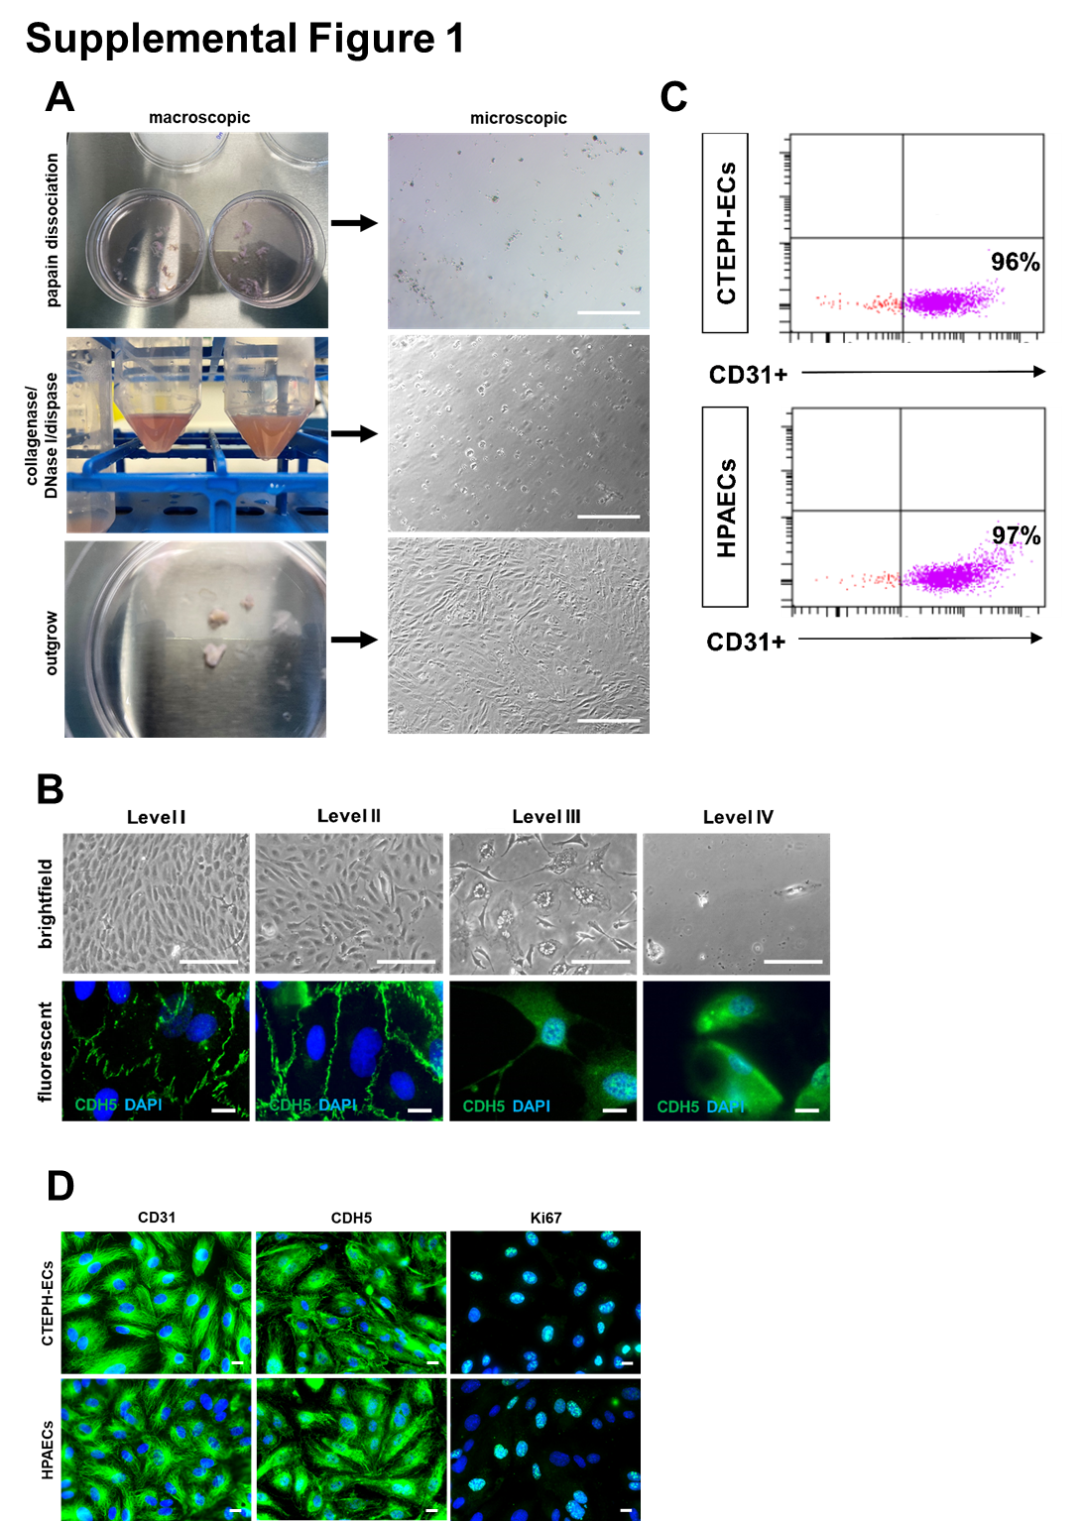
Supplemental Figure 1. Characterization of endothelial cells isolated from CTEPH pulmonary endarterectomy specimens. Representative macroscopic and microscopic images showing the results for three different methods of CTEPH-EC isolation, using papain dissociation kit (top panel), a mixture of collagenase, DNase and dispase (middle panel), or by placing fresh PEA specimens in culture and allowing cells to outgrow (bottom panel) (A). Scale bars represent 100 µm. Representative brightfield (upper panels) and confocal fluorescence microscopy images of CTEPH-ECs in culture obtained from different regions (Level I to IV) following immunodetection of VE-cadherin (CDH5; green signal; lower panels). Size bars represent 10 µm (B). Representative flow cytometry blots showing the percentage of CD31-positive endothelial cells in cultured CTEPH-ECs and in HPAECs used as control (C). Representative high-resolution images of CTEPH-ECs and HPAECs in culture following immunodetection of CD31, CDH5 and Ki67 (green signal; D). Scale bars represent 10 µm.
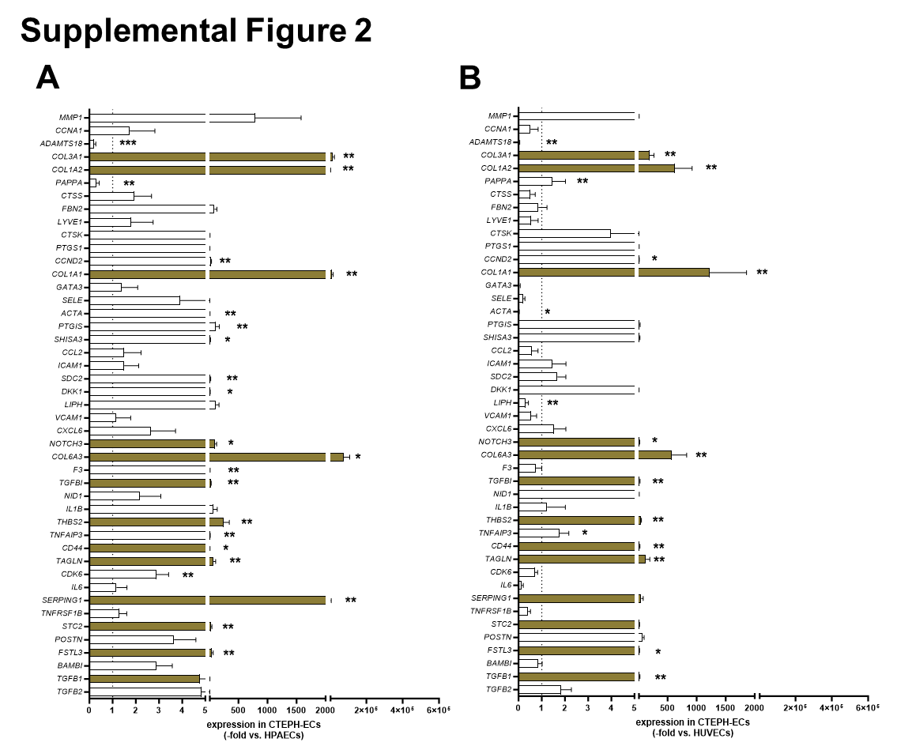
Supplemental Figure 2. Gene expression analysis of CTEPH-ECs using RT² Profiler PCR Arrays. Graphs showing the expression profile of 45 genes of interest, selected following microarray analysis of differentially expressed genes, in additional CTEPH-ECs isolated from PEA specimens (n=7 biological repeats; 60 ± 3.1 years old, 40% male), compared to human pulmonary artery endothelial cells (HPAECs; A) or compared to human umbilical vein endothelial cells (HUVECs; B). Data are expressed as -fold change vs. HPAECs (A) or HUVECs (B). Quantitative data are presented as mean ± SEM. P-values were calculated using Student’s t-test (NOTCH3 vs. HPAECs) or Mann-Whitney U test (ACTA, ADAMTS18, CCND2, CD44, CDK6, COL1A1, COL3A1, COL3A2, COL6A3, DKK1, F3, FSTL3, PAPPA, PTGIS, SDC2, SERPING1, SHISA3, STC2, TAGLN, TGFBI, THBS2, and TNFAIP3 vs. both and NOTCH3 vs. HUVECs) and are shown within the graphs. *p<0.05, **p<0.01 and ***p<0.001. Non-significant values are not shown. Genes selected for further validation by gene expression analysis of laser microdissected material from PEA tissue microarrays are highlighted in brown.
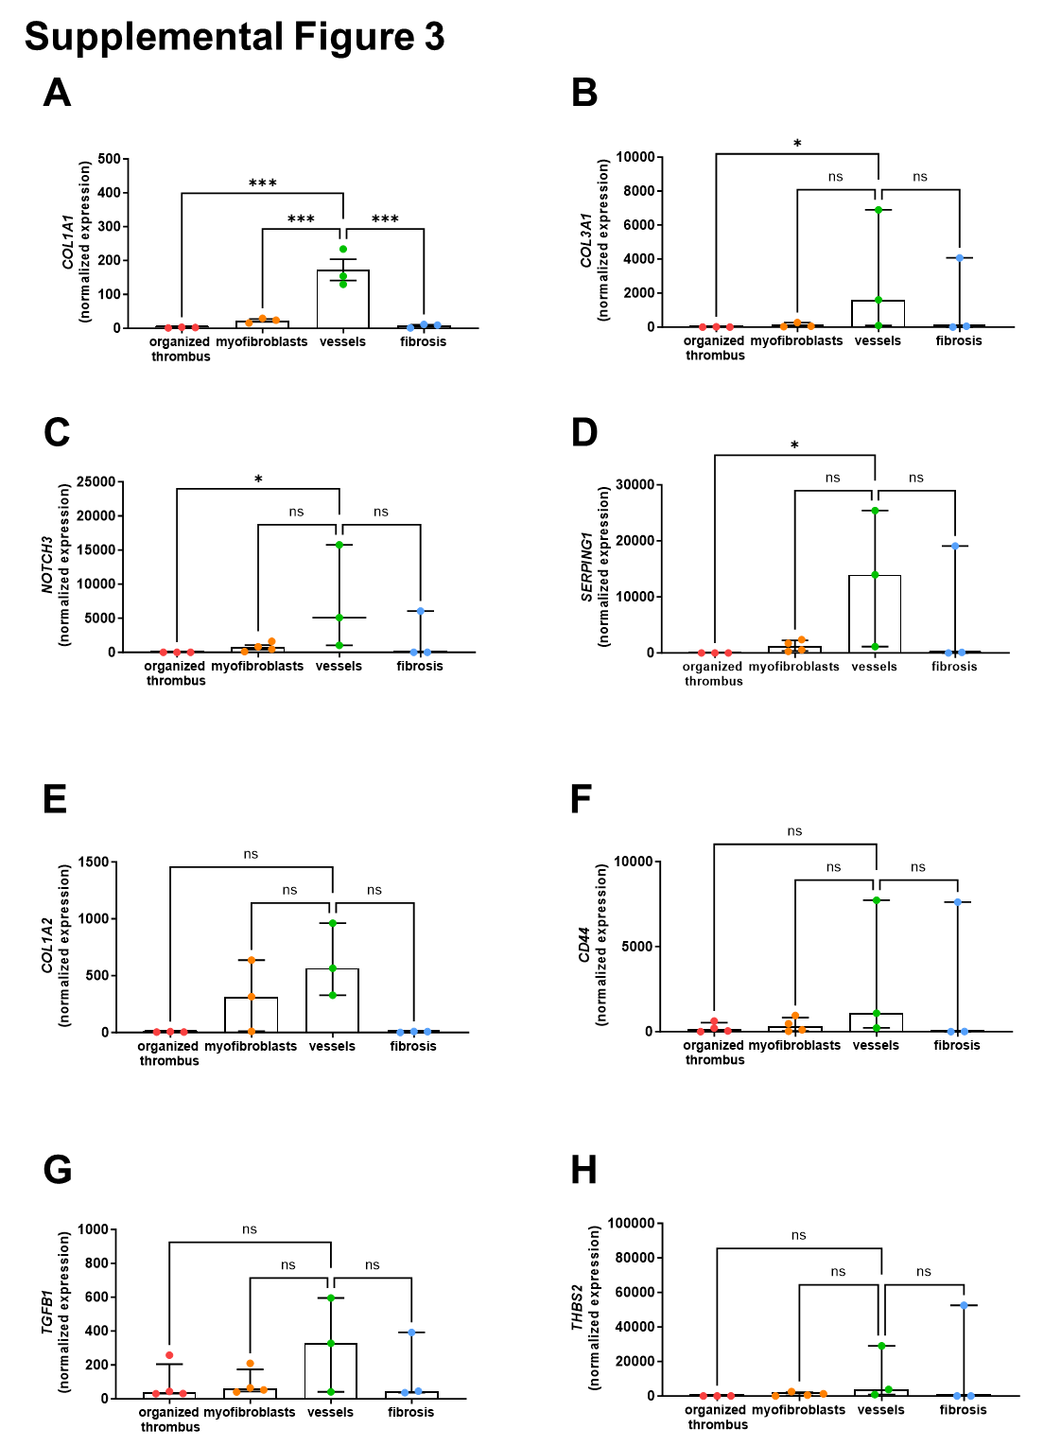

Supplemental Figure 3. Laser microdissection and gene expression analysis of CTEPH tissue microarrays. Graphs showing the results after laser microdissection (n=3-4 samples per area) and nCounter gene expression analysis (nanoString) of mRNA expression levels of collagen type 1 alpha 1 chain (COL1A1; A), collagen type 3 alpha 1 chain (COL3A1; B), neurogenic locus Notch homolog protein 3 (NOTCH3; C), serpin family G member 1 (SERPING1; D), collagen type 1 alpha 2 chain (COL1A2; E), CD44 Molecule (CD44; F), transforming growth factor beta-1 (TGFB1; G), and thrombospondin-2 (THBS2; H). Quantitative data are presented as mean ± SEM, p-values were determined by comparison of findings in ‘vessels’ area with ‘organized thrombus’, ‘myofibroblast’ or ‘fibrosis’ areas (3 comparisons) using one-way ANOVA followed by Bonferroni’s multiple comparisons test for (A). Data shown in B-H are presented as median with interquartile range, and p-values were determined using Kruskal-Wallis test followed by Dunn’s multiple comparisons test. *p<0.05 and ***p<0.001. ns, non-significant.
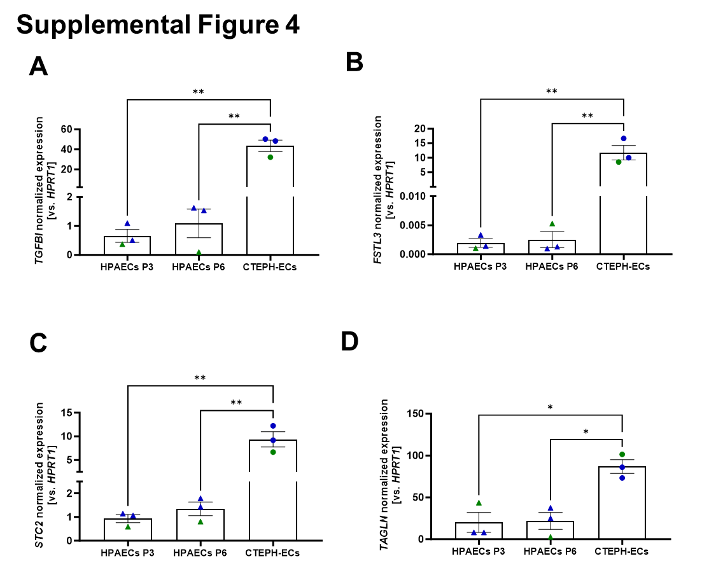
Supplemental Figure 4. Effect of the passage number on the expression of candidate genes. Quantitative analysis of TGFBI (A), FSTL3 (B), STC2 (C) and TAGLN (D) mRNA expression in HPAECs, at passage 3 (P3) or passage 6 (P6) and CTEPH-ECs (passage 3; n=3 biological repeats each; green symbols represent cells from female donors, blue symbols form male donors) and cultivated at two different time-points. Quantitative data are presented as mean ± SEM. P-values were determined using two-way ANOVA followed by Dunnett’s multiple comparisons test. *p<0.05 and **p<0.01.
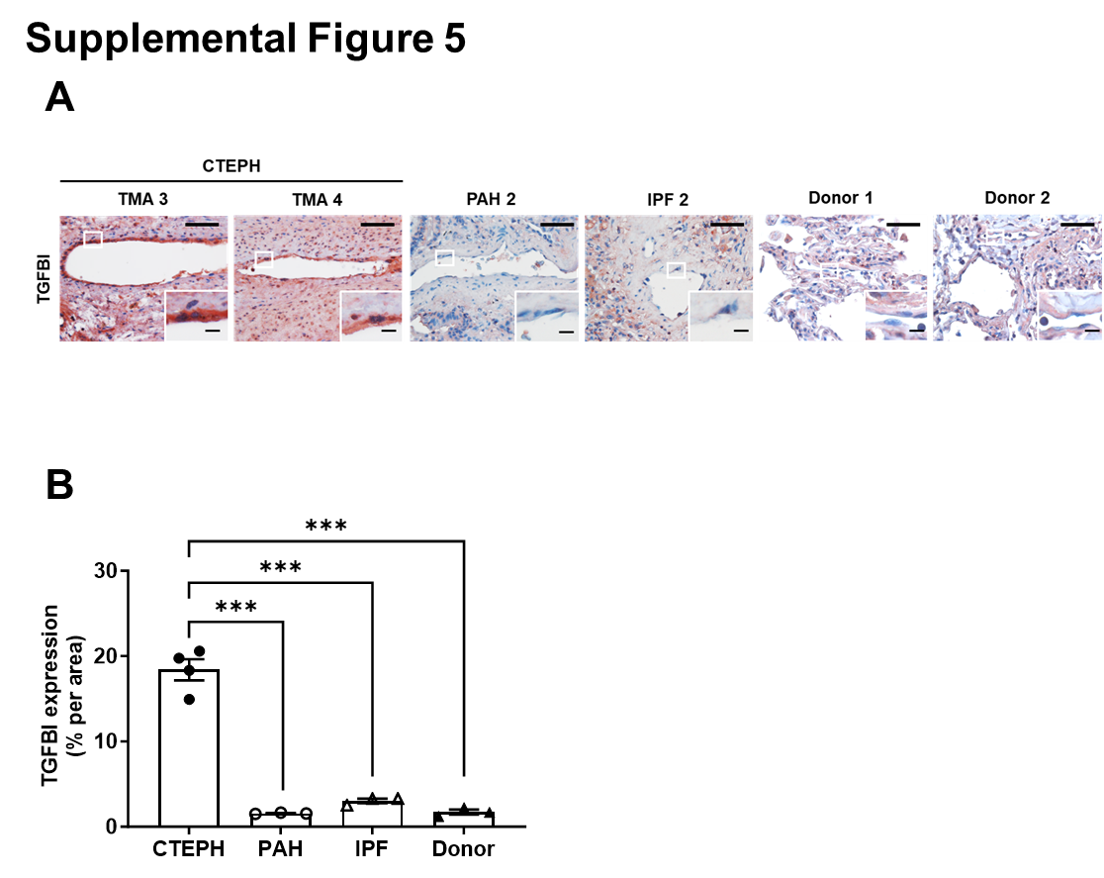
Supplemental Figure 5. Immunohistochemical detection of TGFBI in human lung tissue. Representative immunohistochemical images (A) and quantitative analysis (B) of TGFBI expression in tissue microarrays (TMA) prepared from PEA material of two additional CTEPH patients (TMA 3 and TMA 4) or from lung tissue of one additional patient with pulmonary arterial hypertension (PAH 2) or idiopathic pulmonary fibrosis (IPF 2) and from lung transplant donors without CTEPH, PAH or IPF (Donor 1 and Donor 2). Scale bars represent 100 µm (or 10 µm inside zoom-in pictures). Quantitative data are presented as mean ± SEM. P-values were determined using one-way ANOVA followed by Bonferroni’s multiple comparisons test for normally distributed values. The mean in each column was compared with the mean in each other column (6 comparisons). ***p<0.001. Non-significant P-values are not shown.
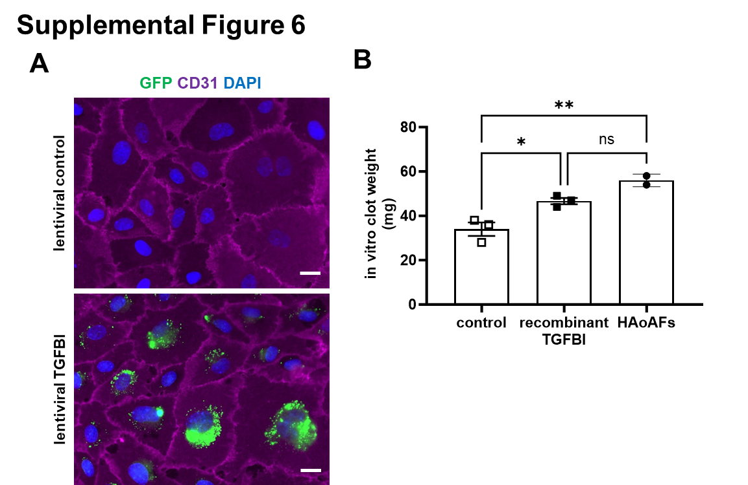
Supplemental Figure 6. Lentiviral overexpression of TGFBI in HPAECs and in vitro blood clot weights. Representative high resolution immunofluorescent images showing HPAECs treated with polybrene (lentiviral control) or transduced with TGFBI lentiviral particles conjugated with GFP (green) followed by immunostaining of CD31 (purple) (A). Cell nuclei are stained with DAPI (blue). Scale bars represent 10 µm. Weights of in vitro blood clots, containing HPAECs treated with recombinant TGFBI or vehicle (control), or HAoAFs (B). Quantitative data are presented as mean ± SEM. P-values were determined using one-way ANOVA followed by Tukey’s multiple comparison test. *p<0.05 and **p<0.01. ns, non-significant.
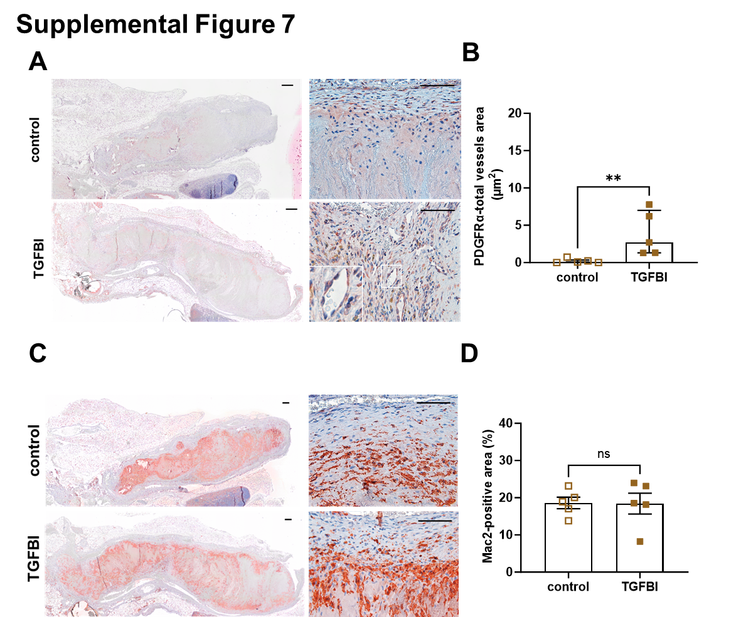
Supplemental Figure 7. Cellular composition of mouse thrombi. Representative images of longitudinal cross-sections through the thrombosed IVC at day 14 after ligation following immunostaining of PDGFRα to visualize fibroblasts (A) and quantification of PDGFRα-immunopositive vessel structures residing thrombi (B). Representative images of longitudinal cross-sections through the thrombosed IVC at day 14 after ligation following immunostaining of Mac-2 to visualize macrophages (A) and quantification of the Mac-2 immunopositive area (B). Scale bars represent 100 µm. Quantitative data are presented as median with interquartile range (B) or as mean ± SEM (D). P-values were determined using Mann-Whitney U test (B) or Student’s t-test (D). **p<0.01. ns, non-significant.
Supplemental References
1. Nukala SB, Tura-Ceide O, Aldini G et al. Protein network analyses of pulmonary endothelial cells in chronic thromboembolic pulmonary hypertension. Sci Rep 2021;11:5583.
2. Smolders V, Lodder K, Rodriguez C et al. The Inflammatory Profile of CTEPH-Derived Endothelial Cells Is a Possible Driver of Disease Progression. Cells 2021;10.
3. Smolders V, Rodriguez C, Blanco I et al. Metabolic profile in endothelial cells of chronic thromboembolic pulmonary hypertension and pulmonary arterial hypertension. Sci Rep 2022;12:2283.
4. Tura-Ceide O, Smolders V, Aventin N et al. Derivation and characterisation of endothelial cells from patients with chronic thromboembolic pulmonary hypertension. Sci Rep 2021;11:18797.
5. Bochenek ML, Rosinus NS, Lankeit M et al. From thrombosis to fibrosis in chronic thromboembolic pulmonary hypertension. Thromb Haemost 2017;117:769-783.
6. Rozen S, Skaletsky H. Primer3 on the WWW for general users and for biologist programmers. Methods Mol Biol 2000;132:365-86.
7. Wood K, Stephens SE, Xu F et al. In Vitro Blood Clot Formation and Dissolution for Testing New Stroke-Treatment Devices. Biomedicines 2022;10.
8. Bochenek ML, Leidinger C, Rosinus NS et al. Activated Endothelial TGFbeta1 Signaling Promotes Venous Thrombus Nonresolution in Mice Via Endothelin-1: Potential Role for Chronic Thromboembolic Pulmonary Hypertension. Circ Res 2020;126:162-181.
9. Xie J, Zhu H, Chang HM, Klausen C, Dong M, Leung PCK. GDF8 Promotes the Cell Invasiveness in Human Trophoblasts by Upregulating the Expression of Follistatin-Like 3 Through the ALK5-SMAD2/3 Signaling Pathway. Front Cell Dev Biol 2020;8:573781.
10. Galiveti CR, Rozhdestvensky TS, Brosius J, Lehrach H, Konthur Z. Application of housekeeping npcRNAs for quantitative expression analysis of human transcriptome by real-time PCR. RNA 2010;16:450-61.
11. Li XN, Grenett HE, Benza RL et al. Genotype-specific transcriptional regulation of PAI-1 expression by hypertriglyceridemic VLDL and Lp(a) in cultured human endothelial cells. Arterioscler Thromb Vasc Biol 1997;17:3215-23.
12. Sturn DH, Kaneider NC, Feistritzer C, Djanani A, Fukudome K, Wiedermann CJ. Expression and function of the endothelial protein C receptor in human neutrophils. Blood 2003;102:1499-505.
13. Liu X, Chen L, Huang H et al. High expression of PDLIM5 facilitates cell tumorigenesis and migration by maintaining AMPK activation in prostate cancer. Oncotarget 2017;8:98117-98134.
14. Hou J, Wang Z, Xu H et al. Stanniocalicin 2 suppresses breast cancer cell migration and invasion via the PKC/claudin-1-mediated signaling. PLoS One 2015;10:e0122179.
15. Ngo ML, Mahdi F, Kolte D, Shariat-Madar Z. Upregulation of prolylcarboxypeptidase (PRCP) in lipopolysaccharide (LPS) treated endothelium promotes inflammation. J Inflamm (Lond) 2009;6:3.
16. Chen Z, He S, Zhan Y et al. TGF-beta-induced transgelin promotes bladder cancer metastasis by regulating epithelial-mesenchymal transition and invadopodia formation. EBioMedicine 2019;47:208-220.
17. Dong X, Song LP, Zhu DW, Zhang HL, Liu LX, Leng XG. Impact of the tissue factor pathway inhibitor gene on apoptosis in human vascular smooth muscle cells. Genet Mol Biol 2011;34:25-30.
18. Diamond SL, Sharefkin JB, Dieffenbach C, Frasier-Scott K, McIntire LV, Eskin SG. Tissue plasminogen activator messenger RNA levels increase in cultured human endothelial cells exposed to laminar shear stress. J Cell Physiol 1990;143:364-71.
19. Xu X, Tan X, Tampe B, Sanchez E, Zeisberg M, Zeisberg EM. Snail Is a Direct Target of Hypoxia-inducible Factor 1alpha (HIF1alpha) in Hypoxia-induced Endothelial to Mesenchymal Transition of Human Coronary Endothelial Cells. J Biol Chem 2015;290:16653-64.
20. Zhang L, Zhang W, Li Y et al. SHP-2-upregulated ZEB1 is important for PDGFRalpha-driven glioma epithelial-mesenchymal transition and invasion in mice and humans. Oncogene 2016;35:5641-5652.

