Supplementary Tables
 | T₀ -T₁ | T₁ –T₂ | T₂ –T₃
M±SD | 400.3±91.6 | 394.4±120.7 | 398.5±119.3
Median | 382 | 373 | 371
IQR | 360-417 | 353-402 | 350-413
Supplementary Table 1: Time between the observations in days

M: Mean; SD: Standard Deviation; IQR: Interquartile range

Supplementary Table 2: Percentage of patients with ceiling effects for each EQ-5D-3L dimension
EQ-5D dimension | SCA 1-3 % (n=728) | SCA 6 % (n=107)
Mobility | 19.6 | 12.1
Self-care | 64.8 | 60.7
Usual activities | 39.1 | 21.5
Pain/Discomfort | 49.7 | 62.6
Anxiety/Depression | 58.1 | 57.9
Over all '11111' % | 10.9 | 3.7
'11111': no problems in all dimensions. Each of the five dimensions consists of three response options, numbered with (1) no problems, (2) some problems, (3) extreme problems, indicating of no problems with ‘11111’.

Supplementary Table 3: Convergent validity of the EQ-5D-3L index and EQ-VAS; baseline to follow-up 3
 | Total | n | p-value |  | SCA 1-3 |  | n | p-value | SCA 6 | n | p-value
Baseline
EQ-5D-3L index
SARA score | -0.603 | 832 | <0.01 |  | -0.612 |  | 725 | <0.01 | -0.500 | 107 | <0.01
ADL | -0.770 | 301 | <0.01 |  | -0.770 |  | 301 | <0.01
INAS count | -0.404 | 748 | <0.01 |  | -0.473 |  | 656 | <0.01 | -0.255 | 92 | 0.014
PHQ-9 | -0.411 | 786 | <0.01 |  | -0.434 |  | 679 | <0.01 | -0.301 | 107 | <0.01
EQ-VAS
SARA score | -0.414 | 810 | <0.01 |  | -0.434 |  | 704 | <0.01 | -0.281 | 106 | <0.01
ADL | -0.504 | 293 | <0.01 |  | -0.504 |  | 293
INAS count | -0.293 | 730 | <0.01 |  | -0.324 |  | 639 | <0.01 | -0.319 | 91 | <0.01
PHQ-9 | -0.389 | 774 | <0.01 |  | -0.393 |  | 668 | <0.01 | -0.381 | 106 | <0.01
Follow-up 1
EQ-5D-3L index
SARA score | -0.541 | 695 | <0.01 |  | -0.559 |  | 612 | <0.01 | -0.357 | 83 | <0.01
ADL | -0.714 | 249 | <0.01 |  | -0.714 |  | 249 | <0.01
INAS count | -0.363 | 585 | <0.01 |  | -0.414 |  | 523 | <0.01 | -0.197 | 62 | 0.125
PHQ-9 | -0.464 | 645 | <0.01 |  | -0.471 |  | 570 | <0.01 | -0.464 | 75 | <0.01
EQ-VAS
SARA score | -0.365 | 672 | <0.01 |  | -0.397 |  | 591 | <0.01 | -0.134 | 81 | 0.231
ADL | -0.484 | 240 | <0.01 |  | -0.484 |  | 240
INAS count | -0.300 | 566 | <0.01 |  | -0.300 |  | 506 | <0.01 | -0.482 | 60 | <0.01
PHQ-9 | -0.466 | 637 | <0.01 |  | -0.454 |  | 562 | <0.01 | -0.552 | 75 | <0.01
Follow-up 2
EQ-5D-3L index
SARA score | -0.547 | 567 | <0.01 |  | -0.561 |  | 484 | <0.01 | -0.477 | 83 | <0.01
ADL | -0.64 | 155 | <0.01 |  | -0.64 |  | 155 | <0.01
INAS count | -0.376 | 525 | <0.01 |  | -0.417 |  | 449 | <0.01 | -0.210 | 76 | 0.068
PHQ-9 | -0.528 | 532 | <0.01 |  | -0.549 |  | 456 | <0.01 | -0.389 | 76 | <0.01
EQ-VAS
SARA score | -0.390 | 556 | <0.01 |  | -0.435 |  | 474 | <0.01 | -0.114 | 82 | 0.309
ADL | -0.523 | 151 | <0.01 |  | -0.523 |  | 151
INAS count | -0.385 | 516 | <0.01 |  | -0.401 |  | 441 | <0.01 | -0.413 | 75 | <0.01
PHQ-9 | -0.510 | 529 | <0.01 |  | -0.486 |  | 453 | <0.01 | -0.626 | 76 | <0.01
Follow-up 3
EQ-5D-3L index
SARA score | -0.475 | 434 | <0.01 |  | -0.469 |  | 357 | <0.01 | -0.550 | 77 | <0.01
ADL | -0.593 | 63 | <0.01 |  | -0.593 |  | 63 | <0.01
INAS count | -0.342 | 403 | <0.01 |  | -0.405 |  | 328 | <0.01 | -0.260 | 75 | 0.024
PHQ-9 | -0.526 | 411 | <0.01 |  | -0.547 |  | 337 | <0.01 | -0.382 | 74 | <0.01
EQ-VAS
SARA score | -0.375 | 422 | <0.01 |  | -0.373 |  | 345 | <0.01 | -0.381 | 77 | <0.01
ADL | -0.525 | 63 | <0.01 |  | -0.525 |  | 63 | <0.01
INAS count | -0.327 | 397 | <0.01 |  | -0.377 |  | 322 | <0.01 | -0.350 | 75 | <0.01
PHQ-9 | -0.461 | 410 | <0.01 |  | -0.453 |  | 336 | <0.01 | -0.522 | 74 | <0.01
Data are given as Spearman's correlation coefficient; n= number of observations; SARA: Scale for Assessment and Rating of Ataxia; INAS: Inventory of Non-Ataxia Signs; ADL: Activities of Daily Living (ADL) part of Friedreich's ataxia rating scale; EQ-VAS: EuroQol Visual Analog Scale; PHQ-9: Patient Health Questionnaire

Supplementary Table 4: Test-Retest Reliability
 | n | Kappa | p-value
Mobility | 27 | 0.93 | <0.01
Self-Care | 27 | 0.68 | <0.01
Usual Activities | 27 | 0.52 | <0.01
Pain/ Discomfort | 27 | 0.57 | <0.01
Anxiety/Depression | 27 | 0.44 | <0.01
 |  | ICC
EQ-5D-3L | 27 | 0.95 | <0.01
EQ-VAS | 25 | 0.88 | <0.01
ICC: Intraclass correlation coefficient; n= number of observations

Supplementary figures
Supplementary Figure 1: Flow-chart of patients at baseline and follow-ups (FU)
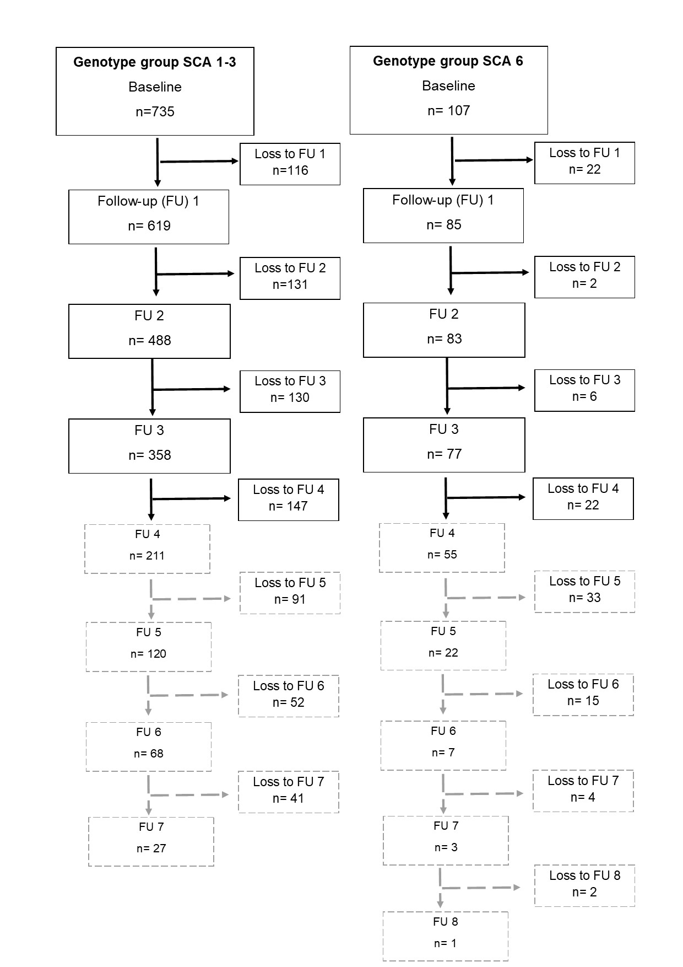
Black bordered fields mark all included follow-ups in our analysis. Fields outlined in grey mark all excluded follow-ups.
Supplementary Figure 2: Distribution of responses to the EQ-5D-3L items MO, SC, UA, PD and AD (in %)

MO: Mobility, SC: Self-care, UA: Usual activities, PD: Pain/Discomfort, AD: Anxiety/Depression

