Supplementary Materials and Methods
Western blot
Following (Z)-4-hydroxytamoxifen (Sigma-Aldrich, H7904-5MG) treatment for 24 h and/or bafilomycin A₁ (BafA) treatment (10 nM) for 2 h or not, cells were washed with PBS and lysed in RIPA lysis buffer (Sigma-Aldrich, R0278) supplemented with complete Protease Inhibitor Cocktail (Roche, 11697498001) and PhosSTOP (Roche, 4906837001). Protein concentration was calculated by using the BCA Assay (Thermo Scientific, 23225). Samples were diluted in 4x Laemmli Sample Buffer (Bio-Rad, 1610747) and boiled at 100 °C for 5 min. Twenty µg protein per sample were used for SDS-PAGE analysis. NuPAGE Novex 4%–12% Bis-Tris gradient gel (Invitrogen, NP0335BOX) with MOPS running buffer (Invitrogen, NP0001) was used. Proteins were transferred to a PVDF membrane (Merck Millipore, IPFL00010) and blocked with 5% skimmed milk-TBST (TBS 10x [Sigma-Aldrich, T5912]) diluted to 1x in distilled water containing 0.1% Tween 20 [Sigma-Aldrich, P1379]) for 1h. Membranes were incubated at 4°C overnight with primary antibodies diluted in 1% skimmed milk-TBST and at room temperature for 1 h with secondary antibodies diluted in 1% skimmed milk-TBST supplemented 0.01% SDS. Primary antibodies used were: anti-ATG16L1, clone EPR15638 (Abcam, ab187671) and anti-GAPDH, clone 6C5 (Sigma-Aldrich, MAB374). Secondary antibodies used were: IRDye 680LT Goat anti-Mouse IgG (H + L) (Licor, 926-680-70) and IRDye 800CW Goat anti-Rabbit IgG (H + L) (Licor, 926-322-11). Images were acquired using the Odyssey CLx Imaging System. Data were analyzed using Image Studio Lite or Fiji.

Autophagy flux
Autophagy flux was measured using the Guava® Autophagy LC3 Antibody-based Detection Kit (Luminex, FCCH100171). As the only modification to manufacturer’s instructions, autophagy inhibition was achieved by BafA (10 nM) treatment for 2 h.

5FU treatment
5FU (fluoracil) (LKT laboratories, F4480) induced proliferation was performed by intravenous administration (3 mg) in C57BL/6 mice with 4 weeks of age.

Supplementary Figures
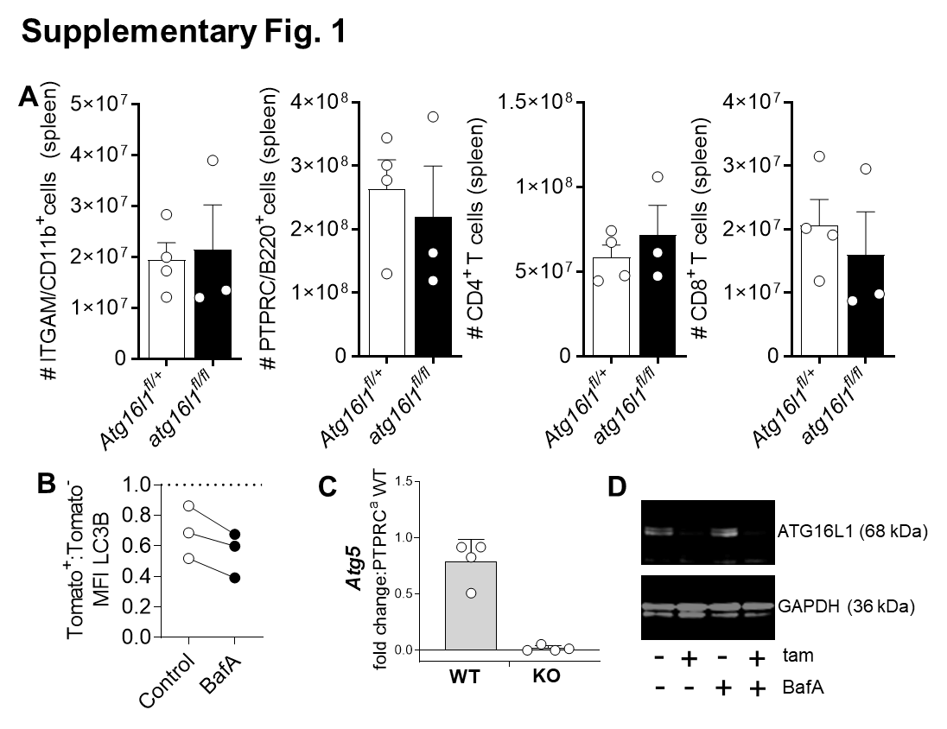
Figure S1. Atg16l1 deletion does not lead to cytopenia and inhibits autophagy flux in the Fgd5 model and tamoxifen-driven deletion of Atg5 and Atg16l1 is efficient. (A) Fgd5^{CreERT2} atg16l1^{fl/fl} mice were analyzed 5 weeks after tamoxifen treatment (n_{WT}=4, n_{KO}=3). Splenic frequencies of myeloid cells (ITGAM/CD11b⁺), PTPRC/B220⁺ cells, CD4⁺ T cells and CD8⁺ T cells are depicted. (B) Ratio (Tomato⁺:Tomato⁻) of LC3B expression in HSCs from Fgd5^{CreERT2} atg16l1^{fl/fl} mice exposed or not to BafA treatment (10 nM for 2 h) (n=3). (C) Real-time qPCR analysis of Atg5 gene expression in sorted LSKs from Mx1^{Cre} atg5^{fl/fl} chimera; fold change to PTPRCª/CD45.1 WT cells. Data are shown as fold change normalized to Actb (n=4). (D) ATG16L1 protein expression in sorted T cells from Rosa26^{CreERT2} atg16L1^{fl/fl} mice 24 h following tamoxifen treatment in vitro assessed by immunoblotting (tam=tamoxifen; BafA=bafilomycin A₁). Data representative of 1 out of 4 experiments.

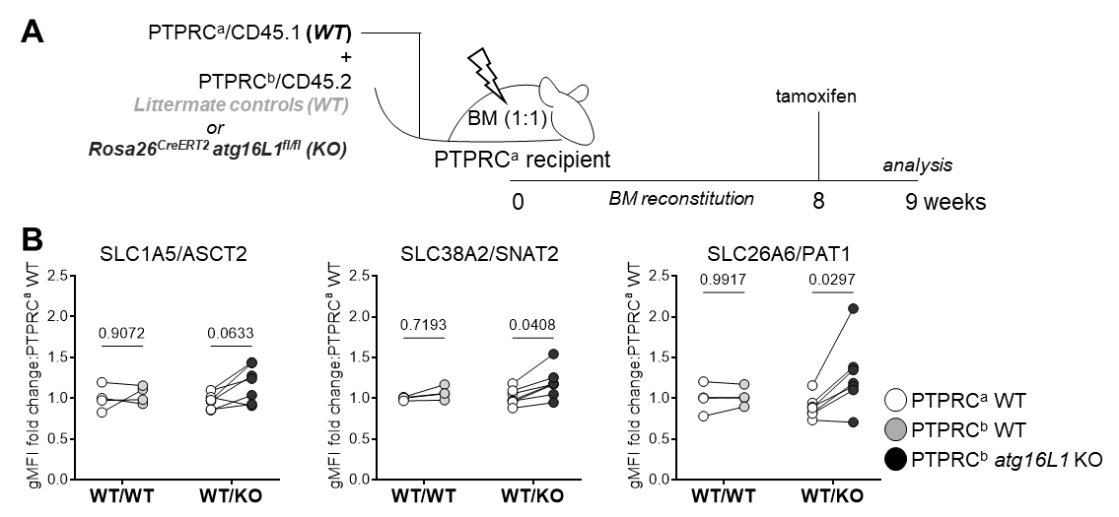

Figure S2. Expression of amino acid transporters is upregulated in constitutive model of autophagy deficiency. (A) Experimental setup for generation of mixed BM chimeras using the inducible Rosa26^{CreERT2} atg16l1^{fl/fl} model. (B) Surface expression of AAT (amino acid transporters) in HSCs from mixed Rosa26^{CreERT2} atg16l1^{fl/fl}:WT (1:1) BM chimera were analyzed by flow cytometry. PTPRCª/CD45.1 WT (white symbols), PTPRC^{b}/CD45.2 WT (gray symbols), and PTPRC^{b}/CD45.2 atg16L1 KO (black symbols). Geometric mean of fluorescence intensity (gMFI) of AAT is normalized and expressed as fold change to WT PTPRCª/CD45.1. n_{WT:WT} =7 and n_{WT:KO}=12 per group with Two-way ANOVA with Sidak’s correction for multiple testing.

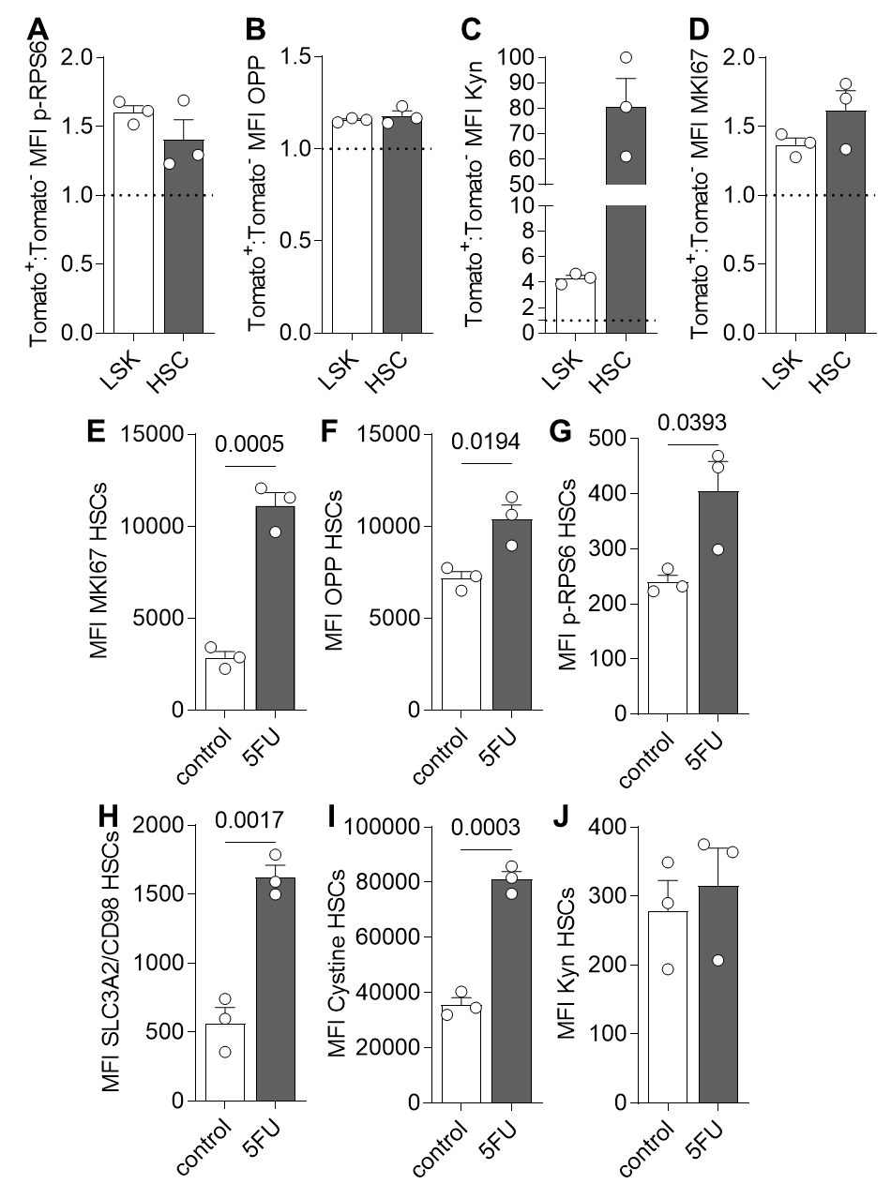

Figure S3. Increased AA uptake in autophagy deficient HSCs from Fgd5^{CreERT2} atg16l1^{fl/fl} mice results in MTOR activation, translation and proliferation. In Tomato⁺ atg16l1 KO HSCs (A) Fold change of p-RPS6 expression, as a readout of MTOR activation, (B) Fold change of OPP expression, as a readout for translation, (C) Fold change of kynurenine (Kyn) expression, as a readout for amino acid uptake, (D) Fold change of MKI67 expression, as a readout for proliferation. Dotted line is WT (Tomato⁻) levels in cells from 3 mice (average). Data was obtained from cells isolated from Fgd5^{CreERT2} atg16L1^{fl/fl} mice 5 weeks post-tamoxifen treatment (n=3). 5FU-induced proliferation increased AA uptake, MTOR activation and translation in HSCs from wild type animals. Mice received 3mg of 5FU intravenously and BM was isolated 7 days later (n_{control}=3; n_{5FU}=3). Proliferation, measured by MKI67 (E), translation, measured by OPP (F), MTOR activation, measured by p-RPS6 (G), SLC3A2/CD98 expression (H) and amino acid uptake (I, J) were assessed by flow cytometry.
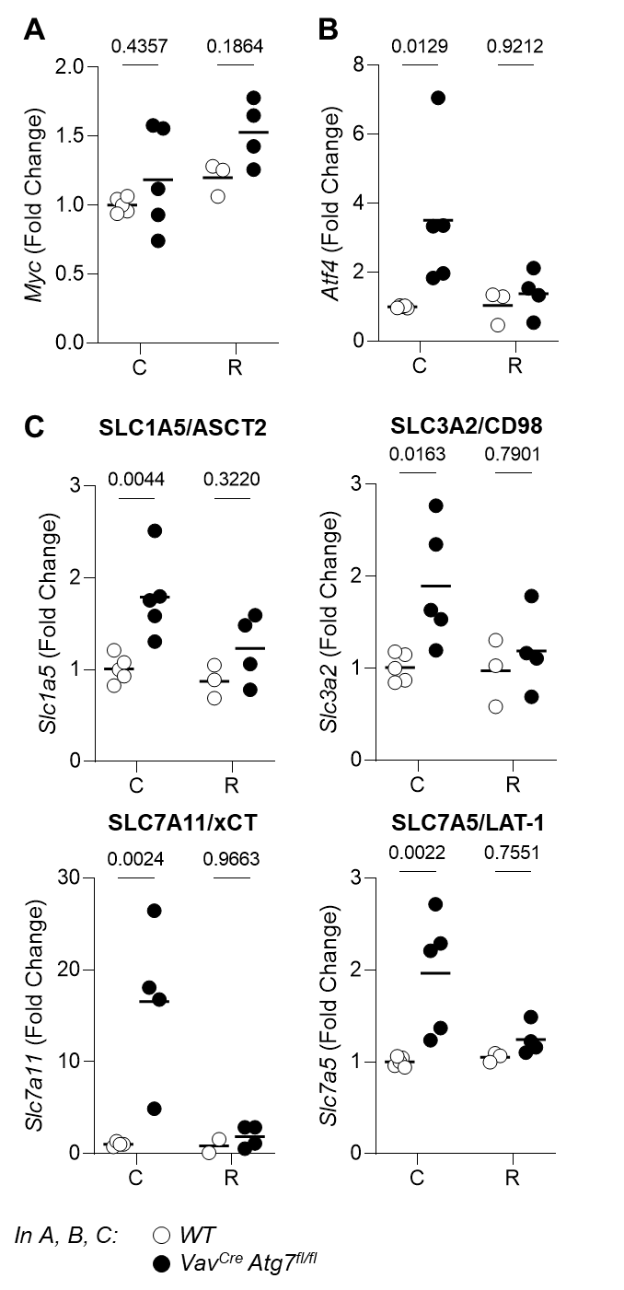
Figure S4. mRNA expression of metabolic regulators and amino acid transporters in HSCs from Vav^{Cre} atg7^{fl/fl} mice. Real-time qPCR analysis of Myc (A), Atf4 (B), and Slc1a5 (encoding for SLC1A5/ASCT2), Slc3a2, Slc7a11 and Slc7a5 (AA transporters, C) expression in sorted LSKs from Vav^{Cre} atg7^{fl/fl} mice. SLC3A2/CD98, SLC7A11/xCT and SLC7A5/LAT-1 are involved in cystine and kynurenine uptake. R= rapamycin treated animals. Data are relative to Actb (n=2-5/group). Two-way ANOVA with post hoc Sidak’s test.

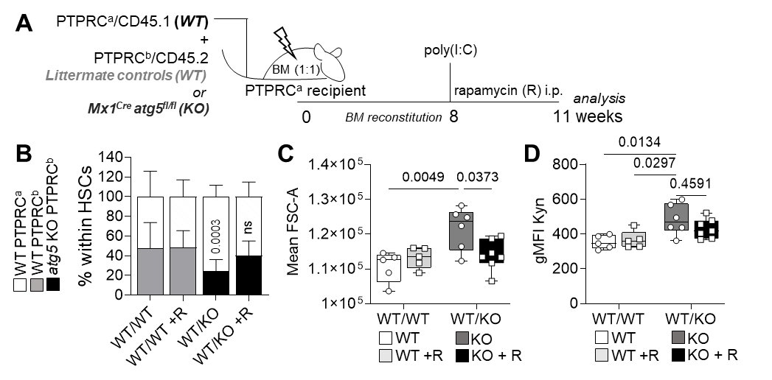
Figure S5. The rescue effect of MTOR inhibition on autophagy deficient HSCs is cell intrinsic and the phenotype of higher AA transporter protein expression is not reversed upon rapamycin treatment. (A) Experimental setup of rapamycin (R) treatment in Mx1^{Cre} atg5^{fl/fl}:WT (1:1) mixed BM chimeras. (B) Contribution of donor-derived PTPRC^{b}/CD45.2 HSCs (WT in gray, KO in black) and recipient-derived PTPRCª/CD45.1 WT HSC (in white) to the total HSC compartment. Multiple unpaired Student’s t test used. (C) HSC cell size measured as mean FSC intensity. (D) gMFI of kynurenine (Kyn) uptake in HSCs. n=4-7 animals/group. When not otherwise stated, data are represented as mean ± SEM with two-way ANOVA with post hoc Tukey’s test.

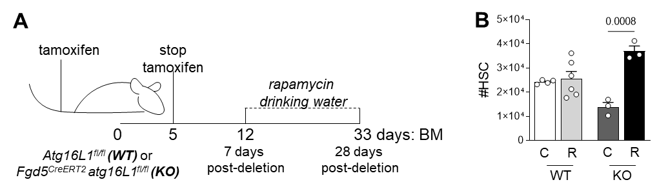

Figure S6. Rapamycin rescues HSCs in an inducible HSC-specific mouse model of autophagy deletion. (A) Experimental setup for the treatment with rapamycin in mice where Atg16l1 deletion in HSC is induced by tamoxifen treatment in Fdg5^{CreERT2} atg16^{fl/fl} mice. (B) Absolute number of HSCs after treatment with rapamycin (R) (n_{WT}=4, n_{WT+R}=6, n_{KO}=3, n_{KO+R}=3). Representative data from one experiment.

