**SDC, Methods**

*Lasso model: ‘HR balancer’, ’PRE balancer’ and ‘HR_interaction’ development*

Lasso (least absolute shrinkage and selection operator) models were calculated using the “glmnet” R package (Version 4.1-3). Glmnet uses a cross-validated regularized Cox regression analysis to identify variables with significant association with an observed outcome, in this case progression-free survival. For variables with significant association with PFS, a coefficient is returned to weigh this variable in comparison with other associated variables (the higher the coefficient, the stronger the association with the outcome). Variables without significant association are not given a coefficient. Using all significantly associated variables with their respective coefficient, a patient-specific risk score for progression can be calculated.

We calculated three models for PFS:

* The ‘HR balancer’ model included all variables with p <0.1 in univariable Cox regression analysis for PFS, except CAR-T product, as we aimed to identify product-independent variables
* The ‘PRE balancer’ model included all variables with p <0.1 in univariable Cox regression analysis for PFS *that were available at the ‘indication’ timepoint*, prior to any CAR-T specific procedures like apheresis, holding or bridging therapy
* A confirmatory model was calculated incorporating the ‘HR balancer’ (and consequently excluding all variables that were already used to calculate the ‘HR balancer’) and the CAR-T product to identify ‘HR balancer -corrected variables with significant influence on PFS.
* Additionally, a model incorporating potential interactions between variables (‘HR_interaction’) was calculated. This model included all variables from the ‘HR balancer’ dataset, supplemented by CAR-T product (Tisa-cel vs. Axi-cel). Interactions between CAR-T product and response to bridging, and CAR-T product and time interval between apheresis and CAR-T infusion were incorporated in the model.

**SDC, Figures**

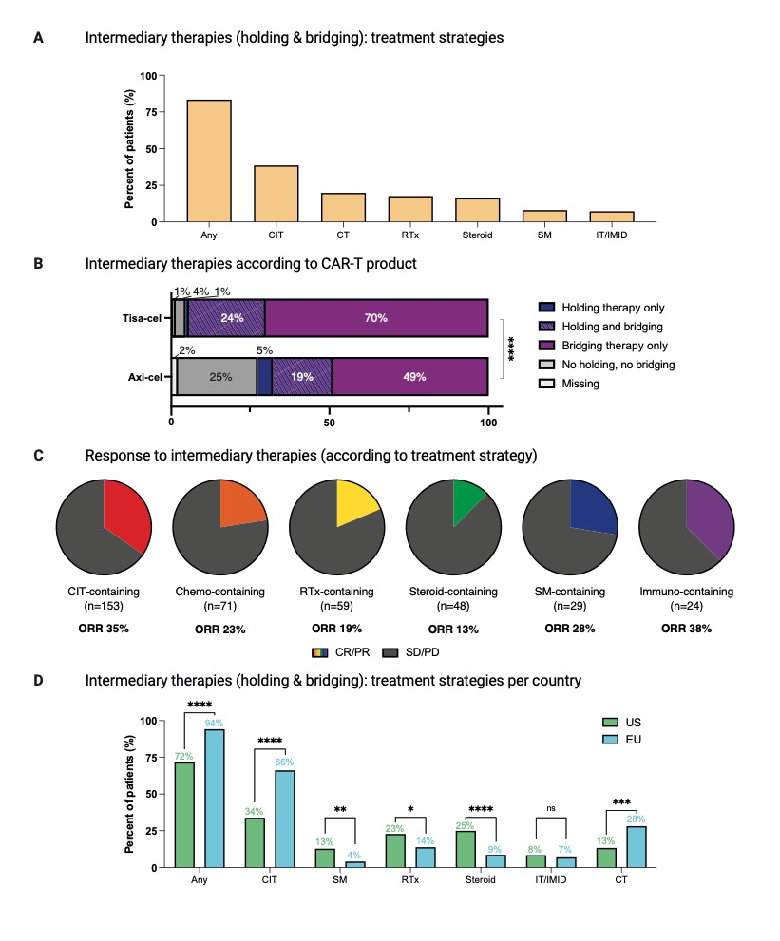

**SDC, Figure 1: More patients received intermediary therapies (holding and/or bridging) in European centers. Chemotherapy-based intermediary treatment strategies were used more frequently in the EU, whereas US patients more frequently were treated with lower-intensity strategies like steroid monotherapy.**

**A:** Frequency of patients receiving holding and/or bridging therapy, and strategies used for holding and/or bridging for all patients. For patients receiving more than one treatment strategy, multiple allocations were possible. **B:** Relative distribution of patients receiving holding and/or bridging therapies (n=374), according to CAR T-cell product. Significance was determined by Chi-square test (****P<0.0001). **C:** Pie charts depicting the best radiographic response after holding and/or bridging therapy. For patients receiving more than one treatment strategy, response assessment was mostly performed only once at the end of the interval, and this radiographic response was therefore allocated to all used strategies (e.g. a patient achieving a PR with RTx and SM therapy was allocated as responder for both RTx and SM groups). **D:** Frequency of patients receiving holding and/or bridging therapy, and strategies used for holding and/or bridging. For patients receiving more than one treatment strategy, multiple allocations were possible. Significance was determined by Fisher’s exact test (*P<0.05, **P<0.01, ***P <0.001, ****P<0.0001). *Abbreviations*: Chemo: chemotherapy (e.g. ICE, when applied *without* e.g. Anti-CD20 antibody). CIT: chemoimmunotherapy (including Rituximab+Polatuzumab Vedotine). Immuno: Immunotherapy (e.g. Rituximab Monotherapy), RTx: Radiotherapy. SM: small molecule (e.g. Ibrutinib, copanlisib).

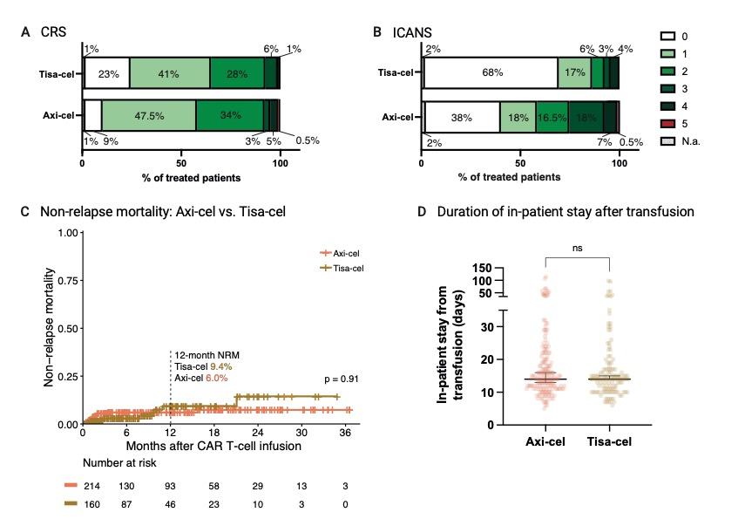

**SDC, Figure 2: Differences in CAR T-cell associated toxicities are driven by the cell product.**

**A:** Relative distribution of highest-grade CRS in Axi-cel and Tisa-cel patients. **B:** Relative distribution of highest-grade ICANS in Axi-cel and Tisa-cel patients. **C:** Cumulative incidence curves for non-relapse mortality in Axi-cel and Tisa-cel patients, calculated from CAR T cell transfusion. Significance was assessed by log-rank test. **D:** Duration of post-transfusion in-patient hospitalization for Axi-cel and Tisa-cel patients in days. Box and whiskers describe the median with 95% confidence intervals. Significance was determined by Mann-Whitney test (****P<0.0001).*Abbreviations*: Axi-cel: Axicabtagene ciloleucel. CRS: cytokine-release syndrome. ICANS: immune effector cell associated neurotoxicity syndrome. mo: months. NRM: non-relapse mortality. Tisa-cel: Tisagenlecleucel.



**SDC, Figure 3: Progression-free survival and overall survival are significantly inferior for patients receiving Tisa-cel vs. Axi-cel after CAR T-cell therapy.**

**A-B:** Kaplan-Meier estimates of progression-free (**A**) and overall (**B**) survival, calculated from the day of CAR T-cell transfusion, for Axi-cel and Tisa-cel patients. Median survival (when reached) is reported with 95% confidence interval in the respective insets. Significance was assessed by log-rank test. *Abbreviations*: mo: months. NR: not reached.



**SDC, Figure 4: High-risk patients, defined by an HR balancer ≥0.52, have significantly inferior progression-free and overall survival.**

**A-B:** Kaplan-Meier estimates of progression-free (**A**) and overall (**B**) survival, calculated from the day of CAR T-cell transfusion, for HR balancer high and low-risk patients. Median survival (when reached) is reported with 95% confidence interval in the respective insets. Significance was assessed by log-rank test. *Abbreviations*: mo: months. NR: not reached.



**SDC, Figure 5: Overall survival for low-risk patients receiving Axi-cel is superior in comparison to low-risk patients receiving Tisa-cel, whereas the choice of CAR T-cell product does not influence outcomes in high-risk patients.**

Kaplan-Meier estimates of overall survival in patients receiving Axi-cel or Tisa-cel for HR balancer low risk (left) and high risk (right) patients, calculated from the day of CAR T-cell transfusion. Median survival (when reached) is reported with 95% confidence interval in the respective insets. Significance was assessed by log-rank test. *Abbreviations*: mo: months. NR: not reached.



**SDC, Figure 6: High-risk** **patients, defined by an HR balancer ≥0.52, tend to have a higher Non-relapse mortality compared to low-risk patients.**

Cumulative incidence curves for non-relapse mortality in HR balancer high- and low-risk patients, calculated from CAR T cell transfusion. Significance was assessed by log-rank test. *Abbreviations:* NRM: non-relapse mortality.

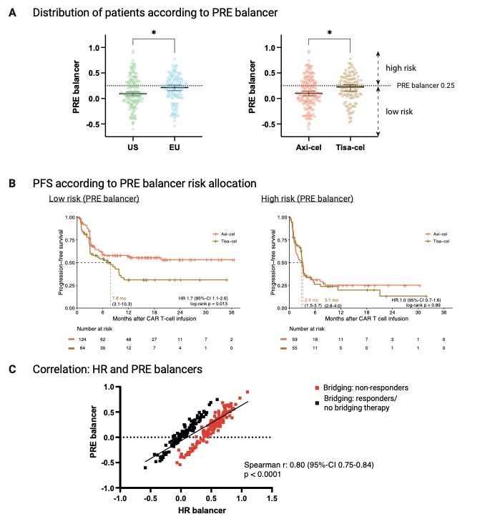

**SDC, Figure 7: Patients from US and Europe, and also Axi-cel vs. Tisa-cel patients, also differ in their pre-*indication* risk profile, as assessed by PRE balancer. Progression-free survival for low-risk patients receiving Axi-cel is superior in comparison to *PRE balancer* low-risk patients receiving Tisa-cel, whereas the choice of CAR T-cell product does not influence outcomes in *PRE balancer* high-risk patients. HR balancer and PRE balancer are strongly correlated.**

**A:** Left: Distribution of European and US patients, according to their PRE balancer value *(including only variables assessed prior to or at CAR-T indication)*. Right: Distribution of patients receiving Axi-cel or Tisa-cel, according to their PRE balancer value. The cut-off between low- and high-risk patients was chosen for maximum difference in progression-free survival for both groups. Box and whiskers describe the median with 95% confidence intervals. Significance was determined by Mann-Whitney test (*P<0.05). **B:** Kaplan-Meier estimates of progression-free survival in patients receiving Axi-cel or Tisa-cel for PRE balancer low risk (left) and high risk (right) patients, calculated from the day of CAR T-cell infusion. Median survival (when reached) is reported with 95% confidence interval in the respective insets. Significance was assessed by log-rank test. **C:** Correlation of HR balancer and PRE balancer, with patient not responding to bridging therapy highlighted in red. The line represents the simple linear regression of all values (including responders and non-responders to bridging). Correlation coefficient and significance was assessed by Spearman’s test.



**SDC, Figure 8: Patients receiving no or steroid-only intermediary therapies have significantly superior progression-free and overall survival compared to patients treated with higher-intensity intermediary therapies.**

**A-B:** Kaplan-Meier estimates of progression-free (**A**) and overall (**B**) survival, calculated from the day of CAR T-cell transfusion, for patients without or with steroid-only intermediary therapies, compared to patients treated with higher-intensity intermediary therapies. Median survival (when reached) is reported with 95% confidence interval in the respective insets. Significance was assessed by log-rank test. *Abbreviations*: mo: months.

**SDC, Tables**

**SDC, Table 1 – Treatment intervals**

|  |  |  |  |  |
| --- | --- | --- | --- | --- |
|  | All patients  (n=374) | US/Moffitt  (n=199) | Europe  (n=175) | p (US vs. EU) |
| **Indication to infusion (days) <0.0001** | | | | |
| Mean (SEM) | 57.7 (1.3) | 50.2 (2.2) | 66.2 (1.2) |  |
| Median | 51 | 48 | 57 |  |
| IQR | 42 - 64 | 41 - 56 | 48 - 75 |  |
| Min - Max | 28 - 229 | 28 - 201 | 33 - 229 |  |
| **Indication to apheresis (days) < 0.0001** | | | | |
| Mean (SEM) | 18.6 (1.0) | 19.9 (1.1) | 17.1 (1.7) |  |
| Median | 15 | 17 | 7 |  |
| IQR | 6 - 23.3 | 11 - 24 | 3 - 22 |  |
| Min - Max | 0 - 161 | 2 - 161 | 0 - 127 |  |
| **Apheresis to infusion (‘vein to vein‘, days) < 0.0001** | | | | |
| Mean (SEM) | 39.1 (1.0) | 30.3 (0.5) | 49.2 (1.7) |  |
| Median | 34 | 28 | 43 |  |
| IQR | 28 - 45 | 26 - 32 | 37 - 55 |  |
| Min - Max | 20 - 225 | 20 - 61 | 27 - 255 |  |

**SDC, Table 1: Region-specific treatment intervals**

Time intervals between indication, apheresis and infusion timepoints are given in days. Statistical significance (p < 0.05) between US and European patients was determined by Mann-Whitney test.

**SDC, Table 2 – Dynamic patients‘ characteristics by Region, additional timepoints**

|  |  |  |  |  |  |
| --- | --- | --- | --- | --- | --- |
|  | n | All patients  (n=374) | US/Moffitt  (n=199) | Europe  (n=175) | p |
| **Inflammation Markers at indication for CAR T therapy** | | | | | |
| CRP (mg/dl, median, range) | 309 | 1.1 (0.03-20.68) | 1.0 (0.03-20.68) | 1.2 (0.04-18.70) | 0.33 |
| Ferritin (ng/ml, median, range) | 195 | 478 (22-5,615) | 422.5 (22-5,615) | 683 (25-3,692) | **0.008** |
| **Status at lymphodepletion** | | | | | |
| LDH  (U/l, median, range) | 353 | 274 (102-3,502) | 261 (111-3,502) | 302 (102-3,243) | **0.03** |

**SDC, Table 2: Dynamic patients‘ characteristics by Region, additional timepoints**

Statistical significance (p < 0.05) between US and European patients was determined by Mann-Whitney test for continuous variables. The center-specific upper limit of normal for Lactate Dehydrogenase (LDH) was 214-378 U/l, for CRP was 0.5 mg/dl, and for Ferritin was 400 ng/ml.

**SDC, Table 3 – Patient contribution from different treatment centers**

|  |  |  |  |  |  |  |
| --- | --- | --- | --- | --- | --- | --- |
| Center | Moffitt Cancer Center, Tampa, FL | University Hospital, LMU Munich, Germany | University Hospital Erlangen, Germany | University Hospital Cologne, Germany | Charité Berlin, Germany | Vall d’Hebron University Hospital, Barcelona, Spain |
|  | **USA** | **Europe** | | | | |
| No. of patients | 199 | 50 | 17 | 32 | 26 | 50 |
| % of patients treated with axi-cel | 85% | 44% | 12% | 0% | 0% | 42% |
| Interval Indication - Transfusion (d, median, range) | 48  (28-201) | 72.5  (40-174) | 55  (37-86) | 64.5  (35-180) | 54.5  (39-102) | 48.5  (33-229) |

**SDC, Table 4 – Treatment intervals per product**

|  |  |  |  |  |
| --- | --- | --- | --- | --- |
|  | All patients  (n=374) | Axi-cel  (n=214) | Tisa-cel  (n=160) | p (Axi vs. Tisa) |
| **Indication to transfusion (days) <0.0001** | | | | |
| Mean (SEM) | 57.7 (1.3) | 50.1 (1.3) | 67.7 (2.3) |  |
| Median | 51 | 48 | 61 |  |
| IQR | 42 - 64 | 40 - 55 | 50 - 75 |  |
| Min - Max | 28 - 229 | 28 - 201 | 35 - 229 |  |
| **Indication to apheresis (days) < 0.0001** | | | | |
| Mean (SEM) | 18.6 (1.0) | 20.0 (1.2) | 16.6 (1.7) |  |
| Median | 15 | 16 | 10 |  |
| IQR | 6 - 23.3 | 10 - 23.5 | 3 - 23 |  |
| Min - Max | 0 - 161 | 0 - 161 | 0 - 127 |  |
| **Apheresis to transfusion (‘vein to vein‘, days) < 0.0001** | | | | |
| Mean (SEM) | 39.1 (1.0) | 30.2 (0.4) | 51.2 (1.8) |  |
| Median | 34 | 28 | 45 |  |
| IQR | 28 - 45 | 26 - 32.5 | 39 - 57 |  |
| Min - Max | 20 - 225 | 20 - 55 | 28 - 225 |  |

**SDC, Table 4: Product-specific treatment intervals**

Time intervals between indication, apheresis and infusion timepoints are given in days. Statistical significance (p < 0.05) between Axi-cel and Tisa-cel patients was determined by Mann-Whitney test.

**SDC, Table 5 – Patients‘ characteristics by Product**

|  |  |  |  |  |  |
| --- | --- | --- | --- | --- | --- |
|  | n | All patients  (n=374) | Axi-cel  (n=214) | Tisa-cel  (n=160) | p |
| **Age,** years  (median, range) | 373 | 64  *(19-85)* | 64 *(19-79)* | 64  *(23-85)* | 0.43 |
| **Gender** (female) | | 162 (43.3%) | 95 (44.4%) | 67 (41.9%) | 0.14 |
| **Histology** | 374 |  | | | **0.03** |
| DLBCL | | 266 (71.1%) | 149 (69.6%) | 117 (73.1%) |  |
| transformed lymphoma | | 99 (26.5%) | 56 (26.2%) | 43 (26.9%) |  |
| PMBCL | | 9 (2.4%) | 9 (4.2%) |  |  |
| **Response to  previous therapy** | 372 |  | | | **0.005** |
| relapsed | | 99 (26.7%) | 50 (23.6%) | 49 (30.6%) |  |
| refractory | | 151 (40.7%) | 78 (36.8%) | 73 (45.6%) |  |
| prim. refractory | | 122 (32.9%) | 84 (39.6%) | 38 (23.8%) |  |
| **Previous treatment (for LBCL)** | | | | | |
| auto-SCT | 372 | 98 (26.3%) | 42 (19.8%) | 56 (35.0%) | **0.001** |
| allo-SCT | 372 | 8 (2.2%) | 6 (2.8%) | 2 (1.3%) | 0.47 |
| therapy lines (excl. H&B, median, IQR) | 372 | 3 (2-4) | 3 (2-4) | 3 (2-4) | 0.91 |
| holding therapy | 357 | 89 (24.9%) | 49 (24.9%) | 40 (25.0%) | 0.99 |
| bridging therapy | 371 | 296 (79.8%) | 155 (72.8%) | 148 (93.7%) | **<0.0001** |
| therapy lines (incl. H&B, median, IQR) | 372 | 4 (3-5) | 4 (3-5) | 4 (3-5) | **0.03** |
| **Status at Indication for CAR T therapy** | | | | | |
| ECOG (median, IQR) | 374 | 1 (0-1) | 1 (0-1) | 1 (0-1) | **0.004** |
| Ann Arbor Stage ≥ 3 | 374 | 81 (21.7%) | 169 (79.0%) | 124 (77.5%) | 0.80 |
| IPI (median, IQR) | 366 | 3 (2-4) | 3 (2-4) | 3 (2-4) | 0.36 |
| END | 374 | 265 (70.9%) | 160 (74.8%) | 105 (65.6%) | 0.07 |
| History of/active CNS disease | 314 | 34 (15.9%) | 13 (6.9%) | 21 (16.8%) | **0.009** |
| LDH  (U/l, median, range) | 353 | 295 (105-3,487) | 271 (118-1,645) | 323 (105-3,487) | **0.003** |
| **Inflammation Markers at lymphodepletion** | | | | | |
| CRP (mg/dl, median, range) | 371 | 1.1 (0.03-26.08) | 1.27 (0.03-26.08) | 1.10 (0.04-22.50) | 0.77 |
| Ferritin (ng/ml, median, range) | 332 | 529.5 (3-12,843) | 423 (8-12,843) | 745 (3-6,896) | **0.003** |

**SDC, Table 5: Baseline demographic and clinical characteristics of CAR T-cell treated patients – comparison of axi-cel and tisa-cel patients**

Statistical significance (p < 0.05) between US and European patients was determined by Fisher‘s exact test for incidence rates and Mann-Whitney test for continuous variables. The center-specific upper limit of normal for Lactate Dehydrogenase (LDH) was 214-378 U/l, for CRP was 0.5 mg/dl, and for Ferritin was 400 ng/ml.

**SDC, Table 6 – Toxicity management**

|  |  |  |  |  |  |
| --- | --- | --- | --- | --- | --- |
|  | n | All patients  (n=374) | US/Moffitt  (n=199) | Europe  (n=175) | p |
| Received Tocilizumab | 356 | 191 (52.3%) | 92 (50.8%) | 99 (56.6%) | 0.29 |
| Received Steroids | 352 | 150 (42.6%) | 85 (48.0%) | 65 (37.1%) | **0.04** |
| Transferred to ICU | 356 | 68 (19.1%) | 32 (17.7%) | 36 (20.6%) | 0.50 |
| In patient stay from transfusion in days (median, IQR) | 316 | 14 (11-19) | 13 (10-17) | 15 (13-22) | **<0.0001** |

|  |  |  |  |  |  |
| --- | --- | --- | --- | --- | --- |
|  | n | All patients  (n=374) | Axi-cel  (n=214) | Tisa-cel  (n=160) | p |
| Received Tocilizumab | 356 | 191 (52.3%) | 111 (56.1%) | 80 (50.6%) | 0.33 |
| Received Steroids | 352 | 150 (42.6%) | 102 (52.0%) | 48 (30.8%) | **<0.0001** |
| Transferred to ICU | 356 | 68 (19.1%) | 38 (19.2%) | 30 (19.0%) | 0.99 |
| In patient stay from transfusion in days (median, IQR) | 316 | 14 (11-19) | 14 (11-20) | 14 (11-17) | 0.35 |

**SDC, Table 6: Toxicity management**

Statistical significance (p < 0.05) between US and European patients, and for Axi-cel and Tisa-cel patients, respectively, was determined by Fisher‘s exact test.

**SDC, Table 7 – Factors *available prior to indication for CAR T-cell therapy* associated with PFS in univariate and multivariate analysis**

|  |  |  |  |  |
| --- | --- | --- | --- | --- |
| Variable | n | univariate  HR (95%CI) | p | PRE balancer coefficients  (Lasso model) |
| Ferritin (fold change ULN, log2) | 332 | 1.2 (1.1-1.4) | **<0.0001** | **0.13** |
| CRP (fold change ULN, log2) | 371 | 1.1 (1.1-1.2) | **<0.0001** | **0.03** |
| ECOG (0-1 vs. 2-4) | 374 | 1.9 (1.3-2.6) | **0.0002** | - |
| Presence of END | 374 | 1.6 (1.1-2.1) | **0.005** | **0.04** |
| LDH (fold change ULN, log2) | 353 | 1.3 (1.1-1.5) | **0.006** | **0.09** |
| Ann Arbor Stage (III/IV vs. I/II) | 374 | 1.5 (1.1-2.1) | **0.020** | - |
| Response to previous therapy (refractory vs. relapsed) | 371 | 1.4 (1.0-1.9) | **0.039** | - |
| Diagnosis (LBCL vs.  transformed LBCL) | 374 | 1.4 (0.99-1.9) | 0.060 | - |
| Bulky Disease | 335 | 1.4 (0.96-2.1) | 0.082 | - |

**SDC, Table 7: Association of patient characteristics *available at indication* with progression-free survival in uni- and multivariate analysis**

A Lasso penalized regression model was used.

**SDC, Table 8 – Factors associated with PFS in multivariate analysis, including interactions**

|  |  |
| --- | --- |
| Variable | HR_interaction coefficients  (Lasso model) |
| Response to bridging (SD/PD vs. CR/PR or no bridging) | **0.36  (Non-response)** |
| Ferritin (fold change ULN, log2) | **0.11** |
| CART Product (Tisa vs. Axi) | **0.04 (Tisa-cel)** |
| CRP (fold change ULN, log2) | **0.02** |
| ECOG (0-1 vs. 2-4) | - |
| Interval Apheresis-CART  (months, log2) | - |
| Presence of END | - |
| Interval Indication-CART  (months, log2) | - |
| LDH (fold change ULN, log2) | - |
| Prior therapy lines (incl. H&B, log2) | - |
| Ann Arbor Stage (III/IV vs. I/II) | - |
| Response to previous therapy (refractory vs. relapsed) | - |
| Bulky Disease | - |
| Interaction: CART Product*Response to Bridging (SD/PD vs.  CR/PR or no bridging) | - |
| Interaction: CART Product*Interval Apheresis-CART (months, log2) | **0.09** |

**SDC, Table 8: Association of patient characteristics with progression-free survival in multivariate analysis, including interactions**

A Lasso penalized regression model was used.