Metabolic syndrome and the risk of postoperative delirium and postoperative cognitive dysfunction: Results from a multi-centre cohort study
Short title: Metabolic syndrome, postoperative delirium and postoperative cognitive dysfunction

Insa Feinkohl^{1,2} PhD, Dr. rer. nat. Jürgen Janke^{2,3}, Arjen J.C. Slooter⁴ MD, Georg Winterer⁵ MD, Claudia Spies⁵ MD, Tobias Pischon^{2,3,5,6} MD MPH, the BioCog Consortium

Supplemental Data

We are aware of the recent change in terminology related to POCD to ‘delayed neurocognitive recovery’ and ‘postoperative neurocognitive disorder’ (Evered et al., 2018). However, with that change in terminology, the disease concept also changed and now includes data on patients’ activities of daily living and subjective cognitive concerns. Because we did not use these types of data for our more ‘traditional’ definition of the condition, we refer to it as ‘POCD’ throughout this manuscript.

Evered, L., et al., Recommendations for the Nomenclature of Cognitive Change Associated with Anaesthesia and Surgery-20181. J Alzheimers Dis, 2018. 66(1): p. 1-10.

Supplemental Table S1: Definition of metabolic syndrome*
Component | Standard criteria¹ | Criteria used in present study
Elevated waist circumference | Population- and  country-specific definitions | BMI ≥30 kg/m²
Elevated TG | TG ≥150 mg/dl (1.7 mmol/l), or drug treatment | Fasting TG ≥150 mg/dl (1.7 mmol/l)
Reduced HDL-C | HDL-C <40 mg/dl (1.0 mmol/l) in  males; HDL-C <50 mg/dl (1.3 mmol/l) in females; or drug treatment | HDL-C <40 mg/dl (1.0 mmol/l) in males  HDL-C <50 mg/dl (1.3 mmol/l) in females
Elevated BP | Systolic ≥130 mmHg and/or diastolic ≥85 mmHg, or drug treatment | Hypertension based on self-report and/or local hospital records
Elevated glucose | ≥100 mg/dl in plasma, or drug treatment | 1. Fasting blood glucose² ≥100 mg/dl (5.5 mmol/l)  and/or  2. Diabetes based on self-report and/or local hospital records
*The metabolic syndrome is defined as the presence of at least 3 of the 5 components
¹Consensus statement (Alberti et al., 2009) ²Glucose measured in serum

Supplemental Table S2: Baseline and follow-up characteristics according to attendance of 3-month follow-up
 | Missing n (%) among N=765 analysis sample | Did not attend 3-month follow-up  (N=245) | Attended 3-month follow-up  (n=520) | p-value¹
Baseline characteristics
Age, years, mean ± SD | -- | 72.8 ± 5.1 | 72.2 ± 5.0 | 0.12
Male sex, n (%) | -- | 123 (50.2%) | 316 (60.8%) | 0.006
CHD, n (%) | 20 (2.6%) | 49 (20.7%) | 96 (18.9%) | 0.57
TIA, n (%) | 21 (2.7%) | 8 (3.3%) | 20 (4.0%) | 0.67
Stroke, n (%) | 16 (2.1%) | 16 (6.6%) | 27 (5.3%) | 0.47
MMSE, median (interquartile range) | -- | 29 (27 – 30) | 29 (28 – 30) | 0.001
Pre-morbid IQ, mean ± SD | 124 (16.2%) | 112 ± 15 | 113 ± 14 | 0.91
Depression score, median (IQ range) | 124 (16.2%) | 2 (1 – 3) | 1 (0 – 2) | <0.001
Obesity², n (%) | -- | 61 (24.9%) | 117 (22.5%) | 0.46
Elevated BP², n (%) | -- | 172 (70.2%) | 318 (61.2%) | 0.02
Elevated fasting glucose², n (%) | -- | 128 (52.2%) | 276 (53.1%) | 0.83
Elevated TG², n (%) | -- | 114 (46.5%) | 177 (34.0%) | 0.001
Reduced HDL-C², n (%) | -- | 100 (40.8%) | 140 (26.9%) | <0.001
MetS², n (%) | -- | 109 (44.5%) | 175 (33.7%) | 0.004
# MetS components, median (IQ range) | -- | 2 (1 – 3) | 2 (1 – 3) | 0.001
Surgery-related/ follow-up factors
Surgery type | 9 (1.2%) |  |  | 0.05
Intracranial, n (%) |  | 5 (2.0%) | 5 (1.0%)
Thoracic/abdominal/pelvic, n (%) |  | 119 (48.6%) | 223 (42.9%)
Peripheral, n (%) |  | 121 (49.4%) | 302 (58.1%)
Anaesthesia duration, median (IQ range) | 10 (1.3%) | 217 (129 – 348) | 196 (122-290) | 0.02
Hospital days, median (IQ range) | 1 (0.1%) | 8 (5 – 15) | 6 (3 – 8) | <0.001
Data shown following imputation of missing data. BMI, body mass index; CHD, coronary heart disease; HDL, high density lipoprotein; IQ range, interquartile range; MetS, metabolic syndrome; MMSE, Mini Mental State Examination; TG, triglycerides; TIA, transient ischaemic attack. ¹t-test. Mann-Whitney or chi² test comparing patients who attended the 3-month follow-up with those who did not attend the 3-month follow-up.²for definitions, see Table S1

Supplemental Table S3: Associations among the 5 MetS components
 |  | Obesity |  | Elevated bp |  | Elevated glucose |  | Elevated TG |  | Reduced HDL-C
 |  | 0 | + | 0 | + | 0 | + | 0 | + | 0 | +
Obesity | 0 | -- | -- | 30.6 | 45.0 | 39.9 | 36.9 | 49.5 | 27.2 | 55.3 | 21.4
 | + | -- | -- | 4.2 | 19.1 | 7.3 | 15.9 | 12.4 | 10.8 | 13.3 | 9.9
Elevated bp | 0 | 31.8 | 4.2 | -- | -- | 19.9 | 16.1 | 24.6 | 11.4 | 26.5 | 9.4
 | + | 45.0 | 19.1 | -- | -- | 27.3 | 36.7 | 37.4 | 26.7 | 42.1 | 22.0
Elevated glucose | 0 | 39.9 | 7.3 | 19.9 | 27.3 | -- | -- | 32.8 | 14.4 | 37.6 | 9.5
 | + | 36.9 | 15.9 | 16.1 | 36.7 | -- | -- | 29.1 | 23.7 | 31.0 | 21.8
Elevated TG | 0 | 49.5 | 12.4 | 25.6 | 37.4 | 32.8 | 29.1 | -- | -- | 48.4 | 13.6
 | + | 27.2 | 10.8 | 11.4 | 26.7 | 14.4 | 23.7 | -- | -- | 20.3 | 17.8
Reduced HDL-C | 0 | 55.3 | 13.3 | 26.5 | 42.1 | 37.6 | 37.5 | 48.4 | 20.3 | -- | --
 | + | 21.4 | 9.9 | 9.4 | 22.0 | 9.5 | 21.8 | 13.6 | 17.8 | -- | --
% Refers to the proportion of patients having (+) or not having (-) the component presented in the respective column having (+) or not having (-) the component assigned in the row. Bp, blood pressure; HDL, high-density lipoprotein; OR, odds ratio; TG, triglycerides ¹for definitions, see Supplemental Table S1. Results of chi² tests: Obesity with TG chi²=7.3, p=0.007; with reduced HDL-C chi²=13.8, p<0.001; with elevated bp chi2=32.5, p<0.001; with elevated glucose chi2=23.0, p<0.001. Elevated BP with elevated TG chi2=7.5, p=0.006; with reduced HDL-C chi2=5.4, p=0.020; with elevated glucose chi2=11.3, p=0.001. Elevated TG with reduced HDL-C chi²=58.5, p<0.001; with elevated glucose chi²=16.6, p=0.001. Reduced HDL-C with elevated glucose chi²=39.5, p<0.001

Supplemental Table S4: MetS, each of the 5 MetS components and POD risk
 | Model 1 |  | Model 2 |  | Model 3
 | OR (95% CI) | p | OR (95% CI) | p | OR (95% CI) | p
# MetS components |  | 0.05 |  | 0.16 |  | 0.37
0² | Reference | -- | Reference | -- | Reference | --
1² | 1.19 (0.57, 2.47) | 0.65 | 1.16 (0.56, 2.43) | 0.69 | 1.03 (0.48, 2.19) | 0.94
2² | 1.17 (0.57, 2.41) | 0.66 | 1.13 (0.55, 2.33) | 0.75 | 0.87 (0.41, 1.84) | 0.72
3² | 2.07 (1.02, 4.19) | 0.04 | 1.90 (0.93, 3.87) | 0.08 | 1.57 (0.76, 3.25) | 0.23
4/5² | 2.18 (1.04, 4.55) | 0.04 | 1.89 (0.89, 4.00) | 0.10 | 1.42 (0.66, 3.08) | 0.37
N=765. CI, confidence interval; OR, odds ratio. Single model. Groups with 4 MetS components and 5 MetS components grouped together due to low N in each group. Model 1: adjusted for age, sex, analysis lab analysis batch, surgery type. Model 2: + +CHD, TIA, stroke, depression score. Model 3: +anesthesia duration.

Supplemental Table S5: MetS, each of the 5 MetS components and POCD risk
 | Model 1 |  | Model 2 |  | Model 3
 | OR (95% CI) | p | OR (95% CI) | p | OR (95% CI) | p
# MetS components |  | 0.19 |  | 0.18 |  | 0.19
0² | Reference | -- | Reference | -- | Reference | --
1² | 1.79 (0.51, 6.29) | 0.36 | 1.83 (0.52, 6.44) | 0.33 | 1.83 (0.52, 6.45) | 0.35
2² | 3.87 (1.22, 12.24) | 0.02 | 3.95 (1.24, 12.56) | 0.02 | 3.95 (1.24, 12.60) | 0.02
3² | 3.07 (0.92, 10.26) | 0.07 | 3.07 (0.91, 10.36) | 0.07 | 3.07 (0.91, 10.39) | 0.07
4/5² | 2.39 (0.62, 9.23) | 0.21 | 2.27 (0.58, 8.94) | 0.24 | 2.26 (0.57, 8.98) | 0.25
N=520. CI, confidence interval; OR, odds ratio. Single model. Groups with 4 MetS components and 5 MetS components grouped together due to low N in each group. Model 1: adjusted for age, sex, analysis lab, analysis batch, surgery type. Model 2: + +CHD, TIA, stroke, depression score. Model 3: +anesthesia duration.

Supplemental Table S6: Results from selected pre-planned analyses of any statistically significant model 3
Statistically significant association (model 3) | Adjusted for  +pre-morbid IQ |  | Exclusion of underweight patients¹ |  | Adjusted for +POD
 | OR  (95% CI) | p-value or p_{trend} | OR  (95% CI) | p-value or p_{trend} | OR  (95% CI) | p-value or p_{trend}
HDL-C - POD | 0.59  (0.37, 0.95) | 0.03 | 0.64  (0.40, 1.03) | 0.06 | -- | --
MetS – POD | 1.45  (0.96, 2.19) | 0.08 | 1.65  (1.09, 2.48) | 0.02 | -- | --
‘Reduced HDL-C’ – POD | 1.73  (1.14, 2.63) | 0.01 | 1.71  (1.12, 2.60) | 0.01 | -- | --
BMI - POCD | 1.09  (1.02, 1.17) | 0.02 | 1.08  (1.02, 1.16) | 0.02 | 1.09  (1.02, 1.16) | 0.02
‘Obesity’ – POCD | 2.25  (1.17, 4.36) | 0.02 | 2.17  (1.13, 4.16) | 0.02 | 2.18  (1.14, 4.19) | 0.02
¹‘Underweight’ defined as BMI<18.5kg/m². ²OR per unit increment (continuous exposures) or ‘present’ (categorical exposures)

Supplemental Table S7: Results on selected metabolic exposures and POD in model 3 after exclusion of patients with CRP≥10mg/L
 | POD
 | OR (95% CI) per unit increment or for presence of categorical exposure | p-value
Body mass index | 1.02 (0.97, 1.07) | 0.56
Triglycerides | 1.04 (0.91, 1.20) | 0.56
HDL cholesterol | 0.51 (0.28, 0.88) | 0.02
Glucose | 1.06 (0.93, 1.21) | 0.41
HbA1c¹ | 1.01 (0.98, 1.04) | 0.48
MetS | 1.77 (1.11, 2.81) | 0.02
Obesity | 1.20 (0.70, 2.06) | 0.52
Elevated TG | 1.17 (0.73, 1.87) | 0.51
Reduced HDL-C | 2.31 (1.43, 3.73) | <0.001
Elevated bp | 0.91 (0.56, 1.49) | 0.71
Elevated glucose | 0.92 (0.57, 1.48) | 0.74
Analyses restricted to n=614 patients with preoperative CRP<10mg/L. ¹n=557.

Supplemental Table S8: Results on selected metabolic exposures and POCD in model 3 after exclusion of patients with CRP≥10mg/L
 | POCD
 | OR (95% CI) per unit increment or for presence of the categorical exposure | p-value
Body mass index | 1.12 (1.03, 1.22) | 0.006
Triglycerides | 0.95 (0.72, 1.25) | 0.69
HDL cholesterol | 1.04 (0.45, 2.43) | 0.92
Glucose | 1.07 (0.85, 1.34) | 0.56
HbA1c¹ | 0.99 (0.94, 1.05) | 0.73
MetS | 0.98 (0.46, 2.11) | 0.96
Obesity | 2.65 (1.22, 5.72) | 0.01
Elevated TG | 0.73 (0.33, 1.61) | 0.44
Reduced HDL-C | 0.69 (0.29, 1.67) | 0.41
Elevated bp | 1.58 (0.75, 3.33) | 0.23
Elevated glucose | 1.63 (0.78, 3.38) | 0.19
Analyses restricted to n=441 patients with preoperative CRP<10mg/L. ¹n=390.

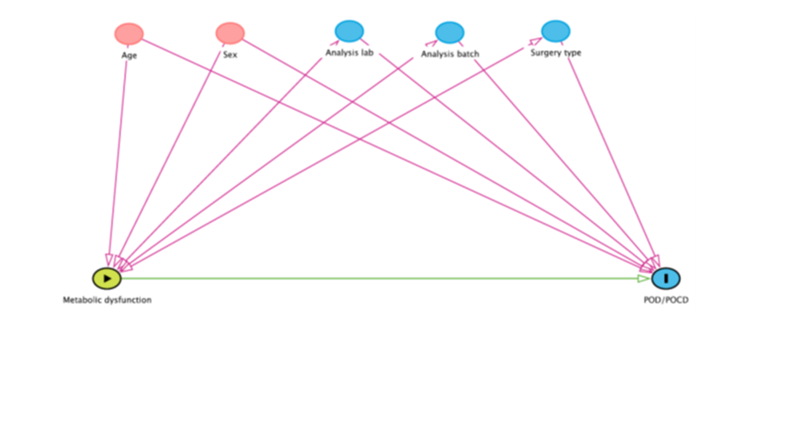
Supplemental Figure S1: DAG on hypothesized relationships assessed in Model 1 (adjusting for the potential confounders age, sex, analysis lab, analysis batch, surgery type). Independence of the exposure (metabolic dysfunction) – outcome (POD/POCD) relationship suggests that these potential confounding factors did not play a role in that relationship, which could support causality.

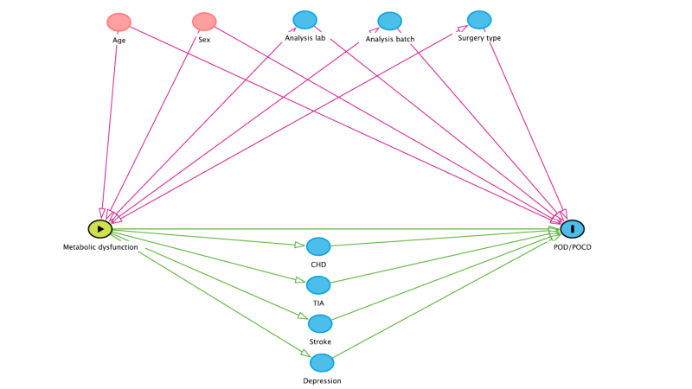
Supplemental Figure S2: DAG on hypothesized relationships assessed in Model 2 (additionally adjusting for the potential pre-operative mediators CHD, TIA, stroke, depression scores). Independence of the exposure (metabolic dysfunction) – outcome (POD/POCD) relationship suggests that these potential mediating factors do not lie on the causal pathway between exposure (metabolic dysfunction) and outcome (POD/POCD).

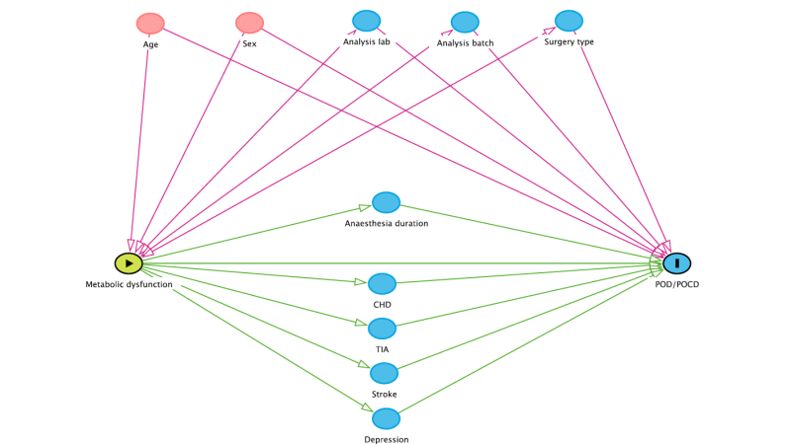
Supplemental Figure S3: DAG on hypothesized relationships assessed in Model 3 (additionally adjusting for anaesthesia duration as a potential intra-operative mediator). Independence of the exposure (metabolic dysfunction) – outcome (POD/POCD) relationship suggests that a longer anaesthesia duration does not lie on the causal pathway between exposure (metabolic dysfunction) and outcome (POD/POCD).

