Supplementary Material

Supplementary Material 1:
Lesion load (mL) and brain tissue volume were assessed for patients only. Specifically, lesion segmentation was conducted semi-automatically with FLAIR images using the lesion prediction algorithm from the Lesion Segmentation Toolbox version 2.0.15, and manually corrected using ITK-SNAP. Subsequently, lesion volume (mL) was calculated using the FSL cluster algorithm. Brain tissue volume, normalized for subject head size, was estimated with SIENAX, part of FSL.

Supplementary Fig. 1: Correlation between dynamic graph metrics based on average values of healthy controls.
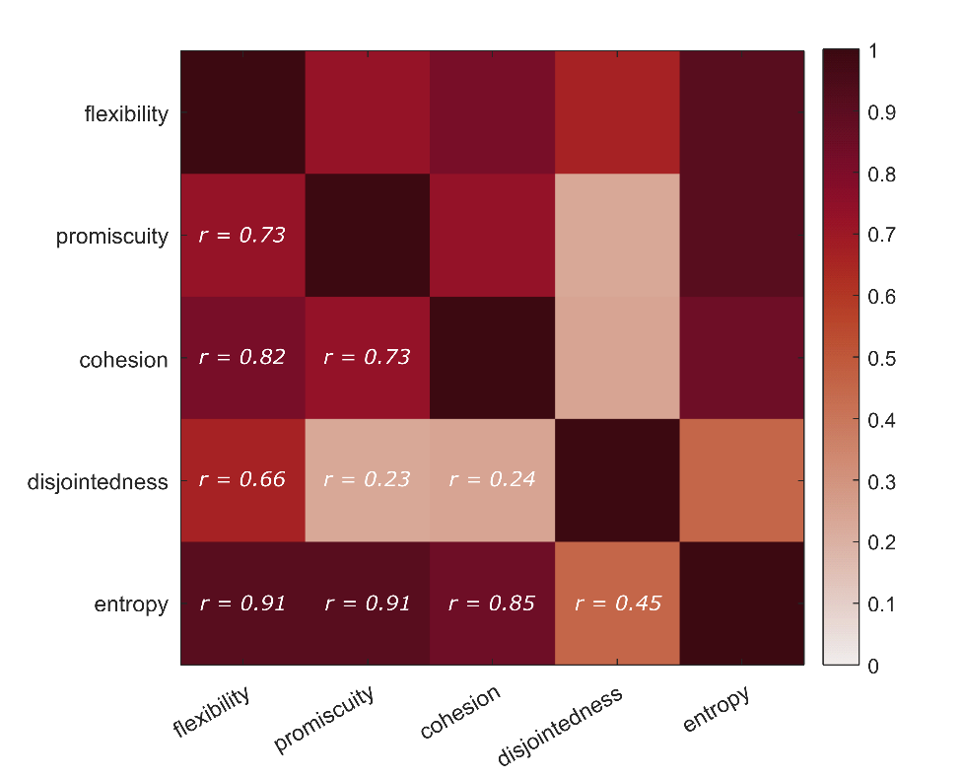

Supplementary Table 1: Group differences of global dynamic graph metrics adjusted for surrogate data. Results indicate that static covariance and autocorrelation in these surrogate data are not sufficient to explain the empirically observed community dynamics. Group comparison of adjusted data was performed with a permutation-based t-test.
Dynamic metric | t | P_{FDR}
Flexibility | 2.57 | 0.012
Promiscuity | 1.94 | 0.045
Cohesion | 2.60 | 0.012
Entropy | 1.68 | 0.052

Supplementary Table 2: Detailed test statistics for group comparison of dynamic metrics for each resting-state functional system (RSFS). Negative t-value indicates increases in the variable of interest in patients. Group comparison was performed with a permutation-based t-test. * P < 0.05, ** P < 0.01, *** P < 0.001 (FDR-corrected).
Graph metric | RSN | t | P_{FDR}
dATT | flexibility | 2.40 | 0.030*
 | promiscuity | 1.98 | 0.081
 | cohesion within RSN | -1.33 | 0.208
 | cohesion across RSN | 2.19 | 0.028*
 | disjointedness | 0.86 | 0.306
 | entropy | 2.18 | 0.039*
vATT | flexibility | 1.15 | 0.144
 | promiscuity | 0.32 | 0.384
 | cohesion within RSN | -0.73 | 0.417
 | cohesion across RSN | 1.41 | 0.107
 | disjointedness | -1.09 | 0.306
 | entropy | 0.75 | 0.226
SM | flexibility | 2.93 | 0.012*
 | promiscuity | 2.54 | 0.030*
 | cohesion within RSN | -0.33 | 0.449
 | cohesion across RSN | 3.13 | 0.0076**
 | disjointedness | 0.91 | 0.306
 | entropy | 2.46 | 0.030*
DMN | flexibility | 2.11 | 0.036*
 | promiscuity | 1.26 | 0.185
 | cohesion within RSN | -0.14 | 0.449
 | cohesion across RSN | 2.37 | 0.024*
 | disjointedness | -1.13 | 0.306
 | entropy | 1.76 | 0.074
FPN | flexibility | 1.07 | 0.151
 | promiscuity | 0.74 | 0.297
 | cohesion within RSN | 0.19 | 0.449
 | cohesion across RSN | 1.17 | 0.123
 | disjointedness | -1.04 | 0.306
 | entropy | 1.23 | 0.144
VIS | flexibility | 1.27 | 0.135
 | promiscuity | 0.55 | 0.336
 | cohesion within RSN | 0.55 | 0.445
 | cohesion across RSN | 1.22 | 0.123
 | disjointedness | -0.34 | 0.416
 | entropy | 0.92 | 0.205
SUB | flexibility | 2.20 | 0.034*
 | promiscuity | 1.75 | 0.092
 | cohesion within RSN | -2.38 | 0.052
 | cohesion across RSN | 2.51 | 0.020*
 | disjointedness | 0.22 | 0.416
 | entropy | 2.20 | 0.039*
LIM | flexibility | 3.74 | < 0.001***
 | promiscuity | 3.14 | 0.006**
 | cohesion within RSN | -3.78 | < 0.001***
 | cohesion across RSN | 3.27 | 0.0067**
 | disjointedness | 3.12 | 0.010*
 | entropy | 3.38 | 0.0038**
CB | flexibility | 1.67 | 0.080
 | promiscuity | 1.12 | 0.205
 | cohesion within RSN | -2.02 | 0.077
 | cohesion across RSN | 1.52 | 0.104
 | disjointedness | -0.40 | 0.416
 | entropy | 1.59 | 0.080
Supplementary Table 3: Significant between-group comparisons of nodal flexibility. Positive t-values indicate higher flexibility in patients compared to controls. Group comparison was performed with a permutation-based t-test. Idx denotes the index of each region from the power atlas [3]. m/a – regions were manually added (see Methods).
idx | region | t | P_{FDR}
1 | 'Precuneus_L' | 2.81 | 0.021
3 | 'Supp_Motor_Area_L' | 2.93 | 0.020
5 | 'Paracentral_Lobule_L' | 4.86 | <0.001
6 | 'Paracentral_Lobule_L' | 3.78 | <0.001
7 | 'Postcentral_R' | 3.50 | 0.006
8 | 'Parietal_Inf_L' | 2.62 | 0.031
9 | 'Precentral_R' | 2.89 | 0.019
11 | 'Postcentral_L' | 3.12 | 0.008
12 | 'Precentral_L' | 3.07 | 0.011
13 | 'Postcentral_R' | 3.24 | 0.008
16 | 'undefined' | 5.20 | <0.001
18 | 'Postcentral_L' | 2.76 | 0.021
19 | 'Supp_Motor_Area_R' | 3.19 | 0.010
20 | 'Postcentral_R' | 3.74 | 0.002
21 | 'Postcentral_L' | 2.62 | 0.034
22 | 'Postcentral_L' | 4.38 | <0.001
23 | 'Paracentral_Lobule_L' | 3.79 | 0.003
24 | 'Precentral_R' | 3.04 | 0.016
26 | 'Parietal_Sup_L' | 2.65 | 0.033
27 | 'Paracentral_Lobule_R' | 3.80 | 0.003
28 | 'Supp_Motor_Area_R' | 5.15 | <0.001
29 | 'Precentral_R' | 2.45 | 0.042
38 | 'Frontal_Sup_R' | 3.38 | 0.009
39 | 'Frontal_Sup_L' | 3.62 | 0.005
40 | 'Cingulum_Mid_L' | 2.89 | 0.017
70 | 'Temporal_Pole_Mid_L' | 2.39 | 0.045
71 | 'Temporal_Pole_Mid_R' | 2.56 | 0.031
80 | 'Precuneus_R' | 2.52 | 0.031
85 | 'Frontal_Sup_Medial_L' | 2.55 | 0.038
89 | 'Frontal_Sup_R' | 3.55 | 0.003
90 | 'Frontal_Sup_L' | 4.14 | 0.002
111 | 'Fusiform_L' | 3.12 | 0.012
113 | 'Temporal_Pole_Mid_R' | 2.46 | 0.043
159 | 'Frontal_Mid_L' | 2.44 | 0.043
180 | 'Cingulum_Mid_R' | 4.06 | <0.001
182 | 'Precentral_R' | 3.25 | 0.009
200 | 'Thalamus_L' | 2.36 | 0.047
211 | 'Supp_Motor_Area_L' | 3.11 | 0.013
227 | 'Precentral_L' | 2.87 | 0.019
230 | 'Precentral_R' | 4.15 | <0.001
236 | 'Lingual_R' | 4.22 | 0.002
238 | 'Temporal_Inf_L' | 3.54 | 0.003
239 | 'Rectus_R' | 3.37 | 0.008
240 | 'undefined' | 2.49 | 0.038
242 | 'Fusiform_L' | 3.34 | 0.006
243 | 'Temporal_Inf_R' | 2.62 | 0.033
244 | 'Temporal_Inf_R' | 3.11 | 0.010
251 | 'Lingual_R' | 3.08 | 0.012
252 | 'Lingual_L' | 2.89 | 0.017
255 | 'Cerebelum_Crus2_R' | 2.91 | 0.017
257 | 'Fusiform_R' | 2.88 | 0.018
260 | 'Temporal_Inf_L' | 3.43 | 0.008
m/a | 'RightNucleusAccumbens' | 2.61 | 0.031
m/a | 'LeftNucleusAccumbens' | 3.21 | 0.011
m/a | 'RightEntorhinalCortex' | 4.63 | <0.001
m/a | 'LeftEntorhinalCortex' | 4.09 | 0.002
m/a | 'RightHippocampus_R' | 2.61 | 0.031

Supplementary Table 4: Significant between-group comparisons of nodal promiscuity. Positive t-values indicate higher promiscuity in patients compared to controls. Group comparison was performed with a permutation-based t-test. Idx denotes the index of each region from the power atlas [3]. m/a – regions were manually added (see Methods).
idx | region | t | P_{FDR}
1 | 'Precuneus_L' | 2.57 | 0.048
5 | 'Paracentral_Lobule_L' | 4.15 | 0.003
6 | 'Paracentral_Lobule_L' | 3.65 | 0.007
7 | 'Postcentral_R' | 3.59 | 0.003
9 | 'Precentral_R' | 2.72 | 0.037
12 | 'Precentral_L' | 2.59 | 0.044
13 | 'Postcentral_R' | 2.96 | 0.026
16 | 'undefined' | 4.77 | <0.001
18 | 'Postcentral_L' | 2.68 | 0.037
20 | 'Postcentral_R' | 3.54 | 0.003
22 | 'Postcentral_L' | 3.82 | 0.002
23 | 'Paracentral_Lobule_L' | 3.34 | 0.012
24 | 'Precentral_R' | 2.77 | 0.038
27 | 'Paracentral_Lobule_R' | 3.34 | 0.013
28 | 'Supp_Motor_Area_R' | 4.58 | <0.001
38 | 'Frontal_Sup_R' | 2.91 | 0.020
39 | 'Frontal_Sup_L' | 2.59 | 0.047
89 | 'Frontal_Sup_R' | 2.87 | 0.032
90 | 'Frontal_Sup_L' | 3.49 | 0.011
180 | 'Cingulum_Mid_R' | 3.97 | <0.001
182 | 'Precentral_R' | 3.03 | 0.020
230 | 'Precentral_R' | 3.15 | 0.020
236 | 'Lingual_R' | 3.39 | 0.004
239 | 'Rectus_R' | 3.18 | 0.012
242 | 'Fusiform_L' | 2.69 | 0.038
244 | 'Temporal_Inf_R' | 2.73 | 0.038
251 | 'Lingual_R' | 3.20 | 0.015
255 | 'Cerebelum_Crus2_R' | 2.91 | 0.025
260 | 'Temporal_Inf_L' | 3.32 | 0.007
m/a | 'LeftNucleusAccumbens' | 3.63 | 0.005
m/a | 'RightEntorhinalCortex' | 4.27 | <0.001
m/a | 'LeftEntorhinalCortex' | 3.73 | <0.001

Supplementary Table 5: Significant between-group comparisons of nodal cohesion. Positive t-values indicate higher cohesion in patients compared to controls. Group comparison was performed with a permutation-based t-test. Idx denotes the index of each region from the power atlas [3]. m/a – regions were manually added (see Methods).
idx | region | t | P_{FDR}
1 | 'Precuneus_L' | 2.89 | 0.014
3 | 'Supp_Motor_Area_L' | 3.03 | 0.014
5 | 'Paracentral_Lobule_L' | 4.85 | <0.001
6 | 'Paracentral_Lobule_L' | 3.81 | 0.002
7 | 'Postcentral_R' | 3.65 | 0.005
8 | 'Parietal_Inf_L' | 2.54 | 0.032
9 | 'Precentral_R' | 2.98 | 0.014
11 | 'Postcentral_L' | 3.12 | 0.012
12 | 'Precentral_L' | 3.08 | 0.012
13 | 'Postcentral_R' | 3.18 | 0.011
16 | 'undefined' | 5.24 | <0.001
18 | 'Postcentral_L' | 2.75 | 0.023
19 | 'Supp_Motor_Area_R' | 3.28 | 0.007
20 | 'Postcentral_R' | 3.77 | 0.003
21 | 'Postcentral_L' | 2.56 | 0.032
22 | 'Postcentral_L' | 4.40 | <0.001
23 | 'Paracentral_Lobule_L' | 3.75 | 0.002
24 | 'Precentral_R' | 3.06 | 0.014
26 | 'Parietal_Sup_L' | 2.84 | 0.022
27 | 'Paracentral_Lobule_R' | 3.89 | <0.001
28 | 'Supp_Motor_Area_R' | 5.21 | <0.001
29 | 'Precentral_R' | 2.49 | 0.034
38 | 'Frontal_Sup_R' | 3.42 | 0.011
39 | 'Frontal_Sup_L' | 3.56 | 0.005
40 | 'Cingulum_Mid_L' | 2.97 | 0.014
70 | 'Temporal_Pole_Mid_L' | 2.36 | 0.047
71 | 'Temporal_Pole_Mid_R' | 2.65 | 0.027
80 | 'Precuneus_R' | 2.66 | 0.027
85 | 'Frontal_Sup_Medial_L' | 2.56 | 0.032
89 | 'Frontal_Sup_R' | 3.52 | 0.003
90 | 'Frontal_Sup_L' | 4.12 | 0.002
111 | 'Fusiform_L' | 3.12 | 0.014
113 | 'Temporal_Pole_Mid_R' | 2.56 | 0.033
159 | 'Frontal_Mid_L' | 2.54 | 0.033
180 | 'Cingulum_Mid_R' | 4.13 | <0.001
182 | 'Precentral_R' | 3.20 | 0.011
200 | 'Thalamus_L' | 2.42 | 0.039
211 | 'Supp_Motor_Area_L' | 3.20 | 0.012
227 | 'Precentral_L' | 2.89 | 0.017
230 | 'Precentral_R' | 4.15 | <0.001
236 | 'Lingual_R' | 4.20 | 0.002
238 | 'Temporal_Inf_L' | 3.54 | <0.001
239 | 'Rectus_R' | 3.36 | 0.011
240 | 'undefined' | 2.54 | 0.032
242 | 'Fusiform_L' | 3.37 | 0.011
243 | 'Temporal_Inf_R' | 2.58 | 0.032
244 | 'Temporal_Inf_R' | 3.06 | 0.014
247 | 'Temporal_Mid_L' | 2.43 | 0.045
251 | 'Lingual_R' | 3.22 | 0.012
252 | 'Lingual_L' | 2.97 | 0.014
255 | 'Cerebelum_Crus2_R' | 2.96 | 0.017
257 | 'Fusiform_R' | 2.83 | 0.017
260 | 'Temporal_Inf_L' | 3.32 | 0.008
m/a | 'RightNucleusAccumbens' | 2.61 | 0.032
m/a | 'LeftNucleusAccumbens' | 3.24 | 0.012
m/a | 'RightEntorhinalCortex' | 4.61 | <0.001
m/a | 'LeftEntorhinalCortex' | 4.10 | <0.001
m/a | 'RightHippocampus_R' | 2.58 | 0.033

Supplementary Table 6: Significant between-group comparisons of nodal disjointedness. Positive t-values indicate higher disjointedness in patients compared to controls. Group comparison was performed with a permutation-based t-test. Idx denotes the index of each region from the power atlas [3]. m/a – regions were manually added (see Methods).
idx | region | t | P_{FDR}
8 | 'Parietal_Inf_L' | 3.45 | 0.035
13 | 'Postcentral_R' | 3.51 | 0.024
39 | 'Frontal_Sup_L' | 3.03 | 0.049
86 | 'Frontal_Sup_L' | -3.56 | 0.024
260 | 'Temporal_Inf_L' | 3.66 | 0.007

Supplementary Table 7: Significant between-group comparisons of nodal entropy. Positive t-values indicate higher entropy in patients compared to controls. Group comparison was performed with a permutation-based t-test. Idx denotes the index of each region from the power atlas [3].
idx | region | t | P_{FDR}
5 | 'Paracentral_Lobule_L' | 4.28 | <0.001
6 | 'Paracentral_Lobule_L' | 3.76 | 0.003
7 | 'Postcentral_R' | 3.81 | 0.001
11 | 'Postcentral_L' | 2.83 | 0.024
13 | 'Postcentral_R' | 2.76 | 0.032
16 | 'undefined' | 4.82 | <0.001
18 | 'Postcentral_L' | 2.88 | 0.024
19 | 'Supp_Motor_Area_R' | 3.00 | 0.016
20 | 'Postcentral_R' | 3.78 | 0.003
21 | 'Postcentral_L' | 2.71 | 0.032
22 | 'Postcentral_L' | 3.78 | 0.002
23 | 'Paracentral_Lobule_L' | 3.13 | 0.015
24 | 'Precentral_R' | 2.64 | 0.032
26 | 'Parietal_Sup_L' | 2.66 | 0.036
27 | 'Paracentral_Lobule_R' | 3.33 | 0.011
28 | 'Supp_Motor_Area_R' | 4.76 | <0.001
38 | 'Frontal_Sup_R' | 3.05 | 0.014
71 | 'Temporal_Pole_Mid_R' | 2.55 | 0.038
89 | 'Frontal_Sup_R' | 3.07 | 0.015
90 | 'Frontal_Sup_L' | 3.54 | 0.004
111 | 'Fusiform_L' | 2.80 | 0.024
180 | 'Cingulum_Mid_R' | 3.81 | <0.001
182 | 'Precentral_R' | 3.11 | 0.010
230 | 'Precentral_R' | 2.87 | 0.024
236 | 'Lingual_R' | 3.61 | 0.003
238 | 'Temporal_Inf_L' | 2.70 | 0.030
239 | 'Rectus_R' | 3.36 | 0.006
242 | 'Fusiform_L' | 2.97 | 0.024
244 | 'Temporal_Inf_R' | 3.28 | 0.005
245 | 'Temporal_Inf_R' | 2.49 | 0.049
250 | 'Lingual_R' | 2.73 | 0.024
251 | 'Lingual_R' | 3.49 | 0.004
252 | 'Lingual_L' | 2.97 | 0.018
255 | 'Cerebelum_Crus2_R' | 3.35 | 0.006
257 | 'Fusiform_R' | 2.62 | 0.032
260 | 'Temporal_Inf_L' | 3.53 | 0.003
m/a | 'RightNucleusAccumbens' | 2.48 | 0.045
m/a | 'LeftNucleusAccumbens' | 3.55 | 0.003
m/a | 'RightEntorhinalCortex' | 4.31 | 0.003
m/a | 'LeftEntorhinalCortex' | 4.03 | <0.001

Supplementary Table 8: Demographic variables and clinical measures of the participants including only patients with relapsing-remitting MS.
 |  | MS Patients | Healthy Controls
N |  | 62 |  | 75
Sex | female/male | 45/30 |  | 45/30
Age (years) | Median ± IQR | 40.8 ± 10.9 |  | 40.2 ± 11.8
EDSS (at scan) | Median; 1st/ 3rd quartile | 2.0; 1/ 2.5 |  | ..
Disease duration (years) | Median ± SD | 4.0 ± 10.0 |  | ··
Lesion volume (mL) | Median ± SD | 4.8 ± 9.3 |  | ··
N = number of participants, EDSS = Expanded Disability Severity Scale, lesion volume = FLAIR hyperintensity volumes (see Supplementary Material 1).
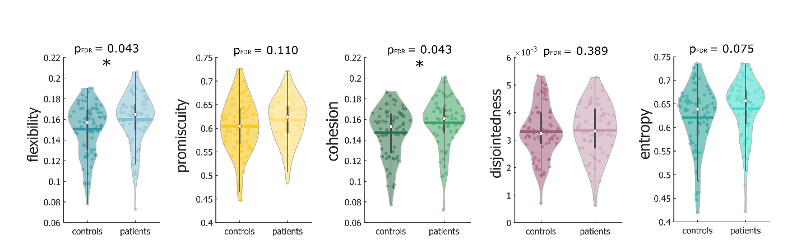Supplementary Fig. 2: Between-group comparison of whole-brain flexibility, promiscuity, cohesion, disjointedness, and entropy excluding patients with primary progressive MS, secondary progressive MS and clinically isolated syndrome. Patients with RRMS exhibit increased flexibility and cohesiveness compared to control groups (t = 2.17, P_{FDR} = 0.043 and t = 2.23, P_{FDR} = 0.043 respectively). While patients also showed a tendency towards higher promiscuity and entropy (t = 1.43, P_{FDR} = 0.110 and t = 1.72, P_{FDR} = 0.075), the difference was not statistically significant. Following the results from the original analysis, disjointedness did not show any significant difference between the two groups (t = 0.30, P_{FDR} = 0.389). Statistical analyses were performed using a permutation-based t-test and corrected for multiple comparisons. Colored dots represent individual values for dynamic graph metrics. Colored thick lines represent the mean. White dots and whiskers represent the median and upper and lower quartile, respectively. Group comparisons were performed with a permutation-based t-test. * P_{FDR} < 0.05.

 | dATT | vATT | SM | DMN | FPN | VIS | SUB | LIM | CB
flexibility | t = 2.52 | t = 1.12 | t = 2.65 | t = 1.85 | t = 1.14 | t = 0.79 | t = 2.47 | t = 3.57 | t = 1.53
 | p_{FDR} = 0.018* | p_{FDR} = 0.149 | p_{FDR} = 0.019* | p_{FDR} = 0.066 | p_{FDR} = 0.149 | p_{FDR} = 0.218 | p_{FDR} = 0.019* | p_{FDR} = 0.003** | p_{FDR} = 0.101
promiscuity | t = 1.98 | t =0.012 | t = 2.09 | t = 0.71 | t = 0.53 | t = -0.24 | t = 1.78 | t = 2.81 | t = 0.71
 | p_{FDR} = 0.086 | p_{FDR} = 0.498 | p_{FDR} = 0.086 | p_{FDR} = 0.369 | p_{FDR} = 0.386 | p_{FDR} = 0.463 | p_{FDR} = 0.101 | p_{FDR} = 0.034 | p_{FDR} = 0.369
cohesion within RSFS | t = -1.29 | t = -0.67 | t = 0.07 | t = -0.22 | t = 0.24 | t = 0.11 | t = -2.84 | t = -3.71 | t = -2.09
 | p_{FDR} = 0.231 | p_{FDR} = 0.448 | p_{FDR} = 0.473 | p_{FDR} = 0.474 | p_{FDR} = 0.474 | p_{FDR} = 0.474 | p_{FDR} = 0.010* | p_{FDR} = 0.003** | p_{FDR} = 0.062
cohesion across RSFS | t = 2.01 | t = 0.98 | t = 2.59 | t = 1.80 | t = 0.97 | t = 0.52 | t = 2.53 | t = 2.88 | t = 1.23
 | p_{FDR} = 0.062 | p_{FDR} = 0.189 | p_{FDR} = 0.023* | p_{FDR} = 0.069 | p_{FDR} = 0.189 | p_{FDR} = 0.304 | p_{FDR} = 0.023* | p_{FDR} = 0.023* | p_{FDR} = 0.183
disjointedness | t = 1.29 | t = -0.52 | t = 1.10 | t = -0.98 | t = -0.74 | t = -0.22 | t = 0.95 | t = 3.22 | t = -0.03
 | p_{FDR} = 0.309 | p_{FDR} = 0.385 | p_{FDR} = 0.309 | p_{FDR} = 0.309 | p_{FDR} = 0.357 | p_{FDR} = 0.466 | p_{FDR} = 0.309 | p_{FDR} = 0.007** | p_{FDR} = 0.493
entropy | t = 2.21 | t = 0.52 | t = 2.03 | t = 1.27 | t = 1.08 | t = 0.22 | t = 2.14 | t = 3.10 | t = 1.24
 | p_{FDR} = 0.058 | p_{FDR} = 0.341 | p_{FDR} = 0.062 | p_{FDR} = 0.171 | p_{FDR} = 0.185 | p_{FDR} = 0.416 | p_{FDR} = 0.058 | p_{FDR} = 0.009** | p_{FDR} = 0.172

Supplementary Table 9: Between-group comparison of dynamic metrics for each resting-state functional system (RSFS) excluding patients with primary progressive MS, secondary progressive MS and clinically isolated syndrome. dATT = dorsal attention; vATT = ventral attention; SM = sensorimotor; DM = default-mode; FP = fronto-parietal; VIS = visual; SUB = subcortical; LIM = limbic; CB = cerebellar. Colored dots represent individual values for dynamic graph metrics. Colored thick lines represent the mean. White dots and whiskers represent the median and upper and lower quartile, respectively. Group comparisons were performed with a permutation-based t-test. * P_{FDR} < 0.05, ** P_{FDR} < 0.01.

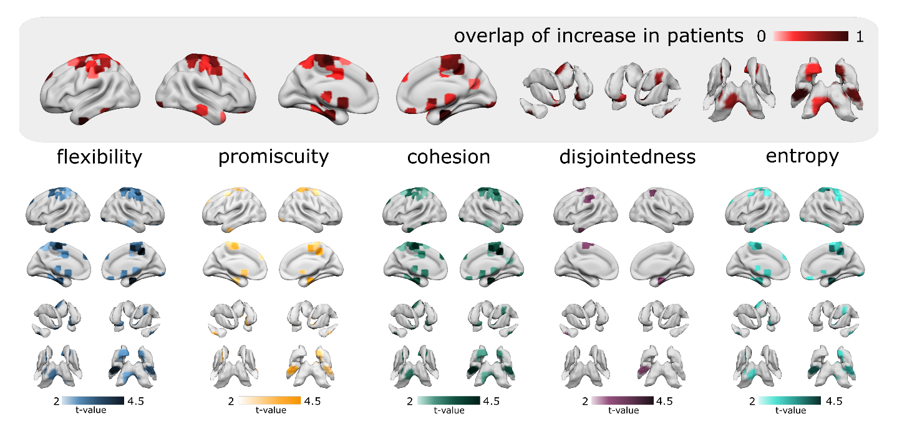
Supplementary Fig. 3: Between-group comparison of node-wise dynamic metrics excluding patients with primary progressive MS, secondary progressive MS and clinically isolated syndrome. Brain plots show significant increases of dynamic metrics in patients with MS compared to controls thresholded to P_{FDR} < 0.05. Group comparisons were performed with a permutation-based t-test. The overlap of the increases in flexibility, promiscuity, cohesion, disjointedness, and entropy is shown in the inset.

Supplementary references

1 Prichard D, Theiler J. Generating surrogate data for time series with several simultaneously measured variables. Phys Rev Lett 1994;73:951–4. doi:10.1103/PhysRevLett.73.951
2 Broeders TAA, Douw L, Eijlers AJC, et al. A more unstable resting-state functional network in cognitively declining multiple sclerosis. Brain Commun 2022;4:fcac095. doi:10.1093/braincomms/fcac095
3 Power JD, Cohen AL, Nelson SM, et al. Functional Network Organization of the Human Brain. Neuron 2011;72:665–78. doi:10.1016/j.neuron.2011.09.006

