Supplementary Materials

Platelet-derived factors deregulate placental sphingosine-1-phosphate receptor 2 in human trophoblast cells

Freya Lyssy¹, Jacqueline Guettler¹*, Beatrice A. Brugger¹, Christina Stern², Désirée Forstner¹, Olivia Nonn^{1,3,4,5}, Cornelius Fischer^{5,6}, Florian Herse³, Stefan Wernitznig¹, Birgit Hirschmugl², Christian Wadsack², Martin Gauster¹

¹Division of Cell Biology, Histology and Embryology; Gottfried Schatz Research Center, Medical University of Graz; Austria
²Department of Obstetrics and Gynaecology, Medical University of Graz; Austria
³Charité-Universitätsmedizin Berlin, Corporate Member of Freie Universität Berlin and Humboldt-Universität zu Berlin, Berlin; Germany
⁴Experimental Clinical Research Centre, Max Delbrueck Center for Molecular Medicine in the Helmholtz Association and Charité Berlin; Germany
⁵Max-Delbrück-Center for Molecular Medicine in the Helmholtz Association (MDC), Berlin; Germany
⁶Institute for Medical Systems Biology (BIMSB), Berlin; Germany

*Correspondence:
Jacqueline Guettler, https://orcid.org/0000-0002-8141-5712
Division of Cell Biology, Histology and Embryology,
Gottfried Schatz Research Center,
Medical University of Graz,
Neue Stiftingtalstraße 6, Graz 8010, Austria
Tel: +43 316 385 71878, Fax: +43 316 385 79612
E-mail: jacqueline.guettler@medunigraz.at

Supplemental Table 1
qPCR Primer Sequences

Gene | forward | reverse
GAPDH | ACCCACTCCTCCACCTTTGA | CTGTTGCTGTAGCCAAATTCG
TBP | TGACCCAGCATCACTGTTTC | CCAGCACACTCTTCTCAGCA
S1PR1 | CCTCCGTGTTCAGTCTCCTC | AGTTATTGCTCCCGTTGTGG
S1PR2 | CGGCCTAGCCAGTTCTGA AA | AATGGCGCAACAGAGGATGA
S1PR3 | CAGCCCCGCTTCCCTTTG | CATCACTTGGCATTCACAGACG

Supplemental Table 2
Antibodies used for Immunohistochemistry (IHC), Immunofluorescence staining (IF) and Immunoblotting (IB)

Protein | Host Species | Company | AG retrieval | Dilution IHC | Dilution IF | Dilution IB
S1PR1 | Rabbit | abcam | pH 6 | 1:1000 | 1:500 | 1:1000
S1PR2 | Rabbit | Invitrogen | pH 9 | 1:200 | 1:100 | 1:400
S1PR3 | Rabbit | abcam | pH 9 | 1:200 | 1:100 | 1:1000
HLA-G | Mouse | BD Pharmingen | pH 9 | - | 1:1000 | -
CD68 | Mouse | Thermo Scientific | pH 9 | - | 1:100 | -
CD42b | Rabbit | Proteintech Europa | pH 9 | 1:1000 | 1:500 | -
IgG | Rabbit | Cell Signaling | pH6/pH9 | 1:200 | 1:200 | -
IgG1 | Mouse | Dako | pH9 |  | 1:1000
β-actin | Mouse | abcam | - | - | - | 1:500.000
DAPI | - | Invitrogen | - | - | 1:2000 | -
Alexa Fluor 488 | Goat anti mouse | Invitrogen | - | - | 1:200 | -
Alexa Fluor 555 | Goat anti rabbit | Invitrogen | - | - | 1:200 | -

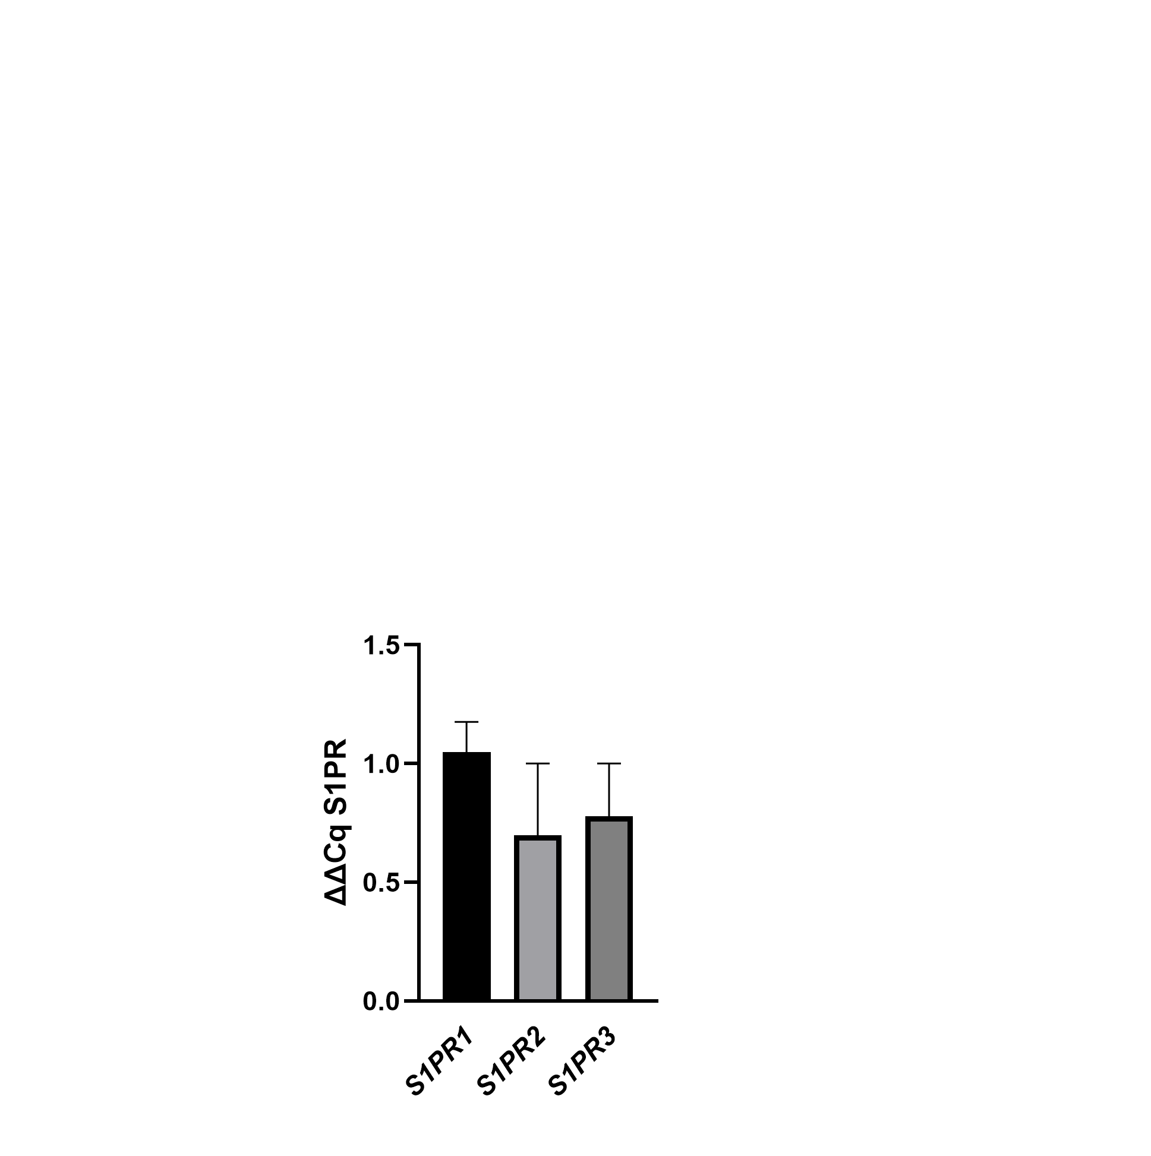

Supplemental Figure 1
S1P receptor expression in isolated human platelets
qPCR for S1PR1, S1PR2 and S1PR3 in human platelets (n=3). Data shown as mean ∆∆Cq ± SD, GAPDH/TBP was used as reference gene.

