Supplement
1. Supplementary figures
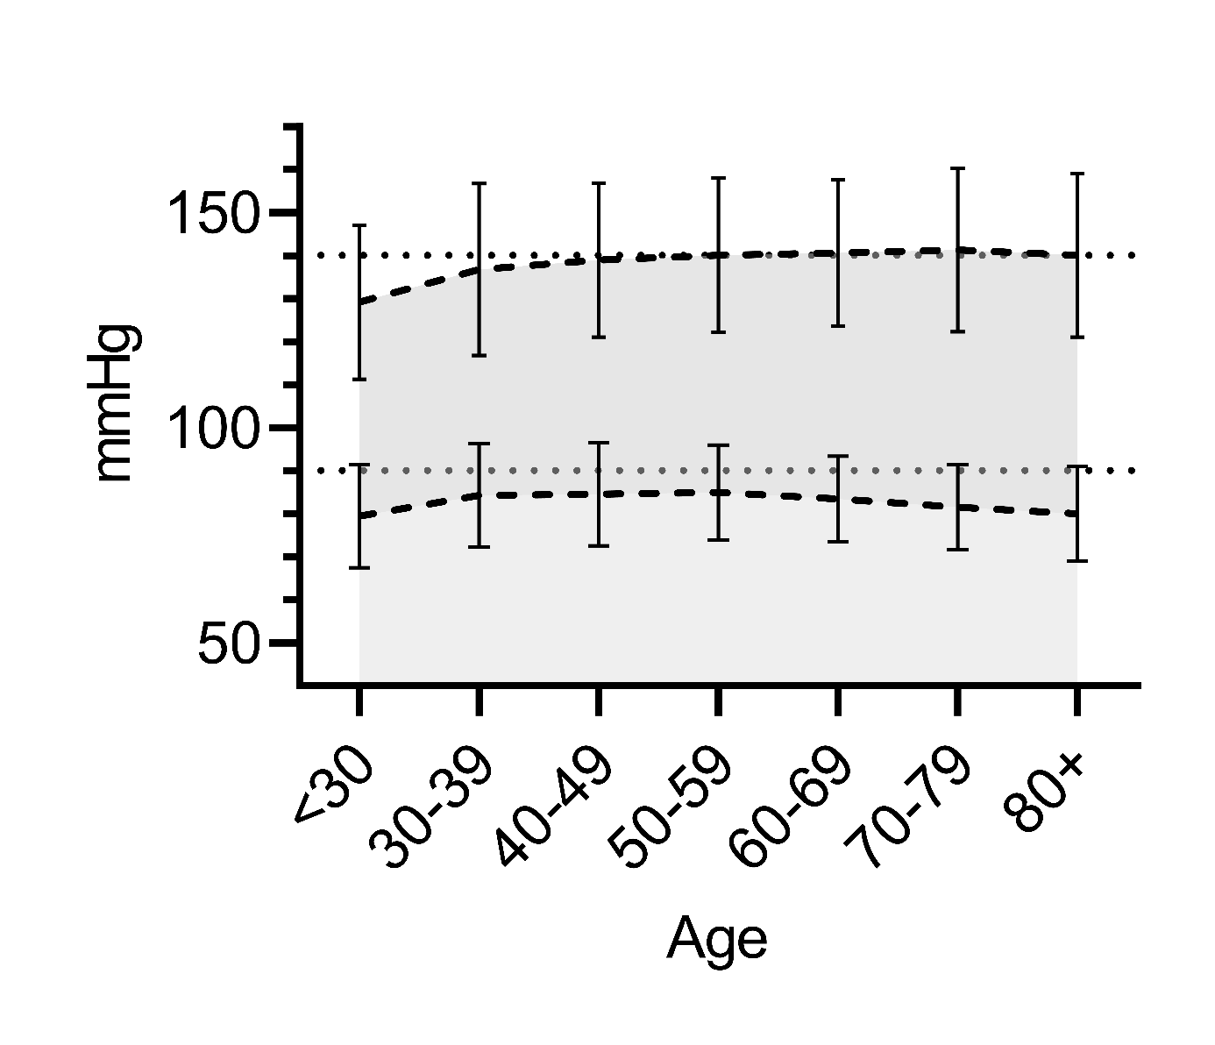
Fig. S1: Systolic and diastolic blood pressure by age. Mean systolic BP (upper dashed line) and mean diastolic BP (lower dashed line) of all patients with documented systolic and diastolic BP-values (n=6970). Data is shown for different age groups. Error bars represent standard errors. Horizontal dashed lines indicate thresholds for diagnosing hypertension based on office blood pressure (syst. BP 140mmHg, diast. BP 90mmHg).

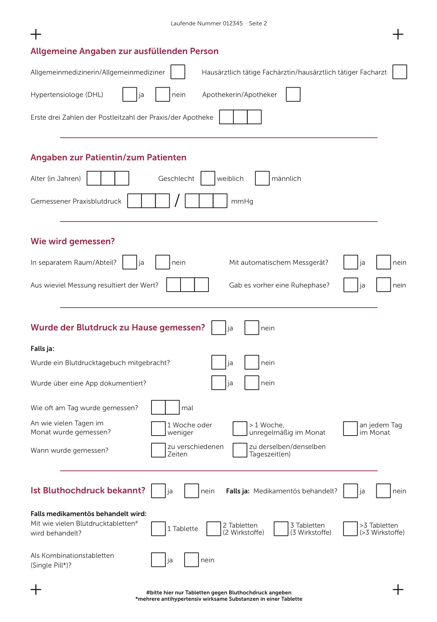
Fig. S2: Questionnaire of the survey
2. Supplementary tables

TABLE S1 Systolic OBP stratified by gender, age and setting
Gender | Age,  years | Separate  room/compartment? | Mean,  mmHg | SD | n
Female | <65 | Yes | 136.4 | 18.2 | 1302
 |  | No | 138.4 | 18.1 | 269
 |  | Total | 136.7 | 18.2 | 1571
 | >65 | Yes | 141.3 | 18.6 | 1482
 |  | No | 142.0 | 17.7 | 362
 |  | Total | 141.5 | 18.4 | 1844
 | Total | Yes | 139.0 | 18.6 | 2784
 |  | No | 140.5 | 17.9 | 631
 |  | Total | 139.3 | 18.5 | 3415
Male | <65 | Yes | 141.3 | 17.6 | 1338
 |  | No | 142.5 | 18.1 | 293
 |  | Total | 141.5 | 17.7 | 1631
 | >65 | Yes | 140.2 | 18.2 | 1416
 |  | No | 140.9 | 19.2 | 318
 |  | Total | 140.3 | 18.4 | 1734
 | Total | Yes | 140.7 | 17.9 | 2754
 |  | No | 141.7 | 18.7 | 611
 |  | Total | 140.9 | 18.1 | 3365
Total | <65 | Yes | 138.9 | 18.1 | 2640
 |  | No | 140.5 | 18.2 | 562
 |  | Total | 139.2 | 18.1 | 3202
 | >65 | Yes | 140.8 | 18.4 | 2898
 |  | No | 141.5 | 18.4 | 680
 |  | Total | 140.9 | 18.4 | 3578
 | Total | Yes | 139.9 | 18.3 | 5538
 |  | No | 141.1 | 18.3 | 1242
 |  | Total | 140.1 | 18.3 | 6780
Systolic blood pressure stratified by age (>65 and <65 years), gender and location of BP measurement (separate room, no separate room).OBP office blood pressure.

TABLE S2 Diastolic OBP stratified by gender, age and setting
Gender | Age,  years | Separate room/  compartment? | Mean,  mmHg | SD | n
Female | <65 | Yes | 83.2 | 11.0 | 1300
 |  | No | 84.8 | 10.6 | 269
 |  | Total | 83.5 | 10.9 | 1569
 | >65 | Yes | 81.7 | 10.7 | 1479
 |  | No | 81.8 | 10.5 | 361
 |  | Total | 81.7 | 10.7 | 1840
 | Total | Yes | 82.4 | 10.9 | 2779
 |  | No | 83.1 | 10.6 | 630
 |  | Total | 82.5 | 10.8 | 3409
Male | <65 | Yes | 85.1 | 11.3 | 1338
 |  | No | 85.2 | 10.5 | 293
 |  | Total | 85.1 | 11.2 | 1631
 | >65 | Yes | 81.0 | 10.5 | 1416
 |  | No | 81.6 | 11.0 | 318
 |  | Total | 81.1 | 10.6 | 1734
 | Total | Yes | 83.0 | 11.1 | 2754
 |  | No | 83.3 | 10.9 | 611
 |  | Total | 83.1 | 11.0 | 3365
Total | <65 | Yes | 84.2 | 11.2 | 2638
 |  | No | 85.0 | 10.6 | 562
 |  | Total | 84.3 | 11.1 | 3200
 | >65 | Yes | 81.4 | 10.6 | 2895
 |  | No | 81.7 | 10.7 | 679
 |  | Total | 81.4 | 10.6 | 3574
 | Total | Yes | 82.7 | 11.0 | 5533
 |  | No | 83.2 | 10.8 | 1241
 |  | Total | 82.8 | 10.9 | 6774
Diastolic blood pressure stratified by age (>65 and <65 years), gender and location of BP measurement (separate room, no separate room).OBP office blood pressure.

TABLE S3 Systolic OBP stratified by medical treatment and setting
Medical treatment? | Separate room/  compartment? | Mean | SD | n
Yes | Yes | 140.7 | 17.7 | 4413
 | No | 141.5 | 17.7 | 1045
 | Total | 140.9 | 17.7 | 5458
No | Yes | 147.0 | 22.1 | 78
 | No | 147.7 | 19.2 | 14
 | Total | 147.1 | 21.6 | 92
Total | Yes | 140.8 | 17.8 | 4491
 | No | 141.6 | 17.8 | 1059
 | Total | 141.0 | 17.8 | 5550
Systolic blood pressure stratified by medication and location of BP measurement (separate room, no separate room). OBP office blood pressure.

Table S4 Diastolic OBP stratified by medical treatment and setting
Medical treatment? | Separate  Room/compartment? | Mean | SD | n
Yes | Yes | 82.8 | 10.9 | 4408
 | No | 83.1 | 10.8 | 1044
 | Total | 82.9 | 10.8 | 5452
No | Yes | 85.0 | 10.4 | 78
 | No | 89.0 | 9.7 | 14
 | Total | 85.6 | 10.3 | 92
Total | Yes | 82.8 | 10.9 | 4486
 | No | 83.2 | 10.8 | 1058
 | Total | 82.9 | 10.8 | 5544
Systolic blood pressure stratified by medication and location of BP measurement (separate room, no separate room). OBP office blood pressure.

TABLE S5 Three-Way ANOVA: Tests of Between-Subjects-Effects (age, gender, location)
Source | Typ III Sum of squares | df | Mean Square | F | Sig. | Partial eta squared
Corrected model | 26444.763* | 7 | 3777.823 | 11.426 | 0.000 | 0.012
Intercept | 79142701.299 | 1 | 79142701.299 | 239373.314 | 0.000 | 0.972
Gender | 2914.468 | 1 | 2914.468 | 8.815 | 0.003 | 0.001
Age categories | 2142.953 | 1 | 2142.953 | 6.482 | 0.011 | 0.001
Location | 1310,967 | 1 | 1310.967 | 3.965 | 0.046 | 0.001
Gender * Age cat. | 8099.194 | 1 | 8099.194 | 24.497 | 0.000 | 0.004
Gender * Location | 42.532 | 1 | 42.532 | 0.129 | 0.720 | 0.000
Age * Location | 206.667 | 1 | 206.667 | 0.625 | 0.429 | 0.000
Gender * Age cat. * Location | 44.974 | 1 | 44.974 | 0.136 | 0.712 | 0.000
Error | 2238989.653 | 6772 | 330.625
Total | 135312522.000 | 6780
Corrected Total | 2265434.415 | 6779
Results of a factorial (three-way) ANOVA comparing the main effects of gender, age categories and location (separate/non-separate room) as well as their interaction effects on the dependent variable systolic office blood pressure. *R-Squared = .012 (adjusted R-Squared = .011)

