Supplementary Material

Circulating plasma IL-8 associated with carotid intima-media thickness.

Contents
- Description of the validation cohorts
- Ethics
- Supplementary Figures
3.1 Supplemental Figure I
3.2 Supplemental Figure II
3.3 Supplemental Figure III
4. Supplementary Tables
4.1 Supplemental Table I
4.2 Supplemental Table II
4.3 Supplemental Table II
4.4 Supplemental Table IV
4.5 Supplemental Table V
4.6 Supplemental Table VI
4.7 Supplemental Table VII
4.8 Supplemental Table VIII
4.9 Supplemental Table IX
4.10 Supplemental Table X
5. References

1. Description of the validation cohorts
Prospective Investigation of the Vasculature in Uppsala Seniors (PIVUS)

PIVUS is a population-based study of 1,016 subjects (50% females) all aged 70 years residing in the City of Uppsala, Sweden. The data were collected in 2001-2004. Details on data collection, c-IMT measurements and genotyping have been previously reported and are summarized in Supplemental Table I ¹
Malmö Diet and Cancer-Cardiovascular Cohort (MDC-CC)

The Malmö Diet and Cancer Study (MDC study) is a prospective population-based cohort study from the city of Malmö in southern Sweden . A baseline examination including samples of peripheral venous blood, blood pressure measurements and anthropometric measures and self-administered questionnaires were taken between March 1991 and September 1996. To study the epidemiology of carotid artery disease, 50% of the participants was randomly selected in MDC-CC (n=6103) between 1991 and 1994. Out of these, 5,540 participants had fasting plasma samples collected. B-mode ultrasonography (Acuson 128 CT System; Siemens) of the right carotid artery was performed according to a standardized protocol, by trained, certified sonographers ². In brief, the bifurcation area of the right common carotid artery was scanned within a predefined “window” comprising 3 cm of the distal common carotid artery, the bifurcation, and 1 cm of the internal and external carotid arteries, respectively. Intra-observer variability for three ultrasound operators were 10%, 6%, and 10%, respectively for intima–media thickness of the common carotid artery (IMT CCA). Interobserver variability of the IMT CCA for three pairs of observers was r=0.66, r=0.94, and r=0.87, respectively

UK Biobank.
The UK Biobank study has been described in detail previously ³. In short, ~0.5M participants were recruited through 22 centres across the UK. At enrollment, all participants underwent a physical examination, blood sampling and completed extensive questionnaires on lifestyle, socioeconomic factors as well as personal and family medical histories. Subsequently, a subset of individuals was invited to attend a follow-up assessment, which included ultrasound imaging of c-IMT ⁴. DNA was extracted from blood samples using standard protocols. Genotyping and imputation to the Haplotype Reference Consortium and 1000Genomes reference panels, with standard quality control procedures (pre and post imputation) being applied by the central UK Biobank team.
The protocol for cIMT measures is available online through the UK Biobank Data Showcase (https://biobank.ctsu.ox.ac.uk/crystal/field.cgi?id=20226) and has been described in detailed elsewhere. Briefly, c-IMT measures were assessed at two angels on each side. C-IMT_{mean}, c-IMT _{max} and c-IMT _{mean-max} values were computed. These measures are considered comparable with those reported for the IMPROVE study. The UK Biobank results presented here are summary statistics from the genome-wide association study of c-IMT ⁴.

2. Ethics.
The IMPROVE study was funded by the Vth European Union (EU) program. The study was carried out in accordance with the Helsinki Declaration and approved by the Institutional Review Board (IRB) at each one of the seven recruiting centers:
- Regional Ethics Review Board at Karolinska Institutet, Stockholm Sweden,
- IRB at the Groupe Hôpitalier Pitie-Salpetriere, Paris, France
- IRB Comitato Etico delle Aziende Sanitarie della regione Umbria, Perugia
- IRB at the Ospedale Niguarda Ca´Granda, Milano, both in Italy
- IRB at the University Hospital Groningen, Groningen, the Netherlands
- IRB Hospital District of Northern Savo, Kuopio, Finland
- IRB at University of Eastern Finland, Kuopio, Finland.
Each participant provided two different written consents one for general participation in the study and one for genotyping at the time they were included in the study. The study presented in the present paper was conducted at Karolinska Institutet and approved by the Regional Ethical Review Board in Stockholm (2017/404-32).
The MDC-CC study: All participants provided written informed consent. The study was approved by the Regional Ethical Review Board in Lund, Sweden (LU 51/90) and was carried out in accordance with the Helsinki Declaration.
The PIVUS study was approved by the Ethics Committee of Uppsala University.
The UK-Biobank: All participants provided written informed consent and ethical approval was granted by the NHS national Research Ethics Service. This work was conducted under the generic ethical approval granted by the NHS National Research Ethics Service (approval letter dated 13 May 2016, Ref 16/NW/0274) and UK Biobank project #6553 (PI RJ Strawbridge).

3. Supplementary Figures

3.1 Supplemental Figure I. Flowchart summarizing the IMPROVE study participants included in the present study.

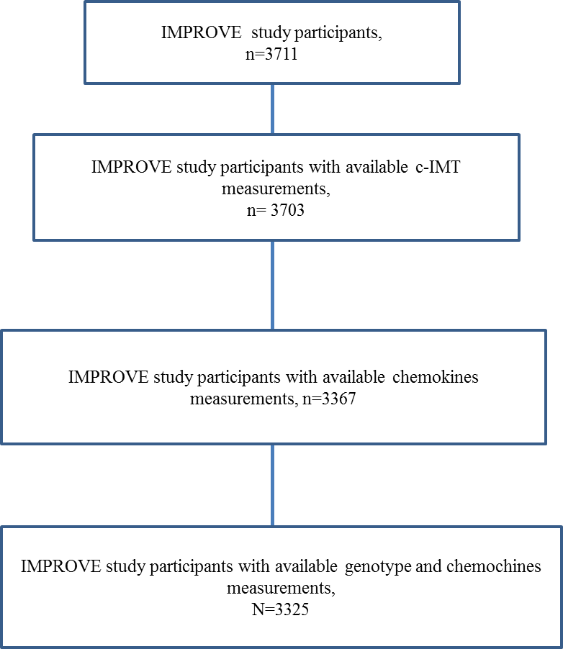

3.2 Supplemental Figure II. Association of the IL-8 genetic score with log transformed IL-8 plasma levels (panel A) and with c-IMT _{mean-max} (panel B) in the IMPROVE. The x axis represents the sum of IL-8 increasing alleles at both loci on chromosome 8 and chromosome 16. Individual in each genotype score group (0=414 1=1566 2=1304 3=55 4=1).
Panel A
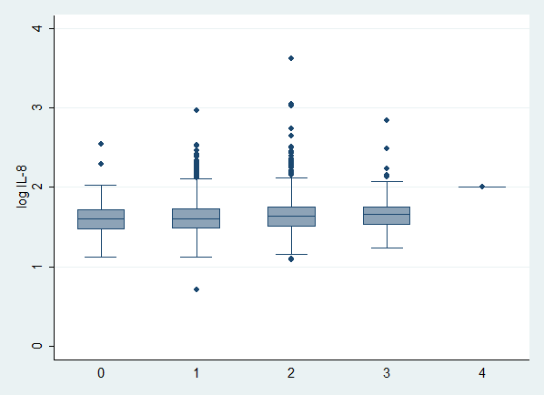

Panel B
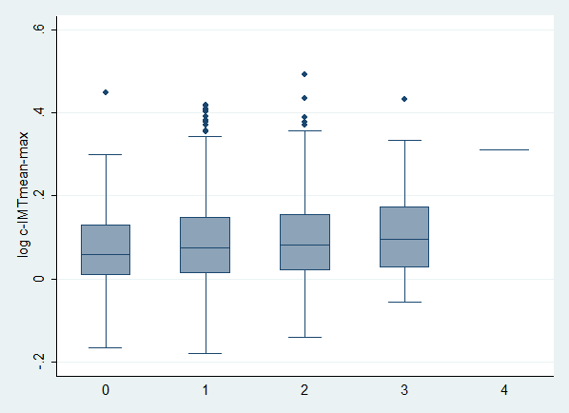

3.3 Supplemental Figure III. Association of the IL-8 genetic score with log transformed c-IMT _{mean-max} (panel B) in the UK Biobank. The x axis represents the sum of IL-8 increasing alleles at both loci on chromosome 8 and chromosome 16. Individual in each genotype score group (0=2991 1=10712 2=9783 3=317 4=2).
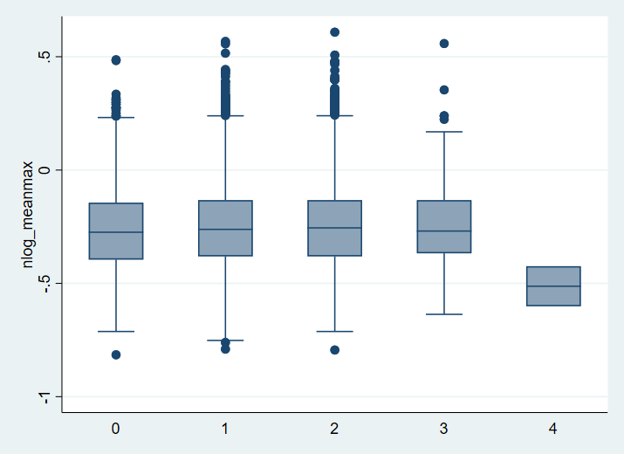
Log c-IMT mean-max

4. Supplementary Tables

4.1 Supplemental Table I. Description of the ultrasonographic measures available for each cohort included in the study
 | IMPROVE (n=3711) | PIVUS  (n=1016) | MDCC-CC  (n=6103) | UK-Biobank  (n=22179)
Year | 2004-2007 | 2001-2004 | 1991-1994 | 2015-2018
Carotid artery segments  measured (n) | 8 (4 segments left and 4 segment right) | 2 (both sides) | right carotid artery | 2 angles each for left and right
Localization | Far wall common carotid  Remaining common carotid in its entire length (excluding the first centimeter),  1st cm proximal to the bifurcation,  carotid bifurcation,  internal carotid artery in the 1st cm distal to the bifurcation | Far wall of the common carotid, 1cm proximal to the carotid artery bifurcation | Far wall of the common carotid 1 cm proximal to the carotid artery bifurcation | Far wall of the distal common carotid
c-IMT measures available for each segment | c-IMT mean,  c-IMT-max | c-IMT mean  c-IMT-max | c-IMT mean | c-IMT mean, c-IMT-max
Average c-IMT measures available | c-IMT mean, c-IMT-max, c-IMT mean-max | c-IMT mean,  c-IMT-max, c-IMT mean-max | c-IMT mean | c-IMT mean, c-IMT-max, c-IMT mean-max
Measurement  reading protocol | Each segment was measured in at least 3 different frames in the core lab (Milan) using dedicated software (M’Ath) | Semi-automatic software | Computer-assisted image analysing system | Automated (after pilot of extensive manual quality control).
Reference with full protocol description (PMID) | 19952003;  22999719 | 17462652 | 1543698;  10821297 | 31801372

4.2. Supplemental Table II. Characteristics of the IMPROVE study population according to GRO-α quartiles.

 | Q1 (n=840) | Q2 (n=843) | Q3 (n=842) | Q4 (n=842)
Men/Women | 394/446 | 438/405 | 417/425 | 375/467
Age (years) | 62.56 (58.65-66.70) | 63.94 (59.43-67.16) | 66.07 (60.04-67.47) | 66.26 (60.51-67.23)
Latitude (°) | 45 (43-48) | 53 (45-62) | 59 (48-62) | 59 (53-62)
BMI (kg/m²) | 26.22 (23.53-28.49) | 26.63 (24.43-29.13) | 27.13 (24.78-29.83) | 27.22 (24.48-30.30)
Carotid Ultrasound Measures
c-IMT_{mean} | 0.81 (0.71-0.96) | 0.84 (0.73-0.98) | 0.86 (0.75-1.01) | 0.87 (0.76-1.01)
c-IMT_{max} | 1.76 (1.30-2.41) | 1.85 (1.39-2.42) | 1.93 (1.45-2.51) | 1.93 (1.45-2.59)
c-IMT_{mean-max} | 1.14 (0.99-1.35) | 1.17 (1.02-1.39) | 1.21 (1.05-1.44) | 1.23 (1.06-1.42)
Risk Factors, n (%)
Hypertension | 581 (70) | 654 (77) | 703 (83) | 726 (86)
Diabetes | 155 (18) | 211 (25) | 241 (29) | 271 (32)
Smoke | 115 (14) | 124 (15) | 136 (13) | 120 (14)
Biochemical measurements
LDL (mmol/L) | 3.62 (2.98-4.29) | 3.49 (2.86-4.24) | 3.42 (2.80-4.14) | 3.44 (2.67-4.18)
HDL (mmol/L) | 1.22 (1.03-1.47) | 1.20 (1.01-1.45) | 1.19 (1.0-1.47) | 1.19 (1.0-1.46)
C-reactive protein (mg/L) | 1.59 (0.65-3.10) | 1.71 (0.79-3.46) | 2.09 (0.81-3.832 | 2.01 (0.88-3.89)
Treatment, n (%)
Statin | 385 (46) | 354 (42) | 333 (39) | 284 (34)
Anti-platelet | 158 (19) | 150 (18) | 139 (16) | 119 (14)
Data are presented as median and IQR for continuous variables and as number for binary variables. LDL: LDL-cholesterol; HDL: HDL-cholesterol. Missing values: c-IMT mean, n=2; c-IMT max, n=2; LDL, n=66; HDL, n=6; CRP, n=2; Diabetes, n=54;

4.3. Supplemental Table III. Association of unit increase of plasma GRO-α with c-IMT measures at baseline adjusted by age and sex and by age and sex and latitude.

 |  | Adjusted by age, sex and latitude
 | N | β (SE) | p
c-IMT_{mean} | 3365 | 2.22 ×10⁻⁶ (4.3×10⁻⁵) | 0.05
c-IMT_{max} | 3365 | -3.96×10⁻⁴ (2.1×10⁻⁴) | 0.06
c-IMT_{mean-max} | 3364 | 3.10×10⁻⁵ (6.4×10⁻⁵) | 0.631

For each model the total number of study participants, the coefficient of association and the p value are reported. Missing values as in Table 1.

4.4. Supplemental Table IV. Association of unit increase of plasma IL-8 with c-IMT at baseline in the PIVUS and MDC-CC studies.
 |  |  | Crude |  |  | Model 1
PIVUS |  | N | β (SE) | p | N | β (SE) | p
 | c-IMT_{mean} | 936 | 9.59×10⁻³(6.9×10⁻³) | 0.165 | 930 | 6.29×10⁻³(6.3×10⁻³) | 0.316
 | c-IMT_{max} | 982 | 1.13×10⁻² (8.5×10⁻³) | 0.185 | 976 | 2.04×10⁻² (9.0×10⁻³) | 0.024
 | c-IMT_{mean-max} | 936 | 1.31×10⁻² (8.7×10⁻³) | 0.134 | 930 | 6.89×10⁻³(8.16×10⁻³) | 0.398
MDC-CC
 | c-IMT_{mean} | 4707 | 1.61×10⁻² (4.3×10⁻³) | 0.001 | 4695 | 1.30×10⁻²(4.4×10⁻³) | 0.003
 | c-IMT_{max} | 4707 | 5.36×10⁻³ (4.8×10⁻³) | 0.270 | 4695 | 1.54×10⁻³(4.7×10⁻³) | 0.744

PIVUS: Crude model adjusted by gender, age is 70 in all study participants; model 1 adjusted by gender, hypertension, diabetes mellitus, LDL_cholesterol, BMI, smoking, treatment with statins and aspirin. The analysis is based on log-trasformed IL-8 levels.
MDCC-CC: crude model adjusted by gender and age; model 1 adjusted by gender, age, hypertension, diabetes mellitus, LDL-cholesterol, BMI, smoking, treatment with statins and aspirin.

4.5 Supplemental Table V. Association of SNPs passing the significance threshold level with plasma IL8 levels.
 |  |  |  |  |  | Crude model (n=3324) |  |  | Model 1 (n=3201)
CHR | SNP | Position  (GRCh37) (bp) | EA | NEA | EAF | β | SE | p | β | SE | p
8 | rs117518778 | 129,289,406 | G | A | 0.02 | 0.078 | 0.017 | 4.55×10⁻⁶ | 0.079 | 0.017 | 2.80×10⁻⁶
16 | rs6564261 | 75,492,242 | C | T | 0.37 | -0.024 | 0.005 | 3.35×10⁻⁶ | -0.023 | 0.005 | 6.25×10⁻⁶
16 | rs8057084 | 75,492,706 | T | G | 0.37 | -0.024 | 0.005 | 3.17×10⁻⁶ | -0.023 | 0.005 | 5.72×10⁻⁶
16 | rs17696831 | 75,493,298 | C | G | 0.37 | -0.024 | 0.005 | 3.27×10⁻⁶ | -0.023 | 0.005 | 6.00×10⁻⁶
16 | rs12918797 | 75,493,810 | T | C | 0.37 | -0.024 | 0.005 | 3.27×10⁻⁶ | -0.023 | 0.005 | 6.00×10⁻⁶
16 | rs4888430 | 75,494,424 | T | C | 0.38 | -0.023 | 0.005 | 5.55×10⁻⁶ | -0.023 | 0.005 | 7.51×10⁻⁶
16 | rs11641430 | 75,495,276 | T | C | 0.37 | -0.024 | 0.005 | 3.63×10⁻⁶ | -0.023 | 0.005 | 6.57×10⁻⁶
16 | rs7195161 | 75,495,572 | T | C | 0.37 | -0.024 | 0.005 | 3.63×10⁻⁶ | -0.023 | 0.005 | 6.57×10⁻⁶
16 | rs1424013 | 75,495,986 | T | C | 0.37 | -0.024 | 0.005 | 3.63×10⁻⁶ | -0.023 | 0.005 | 6.57×10⁻⁶
16 | rs37592 | 75,496,791 | C | G | 0.37 | -0.024 | 0.005 | 3.62×10⁻⁶ | -0.023 | 0.005 | 5.59×10⁻⁶
16 | rs37593 | 75,496,907 | C | T | 0.37 | -0.024 | 0.005 | 3.87×10⁻⁶ | -0.023 | 0.005 | 5.93×10⁻⁶
16 | rs8055490 | 75,497,135 | C | T | 0.38 | -0.023 | 0.005 | 5.48×10⁻⁶ | -0.023 | 0.005 | 7.71×10⁻⁶
16 | rs1834014 | 75,501,274 | G | A | 0.38 | -0.023 | 0.005 | 5.17×10⁻⁶ | -0.023 | 0.005 | 7.32×10⁻⁶
16 | rs977987 | 75,506,593 | G | A | 0.39 | -0.023 | 0.005 | 4.62×10⁻⁶ | -0.023 | 0.005 | 5.34×10⁻⁶
16 | rs10871313 | 75,507,094 | C | T | 0.35 | -0.024 | 0.005 | 3.41×10⁻⁶ | -0.023 | 0.005 | 7.83×10⁻⁶
CHR: Chromosome; BP: base position; EA: effect allele; NEA: non-effect allele; EAF: effect allele frequency

Crude model: adjusted by sex, age, latitude. Model 1, crude model hypertension, diabetes, current smoking, BMI, LDL-cholesterol levels and treatment with statins and anti-platelet agents.

4.6 Supplemental Table VI. Association of rs12075 (A/G) with plasma IL8 and GRO-α levels in the IMPROVE study
 |  | IMPROVE  N (%) | IL8 | p | GRO-α | p
rs12075 | AA | 1124 (31.8) | 40.8 (30.1-54.8) |  | 79.6 (37.4-156.9)
 | AG | 1767 (49.9) | 41.4 (30.8-55.4) |  | 83.8 (41.0-160.8)
 | GG | 646 (18.3) | 41.4 (30.9-55.9) | 0.4 | 83.7 (42.3-155.6) | 0.4

Genotype data were available in 3537 study participants. Of those 3430 had available measurements for IL-8 and GRO- α, AA=1090, AG=1722 and GG=618.The levels of chemokines are expressed in arbitrary units and reported as median (interquartile range).
* p-values are calculated using Kruskal-Wallis test. Missing values as in Table 1.

4.7 Supplemental Table VII. Association of the SNPs at the IL-8 locus on chromosome 4 (IL8 gene +/-250Kb, build 37, UCSU genome browser) with plasma IL-8 in the IMPROVE.
SNP | BP | EA | N | β | SE | p
rs6858087 | 74370838 | A | 3324 | 0.00258 | 0.008313 | 0.7563
rs4694170 | 74373060 | T | 3324 | 0.00444 | 0.005666 | 0.4333
rs6446944 | 74466132 | T | 3324 | -0.0005 | 0.004911 | 0.9183
rs4694627 | 74525356 | T | 3324 | 0.000196 | 0.005066 | 0.9691
rs6836038 | 74573762 | A | 3324 | -0.02003 | 0.01032 | 0.0524
rs17202249 | 74617243 | T | 3324 | -0.00104 | 0.008228 | 0.8995
rs9999446 | 74628455 | G | 3324 | 0.002872 | 0.004954 | 0.5622
rs17809257 | 74677562 | T | 3324 | 0.01565 | 0.0165 | 0.3431
rs960821 | 74727832 | A | 3323 | 0.01228 | 0.01057 | 0.2456
rs3111693 | 74730921 | A | 3324 | 0.009935 | 0.01181 | 0.4002
rs10518117 | 74750051 | A | 3324 | 0.0145 | 0.01181 | 0.2196
rs11574452 | 74846661 | A | 3324 | 0.02095 | 0.01242 | 0.0918
rs442155 | 74851232 | G | 3324 | 0.000315 | 0.008278 | 0.9697
rs2457996 | 74856535 | C | 3324 | -0.00225 | 0.008202 | 0.7836

CHR: Chromosome; BP: base position; EA: effect allele

4.8 Supplemental Table VIII. Reported associations of rs117518778, rs4888378 and rs805708 and/or of SNPs in LD (r2≥0.8) with cardiovascular traits reported in the GWAS catalogue (LDtrait) (https://ldlink.nci.nih.gov/?tab=ldtrait/), PhenoScanner (http://www.phenoscanner.medschl.cam.ac.uk) and PheWas (https://gwas.mrcieu.ac.uk/)

SNP | Trait | Position  (GRCh37) (bp) | SNP, LD (r2) | EA | NEA | EAF | p | PMID | Public domain
rs117518778 | - | Chr8:129,289,406 |  | G | A | 0.02 |  | - - | - LDtrait, Phenoscanner
 | Interleukin 8 | Chr8:129,289,406 |  | G | A | 0.02 | 6.08×10⁻⁶ |  | - PheWas
rs4888378 | Systolic blood pressure | Chr16:75,3310,44  Chr16:75,444,572 | rs11643209  (0.86)  rs35261357  (0.95) | T  C | G  T | 0.42  0.49 | 2.00×10⁻¹²  7.90×10⁻¹² | - 28135244,  27841878 | - LDtrait, Phenoscanner  - PheWas
 | Medication use (RAS inhibitors) | Chr16:75,331,178 | rs11646852  (0.95) | G | A | NR | 9.00×10⁻¹¹ | - 34594039 | - LDtrait, Phenoscanner
 | Coronary heart disease | Chr16:75,332,041 | rs4888378  (1.00) | G | A | 0.41 | 6.00×10⁻¹⁵ | - 29212778 | - LDtrait,  - Phenoscanner,  - PheWas
 | Pulse Pressure | Chr16:75,444,572 | rs35261357  (0.95) | C | T | 0.49 | 1.01×10⁻¹⁵ | 27841878,  30429575 | PheWas
rs8057084 | Plateletcrit | Chr16:75,493279 | rs34539062  (1.00) | A | C | 0.63 | 5.00×10⁻²² | - 32888494 | - LDtrait
 | Platelet count | Chr16:75,493279 | rs34539062  (1.00) | A | C | 0.63 | 1.00×10⁻¹⁵ | - 32888494 | - LDtrait

4.9 Supplemental Table IX. Additional biomarkers and cardiovascular traits associated with rs117518778, rs4888378
and rs8057084 identified in the GWAS project with a p value <1×10⁻⁵

CHR | Position | SNP | Trait | EA | NEA | EAF | N | Beta | SE | P | OpenGwas  Project ID | Dataset | PMID
8 | 129289406 | rs117518778 | C-X-C motif chemokine ligand 8 | G | A | 0.02 | 3394 | 0.379 | 0.084 | 6.08E-06 | prot-b-11 | Folkersen et al | 28369058
16 | 75298143 | rs4888378 | Emergency coronary revascularization (for ACS) | G | A | 0.57 |  | 0.118 | 0.026 | 5.02E-06 | finn-a-I9_REVACS | Finngen Biobank
16 | 75332041 | rs4888378 | apolipoprotein B | G | A | 0.60 |  | -0.010 | 0.002 | 6.00E-06 | ieu-b-108 | MRbase 2
16 | 75332041 | rs4888378 | Coronary artery disease | G | A | 0.59 | 296525 | 0.041 | 0.005 | 2.86E-15 | ebi-a-GCST005194 | EBI
16 | 75332041 | rs4888378 | Coronary artery disease | G | A |  | 547261 | 0.045 | 0.007 | 2.90E-10 | ebi-a-GCST005195 | EBI
16 | 75332041 | rs4888378 | Coronary atherosclerosis | G | A | 0.60 | 361194 | 0.002 | 0.000 | 1.92E-07 | ukb-d-I9_CORATHER | UK Biobank Neale 2
16 | 75332041 | rs4888378 | diastolic blood pressure | G | A | 0.60 | 754685 | 0.121 | 0.018 | 6.96E-12 | ieu-b-39 | MRbase 2
16 | 75332041 | rs4888378 | ENSG00000050820 (BCAR1) | G | A | 0.59 | 30858 | -0.087 | 0.012 | 4.65E-13 | eqtl-a-ENSG00000050820 | eQTLgen
16 | 75332041 | rs4888378 | ENSG00000065457 (ADAT1) | G | A | 0.59 | 31683 | -0.076 | 0.012 | 4.08E-10 | eqtl-a-ENSG00000065457 | eQTLgen
16 | 75332041 | rs4888378 | ENSG00000153774 (CFDP1) | G | A | 0.59 | 31683 | -0.289 | 0.012 | 4.84E-131 | eqtl-a-ENSG00000153774 | eQTLgen
16 | 75332041 | rs4888378 | ENSG00000166822 (TMEM170A) | G | A | 0.59 | 31085 | -0.140 | 0.012 | 2.51E-31 | eqtl-a-ENSG00000166822 | eQTLgen
16 | 75332041 | rs4888378 | ENSG00000261783 ("novel transcript, sense intronic to CFDP1") | G | A | 0.59 | 4339 | -0.335 | 0.012 | 1.51E-178 | eqtl-a-ENSG00000261783 | eQTLgen
16 | 75332041 | rs4888378 | HbA1C | G | A | 0.60 |  | -0.007 | 0.002 | 2.00E-06 | ieu-b-104 | MRbase 2
16 | 75332041 | rs4888378 | HDL cholesterol | G | A | 0.60 |  | 0.009 | 0.002 | 4.50E-06 | ieu-b-109 | MRbase 2
16 | 75332041 | rs4888378 | HDL cholesterol | G | A | 0.60 | 315133 | 0.011 | 0.002 | 5.23E-06 | ukb-d-30760_irnt | UK Biobank Neale 2
16 | 75332041 | rs4888378 | Non-cancer illness code, self-reported: hypertension | G | A | 0.60 | 462933 | 0.005 | 0.001 | 2.10E-07 | ukb-b-14057 | UK Biobank MRC IEU pipeline
16 | 75332041 | rs4888378 | Platelet count | G | A | 0.54 | 145648 | 0.016 | 0.004 | 9.71E-06 | ebi-a-GCST90002358 | EBI
16 | 75332041 | rs4888378 | Platelet count | G | A | 0.60 | 350474 | 0.016 | 0.002 | 1.50E-11 | ukb-d-30080_irnt | UK Biobank Neale 2
16 | 75332041 | rs4888378 | Platelet crit | G | A | 0.60 | 350471 | 0.018 | 0.002 | 1.15E-14 | ukb-d-30090_irnt | UK Biobank Neale 2
16 | 75332041 | rs4888378 | systolic blood pressure | G | A | 0.60 | 742963 | 0.347 | 0.031 | 5.32E-30 | ieu-b-38 | MRbase 2
16 | 75332041 | rs4888378 | Systolic blood pressure automated reading | G | A | 0.60 | 317754 | 0.017 | 0.003 | 3.10E-11 | ukb-a-360 | UK Biobank Neale 1
16 | 75332041 | rs4888378 | Systolic blood pressure, automated reading | G | A | 0.60 | 436419 | 0.016 | 0.002 | 6.60E-14 | ukb-b-20175 | UK Biobank MRC IEU pipeline
16 | 75332041 | rs4888378 | Vascular/heart problems diagnosed by doctor: High blood pressure | G | A | 0.60 | 461880 | 0.005 | 0.001 | 5.50E-08 | ukb-b-14177 | UK Biobank MRC IEU pipeline
16 | 75332041 | rs4888378 | Vascular/heart problems diagnosed by doctor: None of the above | G | A | 0.60 | 461880 | -0.005 | 0.001 | 2.20E-07 | ukb-b-13352 | UK Biobank MRC IEU pipeline
16 | 75492706 | rs8057084 | Coronary artery disease | G | T | 0.62 | 296525 | 0.042 | 0.006 | 1.06E-12 | ebi-a-GCST005194 | EBI
16 | 75492706 | rs8057084 | Coronary artery disease | G | T |  | 547261 | 0.042 | 0.007 | 8.40E-09 | ebi-a-GCST005195 | EBI
16 | 75492706 | rs8057084 | Coronary atherosclerosis | G | T | 0.64 | 361194 | 0.002 | 0.000 | 5.95E-06 | ukb-d-I9_CORATHER | UK Biobank Neale 2
16 | 75492706 | rs8057084 | C-X-C motif chemokine ligand 8 | G | T | 0.63 | 3394 | 0.116 | 0.025 | 5.68E-06 | prot-b-11 | Folkersen et al | 28369058
16 | 75492706 | rs8057084 | diastolic blood pressure | G | T | 0.64 | 751657 | 0.111 | 0.018 | 6.28E-10 | ieu-b-39 | MRbase 2
16 | 75492706 | rs8057084 | ENSG00000050820 (BCAR1) | G | T | 0.63 | 30743 | -0.104 | 0.012 | 2.40E-17 | eqtl-a-ENSG00000050820 | eQTLgen | 34475573
16 | 75492706 | rs8057084 | ENSG00000065457 (ADAT1) | G | T | 0.63 | 31568 | -0.082 | 0.012 | 3.38E-11 | eqtl-a-ENSG00000065457 | eQTLgen | 34475573
16 | 75492706 | rs8057084 | ENSG00000153774 (CFDP1) | G | T | 0.63 | 31568 | -0.252 | 0.012 | 3.82E-96 | eqtl-a-ENSG00000153774 | eQTLgen | 34475573
16 | 75492706 | rs8057084 | ENSG00000261783 ("Novel transcript, sense intronic to CFDP1") | G | T | 0.63 | 4339 | -0.373 | 0.012 | 1.33E-215 | eqtl-a-ENSG00000261783 | eQTLgen | 34475573
16 | 75492706 | rs8057084 | HbA1C | G | T | 0.64 |  | -0.007 | 0.002 | 8.20E-06 | ieu-b-104 | MRbase 2
16 | 75492706 | rs8057084 | Platelet count | G | T | 0.56 | 145648 | 0.017 | 0.004 | 9.86E-06 | ebi-a-GCST90002358 | EBI
16 | 75492706 | rs8057084 | Platelet count | G | T | 0.64 | 350474 | 0.017 | 0.002 | 5.54E-13 | ukb-d-30080_irnt | UK Biobank Neale 2
16 | 75492706 | rs8057084 | Platelet crit | G | T | 0.64 | 350471 | 0.019 | 0.002 | 3.90E-16 | ukb-d-30090_irnt | UK Biobank Neale 2
16 | 75492706 | rs8057084 | systolic blood pressure | G | T | 0.64 | 739920 | 0.302 | 0.031 | 3.35E-22 | ieu-b-38 | MRbase 2
16 | 75492706 | rs8057084 | Systolic blood pressure automated reading | G | T | 0.64 | 317754 | 0.015 | 0.003 | 2.68E-09 | ukb-a-360 | UK Biobank Neale 1
16 | 75492706 | rs8057084 | Systolic blood pressure, automated reading | G | T | 0.64 | 436419 | 0.014 | 0.002 | 5.30E-11 | ukb-b-20175 | UK Biobank MRC IEU pipeline
Where: for PMIDs of published data (EBI, https://www.ebi.ac.uk/gwas/downloads/summary-statistics) or more information on unpublished datasets/full phenotype spectrum go to https://gwas.mrcieu.ac.uk/datasets/#data-overview.

4.10. Supplemental Table X. Genotype-specific gene expression patterns using the GTEx dataset (https://www.gtexportal.org/home/) for the IL-8 lead SNP rs8057084 (variant ID chr16_75458808_T_G_b38) and for the c-IMT lead SNP rs4888378 (chr16_75298143_A_G_b38) in the arterial wall.

SNP | Tissue | Gencode ID | Gene Symbol | P-Value | NES
rs8057084 | Aorta | ENSG00000050820.16 | BCAR1 | 3.40×10⁻¹⁵ | 0.19
 |  | ENSG00000261783.1 | RP11-252K23.2 | 2.20×10⁻³² | -0.77
rs4888378 |  | ENSG00000050820.16 | BCAR1 | 1.20×10⁻²¹ | 0.23
 |  | ENSG00000261783.1 | RP11-252K23.2 | 3.40×10⁻³¹ | -0.77
rs8057084 | Tibial | ENSG00000050820.16 | BCAR1 | 2.80×10⁻²⁰ | 0.18
 |  | ENSG00000261783.1 | RP11-252K23.2 | 1.00×10⁻³⁸ | -0.68
rs4888378 |  | ENSG00000050820.16 | BCAR1 | 1.70×10⁻²⁶ | 0.21
 |  | ENSG00000261783.1 | RP11-252K23.2 | 1.80×10⁻³⁶ | -0.67
rs8057084 | Coronary | ENSG00000261783.1 | RP11-252K23.2 | 2.60×10⁻²¹ | -0.75
rs4888378 |  | ENSG00000261783.1 | RP11-252K23.2 | 6.00×10⁻¹⁷ | -0.7

Only the experimentally confirmed novel sense intron is reported in the table. NES: Normalized effect size
For the full representation of tissue expression go to https://www.gtexportal.org/home/

5. References

1. Lind L, Andersson J, Rönn M and Gustavsson T. The echogenecity of the intima-media complex in the common carotid artery is closely related to the echogenecity in plaques. Atherosclerosis. 2007;195:411-4.
2. Persson J, Stavenow L, Wikstrand J, Israelsson B, Formgren J and Berglund G. Noninvasive quantification of atherosclerotic lesions. Reproducibility of ultrasonographic measurement of arterial wall thickness and plaque size. Arteriosclerosis and thrombosis : a journal of vascular biology. 1992;12:261-6.
3. Bycroft C, Freeman C, Petkova D, Band G, Elliott LT, Sharp K, Motyer A, Vukcevic D, Delaneau O, O'Connell J, Cortes A, Welsh S, Young A, Effingham M, McVean G, Leslie S, Allen N, Donnelly P and Marchini J. The UK Biobank resource with deep phenotyping and genomic data. Nature. 2018;562:203-209.
4. Strawbridge RJ, Ward J, Bailey MES, Cullen B, Ferguson A, Graham N, Johnston KJA, Lyall LM, Pearsall R, Pell J, Shaw RJ, Tank R, Lyall DM and Smith DJ. Carotid Intima-Media Thickness: Novel Loci, Sex-Specific Effects, and Genetic Correlations With Obesity and Glucometabolic Traits in UK Biobank. Arterioscler Thromb Vasc Biol. 2020;40:446-461.

