Landscape of HER2-low metastatic breast cancer (MBC): results from the AGMT_MBC-Registry.
Additional file 1

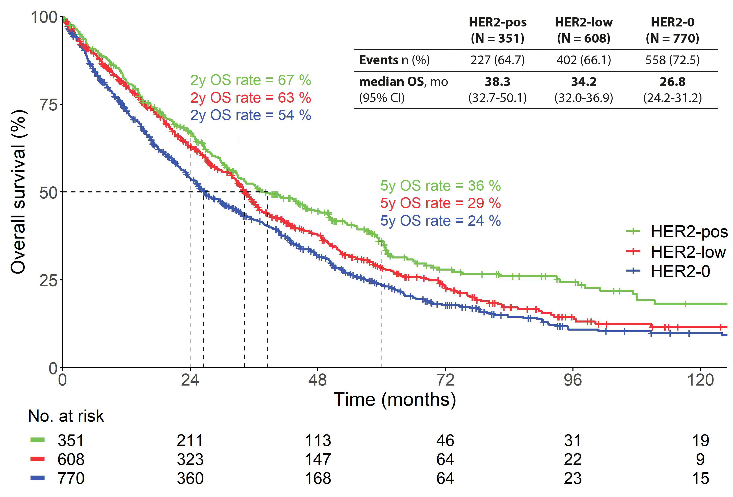
Additional file 1: Figure S1. OS of patients with HER2-low tumors, patients with completely HER2-negative tumors (HER2-0) and patients with HER2-positive tumors (HER2-pos) in the overall population (n = 1,729)

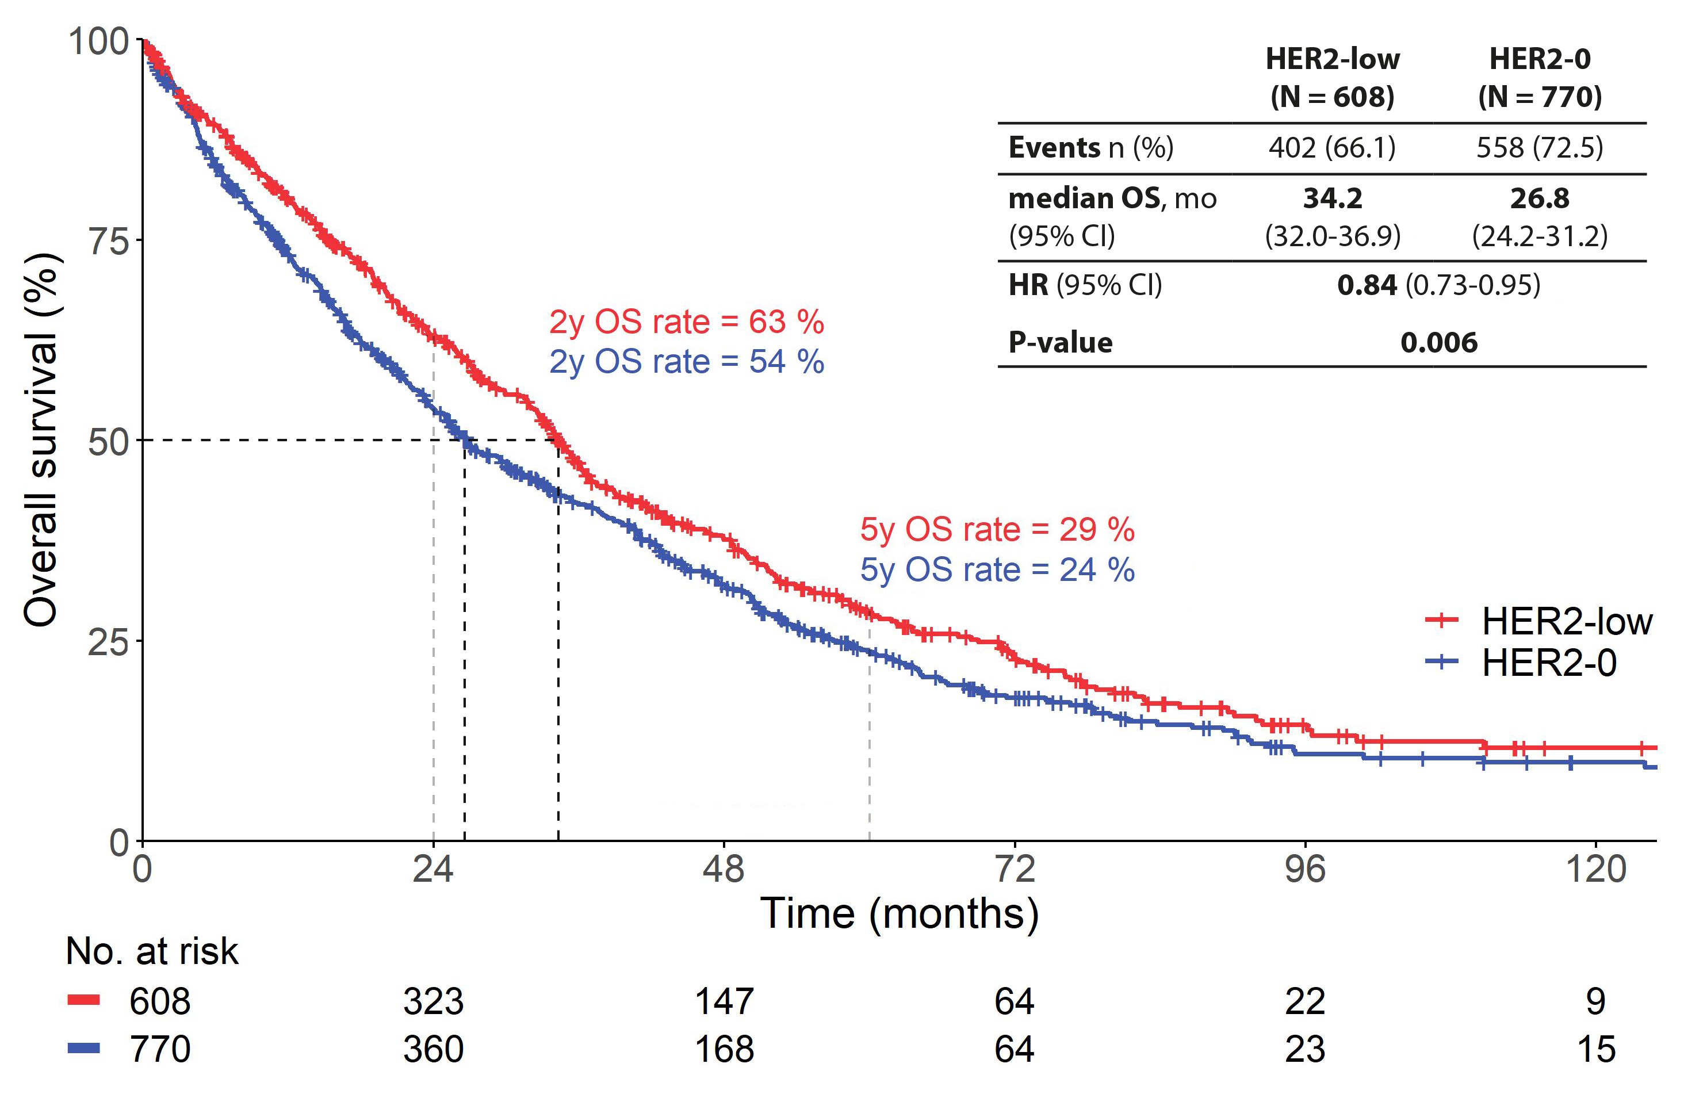
Additional file 1: Figure S2. OS of patients with HER2-low tumors and patients with completely HER2-negative tumors (HER2-0) in the overall population (n = 1,378)

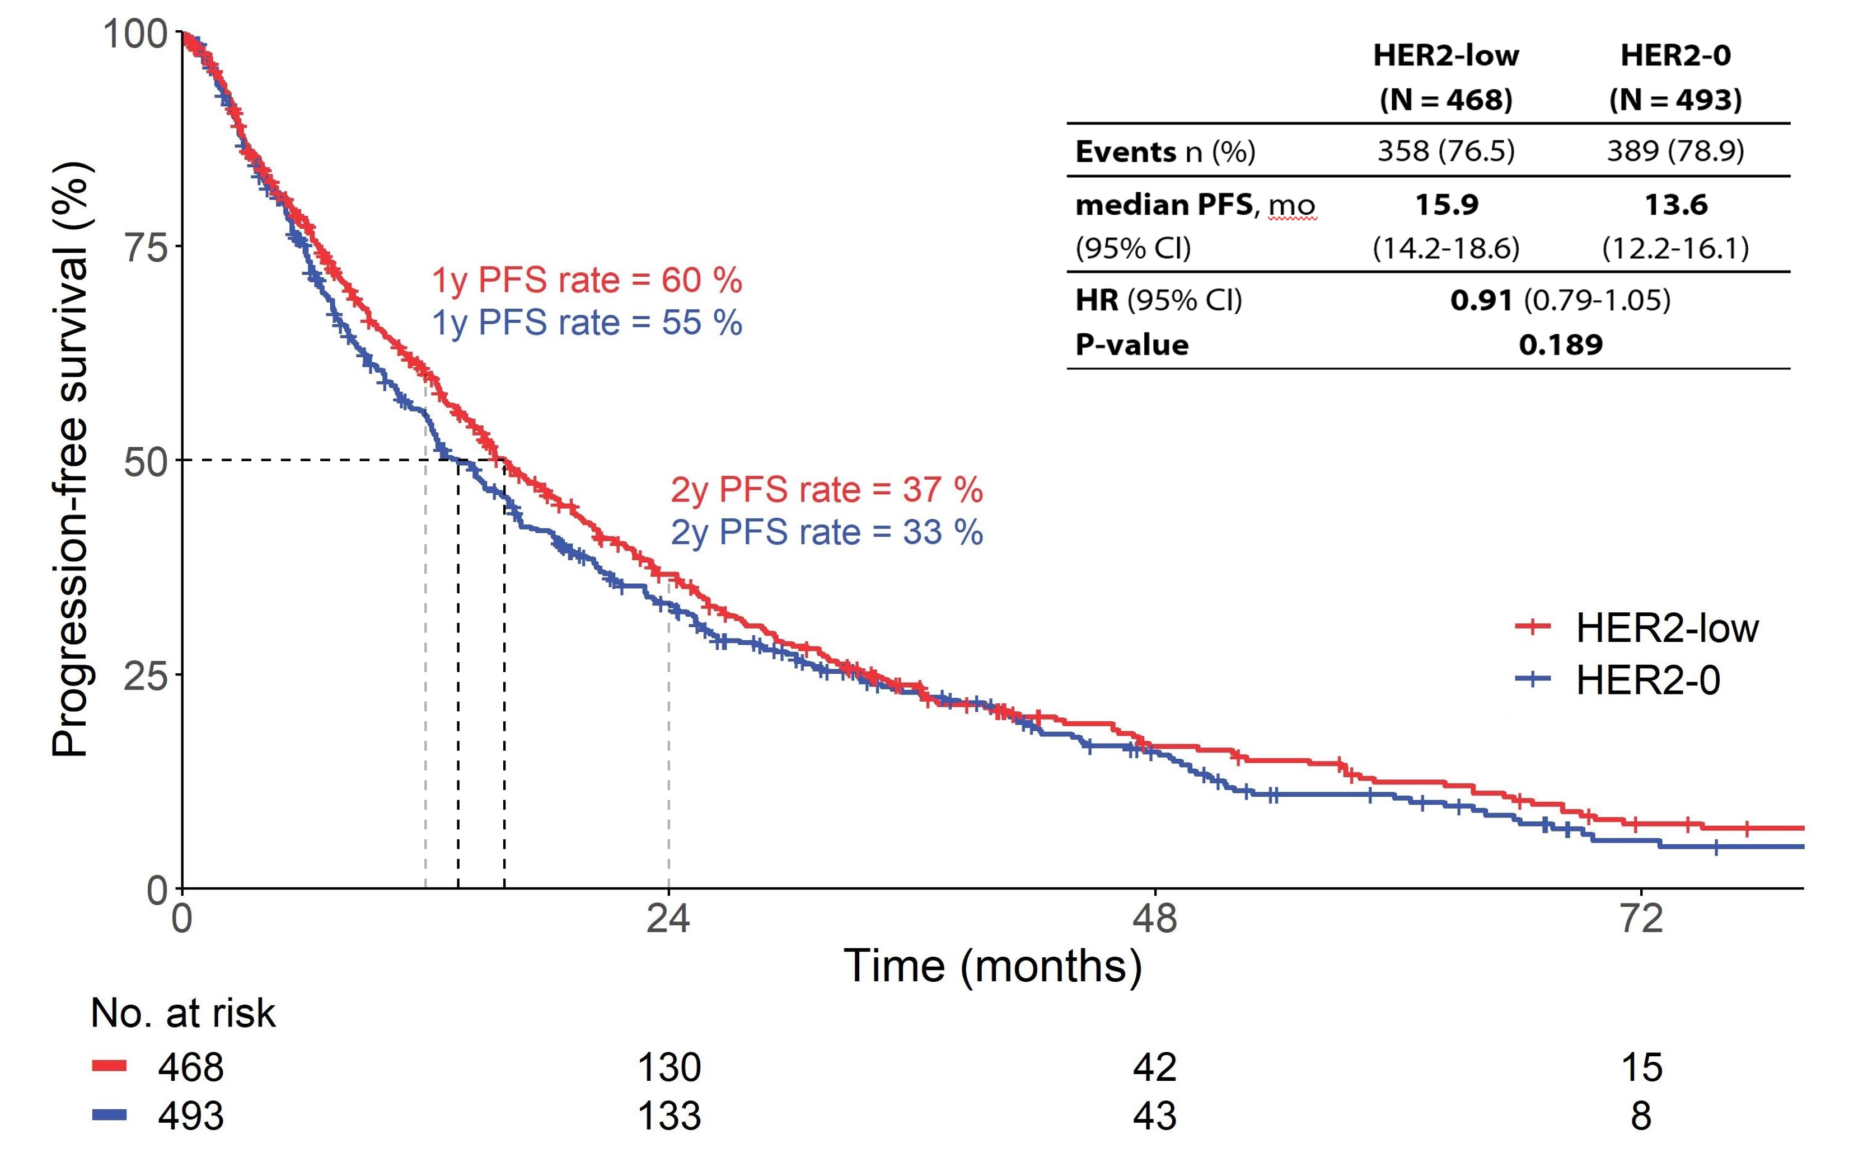
Additional file 1: Figure S3. PFS of patients with HER2-low tumors and patients with completely HER2-negative tumors (HER2-0) in the HR+ population (n = 961).

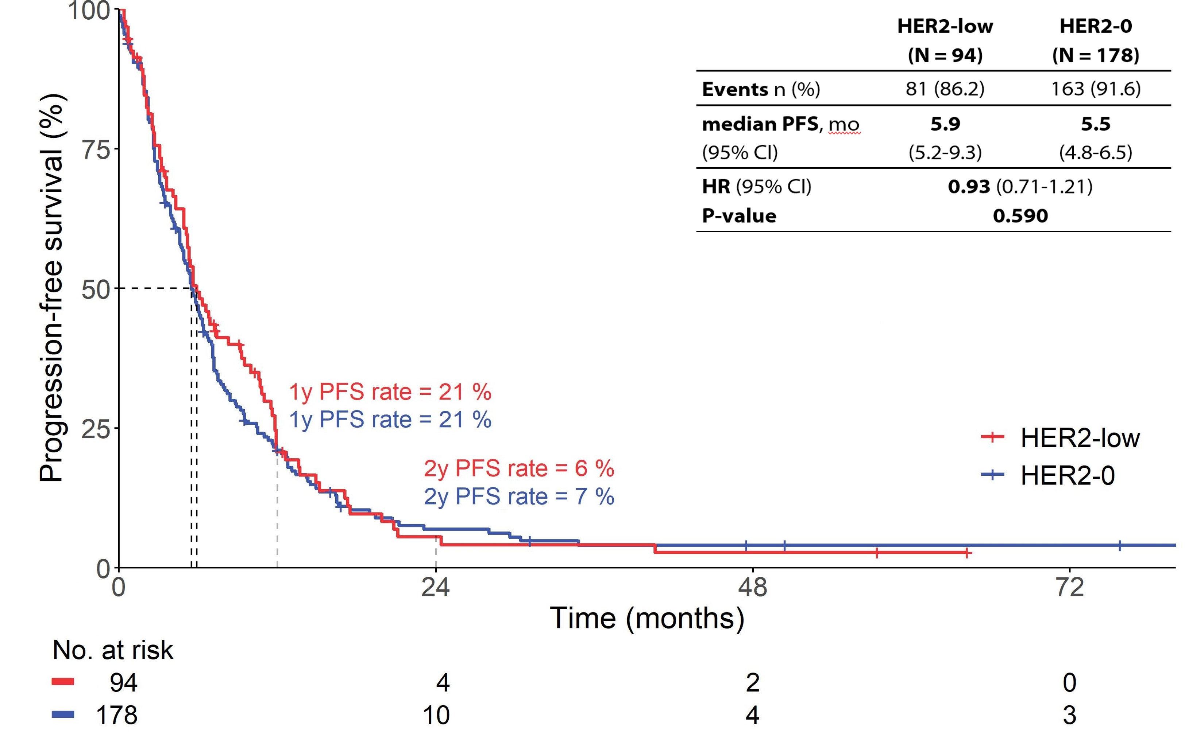
Additional file 1: Figure S4. PFS of patients with HER2-low tumors and patients with completely HER2-negative tumors (HER2-0) in the HR-negative population (n = 272).

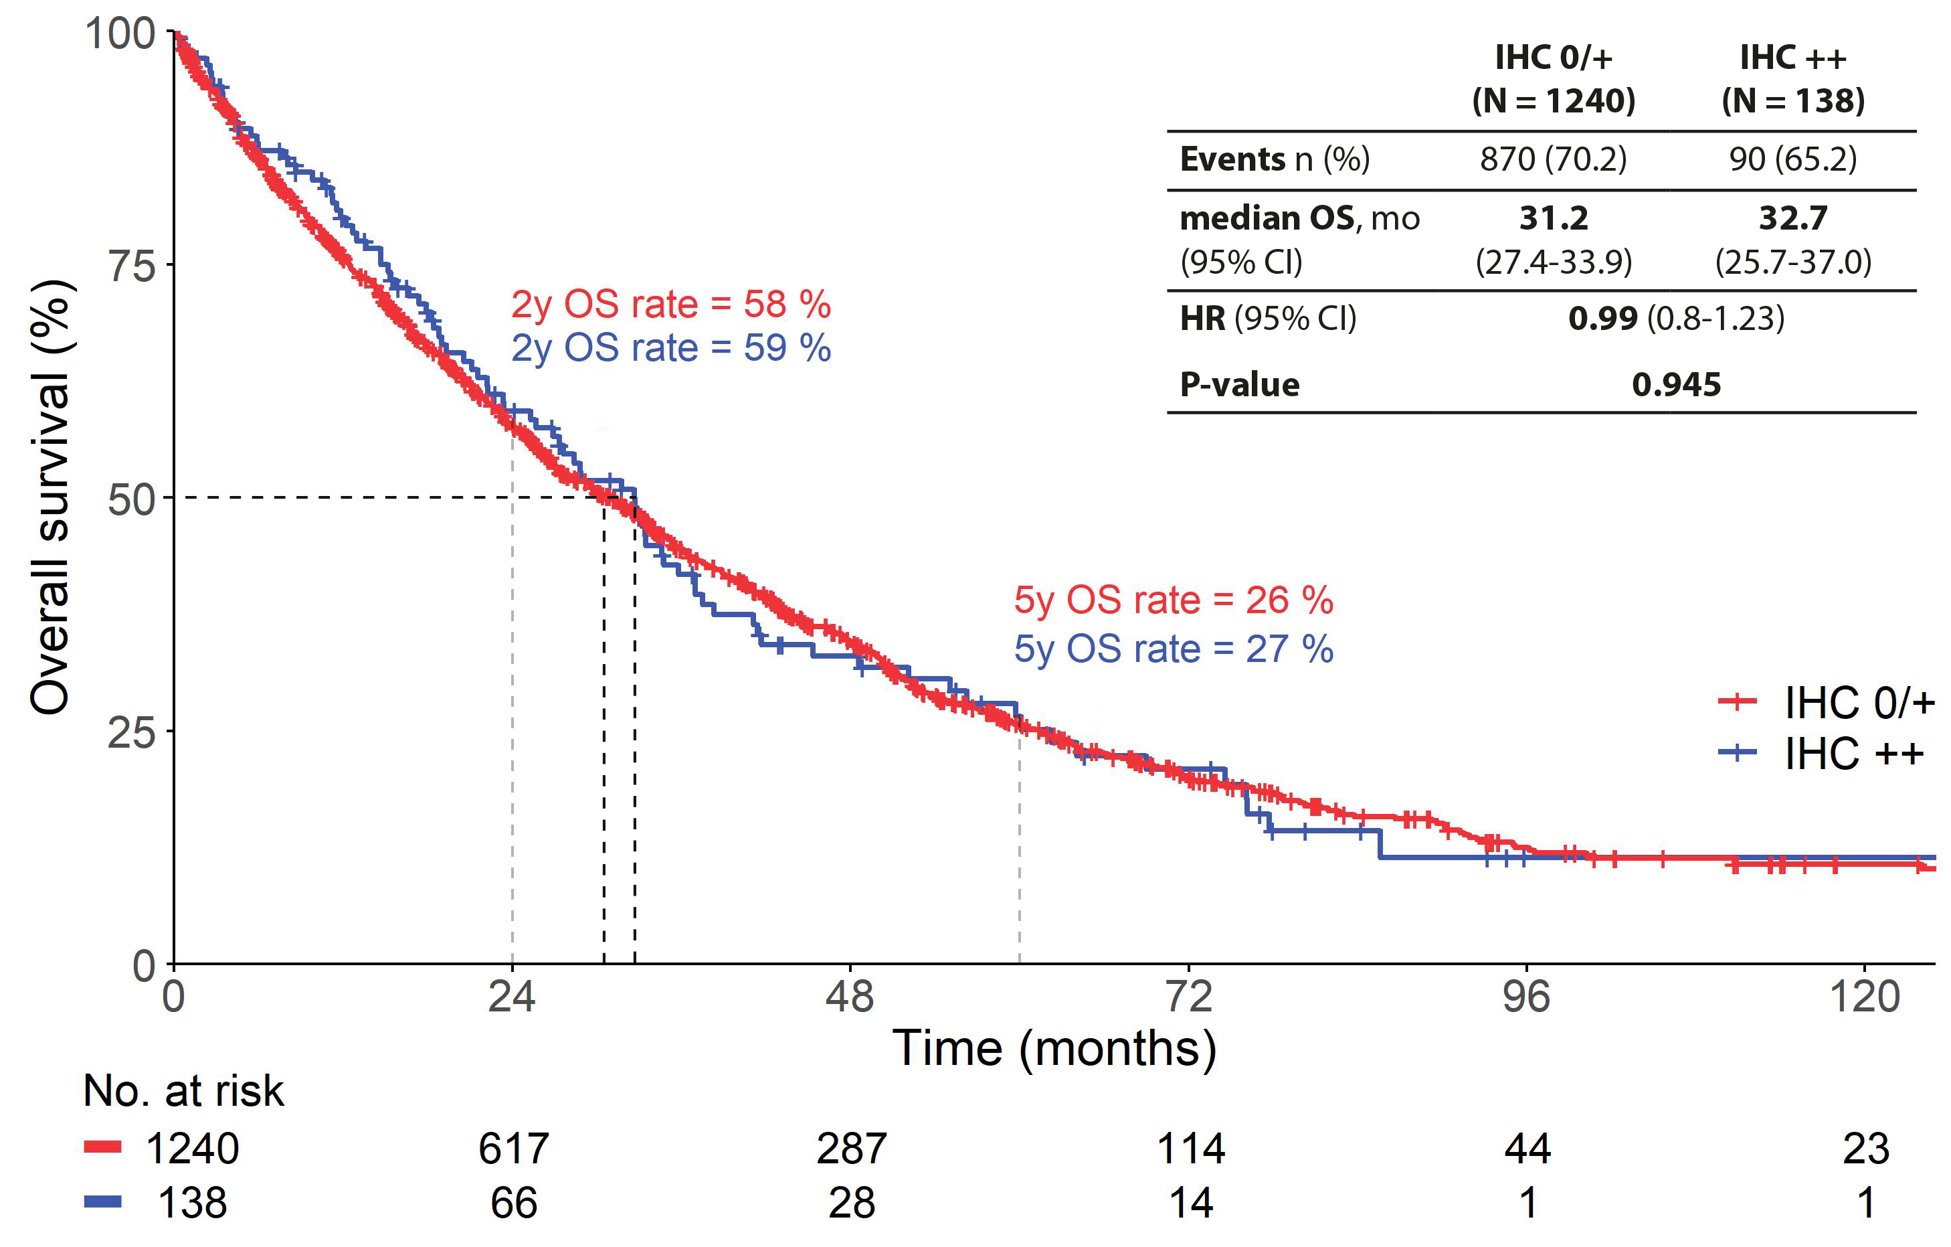
Additional file 1: Figure S5. OS of patients with HER2 2+ tumors and patients with HER2 0 or 1+ tumors in the overall population (n = 1,378)
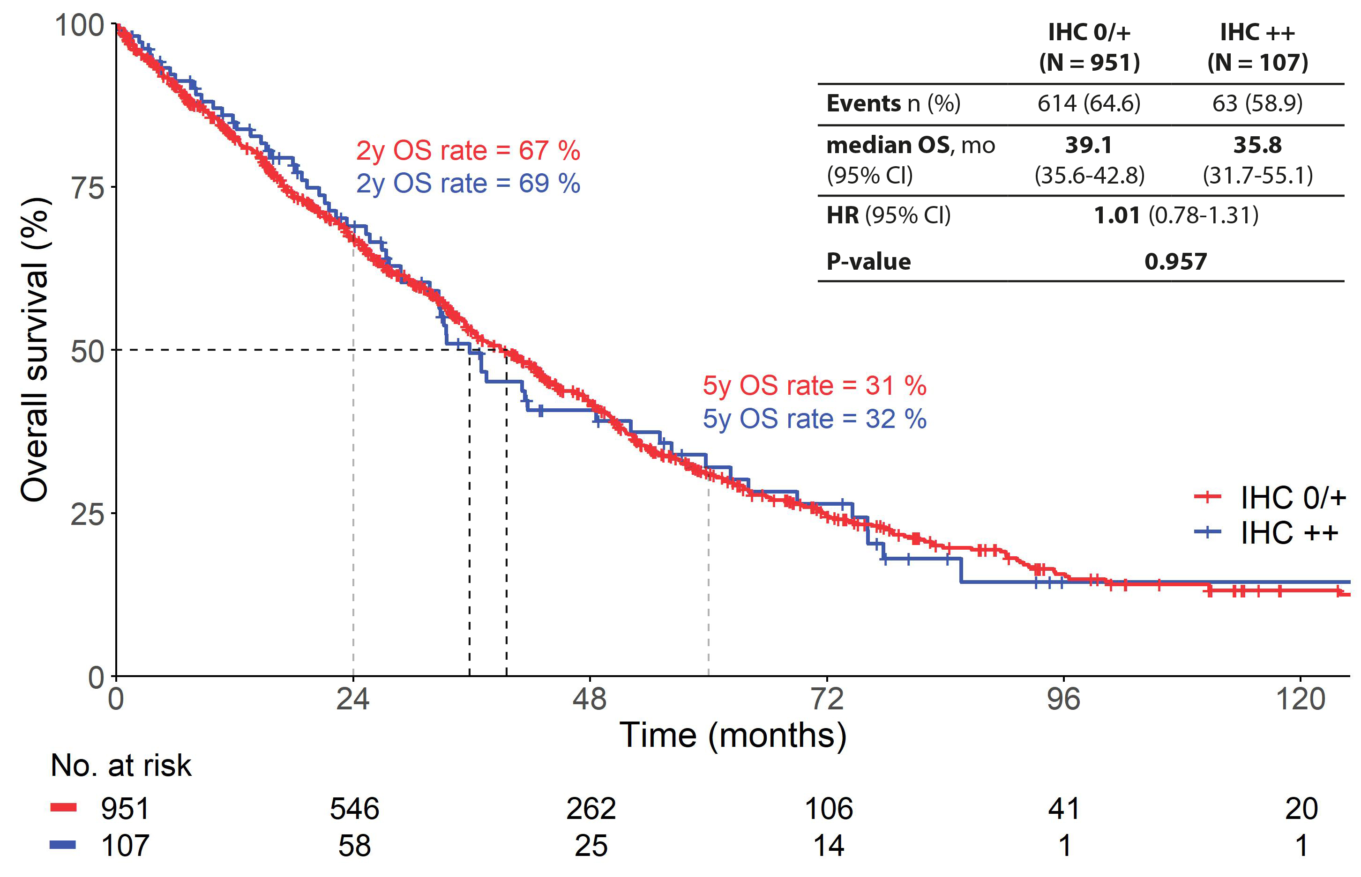
Additional file 1: Figure S6. OS of patients with HER2 2+ tumors and patients with HER2 0 or 1+ tumors in the HR+ population (n = 1,058).

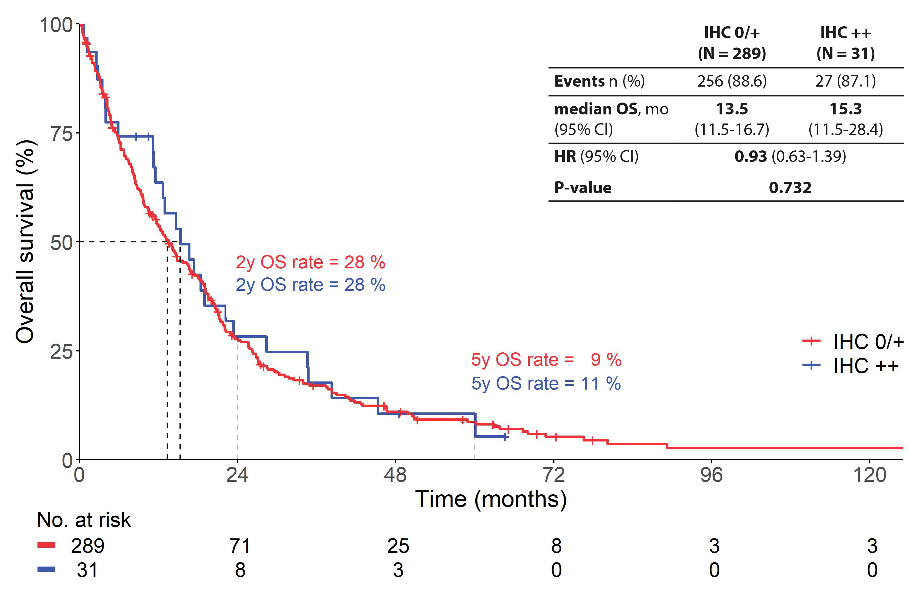
Additional file 1: Figure S7. OS of patients with HER2 2+ tumors and patients with HER2 0 or 1+ tumors in the HR-negative population (n = 320).

Additional file 1: Table S1. Multivariate analysis (Cox proportional hazard model) of PFS for HR+ MBC.
N = 754 (events 567) | HR | 95%CI | P
Age (continuous) according to menopausal status  Premenopausal  Postmenopausal | 1.01  1.01 | 1.00 - 1.03  1.00 - 1.02 | 0.128  0.055
DFS  ≥ 24 months or de novo vs. < 24 months | 0.71 | 0.56 – 0.91 | 0.008
Visceral vs. no visceral disease* | 1.16 | 0.95 – 1.41 | 0.152
Number of metastatic sites*  2-3 vs. 1  ≥ 4 vs. 1 | 1.24  1.36 | 1.02 - 1.51  0.90 – 2.05 | 0.029  0.147
HER2-low vs. HER2-0 | 0.92 | 0.78 – 1.08 | 0.308
* at diagnosis of metastatic disease

Additional file 1: Table S2. Multivariate analysis (Cox proportional hazard model) of PFS for HR-negative MBC.
N = 189 (events 167) | HR | 95%CI | P
Age (continuous) according to menopausal status  Premenopausal  Postmenopausal | 1.03  1.01 | 1.00 - 1.05  1.00 - 1.03 | 0.033  0.122
DFS  ≥ 24 months or de novo vs. < 24 months | 0.60 | 0.43 – 0.83 | 0.002
Visceral vs. no visceral disease* | 1.33 | 0.95 – 1.85 | 0.095
Number of metastatic sites*  2-3 vs. 1  ≥ 4 vs. 1 | 1.35  1.54 | 0.96 – 1.91  0.84 – 2.82 | 0.084  0.163
HER2-low vs. HER2-0 | 0.98 | 0.70 – 1.37 | 0.908
* at diagnosis of metastatic disease

Additional file 1: Table S3. Multivariate analysis (Cox proportional hazard model) of OS for premenopausal patients with HR+ MBC.
N = 113 (events 75) | HR | 95%CI | P
Age (continuous) | 1.01 | 0.98 - 1.04 | 0.620
DFS  ≥ 24 months or de novo vs. < 24 months | 0.50 | 0.30 – 0.84 | 0.009
Visceral vs. no visceral disease* | 2.00 | 1.11 – 3.61 | 0.021
Number of metastatic sites*  2-3 vs. 1  ≥ 4 vs. 1 | 1.03  2.00 | 0.57 - 1.87  0.64 – 6.25 | 0.920  0.232
HER2-low vs. HER2-0 | 1.10 | 0.67 – 1.82 | 0.705
* at diagnosis of metastatic disease

Additional file 1: Table S4. Multivariate analysis (Cox proportional hazard model) of OS for postmenopausal patients with HR+ MBC.
N = 719 (events 450) | HR | 95%CI | P
Age (continuous) | 1.04 | 1.03 - 1.05 | <0.001
DFS  ≥ 24 months or de novo vs. < 24 months | 0.91 | 0.69 – 1.21 | 0.529
Visceral vs. no visceral disease* | 1.16 | 0.93 – 1.45 | 0.185
Number of metastatic sites*  2-3 vs. 1  ≥ 4 vs. 1 | 1.27  1.72 | 1.02 - 1.58  1.12 – 2.65 | 0.031  0.013
HER2-low vs. HER2-0 | 0.84 | 0.70 – 1.01 | 0.069
* at diagnosis of metastatic disease

Additional file 1: Table S5. HR+ model stability investigations according Heinze G. et al. [17].
 | Global model |  | Selected model
Predictors | HR (Std. Error) | Bootstrap inclusion frequency (%) | Estimate (Std. Error) | RMSD ratio | Relative cond. bias (%) | Bootstrap median (boot. 95%-CI)
Age (continuous) according to menopausal status  Premenopausal  Postmenopausal | 1.04 (1.00)  1.03 (1.00) | 100 | 1.04 (1.00)  1.03 (1.00) | 0.01  0.01 | 0.08  0.04 | 1.04 (1.03-1.06)  1.03 (1.02-1.04)
DFS  ≥ 24 months or de novo vs. < 24 months | 0.75 (1.01) | 100 (fixed) | 0.75 (1.01) | 0.11 | 1.27 | 0.75 (0.56-1.02)
Visceral vs. no visceral disease* | 1.26 (1.01) | 100 (fixed) | 1.26 (1.01) | 0.16 | 1.85 | 1.27 (1.01-1.65)
Number of metastatic sites*  2-3 vs. 1  ≥ 4 vs. 1 | 1.25 (1.01)  1.73 (1.02) | 87  87 | 1.25 (1.01)  1.73 (1.02) | 0.47  0.74 | 2.66  10.10 | 1.25 (0.00-1.54)  1.77 (0.00-2.84)
HER2-low vs. HER2-0 | 0.89 (1.00) | 100 (fixed) | 0.89 (1.00) | 0.08 | 1.05 | 0.89 (0.74-1.06)
* at diagnosis of metastatic disease

Additional file 1: Table S6. HR+ model selection frequencies according Heinze G. et al. [17].
Model | Included predictors | Count | Percent | Cumulative percent
1 | Age:menopausal status, DFS, Visceral disease, Nr. of metastatic sites, HER2-low/0 | 870 | 87 | 87
2 | Age:menopausal status, DFS, Visceral disease, HER2-low/0 | 130 | 13 | 100

Additional file 1: Table S7. HR- Model stability investigations according Heinze G. et al. [17].
 | Global model |  | Selected model
Predictors | HR (Std. Error) | Bootstrap inclusion frequency (%) | Estimate (Std. Error) | RMSD ratio | Relative cond. bias (%) | Bootstrap median (boot. 95%-CI)
Age (continuous) according to menopausal status  Premenopausal  Postmenopausal | 1.04 (1.00)  1.02 (1.00) | 91.6 | 1.04 (1.00)  1.02 (1.00) | 0.30  0.30 | 0.39  0.29 | 1.04 (0.00-1.07)  1.03 (0.00-1.04)
DFS  ≥ 24 months or de novo vs. < 24 months | 0.59 (1.01) | 100 (fixed) | 0.59 (1.01) | 0.09 | 1.75 | 0.60 (0.44-0.80)
Visceral vs. no visceral disease* | 1.59 (1.01) | 100 (fixed) | 1.59 (1.01) | 0.32 | 6.88 | 1.67 (1.20-2.38)
Number of metastatic sites*  2-3 vs. 1  ≥ 4 vs. 1 | 1.23 (1.01)  2.01 (1.04) | 73.7  73.7 | 1.23 (1.01)  2.01 (1.04) | 0.65  1.44 | 5.77  30.52 | 1.18 (0.00-1.73)  2.05 (0.00-4.88)
HER2-low vs. HER2-0 | 0.92 (1.01) | 100 (fixed) | 0.92 (1.01) | 0.16 | -0.31 | 0.91 (0.65-1.26)
* at diagnosis of metastatic disease

Additional file 1: Table S8. HR- Model selection frequencies according Heinze G. et al. [17]
Model | Included predictors | Count | Percent | Cumulative percent
1 | Age:menopausal status, DFS, Visceral disease, Nr. of metastatic sites, HER2-low/0 | 663 | 66.3 | 66.3
2 | Age:menopausal status, DFS, Visceral disease, HER2-low/0 | 253 | 25.3 | 91.6
3 | DFS, Visceral disease, Nr. of metastatic sites, HER2-low/0 | 74 | 7.4 | 99.0
4 | DFS, Visceral disease, HER2-low/0 | 10 | 1.0 | 100

