**Supplemental Material to**

**Epidemiological, genetic and clinical characterization of newly diagnosed acute myeloid leukemia based on an academic population-based registry study (AMLSG BiO)**

Nagel G1, Weber D2, Fromm E1, Erhardt S1, Lübbert M3, Fiedler W4, Kindler T5, Krauter J6, Brossart P7, Kündgen A8, Salih HR9, Westermann J10, Wulf G11, Hertenstein B12, Wattad M13, Götze K14, Kraemer D15, Fischer T16, Girschikofsky M17, Derigs HG18, Horst HA19, Rudolph C2, Heuser M20, Göhring G21, Teleanu V2, Bullinger L2, Thol F20, Gaidzik VI2, Paschka P2, Döhner K2, Ganser A20, Döhner H2, Schlenk RF2,22, German-Austrian AML Study Group (AMLSG)

**Supplemental Figure 1: Recruitment in the AMLSG BiO registry in Austria (N= 270)\***

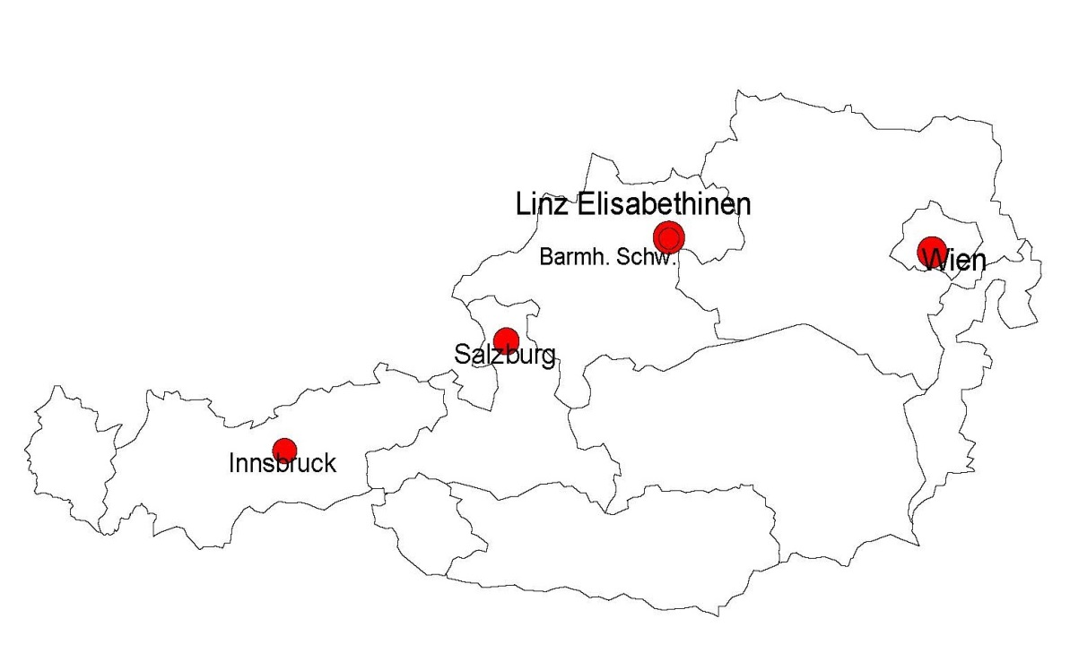

*Size of the dots corresponds to the number of reported cases of AML

**Supplemental Figure 2: Recruitment in the AMLSG BiO registry in Germany (N=3,251)**

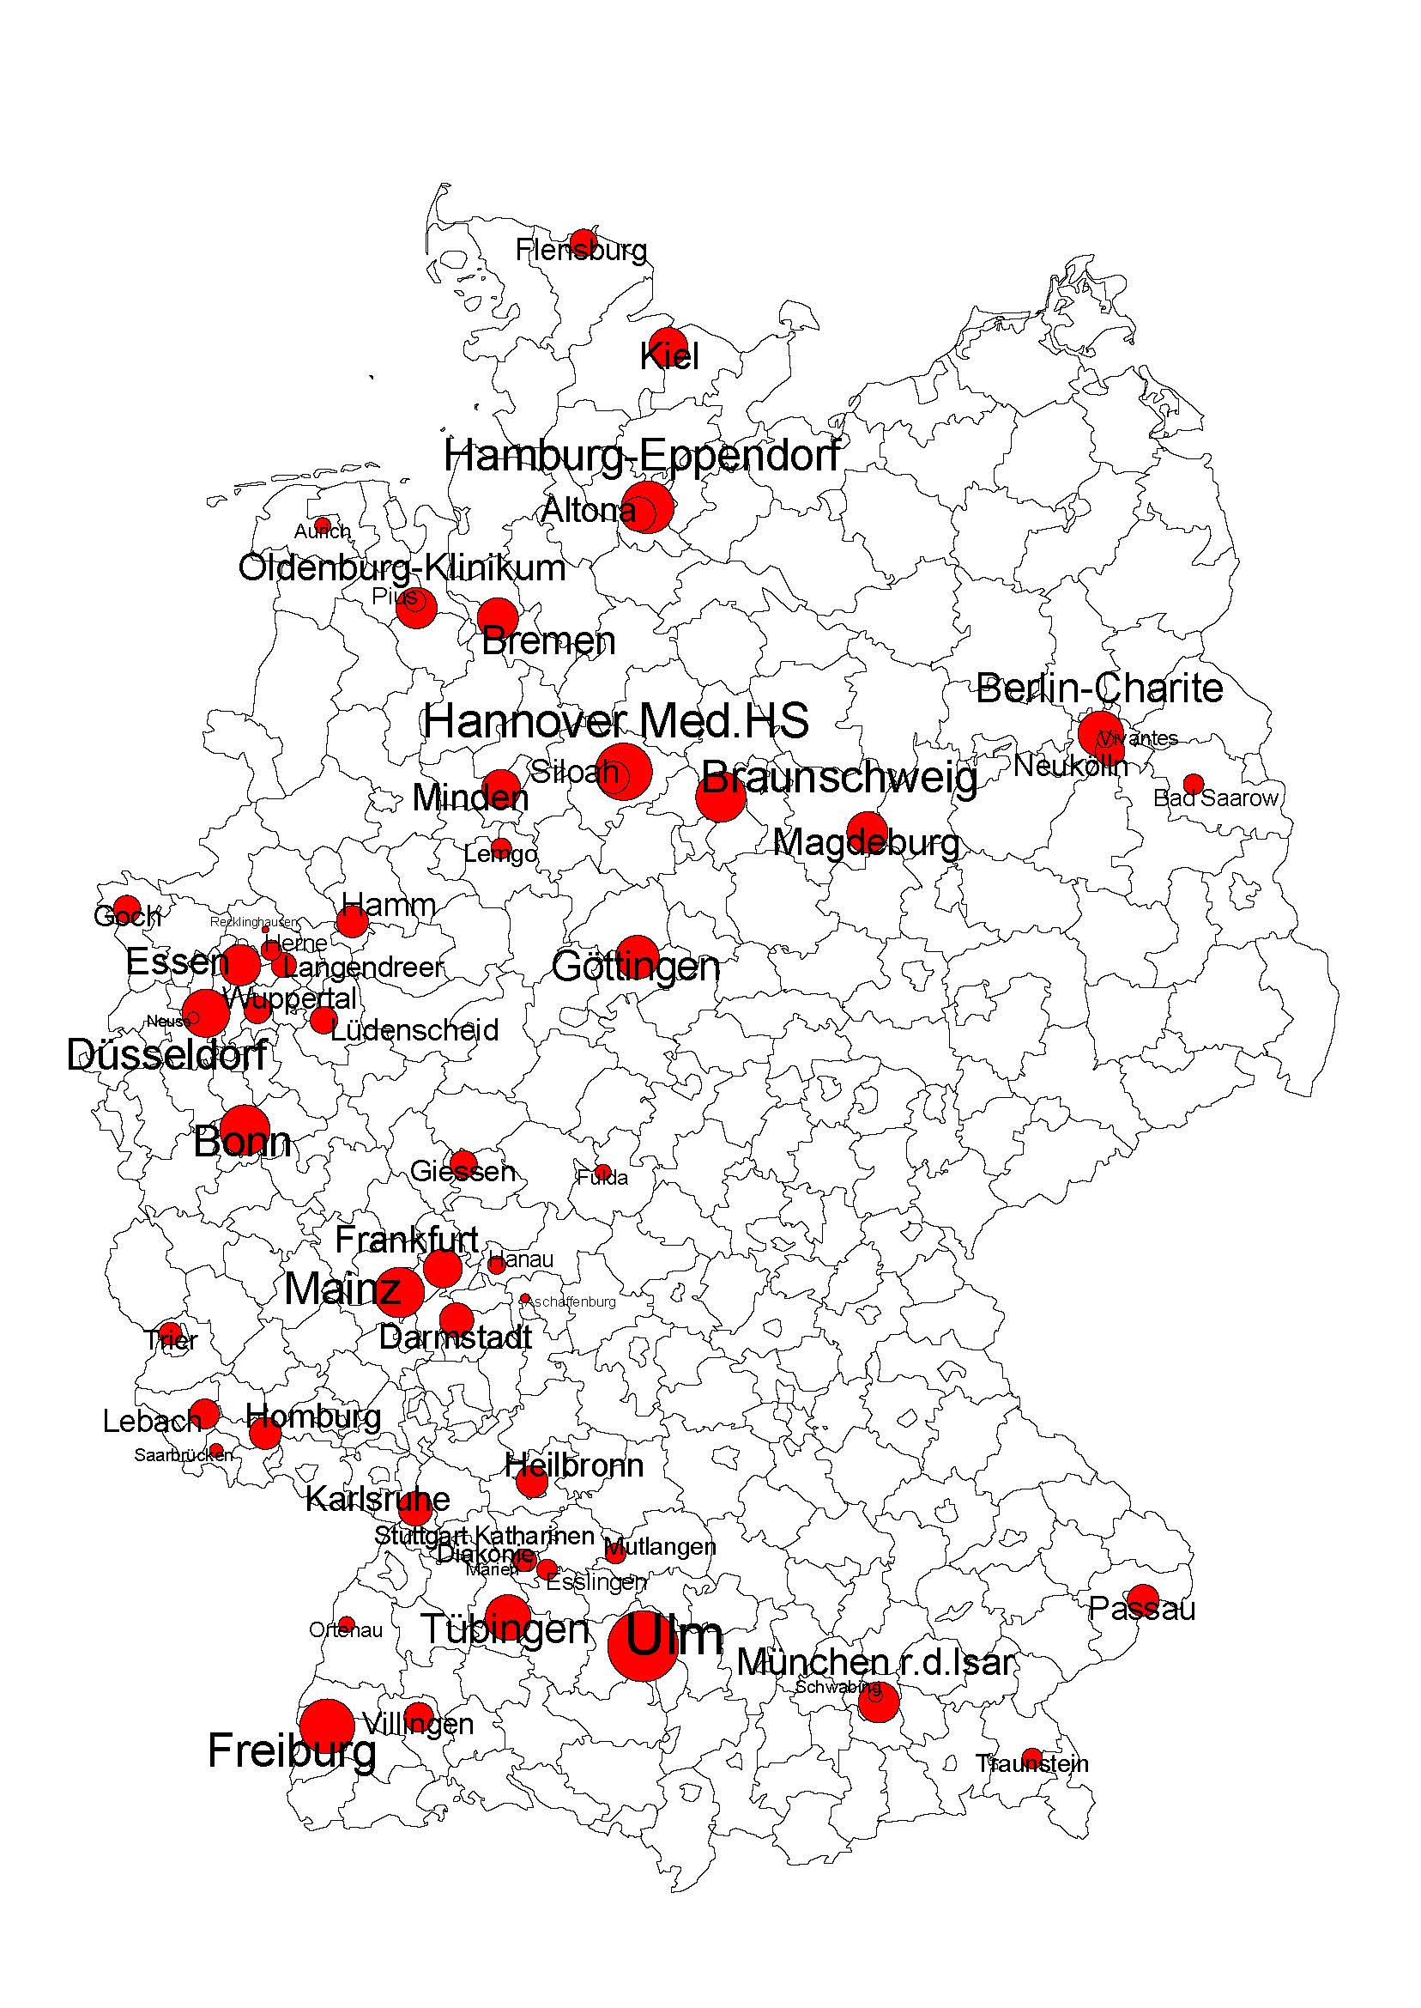

*Size of the dots corresponds to the number of reported cases of AML

|  |  |  |  |  |  |
| --- | --- | --- | --- | --- | --- |
| **Supplemental Table 1: Study population AMLSG BiO registry 2012-2014 in the multivariate model** | | | | | |
| **Covariate** | | | **Total**  **N=2,336** | **Men**  **N=1,273** | **Women**  **N=1,063** |
|  | | | **Median (Q1;Q3)** | **Median (Q1;Q3)** | **Median (Q1;Q3)** |
| **Age (years)** | | | 66 (55;74) | 68 (57;74) | 65 (53;74) |
| **BMI (kg/m2)** | | | 26 (23;29) | 26 (24;29) | 25 (23;29) |
|  | | | **N (%)** | **N (%)** | **N (%)** |
| **Age classes (years)** | < 59 | | 770 (32.96) | 372 (48.31) | 398 (51.69) |
| 60 - 69 | | | 608 (26.03) | 349 (57.40) | 259 (42.60) |
| ≥70 | | | 958 (41.01) | 552 (57.62) | 406 (42.38) |
| **Prevalence of *FLT3-*ITD** | | | 457 (19.56) | 200 (43.76) | 257 (56.24) |
| **Prevalence of *FLT3-*TKD mutation** | | | 138 (5.91) | 72 (52.17) | 66 (47.83) |
| **Prevalence of  *NPM1* mutation** | | | 650 (27.83) | 287 (44.15) | 363 (55.85) |
| **Prevalence of *CEBPA* mutation** | | | 136 (5.83) | 70 (51.47) | 66 (48.53) |
| **2010 ELN classification** | | Favorable | 479 (20.51) | 250 (52.19) | 229 (47.81) |
|  | | Intermediate-1 | 722 (30.91) | 393 (54.43) | 329 (45.57) |
|  | | Intermediate-2 | 652 (27.91) | 361 (55.37) | 291 (44.63) |
|  | | Adverse | 483 (20.68) | 269 (55.69) | 214 (44.31) |
| **HCT-Comorbidity index** | | 0 | 920 (39.38) | 480 (52.17) | 440 (47.83) |
|  | | 1-2 | 787 (33.69) | 425 (54.00) | 362 (46.00) |
|  | | ≥ 3 | 629 (26.93) | 368 (58.51) | 261 (41.49) |
| **ECOG** | | 0-1 | 1,957 (83.78) | 1,060 (54.16) | 897 (45.84) |
|  | | 2-4 | 379 (16.22) | 213 (56.20) | 166 (43.80) |
| **Therapy** | | Intensive | 1,663 (71.19) | 888 (53.40) | 775 (46.60) |
|  | | BSC | 211 (9.03) | 124 (58.77) | 87 (41.23) |
|  | | Non-intensive* | 462 (19.78) | 261 (56.49) | 201 (43.51) |
| Abbreviations: BMI, body mass index; BSC, best supportive care; ECOG, Eastern Cooperative Oncology Group performance status; ELN, European LeukemiaNet ; HCT, Hematopoietic cell transplantation; N, number of patients; Q, quartile.  *Including azacitidine, decitabine, and low-dose cytarabine | | | | | |

**Supplemental Figure 3: Frequency of *NPM1* mutation by age groups**

