Supplementary Table 1. Baseline demographic and disease characteristics of patients in the “Biomarker Cohort” with available baseline mutational data
Characteristic | AZA  (n=83) | CCR  (n=73)
Age, median (range) | 76.0 (64-89) | 75.0 (65-88)
Age ≥ 75, n (%) | 48 (58) | 38 (52)
Gender, n (%)
Male | 44 (53) | 44 (60)
Female | 39 (47) | 29 (40)
Prior diagnosis of MDS, n (%) | 19 (23) | 10 (14)
WHO 2008 AML classification, n (%)
AML not otherwise specified | 52 (63) | 37 (51)
AML with myelodysplasia-related changes | 27 (33) | 29 (40)
Therapy-related myeloid neoplasms | 2 (2) | 5 (7)
AML with recurrent genetic abnormalities | 2 (2) | 2 (3)
BM blasts (%), median (range) | 73.0 (3-100) | 71.0 (8-100)
ECOG PS, n (%)
Grade 0-1 | 66 (80) | 57 (78)
Grade 2 | 17 (20) | 16 (22)
2010 ELN cytogenetic risk, n (%)
Intermediate I/II | 56 (67) | 41 (56)
Adverse | 27 (33) | 32 (44)
WBC (10⁹/L), median (range) | 3.2 (0.6-19.5) | 2.3 (0.4-22.6)
ANC (x10⁹/L), median (range) | 0.3 (0.0-4.9) | 0.2 (0.0-4.5)
Hemoglobin (10⁹/L), median (range) | 9.6 (5.0-13.4) | 9.4 (7.3-14.4)
Platelets (10⁹/L), median (range) | 54.0 (7-585) | 73.0 (9-327)
ANC, absolute neutrophil count; AZA, azacitidine; BM, bone marrow; CCR, conventional care regimens; ECOG PS, Eastern Cooperative Oncology Group performance status; ELN, European LeukemiaNet; MDS, myelodysplastic syndromes; WBC, white blood cells count; WHO, World Health Organization

Supplementary Figure 1. Significantly co-mutated gene pairs and mutually exclusive gene pairs
Gene 1 | Gene 2 | Gene 1^{wt}: Gene 2^{wt} | Gene 1^{mut}: Gene 2^{wt} | Gene 1^{wt}:  Gene 2^{mut} | Gene 1^{mut}: Gene 2^{mut} | Co-mutation  P value | Mutually exclusive  P value
EZH2 | ASXL1 | 134 | 5 | 14 | 3 | 0.043 | 0.995
GNAS | ETV6 | 147 | 5 | 2 | 2 | 0.010 | 1.000
IDH2 | IDH1 | 106 | 36 | 14 | 0 | 1.000 | 0.021
NPM1 | ASXL1 | 114 | 25 | 17 | 0 | 1.000 | 0.043
NPM1 | FLT3 | 122 | 16 | 9 | 9 | 0.000 | 1.000
NPM1 | KIT | 131 | 23 | 0 | 2 | 0.025 | 1.000
NRAS | GATA2 | 132 | 14 | 6 | 4 | 0.017 | 0.998
PHF6 | ASXL1 | 138 | 1 | 15 | 2 | 0.032 | 0.999
PTPN11 | NPM1 | 123 | 8 | 20 | 5 | 0.037 | 0.993
PTPN11 | NRAS | 129 | 9 | 14 | 4 | 0.046 | 0.992
RAD21 | KIT | 152 | 2 | 1 | 1 | 0.038 | 1.000
RUNX1 | NPM1 | 103 | 28 | 25 | 0 | 1.000 | 0.004
SF3B1 | RUNX1 | 123 | 5 | 23 | 5 | 0.017 | 0.997
STAG2 | CEBPA | 140 | 13 | 0 | 3 | 0.001 | 1.000
STAG2 | RUNX1 | 119 | 9 | 21 | 7 | 0.010 | 0.998
TET2 | IDH1 | 103 | 39 | 14 | 0 | 1.000 | 0.014
TET2 | IDH2 | 85 | 35 | 32 | 4 | 0.995 | 0.020
TP53 | ASXL1 | 107 | 32 | 17 | 0 | 1.000 | 0.016
TP53 | DNMT3A | 86 | 28 | 38 | 4 | 0.992 | 0.028
TP53 | IDH1 | 110 | 32 | 14 | 0 | 1.000 | 0.034
TP53 | IDH2 | 91 | 29 | 33 | 3 | 0.993 | 0.028
TP53 | MLL | 123 | 28 | 1 | 4 | 0.006 | 1.000
TP53 | NPM1 | 99 | 32 | 25 | 0 | 1.000 | 0.002
TP53 | RUNX1 | 96 | 32 | 28 | 0 | 1.000 | 0.001
U2AF1 | ETV6 | 142 | 10 | 1 | 3 | 0.002 | 1.000
U2AF1 | IDH2 | 107 | 13 | 36 | 0 | 1.000 | 0.028
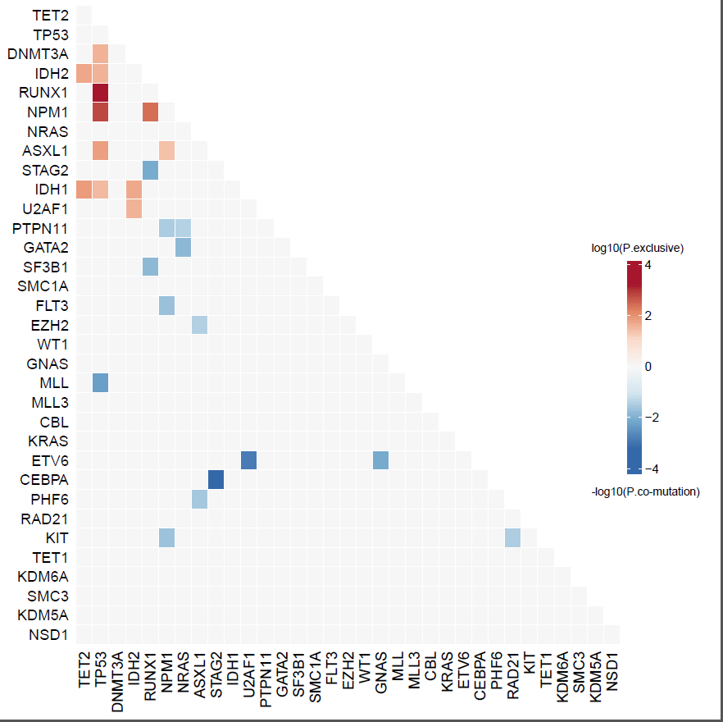
P values from Fisher’s exact test

Supplementary Figure 2. Gene mutations not significantly correlated with overall survival within treatment arms (mutant vs. wild-type)

Supplementary Figure 3. Relative hazards on overall survival with increasing variant allele frequencies of relevant mutant genes compared with survival of patients with wild-type genes. FLT3 not shown; FLT3-ITD analyzed by capillary electrophoresis PCR precluding assessmenet of variant allele frequency. Treatments (azacitidine, CCR) were stratification factors in the Cox model.
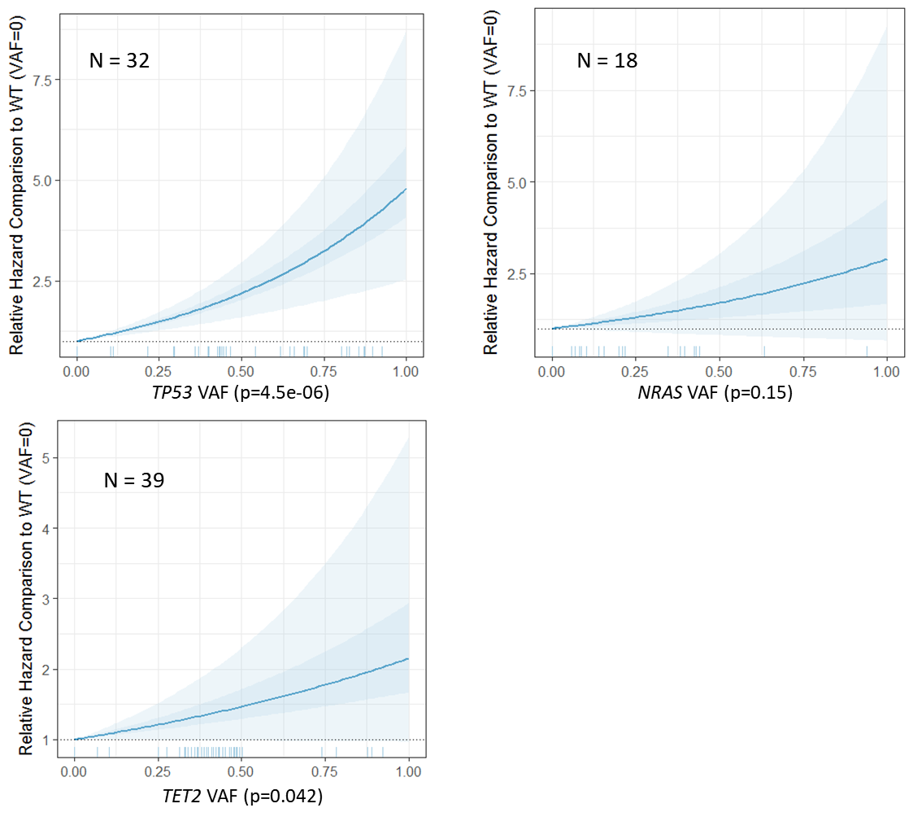

Supplementary Figure 4. Relative hazards on overall survival with increasing variant allele frequencies of relevant mutant genes compared with survival of patients with wild-type genes by treatment arm. FLT3 not shown; FLT3-ITD analyzed by capillary electrophoresis PCR precluding assessmenet of variant allele frequency.
