Supporting Information
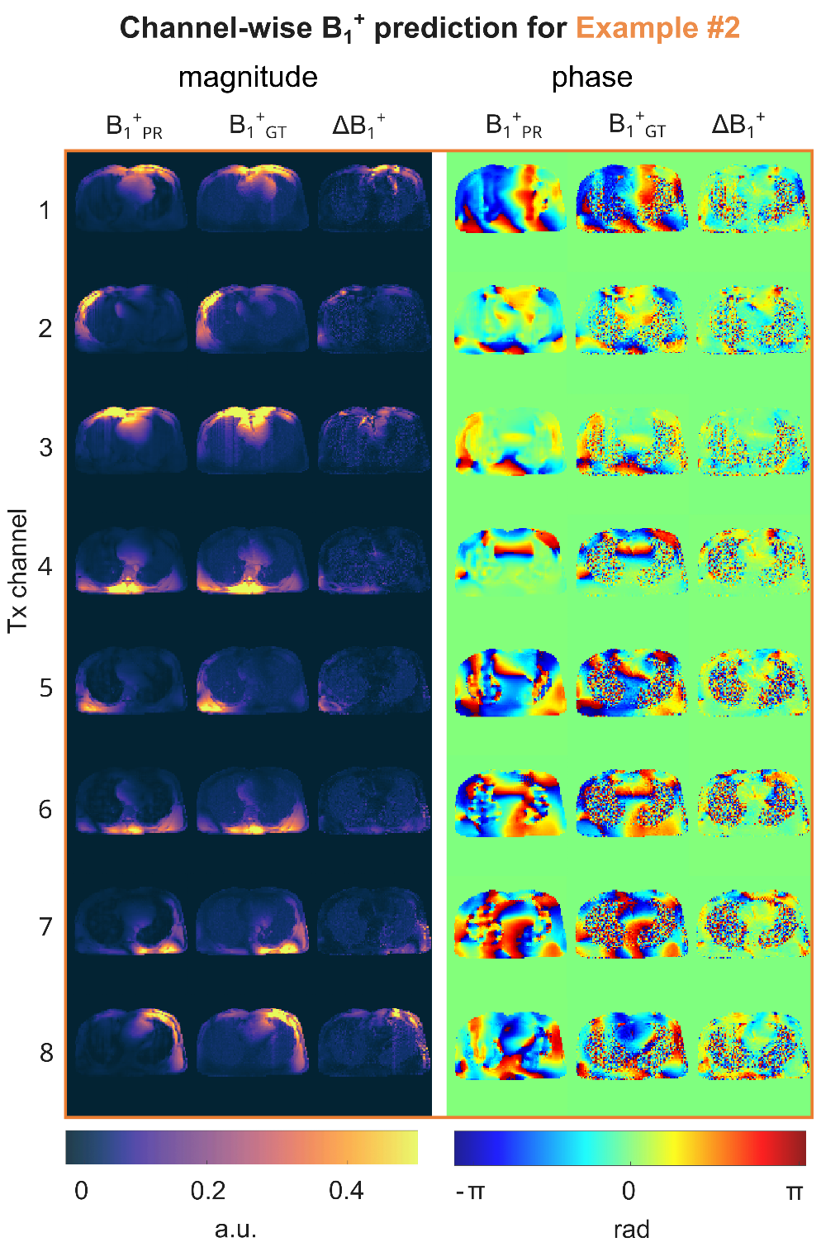
Supporting Information Figure S1: B₁⁺-magnitude and phase maps for the prediction of the neural network B₁⁺_{PR} compared to the ground truth (GT) B₁⁺_{GT} for the unseen example #2 with a medium SSIM value. The absolute error ΔB₁⁺ between the prediction and GT shows a higher residual error for the first transmission (Tx) channel and the eighth channel as compared to channels 2-7. Overall, the prediction qualitatively matches the GT for both, the magnitude and the phase.

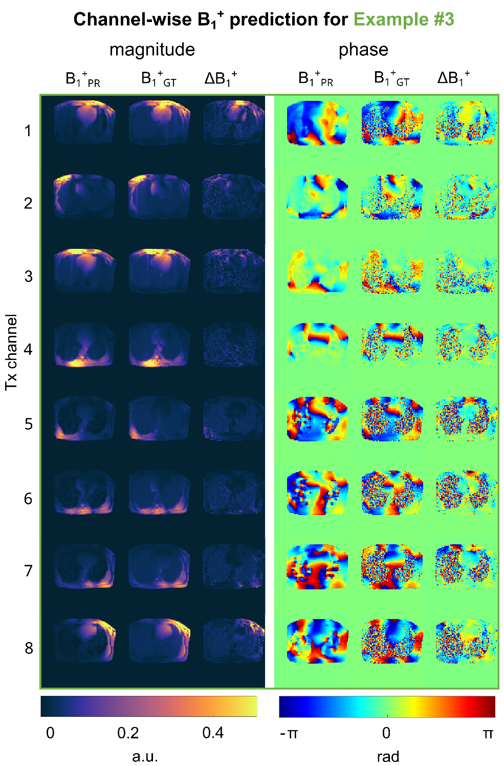
Supporting Information Figure S2: B₁⁺-magnitude and phase maps for the prediction of the neural network B₁⁺_{PR} compared to the ground truth (GT) B₁⁺_{GT} for the unseen example #3 with a low SSIM value. The absolute error ΔB₁⁺ between the prediction and GT shows a higher residual error for the first transmission (Tx) channel and the eighth channel as compared to channels 2-7. Overall, the prediction qualitatively matches the GT for both, the magnitude and the phase.

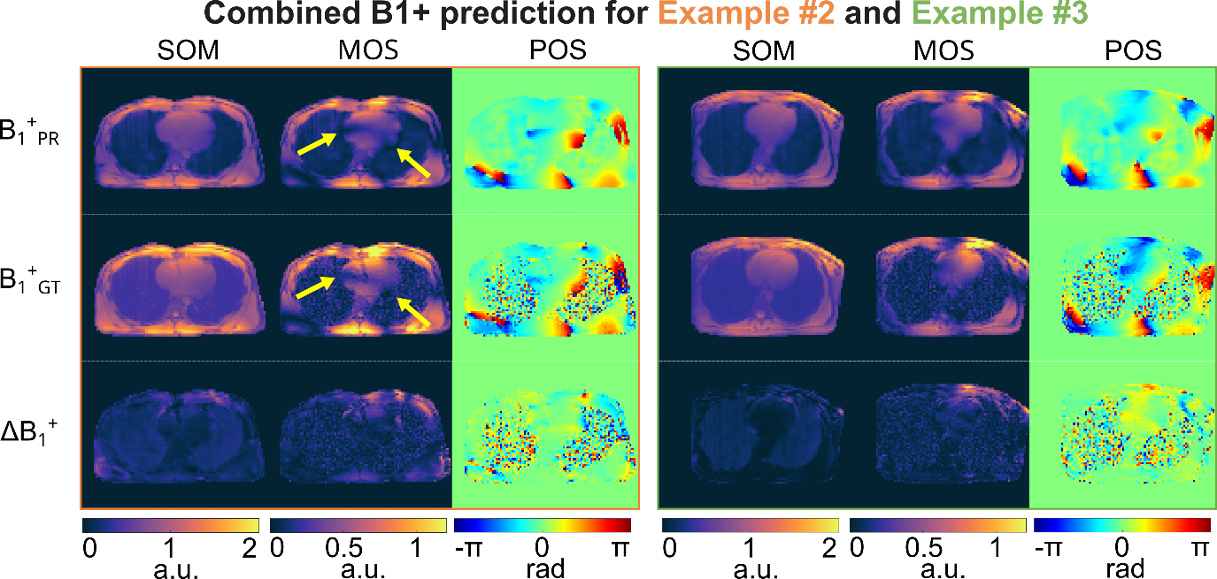 Supporting Information Figure S3: Combined B₁⁺ maps for the unseen validation data set example #2 and example #3. The predicted (B₁⁺_{PR}) and the ground truth (B₁⁺_{GT}) data is shown for the sum of magnitudes (SOM) over the 8 Tx channels, the magnitude of sum (MOS), and the phase of the summed-up data (POS). When evaluating the ROI over the heart the average error is 4.65% regarding the SOM for example #2 and 1.07% for #3, 4.81% for the MOS for example #2 and 1.92% for #3, as well as a mean difference for the POS of 0.010rad for example #2 and 0.0124rad for #3. The absolute error ΔB₁⁺ between the prediction and the ground truth, as well as local signal dropouts marked by the yellow arrows are presented.

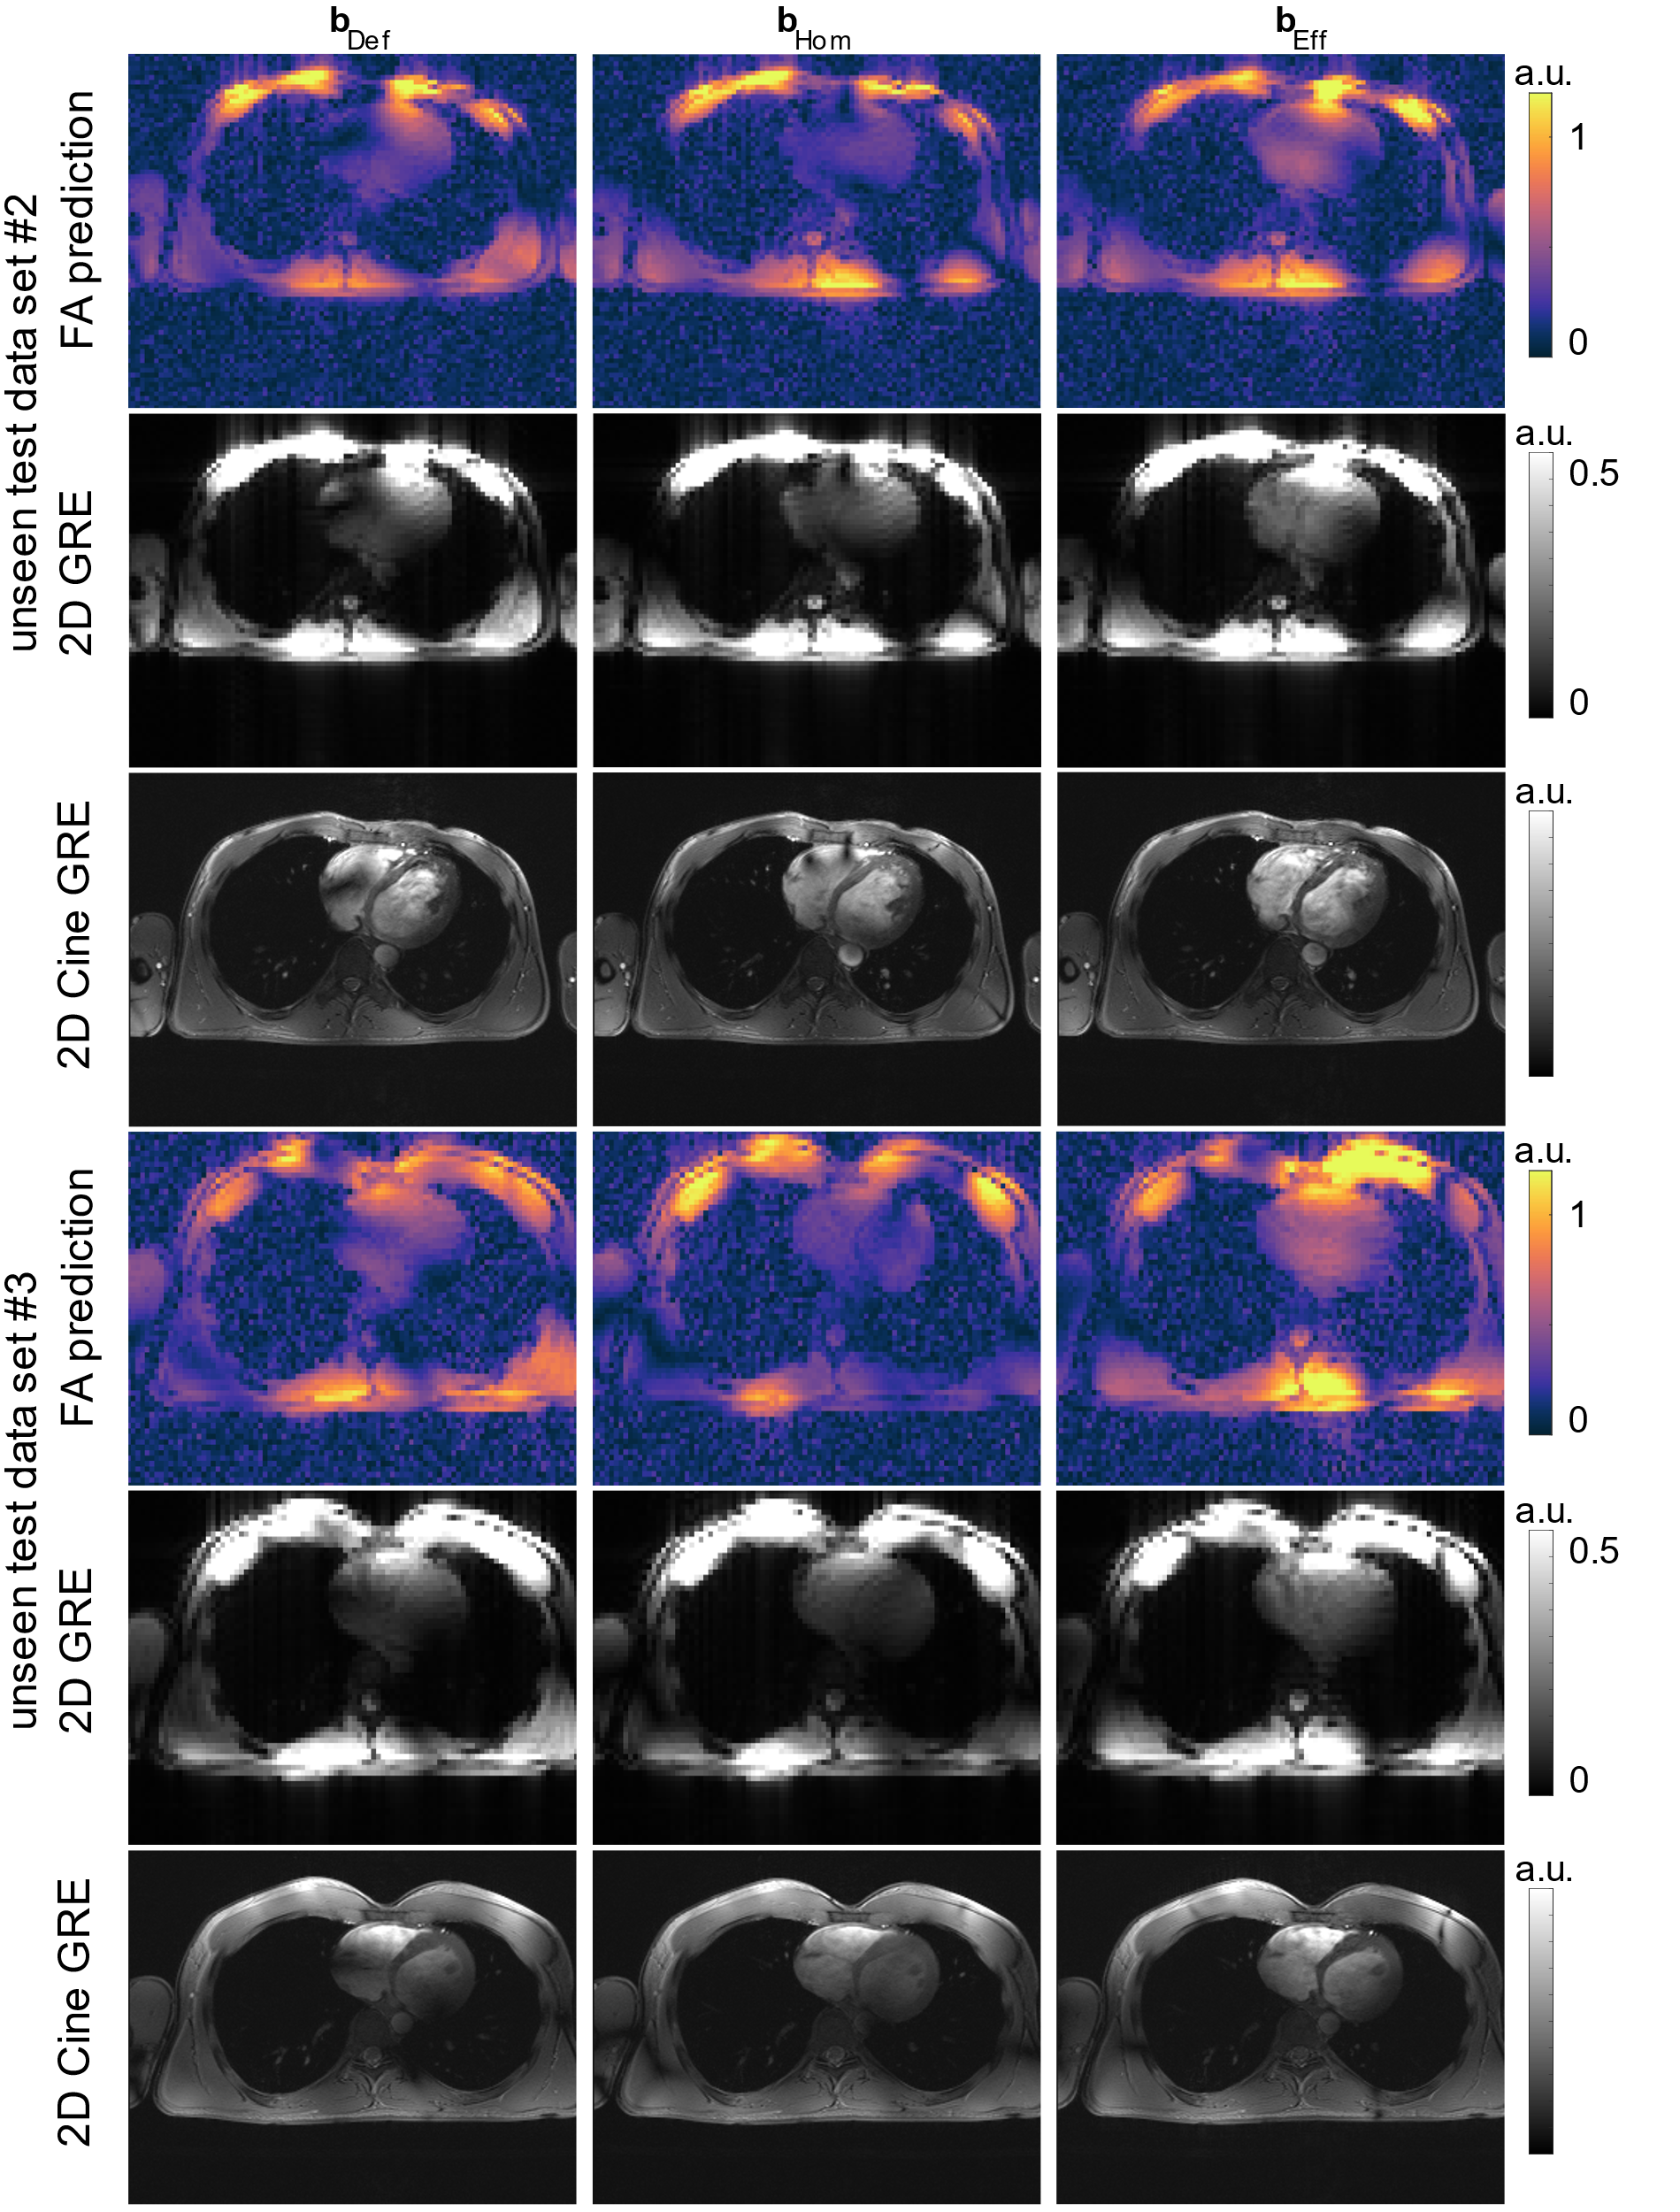
Supporting Information Figure S4: FA prediction for the measured channel-combined B₁⁺-maps, the reconstructed 2D GRE image and Cine GRE for the unseen test case #2 and #3. The utilized B₁⁺-shims for the default, homogenous and the efficiency settings were calculated on the PR B₁⁺-maps. The 2D cine GRE images for the unseen test case #2 have been acquired with a higher FA.

Neural Network | Tested on | mean RMSE ± std (%) | mean SSIM ± std | mean $⊥$ ± std
#1 | Subset #1 | 0.042 ± 0.012 | 0.745 ± 0.050 | 0.018 ± 0.003
#2 | Subset #2 | 0.040 ± 0.007 | 0.752 ± 0.035 | 0.017 ± 0.002
#3 | Subset #3 | 0.040 ± 0.008 | 0.746 ± 0.041 | 0.017 ± 0.003
#4 | Subset #4 | 0.038± 0.006 | 0.754 ± 0.045 | 0.016 ± 0.003
#5 | Subset #5 | 0.042 ± 0.012 | 0.755± 0.034 | 0.016 ± 0.003
Supporting Information Table S1: RMSE, SSIM and $⊥$ loss values obtained from the evaluation of the five networks applied to the corresponding five test subsets when performing a 5-fold cross-validation using all thorax geometries. Network #5 evaluated on Subset #5 is used for the in vivo application because it results in the highest mean SSIM.

