Supplementary Figures
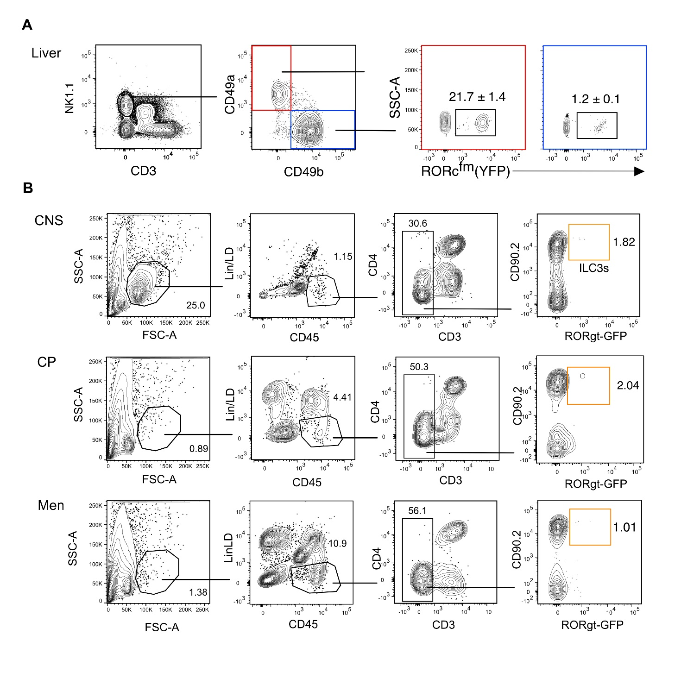
Supplementary Figure 1. RORc^{fm+} expression in liver ILC1s and examination of ILC3s in the CNS compartments using the RORgt reporter mouse (RORgt-GFP). (A) Contour plots show the expression of YFP in ILC1s (CD3⁺NK1.1⁺CD49a⁺CD49b⁻) and NK cells (CD3⁻NK1.1⁺CD49a⁻CD49b⁻) of the liver of RORc-fate mapping mice. Numbers represent the mean percentage of 3 mice. (B) Contour plot showing the gating strategy to identify ILC3s in the CNS (brain + spinal cord), choroid plexus (CP) and meninges (men) of healthy RORgt-GFP mice. ILC3s were identified as Lin⁻ (B220, CD11c, Ly6G/D, F4/80, FcεR1α) CD45⁺CD3⁻CD4⁻CD90.2⁺GFP⁺ cells. Representative plots of 2 mice, pooled CP and meninges.
Supplementary Figure 2. Phenotypic profile of intILC1s of the healthy CNS. Histogram overlay of intILC1s and ILC1s showing the expression of the indicated markers. Representative histograms showing concatenated samples of 3 mice. The expression of each marker was analyzed in at least 4 different mice performed in at least 2 independent experiments.

