SUPPLEMENT

Table S2 Annual percentage atrophy rates for total brain, grey matter and white matter volumes calculated from separate cross-sectional analysis (FSL-SIENAX) at two timepoints compared between untreated patients and patients treated with interferon-beta during the first and the second years.
 | Total brain volume |  |  |  | Grey matter |  |  |  | White matter
 | BL to FU1 |  | FU1 to FU2 |  | BL to FU1 |  | FU1 to FU2 |  | BL to FU1 |  | FU1 to FU2
 | no therapy | Interferon | no therapy | Interferon | no therapy | Interferon | no therapy | Interferon | no therapy | Interferon | no therapy | Interferon
Atrophy rate  [% / year] | -0.31  (-0.93, 0.88) | -1.34  (-2.37, 0.00) | -0.48  (-1.31, 0.61) | -0.12  (-1.24, 0.79) | -0.16  (-1.27, 1.18) | -1.40  (-2.92, 0.18) | -0.95  (-2.25, 0.56) | -0.21  (-1.47, 1.01) | -0.30  (-0.87, 0.38) | -0.90  (-1.92, -0.19) | -0.10  (-1.20, 1.07) | 0.15  (-1.17, 1.16)
p-value¹ | 0.007 |  | 0.14 |  | 0.0558 |  | 0.25 |  | 0.002 |  | 0.12
Median (IQR)
no therapy: N =42; Interferon: N = 79
¹ comparison between “no therapy” and “interferon” groups by linear mixed-model analysis

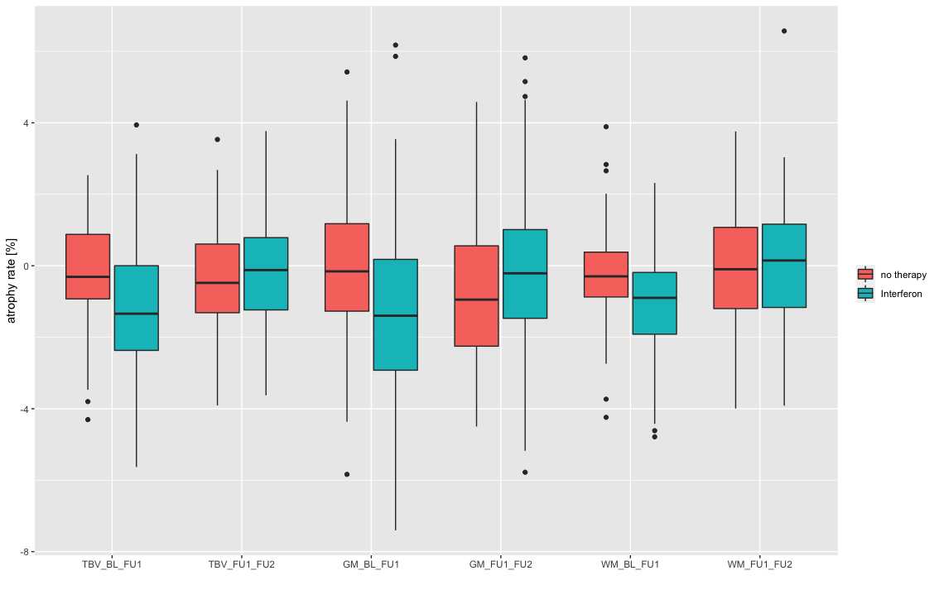
Figure S1 Visualisation of atrophy rates for total brain (TBV), grey matter (GM) and white matter (WM) volumes calculated from cross-sectional analysis (FSL-SIENAX) compared between untreated patients and patients treated with interferon-beta during the first and the second years.

