Supplementary Methods

Human proIAPP₁₋₄₈ and IAPP secretion from isolated islets
Groups of 30 islets were collected in low-retention Eppendorf tubes and incubated in 200 μl of KRBH buffer with the indicated glucose concentration. Islets were first equilibrated in 11 mM glucose KRBH for 1 h, followed by sequential stimulations for 1 h with 11 mM (culture) glucose, 1.67 mM (low) glucose and 16.7 mM (high) glucose. Islet supernatants were collected for measurement of human proIAPP₁₋₄₈ and mature IAPP by ELISA. Islets were washed and harvested for BCA protein quantification. Levels of human proIAPP₁₋₄₈ and IAPP were normalized to total protein content.

Gene expression analysis
Total RNA from islets was extracted using RNeasy Micro Kit (Qiagen, USA), while RNA from hypothalamus and cortex was extracted using RNeasy Mini kit (Qiagen, USA). Extracted RNA was reverse transcribed and transcript levels were analyzed by quantitative RT-PCR. The following Taqman probes (ThermoFisher Scientific, USA) were used to examine expression of gene targets: hIAPP (Hs00169095_m1); mIAPP (Mm00439403_m1); 18s ribosomal RNA (Mm03928990_g1).
Supplementary Table

Table 1. Information on antibodies for immunofluorescence staining.

Antibody | Manufacturer | Catalog number | Host Species | Dilution
SORLA | J. Gliemann (University of Aarhus, Denmark) |  | Goat | 1:200, PLA 1:400
Insulin | Agilent, USA | IR002 | Guinea pig | 1:3
Mouse IAPP (pro and mature form) | Peninsula Laboratories, USA | T-4145 | Rabbit | 1:400, PLA 1:800
Human IAPP (pro and mature form) | Peninsula Laboratories, USA | T-4149 | Rabbit | 1:400, PLA 1:800
Glucagon | Abcam, USA | Ab10988 | Mouse | 1:500
Somatostatin (SST) | Abcam, USA | Ab111912 | Rabbit | 1:250
Pancreatic polypeptide (PPY) | Sigma-Aldrich, USA | AB939-I | Rabbit | 1:500
Syntaxin6 (STX6) | BD bioscience, USA | BD610636 | Mouse | 1:200
Ki67 | Abcam, USA | Ab16667 | Rabbit | 1:100
EEA1 | BD bioscience, USA | BD610457 | Mouse | 1:100
Rab4 | Abcam, USA | Ab13252 | Rabbit | 1:100
Rab4 | BD bioscience | BD610889 | Mouse | 1:100
Rab9 | Invitrogen, USA | MA3-067 | Mouse | 1:100
Rab11 | BD bioscience, USA | BD610657 | Mouse | 1:100
TGN38 | BD bioscience, USA | BD610899 | Mouse | 1:50
Anti-goat AlexaFluor488 | Abcam, USA | ab150129 | Donkey | 1:1000
Anti-mouse AlexaFluor555 | Abcam, USA | Ab150106 | Donkey | 1:1000
Anti-mouse AlexaFluor647 | Invitrogen, USA | A31571 | Donkey | 1:1000
Anti-guinea pig Cy3 | Jackson ImmunoResearch, UK | 706-165-148 | Donkey | 1:1000
Anti-guinea pig AlexaFluor647 | Merck Milipore | AP193SA6 | Donkey | 1:1000
Anti-rabbit AlexaFluor555 | Invitrogen , USA | A31572 | Donkey | 1:1000
Anti-rabbit AlexaFluor647 | Abcam, USA | Ab150075 | Donkey | 1:1000
All antibodies were validated by the manufacturer.
Table 2. Gene expression of hIAPP in islets, hypothalamus and cortex. Ectopic expression of the hIAPP transgene in the brain (hypothalamus, cortex) was tested in hIAPP-transgenic (samples 6-9) and non-transgenic control mice (samples 1-5). Expression of hIAPP in islets was analyzed as a positive control. Transcript levels are given as mean Ct value. Abbreviation: UD, undetected.

Tissue | Genotype |  | Mean Ct value
Islets | hIAPP | SORLA | mIAPP | hIAPP | 18s rRNA
Sample 1 | 0/0 | +/+ | 20.3 | UD | 9.0
Sample 2 | 0/0 | +/+ | 21.7 | UD | 9.4
Sample 3 | 0/0 | +/+ | 22.1 | UD | 9.5
Sample 4 | 0/0 | +/+ | 22.0 | UD | 8.8
Sample 5 | 0/0 | +/+ | 20.9 | UD | 8.4
Mean±SEM | 0/0 | +/+ | 21.4±0.4 | UD | 9.0±0.2
Sample 6 | +/0 | +/+ | 22.3 | 21.9 | 9.7
Sample 7 | +/0 | +/+ | 23.0 | 21.9 | 9.6
Sample 8 | +/0 | +/+ | 20.5 | 19.5 | 8.4
Sample 9 | +/0 | +/+ | 21.1 | 18.5 | 9.5
Mean±SEM | +/0 | +/+ | 21.7±0.6 | 20.5±0.9 | 9.3±0.3
Tissue | Genotype |  | Mean Ct value
Hypothalamus | hIAPP | SORLA | mIAPP | hIAPP | 18s rRNA
Sample 1 | 0/0 | +/+ | UD | UD | 8.2
Sample 2 | 0/0 | +/+ | UD | UD | 8.7
Sample 3 | 0/0 | +/+ | UD | UD | 8.6
Sample 4 | 0/0 | +/+ | UD | UD | 8.6
Sample 5 | 0/0 | +/+ | UD | UD | 8.1
Mean±SEM | 0/0 | +/+ | UD | UD | 8.4±0.1
Sample 6 | +/0 | +/+ | UD | UD | 8.0
Sample 7 | +/0 | +/+ | UD | UD | 7.7
Sample 8 | +/0 | +/+ | UD | UD | 7.7
Sample 9 | +/0 | +/+ | UD | UD | 8.1
Mean±SEM | +/0 | +/+ | UD | UD | 7.9±0.1
Tissue | Genotype |  | Mean Ct value
Cortex | hIAPP | SORLA | mIAPP | hIAPP | 18s rRNA
Sample 1 | 0/0 | +/+ | UD | UD | 8.7
Sample 2 | 0/0 | +/+ | UD | UD | 8.5
Sample 3 | 0/0 | +/+ | UD | UD | 8.1
Sample 4 | 0/0 | +/+ | UD | UD | 8.3
Sample 5 | 0/0 | +/+ | UD | UD | 7.9
Mean±SEM | 0/0 | +/+ | UD | UD | 8.3±0.1
Sample 6 | +/0 | +/+ | UD | UD | 9.4
Sample 7 | +/0 | +/+ | UD | UD | 8.3
Sample 8 | +/0 | +/+ | UD | UD | 8.2
Sample 9 | +/0 | +/+ | UD | UD | 8.1
Mean±SEM | +/0 | +/+ | UD | UD | 8.5±0.3
Supplementary Figures

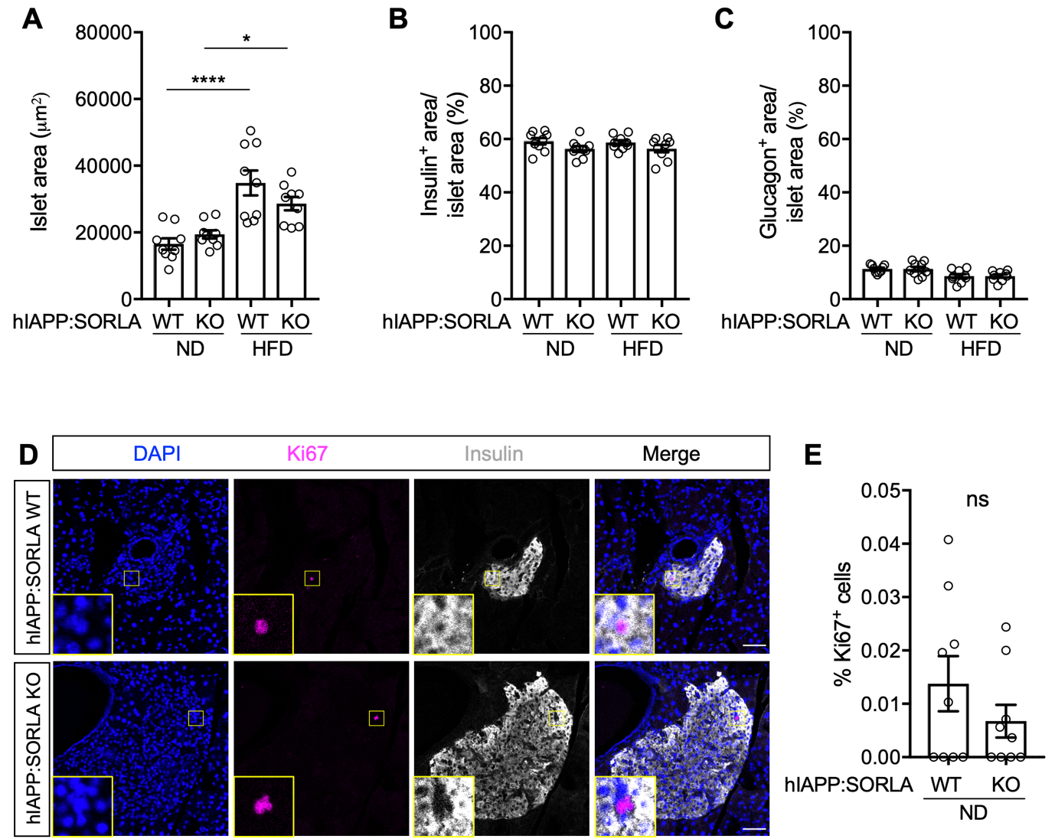
Figure S1. SORLA deficiency does not impact islet size or islet cell composition in hIAPP-expressing mice.
(A) Quantifications of total islet area. (B, C) Percentage of beta cell (insulin⁺, B) or alpha cell (glucagon⁺, C) area per islet area in pancreatic sections from 33- to 35-weeks old mice of the indicated genotypes (immunostainings exemplified in Fig 3). Animals were fed a normal chow (ND) or a high fat diet (HFD) for 6 months (n = 9 mice per genotype, 20-30 islets per mouse). (D) Pancreatic sections from ND-fed, 33- to 35-weeks old mice were examined for cell proliferation by immunostaining for Ki67 (magenta). Islets were identified by insulin staining (grey) and nuclei by DAPI counterstain (blue). Single and merged channel configurations are shown. Insets depict higher magnifications of the areas indicated by yellow boxes in the overview. Scale bars, 50 µm. (E) Quantification of cell proliferation (% Ki67 positive cells/ total islet cells, n = 9 mice per genotype, 20-30 islets per mouse). Data are given as mean ± SEM. Statistical significance in (A – C) was determined by two-way ANOVA with post-hoc test. * p < 0.05, **** p < 0.0001. Abbreviation: ns, non-significant.
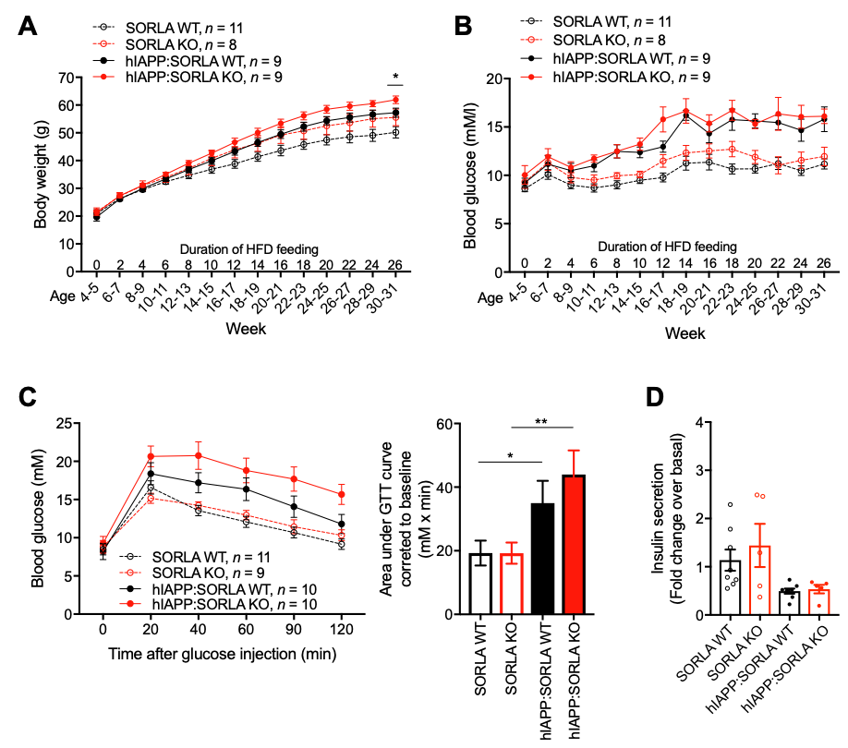
Figure S2. Metabolic characterization of hIAPP-expressing wildtype and SORLA-deficient mice on a high fat diet.
(A, B) Bi-weekly analysis of mice of the indicated genotypes for (A) body weight and (B) 6 h fasting blood glucose levels. (C) Glucose tolerance test (GTT) performed in 30- to 32-weeks old mice after a 16 h fast via intraperitoneal injection of glucose (0.75 g/kg). A lower glucose dose was used for HFD-fed mice as compared to ND-fed mice (2 g/kg, Fig. 3C) to ensure glucose measurements in the overweight mice remain within the detection range of glucometer. Response to glucose clearance was quantified as area under the curve and corrected to baseline glucose values. (D) Glucose-stimulated insulin secretion was assessed in 31-33 weeks old mice. A glucose dose of 2 g/ kg was administered intraperitoneally after a 16 h fast. Data are presented as fold change in insulin secretion at 30 minutes post-glucose injection compared to basal levels. All data are expressed as mean ± SEM. Statistical significance of differences between hIAPP:SORLA WT and hIAPP:SORLA KO in (A) was determined by unpaired Student’s t-test, * p < 0.05. Statistical significance of differences in (C) was determined by unpaired Student t-test. * p < 0.05, ** p < 0.01.
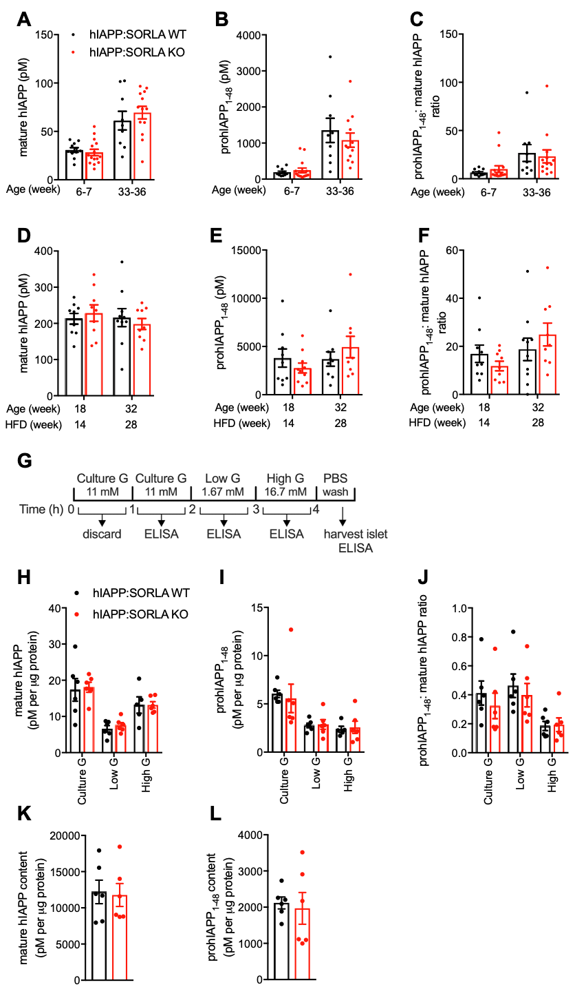
Figure S3. SORLA deficiency does not impact hIAPP processing.
(A-F) Fasting plasma levels of (pro)hIAPP and their ratios in animals were fed a ND (A-C) or HFD (D-F). Analyses were performed at the indicated age (in weeks) and indicated genotypes. No statistically significant differences were seen between genotypes using unpaired Student’s t-test (n = 6-15). (G) Schematic workflow of in vitro islet secretion assay. Islets were subjected to a series of incubations with secretion buffers containing the indicated concentrations of glucose (G). At the end of each incubation period, the buffer was collected for ELISA measurements. (H-L) Secreted levels of (H) mature hIAPP, (I) prohIAPP₁₋₄₈, (J) pro- to mature-hIAPP ratio, as well as islet content of (K) mature hIAPP and (L) prohIAPP₁₋₄₈ in isolated islets of ND-fed hIAPP:SORLA WT and hIAPP:SORLA KO mice. Data are expressed as mean ± SEM. No statistically significant differences were seen between genotypes using unpaired Student’s t-test (n = 6).

