CXCR4 mediates leukemic cell migration and survival in the testicular microenvironment
T Skroblyn et al. J Pathol DOI: 10.1002/path.5924

Supplementary materials and methods
Supplementary Figures S1–S7
Supplementary Tables S1–S4

Supplementary materials and methods
Reference numbers refer to the main text list

RT-qPCR. Murine macrophages were purified by FACS (>95% purity). Total RNA was extracted by RNeasy Micro Kit (Qiagen, Hilden, Germany), transcribed into cDNA using SuperScript VILO cDNA Synthesis Kit (Life Technologies, Carlsbad, California, USA), and analyzed with the TaqMan based qPCR assays (Applied Biosystems, Foster City, California, USA). RT-qPCR assays were performed using the TaqMan Primer sets shown in supplementary material, Table S2.
Generation of human stroma cultures from BM and testis. BM-MSCs were generated and characterized as described [20]. Approximately 2 ml of bone marrow aspirate or a cell suspension derived from shredded testicular tissue were cultivated in Iscove basal medium (10% FCS, 10% horse serum (Biochrome, Berlin, Germany) supplemented with 100 µg/ml primocin (Amaxa, Basel, Switzerland) for 24 h, followed by purification using a Ficoll gradient. Purified cell suspensions (2–5×10⁵ cells/ml) were resuspended in Iscove basal medium supplemented with 10⁻⁶ μM hydrocortisone. Non-adherent cells were removed by changing the medium weekly and washing steps with PBS. At 70–90% confluency, cells were harvested using Accutase solution (PAA Laboratories GmbH, Cölbe, Germany) After the second and third passage, cells were stained with monoclonal antibodies against common MSC markers (CD29⁺CD44⁺CD73⁺CD90⁺CD105⁺CD146⁺/ CD19⁻CD45⁻) or IgG isotype controls and analyzed using flow cytometry [53,54]. To further characterize cells for their multipotency and self-renewal, they were analyzed for their capacity to differentiate to adipocytes and osteoblasts using specific culture conditions, specific staining for adipocytes (oil red-O staining) and for osteoblasts (Alizarin Red staining), and by applying a low-density fibroblast colony-forming unit assay (CFU-F) [20]. Cells were frozen at passage two or three and kept in liquid nitrogen until further experiments were performed.

Flow cytometry analysis and cell sorting. FcR blocking was performed for 15 min at room temperature (RT) with either 5% human AB serum (Sigma-Aldrich, St. Louis, MI, USA) or purified anti-mouse CD16/32 (Biolegend, San Diego, CA, USA) in FACS buffer (PBS, 2% FCS, 5 mM EDTA). Dead cells were excluded by staining with 7-AAD (Biolegend) or AquaDye (ThermoFisher Scientific, Waltham, MA, USA). Specific staining of the Abs was verified by isotype control staining. Staining was performed using the following antibodies against human targets: Allophycocyanin (APC) anti-CD10 (HI10a, mouse IgG1, #312209, Biolegend, 1:50); Pacific Blue (PB) anti-CD19 (HIB19, mouse IgG1, #302223, Biolegend, 1:50); PB anti-CD3 (HIT3a, mouse IgG2a, #300330, Biolegend, 1:50), PB anti-CD45 (HI30, mouse IgG1, 304021, Biolegend, 1:50); Phycoerythrin (PE) anti-CCR5 (2D7/CCR5, mouse IgG2a , #560935, BD, Franklin Lakes, NJ, USA, 1:5); PE anti-CCR7 (150503, mouse IgG2a, #FAB197P R&D, Minneapolis, MN, USA, 1:10); PE anti-CCR9 (112509, mouse IgG2a, #561607, BD, 1:5), PE anti-CXCR3 (1C6/CXCR3, mouse IgG1, #550633, BD, 1:10); PE anti-CXCR4 (44717, mouse IgG2b, #FAB173P, R&D, 1:10); FITC anti-CXCR5 (2G8, rat IgG2b, #564624, BD, 1:10); PE anti-CXCR7 (8F11-M16, mouse IgG2b, #331104, Biolegend, 1:10); PE anti-CD44 (G44-26, mouse IgG2b, #550989, BD, 1:5); PE anti-IL7R (A019D5, mouse IgG1, #351340, Biolegend, 1:20); APC anti-CD29 (MAR4, mouse IgG1, #561794, eBiosciences, San Diego, CA, USA, 1:50), PE anti-73 (AD2, mouse IgG1, #550257, BD, 1:50); FITC anti-CD90 (5E10, mouse IgG1, #12-0909-41, eBiosciences, 1:50); PE anti-CD105 (43A3, mouse IgG1, #323205, Biolegend, 1:50); APC anti-CD146 (541-10B2, mouse IgG1, # 130-120-771, Miltenyi Biotec, Bergisch Gladbach, Germany, 1:50).
Staining was performed using the following antibodies against mouse targets: PB anti-CD45 (30-F11, rat IgG2b, #103116, Biolegend, 1:100); PB CD45.1 (A20, mouse IgG2a, #110722, Biolegend, 1:100); PB anti-CD45.2 (104, mouse IgG2a, #109820, Biolegend, 1:100); FITC anti-Ly6C (HK1.4, rat IgG2a, #128005, Biolegend, 1:100); PE anti-CD11c (N418, hamster IgG1, #117308, Biolegend, 1:300); Phycoerythrin-cyanin 7 (PE-Cy7) anti-CD11b (M1/70, rat IgG2b, #101216, Biolegend, 1:400); Allophycocyanin -cyanin7 (APC-Cy7) anti-F4/80 (BM8, rat IgG2a, #123118, Biolegend, 1:50); Peridinin chlorophyll protein complex/cyanin 5.5 (PerCP-Cy5.5) anti-CD64 (X54-5/7.1, mouse IgG1, #139308, Biolegend, 1:50); APC anti-MHCII (M5/114.15.2, rat IgG2b, #107613, Biolegend, 1:1000).
Data were acquired on a FACS Canto II flow cytometer running FACS Diva version 6.1.3 and were further analyzed with the FlowJo 10 software (all BD Bioscience). Results were exported from FlowJo and further analyzed using Excel 14.7.3 (Microsoft, Redmond, WA, USA). Macrophage cell sorting was performed by gating on live, single cells, CD45⁺ Ly6C⁻ CD11c⁻ and F4/80⁺CD11b⁺ cells and carried out on a FACS Aria III or FACS Fusion instrument (BD Biosciences).

Transduction of PDX-ALL cells with Luciferase-GFP. PDX-ALL cells were thawed and 5x10⁶ cells were resuspended in 1 ml RPMI 1640 + 10% FCS and in a 24-well plate (Sarstedt, Nümbrecht, Germany). Virus-containing supernatant (1 ml) and 16 µl polybrene (1 µg/µl) were added to each well and the plate was centrifuged for 90 min at 2,000 rpm and 37 °C. The plate was incubated a further 2 h at 37 °C before cells were washed three times in PBS, resuspended in 250 µl cold RPMI 1640 and transplanted into two mice (2x10⁶ cells/mouse). After five weeks, IVIS imaging was applied and upon positive signals, BM and spleen were dissected and Luciferase-GFP positive cells were sorted using fluorescence associated cell sorting (BD Aria). Luciferase-GFP positive cells were re-transplanted into mice and tumor growth monitored by IVIS imaging and blood analysis. After approximately seven weeks, mice were sacrificed, BM cells were FACS sorted a second time and cryopreserved until further experiments.

In vivo IVIS imaging. Mice were anesthetized by isoflurane (Abbot, Chicago, IL, USA) exposure (2.5 % isoflurane in oxygen) in an XGI-8 Gas Anesthesia Chamber (Caliper Life Science, Waltham, MA, USA). The substrate luciferin (Biosynth, St. Gallen, Switzerland, 150 µg/mouse in PBS) was injected intraperitoneally (i.p.) and after 10 min mice were placed onto the 37 °C heated imaging platform of a Xenogen IVIS 2000 (Caliper LifeScience). Detector exposure times between 1–240 s and small binning were used to image the mice.

Chemotaxis assays. Chemotaxis assays were performed in 5-µm pore size Transwell inserts (Sarstedt) for 4 h at 37 °C. Chemotactic factors diluted in assay medium or cell culture supernatants were added to the 24-well tissue culture plates in a final volume of 500 µl. Collagen-coated Transwell inserts were placed in each well, and 1x10⁶ cells were added to the top chamber in a final volume of 100 μl. Migrated cells were collected and counted in a Neubauer chamber. Recombinant human or murine CXCL12 (Peprotech, Hamburg, Germany) was used at a concentration of 100 nM.

Cytokine secretion assay. CXCL12 secretion was quantified in supernatants (SN) from human BM-MSC and testis stroma cultures using U-PLEX assays (MSD, Rockville, MD, USA), following the manufacturer’s instruction manual. Total protein concentration in human BM-MSC and testis stroma supernatants was determined using the Bradford assay (Thermo Fisher Scientific).

Immunohistology. Testes were collected at the days indicated, fixed in 4% phosphate-buffered formaldehyde, embedded in paraffin, then cut into 5-μm-thick cross-sections. Sections were deparaffinized and rehydrated through xylene (Roth, Karlsruhe, Germany) and acetone/Tris (BD, Sigma) and by xylene and graded ethanol treatment. Afterwards, sections were boiled for 5 min in citric buffer (2 mM Citric acid mono hydrate (Roth) + 9 mM Trisodium citrate dehydrate (Roth), pH 6.0) followed by an incubation for 30 min in 0.4% Triton X 100/PBS plus 5% serum to block unspecific binding. Subsequently, sections were incubated with the antibody solution at 4 °C overnight. On the next day, the antibody solution was removed, sections were washed three times with TBST (0.5 M Tris base (Roth) + 1.5 M Sodium chloride (Roth), pH 7.6, + 0.5% Tween 20 (Roth)) buffer before the secondary antibody solution was applied for 1 h at RT. Sections were washed three times with TBST buffer and treated for 3 min with a DAPI solution or in case of a peroxidase-labelled secondary antibody for 10 min with a aminoethyl carbazole solution (Dako, Santa Clara, CA, USA) to gain a red bright-field staining. Images were recorded using an AxioCam MRm (Zeiss, Oberkochen, Germany) camera for bright field or an AxioCam MRc2 (Zeiss) camera for fluorescence images. Images were further processed with the Axio Vision 4.5 system (Zeiss).
Immunostaining was performed using the following antibodies: Anti-human CD10 (56C6, mouse IgG1, NB600-1061, Novus, Littleton, CO, USA, 1:20); Anti-Human/Mouse CXCL12 (79018, mouse IgG1, MAB350, R&D, 1:50); Anti-mouse Vimentin (EPR3776, rabbit, Abcam, Cambridge, UK, 1:200), Anti-mouse aSMA-Cy3 (1A4, mouse, C6198, Sigma, 1:200); Anti-human CD64 (UMAB74, mouse, #UM570062, OriGene, Rockville, MD, USA, 1:100); Anti-human CD68 (polyclonal, rabbit, #PA5-32331, Thermo Fisher, 1:100); Anti-human TdT (EP266, rabbit, #M3651, Dako, 1:100); Anti-human SOX9 (polyclonal, goat, #AF3075, R&D, 1:500); Anti-human CD206 (EPR22489-7, rabbit, #ab254471, Abcam, 1:500); Anti-human IL7 (polyclonal, rabbit, #ab175380, Abcam, 1:50).
Supplementary Figures S1-S7

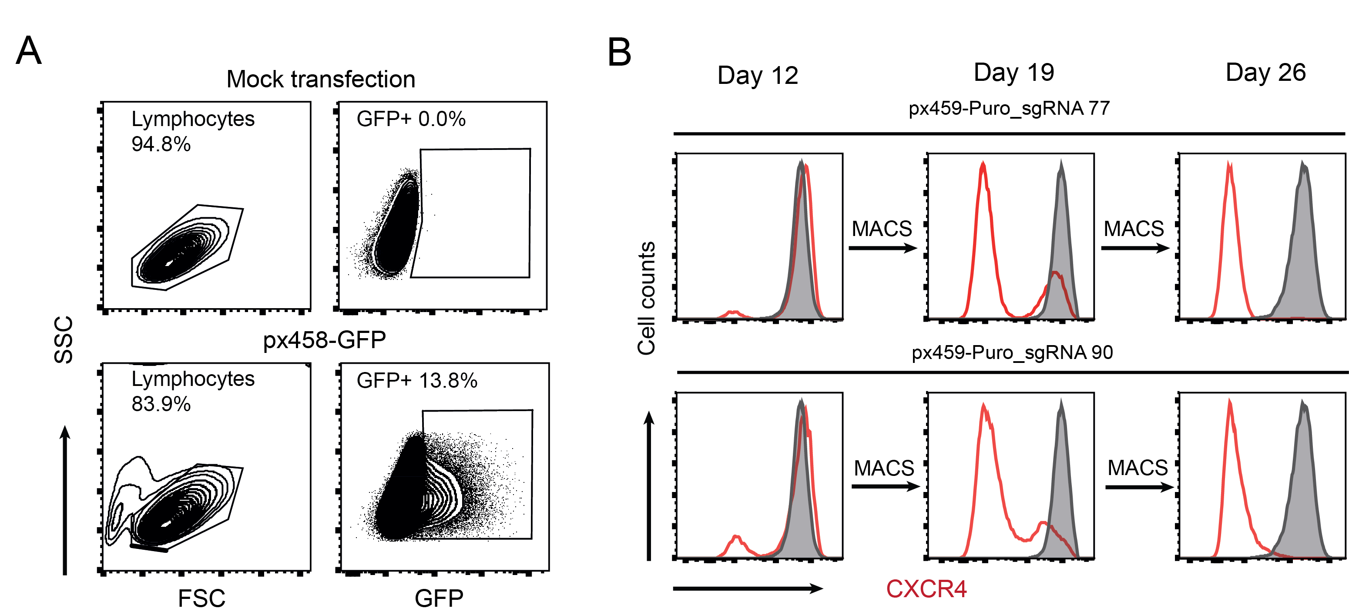

Figure S1. Generation of a Nalm6-CXCR4 KO cell line. Nalm6 cells were transfected with a pSpCas9(BB)-2S-Puro (px459) plasmid (Puro) containing two different sgRNAs (sgRNA77 or 90) and kept under Puromycin selection for 48 h to enrich for transfected cells. (A) shows representative dot plots from Nalm6 cells 24 h after transfection with px459-Puro_sgRNA77 compared to mock transfection. (B) shows the enriched proportion of sgRNA77 and sgRNA90 transfected Nalm6 cells after two rounds of CXCR4⁻ MACS cell sorting steps over 26 days. Histograms display surface expression of CXCR4 (red line) compared to mock transfected Nalm6 cells (filled curve) during the enrichment of sgRNA77 and sgRNA90 transfected Nalm6 cells from day 12 to day 26 by two rounds of MACS sorting.

Figure S2. CXCL12 protein expression in B-ALL affected testis. Analysis of CXCL12 expression (green) and TdT-expressing ALL cells (red) in sections of affected testis counterstained with DAPI (blue). Representative section of n=3 analyzed testes are shown. White arrows depict expression of CXCL12 by testis stroma cells. Scale bars, 100 μm.

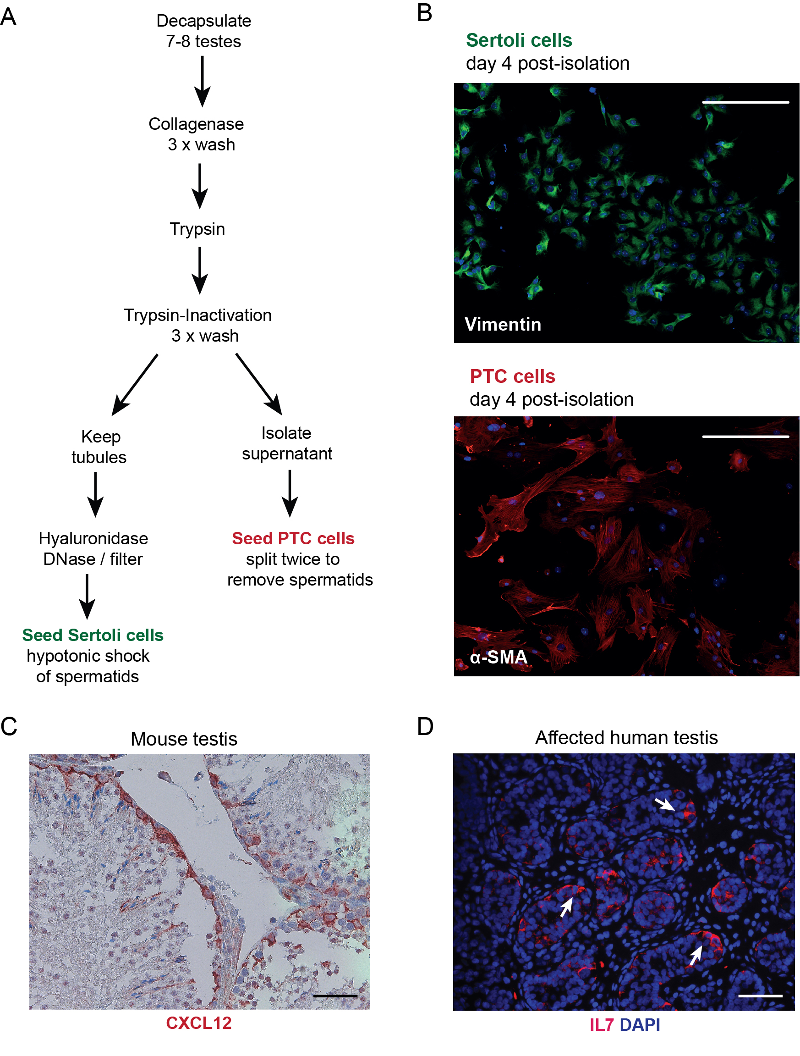
Figure S3. Staining of isolated and cultured testicular Sertoli and PTC cells and testis sections. (A) Workflow of mouse testicular Sertoli and PTC cell isolation steps according to a protocol as described [55,56]. (B) Isolated Sertoli and PTC cells were cultured and stained either for Vimentin (green) as a marker for Sertoli cells or for α-SMA (red) as a marker for PTC cells demonstrating high purity for both testicular stroma cell subpopulations. Scale bars: 100 μm. (C) CXCL12 staining of a representative NSG mouse testis section (n=3) by an anti-CXCL12 antibody and a secondary antibody conjugated with peroxidase. (D) Representative section of a patient’s testis sections (n=3) analyzed for IL7 staining (red) counterstained with DAPI (blue). Scale bars, 100 μm.

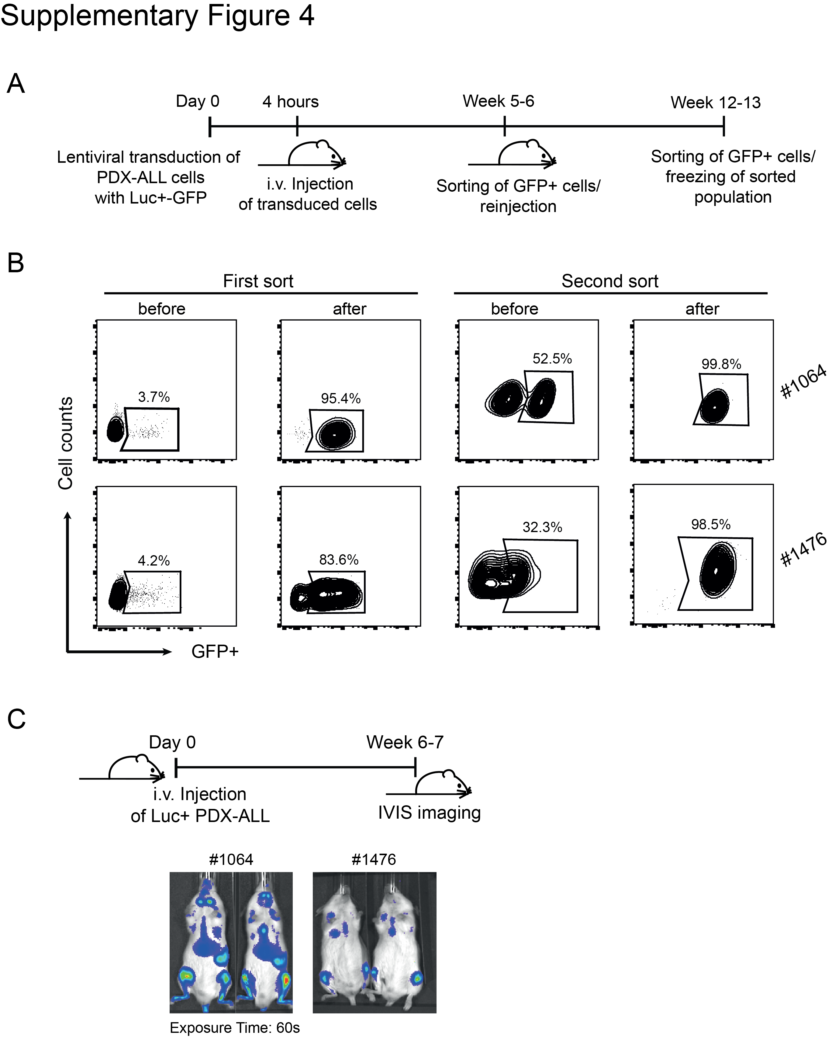
Figure S4. Generation of luciferase-GFP stably expressing PDX-ALL cells by lentiviral transduction. (A) Schematic of the experimental setup for the generation of stably expressing luciferase-GFP (Luc⁺GFP⁺) PDX-ALL cells. (B) Dot plots display the successful lentiviral transduction of PDX-ALL sample #1064 and #1476 with a luciferase-GFP construct and their enrichment from <5% up to >98% of GFP⁺ cells through two rounds of transfers in NSG mice and subsequent FACS sorting steps. (C) Luc⁺GFP⁺ PDX-ALL #1064 and #1476 cells were xeno-transplanted into NSG mice and their expansion was visualized by IVIS imaging after 6–7 weeks.

Figure S5. Isolation of testicular macrophages from NSG mice and expression of TAM-inducing cytokines by PDX-ALL cells. (A) Representative dot plots show testicular macrophages sorted by gating on live, single cells, CD45⁺ Ly6C⁻ CD11c⁻ and F4/80⁺CD11b⁺ cells. (B) IL10 and MCSF expression in PDX-ALL cells (n=4) relative to GAPDH.

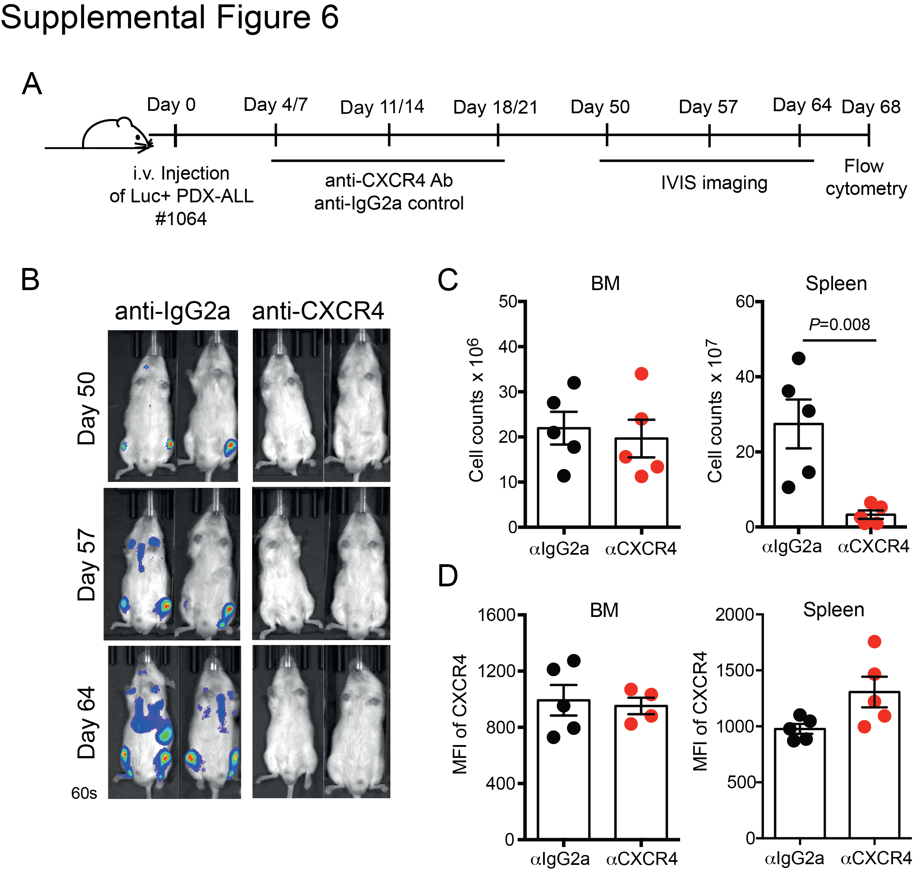

Figure S6. Treatment with an anti-CXCR4 antibody inhibits engraftment of PDX-ALL cells. (A) Schematic of the experimental design for the i.p. anti-CXCR4 treatment in the PDX-ALL #1064 xenotransplantation model. (B) The expansion of transplanted cells was monitored by IVIS imaging (exposure time 60 s) in anti-CXCR4-treated compared to anti-IgG isotype-treated mice (n=2 per group) over time, starting from day 50 up to day 64. (C) After sacrificing mice, the total cell number of BM and spleen was determined. (D) The MFI of CXCR4 expression levels in anti-CXCR4-treated in comparison to anti-IgG isotype-treated mice, with n=5 mice per group from two independent experiments. Data are displayed as single animals; bars present mean±SEM, P values were calculated using a Mann–Whitney U test.

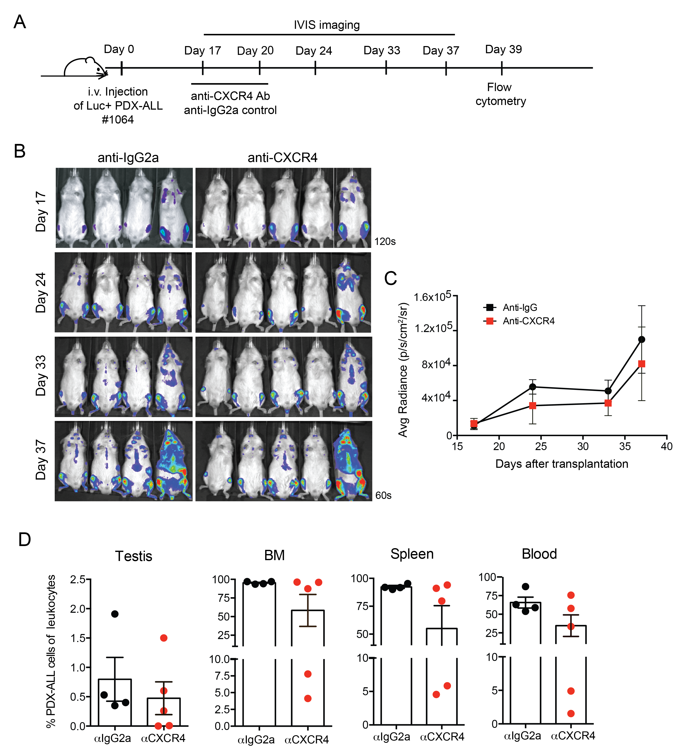

Figure S7. Treatment of advanced leukemia with an anti-CXCR4 antibody partially inhibits progression of PDX-ALL. (A) Schematic of the experimental design for the i.p. anti-CXCR4 treatment in the PDX-ALL #1064 xenotransplantation model. (B) The expansion of transplanted cells was monitored by IVIS imaging (exposure time 120 and 60s) in two independent experiments in anti-CXCR4-treated (n=5)) compared to anti-IgG isotype-treated mice (n=4) over time, starting from day 17 up to day 37. (C) Mean±SEM of the signal intensities obtained from the entire body tumor burden are plotted for each group over time. (D) At day 39 after transplantation, the percentage of CD19⁺CD45⁺ PDX-ALL cells of all leukocytes in testis, BM, spleen, and blood were determined in all groups. Data are displayed as single animals; bars present mean±SEM.

Table S1. Disease characteristics of primary patient samples used for generation of human B-ALL xenografts.

Patient # | Stage | Site of relapse | Timing of relapse | Immunophenotype | Genetic subtype | Response to relapse treatment
1064 | 1st relapse | Bone marrow isolated | Very early* (12 months) | common-ALL | B-other# | Morphological nonresponse
1476 | 1st relapse | Bone marrow isolated | Very early* (12 months) | common-ALL | B-other# | Morphological nonresponse
*very early relapses are defined as relapses occurring within 18 months of initial diagnosis
#negative for frequent fusion genes or aneuploidies in pediatric ALL

Table S2. Oligonucleotide primers for RT-qPCR using TaqMan probes

Target | Reactivity | Assay ID
GAPDH | Human | Hs03929097_g1
IL4 | Human | Hs00174122_m1
IL10 | Human | Hs00961622_m1
INFy | Human | Hs00989291_m1
M-CSF | Human | Hs00174164_m1
IL6 | Human | Hs00174131_m1
B2m | Mouse | Mm00437762_m1
Cxcl12 | Mouse | Mm00445553_m1
Il7 | Mouse | Mm01295803_m1
Il10 | Mouse | Mm01288386_m1
Il1b | Mouse | Mm00434228_m1
Cx3cr1 | Mouse | Mm02620111_s1
Csf1r | Mouse | Mm01266652_m1
Icam1 | Mouse | Mm00516023_m1
H2.k1 | Mouse | Mm01612247_mH
Nlrp2 | Mouse | Mm00624616_m1
H2.dmb | Mouse | Mm00783707_s1
Marco | Mouse | Mm00440265_m1
Il4 | Mouse | IL4 Mm00445259_m1
Arg1 | Mouse | Mm00475988_m1
Vegfa | Mouse | Mm00437306_m1
Mmp9 | Mouse | Mm00600164_g1
Cxcl10 | Mouse | Mm00445235_m1

Table S3. Chemokine receptor expression of primary B-ALL patient cell samples
 | CCR7 |  | CXCR3 |  | CXCR4 |  | CXCR5
 | diagnosis | relapse | diagnosis | relapse | diagnosis | relapse | diagnosis | relapse
BM 1 | - | - | + | - | ++ | +++ | - | -
BM 2 | - | - | - | - | +++ | +++ | - | -
BM 3 | - | - | - | - | ++ | ++ | - | -
BM 4 | - | - | - | - | +++ | ++ | - | -
BM 5 | - | + | + | - | +++ | +++ | - | -
BM 6 | - | - | - | ++ | ++ | +++ | - | -
BM 7 | - | - | - | - | ++ | ++ | - | -
BM 8 | + | / | +++ | / | +++ | / | - | /
BM 9 | - | - | - | - | +++ | ++ | - | -
BM 10 | - | - | - | - | ++ | +++ | - | -
BM 11 | / | - | / | + | +++ | +++ | / | -
BM 12 | + | - | - | - | +++ | ++ | - | -
BM 13 | - | - | - | - | +++ | +++ | - | -
CNS 1 | ++ | - | - | + | +++ | +++ | + | -
CNS 2 | - | - | - | - | +++ | +++ | - | -
CNS 3 | - | - | - | - | ++ | +++ | - | -
CNS 4 | - | - | - | - | ++ | +++ | - | -
CNS 5 | - | - | + | ++ | +++ | ++ | - | -
CNS 6 | - | - | - | - | ++ | ++ | - | -
CNS/Testis | - | / | - | / | +++ | / | - | /
Testis 1 | - | - | - | - | +++ | +++ | - | -
Testis 2 | - | / | - | / | ++ | / | - | /
Testis 3 | - | - | - | - | +++ | ++ | - | -
Testis 4 | - | - | - | - | ++ | ++ | - | -
Testis 5 | - | / | - | / | +++ | +++ | - | /
Testis 6 | - | - | + | - | +++ | +++ | - | -
Testis 7 | - | - | - | + | +++ | ++ | - | -
Testis 8 | - | - | - | - | +++ | + | - | -
Testis 9 | - | / | - | / | ++ | / | - | /
Testis 10 | / | - | / | - | / | ++ | / | -

Chemokine receptor expression intensity was classified based on the measured MFI.
MFI <200, depicted as -; MFI 200-500, depicted as +; MFI 500-2000, depicted as ++; MFI >2000, depicted as +++ in the table.

Table S4. Chemokine receptor expression of PDX-ALL cell samples

Patient # | CCR5 | CCR7 | CCR9 | CXCR1 | CXCR2 | CXCR3 | CXCR4 | CXCR5 | CXCR7
1064 | - | - | - | - | - | - | +++ | - | -
1476 | - | - | - | - | - | - | ++ | - | -

Chemokine receptor expression intensity was classified based on the measured MFI.
MFI <200, depicted as -; MFI 200-500, depicted as +; MFI 500-2000, depicted as ++; MFI >2000, depicted as +++ in the table.

