Online Appendix

Supplemental Figure 1: Schematic model of volume distribution in intravascular space and its changes (A) underlying Strauss formula (B, C).
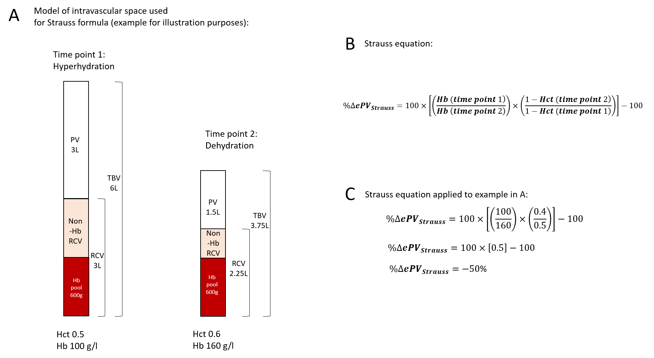

Supplemental figure 2: Agreement between estimated PV by Kaplan-Hakim formula (ePV_{Kaplan-Hakim}) and absolute measured PV (mPV) upon enrollment (day 1). “Difference” indicates difference between ePV_{Kaplan Hakim} and mPV. “Average” shows average of ePV_{Kaplan-Hakim} and mPV. Solid line shows zero. Dotted lines show bias and bias ± 1.96 standard deviation. Data are presented in milliliters.

Supplemental Figure 3: Absolute 48h changes of mPV (milliliters) and bodyweight (grams) are shown in individual patients. Patients with decreasing PV are presented on the left, patients with increasing PV on the right.

Supplemental Figure 4: Agreement between estimated PV change by Kaplan-Hakim (Δ%ePV_{Kaplan-Hakim})(A) and Strauss’ formula (Δ%ePV_{Strauss}) (B) and measured PV change (Δ%mPV) “Difference” indicates difference between Δ%ePV and Δ%mPV change. “Average” shows average of Δ%ePV and Δ%mPV. Solid line shows zero. Dotted lines show bias and bias ± 1.96 standard deviation. Data are presented in percentages

