Supporting Information

Proportionality of hybrid and sensitivity methods for a “perfect” EPG-simulated RARE SI model
The hybrid method is proportional to the sensitivity method when the RARE SI model is calculated using simulations and does not have a bias introduced by measurements.
Both correction methods can be expressed as:
$$sensitivity= \frac{image (sample)}{image (uniform sample)}$$
$$hybrid= \frac{B_{1}^{+} correction(image (sample)) }{B_{1}^{+} correction(image \left(uniform sample\right)) }$$
being $image (sample)$ and $image (uniform sample)$ the image to be corrected and the uniform phantom image used for sensitivity correction, respectively.
Replacing the B₁⁺ corrections by their definitions²³ as:
$$= \frac{image (T_{1}\left(sample\right), FA)×\frac{{SI}_{nominal}\left(sample\right)}{{SI}_{actual}\left(sample\right)}}{\left|image (T_{1}\left(uniform sample\right), FA)×\frac{{SI}_{nominal}\left(uniform sample\right)}{{SI}_{actual}\left(uniform sample\right)}\right|}$$

Since ${SI}_{nominal}\left(sample\right)$ and ${SI}_{nominal}\left(uniform sample\right)$are the SIs for perfect 90º excitations and both samples have constant T₁ relaxation times, they can be replaced by a constant. Similarly, ${SI}_{actual}\left(sample\right)$ and ${SI}_{actual}\left(uniform sample\right)$ are the SIs for the actual excitations FA which equal to a constant for each pixel. Thus:
$$=k× \frac{image (T_{1}\left(sample\right), FA)}{\left|image (T_{1}\left(uniform sample\right), FA)\right|}=k × sensitivity$$

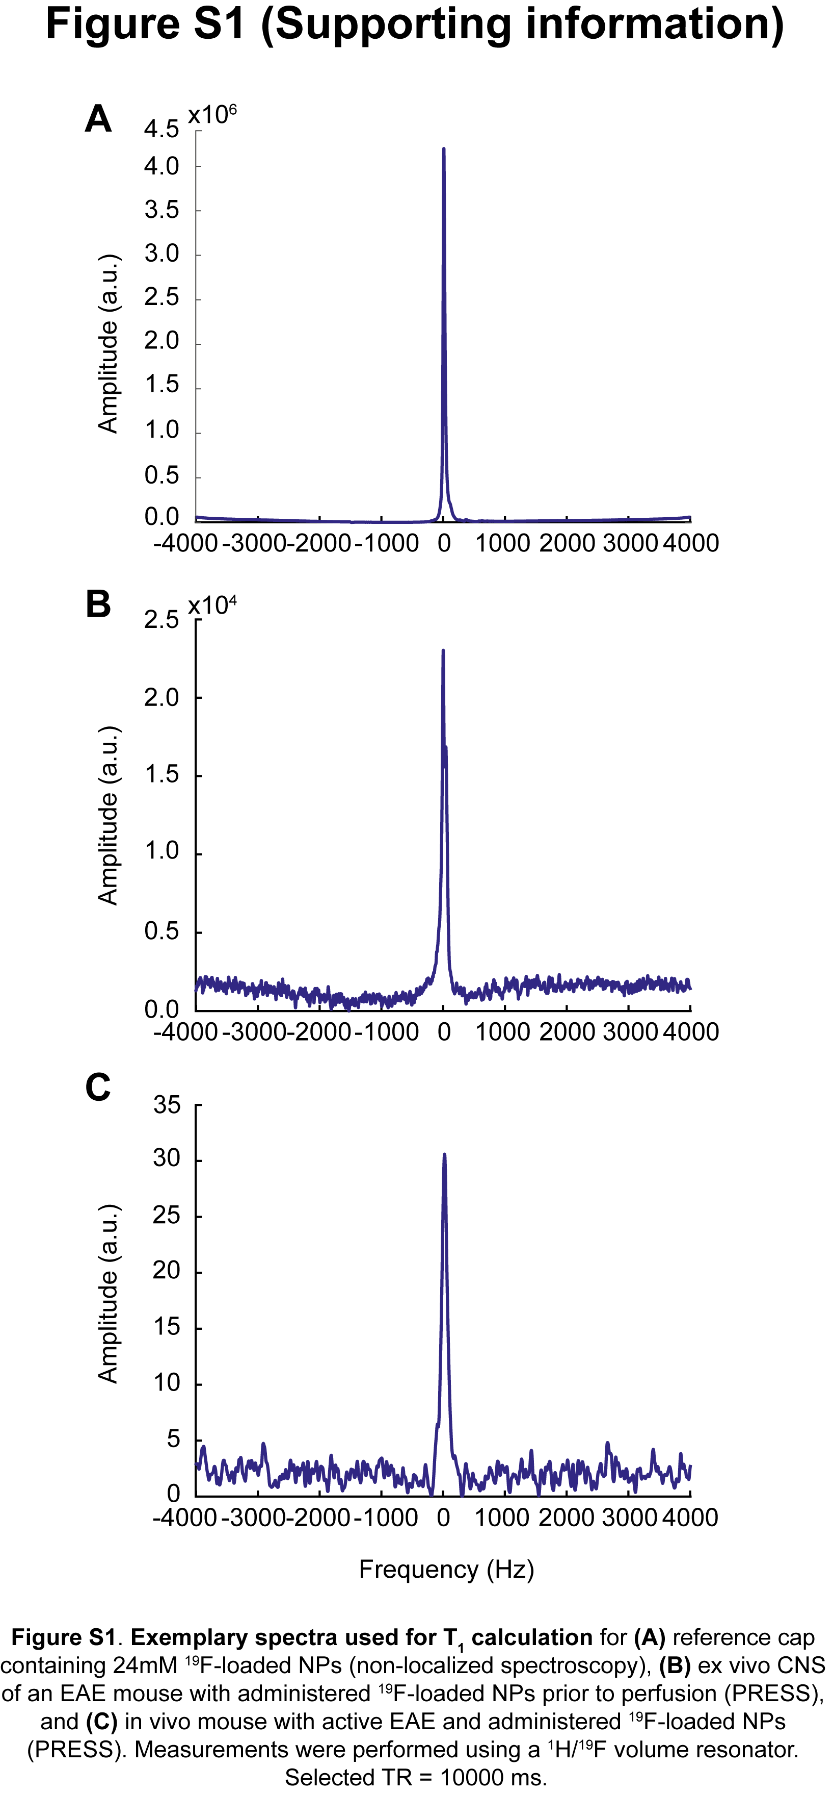
Figure S1. Exemplary spectra used for T₁ calculation for (A) reference cap containing 24mM ¹⁹F-loaded NPs (non-localized spectroscopy), (B) ex vivo CNS of an EAE mouse with administered ¹⁹F-loaded NPs prior to perfusion (PRESS), and (C) in vivo mouse with active EAE and administered ¹⁹F-loaded NPs (PRESS). Measurements were performed using a ¹H/¹⁹F volume resonator. Selected TR = 10000 ms.
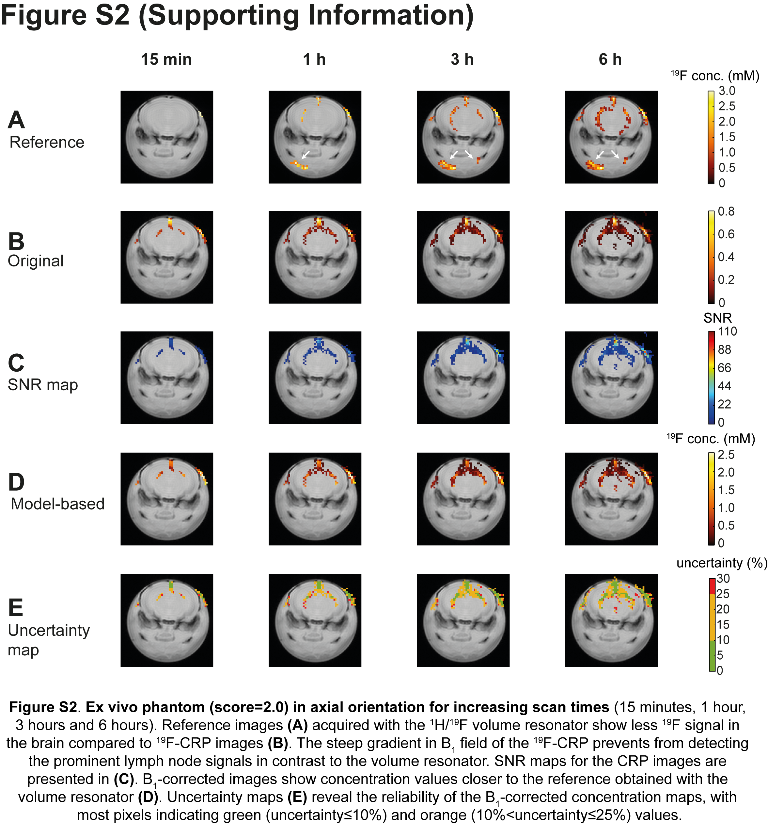
Figure S2. Ex vivo phantom (score=2.0) in axial orientation for increasing scan times (15 minutes, 1 hour, 3 hours and 6 hours). Reference images (A) acquired with the ¹H/¹⁹F volume resonator show less ¹⁹F signal in the brain compared to ¹⁹F-CRP images (B). The steep gradient in B₁ field of the ¹⁹F-CRP prevents from detecting the prominent lymph node signals in contrast to the volume resonator. SNR maps for the CRP images are presented in (C). B₁-corrected images show concentration values closer to the reference obtained with the volume resonator (D). Uncertainty maps (E) reveal the reliability of the B₁-corrected concentration maps, with most pixels indicating green (uncertainty≤10%) and orange (10%<uncertainty≤25%) values.

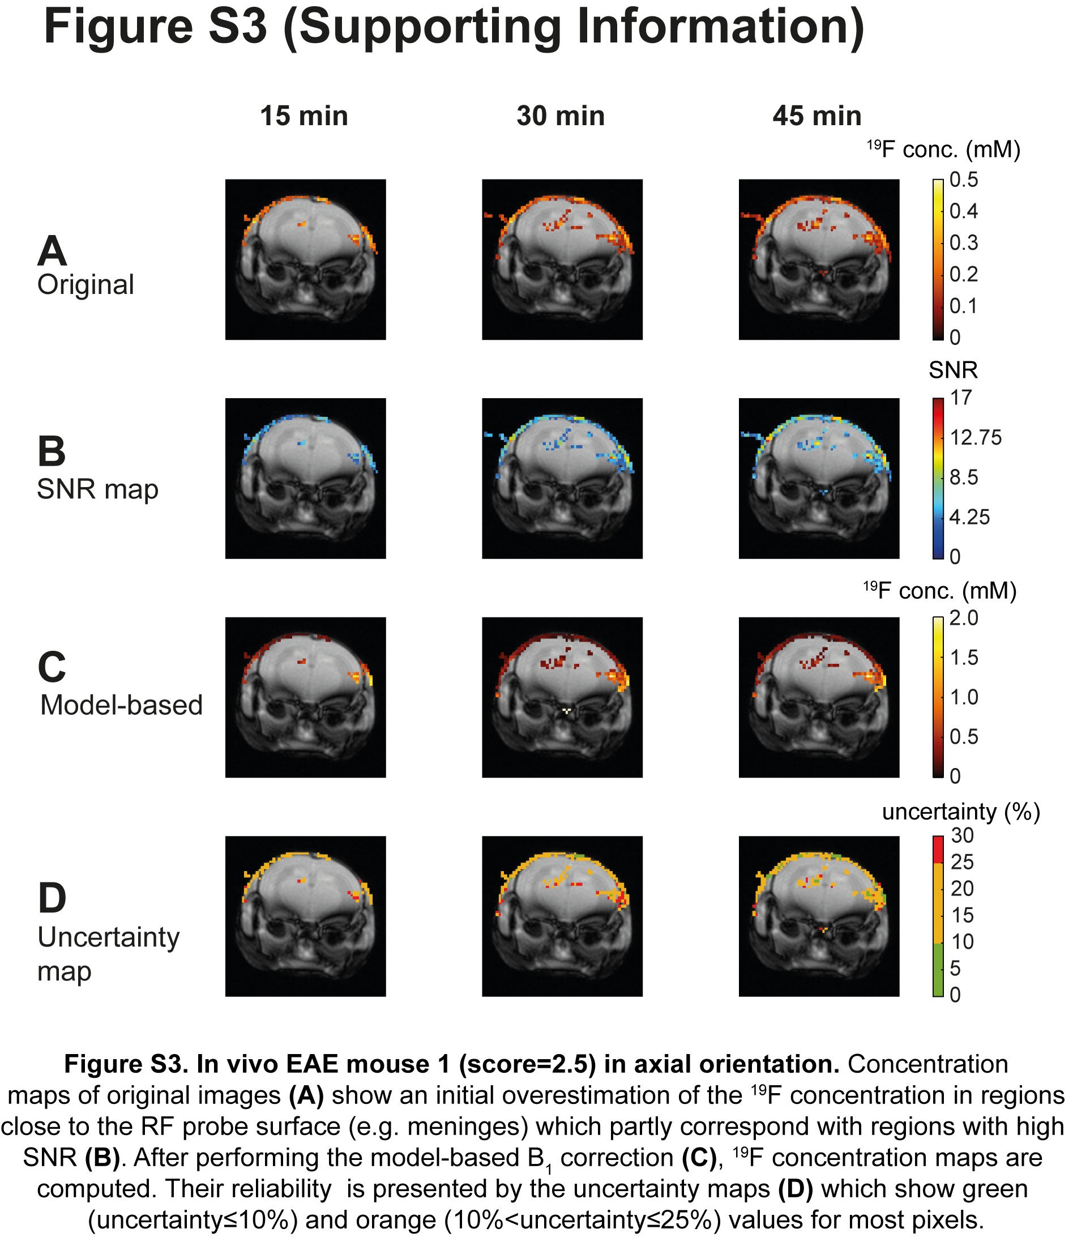
Figure S3. In vivo EAE mouse 1 (score=2.5) in axial orientation. Concentration maps of original images (A) show an initial overestimation of the ¹⁹F concentration in regions close to the RF probe surface (e.g. meninges) which partly correspond with regions with high SNR (B). After performing the model-based B₁ correction (C), ¹⁹F concentration maps are computed. Their reliability is presented by the uncertainty maps (D) which show green (uncertainty≤10%) and orange (10%<uncertainty≤25%) values for most pixels.

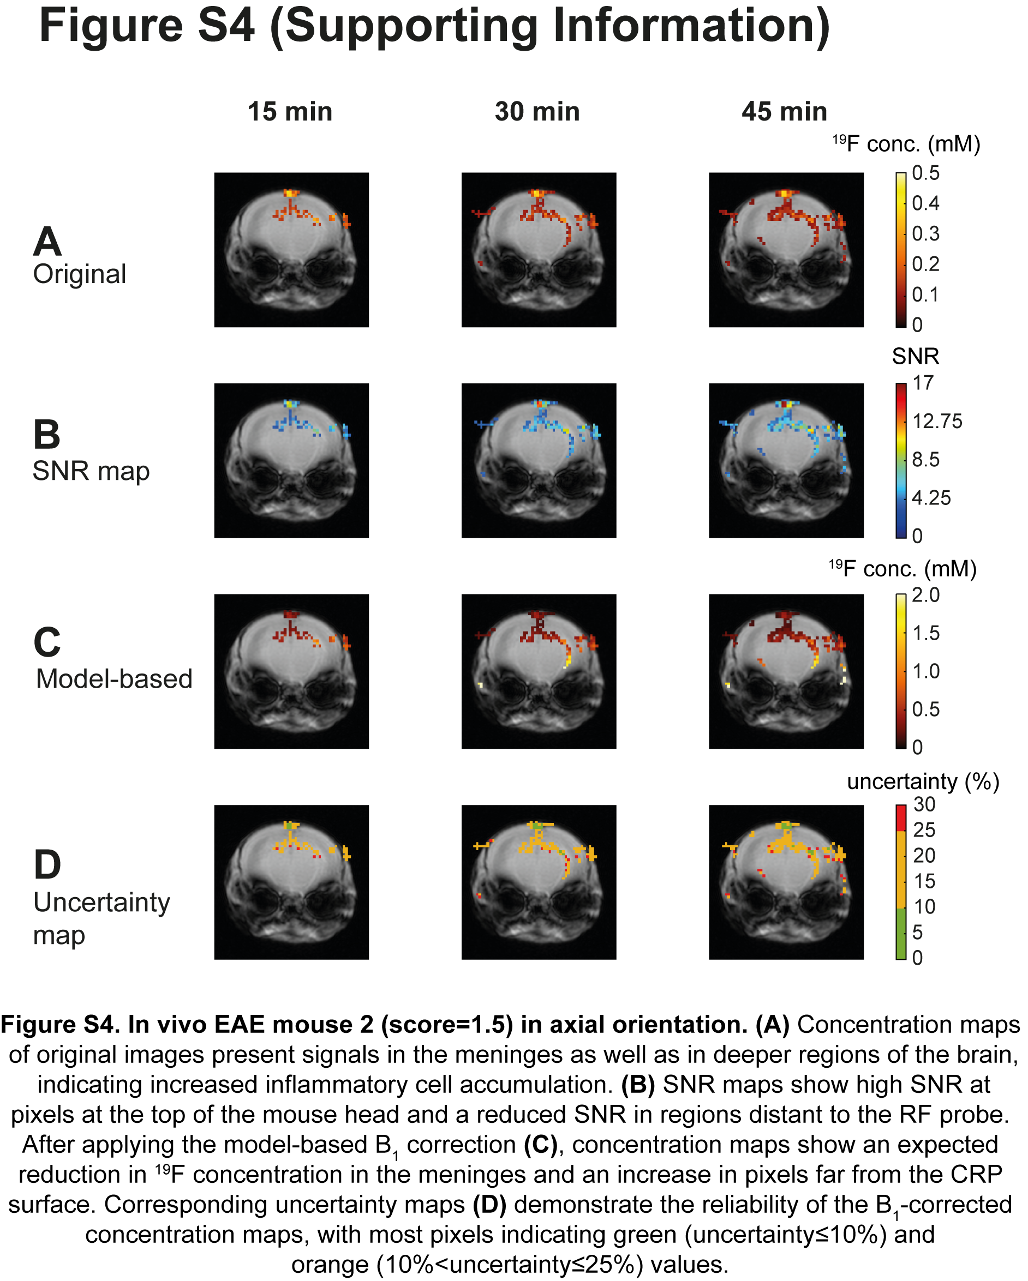
Figure S4. In vivo EAE mouse 2 (score=1.5) in axial orientation. (A) Concentration maps of original images present signals in the meninges as well as in deeper regions of the brain, indicating increased inflammatory cell accumulation. (B) SNR maps show high SNR at pixels at the top of the mouse head and a reduced SNR in regions distant to the RF probe. After applying the model-based B₁ correction (C), concentration maps show an expected reduction in ¹⁹F concentration in the meninges and an increase in pixels far from the CRP surface. Corresponding uncertainty maps (D) demonstrate the reliability of the B₁-corrected concentration maps, with most pixels indicating green (uncertainty≤10%) and orange (10%<uncertainty≤25%) values.

