**SUPPORTING INFORMATION**

**Figure S1: Pedigrees and segregation of solved patients**

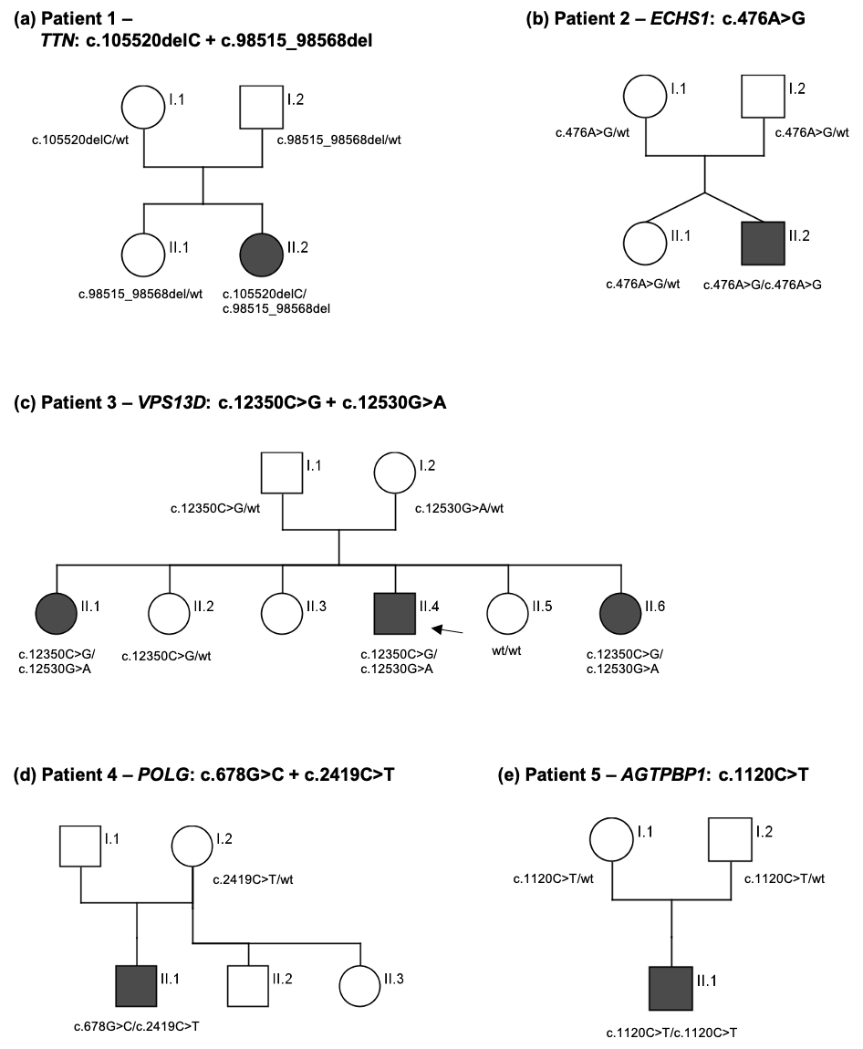

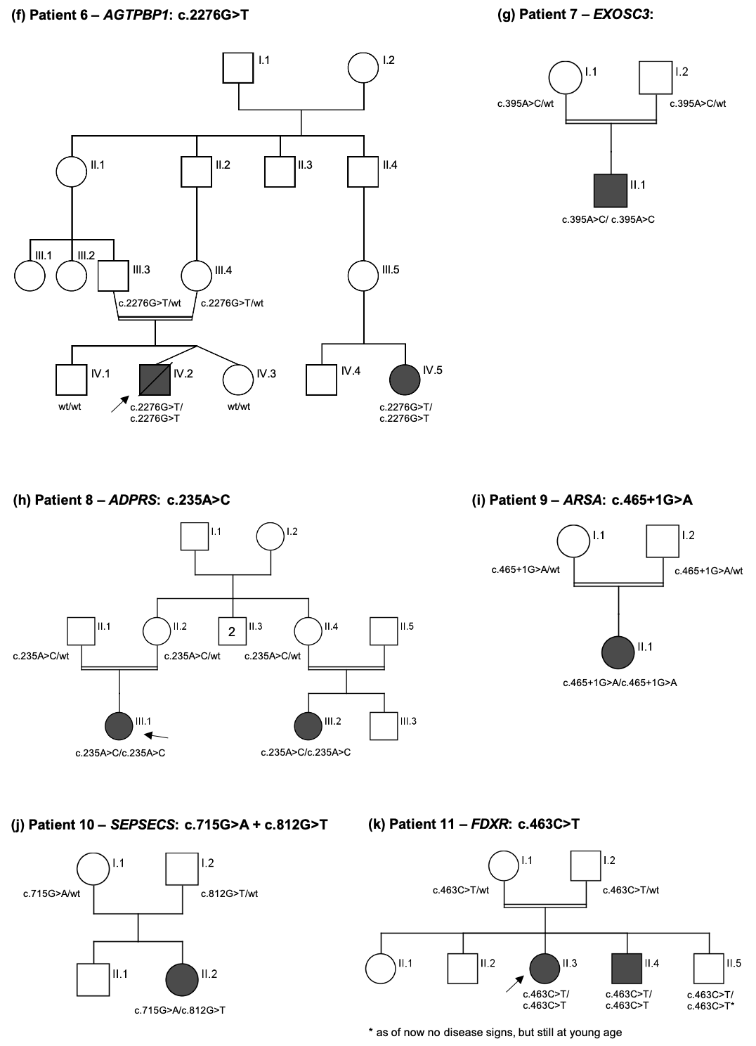

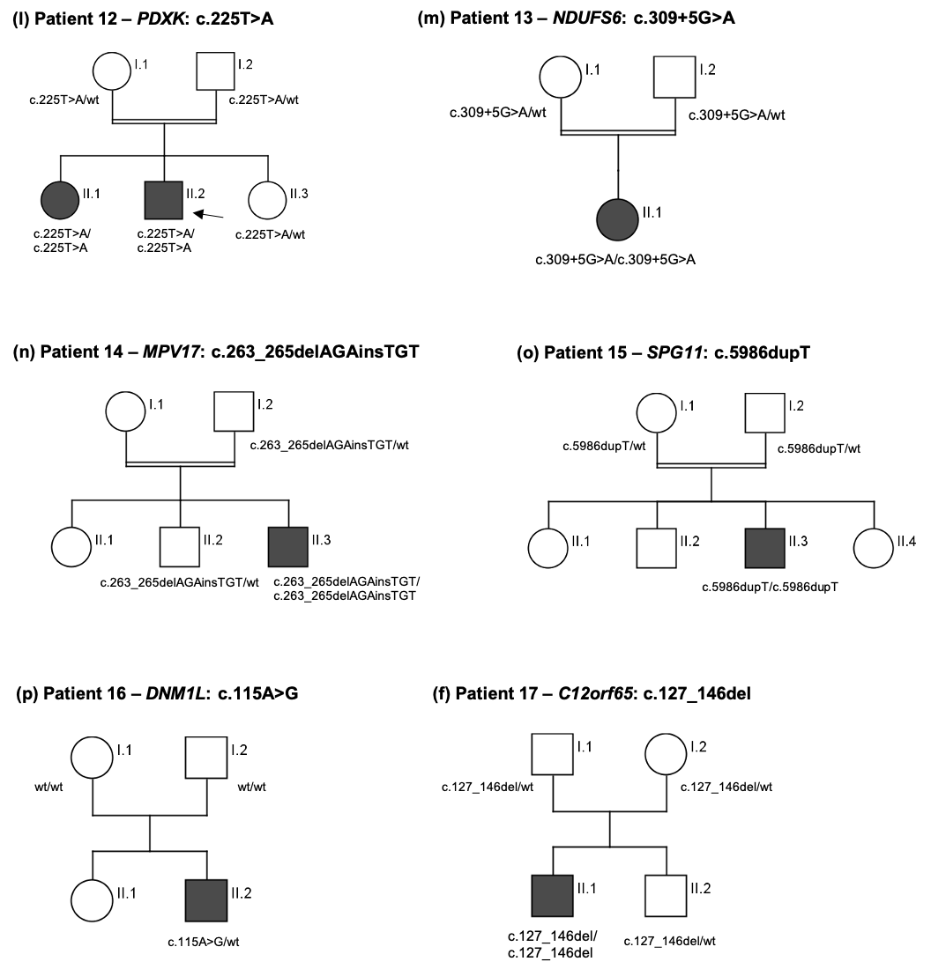

**Figure S2: Study workflow**

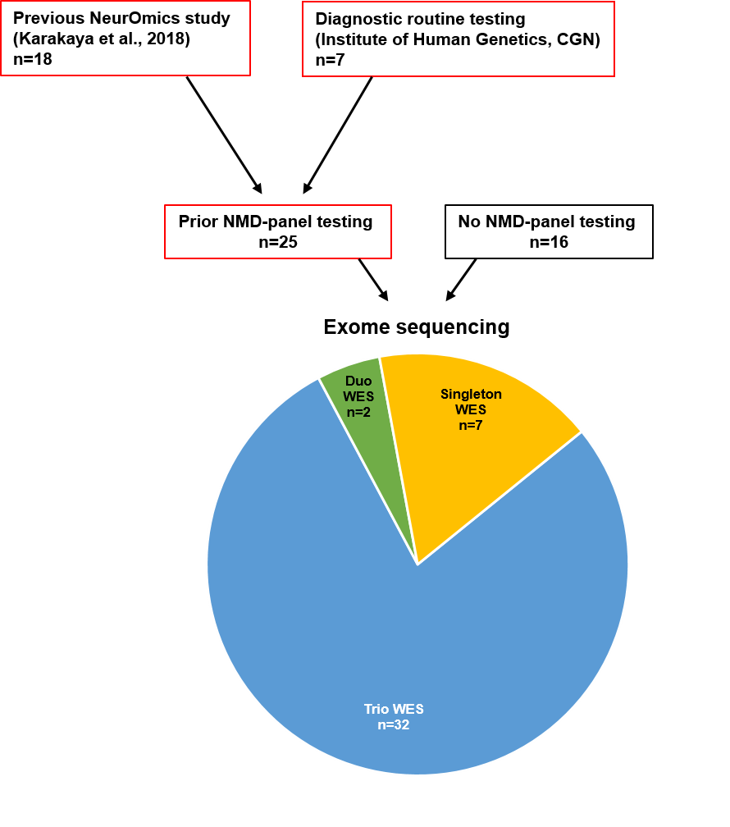

**Figure S3: Comparison of ES outcome post NMD-panel versus without NMD-panel analysis**

Diagnostic yields in the NMD-panel cohort and the cohort without prior NMD-panel screening amounted to 40% and 44%, respectively. Importantly, more than half of the genes detected in the cohort without prior NMD-panel screening were ‘panel-detectable’, highlighting the diagnostic potential of the NMD-panel despite the comparable diagnostic yields in both cohorts.

**Table S1: Clinical details of the individuals with positive results – Patients 1-6**

|  |  |  |  |  |  |  |
| --- | --- | --- | --- | --- | --- | --- |
| **ID** | **1** | **2** | **3** | **4** | **5** | **6** |
| **Variant** | *TTN* (NM_133378.4): c.[97816delC]; [90811_90864del] | *ECHS1* (NM_004092.3): c.[476A>G]; [476A>G] | *VPS13D* (NM_015378.3): c.[12350C>G]; [12530G>A] | *POLG* (NM_002693.2): c.[2419C>T]; [678G>C] | *AGTPBP1* (NM_015239.2): c.[1120C>T]; [1120C>T] | *AGTPBP1* (NM_015239.2): c.[2276G>T]; [2276G>T] |
| **Sex** | f | m | m | m | m | m |
| **Year of birth** | 1971 | 2016 | 1999 | 2008 | 2018 | 2017 |
| **Suspected diagnosis** | non-5q-SMA | non-5q-SMA | non-5q-SMA | non-5q-SMA | non-5q-SMA | non-5q-SMA |
| **Age at onset** | 2 years | congenital | 12 years | infancy | 4 months | 7 months |
| **Disease course** | progressive | death at 2 years | progressive | not progressive | progressive | death at 14 months |
| **Consanguinity** | no | no | no | no | N/A | yes |
| **Affected family members** | two distant paternal relatives | ‒ | two sisters | ‒ | ‒ | second-degree cousin |
| **NMD panel** | negative | negative | negative | not performed | not performed | not performed |
| **Ocular signs** | no | optic nerve atrophy | saccadic eye movements, gaze-evoked nystagmus | ptosis | no | detailed phenotype description: Karakaya et al., 2019 |
| **Bulbar signs** | no | dysphagia | no | dysarthria | tongue fasciculations |
| **PEG (tube) feeding** | no | yes | no | no | yes |
| **Hearing loss** | N/A | sensorineural | no | no | N/A |
| **Muscle atrophy** | p LE | (d LE) | p + d UE + LE | p UE, p + d LE | p + d UE + LE |
| **Musculoskeletal deformities** | scoliosis | scoliosis | high palate, dysmorphic jaw and shoulder/neck, pes cavus, genu recurvatum | scapula alata, pes cavus, pes planovalgus | N/A |
| **Initially affected muscles** | p LE | p + d LE, paraspinal | N/A | p LE, facial | N/A |
| **Muscle weakness** | p + d UE + LE, facial | p + d LE, paraspinal | p + d UE + LE | p UE, p + d LE, facial, voice, paraspinal | yes, affected muscle groups N/A |
| **Tendon reflexes** | UE: normal, LE: weak PTR,  absent ATR | absent | increased | weak | weak |
| **Muscle tone** | N/A | floppy | increased: LE | weak | floppy |
| **Dystonia** | N/A | no | no | no | no |
| **Tremor** | N/A | no | no | no | no |
| **Other muscular symptoms** | ‒ | ‒ | ‒ | no spontaneous muscle activity, muscle pain under exertion | ‒ |
| **Sensation** | N/A | N/A | normal | normal | diminished: UE + LE |
| **Autonomic dysfunction** | N/A | hyperhidrosis | no | no | no |
| **Cognition/ personality** | normal | cognitive delay | mild mnestic and moderate cognitive impairment | normal | cognitive delay |
| **Respiratory dysfunction** | no | respiratory distress at birth and at the age of 17 months, artificial ventilation | no | no | permanent dysfunction, artificial ventilation |
| **Cardiac dysfunction** | no | patent foramen ovale | no | no | no |
| **Other features** | ‒ | hypoxic ischemic encephalopathy after birth | standing and gait ataxia, mild limb ataxia | ‒ | ‒ |
| **EMG** | myopathic | neurogenic | neurogenic | normal | N/A |
| **MNCS** | N/A | axonal | axonal | normal | N/A |
| **SNCS** | N/A | axonal | normal | normal | N/A |
| **Muscle biopsy** | neurogenic myopathy, pseudo-dystrophic features | N/A | N/A | normal | N/A |
| **Muscle MRI** | N/A | N/A | N/A | N/A | N/A |
| **Cranial/spinal MRI** | N/A | severe cerebral atrophy, thin corpus callosum, asymmetric dilatation of the lateral ventricles, periventricular white matter hypomyelination | N/A | normal | normal |
| **CK levels** | normal | normal | normal | normal | normal |

m, male; f, female; p, proximal; d, distal; LE, lower extremity, UE, upper extremity; N/A, not available; PTR, patellar tendon reflex; ATR, achilles tendon reflex; Questionable proband information is enclosed in brackets.

**Cont. Table S1 – Patients 7-12**

|  |  |  |  |  |  |  |
| --- | --- | --- | --- | --- | --- | --- |
| **ID** | **7** | **8** | **9** | **10** | **11** | **12** |
| **Variant** | *EXOSC3* (NM_016042.3): c.[395A>C]; [395A>C] | *ADPRS* (NM_017825.2): c.[235A>C]; [235A>C] | *ARSA* (NM_000487.5): c.[465+1G>A]; [465+1G>A] | *SEPSECS* (NM_016955.3): c.[715G>A]; [812G>T] | *FDXR* (NM_024417.4): c.[463C>T]; [463C>T] | *PDXK* (NM_003681.4): c.[225T>A]; [225T>A] |
| **Sex** | m | f | f | f | f | m |
| **Year of birth** | 2016 | 2007 | 2013 | 2012 | 2006 | 2006 |
| **Suspected diagnosis** | non-5q-SMA | axonal CMT | intermediate CMT | axonal CMT | axonal CMT | axonal CMT |
| **Age at onset** | 4.5 months | 3 years | 1 year | 6 months | 4 years | 10 years |
| **Disease course** | progressive | not progressive | progressive | progressive | progressive | progressive |
| **Consanguinity** | yes | yes | yes | no | yes | yes |
| **Affected family members** | ‒ | cousin, two distant relatives | ‒ | paternal second cousin | brother | sister |
| **NMD panel** | not performed | negative | negative | negative | negative | negative |
| **Ocular signs** | no | no | ptosis | strabismus, low vision | optic atrophy, blindness since the age of 6 years | detailed phenotype description: Keller et al., 2020 |
| **Bulbar signs** | dysphagia | no | no | no | no |
| **PEG (tube) feeding** | yes | no | no | no | no |
| **Hearing loss** | no | no | no | no | N/A |
| **Muscle atrophy** | p + d UE + LE | d LE | no | no | yes, affected muscle groups N/A |
| **Musculoskeletal deformities** | contractures | scoliosis, scapular winging, pes cavus | no | no | no |
| **Initially affected muscles** | p + d UE | N/A | N/A | N/A | N/A |
| **Muscle weakness** | global | p + dUE, d LE, neck, paraspinal | yes, affected muscle groups N/A | yes, affected muscle groups N/A | yes, affected muscle groups N/A |
| **Tendon reflexes** | absent | weak | increased | N/A | weak |
| **Muscle tone** | floppy | weak | weak | weak | weak |
| **Dystonia** | no | yes | yes | no | yes |
| **Tremor** | no | intentional | no | no | no |
| **Other muscular symptoms** | ‒ | ‒ | ‒ | ‒ | ‒ |
| **Sensation** | normal | normal | N/A | N/A | N/A |
| **Autonomic dysfunction** | no | no | no | no | no |
| **Cognition/ personality** | N/A | normal | speech delay | mental retardation | normal |
| **Respiratory dysfunction** | yes | no | no | no | no |
| **Cardiac dysfunction** | no | no | no | no | no |
| **Other features** | ‒ | ‒ | ‒ | ‒ | ‒ |
| **EMG** | neurogenic | N/A | neurogenic | neurogenic | neurogenic |
| **MNCS** | N/A | axonal | demyelinating | N/A | axonal |
| **SNCS** | N/A | normal | demyelinating | N/A | N/A |
| **Muscle biopsy** | N/A | N/A | N/A | N/A | N/A |
| **Muscle MRI** | N/A | N/A | abnormal | N/A | N/A |
| **Cranial/spinal MRI** | cerebellar atrophy | normal | dysmyelination, leukodystrophy, periventricular leukomalacia | normal | normal |
| **CK levels** | N/A | normal | N/A | elevated <10x | N/A |

m, male; f, female; p, proximal; d, distal; LE, lower extremity, UE, upper extremity; N/A, not available; elevated <10x, elevation to less than 10 times the normal value.

**Cont. Table S1 – Patients 13-17**

|  |  |  |  |  |  |
| --- | --- | --- | --- | --- | --- |
| **ID** | **13** | **14** | **15** | **16** | **17** |
| **Variant** | *NDUFS6* (NM_004553.4): c.[309+5G>A]; [309+5G>A] | *MPV17* (NM_002437.4): c.[263_265delAGAinsTGT]; [263_265delAGAinsTGT] | *SPG11* (NM_025137.3): c.[5986dup]; [5986dup] | *DNM1L* (NM_012062.4): c.[115A>G] | *C12orf65* (NM_152269.4): c.[127_146del]; [127_146del] |
| **Sex** | f | m | m | m | m |
| **Year of birth** | 2003 | 1990 | 2005 | 2009 | 2006 |
| **Suspected diagnosis** | axonal CMT | axonal CMT | axonal CMT | axonal CMT | axonal CMT |
| **Age at onset** | 10 years | 26 years | 13 years | 4 months | 7 years |
| **Disease course** | not progressive | progressive | progressive | progressive | progressive |
| **Consanguinity** | yes | yes | yes | no | no |
| **Affected family members** | ‒ | ‒ | ‒ | ‒ | ‒ |
| **NMD panel** | negative | negative | not performed | not performed | not performed |
| **Ocular signs** | nystagmus | no | no | no | no |
| **Bulbar signs** | no | no | no | no | no |
| **PEG (tube) feeding** | no | no | no | no | no |
| **Hearing loss** | no | N/A | no | no | no |
| **Muscle atrophy** | left d LE | no | no | p + d UE + LE | d LE |
| **Musculoskeletal deformities** | no | no | pes cavus | scoliosis, dysmorphic facial features | pes planus |
| **Initially affected muscles** | d LE | p LE | d LE | p + d UE + LE, neck | d LE |
| **Muscle weakness** | d LE | p LE | d LE | p + d UE + LE, neck, voice | d LE |
| **Tendon reflexes** | increased | N/A | increased | absent | absent |
| **Muscle tone** | normal | N/A | normal | weak | weak |
| **Dystonia** | no | yes | no | yes | no |
| **Tremor** | no | no | no | no | no |
| **Other muscular symptoms** | ‒ | ‒ | ‒ | ‒ | ‒ |
| **Sensation** | normal | N/A | normal | N/A | normal |
| **Autonomic dysfunction** | no | no | no | no | no |
| **Cognition/ personality** | normal | normal | normal | mental retardation | normal |
| **Respiratory dysfunction** | no | no | no | no | no |
| **Cardiac dysfunction** | no | no | no | mitral insufficiency | no |
| **Other features** | ‒ | ‒ | ‒ | generalized tonic clonic seizures | ‒ |
| **EMG** | neurogenic | neurogenic | N/A | neurogenic | N/A |
| **MNCS** | axonal | axonal | axonal | normal | axonal |
| **SNCS** | axonal | axonal | normal | axonal | axonal |
| **Muscle biopsy** | N/A | N/A | N/A | N/A | N/A |
| **Muscle MRI** | normal | N/A | N/A | N/A | N/A |
| **Cranial/spinal MRI** | abnormal | N/A | N/A | left cerebellar venous angioma | normal |
| **CK levels** | normal | N/A | N/A | normal | normal |

m, male; f, female; p, proximal; d, distal; LE, lower extremity, UE, upper extremity; N/A, not availabl

**Table S2: List of individuals with variant of uncertain significance**



y, years; mo, months; CHZ, compound heterozygous; het, heterozygous; hmz, homozygous; CADD, combined annotation dependent depletion; ACMG: American College of Medical Geneticists.

*EGR2*: NM_001136178.1, *SETX*: NM_015046.5, *MACF1*: NM_012090.5.

† The phenotype is not established and therefore has no OMIM entry but has previously been reported: Jorgensen et al. 2015; Kang et al., 2020

**Table S3: Pathogenicity prediction scores incorporated into the MedPred score**

|  |  |  |  |
| --- | --- | --- | --- |
| 1 | SIFT | 17 | fathmm-MKL_coding |
| 2 | Polyphen2_HDIV | 18 | Eigen-PC-raw |
| 3 | Polyphen2_HVAR | 19 | GenoCanyon |
| 4 | LRT | 20 | fitCons_integrated |
| 5 | MutationTaster | 21 | fitCons_GM12878 |
| 6 | MutationAssessor | 22 | fitCons_H1-hESC |
| 7 | FATHMM | 23 | fitCons_HUVEC |
| 8 | PROVEAN | 24 | Gerp++_RS |
| 9 | VEST3 | 25 | phyloP100way_vertebrate |
| 10 | MetaSVM | 26 | phyloP20way_mammalian |
| 11 | MetaLR | 27 | phastCons100way_vertebrate |
| 12 | M-CAP | 28 | phastCons20way_mammalian |
| 13 | REVEL | 29 | SiPhy_29way_logOdds |
| 14 | MutPred | 30 | ADA_score |
| 15 | CADD_raw | 31 | RF_score |
| 16 | DANN |  |  |

The scores were taken from the [dbNSFP/dbSCSNV](https://sites.google.com/site/jpopgen/dbNSFP) v3.4 databases. Filtering is based on the normalized rank scores, which range from 0=benign to 1=pathogenic.