Supplemental Data

Supp. Figure S1: Electropherograms of the identified RHOA c.139G>A variant.
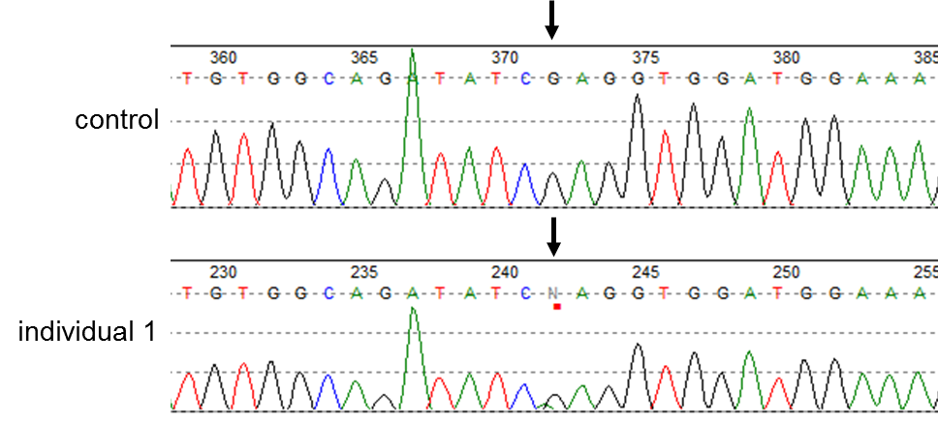
Legend: PCR and subsequent Sanger sequencing confirmed the RHOA c.139G>A (RefSeq NM_001664.4) variant in DNA extracted from skin biopsy of individual 1 (lower panel) and its absence in control DNA (upper panel). c.139 position in RHOA is indicated by black arrow.

Supp. Table S1: Deep-Sequencing results for the RHOA c.139G>A on DNA isolated from blood, skin biopsy and buccal swab of individual 1, and control DNA derived from blood.
Sample |  | Total number of reads | T | G | C | A | del
Individual 1 (blood) | read count | 1,2 10*6
 | % |  | 0.05 | 99.86 | 0.05 | 0.05 | 0.00
Individual 1 (skin biopsy) | read count | 1,2 10*6
 | % |  | 0.02 | 74.32 | 0.05 | 25.62 | 0.00
Individual 1 (buccal swab) | read count | 1,1 10*6
 | % |  | 0.03 | 99.94 | 0.00 | 0.03 | 0.00
control DNA (blood) | read count | 1,2 10*6
 | % |  | 0.01 | 99.99 | 0.00 | 0.00 | 0.00

Supp. Table S2: Deep-Sequencing results for the RHOA c.139G>A on DNA isolated from skin biopsy of individual 2, and parental saliva samples.
Sample |  | Total number of reads | T | G | C | A | del
Individual 2  (skin biopsy) | read count | 110736 | 26 | 92291 | 9 | 9205 | 0
 | % |  | 0.0 | 83.3 | 0.0 | 8.3 | 0.0
Father  (saliva) | read count | 122634 | 19 | 122568 | 8 | 39 | 0
 | % |  | 0.0 | 99.9 | 0.0 | 0.0 | 0.0
Mother  (saliva) | read count | 89680 | 8 | 89612 | 10 | 50 | 0
 | % |  | 0.0 | 99.9 | 0.0 | 0.1 | 0.0

Supp. Table S3: Deep-Sequencing results for the RHOA c.139G>A on DNA isolated from blood and skin biopsy of individual 3, and parental blood samples.
Sample |  | Total number of reads | T | G | C | A | del
Individual 3 (blood) | read count | 8382 | 4 | 8370 | 4 | 4 | 0
 | % |  | 0.05 | 99.86 | 0.05 | 0.05 | 0.00
Individual 3 (skin biopsy) | read count | 11056 | 2 | 8217 | 5 | 2832 | 0
 | % |  | 0.02 | 74.32 | 0.05 | 25.62 | 0.00
Father  (blood) | read count | 18008 | 5 | 17998 | 0 | 5 | 0
 | % |  | 0.03 | 99.94 | 0.00 | 0.03 | 0.00
Mother (blood) | read count | 9109 | 1 | 9108 | 0 | 0 | 0
 | % |  | 0.01 | 99.99 | 0.00 | 0.00 | 0.00

Supplemental Material and Methods

RHOA expression construct
Generation of expression wild-type RHOA (RefSeq NM_001664.4; NP_001655.1) expression plasmid containing coding sequences of human RHOA with an additional, N-terminal FLAG tag was amplified by RT-PCR from isolated HEK293T RNA and cloned into the pcDNA3 expression vector (Life Technologies, Germany). c.139G>A variant was introduced by site directed mutagenesis and all cDNA sequences were confirmed by Sanger sequencing.

Cell culture and immunoblotting
HEK293T cells were cultured in Dulbecco’s modified Eagle medium (DMEM, Gibco) supplemented with 10% fetal calf serum (FCS, Gibco), and antibiotics. Transfection was carried out with 2 µg of each plasmid by using Fugene® HD Transfection reagent (Promega, Germany) following manufacturer’s instructions, and cells were solubilized 24 hours post transfection.

Protein isolation and Western blot analysis
HEK293T cells were solubilized by using ice-cold RIPA buffer (10 mM Tris, pH: 8.0; 150 mM NaCl; 1 mM EDTA; 10 mM NaF; 1 mM Na₃VO₄; 10 µM Na₂MoO₄; 1% NP-40; protease inhibitors P 2714 [Sigma-Aldrich, USA]). The total protein concentration of extracts was determined using the BCA Protein Assay Kit (Thermo Fisher Scientific, USA), and 20 µg of total cell lysates were separated by SDS-Polyacrylamide gel electrophoresis. Transfer and immunoblotting were performed according to standard protocols. Anti-β-Actin and anti-FLAG antibodies were purchased from Sigma-Aldrich. Secondary antibodies conjugated to peroxidase (Santa Cruz Biotechnology Inc., USA) were used and blots were developed using an enhanced chemiluminescence system (Bio-Rad, USA), followed by detection using the ChemiDocTM Touch Imaging System (Bio-Rad, USA).

Amplicon-based deep sequencing
PCR-amplification on the targeted DNA sequences was performed using custom designed primers. PCR products were then used for Illumina TruSeq DNA library preparation without introducing further amplification steps and subsequently sequenced on a Illumina HiSeq4000 sequencer with a PE75 protocol.

Structural analysis and in silico prediction
Structure of the GTP-bound form of RHOA in complex with the effector domain of PKN1 were obtained from the Protein Data Bank (www.wwpdb.org; PDB 1CXZ). The RHOA-PKN1 complex comprises of RHOA (residues 1–181) and PKN1 (residue 13–98), and structural analysis and figure preparation were carried out with the program PyMOL 2.3 (www.pymol.org; Schrödinger, LLC). In silico prediction of the potential effect of the identified variant c.139G>A in RHOA was performed using SIFT (http://sift.bii.a‐star.edu.sg/), PolyPhen-2 (http://genetics.bwh.harvard.edu/pph2/), CADD (https://cadd.gs.washington.edu), and MutationTaster (http://www.mutationtaster.org). Protein alignment was performed using Clustal Omega (https://www.ebi.ac.uk/Tools/msa/clustalo).

