The gut microbiota is associated with the small intestinal paracellular permeability and the development of the immune system in healthy children during the first two years of life

Mariusz Kaczmarczyk, Ulrike Löber, Karolina Adamek, Dagmara Węgrzyn, Karolina Skonieczna-Żydecka, Damian Malinowski, Igor Łoniewski, Lajos Markó, Thomas Ulas, Sofia K. Forslund, Beata Łoniewska

Supplementary materials

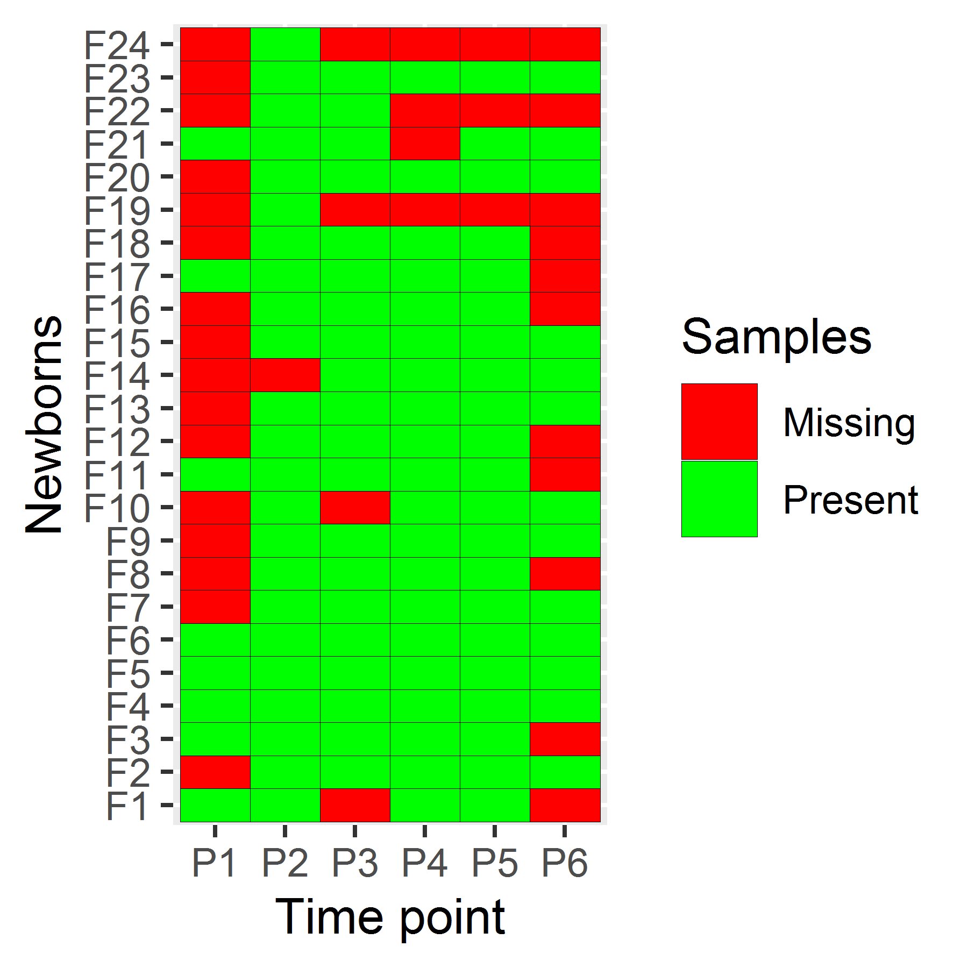
Figure S1. Sample selection and availability (PMU cohort)
From 100 healthy, full-term newborns during the period from March 2015 to April 2016, 18 mother + child pairs were initially selected with the highest number of samples available. Since only in two cases the delivery was natural and neither the mother nor the child was treated with antibiotics, it was decided to supplement this cohort with six pairs of mother + child who were not given antibiotics and the delivery was natural. Out of the 24 newborns that were selected in this way, three newborns (F19, F22, F24) were excluded due to inadequate number of samples. Twenty-one newborns (101 samples in total, green tiles) were included, in whom at least four longitudinal stool samples were available.

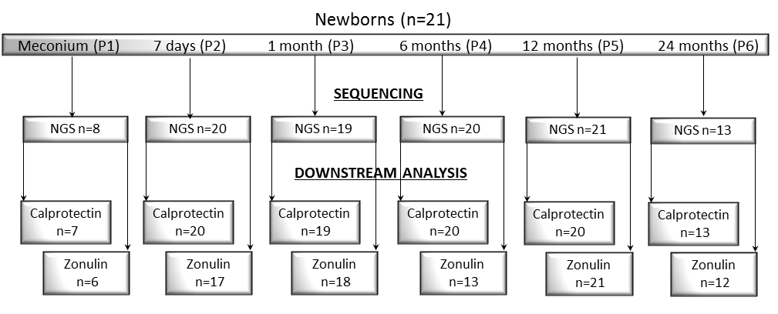

Figure S2. Study flow chart, including zonulin and calprotectin (PMU cohort)
The number of samples for downstream analyses might differ due to results out of determination limits (zonulin 800 ng/mL and calprotectin 2100 ug/mL), technical problems (small volume of collected stool specimen, inadequate amount of DNA, sequencing depth), participant attrition.

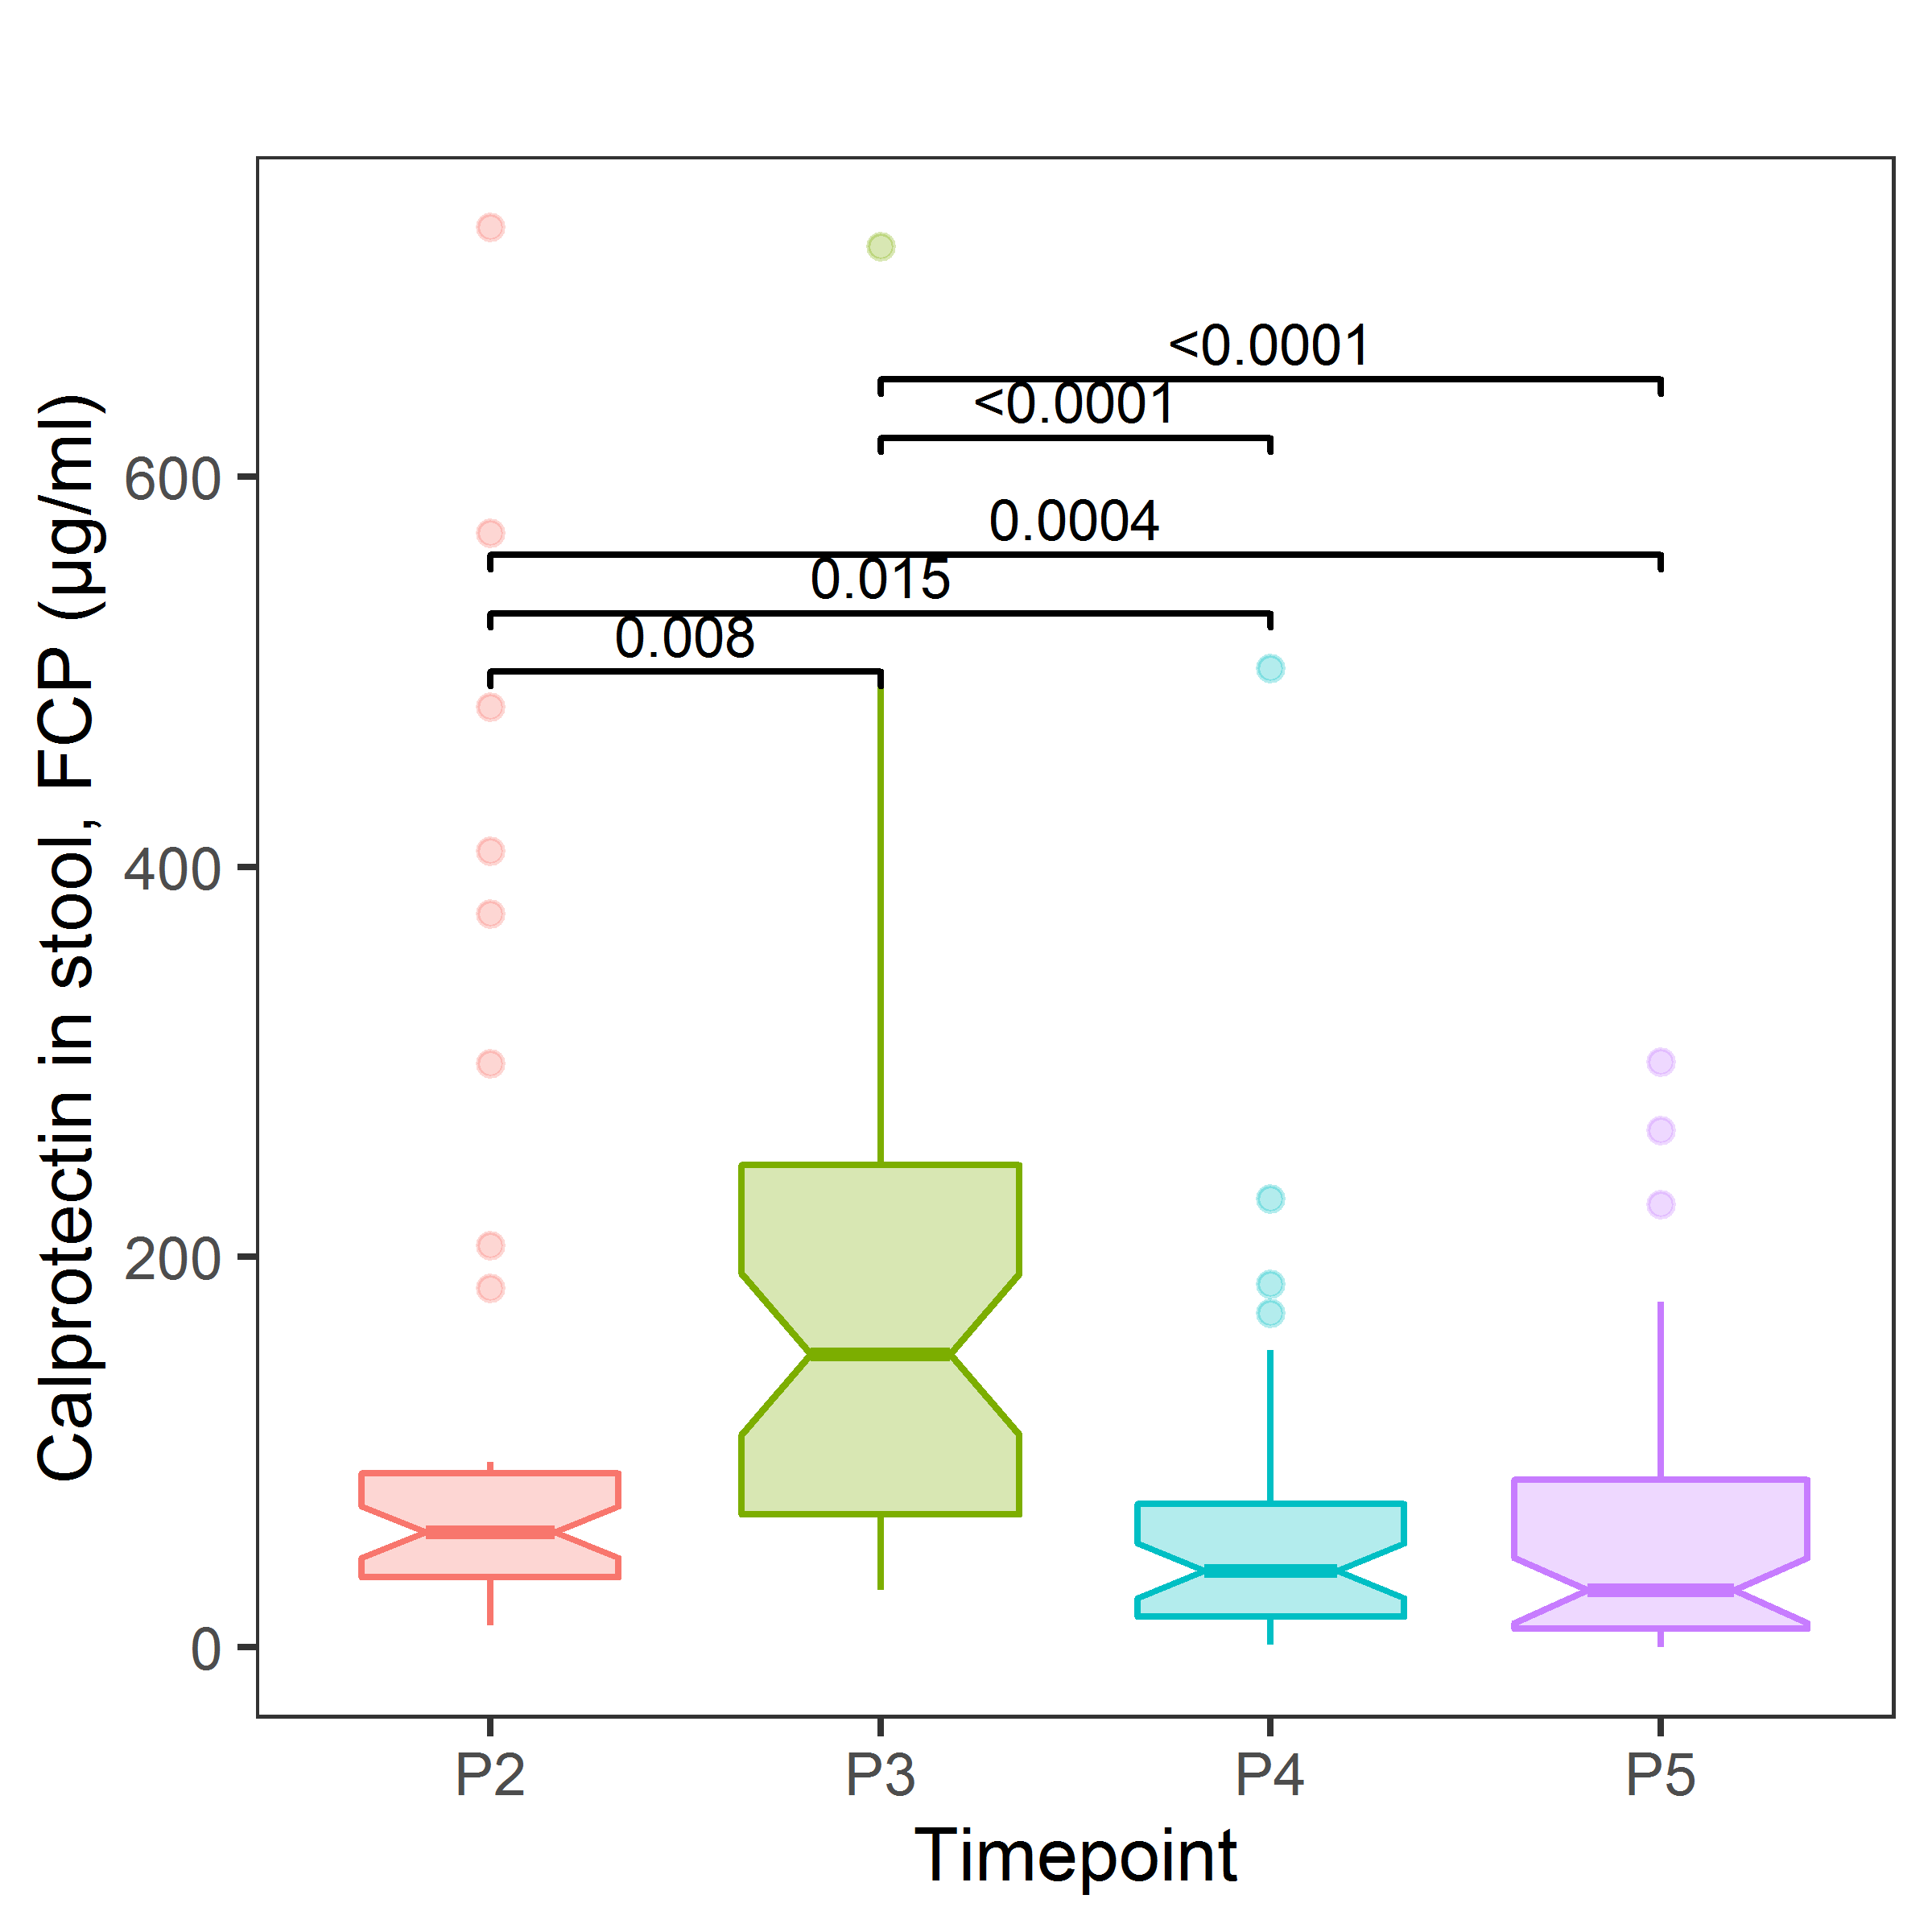

Figure S3. Stool calprotectin level by time in the HMS cohort
Likelihood ratio test, df=3, P=2.56e-10, adjusted for mode of delivery Notched boxplot with variable widths proportional to the square-roots of the number of observations in the groups; FDR adjusted p-values < 0.05 are shown, P2 - 10th day, P3 - 1st month, P4 - 6th month, P5 - 12th month.

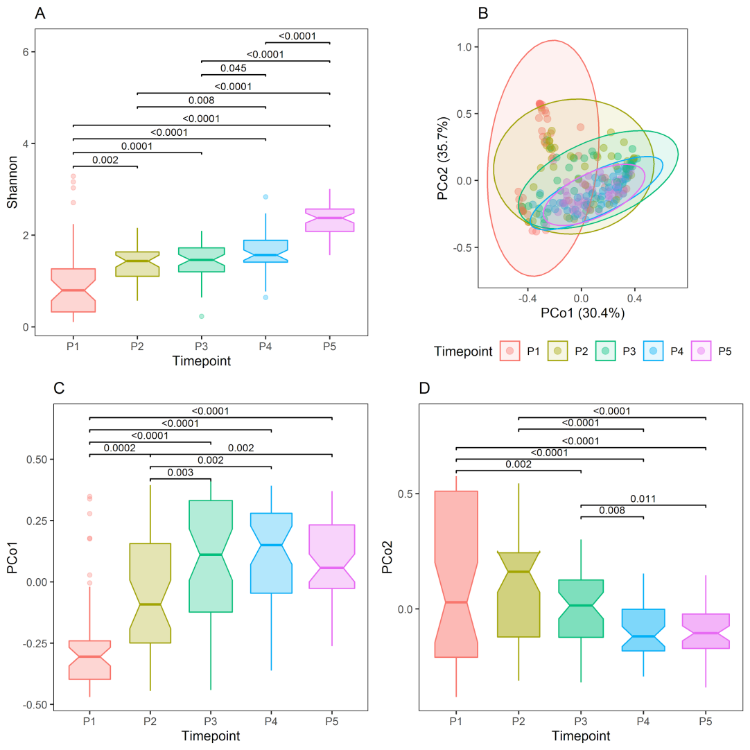
Figure S4. Alpha and beta diversity over time in the HMS cohort
A - Shannon alpha diversity by time, LRT, df=4, P< 2.2e-16, adjusted for mode of delivery, notched boxplot with variable widths proportional to the square-roots of the number of observations in the groups, B - Principal coordinate analysis plot with Bray-Curtis dissimilarity calculated from genus abundances, ellipses were drawn assuming a multivariate t-distribution, C - PCo1 scores by time, LRT, df = 4, P = 2.97e-14, adjusted for mode of delivery; D - PCo2 scores by time, LRT, df = 4, P = 7.31e-11; FDR adjusted p values < 0.05 are shown P1 - 1st day (meconium/the first stool), P2 - 10th day, P3 - 1st month, P4 - 6th month, P5 - 12th month

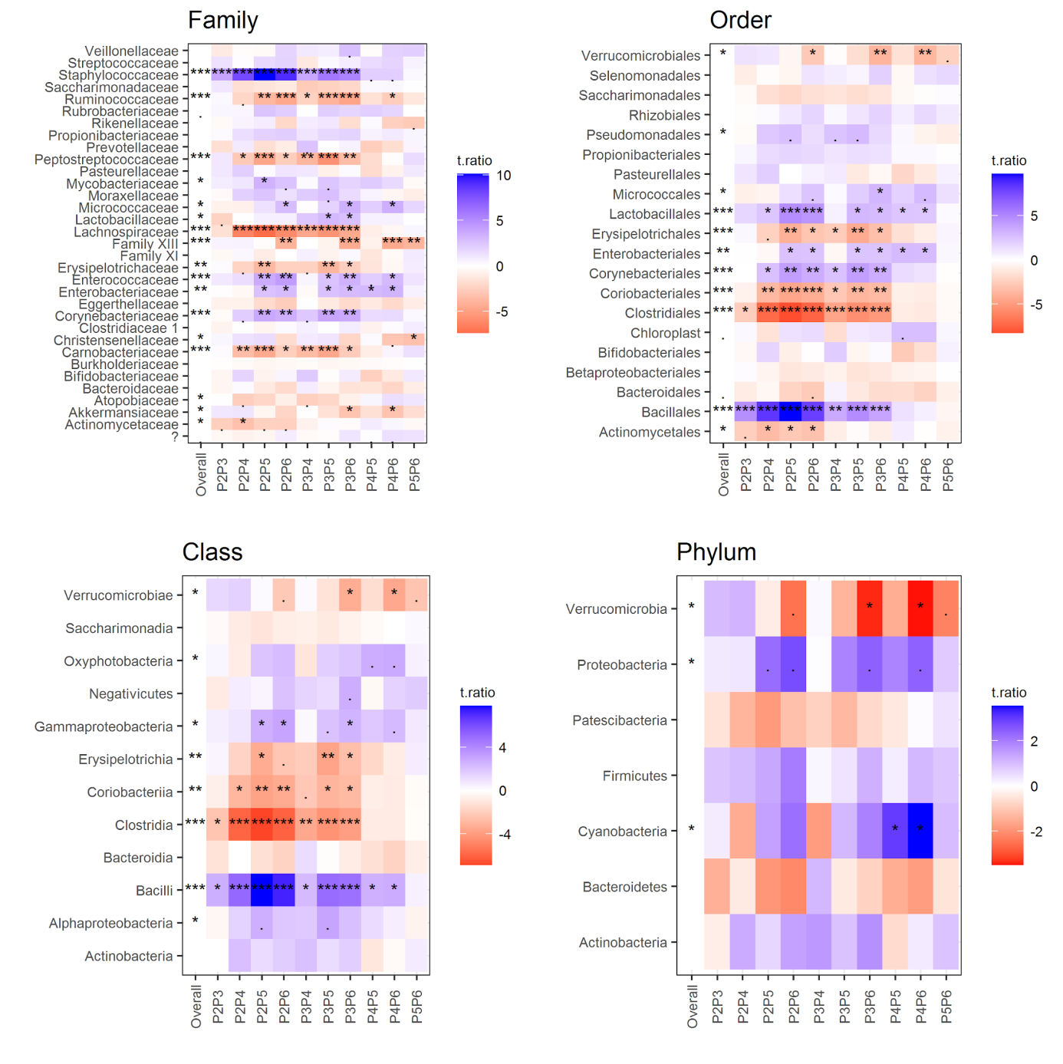

Figure S5. Gut microbiota composition change over time (PMU cohort)
A linear mixed effects analysis followed by pairwise comparison of time points (adjusted for mode of delivery and breastfeeding time). The overall p-value - a likelihood ratio test (LRT) of nested models (FDR adjusted across genera); PXPY - contrast p values between the two time points (PX and PY), FDR adjusted for all possible contrasts, t.ratio - t statistics for the contrasts estimates (a positive value, colored blue, indicates a decrease abundance, a negative value, colored red, indicates increase in abundance). Taxa abundances (unrarefied) were transformed by generating 128 Monte Carlo instances of the Dirichlet distribution for each gut sample, followed by center-logtransform of each instance. A linear mixed effects analysis was performed for each instance separately and the results were averaged over 128 instances. P2 - 7th day, P3 - 1st month, P4 - 6th month, P5 - 12th month, P6 - 24th month.

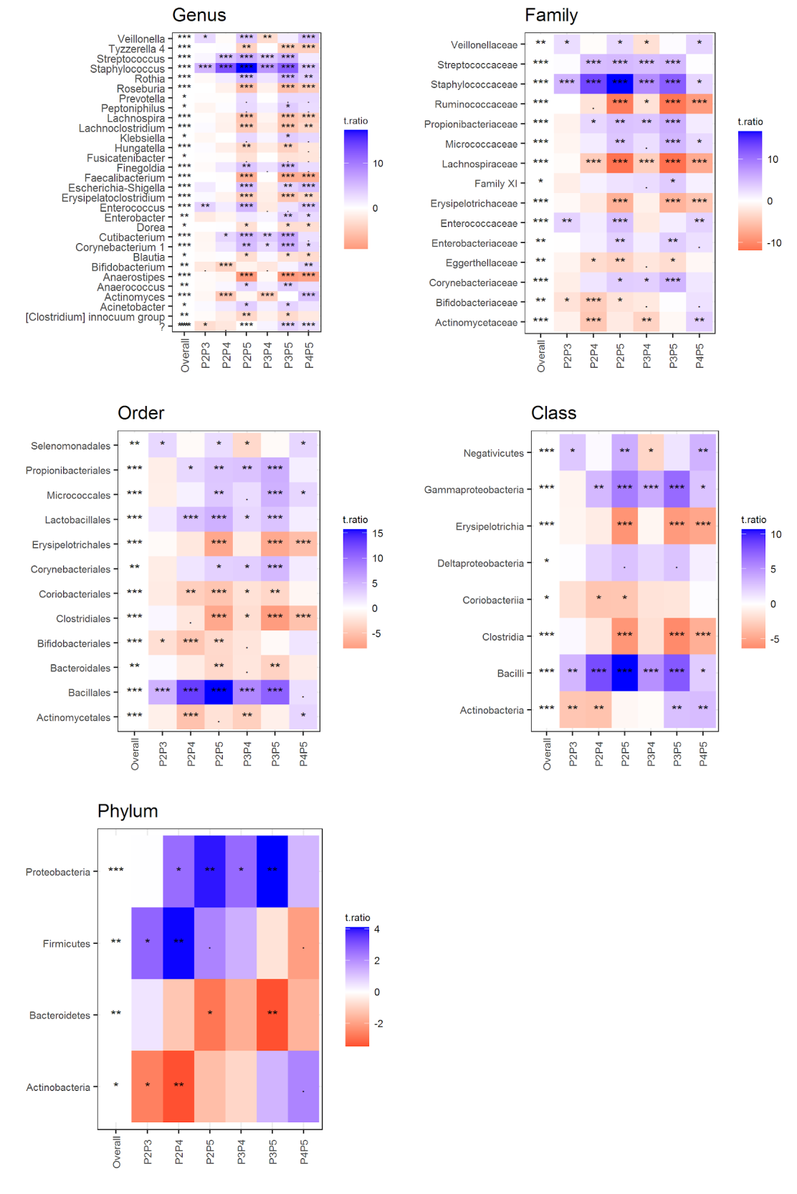

Figure S6. Gut microbiota composition change over time (HMS cohort)
A linear mixed effects analysis followed by pairwise comparison of time points (adjusted for mode of delivery) for five taxonomic ranks (present in at least 10% samples), only taxons significantly associated with time are shown. The overall p-value - a likelihood ratio test (LRT) of nested models (FDR adjusted across taxons); PXPY - contrast p-values between the two time points (PX and PY), FDR adjusted for all possible contrasts, t.ratio - t statistics for the contrasts estimates (a positive value, colored blue, indicates a decrease in abundance, a negative value, colored red, indicates an increase in abundance). Taxa abundances (unrarefied) were transformed by generating 128 Monte Carlo instances of the Dirichlet distribution for each gut sample, followed by center-log transform of each instance. A linear mixed effects analysis was performed for each instance separately and the results were averaged over 128 instances. P2 - 10th day, P3 - 1st month, P4 - 6th month, P5 - 12th month.

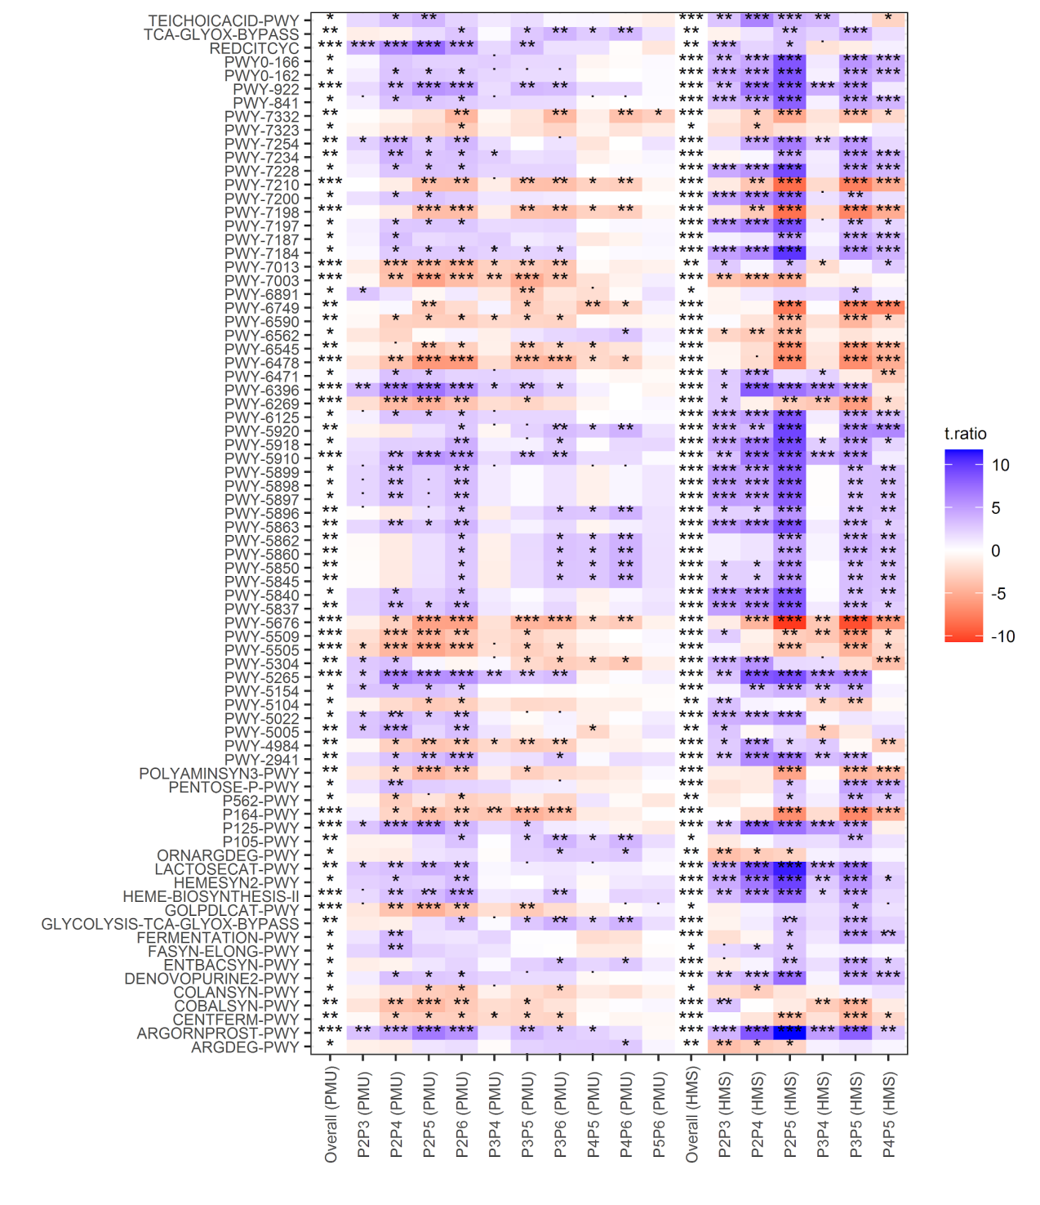

Figure S7. Predicted MetaCyc pathways that change significantly over time in both cohorts (PMU and HMS)
Linear mixed effects analysis followed by pairwise comparison of time points (adjusted for mode of delivery and breastfeeding time (PMU) and mode of delivery only in the HMS cohort). The overall p-value - a likelihood ratio test (LRT) of nested models (FDR adjusted across pathways); PXPY - contrast p values between the two time points (X and Y), FDR adjusted for all possible contrasts, t.ratio - t statistics for the contrasts estimates. Pathway abundances (unrarefied) were transformed by generating 128 Monte Carlo instances of the Dirichlet distribution for each gut sample, followed by center-log transform of each instance. A linear mixed effects analysis was performed for each instance separately and the results were averaged over 128 instances. P2 - 7th day (PMU) or 10th day (HMS), P3 - 1st month, P4 - 6th month, P5 - 12th month, P6 - 24th month (PMU only).

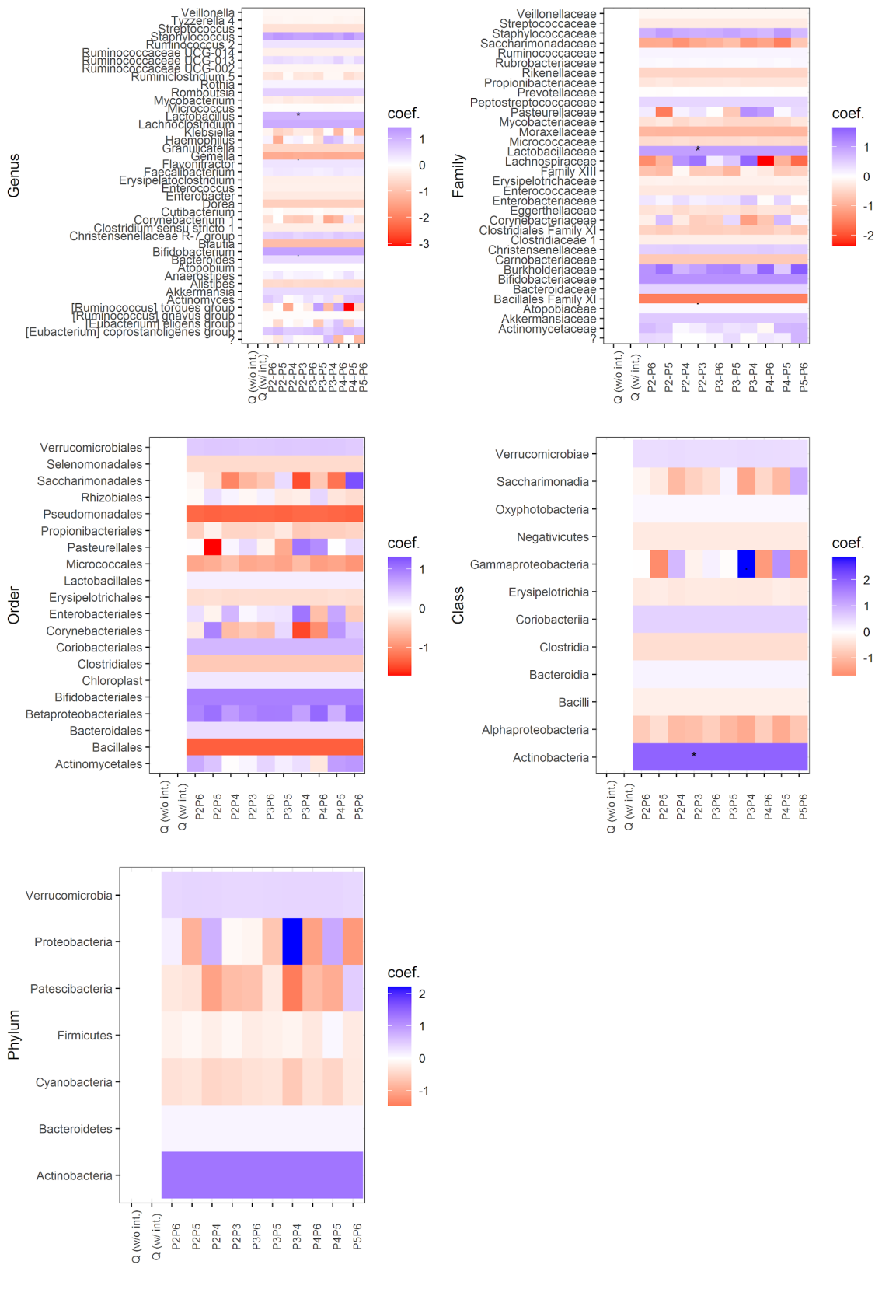

Figure S8. Taxon change versus zonulin change (PMU cohort)
Linear mixed effects models were used to test for an association between the taxon abundance change and zonulin change accounting for ten time point pairs (P2-P3, P3-P4, etc.) from the same subject, adjusted for mode of delivery and breastfeeding time. Two models were considered: without interaction (w/o int.) and with interaction between time point pair and taxon change (w/ int.). If the interaction term was significant - Q (w/ int.) < 0.05, individual p values (FDR adjusted) were interpreted. If the common slope model was chosen - Q (w/o int.) < 0.05 and Q (w /int) > 0.05, the same common slope coefficient β (coef.) across all time points and one p-value (P2-P3) were shown. Coefficients and Q values were averaged over 128 Monte Carlo instances of the Dirichlet distribution, followed by center-log transform of each instance.

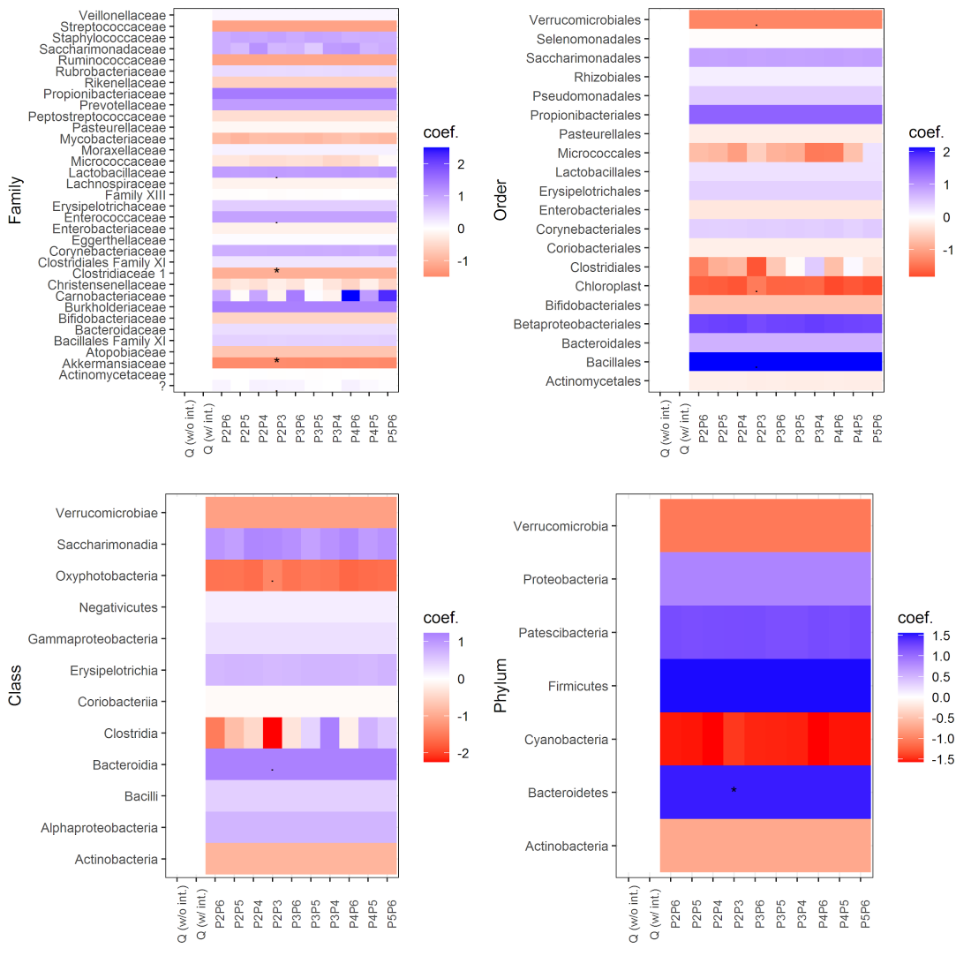

Figure S9. Taxon change versus calprotectin change (PMU cohort)
Linear mixed effects models were used to test for an association between the taxon abundance change and calprotectin change accounting for ten time point pairs (P2-P3, P3-P4, etc.) from the same subject, adjusted for mode of delivery and breastfeeding time. Two models were considered: without interaction (w/o int.) and with interaction between time point pair and taxon change (w/ int.). If the interaction term was significant - Q (w/ int.) < 0.05, individual p values (FDR adjusted) were interpreted. If the common slope model was chosen - Q (w/o int.) < 0.05 and Q (w /int) > 0.05, the same common slope coefficient β (coef.) across all time points and one p-value (P2-P3) were shown. Coefficients and Q values were averaged over 128 Monte Carlo instances of the Dirichlet distribution, followed by center-log transform of each instance.
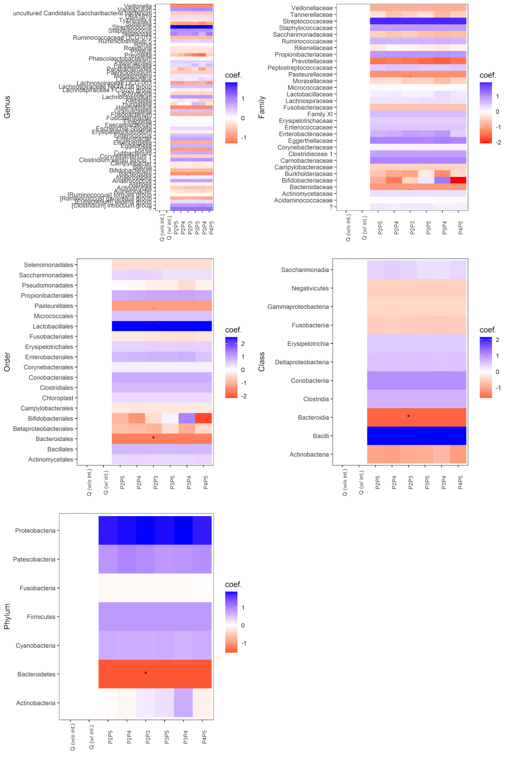

Figure S10. Taxon change versus calprotectin change (HMS cohort)
Linear mixed effects models were used to test for an association between the taxon abundance change and calprotectin change accounting for six time point pairs (P2-P3, P3-P4, etc.) from the same subject, adjusted for mode of delivery. Two models were considered: without interaction (w/o int.) and with interaction between time point pair and taxon change (w/ int.). If the interaction term was significant - Q (w/ int.) < 0.05, individual p values (FDR adjusted) were interpreted. If the common slope model was chosen - Q (w/o int.) < 0.05 and Q (w /int) > 0.05, the same common slope coefficient β (coef.) across all time points and one p-value (P2-P3) were shown. Coefficients and Q values were averaged over 128 Monte Carlo instances of the Dirichlet distribution, followed by center-log transform of each instance.

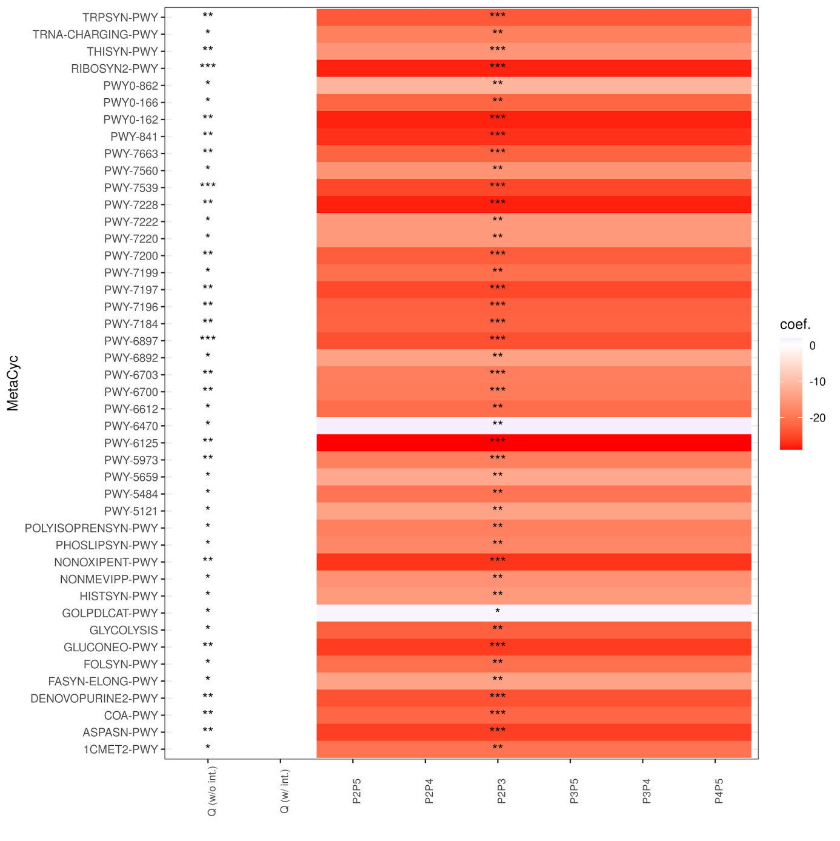

Figure S11. Pathway change vs calprotectin change (HMS cohort)
Linear mixed effects models were used to test for an association between the pathway abundance change and calprotectin change accounting for six time point pairs (P2-P3, P3-P4, etc.) from the same subject, adjusted for mode of delivery. Two models were considered: without interaction (w/o int.) and with interaction between time point pair and taxon change (w/ int.). If the interaction term was significant - Q (w/ int.) < 0.05, individual p values (FDR adjusted) were interpreted. If the common slope model was chosen - Q (w/o int.) < 0.05 and Q (w /int) > 0.05, the same common slope coefficient β (coef.) across all time points and one p-value (P2-P3) were shown. Coefficients and Q values were averaged over 128 Monte Carlo instances of the Dirichlet distribution, followed by center-log transform of each instance.
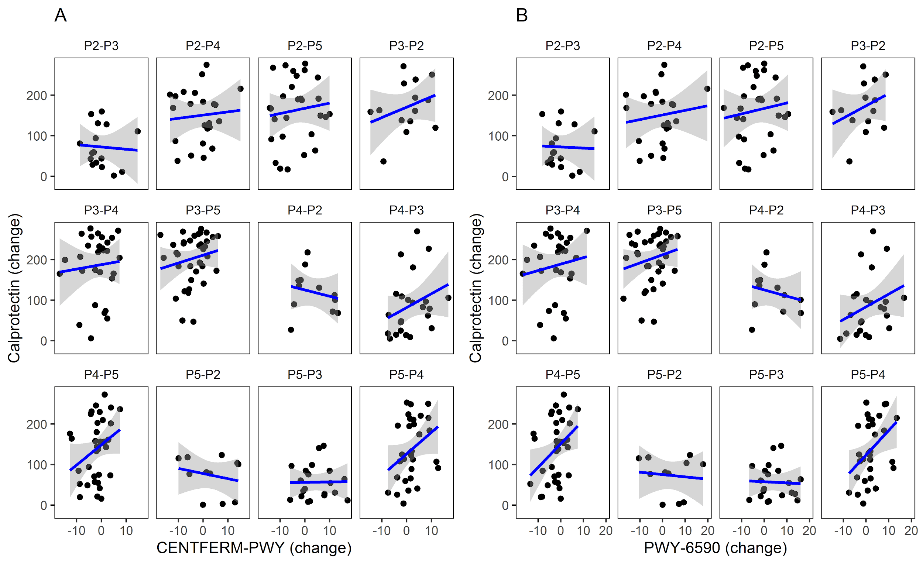

Figure S12. Relationship between (changes in) gut abundance of inferred MetaCyc pathways and (changes in) calprotectin levels (HMS cohort)
A - common slope model illustrating relationships between CENTFERM-PWY change (centered log-ratio transformed) and calprotectin change (rank transformed), B - common slope model illustrating relationships between PWY-6590 change (centered log-ratio transformed) and calprotectin change (rank transformed); Likelihood ratio test (LRT) p- and Q-values were computed based on 128 Monte Carlo instances of the Dirichlet distribution, followed by center-log transform of each instance, the plots were based on the first Monte Carlo instance.

Table S1. Repeated measures correlation of zonulin and calprotectin with microorganisms and predicted MetaCyc pathways (PMU cohort)
Biomarker | Bacterial/Pathway name | r | Taxonomic rank/MetaCyc pathway category | Q
Zonulin | Corynebacterium 1 | -0.38 | Genus | 0.033
 | Staphylococcus | -0.39 |  | 0.028
 | Lachnoclostridium | 0.45 |  | 0.014
 | [Ruminococcus] gnavus group | 0.36 |  | 0.046
 | [Ruminococcus] torques group | 0.40 |  | 0.026
Calprotectin | Staphylococcus | 0.38 |  | 0.023
 | Enterococcus | 0.40 |  | 0.019
 | Anaerostipes | -0.35 |  | 0.043
Zonulin | Staphylococcaceae | -0.41 | Family | 0.014
 | Lachnospiraceae | 0.47 |  | 0.004
 | Peptostreptococcaceae | 0.38 |  | 0.030
 | Ruminococcaceae | 0.36 |  | 0.041
 | Moraxellaceae | -0.41 |  | 0.022
Calprotectin | Staphylococcaceae | 0.35 |  | 0.040
 | Enterococcaceae | 0.36 |  | 0.038
 | Ruminococcaceae | -0.34 |  | 0.046
Zonulin | Coriobacteriales | 0.42 | Order | 0.006
 | Bacillales | -0.52 |  | 0.0004
 | Clostridiales | 0.48 |  | 0.001
 | Erysipelotrichales | 0.34 |  | 0.035
 | Pseudomonadales | -0.41 |  | 0.012
Calprotectin | Clostridiales | -0.34 |  | 0.048
Zonulin | Coriobacteriia | 0.38 | Class | 0.012
 | Bacilli | -0.41 |  | 0.006
 | Clostridia | 0.44 |  | 0.004
 | Alphaproteobacteria | -0.33 |  | 0.036
Zonulin | FUC-RHAMCAT-PWY | 0.51 | Superpathways | 0.004
Zonulin | FUCCAT-PWY | 0.48 | Degradation/Utilization/Assimilation | 0.007
 | PWY-6353 | 0.42 |  | 0.025
 | PWY-7237 | 0.46 |  | 0.011
 | SALVADEHYPOX-PWY | 0.42 |  | 0.026
Zonulin | PWY-5676 | 0.40 | Generation of Precursor Metabolites and Energy | 0.044
 | PWY-5677 | 0.52 |  | 0.004
 | PWY-6588 | 0.49 |  | 0.006
 | PWY-7003 | 0.50 |  | 0.006
Calprotectin | PWY-5677 | -0.45 |  | 0.026
 | PWY-6588 | -0.42 |  | 0.041
Zonulin | PWY-6478 | 0.47 | Biosynthesis | 0.009
Note: r- repeated measures correlation coefficient, Q - FDR adjusted p-value

Table S2. Repeated measures correlation of calprotectin with bacteria and MetaCyc pathway abundance in the PMU and HMS cohorts
PMU cohort (P2-P6) | HMS cohort (P2-P5)
Genus  Staphylococcus (0.38), Enterococcus (0.40), Anaerostipes (-0.36) | Genus  Staphylococcus (0.34), Lachnospira (-0.22), Streptococcus (0.30), Rothia (0.25), Cutibacterium (0.25)
Family  Staphylococcaceae (0.35), Enterococcaceae (0.36), Ruminococcaceae (-0.34) | Family  Staphylococcaceae (0.34),  Streptococcaceae (0.29),  Ruminococcaceae (-0.29),  Lachnospiraceae (-0.34),  Micrococcaceae (0.23),  Propionibacteriaceae (0.24)
Order  Clostridiales (-0.34) | Order  Clostridiales (-0.23),  Micrococcales (0.26),  Propionibacteriales (0.23),  Bacteroidales (-0.22),  Bacillales (0.32),  Lactobacillales (0.25),  Erysipelotrichales (-0.19),  Pasteurellales (-0.20)
Class  No significant correlations | Class  Bacilli (0.30)
Phylum  No significant correlations | Phylum  No significant correlations
MetaCyc pathways  PWY-5677 (-0.45), PWY-6588 (-0.42) | MetaCyc pathways  ARGORNPROST-PWY (0.30), GOLPDLCAT-PWY (0.32), LACTOSECAT-PWY (0.33), P125-PWY (0.33), P562-PWY (0.30), PWY-2941 (0.33), PWY-5265 (0.38), PWY-5509 (-0.30), PWY-5676 (-0.35), PWY-5910 (0.33), PWY-6269 (-0.30), PWY-6396 (0.29), PWY-7198 (-0.29), PWY-7210 (-0.30), PWY-922 (0.33)

Table S3. Pathway change vs Zonulin change (PMU cohort)
No | Pathway | P (w/o int.) | P (w/ int.) | Q (w/o int.) | Q (w/ int.)
1 | 1CMET2-PWY | 0.181 | 0.097 | 0.564 | 0.349
2 | 3-HYDROXYPHENYLACETATE-DEGRADATION-PWY | 0.694 | 0.292 | 0.881 | 0.523
3 | AEROBACTINSYN-PWY | 0.273 | 0.462 | 0.635 | 0.643
4 | ALL-CHORISMATE-PWY | 0.869 | 0.336 | 0.962 | 0.562
5 | ANAEROFRUCAT-PWY | 0.357 | 0.098 | 0.701 | 0.349
6 | ANAGLYCOLYSIS-PWY | 0.116 | 0.307 | 0.543 | 0.535
7 | ARG+POLYAMINE-SYN | 0.890 | 0.233 | 0.968 | 0.494
8 | ARGDEG-PWY | 0.694 | 0.408 | 0.883 | 0.605
9 | ARGORNPROST-PWY | 0.945 | 0.228 | 0.983 | 0.490
10 | ARGSYN-PWY | 0.753 | 0.045 | 0.931 | 0.240
11 | ARGSYNBSUB-PWY | 0.884 | 0.014 | 0.970 | 0.185
12 | ARO-PWY | 0.378 | 0.179 | 0.707 | 0.463
13 | ASPASN-PWY | 0.230 | 0.703 | 0.619 | 0.803
14 | AST-PWY | 0.051 | 0.036 | 0.494 | 0.221
15 | BIOTIN-BIOSYNTHESIS-PWY | 0.145 | 0.029 | 0.553 | 0.220
16 | BRANCHED-CHAIN-AA-SYN-PWY | 0.372 | 0.025 | 0.705 | 0.212
17 | CALVIN-PWY | 0.279 | 0.724 | 0.664 | 0.816
18 | CATECHOL-ORTHO-CLEAVAGE-PWY | 0.376 | 0.022 | 0.707 | 0.180
19 | CENTFERM-PWY | 0.600 | 0.228 | 0.844 | 0.488
20 | CHLOROPHYLL-SYN | 0.551 | 0.696 | 0.800 | 0.799
21 | COA-PWY | 0.185 | 0.282 | 0.566 | 0.522
22 | COBALSYN-PWY | 0.950 | 0.261 | 0.984 | 0.508
23 | COLANSYN-PWY | 0.563 | 0.195 | 0.823 | 0.474
24 | COMPLETE-ARO-PWY | 0.411 | 0.182 | 0.725 | 0.466
25 | DAPLYSINESYN-PWY | 0.220 | 0.032 | 0.607 | 0.225
26 | DENOVOPURINE2-PWY | 0.215 | 0.411 | 0.601 | 0.616
27 | DTDPRHAMSYN-PWY | 0.025 | 0.050 | 0.498 | 0.249
28 | ECASYN-PWY | 0.710 | 0.330 | 0.889 | 0.555
29 | ENTBACSYN-PWY | 0.861 | 0.534 | 0.959 | 0.694
30 | FAO-PWY | 0.305 | 0.831 | 0.674 | 0.886
31 | FASYN-ELONG-PWY | 0.758 | 0.398 | 0.934 | 0.608
32 | FASYN-INITIAL-PWY | 0.070 | 0.105 | 0.534 | 0.360
33 | FERMENTATION-PWY | 0.339 | 0.020 | 0.695 | 0.201
34 | FOLSYN-PWY | 0.085 | 0.010 | 0.538 | 0.175
35 | FUC-RHAMCAT-PWY | 0.620 | 0.887 | 0.855 | 0.923
36 | FUCCAT-PWY | 0.889 | 0.952 | 0.969 | 0.968
37 | GALACT-GLUCUROCAT-PWY | 0.168 | 0.286 | 0.562 | 0.525
38 | GALACTARDEG-PWY | 0.133 | 0.153 | 0.558 | 0.414
39 | GALACTUROCAT-PWY | 0.086 | 0.038 | 0.537 | 0.231
40 | GALLATE-DEGRADATION-I-PWY | 0.426 | 0.078 | 0.730 | 0.284
41 | GALLATE-DEGRADATION-II-PWY | 0.422 | 0.081 | 0.728 | 0.284
42 | GLCMANNANAUT-PWY | 0.729 | 0.643 | 0.919 | 0.764
43 | GLUCARDEG-PWY | 0.144 | 0.168 | 0.562 | 0.433
44 | GLUCARGALACTSUPER-PWY | 0.136 | 0.159 | 0.559 | 0.422
45 | GLUCONEO-PWY | 0.841 | 0.416 | 0.955 | 0.619
46 | GLUCOSE1PMETAB-PWY | 0.898 | 0.711 | 0.971 | 0.807
47 | GLUCUROCAT-PWY | 0.138 | 0.565 | 0.548 | 0.713
48 | GLUTORN-PWY | 0.547 | 0.008 | 0.813 | 0.162
49 | GLYCOCAT-PWY | 0.540 | 0.030 | 0.808 | 0.222
50 | GLYCOGENSYNTH-PWY | 0.876 | 0.052 | 0.968 | 0.252
51 | GLYCOL-GLYOXDEG-PWY | 0.553 | 0.006 | 0.813 | 0.124
52 | GLYCOLYSIS | 0.292 | 0.370 | 0.672 | 0.586
53 | GLYCOLYSIS-E-D | 0.363 | 0.890 | 0.703 | 0.923
54 | GLYCOLYSIS-TCA-GLYOX-BYPASS | 0.855 | 0.035 | 0.958 | 0.227
55 | GLYOXYLATE-BYPASS | 0.760 | 0.043 | 0.920 | 0.237
56 | GOLPDLCAT-PWY | 0.636 | 0.647 | 0.852 | 0.766
57 | HCAMHPDEG-PWY | 0.559 | 0.121 | 0.806 | 0.339
58 | HEME-BIOSYNTHESIS-II | 0.617 | 0.810 | 0.856 | 0.872
59 | HEMESYN2-PWY | 0.589 | 0.427 | 0.839 | 0.628
60 | HEXITOLDEGSUPER-PWY | 0.072 | 0.157 | 0.533 | 0.433
61 | HISDEG-PWY | 0.027 | 0.053 | 0.499 | 0.259
62 | HISTSYN-PWY | 0.700 | 0.040 | 0.907 | 0.235
63 | HOMOSER-METSYN-PWY | 0.107 | 0.042 | 0.541 | 0.238
64 | HSERMETANA-PWY | 0.917 | 0.001 | 0.976 | 0.099
65 | ILEUSYN-PWY | 0.378 | 0.019 | 0.707 | 0.198
66 | KDO-NAGLIPASYN-PWY | 0.033 | 0.521 | 0.491 | 0.686
67 | LACTOSECAT-PWY | 0.032 | 0.391 | 0.508 | 0.603
68 | LEU-DEG2-PWY | 0.349 | 0.774 | 0.679 | 0.850
69 | LPSSYN-PWY | 0.274 | 0.228 | 0.610 | 0.444
70 | MET-SAM-PWY | 0.101 | 0.031 | 0.540 | 0.224
71 | METH-ACETATE-PWY | 0.334 | 0.113 | 0.682 | 0.368
72 | METHGLYUT-PWY | 0.510 | 0.394 | 0.774 | 0.579
73 | METHYLGALLATE-DEGRADATION-PWY | 0.494 | 0.077 | 0.773 | 0.285
74 | NAD-BIOSYNTHESIS-II | 0.335 | 0.138 | 0.686 | 0.405
75 | NAGLIPASYN-PWY | 0.414 | 0.191 | 0.729 | 0.472
76 | NONMEVIPP-PWY | 0.112 | 0.045 | 0.542 | 0.240
77 | NONOXIPENT-PWY | 0.121 | 0.533 | 0.544 | 0.690
78 | OANTIGEN-PWY | 0.064 | 0.508 | 0.534 | 0.677
79 | ORNARGDEG-PWY | 0.683 | 0.392 | 0.878 | 0.596
80 | ORNDEG-PWY | 0.703 | 0.463 | 0.886 | 0.646
81 | P101-PWY | 0.440 | 0.099 | 0.734 | 0.315
82 | P105-PWY | 0.854 | 0.092 | 0.959 | 0.336
83 | P108-PWY | 0.601 | 0.086 | 0.845 | 0.335
84 | P122-PWY | 0.143 | 0.118 | 0.548 | 0.380
85 | P124-PWY | 0.070 | 0.123 | 0.535 | 0.387
86 | P125-PWY | 0.196 | 0.689 | 0.588 | 0.793
87 | P161-PWY | 0.202 | 0.045 | 0.585 | 0.242
88 | P162-PWY | 0.716 | 0.174 | 0.892 | 0.402
89 | P163-PWY | 0.565 | 0.889 | 0.811 | 0.925
90 | P164-PWY | 0.222 | 0.225 | 0.613 | 0.480
91 | P221-PWY | 0.009 | 0.065 | 0.380 | 0.282
92 | P23-PWY | 0.504 | 0.624 | 0.788 | 0.751
93 | P281-PWY | 0.696 | 0.319 | 0.881 | 0.531
94 | P381-PWY | 0.238 | 0.174 | 0.602 | 0.399
95 | P4-PWY | 0.305 | 0.004 | 0.678 | 0.121
96 | P42-PWY | 0.267 | 0.280 | 0.656 | 0.520
97 | P441-PWY | 0.530 | 0.739 | 0.803 | 0.825
98 | P461-PWY | 0.045 | 0.393 | 0.517 | 0.604
99 | P562-PWY | 0.031 | 0.762 | 0.476 | 0.841
100 | PANTO-PWY | 0.245 | 0.327 | 0.629 | 0.554
101 | PANTOSYN-PWY | 0.247 | 0.305 | 0.631 | 0.538
102 | PENTOSE-P-PWY | 0.0000091 | 0.134 | 0.003 | 0.406
103 | PEPTIDOGLYCANSYN-PWY | 0.165 | 0.294 | 0.553 | 0.529
104 | PHOSLIPSYN-PWY | 0.671 | 0.504 | 0.890 | 0.675
105 | POLYAMINSYN3-PWY | 0.783 | 0.376 | 0.927 | 0.591
106 | POLYAMSYN-PWY | 0.841 | 0.332 | 0.952 | 0.560
107 | POLYISOPRENSYN-PWY | 0.866 | 0.483 | 0.963 | 0.663
108 | PPGPPMET-PWY | 0.062 | 0.216 | 0.500 | 0.473
109 | PROTOCATECHUATE-ORTHO-CLEAVAGE-PWY | 0.712 | 0.014 | 0.891 | 0.162
110 | PRPP-PWY | 0.937 | 0.826 | 0.981 | 0.883
111 | PWY-1269 | 0.461 | 0.341 | 0.757 | 0.567
112 | PWY-1861 | 0.099 | 0.402 | 0.540 | 0.610
113 | PWY-2941 | 0.543 | 0.227 | 0.811 | 0.489
114 | PWY-2942 | 0.147 | 0.254 | 0.548 | 0.504
115 | PWY-3001 | 0.302 | 0.034 | 0.677 | 0.227
116 | PWY-3781 | 0.727 | 0.766 | 0.898 | 0.844
117 | PWY-4984 | 0.838 | 0.636 | 0.955 | 0.759
118 | PWY-5005 | 0.746 | 0.464 | 0.929 | 0.653
119 | PWY-5022 | 0.179 | 0.045 | 0.566 | 0.243
120 | PWY-5028 | 0.202 | 0.414 | 0.575 | 0.606
121 | PWY-5088 | 0.342 | 0.846 | 0.674 | 0.897
122 | PWY-5097 | 0.056 | 0.199 | 0.533 | 0.475
123 | PWY-5100 | 0.310 | 0.651 | 0.681 | 0.770
124 | PWY-5101 | 0.569 | 0.033 | 0.824 | 0.226
125 | PWY-5103 | 0.376 | 0.023 | 0.707 | 0.207
126 | PWY-5104 | 0.919 | 0.225 | 0.977 | 0.488
127 | PWY-5121 | 0.084 | 0.052 | 0.537 | 0.251
128 | PWY-5154 | 0.141 | 0.036 | 0.547 | 0.228
129 | PWY-5177 | 0.840 | 0.819 | 0.957 | 0.879
130 | PWY-5178 | 0.207 | 0.117 | 0.598 | 0.333
131 | PWY-5180 | 0.131 | 0.329 | 0.555 | 0.559
132 | PWY-5181 | 0.119 | 0.595 | 0.542 | 0.733
133 | PWY-5182 | 0.123 | 0.337 | 0.552 | 0.563
134 | PWY-5188 | 0.143 | 0.085 | 0.552 | 0.331
135 | PWY-5189 | 0.155 | 0.087 | 0.557 | 0.334
136 | PWY-5198 | 0.401 | 0.300 | 0.710 | 0.510
137 | PWY-5265 | 0.373 | 0.084 | 0.706 | 0.314
138 | PWY-5304 | 0.036 | 0.081 | 0.513 | 0.320
139 | PWY-5345 | 0.830 | 0.479 | 0.958 | 0.662
140 | PWY-5347 | 0.065 | 0.046 | 0.534 | 0.241
141 | PWY-5384 | 0.176 | 0.602 | 0.561 | 0.736
142 | PWY-5415 | 0.447 | 0.278 | 0.745 | 0.523
143 | PWY-5417 | 0.243 | 0.021 | 0.625 | 0.176
144 | PWY-5431 | 0.237 | 0.018 | 0.621 | 0.170
145 | PWY-5484 | 0.162 | 0.205 | 0.552 | 0.478
146 | PWY-5505 | 0.221 | 0.343 | 0.607 | 0.566
147 | PWY-5507 | 0.241 | 0.172 | 0.606 | 0.396
148 | PWY-5509 | 0.875 | 0.396 | 0.968 | 0.606
149 | PWY-5531 | 0.544 | 0.643 | 0.799 | 0.764
150 | PWY-5532 | 0.209 | 0.276 | 0.566 | 0.495
151 | PWY-5659 | 0.955 | 0.525 | 0.986 | 0.688
152 | PWY-5667 | 0.351 | 0.527 | 0.700 | 0.687
153 | PWY-5676 | 0.460 | 0.946 | 0.751 | 0.963
154 | PWY-5677 | 0.086 | 0.769 | 0.512 | 0.846
155 | PWY-5686 | 0.142 | 0.252 | 0.547 | 0.503
156 | PWY-5695 | 0.045 | 0.574 | 0.529 | 0.718
157 | PWY-5705 | 0.026 | 0.588 | 0.455 | 0.729
158 | PWY-5747 | 0.502 | 0.327 | 0.773 | 0.549
159 | PWY-5837 | 0.170 | 0.393 | 0.563 | 0.604
160 | PWY-5838 | 0.421 | 0.429 | 0.737 | 0.629
161 | PWY-5840 | 0.378 | 0.212 | 0.714 | 0.482
162 | PWY-5845 | 0.146 | 0.685 | 0.556 | 0.791
163 | PWY-5850 | 0.153 | 0.692 | 0.558 | 0.795
164 | PWY-5855 | 0.544 | 0.024 | 0.808 | 0.190
165 | PWY-5856 | 0.557 | 0.023 | 0.816 | 0.186
166 | PWY-5857 | 0.565 | 0.026 | 0.821 | 0.191
167 | PWY-5860 | 0.153 | 0.598 | 0.562 | 0.736
168 | PWY-5861 | 0.470 | 0.530 | 0.767 | 0.690
169 | PWY-5862 | 0.151 | 0.599 | 0.560 | 0.736
170 | PWY-5863 | 0.181 | 0.391 | 0.571 | 0.603
171 | PWY-5896 | 0.156 | 0.691 | 0.561 | 0.795
172 | PWY-5897 | 0.358 | 0.232 | 0.708 | 0.491
173 | PWY-5898 | 0.358 | 0.230 | 0.707 | 0.490
174 | PWY-5899 | 0.359 | 0.232 | 0.708 | 0.491
175 | PWY-5910 | 0.374 | 0.712 | 0.713 | 0.808
176 | PWY-5913 | 0.143 | 0.012 | 0.548 | 0.179
177 | PWY-5918 | 0.503 | 0.632 | 0.787 | 0.756
178 | PWY-5920 | 0.722 | 0.488 | 0.909 | 0.665
179 | PWY-5971 | 0.024 | 0.204 | 0.494 | 0.477
180 | PWY-5973 | 0.848 | 0.790 | 0.964 | 0.861
181 | PWY-5989 | 0.071 | 0.097 | 0.534 | 0.350
182 | PWY-6071 | 0.393 | 0.257 | 0.717 | 0.500
183 | PWY-6121 | 0.138 | 0.300 | 0.547 | 0.531
184 | PWY-6122 | 0.147 | 0.308 | 0.548 | 0.536
185 | PWY-6123 | 0.117 | 0.271 | 0.543 | 0.514
186 | PWY-6125 | 0.300 | 0.694 | 0.677 | 0.798
187 | PWY-6126 | 0.057 | 0.197 | 0.533 | 0.474
188 | PWY-6147 | 0.233 | 0.003 | 0.623 | 0.116
189 | PWY-6151 | 0.089 | 0.476 | 0.538 | 0.660
190 | PWY-6163 | 0.265 | 0.197 | 0.654 | 0.474
191 | PWY-6165 | 0.295 | 0.536 | 0.607 | 0.685
192 | PWY-6182 | 0.520 | 0.123 | 0.786 | 0.325
193 | PWY-6185 | 0.548 | 0.348 | 0.801 | 0.551
194 | PWY-621 | 0.605 | 0.487 | 0.846 | 0.667
195 | PWY-6269 | 0.873 | 0.394 | 0.967 | 0.604
196 | PWY-6277 | 0.148 | 0.308 | 0.548 | 0.536
197 | PWY-6282 | 0.072 | 0.103 | 0.534 | 0.357
198 | PWY-6317 | 0.367 | 0.157 | 0.705 | 0.442
199 | PWY-6353 | 0.780 | 0.776 | 0.941 | 0.851
200 | PWY-6383 | 0.676 | 0.193 | 0.875 | 0.447
201 | PWY-6385 | 0.134 | 0.243 | 0.547 | 0.499
202 | PWY-6386 | 0.178 | 0.258 | 0.560 | 0.506
203 | PWY-6387 | 0.166 | 0.300 | 0.554 | 0.532
204 | PWY-6396 | 0.464 | 0.832 | 0.762 | 0.886
205 | PWY-6397 | 0.504 | 0.204 | 0.772 | 0.424
206 | PWY-6467 | 0.849 | 0.475 | 0.962 | 0.660
207 | PWY-6470 | 0.877 | 0.358 | 0.968 | 0.579
208 | PWY-6471 | 0.325 | 0.036 | 0.689 | 0.229
209 | PWY-6478 | 0.136 | 0.922 | 0.557 | 0.948
210 | PWY-6507 | 0.455 | 0.200 | 0.753 | 0.475
211 | PWY-6519 | 0.162 | 0.026 | 0.559 | 0.214
212 | PWY-6545 | 0.653 | 0.000041 | 0.878 | 0.014
213 | PWY-6562 | 0.780 | 0.808 | 0.925 | 0.872
214 | PWY-6572 | 0.600 | 0.728 | 0.829 | 0.819
215 | PWY-6588 | 0.150 | 0.081 | 0.565 | 0.314
216 | PWY-6590 | 0.558 | 0.234 | 0.820 | 0.492
217 | PWY-6608 | 0.938 | 0.516 | 0.981 | 0.683
218 | PWY-6609 | 0.778 | 0.854 | 0.939 | 0.900
219 | PWY-6612 | 0.087 | 0.005 | 0.538 | 0.136
220 | PWY-6628 | 0.427 | 0.483 | 0.735 | 0.664
221 | PWY-6629 | 0.262 | 0.145 | 0.606 | 0.358
222 | PWY-6630 | 0.436 | 0.490 | 0.741 | 0.667
223 | PWY-6690 | 0.539 | 0.117 | 0.796 | 0.333
224 | PWY-6700 | 0.851 | 0.621 | 0.959 | 0.749
225 | PWY-6703 | 0.215 | 0.200 | 0.601 | 0.477
226 | PWY-6708 | 0.563 | 0.025 | 0.819 | 0.191
227 | PWY-6737 | 0.300 | 0.017 | 0.676 | 0.194
228 | PWY-6749 | 0.778 | 0.058 | 0.923 | 0.271
229 | PWY-6876 | 0.434 | 0.370 | 0.737 | 0.582
230 | PWY-6891 | 0.197 | 0.130 | 0.586 | 0.399
231 | PWY-6892 | 0.909 | 0.030 | 0.975 | 0.222
232 | PWY-6895 | 0.818 | 0.224 | 0.950 | 0.487
233 | PWY-6897 | 0.797 | 0.329 | 0.944 | 0.554
234 | PWY-6901 | 0.003 | 0.001 | 0.290 | 0.087
235 | PWY-6906 | 0.294 | 0.569 | 0.607 | 0.708
236 | PWY-6969 | 0.687 | 0.120 | 0.898 | 0.380
237 | PWY-7003 | 0.038 | 0.133 | 0.496 | 0.396
238 | PWY-7007 | 0.489 | 0.116 | 0.764 | 0.334
239 | PWY-7013 | 0.694 | 0.144 | 0.881 | 0.416
240 | PWY-7094 | 0.211 | 0.473 | 0.597 | 0.650
241 | PWY-7111 | 0.373 | 0.016 | 0.706 | 0.192
242 | PWY-7159 | 0.567 | 0.654 | 0.811 | 0.770
243 | PWY-7184 | 0.562 | 0.327 | 0.821 | 0.554
244 | PWY-7187 | 0.090 | 0.192 | 0.538 | 0.471
245 | PWY-7196 | 0.603 | 0.825 | 0.845 | 0.882
246 | PWY-7197 | 0.518 | 0.787 | 0.797 | 0.858
247 | PWY-7198 | 0.245 | 0.343 | 0.624 | 0.564
248 | PWY-7199 | 0.354 | 0.945 | 0.700 | 0.964
249 | PWY-7200 | 0.697 | 0.511 | 0.905 | 0.680
250 | PWY-7208 | 0.334 | 0.399 | 0.693 | 0.608
251 | PWY-7210 | 0.263 | 0.372 | 0.635 | 0.584
252 | PWY-7211 | 0.474 | 0.577 | 0.771 | 0.719
253 | PWY-7219 | 0.165 | 0.300 | 0.553 | 0.532
254 | PWY-7220 | 0.011 | 0.181 | 0.423 | 0.466
255 | PWY-7221 | 0.102 | 0.270 | 0.541 | 0.514
256 | PWY-7222 | 0.011 | 0.181 | 0.423 | 0.466
257 | PWY-7228 | 0.311 | 0.714 | 0.682 | 0.809
258 | PWY-7229 | 0.069 | 0.230 | 0.535 | 0.492
259 | PWY-7234 | 0.030 | 0.262 | 0.507 | 0.508
260 | PWY-7237 | 0.006 | 0.668 | 0.351 | 0.780
261 | PWY-7242 | 0.084 | 0.078 | 0.536 | 0.316
262 | PWY-7254 | 0.119 | 0.326 | 0.544 | 0.553
263 | PWY-7255 | 0.541 | 0.279 | 0.795 | 0.500
264 | PWY-7295 | 0.427 | 0.625 | 0.715 | 0.749
265 | PWY-7315 | 0.553 | 0.944 | 0.816 | 0.963
266 | PWY-7323 | 0.828 | 0.109 | 0.957 | 0.365
267 | PWY-7328 | 0.709 | 0.428 | 0.909 | 0.628
268 | PWY-7332 | 0.578 | 0.122 | 0.816 | 0.340
269 | PWY-7376 | 0.435 | 0.129 | 0.731 | 0.348
270 | PWY-7377 | 0.624 | 0.872 | 0.859 | 0.912
271 | PWY-7392 | 0.361 | 0.515 | 0.708 | 0.681
272 | PWY-7400 | 0.759 | 0.045 | 0.933 | 0.240
273 | PWY-7431 | 0.560 | 0.398 | 0.805 | 0.596
274 | PWY-7446 | 0.346 | 0.501 | 0.681 | 0.670
275 | PWY-7456 | 0.069 | 0.019 | 0.523 | 0.184
276 | PWY-7539 | 0.520 | 0.099 | 0.798 | 0.351
277 | PWY-7560 | 0.112 | 0.045 | 0.542 | 0.240
278 | PWY-7616 | 0.533 | 0.331 | 0.791 | 0.536
279 | PWY-7663 | 0.923 | 0.879 | 0.977 | 0.916
280 | PWY-7664 | 0.068 | 0.104 | 0.533 | 0.358
281 | PWY-841 | 0.285 | 0.521 | 0.668 | 0.685
282 | PWY-922 | 0.394 | 0.700 | 0.722 | 0.801
283 | PWY0-1061 | 0.253 | 0.079 | 0.644 | 0.319
284 | PWY0-1241 | 0.778 | 0.992 | 0.938 | 0.993
285 | PWY0-1261 | 0.597 | 0.571 | 0.844 | 0.717
286 | PWY0-1277 | 0.490 | 0.056 | 0.769 | 0.243
287 | PWY0-1296 | 0.536 | 0.398 | 0.807 | 0.608
288 | PWY0-1297 | 0.752 | 0.299 | 0.932 | 0.534
289 | PWY0-1298 | 0.890 | 0.222 | 0.970 | 0.487
290 | PWY0-1319 | 0.352 | 0.527 | 0.700 | 0.687
291 | PWY0-1338 | 0.717 | 0.408 | 0.892 | 0.605
292 | PWY0-1415 | 0.095 | 0.415 | 0.539 | 0.616
293 | PWY0-1479 | 0.344 | 0.448 | 0.696 | 0.640
294 | PWY0-1533 | 0.117 | 0.128 | 0.547 | 0.384
295 | PWY0-1586 | 0.964 | 0.175 | 0.988 | 0.463
296 | PWY0-162 | 0.418 | 0.573 | 0.729 | 0.715
297 | PWY0-166 | 0.451 | 0.149 | 0.750 | 0.426
298 | PWY0-321 | 0.333 | 0.397 | 0.680 | 0.600
299 | PWY0-41 | 0.051 | 0.587 | 0.465 | 0.726
300 | PWY0-42 | 0.347 | 0.496 | 0.674 | 0.663
301 | PWY0-781 | 0.479 | 0.005 | 0.769 | 0.126
302 | PWY0-845 | 0.841 | 0.002 | 0.958 | 0.106
303 | PWY0-862 | 0.940 | 0.230 | 0.982 | 0.491
304 | PWY1G-0 | 0.471 | 0.735 | 0.754 | 0.824
305 | PWY490-3 | 0.318 | 0.535 | 0.683 | 0.695
306 | PWY4FS-7 | 0.801 | 0.223 | 0.944 | 0.487
307 | PWY4FS-8 | 0.801 | 0.222 | 0.944 | 0.487
308 | PWYG-321 | 0.070 | 0.104 | 0.534 | 0.359
309 | PYRIDNUCSAL-PWY | 0.310 | 0.012 | 0.681 | 0.183
310 | PYRIDNUCSYN-PWY | 0.170 | 0.016 | 0.557 | 0.193
311 | PYRIDOXSYN-PWY | 0.905 | 0.002 | 0.973 | 0.108
312 | REDCITCYC | 0.931 | 0.675 | 0.980 | 0.785
313 | RHAMCAT-PWY | 0.482 | 0.167 | 0.772 | 0.449
314 | RIBOSYN2-PWY | 0.381 | 0.248 | 0.709 | 0.500
315 | RUMP-PWY | 0.051 | 0.416 | 0.532 | 0.620
316 | SALVADEHYPOX-PWY | 0.559 | 0.987 | 0.821 | 0.991
317 | SER-GLYSYN-PWY | 0.146 | 0.022 | 0.548 | 0.205
318 | SO4ASSIM-PWY | 0.283 | 0.499 | 0.663 | 0.673
319 | SULFATE-CYS-PWY | 0.373 | 0.327 | 0.713 | 0.556
320 | TCA | 0.955 | 0.066 | 0.986 | 0.289
321 | TCA-GLYOX-BYPASS | 0.827 | 0.035 | 0.947 | 0.225
322 | TEICHOICACID-PWY | 0.835 | 0.565 | 0.956 | 0.712
323 | THISYN-PWY | 0.438 | 0.101 | 0.742 | 0.355
324 | THREOCAT-PWY | 0.802 | 0.213 | 0.935 | 0.471
325 | THRESYN-PWY | 0.254 | 0.045 | 0.646 | 0.241
326 | TRNA-CHARGING-PWY | 0.264 | 0.243 | 0.653 | 0.499
327 | TRPSYN-PWY | 0.100 | 0.189 | 0.541 | 0.472
328 | TYRFUMCAT-PWY | 0.462 | 0.664 | 0.744 | 0.776
329 | UBISYN-PWY | 0.633 | 0.019 | 0.856 | 0.171
330 | UDPNAGSYN-PWY | 0.438 | 0.211 | 0.741 | 0.482
331 | VALDEG-PWY | 0.589 | 0.414 | 0.821 | 0.599
332 | VALSYN-PWY | 0.378 | 0.019 | 0.707 | 0.198

Table S4. Pathway change vs Calprotectin change (PMU cohort)
No | Taxon | P (w/o int.) | P (w/ int.) | Q (w/o int.) | Q ( w/ int.)
1 | 1CMET2-PWY | 0.125 | 0.439 | 0.484 | 0.993
2 | 3-HYDROXYPHENYLACETATE-DEGRADATION-PWY | 0.560 | 0.684 | 0.813 | 0.993
3 | AEROBACTINSYN-PWY | 0.256 | 0.840 | 0.561 | 0.995
4 | ALL-CHORISMATE-PWY | 0.546 | 0.910 | 0.813 | 0.994
5 | ANAEROFRUCAT-PWY | 0.036 | 0.594 | 0.299 | 0.993
6 | ANAGLYCOLYSIS-PWY | 0.466 | 0.831 | 0.779 | 0.993
7 | ARG+POLYAMINE-SYN | 0.404 | 0.065 | 0.756 | 0.993
8 | ARGDEG-PWY | 0.532 | 0.681 | 0.800 | 0.993
9 | ARGORNPROST-PWY | 0.367 | 0.898 | 0.741 | 0.993
10 | ARGSYN-PWY | 0.249 | 0.842 | 0.648 | 0.993
11 | ARGSYNBSUB-PWY | 0.334 | 0.829 | 0.724 | 0.993
12 | ARO-PWY | 0.856 | 0.887 | 0.930 | 0.993
13 | ASPASN-PWY | 0.237 | 0.533 | 0.636 | 0.993
14 | AST-PWY | 0.528 | 0.847 | 0.796 | 0.993
15 | BIOTIN-BIOSYNTHESIS-PWY | 0.739 | 0.919 | 0.894 | 0.993
16 | BRANCHED-CHAIN-AA-SYN-PWY | 0.905 | 0.252 | 0.951 | 0.993
17 | CALVIN-PWY | 0.044 | 0.748 | 0.317 | 0.993
18 | CATECHOL-ORTHO-CLEAVAGE-PWY | 0.436 | 0.884 | 0.747 | 0.993
19 | CENTFERM-PWY | 0.00033 | 0.438 | 0.048 | 0.993
20 | CHLOROPHYLL-SYN | 0.091 | 0.495 | 0.333 | 0.993
21 | COA-PWY | 0.216 | 0.464 | 0.608 | 0.993
22 | COBALSYN-PWY | 0.117 | 0.703 | 0.471 | 0.993
23 | COLANSYN-PWY | 0.597 | 0.973 | 0.849 | 0.997
24 | COMPLETE-ARO-PWY | 0.859 | 0.868 | 0.932 | 0.993
25 | DAPLYSINESYN-PWY | 0.934 | 0.906 | 0.964 | 0.993
26 | DENOVOPURINE2-PWY | 0.036 | 0.718 | 0.298 | 0.993
27 | DTDPRHAMSYN-PWY | 0.504 | 0.912 | 0.806 | 0.993
28 | ECASYN-PWY | 0.525 | 0.741 | 0.795 | 0.993
29 | ENTBACSYN-PWY | 0.788 | 0.346 | 0.911 | 0.993
30 | FAO-PWY | 0.033 | 0.310 | 0.281 | 0.993
31 | FASYN-ELONG-PWY | 0.003 | 0.638 | 0.146 | 0.993
32 | FASYN-INITIAL-PWY | 0.583 | 0.812 | 0.842 | 0.993
33 | FERMENTATION-PWY | 0.072 | 0.817 | 0.391 | 0.993
34 | FOLSYN-PWY | 0.673 | 0.407 | 0.875 | 0.993
35 | FUC-RHAMCAT-PWY | 0.134 | 0.558 | 0.495 | 0.993
36 | FUCCAT-PWY | 0.315 | 0.742 | 0.707 | 0.993
37 | GALACT-GLUCUROCAT-PWY | 0.014 | 0.844 | 0.209 | 0.993
38 | GALACTARDEG-PWY | 0.226 | 0.045 | 0.600 | 0.993
39 | GALACTUROCAT-PWY | 0.010 | 0.792 | 0.192 | 0.993
40 | GALLATE-DEGRADATION-I-PWY | 0.395 | 0.439 | 0.692 | 0.993
41 | GALLATE-DEGRADATION-II-PWY | 0.377 | 0.441 | 0.679 | 0.993
42 | GLCMANNANAUT-PWY | 0.399 | 0.684 | 0.752 | 0.993
43 | GLUCARDEG-PWY | 0.360 | 0.044 | 0.715 | 0.993
44 | GLUCARGALACTSUPER-PWY | 0.227 | 0.046 | 0.603 | 0.993
45 | GLUCONEO-PWY | 0.015 | 0.463 | 0.216 | 0.993
46 | GLUCOSE1PMETAB-PWY | 0.008 | 0.871 | 0.182 | 0.993
47 | GLUCUROCAT-PWY | 0.007 | 0.843 | 0.180 | 0.993
48 | GLUTORN-PWY | 0.281 | 0.345 | 0.681 | 0.993
49 | GLYCOCAT-PWY | 0.539 | 0.252 | 0.825 | 0.993
50 | GLYCOGENSYNTH-PWY | 0.610 | 0.827 | 0.853 | 0.993
51 | GLYCOL-GLYOXDEG-PWY | 0.686 | 0.481 | 0.873 | 0.993
52 | GLYCOLYSIS | 0.038 | 0.352 | 0.301 | 0.993
53 | GLYCOLYSIS-E-D | 0.009 | 0.938 | 0.189 | 0.994
54 | GLYCOLYSIS-TCA-GLYOX-BYPASS | 0.334 | 0.917 | 0.716 | 0.993
55 | GLYOXYLATE-BYPASS | 0.511 | 0.881 | 0.801 | 0.993
56 | GOLPDLCAT-PWY | 0.601 | 0.550 | 0.833 | 0.993
57 | HCAMHPDEG-PWY | 0.668 | 0.668 | 0.861 | 0.993
58 | HEME-BIOSYNTHESIS-II | 0.073 | 0.364 | 0.392 | 0.993
59 | HEMESYN2-PWY | 0.009 | 0.237 | 0.192 | 0.993
60 | HEXITOLDEGSUPER-PWY | 0.868 | 0.278 | 0.938 | 0.993
61 | HISDEG-PWY | 0.212 | 0.792 | 0.604 | 0.993
62 | HISTSYN-PWY | 0.724 | 0.212 | 0.889 | 0.993
63 | HOMOSER-METSYN-PWY | 0.377 | 0.284 | 0.742 | 0.993
64 | HSERMETANA-PWY | 0.459 | 0.734 | 0.781 | 0.993
65 | ILEUSYN-PWY | 0.822 | 0.221 | 0.920 | 0.993
66 | KDO-NAGLIPASYN-PWY | 0.805 | 0.842 | 0.917 | 0.993
67 | LACTOSECAT-PWY | 0.890 | 0.865 | 0.949 | 0.993
68 | LEU-DEG2-PWY | 0.485 | 0.360 | 0.734 | 0.985
69 | LPSSYN-PWY | 0.313 | 0.433 | 0.584 | 0.989
70 | MET-SAM-PWY | 0.572 | 0.286 | 0.839 | 0.993
71 | METH-ACETATE-PWY | 0.623 | 0.827 | 0.837 | 0.994
72 | METHGLYUT-PWY | 0.387 | 0.473 | 0.653 | 0.987
73 | METHYLGALLATE-DEGRADATION-PWY | 0.314 | 0.496 | 0.631 | 0.993
74 | NAD-BIOSYNTHESIS-II | 0.540 | 0.506 | 0.818 | 0.993
75 | NAGLIPASYN-PWY | 0.226 | 0.712 | 0.620 | 0.993
76 | NONMEVIPP-PWY | 0.628 | 0.232 | 0.857 | 0.993
77 | NONOXIPENT-PWY | 0.660 | 0.682 | 0.865 | 0.993
78 | OANTIGEN-PWY | 0.350 | 0.779 | 0.731 | 0.993
79 | ORNARGDEG-PWY | 0.548 | 0.685 | 0.809 | 0.993
80 | ORNDEG-PWY | 0.394 | 0.655 | 0.723 | 0.993
81 | P101-PWY | 0.524 | 0.432 | 0.771 | 0.993
82 | P105-PWY | 0.356 | 0.839 | 0.732 | 0.993
83 | P108-PWY | 0.049 | 0.817 | 0.333 | 0.993
84 | P122-PWY | 0.824 | 0.362 | 0.921 | 0.993
85 | P124-PWY | 0.577 | 0.444 | 0.843 | 0.993
86 | P125-PWY | 0.179 | 0.904 | 0.559 | 0.993
87 | P161-PWY | 0.958 | 1.000 | 0.978 | 1.000
88 | P162-PWY | 0.171 | 0.344 | 0.483 | 0.993
89 | P163-PWY | 0.018 | 0.533 | 0.179 | 0.993
90 | P164-PWY | 0.456 | 0.872 | 0.780 | 0.993
91 | P221-PWY | 0.693 | 0.838 | 0.877 | 0.993
92 | P23-PWY | 0.072 | 0.959 | 0.389 | 0.995
93 | P281-PWY | 0.355 | 0.763 | 0.660 | 0.994
94 | P381-PWY | 0.550 | 0.466 | 0.790 | 0.993
95 | P4-PWY | 0.741 | 0.489 | 0.895 | 0.993
96 | P42-PWY | 0.142 | 0.578 | 0.511 | 0.993
97 | P441-PWY | 0.789 | 0.987 | 0.911 | 0.999
98 | P461-PWY | 0.730 | 0.029 | 0.892 | 0.993
99 | P562-PWY | 0.155 | 0.261 | 0.512 | 0.993
100 | PANTO-PWY | 0.131 | 0.731 | 0.494 | 0.993
101 | PANTOSYN-PWY | 0.099 | 0.757 | 0.440 | 0.993
102 | PENTOSE-P-PWY | 0.115 | 0.197 | 0.468 | 0.993
103 | PEPTIDOGLYCANSYN-PWY | 0.446 | 0.623 | 0.768 | 0.993
104 | PHOSLIPSYN-PWY | 0.229 | 0.831 | 0.621 | 0.993
105 | POLYAMINSYN3-PWY | 0.321 | 0.379 | 0.697 | 0.993
106 | POLYAMSYN-PWY | 0.191 | 0.132 | 0.573 | 0.993
107 | POLYISOPRENSYN-PWY | 0.485 | 0.244 | 0.791 | 0.993
108 | PPGPPMET-PWY | 0.690 | 0.738 | 0.874 | 0.993
109 | PROTOCATECHUATE-ORTHO-CLEAVAGE-PWY | 0.331 | 0.691 | 0.686 | 0.993
110 | PRPP-PWY | 0.111 | 0.145 | 0.458 | 0.993
111 | PWY-1269 | 0.257 | 0.715 | 0.657 | 0.993
112 | PWY-1861 | 0.236 | 0.150 | 0.630 | 0.993
113 | PWY-2941 | 0.662 | 0.749 | 0.868 | 0.993
114 | PWY-2942 | 0.477 | 0.565 | 0.785 | 0.993
115 | PWY-3001 | 0.933 | 0.251 | 0.964 | 0.993
116 | PWY-3781 | 0.707 | 0.742 | 0.877 | 0.993
117 | PWY-4984 | 0.006 | 0.392 | 0.171 | 0.993
118 | PWY-5005 | 0.399 | 0.848 | 0.753 | 0.993
119 | PWY-5022 | 0.131 | 0.080 | 0.491 | 0.993
120 | PWY-5028 | 0.228 | 0.517 | 0.521 | 0.993
121 | PWY-5088 | 0.064 | 0.714 | 0.279 | 0.994
122 | PWY-5097 | 0.227 | 0.535 | 0.619 | 0.993
123 | PWY-5100 | 0.673 | 0.876 | 0.870 | 0.993
124 | PWY-5101 | 0.814 | 0.255 | 0.918 | 0.993
125 | PWY-5103 | 0.875 | 0.234 | 0.937 | 0.993
126 | PWY-5104 | 0.010 | 0.680 | 0.195 | 0.993
127 | PWY-5121 | 0.647 | 0.248 | 0.862 | 0.993
128 | PWY-5154 | 0.770 | 0.209 | 0.904 | 0.993
129 | PWY-5177 | 0.044 | 0.343 | 0.314 | 0.993
130 | PWY-5178 | 0.631 | 0.894 | 0.839 | 0.994
131 | PWY-5180 | 0.123 | 0.230 | 0.467 | 0.993
132 | PWY-5181 | 0.289 | 0.547 | 0.608 | 0.993
133 | PWY-5182 | 0.129 | 0.234 | 0.474 | 0.993
134 | PWY-5188 | 0.046 | 0.181 | 0.331 | 0.993
135 | PWY-5189 | 0.056 | 0.215 | 0.356 | 0.993
136 | PWY-5198 | 0.491 | 0.837 | 0.743 | 0.994
137 | PWY-5265 | 0.025 | 0.346 | 0.241 | 0.993
138 | PWY-5304 | 0.066 | 0.826 | 0.377 | 0.993
139 | PWY-5345 | 0.209 | 0.669 | 0.603 | 0.993
140 | PWY-5347 | 0.373 | 0.148 | 0.741 | 0.993
141 | PWY-5384 | 0.070 | 0.638 | 0.389 | 0.993
142 | PWY-5415 | 0.076 | 0.219 | 0.374 | 0.993
143 | PWY-5417 | 0.729 | 0.813 | 0.887 | 0.993
144 | PWY-5431 | 0.719 | 0.810 | 0.883 | 0.993
145 | PWY-5484 | 0.054 | 0.268 | 0.350 | 0.993
146 | PWY-5505 | 0.302 | 0.959 | 0.709 | 0.995
147 | PWY-5507 | 0.536 | 0.421 | 0.774 | 0.993
148 | PWY-5509 | 0.382 | 0.829 | 0.747 | 0.993
149 | PWY-5531 | 0.098 | 0.505 | 0.345 | 0.993
150 | PWY-5532 | 0.398 | 0.273 | 0.665 | 0.990
151 | PWY-5659 | 0.608 | 0.519 | 0.853 | 0.993
152 | PWY-5667 | 0.574 | 0.797 | 0.842 | 0.993
153 | PWY-5676 | 0.213 | 0.103 | 0.564 | 0.993
154 | PWY-5677 | 0.036 | 0.242 | 0.226 | 0.993
155 | PWY-5686 | 0.459 | 0.618 | 0.774 | 0.993
156 | PWY-5695 | 0.379 | 0.587 | 0.747 | 0.993
157 | PWY-5705 | 0.865 | 0.126 | 0.939 | 0.993
158 | PWY-5747 | 0.139 | 0.338 | 0.411 | 0.992
159 | PWY-5837 | 0.856 | 0.663 | 0.931 | 0.993
160 | PWY-5838 | 0.401 | 0.699 | 0.752 | 0.993
161 | PWY-5840 | 0.380 | 0.680 | 0.746 | 0.993
162 | PWY-5845 | 0.837 | 0.426 | 0.930 | 0.993
163 | PWY-5850 | 0.836 | 0.423 | 0.930 | 0.993
164 | PWY-5855 | 0.228 | 0.804 | 0.602 | 0.993
165 | PWY-5856 | 0.223 | 0.801 | 0.597 | 0.993
166 | PWY-5857 | 0.227 | 0.802 | 0.600 | 0.993
167 | PWY-5860 | 0.779 | 0.507 | 0.909 | 0.993
168 | PWY-5861 | 0.597 | 0.615 | 0.849 | 0.993
169 | PWY-5862 | 0.769 | 0.509 | 0.906 | 0.993
170 | PWY-5863 | 0.840 | 0.658 | 0.926 | 0.993
171 | PWY-5896 | 0.832 | 0.431 | 0.927 | 0.993
172 | PWY-5897 | 0.384 | 0.666 | 0.747 | 0.993
173 | PWY-5898 | 0.385 | 0.666 | 0.748 | 0.993
174 | PWY-5899 | 0.386 | 0.665 | 0.748 | 0.993
175 | PWY-5910 | 0.374 | 0.749 | 0.745 | 0.993
176 | PWY-5913 | 0.101 | 0.506 | 0.445 | 0.993
177 | PWY-5918 | 0.213 | 0.518 | 0.605 | 0.993
178 | PWY-5920 | 0.355 | 0.388 | 0.724 | 0.993
179 | PWY-5971 | 0.788 | 0.660 | 0.910 | 0.993
180 | PWY-5973 | 0.111 | 0.732 | 0.461 | 0.993
181 | PWY-5989 | 0.535 | 0.833 | 0.820 | 0.993
182 | PWY-6071 | 0.602 | 0.923 | 0.832 | 0.994
183 | PWY-6121 | 0.373 | 0.593 | 0.746 | 0.993
184 | PWY-6122 | 0.395 | 0.617 | 0.750 | 0.993
185 | PWY-6123 | 0.329 | 0.566 | 0.730 | 0.993
186 | PWY-6125 | 0.018 | 0.829 | 0.224 | 0.993
187 | PWY-6126 | 0.620 | 0.393 | 0.855 | 0.993
188 | PWY-6147 | 0.577 | 0.220 | 0.844 | 0.993
189 | PWY-6151 | 0.771 | 0.954 | 0.906 | 0.995
190 | PWY-6163 | 0.798 | 0.737 | 0.914 | 0.993
191 | PWY-6165 | 0.311 | 0.438 | 0.559 | 0.988
192 | PWY-6182 | 0.714 | 0.785 | 0.882 | 0.993
193 | PWY-6185 | 0.610 | 0.628 | 0.832 | 0.993
194 | PWY-621 | 0.420 | 0.998 | 0.757 | 1.000
195 | PWY-6269 | 0.382 | 0.831 | 0.746 | 0.993
196 | PWY-6277 | 0.396 | 0.618 | 0.750 | 0.993
197 | PWY-6282 | 0.593 | 0.813 | 0.845 | 0.993
198 | PWY-6317 | 0.560 | 0.999 | 0.839 | 1.000
199 | PWY-6353 | 0.796 | 0.231 | 0.913 | 0.993
200 | PWY-6383 | 0.183 | 0.084 | 0.515 | 0.992
201 | PWY-6385 | 0.314 | 0.620 | 0.721 | 0.993
202 | PWY-6386 | 0.537 | 0.631 | 0.828 | 0.993
203 | PWY-6387 | 0.435 | 0.621 | 0.763 | 0.993
204 | PWY-6396 | 0.104 | 0.959 | 0.450 | 0.995
205 | PWY-6397 | 0.449 | 0.554 | 0.715 | 0.993
206 | PWY-6467 | 0.168 | 0.787 | 0.546 | 0.993
207 | PWY-6470 | 0.672 | 0.362 | 0.871 | 0.993
208 | PWY-6471 | 0.376 | 0.960 | 0.742 | 0.996
209 | PWY-6478 | 0.581 | 0.343 | 0.815 | 0.993
210 | PWY-6507 | 0.012 | 0.791 | 0.201 | 0.993
211 | PWY-6519 | 0.708 | 0.918 | 0.884 | 0.993
212 | PWY-6545 | 0.362 | 0.882 | 0.734 | 0.993
213 | PWY-6562 | 0.590 | 0.835 | 0.825 | 0.993
214 | PWY-6572 | 0.597 | 0.673 | 0.819 | 0.993
215 | PWY-6588 | 0.007 | 0.559 | 0.151 | 0.993
216 | PWY-6590 | 0.00030 | 0.439 | 0.047 | 0.993
217 | PWY-6608 | 0.747 | 0.505 | 0.897 | 0.993
218 | PWY-6609 | 0.041 | 0.824 | 0.309 | 0.993
219 | PWY-6612 | 0.526 | 0.421 | 0.820 | 0.993
220 | PWY-6628 | 0.632 | 0.978 | 0.859 | 0.998
221 | PWY-6629 | 0.266 | 0.407 | 0.549 | 0.992
222 | PWY-6630 | 0.636 | 0.978 | 0.860 | 0.998
223 | PWY-6690 | 0.665 | 0.657 | 0.858 | 0.993
224 | PWY-6700 | 0.171 | 0.455 | 0.550 | 0.993
225 | PWY-6703 | 0.227 | 0.392 | 0.621 | 0.993
226 | PWY-6708 | 0.228 | 0.804 | 0.600 | 0.993
227 | PWY-6737 | 0.707 | 0.355 | 0.884 | 0.993
228 | PWY-6749 | 0.770 | 0.713 | 0.904 | 0.993
229 | PWY-6876 | 0.045 | 0.679 | 0.291 | 0.993
230 | PWY-6891 | 0.156 | 0.908 | 0.531 | 0.993
231 | PWY-6892 | 0.680 | 0.555 | 0.873 | 0.993
232 | PWY-6895 | 0.179 | 0.704 | 0.561 | 0.993
233 | PWY-6897 | 0.868 | 0.407 | 0.941 | 0.993
234 | PWY-6901 | 0.695 | 0.373 | 0.880 | 0.993
235 | PWY-6906 | 0.402 | 0.476 | 0.654 | 0.987
236 | PWY-6969 | 0.042 | 0.891 | 0.314 | 0.993
237 | PWY-7003 | 0.074 | 0.372 | 0.344 | 0.993
238 | PWY-7007 | 0.547 | 0.617 | 0.782 | 0.993
239 | PWY-7013 | 0.698 | 0.884 | 0.880 | 0.993
240 | PWY-7094 | 0.535 | 0.126 | 0.785 | 0.987
241 | PWY-7111 | 0.952 | 0.249 | 0.975 | 0.993
242 | PWY-7159 | 0.107 | 0.473 | 0.358 | 0.993
243 | PWY-7184 | 0.020 | 0.714 | 0.232 | 0.993
244 | PWY-7187 | 0.785 | 0.411 | 0.910 | 0.993
245 | PWY-7196 | 0.006 | 0.808 | 0.177 | 0.993
246 | PWY-7197 | 0.033 | 0.805 | 0.293 | 0.993
247 | PWY-7198 | 0.380 | 0.211 | 0.696 | 0.993
248 | PWY-7199 | 0.037 | 0.192 | 0.301 | 0.993
249 | PWY-7200 | 0.014 | 0.905 | 0.212 | 0.993
250 | PWY-7208 | 0.389 | 0.661 | 0.749 | 0.993
251 | PWY-7210 | 0.368 | 0.222 | 0.690 | 0.993
252 | PWY-7211 | 0.026 | 0.360 | 0.260 | 0.993
253 | PWY-7219 | 0.427 | 0.624 | 0.760 | 0.993
254 | PWY-7220 | 0.722 | 0.247 | 0.889 | 0.993
255 | PWY-7221 | 0.443 | 0.593 | 0.767 | 0.993
256 | PWY-7222 | 0.723 | 0.247 | 0.889 | 0.993
257 | PWY-7228 | 0.017 | 0.832 | 0.222 | 0.993
258 | PWY-7229 | 0.559 | 0.420 | 0.838 | 0.993
259 | PWY-7234 | 0.620 | 0.794 | 0.855 | 0.993
260 | PWY-7237 | 0.776 | 0.442 | 0.908 | 0.993
261 | PWY-7242 | 0.003 | 0.904 | 0.148 | 0.993
262 | PWY-7254 | 0.674 | 0.666 | 0.875 | 0.993
263 | PWY-7255 | 0.546 | 0.514 | 0.784 | 0.993
264 | PWY-7295 | 0.391 | 0.398 | 0.649 | 0.989
265 | PWY-7315 | 0.102 | 0.503 | 0.443 | 0.993
266 | PWY-7323 | 0.364 | 0.994 | 0.739 | 1.000
267 | PWY-7328 | 0.081 | 0.921 | 0.409 | 0.993
268 | PWY-7332 | 0.538 | 0.458 | 0.782 | 0.993
269 | PWY-7376 | 0.537 | 0.401 | 0.778 | 0.993
270 | PWY-7377 | 0.416 | 0.387 | 0.761 | 0.993
271 | PWY-7392 | 0.915 | 0.346 | 0.960 | 0.993
272 | PWY-7400 | 0.254 | 0.838 | 0.654 | 0.993
273 | PWY-7431 | 0.152 | 0.622 | 0.432 | 0.993
274 | PWY-7446 | 0.276 | 0.814 | 0.588 | 0.994
275 | PWY-7456 | 0.022 | 0.858 | 0.237 | 0.993
276 | PWY-7539 | 0.769 | 0.316 | 0.905 | 0.993
277 | PWY-7560 | 0.628 | 0.232 | 0.857 | 0.993
278 | PWY-7616 | 0.244 | 0.761 | 0.528 | 0.994
279 | PWY-7663 | 0.068 | 0.680 | 0.382 | 0.993
280 | PWY-7664 | 0.629 | 0.783 | 0.858 | 0.993
281 | PWY-841 | 0.025 | 0.778 | 0.261 | 0.993
282 | PWY-922 | 0.415 | 0.744 | 0.758 | 0.993
283 | PWY0-1061 | 0.773 | 0.910 | 0.904 | 0.993
284 | PWY0-1241 | 0.425 | 0.394 | 0.765 | 0.993
285 | PWY0-1261 | 0.119 | 0.423 | 0.471 | 0.993
286 | PWY0-1277 | 0.712 | 0.620 | 0.882 | 0.993
287 | PWY0-1296 | 0.183 | 0.811 | 0.567 | 0.993
288 | PWY0-1297 | 0.153 | 0.836 | 0.527 | 0.993
289 | PWY0-1298 | 0.089 | 0.817 | 0.424 | 0.993
290 | PWY0-1319 | 0.573 | 0.797 | 0.842 | 0.993
291 | PWY0-1338 | 0.616 | 0.754 | 0.839 | 0.993
292 | PWY0-1415 | 0.654 | 0.087 | 0.866 | 0.993
293 | PWY0-1479 | 0.840 | 0.905 | 0.930 | 0.993
294 | PWY0-1533 | 0.773 | 0.177 | 0.905 | 0.993
295 | PWY0-1586 | 0.084 | 0.690 | 0.414 | 0.993
296 | PWY0-162 | 0.021 | 0.822 | 0.241 | 0.993
297 | PWY0-166 | 0.066 | 0.591 | 0.378 | 0.993
298 | PWY0-321 | 0.589 | 0.934 | 0.827 | 0.994
299 | PWY0-41 | 0.200 | 0.798 | 0.554 | 0.994
300 | PWY0-42 | 0.231 | 0.296 | 0.505 | 0.988
301 | PWY0-781 | 0.617 | 0.606 | 0.856 | 0.993
302 | PWY0-845 | 0.383 | 0.922 | 0.744 | 0.994
303 | PWY0-862 | 0.323 | 0.047 | 0.727 | 0.993
304 | PWY1G-0 | 0.468 | 0.879 | 0.736 | 0.995
305 | PWY490-3 | 0.877 | 0.458 | 0.942 | 0.993
306 | PWY4FS-7 | 0.173 | 0.893 | 0.553 | 0.993
307 | PWY4FS-8 | 0.174 | 0.892 | 0.554 | 0.993
308 | PWYG-321 | 0.619 | 0.814 | 0.855 | 0.993
309 | PYRIDNUCSAL-PWY | 0.887 | 0.149 | 0.948 | 0.993
310 | PYRIDNUCSYN-PWY | 0.599 | 0.290 | 0.850 | 0.993
311 | PYRIDOXSYN-PWY | 0.435 | 0.947 | 0.769 | 0.995
312 | REDCITCYC | 0.435 | 0.075 | 0.769 | 0.993
313 | RHAMCAT-PWY | 0.075 | 0.548 | 0.396 | 0.993
314 | RIBOSYN2-PWY | 0.692 | 0.338 | 0.879 | 0.993
315 | RUMP-PWY | 0.328 | 0.391 | 0.730 | 0.993
316 | SALVADEHYPOX-PWY | 0.736 | 0.252 | 0.893 | 0.993
317 | SER-GLYSYN-PWY | 0.830 | 0.378 | 0.927 | 0.993
318 | SO4ASSIM-PWY | 0.153 | 0.528 | 0.523 | 0.993
319 | SULFATE-CYS-PWY | 0.229 | 0.519 | 0.627 | 0.993
320 | TCA | 0.069 | 0.781 | 0.384 | 0.993
321 | TCA-GLYOX-BYPASS | 0.377 | 0.920 | 0.737 | 0.994
322 | TEICHOICACID-PWY | 0.114 | 0.210 | 0.463 | 0.993
323 | THISYN-PWY | 0.029 | 0.402 | 0.279 | 0.993
324 | THREOCAT-PWY | 0.641 | 0.793 | 0.855 | 0.993
325 | THRESYN-PWY | 0.951 | 0.262 | 0.975 | 0.993
326 | TRNA-CHARGING-PWY | 0.392 | 0.459 | 0.751 | 0.993
327 | TRPSYN-PWY | 0.099 | 0.645 | 0.442 | 0.993
328 | TYRFUMCAT-PWY | 0.451 | 0.345 | 0.714 | 0.988
329 | UBISYN-PWY | 0.231 | 0.837 | 0.602 | 0.993
330 | UDPNAGSYN-PWY | 0.110 | 0.423 | 0.458 | 0.993
331 | VALDEG-PWY | 0.482 | 0.348 | 0.739 | 0.993
332 | VALSYN-PWY | 0.824 | 0.221 | 0.920 | 0.993

