Supplemental material 1. Circumferential strain and radial_{SAX} strain in 1.5 T and 3 T using three short axis slices (3 SAX) and full coverage
 | Circumferential Strain [%] |  |  |  |  |  | Radial_{SAX} Strain [%]
 | 3 SAX |  |  | Full coverage |  |  |  | 3 SAX |  |  | Full coverage
AHA-Segment | 1.5 T | 3 T | p value | 1.5 T | 3 T | p value |  | 1.5 T | 3 T | p value | 1.5 T | 3 T | p value
1 | -24.4 ± 3.8 | -23.9 ± 4.0 | 0.678 | -22.8 ± 3.4 | -23.4 ± 3.0 | 0.412 |  | 51.6 ± 17.3 | 49.4 ± 17.8 | 0.664 | 44.7 ± 12.6 | 46.8 ± 12.3 | 0.437
2 | -16.3 ± 3.3 | -16.4 ± 3.1 | 0.683 | -15.2 ± 3.4 | -15.4 ± 3.6 | 0.994 |  | 25.7 ± 8.3 | 26.1 ± 8.2 | 0.706 | 23.3 ± 7.2 | 23.8 ± 8.3 | 0.965
3 | -11.8 ± 3.0 | -12.8 ± 4.6 | 0.033 | -11.3 ± 3.1 | -12.6 ± 3.6 | 0.105 |  | 16.2 ± 5.4 | 18.8 ± 5.6 | 0.036 | 15.3 ± 5.6 | 18.0 ± 7.1 | 0.110
4 | -17.4 ± 4.5 | -17.3 ± 4.0 | 0.900 | -17.8 ± 3.1 | -17.8 ± 3.2 | 0.953 |  | 29.6 ± 12.1 | 28.4 ± 10.9 | 0.772 | 29.3 ± 8.1 | 29.1 ± 8.4 | 0.912
5 | -22.2 ± 3.5 | -18.2 ± 3.4 | < 0.001 | -19.3 ± 3.2 | -18.5 ± 2.3 | 0.182 |  | 42.2 ± 12.4 | 30.1 ± 8.5 | < 0.001 | 33.1 ± 8.8 | 30.5 ± 6.0 | 0.218
6 | -23.1 ± 4.3 | -21.2 ± 3.9 | 0.077 | -21.7 ± 3.3 | -20.8 ± 3.0 | 0.333 |  | 46.4 ± 15.5 | 39.1 ± 11.7 | 0.097 | 40.7 ± 11.5 | 37.6 ± 9.5 | 0.340
7 | -19.8 ± 4.1 | -19.0 ± 4.1 | 0.597 | -18.8 ± 3.8 | -18.9 ± 3.1 | 0.415 |  | 35.0 ± 12.9 | 32.7 ± 11.3 | 0.624 | 32.2 ± 12.0 | 31.8 ± 8.5 | 0.469
8 | -15.9 ± 3.9 | -17.3 ± 2.7 | 0.093 | -15.3 ± 3.3 | -15.5 ± 2.6 | 0.856 |  | 24.7 ± 9.1 | 27.6 ± 6.7 | 0.083 | 23.3 ± 7.5 | 23.3 ± 5.8 | 0.928
9 | -14.4 ± 2.4 | -15.2 ± 2.7 | 0.211 | -12.8 ± 3.5 | -13.6 ± 3.5 | 0.551 |  | 20.7 ± 5.1 | 22.6 ± 5.7 | 0.161 | 18.1 ± 6.7 | 19.8 ± 7.4 | 0.571
10 | -16.5 ± 3.6 | -17.1 ± 3.0 | 0.619 | -16.3 ± 3.3 | -16.4 ± 3.3 | 0.662 |  | 26.1 ± 8.9 | 27.2 ± 7.6 | 0.576 | 25.5 ± 8.3 | 25.8 ± 7.7 | 0.640
11 | -20.6 ± 3.7 | -18.5 ± 3.6 | 0.022 | -19.7 ± 3.7 | -18.2 ± 3.4 | 0.179 |  | 37.2 ± 10.9 | 30.8 ± 9.1 | 0.019 | 34.5 ± 10.7 | 30.2 ± 8.6 | 0.147
12 | -21.4 ± 3.9 | -18.8 ± 3.8 | 0.008 | -20.0 ± 3.5 | -19.4 ± 3.7 | 0.488 |  | 39.9 ± 12.6 | 31.9 ± 9.8 | 0.009 | 35.5 ± 10.4 | 33.6 ± 10.6 | 0.478
13 | -22.2 ± 3.8 | -21.4 ± 3.9 | 0.337 | -20.8 ± 3.7 | -19.2 ± 3.5 | 0.069 |  | 43.1 ± 13.6 | 40.4 ± 13.6 | 0.309 | 39.3 ± 11.9 | 33.9 ± 10.4 | 0.066
14 | -19.4 ± 4.3 | -19.4 ± 3.8 | 0.933 | -17.8 ± 4.0 | -18.1 ± 2.9 | 0.898 |  | 34.3 ± 12.2 | 33.9 ± 10.7 | 0.913 | 30.4 ± 10.2 | 30.3 ± 7.9 | 0.988
15 | -23.1 ± 4.0 | -22.3 ± 4.2 | 0.531 | -21.5 ± 3.9 | -22.3 ± 3.7 | 0.497 |  | 47.5 ± 15.8 | 43.6 ± 14.3 | 0.391 | 41.6 ± 12.5 | 44.0 ± 12.4 | 0.446
16 | -25.4 ± 3.6 | -23.5 ± 4.8 | 0.104 | -23.1 ± 4.1 | -21.9 ± 3.4 | 0.197 |  | 56.6 ± 16.6 | 48.8 ± 16.1 | 0.097 | 48.1 ± 14.7 | 42.7 ± 11.5 | 0.189
Global | -19.6 ± 2.3 | -18.8 ± 2.2 | 0.263 | -17.7 ± 1.8 | -17.6 ± 1.8 | 0.855 |  | 36.0 ± 7.5 | 33.0 ± 6.2 | 0.128 | 29.4 ± 5.1 | 28.7 ± 4.5 | 0.665
Data are shown as mean values ± standard deviation (SD) according to the AHA-segment model [18]. Significant differences (p < 0.05) are highlighted in bold.

Supplemental material 2.

Gender-related strain values using CVI⁴²

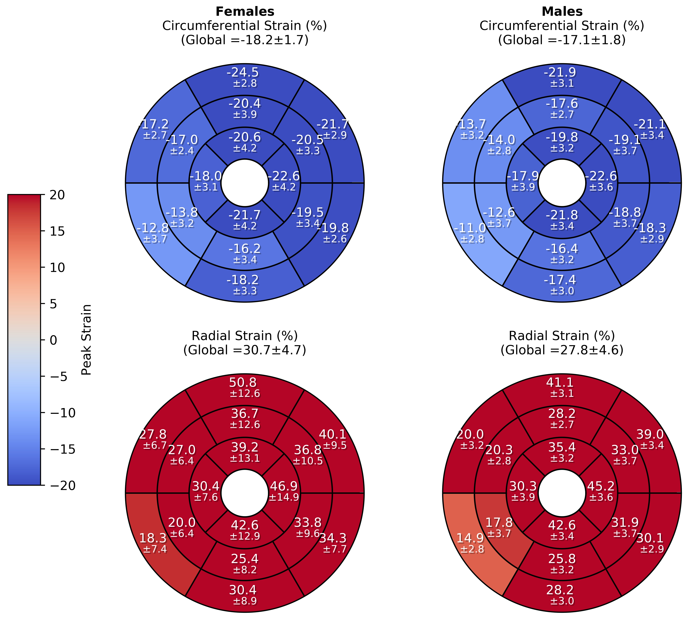

Supplemental material 3.

Supplemental material 3. Software Comparison – Longitudinal Strain
 | CVI⁴² |  |  | TomTec
AHA-Segment | 1.5 T | 3 T | p value | 1.5 T | 3 T | p value | p value (1.5 T) | p value (3 T)
1 | -17.4 ± 4.3 | -15.1 ± 6.5 | 0.129 | -21.2 ± 10.4 | -16.7 ± 8.5 | 0.026 | 0.030 | 0.723
2 | -17.2 ± 8.2 | -18.4 ± 5.5 | 0.692 | -21.8 ± 6.2 | -18.6 ± 8.4 | 0.110 | 0.006 | 0.879
3 | -16.3 ± 5.8 | -15.4 ± 5.1 | 0.476 | -22.0 ± 7.4 | -20.2 ± 8.0 | 0.300 | 0.001 | 0.007
4 | -20.0 ± 5.0 | -22.2 ± 4.1 | 0.087 | -21.4 ± 7.9 | -19.4 ± 9.6 | 0.369 | 0.371 | 0.243
5 | -23.3 ± 6.0 | -25.8 ± 4.7 | 0.080 | -26.8 ± 9.2 | -30.6 ± 9.2 | 0.114 | 0.075 | 0.016
6 | -24.8 ± 5.2 | -26.0 ± 5.5 | 0.345 | -29.2 ± 9.9 | -30.9 ± 8.6 | 0.410 | 0.034 | 0.009
7 | -19.8 ± 4.9 | -20.0 ± 6.0 | 0.685 | -29.1 ± 11.1 | -32.0 ± 9.3 | 0.559 | < 0.001 | < 0.001
8 | -18.0 ± 7.6 | -20.4 ± 5.7 | 0.159 | -17.6 ± 9.0 | -23.5 ± 8.2 | 0.006 | 0.382 | 0.036
9 | -14.2 ± 5.7 | -16.3 ± 4.5 | 0.143 | -22.0 ± 8.8 | -23.4 ± 7.5 | 0.339 | < 0.001 | < 0.001
10 | -16.5 ± 3.9 | -16.2 ± 4.7 | 0.916 | -26.1 ± 7.0 | -22.5 ± 10.0 | 0.073 | < 0.001 | 0.001
11 | -14.8 ± 6.3 | -11.7 ± 7.3 | 0.150 | -28.8 ± 10.7 | -21.1 ± 9.4 | 0.003 | < 0.001 | < 0.001
12 | -15.9 ± 5.4 | -13.4 ± 8.6 | 0.268 | -25.8 ± 14.1 | -28.9 ± 9.9 | 0.161 | 0.002 | < 0.001
13 | -19.1 ± 5.4 | -19.6 ± 5.2 | 0.697 | -17.3 ± 9.7 | -27.2 ± 11.2 | 0.001 | 0.374 | 0.001
14 | -17.2 ± 4.6 | -16.0 ± 4.8 | 0.336 | -16.3 ± 5.6 | -19.0 ± 6.6 | 0.078 | 0.503 | 0.068
15 | -14.0 ± 3.6 | -15.0 ± 3.7 | 0.437 | -12.0 ± 7.3 | -19.7 ± 9.2 | < 0.001 | 0.041 | 0.034
16 | -13.0 ± 3.7 | -13.5 ± 5.0 | 0.639 | -14.0 ± 6.5 | -17.5 ± 7.6 | 0.101 | 0.470 | 0.024
Global | -17.0 ± 2.1 | -17.0 ± 1.7 | 0.845 | -20.2 ± 2.3 | -20.8 ± 3.2 | 0.195 | < 0.001 | < 0.001
Data are shown as mean values (in %) ± standard deviation (SD) according to the AHA-segment model [18]. Significant differences (p < 0.05) are marked bold.

Supplemental material 4.

Supplemental material 4. Software Comparison – Radial_{LAX} Strain
 | CVI⁴² |  |  | TomTec
AHA-Segment | 1.5 T | 3 T | p value | 1.5 T | 3 T | p value | p value (1.5 T) | p value (3 T)
1 | 29.4 ± 10.8 | 24.7 ± 13.6 | 0.110 | 72.1 ± 40.3 | 72.8 ± 67.7 | 0.312 | < 0.001 | < 0.001
2 | 34.3 ± 14.0 | 32.0 ± 14.2 | 0.534 | 54.1 ± 70.9 | 47.7 ± 22.3 | 0.620 | 0.043 | 0.005
3 | 26.8 ± 12.3 | 26.0 ± 13.3 | 0.653 | 59.3 ± 63.5 | 76.8 ± 59.2 | 0.077 | 0.003 | < 0.001
4 | 39.4 ± 15.9 | 46.2 ± 18.1 | 0.139 | 78.9 ± 67.5 | 69.0 ± 48.5 | 0.797 | 0.008 | 0.044
5 | 52.5 ± 26.1 | 61.1 ± 21.3 | 0.074 | 106.9 ± 69.2 | 94.7 ± 50.4 | 0.580 | < 0.001 | 0.005
6 | 55.0 ± 23.3 | 60.8 ± 28.1 | 0.346 | 112.8 ± 86.4 | 69.6 ± 48.6 | 0.036 | 0.004 | 0.859
7 | 37.4 ± 14.5 | 37.9 ± 17.3 | 0.898 | 64.3 ± 39.8 | 42.3 ± 21.6 | 0.015 | < 0.001 | 0.408
8 | 33.2 ± 20.6 | 40.3 ± 20.9 | 0.126 | 39.0 ± 24.2 | 48.5 ± 20.3 | 0.023 | 0.220 | 0.056
9 | 23.5 ± 12.8 | 27.0 ± 10.8 | 0.122 | 50.7 ± 23.6 | 41.8 ± 22.2 | 0.093 | < 0.001 | 0.002
10 | 27.3 ± 10.3 | 27.6 ± 11.5 | 0.797 | 54.7 ± 43.9 | 43.4 ± 30.0 | 0.399 | < 0.001 | 0.009
11 | 26.0 ± 13.0 | 17.3 ± 11.4 | 0.020 | 72.8 ± 37.9 | 46.0 ± 28.8 | 0.002 | < 0.001 | < 0.001
12 | 26.4 ± 13.6 | 23.5 ± 15.4 | 0.254 | 73.2 ± 99.7 | 40.5 ± 29.8 | 0.030 | < 0.001 | 0.032
13 | 36.9 ± 18.8 | 38.0 ± 18.5 | 0.763 | 66.7 ± 67.4 | 64.7 ± 63.6 | 0.625 | 0.005 | 0.126
14 | 29.7 ± 11.9 | 27.0 ± 12.4 | 0.300 | 62.3 ± 52.8 | 55.5 ± 46.0 | 0.491 | < 0.001 | < 0.001
15 | 21.6 ± 9.4 | 23.8 ± 8.6 | 0.382 | 72.8 ± 86.1 | 64.7 ± 86.0 | 0.410 | 0.001 | 0.051
16 | 19.5 ± 7.9 | 21.2 ± 10.6 | 0.659 | 80.7 ± 92.0 | 41.5 ± 26.6 | 0.001 | < 0.001 | < 0.001
Global | 29.1 ± 5.8 | 29.1 ± 4.6 | 0.792 | 77.8 ± 22.9 | 60.9 ± 14.1 | 0.002 | < 0.001 | < 0.001
Data are shown as mean values (in %) ± standard deviation (SD) according to the AHA-segment model [18]. Significant differences (p < 0.05) are marked bold.

Supplemental material 5.

Supplemental material 5. Software Comparison – Circumferential Strain (using 3 short axis slices)
 | CVI⁴² |  |  | TomTec
AHA-Segment | 1.5 T | 3 T | p value | 1.5 T | 3 T | p value | p value (1.5 T) | p value (3 T)
1 | -24.4 ± 3.8 | -23.9 ± 4.0 | 0.678 | -24.6 ± 7.2 | -24.6 ± 5.9 | 0.854 | 0.487 | 0.554
2 | -16.3 ± 3.3 | -16.4 ± 3.1 | 0.683 | -18.5 ± 6.6 | -17.4 ± 12.8 | 0.481 | 0.222 | 0.049
3 | -11.8 ± 3.0 | -12.8 ± 4.6 | 0.033 | -20.7 ± 10.5 | -25.2 ± 7.2 | 0.048 | < 0.001 | < 0.001
4 | -17.4 ± 4.5 | -17.3 ± 4.0 | 0.900 | -17.3 ± 8.3 | -18.5 ± 5.1 | 0.900 | 0.503 | 0.328
5 | -22.2 ± 3.5 | -18.2 ± 3.4 | < 0.001 | -22.9 ± 6.8 | -22.5 ± 5.8 | 0.985 | 0.866 | 0.002
6 | -23.1 ± 4.3 | -21.2 ± 3.9 | 0.077 | -26.7 ± 7.9 | -27.1 ± 6.0 | 0.753 | 0.003 | < 0.001
7 | -19.8 ± 4.1 | -19.0 ± 4.1 | 0.597 | -18.3 ± 6.4 | -18.1 ± 7.0 | 0.669 | 0.506 | 0.410
8 | -15.9 ± 3.9 | -17.3 ± 2.7 | 0.093 | -17.1 ± 5.3 | -18.2 ± 8.3 | 0.271 | 0.374 | 0.301
9 | -14.4 ± 2.4 | -15.2 ± 2.7 | 0.211 | -18.7 ± 6.3 | -16.6 ± 7.6 | 0.521 | 0.009 | 0.073
10 | -16.5 ± 3.6 | -17.1 ± 3.0 | 0.619 | -18.2 ± 5.9 | -17.3 ± 8.3 | 0.860 | 0.180 | 0.593
11 | -20.6 ± 3.7 | -18.5 ± 3.6 | 0.022 | -22.0 ± 5.2 | -21.3 ± 6.7 | 0.826 | 0.246 | 0.018
12 | -21.4 ± 3.9 | -18.8 ± 3.8 | 0.008 | -18.7 ± 7.2 | -21.6 ± 8.2 | 0.183 | 0.064 | 0.203
13 | -22.2 ± 3.8 | -21.4 ± 3.9 | 0.337 | -22.0 ± 6.2 | -22.4 ± 6.6 | 0.637 | 0.946 | 0.123
14 | -19.4 ± 4.3 | -19.4 ± 3.8 | 0.933 | -19.8 ± 6.7 | -24.3 ± 5.5 | 0.004 | 0.982 | 0.001
15 | -23.1 ± 4.0 | -22.3 ± 4.2 | 0.531 | -26.5 ± 6.4 | -26.8 ± 5.8 | 0.900 | 0.005 | 0.001
16 | -25.4 ± 3.6 | -23.5 ± 4.8 | 0.104 | -26.7 ± 5.4 | -24.0 ± 7.3 | 0.102 | 0.352 | 0.861
Global | -19.6 ± 2.3 | -18.8 ± 2.2 | 0.263 | -20.6 ± 2.4 | -20.9 ± 2.8 | 0.385 | 0.076 | 0.001
Data are shown as mean values (in %) ± standard deviation (SD) according to the AHA-segment model [18]. Significant differences (p < 0.05) are marked bold.

Supplemental material 6.

Supplemental material 6. Software Comparison – Radial_{SAX} Strain (using 3 short axis slices)
 | CVI⁴² |  |  | TomTec
AHA-Segment | 1.5 T | 3 T | p value | 1.5 T | 3 T | p value | p value (1.5 T) | p value (3 T)
1 | 51.6 ± 17.3 | 49.4 ± 17.8 | 0.664 | 55.0 ± 31.7 | 59.0 ± 31.7 | 0.554 | 0.937 | 0.328
2 | 25.7 ± 8.3 | 26.1 ± 8.2 | 0.706 | 38.1 ± 25.3 | 41.3 ± 20.4 | 0.359 | 0.009 | 0.003
3 | 16.2 ± 5.4 | 18.8 ± 5.6 | 0.036 | 26.2 ± 17.3 | 30.7 ± 15.1 | 0.181 | 0.008 | < 0.001
4 | 29.6 ± 12.1 | 28.4 ± 10.9 | 0.772 | 47.1 ± 27.7 | 61.0 ± 32.9 | 0.024 | 0.001 | < 0.001
5 | 42.2 ± 12.4 | 30.1 ± 8.5 | < 0.001 | 67.4 ± 32.7 | 82.0 ± 42.4 | 0.155 | < 0.001 | < 0.001
6 | 46.4 ± 15.5 | 39.1 ± 11.7 | 0.097 | 52.4 ± 33.7 | 67.3 ± 27.4 | 0.012 | 0.685 | < 0.001
7 | 35.0 ± 12.9 | 32.7 ± 11.3 | 0.624 | 46.9 ± 23.6 | 62.9 ± 29.8 | 0.026 | 0.018 | < 0.001
8 | 24.7 ± 9.1 | 27.6 ± 6.7 | 0.083 | 44.8 ± 19.5 | 45.6 ± 23.4 | 0.806 | < 0.001 | < 0.001
9 | 20.7 ± 5.1 | 22.6 ± 5.7 | 0.161 | 38.2 ± 17.0 | 49.1 ± 21.7 | 0.013 | < 0.001 | < 0.001
10 | 26.1 ± 8.9 | 27.2 ± 7.6 | 0.576 | 41.9 ± 21.4 | 54.5 ± 20.3 | 0.010 | 0.001 | < 0.001
11 | 37.2 ± 10.9 | 30.8 ± 9.1 | 0.019 | 50.4 ± 20.5 | 65.2 ± 26.1 | 0.010 | 0.004 | < 0.001
12 | 39.9 ± 12.6 | 31.9 ± 9.8 | 0.009 | 53.5 ± 22.0 | 63.0 ± 25.5 | 0.044 | 0.003 | < 0.001
13 | 43.1 ± 13.6 | 40.4 ± 13.6 | 0.309 | 45.6 ± 19.5 | 63.1 ± 26.6 | 0.010 | 0.374 | 0.001
14 | 34.3 ± 12.2 | 33.9 ± 10.7 | 0.913 | 38.6 ± 23.6 | 66.5 ± 34.6 | < 0.001 | 0.652 | < 0.001
15 | 47.5 ± 15.8 | 43.6 ± 14.3 | 0.391 | 43.5 ± 23.8 | 66.0 ± 39.5 | 0.014 | 0.262 | 0.025
16 | 56.6 ± 16.6 | 48.8 ± 16.1 | 0.097 | 56.8 ± 27.3 | 67.7 ± 28.4 | 0.136 | 0.791 | 0.012
Global | 36.0 ± 7.5 | 33.0 ± 6.2 | 0.128 | 57.4 ± 12.7 | 71.0 ± 16.4 | 0.001 | < 0.001 | < 0.001
Data are shown as mean values (in %) ± standard deviation (SD) according to the AHA-segment model [18]. Significant differences (p < 0.05) are marked bold.

Supplemental material 7.

Supplemental material 7. Intra- and inter-observer reproducibility
 | Intra-observer |  |  |  | Inter-observer
n = 10 | Observer 1  First analysis | Observer 1  Second analysis | p value |  | Observer 2 | p value
Global longitudinal strain (%) | -16.34 ± 1.42 | -16.40 ± 1.53 | 0.971 |  | -16.37 ± 1.36 | 0.853
Global circumferential strain (%) | -17.20 ± 1.67 | -17.26 ± 1.52 | 0.971 |  | -16.86 ± 2.08 | 0.796
Global radial_{SAX} strain (%) | 28.03 ± 4.48 | 28.06 ± 3.87 | 0.912 |  | 27.24 ± 5.13 | 0.853
Global radial_{LAX} strain (%) | 27.40 ± 3.77 | 27.54 ± 4.47 | 0.853 |  | 27.36 ± 3.62 | 1.00

 | Intra-observer |  |  |  | Inter-observer
n = 10 | ICC | Lower CI | Upper CI |  | ICC | Lower CI | Upper CI
Global longitudinal strain | 0.941 | 0.759 | 0.985 |  | 0.829 | 0.273 | 0.958
Global cicrumferential strain | 0.977 | 0.907 | 0.994 |  | 0.969 | 0.862 | 0.992
Global radial_{SAX} strain | 0.969 | 0.874 | 0.992 |  | 0.975 | 0.889 | 0.994
Global radial_{LAX} strain | 0.930 | 0.715 | 0.983 |  | 0.850 | 0.365 | 0.963
Data is shown as mean values ± standard deviations (SD)
ICC: intra-class correlation coefficient, CI: 95% confidence interval

