Appendices
- Visualizing Methods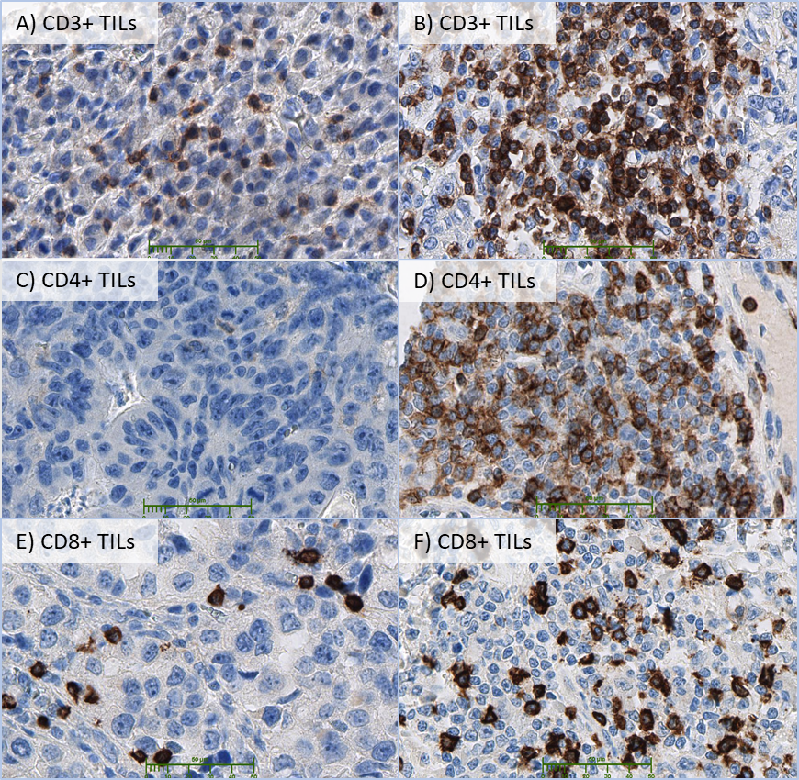
Figure S1: Immunohistological staining for CD3+, CD4+ and CD8+ cells in 400fold magnification.
Tumor samples were grouped into a low or high state of infiltration with CD3, CD4 or CD8 positive TILs by using the median. TIL cell count per visual field: A): 35; B): 147; C): 0; D): 133; E): 14; F): 56.

Visualized Antigen | Antibody | Manufacturer
CD3 | LN10 | Novocastra®
CD4 | 4B12 | Novocastra®
CD8 | C8/144B | DAKO®
PD-L1 | E1L3N | Cell Signaling technologies®
PD-1 | EP239 | Epitomics®
MLH1 | M1 | Roche Ventana®
PMS2 | EPR3947 | Roche Ventana®
MSH2 | G219-1129 | Roche Ventana®
MSH6 | 44 | Roche Ventana®

Table S1: Visualizing agents for TILs, Checkpoint proteins and mismatch-repair proteins.
TILs were visualized using monoclonal mouse antibodies against human CD3, 4 and 8 in a 1:100 dilution. Every lymphocyte subgroup was pre-treated with 20’ER2 BOND (EDTA based). Antibody binding was performed with BOND polymers. Anti-PD-L1 staining was performed in 1:200 dilution, Anti-PD-1 in a 1:100 dilution. For mismatch-repair proteins, immunohistochemistry was performed on an automated staining system (BenchMark Ultra, Roche Ventana, Germany) using prediluted antibodies.

- Patient Characteristics
  - Clinical characteristics
We collected data of 438 patients (female=178, median age=62 years) (95% CI: 60.97- 63.15 years). We included patients with all tumor stages (UICC I = 162; UICC II= 111; UICC III=50; UICC IV= 115 patients). Data about lymphatic infiltration were available in 363 cases and 213 showed a L1 state (48.66%). Information about the venous infiltration was available in 353 cases, 120 patients were classified as V1 state (27.4%).
Regarding the resection state, 300 cases were categorized as R0, 22 as R1 and one as R2. In 115 cases, a palliative tumor resection was performed in patients with UICC IV stage. Reasons for palliative surgery were for example tumor bleeding, obstruction or perforation. The resection state of the palliative cases was therefore censored in multivariate confounder analysis, because of strong statistical interaction with the respecting parameters.
The mean follow-up was 121.7 months (95% CI: 113.9 – 129.5 months) and 291 patients (66.4%) died during follow-up time, 225 (51.4%) of those tumor-related. The 5-year overall survival was 38.1%, the 5-year tumor-related survival was 45.4%.
  - Morphological Characteristics
We evaluated tumor grading and the morphological state of tumors using the Laurén and Ming classification. Tumor grading was: G1 in 8 (1.8%), G2 in 116 (26.5%) and G3 in 311 patients (71.0%), three were unclassified (0.7%). Tumor classification according to Laurén was intestinal type in 176 (40.2%), diffuse type in 201 (45.9%) and mixed type in 58 patients (13.2%), three cases were unclassified (0.7%). Tumor classification according to Ming was expansive in 172 (39.3%), infiltrative growth in 259 (59.1%) and unclassified in seven patients (1.6%).
Demographic | No. of  Patients  (N = 438) | %
Age  ≤ 62 years  > 62 years | 214  224 | 48.9  51.1
Sex  Female  Male | 178  260 | 40.6  59.4
Localization
AGE | 66 | 15,1
Gastric | 372 | 84,9
UICC  pI  pII  pIII  pIV | 162  111  50  115 | 37.0  25.3  11.4  26.3
R  R0  R1  R2  Palliative | 300  22  1  115 | 68.6  5.0  0.2  26.3
Lymphatic Infiltration  L0  L1  Unknown | 150  213  75 | 34.2  48.6  17.2
Venous Infiltration  V0  V1  Unknown | 233  120  85 | 53.2  27.4  19.4
Lauren  Intestinal  Diffuse  Mixed  Unknown | 176  201  58  3 | 40.2  45.9  13.2  0.7
Ming  Expansive  Infiltrative  Unknown | 172  259  7 | 39.3  59.1  1.6
Grading  G1  G2  G3  Unknown | 8  116  311  3 | 1.8  26.5  71.0  0.7
MMR  dMMR  pMMR  Unknown | 45  338  55 | 10.3  77.2  12.6

Table S2: Patient Characteristics

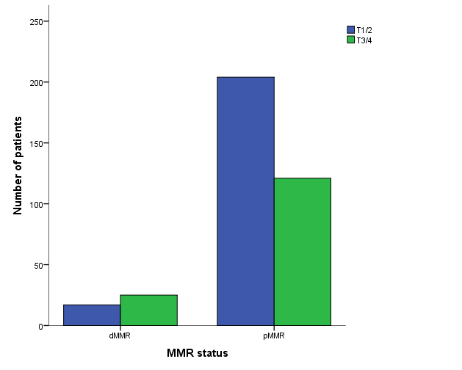

Figure S2: MMR status in correlation to tumor stage.

Factor | CD3 |  |  | CD4 |  |  | CD8
 | Low | High | p* | Low | High | p* | Low | High | p*
Sex
m | 93 (26.6%) | 107 (30.7%) | 0.115 | 100 (29.9%) | 92 (27.5%) | 0.344 | 98 (28.5%) | 100 (29.1%) | 0.827
w | 82 (23.5%) | 67 (19.2%) |  | 67 (20.0%) | 76 (22.7%) |  | 74 (21.5%) | 72 (20.9%)
T
T1 | 29 (8.3%) | 53 (15.2%) | 0.020 | 20 (6.0%) | 62 (18.5%) | <0.001 | 29 (8.4%) | 53 (15.4%) | 0.026
T2 | 72 (20.6%) | 64 (18.3%) |  | 70 (20.9%) | 59 (17.6%) |  | 72 (20.9%) | 59 (17.2%)
T3 | 58 (16.6%) | 43 (12.3%) |  | 60 (17.9%) | 36 (10.7%) |  | 55 (16.0%) | 46 (13.4%)
T4 | 16 (4.6%) | 14 (4.0%) |  | 17 (5.1%) | 11 (3.3%) |  | 16 (4.7%) | 14 (4.1%)
M
M0 | 120 (35.0%) | 144 (42.0%) | 0.001 | 113 (34.3%) | 142 (43.2%) | <0.001 | 120 (35.5%) | 140 (41.4%) | 0.010
M1 | 53 (15.5%) | 26 (7.6%) |  | 54 (16.4%) | 20 (6.1%) |  | 49 (14.5%) | 29 (8.6%)
N
N0 | 57 (16.3%) | 84 (24.1%) | 0.003 | 40 (11.9%) | 99 (29.6%) | <0.001 | 58 (16.9%) | 82 (23.8%) | 0.008
N+ | 118 (33.8%) | 90 (25.8%) |  | 127 (37.9%) | 69 (20.6%) |  | 114 (33.1%) | 90 (26.2%)
V
V0 | 97 (30.9%) | 99 (31.5%) | 0.514 | 92 (30.5%) | 96 (31.8%) | 0.027 | 101 (32.5%) | 92 (29.6%) | 0.761
V1 | 53 (16.9%) | 43 (13.7%) |  | 53 (17.5%) | 39 (12.9%) |  | 52 (16.7%) | 44 (14.1%)
unspecified | 13 (4.1%) | 9 (2.9%) |  | 17 (5.6%) | 5 (1.7%) |  | 10 (3.2%) | 12 (3.9%)
L
L0 | 59 (18.6%) | 65 (20.4%) | 0.346 | 45 (14.7%) | 79 (25.8%) | <0.001 | 66 (21.0%) | 57 (18.1%) | 0.983
L1 | 94 (29.6%) | 81 (25.5%) |  | 104 (34.0%) | 59 (19.3%) |  | 91 (28.9%) | 82 (26.0%)
unspecified | 12 (3.8%) | 7 (2.2%) |  | 14 (4.6%) | 5 (1.6%) |  | 10 (3.2%) | 9 (2.9%)
R
R0 | 113 (32.4%) | 140 (40.1%) | 0.002 | 103 (30.7%) | 142 (42.4%) | <0.001 | 114 (33.1%) | 135 (39.2%) | 0.031
R1 | 9 (2.6%) | 8 (2.3%) |  | 10 (3.0%) | 6 (1.8%) |  | 9 (2.6%) | 8 (2.3%)
palliative | 53 (15.2%) | 26 (7.4%) |  | 54 (16.1%) | 20 (6.0%) |  | 49 (14.2%) | 29 (8.4%)
Grading
G1 | 2 (0.6%) | 5 (1.4%) | 0.489 | 0 | 7 (2.1%) | 0.009 | 3 (0.9%) | 4 (1.2%) | 0.514
G2 | 46 (13.3%) | 48 (13.9%) |  | 42 (12.7%) | 52 (15.7%) |  | 43 (12.6%) | 52 (15.2%)
G3 | 125 (36.1%) | 120 (34.7%) |  | 124 (37.3%) | 107 (32.2%) |  | 124 (36.4%) | 115 (33.7%)
UICC
I | 52 (14.9%) | 84 (24.1%) | <0.001 | 40 (11.9%) | 93 (27.8%) | <0.001 | 54 (15.7%) | 81 (23.5%) | 0.007
II | 51 (14.6%) | 40 (11.5%) |  | 48 (14.3%) | 38 (11.3%) |  | 50 (14.5%) | 39 (11.3%)
III | 19 (5.4%) | 24 (6.9%) |  | 25 (7.5%) | 17 (5.1%) |  | 19 (5.5%) | 23 (6.7%)
IV | 53 (15.2%) | 26 (7.4%) |  | 54 (16.1%) | 20 (6.0%) |  | 49 (14.2%) | 29 (8.4%)
MMR
pMMR | 154 (46.4%) | 141 (42.5%) | 0.05 | 142 (44.5%) | 142 (44.5%) | 0.151 | 155 (47.3%) | 137 (41.8%) | 0.011
dMMR | 13 (3.9%) | 24 (11.1%) |  | 22 (6.9%) | 13 (4.1%) |  | 11 (3.4%) | 25 (7.6%)

Table S3: Clinicopathological Characteristics dependent on CD3, 4 and 8 state.

Tumor samples were grouped for low versus high infiltration with CD4 and CD8 positive TILs by using the median.

Factor | PD-L1 Immune Cells |  |  | PD-L1 Tumor Cells |  |  | PD-1 Immune Cells |  |  | PD-1 Tumor Cells
 | negative | positive | P* | negative | positive | P* | negative | positive | P* | negative | positive | P*
Sex
m | 134 (40.0%) | 70 (20.9%) | 0.003 | 178 (53.3%) | 25 (7.5%) | 0.978 | 99 (30.3%) | 102 (31.2%) | 0.332 | 185 (55.9%) | 16 (4.8%) | 0.012
w | 106 (31.6%) | 25 (7.5%) |  | 115 (34.4%) | 16 (4.8%) |  | 69 (21.1%) | 57 (17.4%) |  | 108 (32.6%) | 22 (6.6%)
T
T1 | 46 (13.7%) | 17 (5.1%) | 0.208 | 49 (14.7%) | 14 (4.2%) | 0.003 | 37 (11.3%) | 22 (6.7%) | 0.124 | 38 (11.5%) | 23 (6.9%) | <0.001
T2 | 90 (26.9%) | 43 (12.8%) |  | 112 (33.5%) | 20 (6.0%) |  | 67 (20.5%) | 66 (20.2%) |  | 118 (35.6%) | 15 (4.5%)
T3 | 85 (25.4%) | 24 (7.2%) |  | 104 (31.1%) | 4 (1.2%) |  | 52 (15.9%) | 52 (15.9%) |  | 106 (32.0%) | 0
T4 | 18 (5.4%) | 11 (3.3%) |  | 27 (8.1%) | 3 (0.9%) |  | 11 (3.4%) | 19 (5.8%) |  | 30 (9.1%) | 0
M
M0 | 177 (53.2%) | 73 (21.9%) | 0.638 | 213 (64.2%) | 36 (10.8%) | 0.019 | 127 (39.0%) | 117 (35.9%) | 0.608 | 209 (63.5%) | 36 (10.9%) | <0.001
M1 | 61 (18.3%) | 22 (6.6%) |  | 79 (23.8%) | 4 (1.2%) |  | 40 (12.3%) | 42 (12.9%) |  | 84 (25.5%) | 0
N
N0 | 80 (23.9%) | 36 (10.7%) | 0.429 | 88 (26.3%) | 27 (8.1%) | <0.001 | 65 (19.9%) | 47 (14.4%) | 0.082 | 76 (21.0%) | 38 (11.5%) | <0.001
N+ | 160 (47.8%) | 59 (17.6%) |  | 205 (61.4%) | 14 (4.2%) |  | 103 (31.5%) | 112 (34.3%) |  | 217 (65.6%) | 0
V
V0 | 122 (39.7%) | 60 (19.5%) | 0.104 | 163 (53.1%) | 18 (5.9%) | 0.557 | 78 (26.0%) | 98 (32.7%) | 0.219 | 168 (55.4%) | 10 (3.3%) | 0.313
V1 | 77 (25.1%) | 24 (7.8%) |  | 94 (30.6%) | 8 (2.6%) |  | 52 (17.3%) | 48 (16.0%) |  | 98 (32.3%) | 3 (1.0%)
unspecified | 18 (5.9%) | 6 (2.0%) |  | 23 (7.5%) | 1 (0.3%) |  | 12 (4.0%) | 12 (4.0%) |  | 24 (7.9%) | 0
L
L0 | 72 (23.3%) | 37 (12.0%) | 0.237 | 98 (31.7%) | 11 (3.6%) | 0.869 | 56 (18.5%) | 50 (16.6%) | 0.151 | 94 (30.8%) | 12 (3.9%) | <0.001
L1 | 130 (42.1%) | 49 (15.9%) |  | 162 (52.4%) | 17 (5.5%) |  | 77 (25.5%) | 98 (32.5%) |  | 175 (57.4%) | 3 (1.0%)
unspecified | 17 (5.5%) | 4 (1.3%) |  | 21 (6.8%) | 0 |  | 11 (3.6%) | 10 (3.3%) |  | 21 (6.9%) | 0
R
R0 | 166 (49.6%) | 69 (20.6%) | 0.798 | 198 (59.3%) | 36 (10.8%) | 0.030 | 120 (36.7%) | 109 (33.3%) | 0.848 | 193 (58.3%) | 38 (11.5%) | <0.001
R1 | 13 (3.6%) | 4 (1.2%) |  | 16 (4.8%) | 1 (0.3%) |  | 8 (2.4%) | 8 (2.4%) |  | 16 (4.8%) | 0
palliative | 61 (18.2%) | 22 (6.6%) |  | 79 (23.7%) | 4 (1.2%) |  | 40 (12.2%) | 42 (12.8%) |  | 84 (25,4%) | 0
Grading
G1 | 4 (1.2%) | 1 (0.3%) | 0.009 | 3 (0.9%) | 1 (0.3%) | 0.059 | 4 (1.2%) | 1 (0.3%) | 0.020 | 2 (0.6%) | 3 (0.9%) | 0.001
G2 | 53 (16.0%) | 37 (11.1%) |  | 73 (22.1%) | 17 (5.1%) |  | 35 (10.8%) | 54 (16.7%) |  | 77 (23.5%) | 13 (4.0%)
G3 | 180 (54.2%) | 57 (17.2%) |  | 214 (64.7%) | 23 (6.9%) |  | 126 (38.9%) | 104 (32.1%) |  | 211 (64.3%) | 22 (6.7%)
UICC
I | 75 (22.4%) | 35 (10.4%) | 0.791 | 81 (24.3%) | 28 (8.4%) | <0.001 | 63 (19.3%) | 44 (13.5%) | 0.066 | 71 (21.5%) | 38 (11.5%) | <0.001
II | 71 (21.2%) | 25 (7.5%) |  | 90 (26.9%) | 6 (1.8%) |  | 50 (14.5%) | 39 (11.3%) |  | 93 (28.1%) | 0
III | 33 (9.9%) | 13 (3.9%) |  | 43 (12.9%) | 3 (0.9%) |  | 19 (5.5%) | 23 (6.7%) |  | 45 (13.6%) | 0
IV | 61 (18.2%) | 22 (6.6%) |  | 79 (23.7%) | 4 (1.2%) |  | 84 (25.4%) | 0 |  | 84 (25.4%) | 0
MMR
pMMR | 205 (64.1%) | 79 (24.7%) | 0.168 | 253 (79.3%) | 30 (9.4%) | 0.552 | 140 (44.6%) | 139 (44.3%) | 0.618 | 256 (80.8%) | 26 (8.2%) | 0.491
dMMR | 22 (6.9%) | 14 (4.4%) |  | 31 (9.7%) | 5 (1.6%) |  | 16 (5.1%) | 19 (6.1%) |  | 33 (10.4%) | 2 (0.6%)

Table S4: Clinicopathological Characteristic dependent on PD-L1 and PD-1 expression.
For grouping in PD-1 and PD-L1 positive/negative, an expression ≥1% was used as a cutoff.

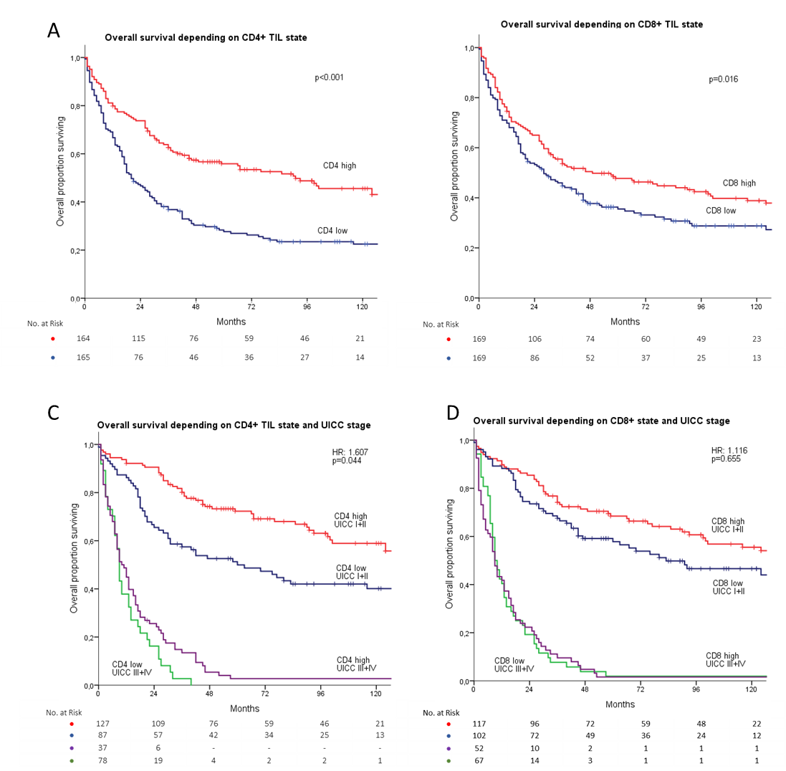

Figure S3: a) Overall Survival depending on CD4 infiltration state. b) Overall Survival depending on CD8 infiltration state. c) Overall Survival depending on CD4 infiltration state and UICC stage. d) Overall Survival depending on CD8 infiltration state and UICC stage. Tumor samples were grouped for low versus high infiltration with CD4 and CD8 positive TILs by using the median.

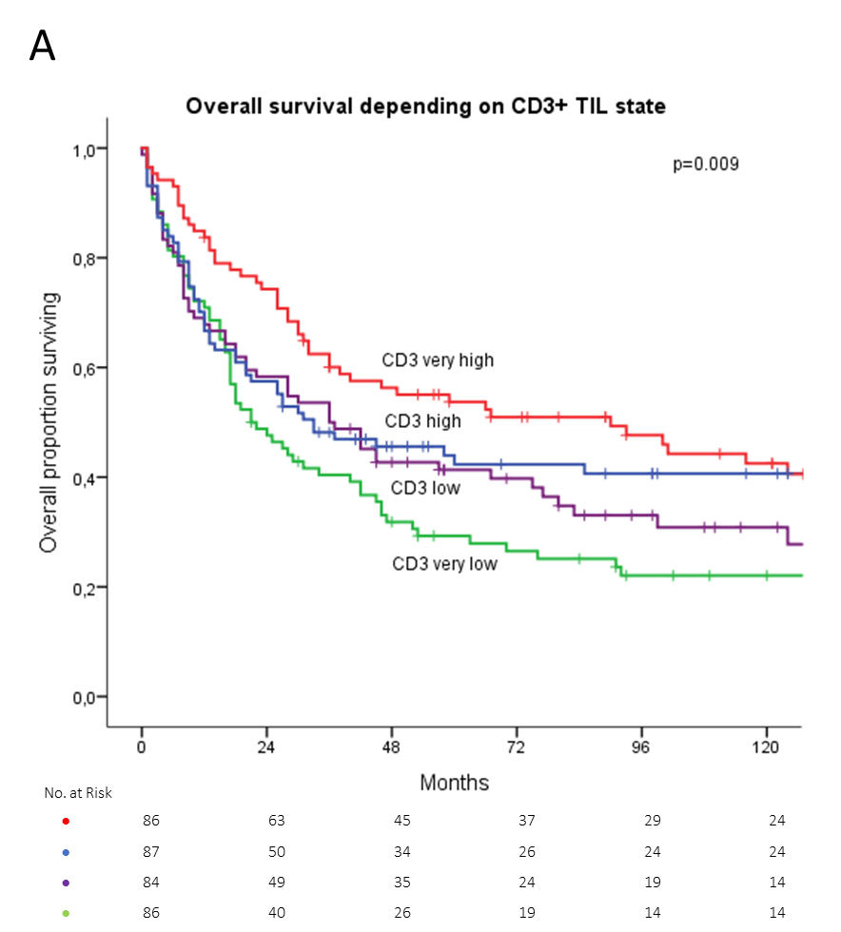
Figure S4: a) Overall Survival depending on CD3 infiltration state.

 | Univariate |  |  |  | Multiple Cox Regression (after forward/backward selection)
Clinical Factor | Mean Survival | CI | p |  | HR | CI | p
Total patients | 83.78 | 74.7-92.86
Age  ≤ 62 years  > 62 years | 97.85  65.86 | 84.97-110.72  54.51-77.2 | <0.001 |  | 1.027  1.028‡ | 1.009-1.046  1.010-1.046 | 0.004  0.002
Sex  Female  Male | 96.82  72.92 | 81.88-111.76  62.09-83.75 | <0.005 |  | 0.765 | 0.522-1.123 | 0.172
UICC stage  UICC I  UICC II  UICC III  UICC IV | 154.83  70.16  26.65  10.97 | 140.48-169.18  56.53-83.79  16.61-36.68  8.93-12 | <0.001 |  | 2.096  2.323‡ | 1.456-3.017  1.820-2.966 | <0.001  <0.001
R  R0  R1  R2 | 116.82  23.91  7.0 | 105.42-128.22  8.53-39.28  7.0-7.0 | <0.001 |  | 2.465  2.428‡ | 1.338-4.539  1.349-4.369 | 0.004  0.003
Lauren  Intestinal  Diffuse  Mixed | 95.96  69.83  69.34 | 82.01-109.91  56.78-82.86  51.39-87.4 | 0.002 |  | 1.268  1.288‡ | 0.981-1.637  1.005-1.650 | 0.070  0.046
MMR  dMMR  pMMR | 47.22  79.78 | 28.16-66.28  70.15-89.39 | 0.025 |  | 0.983 | 0.572-1.691 | 0.951
CD3  High  Low | 106.04  64.38 | 90.73-121.34  53.43-75.32 | 0.002
CD8  High  Low | 101.53  67.34 | 86.49-116.56  55.8-78.97 | 0.016 |  | 0.694 | 0.240-2.010 | 0.501
CD4  High  Low | 116.92  56.36 | 101.16-132.67  78.95-100.08 | <0.001
PD-L1  - Immune Cells  Positive  Negative  - Tumor Cells  Positive  Negative | 63.03  83.25  119.56  68.23 | 49.19-76.86  71.29-95.21  90.57-148.56  59.05-77.53 | 0.428  0.003 |  | 0.840 | 0.464-1.518 | 0.563
PD-1  - Immune Cells  Positive  Negative  - Tumor Cells  Positive  Negative | 56.51  95.07  175.79  58.96 | 45.99-67.02  80.32-109.82  152.29-199.28  50.78-67.13 | 0.001  <0.001 |  | 1.171 | 0.701-1.957 | 0.547
UICC*CD8 |  |  |  |  | 1.116 | 0.691-1.802 | 0.655
PD-1*CD8 |  |  |  |  | 1.191 | 0.546-2.597 | 0.660

Table S4: Univariate and multivariate survival analysis including CD8 and PD-1 and PD-L1.

CI: confidence interval; HR: hazard ratio. TILs were grouped into high or low by a median cutoff. Mean survival is shown in months of survival. All factors significant in univariate analysis were analyzed in a multivariate cox regression model. The reference categories for multivariate analysis are “low infiltration” for CD3, CD4 and CD8, “low CD3 infiltration and UICC I + II” for interaction between CD3 and UICC stage, “low CD3 infiltration and PD-1 expression negative” for interaction between PD-1 expression and CD3, “patient age < 62 years” for age, “male” for sex, “positive” for MMR status, “UICC I” for UICC stage,“R0” for R, “negative” for PD-1 and PD-L1 and “intestinal type”. CD3 and CD4+ TILs infiltration as well as PD-1 expression in tumor cells were excluded from multivariate analysis due to high statistical correlation.

 | Univariate |  |  |  | Multiple Cox Regression (after forward/[backward] selection)
Clinical Factor | Mean Survival | CI | p |  | HR | CI | p
Total patients | 83.78 | 74.7-92.86
Age  ≤ 62 years  > 62 years | 97.85  65.86 | 84.97-110.72  54.51-77.2 | <0.001 |  | 1.026  1.028‡ | 1.008-1.045  1.010-1.046 | 0.006  0.002
Sex  Female  Male | 96.82  72.92 | 81.88-111.76  62.09-83.75 | <0.005 |  | 0.769 | 0.522-1.133 | 0.183
UICC stage  UICC I  UICC II  UICC III  UICC IV | 154.83  70.16  26.65  10.97 | 140.48-169.18  56.53-83.79  16.61-36.68  8.93-12 | <0.001 |  | 1.973  2.378‡ | 1.437-2.708  1.869-3.026 | <0.001  <0.001
R  R0  R1  R2 | 116.82  23.91  7.0 | 105.42-128.22  8.53-39.28  7.0-7.0 | <0.001 |  | 2.374  2.335‡ | 1.302-4.327  1.301-4.194 | 0.005  0.005
Lauren  Intestinal  Diffuse  Mixed | 95.96  69.83  69.34 | 82.01-109.91  56.78-82.86  51.39-87.4 | 0.002 |  | 1.286  1.329‡ | 0.988-1.674  1.029-1.717 | 0.062  0.029
MMR  dMMR  pMMR | 47.22  79.78 | 28.16-66.28  70.15-89.39 | 0.025 |  | 1.077 | 0.601-1.932 | 0.803
CD3  High  Low | 106.04  64.38 | 90.73-121.34  53.43-75.32 | 0.002
CD8  High  Low | 101.53  67.34 | 86.49-116.56  55.8-78.97 | 0.016
CD4  High  Low | 116.92  56.36 | 101.16-132.67  78.95-100.08 | <0.001 |  | 0.448  [0.391‡ | 0.154-1.299  0.144-1.062 | 0.139  0.065]
PD-L1  - Immune Cells  Positive  Negative  - Tumor Cells  Positive  Negative | 63.03  83.25  119.56  68.23 | 49.19-76.86  71.29-95.21  90.57-148.56  59.05-77.53 | 0.428  0.003 |  | 0.878 | 0.474-1.625 | 0.678
PD-1  - Immune Cells  Positive  Negative  - Tumor Cells  Positive  Negative | 56.51  95.07  175.79  58.96 | 45.99-67.02  80.32-109.82  152.29-199.28  50.78-67.13 | 0.001  <0.001 |  | 1.176 | 0.730-1.895 | 0.505
UICC*CD4 |  |  |  |  | 1.430  [1.607‡ | 0.879-2.327  1.014-2.546 | 0.150  0.044]
PD-1*CD4 |  |  |  |  | 1.128 | 0.510-2.497 | 0.766
Table S5: Univariate and multivariate survival analysis including CD4 and PD-1 and PD-L1.
CI: confidence interval; HR: hazard ratio. TILs were grouped into high or low by a median cutoff. Mean survival is shown in months of survival. All factors significant in univariate analysis were analyzed in a multivariate cox regression model. The reference categories for multivariate analysis are “low infiltration” for CD3, CD4 and CD8, “low CD3 infiltration and UICC I + II” for interaction between CD3 and UICC stage, “low CD3 infiltration and PD-1 expression negative” for interaction between PD-1 expression and CD3, ”patient age ≤ 62 years” for age, “male” for sex, “positive” for MMR status, “UICC I” for UICC stage, “R0” for R, “negative” for PD-1 and PD-L1 and “intestinal type” for Laurén classification. CD3 and CD8⁺ TILs infiltration as well as PD-1 infiltration in tumor cells were excluded from multivariate analysis due to high statistical correlation.

