(13) Supporting Information

Supplemental Table S1 - Amino-acid sequences and denomination of cyclopeptides.

Denomination | Amino acid sequence
18 C/C/S  18 C/S/C | ADEARRCYNDPKCSDFVQ  ADEARRCYNDPKSCDFVQ
β₁EC_{II}²⁰¹⁻²²⁰  β₂EC_{II}¹⁸³⁻²⁰² | AESDEARRCYNDPKCCDFVT  ATHQEAINCYANETCCDFFT
22 C/C/B-β₁  22 C/C/D-β₂  E202A  S203A  D204A  R207A  R208A  N211A  D212A  P213A  K214A | RAESDEARRCYNDPKCBDFVTG  RATHQEAINCYANETCDDFFTG  RAASDEARRCYNDPKCBDFVTG  RAEADEARRCYNDPKCBDFVTG  RAESAEARRCYNDPKCBDFVTG  RAESDEAARCYNDPKCBDFVTG  RAESDEARACYNDPKCBDFVTG  RAESDEARRCYADPKCBDFVTG  RAESDEARRCYNAPKCBDFVTG  RAESDEARRCYNDAKCBDFVTG  RAESDEARRCYNDPACBDFVTG

Amino-acids added to the primary human β₁AR-sequence (to allow for cyclisation between N- and C-terminal residues) are typeset in bold. Amino-acid sequences not conserved between β₁/β₂-adrenoceptors are typeset in green. Mutated residues are typeset in red. Cysteines are typeset in blue. Amino-acids are denominated by the standard one-letter-code. Letter “B” stands for the synthetic amino-acid α-amino-butyrate introduced to prevent aberrant C209↔C216 disulfide-bridging.

Supplemental Table S2 - Primer for site directed mutagenesis by nested PCR

Primer | Sequence (5‘ → 3‘)
OuterPri1 for  OuterPri2 rev  E202A for  E202A rev  R207A for  R207A rev  D212N for  D212N rev  P213A for  P213A rev  V219A for  V219A rev | GACCTGGTCATGGGGCTGCTGGTGGTGC  CGCGGGGACGGGCGAGGGCGAGGGCGA  ACTGGTGGCGGGCGGCTAGCGACGAGGC  GCCTCGTCGCTAGCCGCCCGCCACCAGT  GCGACGAGGCGGCACGCTGCTACAACGACCC  GGGTCGTTGTAGCAGCGTGCCGCCTCGTCGC  CCGCTGCTACAACGCTCCCAAGTGCTGCGACTTC  GAAGTCGCAGCACTTGGGAGCGTTGTAGCAGCGG  GCTGCTACAACGACGCCAAGTGCTGCGACTTCG  CGAAGTCGCAGCACTTGGCGTCGTTGTAGCAGC  AGTGCTGCGACTTCGCTACCAACCGGGCCTACG  CGTAGGCCCGGTTGGTAGCGAAGTCGCAGCACT

Primers (for: forward; rev: reverse) designed for the directed mutagenesis (point mutations) of the native human β₁-AR, with the respective nucleotide-changes underscored. Successful introduction of the mutations in the β₁AR-cDNA was checked by sequencing.
Single-AA mutant human β₁-AR were expressed in HEK293-cells and their functionality was ascertained by radioligand-binding and by adequate cAMP-responses following agonist (-)isoproterenol-stimulation (see suppl. Table S3).

Supplemental Table S3 - Characteristics of β₁AR-mutants expressed in HEK293-cells

Construct | Ligand binding  K_{i} CGP20712A (nM) | cAMP-stimulation  -Log EC₅₀ (-)- Isoproterenol (nM)
β₁AR wildtype | 7.56 | 0.694 ± 0.027
β₁AR R207A | 7.03 (n.s.)¹ | 0.592 ± 0.036 (n.s.)²
β₁AR D212N | 8.49 (n.s.)¹ | 0.628 ± 0.019 (n.s.)²
β₁AR P213A | 9.95 (n.s.)¹ | 0.402 ± 0.090 (n.s.)²
β₁AR V219A | 4.55 (n.s.)¹ | 0.651 ± 0.031 (n.s.)²
¹Significance of deviation from wildtype, Dunnett's Multiple Comparison Test, n.s.= not significant
²Significance of deviation from wildtype, Dunnett's Multiple Comparison Test, n.s.= not significant

Supplemental Figure S1

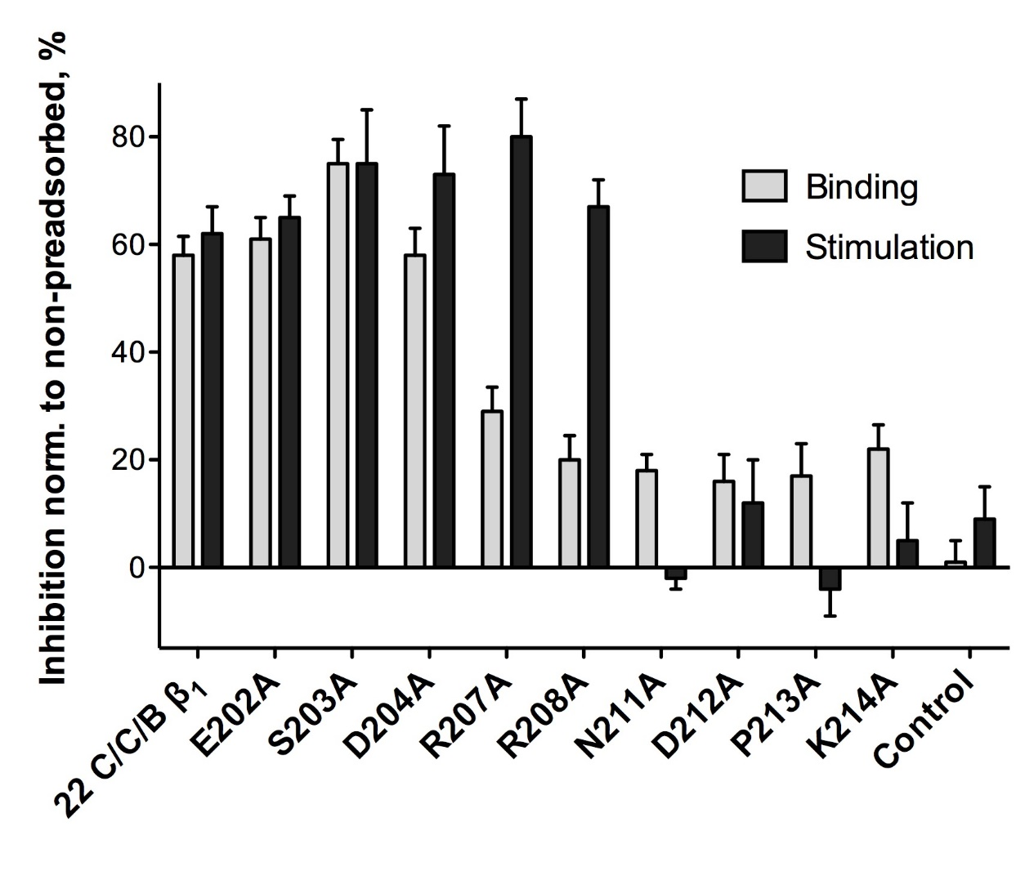
*

*

*

*

**

*

*

*

*

**

**

Supplemental Figure S1 - Neutralization of a monoclonal mouse anti-β₁EC_{II}-antibody by 22mer-cyclopeptides corresponding to the human β₁-EC_{II}, each having a different non-conserved amino-acid (compared to the amino-acids constituting the EC_{II}-loop of the β₂-AR) sequentially replaced with alanine. Monoclonal mouse anti-β₁EC_{II}-abs were pre-absorbed with the indicated cyclopeptides (40 mol/ mol IgG, 4°C, 16 h). Grey columns: mouse anti-β₁EC_{II}-Mab binding to a linear 25AA-β₁EC_{II}-peptide (residues 199-223) as determined by ELISA. Black columns: β₁AR-mediated cAMP-stimulation as measured in cells expressing the native β₁-AR functionally coupled to a FRET-sensor for intracellular cAMP. Decreases in immuno-reactivity (grey bars) or cAMP-stimulation (black bars) after pre-absorption with the indicated cyclopeptides (40 mol CP/ mol IgG) normalized to the values obtained without pre-absorption. Columns represent mean values ±SEM of triplicate determinations. Differences between the non-mutated 22 C/C/B-β₁-cyclopeptide and CP-mutations were analyzed by one-way ANOVA with subsequent Dunnett's post-hoc test for multiple comparisons; * p< 0.05; ** p< 0.01). Internal negative control: non-mutated 22C/C/D-beta2 (sequence and alignment see Tab S1).
Supplemental Figure S2
***
***
****
****
LVED
LVES

Supplemental Figure S2 - Time course of left ventricular diameters from rats immunized against β₁EC_{II} or receiving a monoclonal rat anti-β₁EC_{II} and corresponding control animals, determined by echocardiography. The graphs show the time-course of the LV end-diastolic and end-systolic diameters (LVED/LVES) over 12 months of Lewis-rats immunized subcutaneously every 4 weeks with β₁EC_{II}/GST fusion-proteins (beta1-ECII, black circles, n=10) as previously described in detail (11), or receiving a monoclonal rat anti-β₁EC_{II} intravenously every 4 weeks (rat Mab 13F6, black triangles, n=8). Untreated Lewis rats (controls, white circles, n=10) or animals receiving a rat IgG isotype-control every 4 weeks (isotype control, white triangles, n=5) served as the respective control groups.
Error bars indicate mean ±SEM in the indicated groups; ***p<0.001, ****p<0.0001 (two-way ANOVA and Dunnett's post-hoc test for multiple comparisons, asterisks are indicated for the Mab 13F6 transfer-group versus control animals).

