Supplementary Data
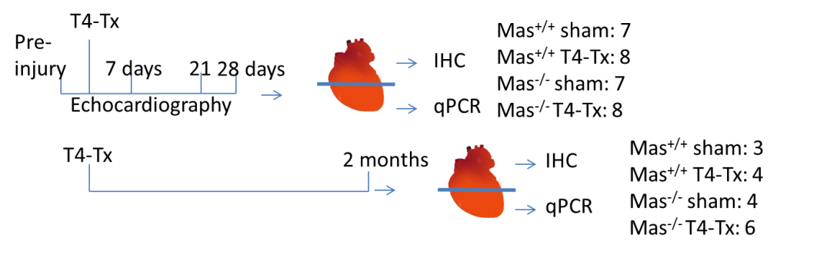
Supplementary Fig. 1. Experimental plan. There were 2 groups of mice, one group received echocardiography and was sacrificed one month post-SCI, the other group was sacrificed 2 months post-SCI.

