Supplementary Material

MRI Markers and Functional Performance in Patients with CIS and MS: A Cross-Sectional Study
Ludwig Rasche, Michael Scheel, Karen Otte, Patrik Althoff, Annemieke Van Vuuren, Rene M. Gieß, Joseph Kuchling, Judith Bellmann-Strobl, Klemens Ruprecht, Friedemann Paul, Alexander U. Brandt, Tanja Schmitz-Hübsch*
* Correspondence:
Corresponding Author
tanja.schmitz-huebsch@charite.de

Supplementary Figures and Tables

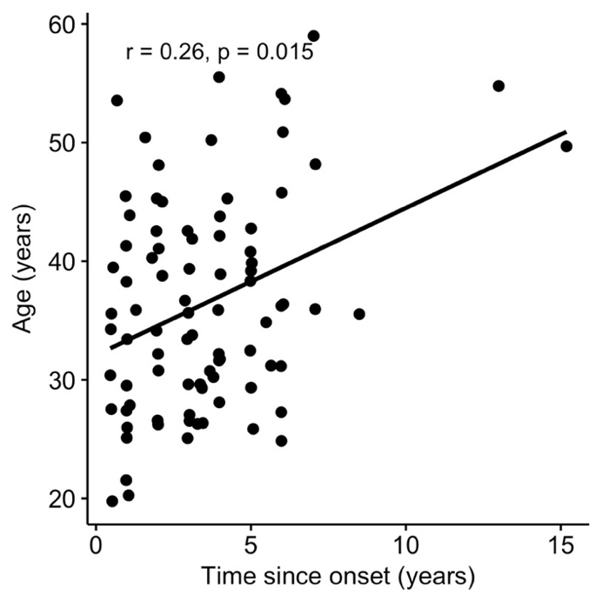
Supplementary Figures

Supplementary Figure 1. Association of time since onset and age in all patients. Given are the spearman´s rho and p. When excluding the two individuals with a time since onset >10years, only a trend remained for this correlation (r_{s}=0.21, p=0.053).

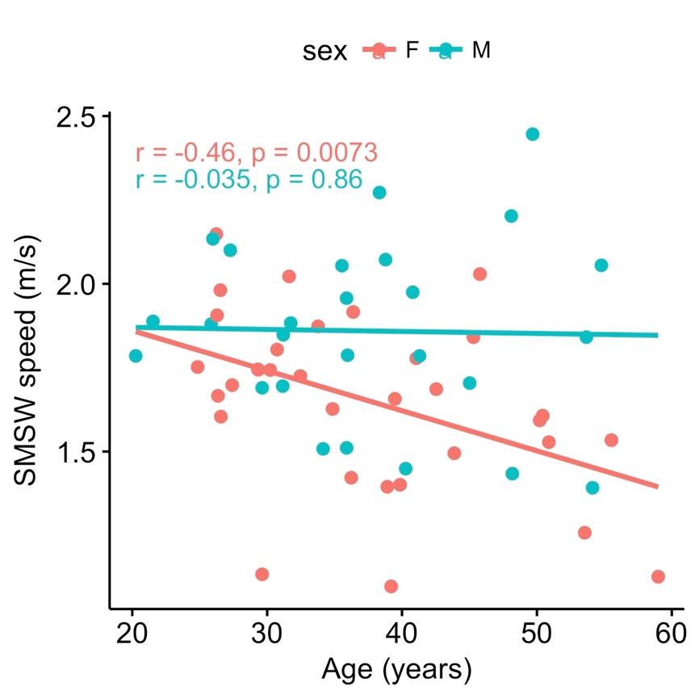
Supplementary Figure 2. Association of short maximum walking speed (SMSW) and age in patients with relapsing-remitting multiple sclerosis (RRMS), stratified by sex. Given are the Pearsons r and p.

Supplementary Tables

 | Dependent variables:
 | SDMT |  |  | 9HPTr |  |  | SMSW speed |  |  | EDSS
Age | -0.361 | -0.361 | -0.360 | -0.491*** | -0.488*** | -0.481*** | -0.235*** | -0.237*** | -0.214*** | 0.419*** | 0.419*** | 0.385***
 | p = 0.016 | p = 0.016 | p = 0.019 | p < 0.0001 | p < 0.0001 | p < 0.0001 | p < 0.0001 | p < 0.0001 | p < 0.0001 | p < 0.0001 | p < 0.0001 | p < 0.0001
SexM |  | 0.044 | 0.044 |  | -0.164*** | -0.159*** |  | 0.368*** | 0.377*** |  | 0.081 | 0.069
 |  | p = 0.989 | p = 0.989 |  | p < 0.0001 | p < 0.0001 |  | p < 0.0001 | p < 0.0001 |  | p = 0.714 | p = 0.753
logT2C |  |  | -0.010 |  |  | -0.054*** |  |  | -0.147 |  |  | 0.213
 |  |  | p = 0.998 |  |  | p < 0.0001 |  |  | p = 0.048 |  |  | p = 0.374
R² | 0.130 | 0.132 | 0.132 | 0.241 | 0.268 | 0.270 | 0.055 | 0.191 | 0.212 | 0.176 | 0.182 | 0.227
F | 8.550* | 4.270 | 2.798 | 17.128** | 9.682** | 6.426** | 3.341 | 6.598* | 4.926* | 12.163** | 6.249* | 5.372*
 | SDMT |  |  | 9HPTr |  |  | SMSW speed |  |  | EDSS
Age | -0.361 | -0.361 | -0.365 | -0.491*** | -0.488*** | -0.482*** | -0.235*** | -0.237*** | -0.224*** | 0.419*** | 0.419*** | 0.405***
 | p = 0.016 | p = 0.016 | p = 0.016 | p < 0.0001 | p < 0.0001 | p < 0.0001 | p < 0.0001 | p < 0.0001 | p < 0.0001 | p < 0.0001 | p < 0.0001 | p < 0.0001
SexM |  | 0.044 | 0.039 |  | -0.164*** | -0.147*** |  | 0.368*** | 0.385*** |  | 0.081 | 0.064
 |  | p = 0.989 | p = 0.990 |  | p < 0.0001 | p < 0.0001 |  | p < 0.0001 | p < 0.0001 |  | p = 0.714 | p = 0.771
logT2V |  |  | 0.050 |  |  | -0.150*** |  |  | -0.191** |  |  | 0.197
 |  |  | p = 0.984 |  |  | p < 0.0001 |  |  | p = 0.001 |  |  | p = 0.278
R² | 0.130 | 0.132 | 0.135 | 0.241 | 0.268 | 0.290 | 0.055 | 0.191 | 0.227 | 0.176 | 0.182 | 0.221
F | 8.550* | 4.270 | 2.856 | 17.128** | 9.682** | 7.075** | 3.341 | 6.598* | 5.376* | 12.163** | 6.249* | 5.195*
 | *p**p***p<1e-04

Supplementary Table 1. Regression models in RRMS for functional performance measures as dependent variable and stepwise inclusion of Age, Sex and logarithmic T2 count and volume. Given are the standardized beta coefficients, R² and respective F-Statistic, * is signifying significance after correction for multiple testing.

 | Dependent variables:
 | SDMT |  |  | 9HPTr |  |  | SMSW speed |  |  | EDSS
Age | 0.151 | 0.144 | 0.241 | -0.073*** | 0.007*** | 0.282*** | -0.197*** | -0.086*** | -0.252*** | 0.125*** | 0.089** | 0.024
 | p = 0.435 | p = 0.497 | p = 0.342 | p < 0.0001 | p < 0.0001 | p < 0.0001 | p < 0.0001 | p < 0.0001 | p < 0.0001 | p < 0.0001 | p = 0.001 | p = 0.441
SexM |  | 0.022 | -0.009 |  | -0.228*** | -0.318*** |  | -0.319* | -0.265* |  | 0.103 | 0.124
 |  | p = 0.995 | p = 0.998 |  | p < 0.0001 | p < 0.0001 |  | p = 0.002 | p = 0.007 |  | p = 0.794 | p = 0.761
NBV |  |  | 0.169*** |  |  | 0.477*** |  |  | -0.289*** |  |  | -0.113***
 |  |  | p < 0.0001 |  |  | p < 0.0001 |  |  | p < 0.0001 |  |  | p < 0.0001
R² | 0.023 | 0.023 | 0.044 | 0.005 | 0.051 | 0.212 | 0.039 | 0.128 | 0.187 | 0.016 | 0.025 | 0.034
F | 0.586 | 0.287 | 0.349 | 0.133 | 0.644 | 2.059 | 1.011 | 1.764 | 1.764 | 0.398 | 0.307 | 0.269
 | SDMT |  |  | 9HPTr |  |  | SMSW speed |  |  | EDSS
Age | 0.151 | 0.144 | 0.231 | -0.073*** | 0.007*** | 0.352*** | -0.197*** | -0.086*** | -0.442*** | 0.125*** | 0.089** | 0.033
 | p = 0.435 | p = 0.497 | p = 0.453 | p < 0.0001 | p < 0.0001 | p < 0.0001 | p < 0.0001 | p < 0.0001 | p < 0.0001 | p < 0.0001 | p = 0.001 | p = 0.392
SexM |  | 0.022 | 0.037 |  | -0.228*** | -0.170*** |  | -0.319* | -0.379*** |  | 0.103 | 0.093
 |  | p = 0.995 | p = 0.991 |  | p < 0.0001 | p < 0.0001 |  | p = 0.002 | p < 0.0001 |  | p = 0.794 | p = 0.819
NGMV |  |  | 0.123* |  |  | 0.485*** |  |  | -0.501*** |  |  | -0.080***
 |  |  | p = 0.002 |  |  | p < 0.0001 |  |  | p < 0.0001 |  |  | p < 0.0001
R² | 0.023 | 0.023 | 0.030 | 0.005 | 0.051 | 0.150 | 0.039 | 0.128 | 0.234 | 0.016 | 0.025 | 0.028
F | 0.586 | 0.287 | 0.235 | 0.133 | 0.644 | 1.355 | 1.011 | 1.764 | 2.342 | 0.398 | 0.307 | 0.218
 | SDMT |  |  | 9HPTr |  |  | SMSW speed |  |  | EDSS
Age | 0.151 | 0.144 | 0.200 | -0.073*** | 0.007*** | 0.101*** | -0.197*** | -0.086*** | -0.163*** | 0.125*** | 0.089** | 0.006
 | p = 0.435 | p = 0.497 | p = 0.371 | p < 0.0001 | p < 0.0001 | p < 0.0001 | p < 0.0001 | p < 0.0001 | p < 0.0001 | p < 0.0001 | p = 0.001 | p = 0.834
SexM |  | 0.022 | -0.007 |  | -0.228*** | -0.276*** |  | -0.319* | -0.279* |  | 0.103 | 0.146
 |  | p = 0.995 | p = 0.999 |  | p < 0.0001 | p < 0.0001 |  | p = 0.002 | p = 0.005 |  | p = 0.794 | p = 0.711
NThalV |  |  | 0.173 |  |  | 0.287*** |  |  | -0.236*** |  |  | -0.256
 |  |  | p = 0.895 |  |  | p < 0.0001 |  |  | p < 0.0001 |  |  | p = 0.109
R² | 0.023 | 0.023 | 0.050 | 0.005 | 0.051 | 0.125 | 0.039 | 0.128 | 0.179 | 0.016 | 0.025 | 0.084
F | 0.586 | 0.287 | 0.407 | 0.133 | 0.644 | 1.098 | 1.011 | 1.764 | 1.666 | 0.398 | 0.307 | 0.703
 | SDMT |  |  | 9HPTr |  |  | SMSW speed |  |  | EDSS
Age | 0.151 | 0.144 | 0.152 | -0.073*** | 0.007*** | 0.026*** | -0.197*** | -0.086*** | -0.090*** | 0.125*** | 0.089** | 0.084*
 | p = 0.435 | p = 0.497 | p = 0.475 | p < 0.0001 | p < 0.0001 | p < 0.0001 | p < 0.0001 | p < 0.0001 | p < 0.0001 | p < 0.0001 | p = 0.001 | p = 0.002
SexM |  | 0.022 | -0.086 |  | -0.228*** | -0.471*** |  | -0.319* | -0.266 |  | 0.103 | 0.176
 |  | p = 0.995 | p = 0.982 |  | p < 0.0001 | p < 0.0001 |  | p = 0.002 | p = 0.021 |  | p = 0.794 | p = 0.703
NWMV |  |  | 0.204*** |  |  | 0.457*** |  |  | -0.100*** |  |  | -0.137***
 |  |  | p < 0.0001 |  |  | p < 0.0001 |  |  | p < 0.0001 |  |  | p < 0.0001
R² | 0.023 | 0.023 | 0.054 | 0.005 | 0.051 | 0.203 | 0.039 | 0.128 | 0.136 | 0.016 | 0.025 | 0.039
F | 0.586 | 0.287 | 0.435 | 0.133 | 0.644 | 1.958 | 1.011 | 1.764 | 1.202 | 0.398 | 0.307 | 0.309
 | SDMT |  |  | 9HPTr |  |  | SMSW speed |  |  | EDSS
Age | 0.151 | 0.144 | 0.222 | -0.073*** | 0.007*** | 0.037*** | -0.197*** | -0.086*** | -0.145*** | 0.125*** | 0.089** | 0.096**
 | p = 0.435 | p = 0.497 | p = 0.294 | p < 0.0001 | p < 0.0001 | p < 0.0001 | p < 0.0001 | p < 0.0001 | p < 0.0001 | p < 0.0001 | p = 0.001 | p < 0.00015
SexM |  | 0.022 | 0.030 |  | -0.228*** | -0.225*** |  | -0.319* | -0.325** |  | 0.103 | 0.103
 |  | p = 0.995 | p = 0.993 |  | p < 0.0001 | p < 0.0001 |  | p = 0.002 | p = 0.001 |  | p = 0.794 | p = 0.797
logT2C |  |  | -0.314 |  |  | -0.119*** |  |  | 0.239 |  |  | -0.025
 |  |  | p = 0.922 |  |  | p < 0.0001 |  |  | p = 0.017 |  |  | p = 0.952
R² | 0.023 | 0.023 | 0.115 | 0.005 | 0.051 | 0.064 | 0.039 | 0.128 | 0.181 | 0.016 | 0.025 | 0.026
F | 0.586 | 0.287 | 1.000 | 0.133 | 0.644 | 0.526 | 1.011 | 1.764 | 1.698 | 0.398 | 0.307 | 0.201
 | SDMT |  |  | 9HPTr |  |  | SMSW speed |  |  | EDSS
Age | 0.151 | 0.144 | 0.217 | -0.073*** | 0.007*** | 0.035*** | -0.197*** | -0.086*** | -0.126*** | 0.125*** | 0.089** | 0.071
 | p = 0.435 | p = 0.497 | p = 0.279 | p < 0.0001 | p < 0.0001 | p < 0.0001 | p < 0.0001 | p < 0.0001 | p < 0.0001 | p < 0.0001 | p = 0.001 | p = 0.009
SexM |  | 0.022 | -0.029 |  | -0.228*** | -0.248*** |  | -0.319* | -0.291* |  | 0.103 | 0.116
 |  | p = 0.995 | p = 0.993 |  | p < 0.0001 | p < 0.0001 |  | p = 0.002 | p = 0.003 |  | p = 0.794 | p = 0.773
logT2V |  |  | -0.404 |  |  | -0.155*** |  |  | 0.220* |  |  | 0.103
 |  |  | p = 0.849 |  |  | p < 0.0001 |  |  | p = 0.002 |  |  | p = 0.718
R² | 0.023 | 0.023 | 0.181 | 0.005 | 0.051 | 0.074 | 0.039 | 0.128 | 0.175 | 0.016 | 0.025 | 0.035
F | 0.586 | 0.287 | 1.698 | 0.133 | 0.644 | 0.614 | 1.011 | 1.764 | 1.628 | 0.398 | 0.307 | 0.279
 | *p**p***p<1e-04

Supplementary Table 2. Regression models in CIS for functional performance measures as dependent variable and stepwise inclusion of Age, Sex and NBV, NGMV, NThalV, NWMV, logarithmic T2 count and logarithmic T2 volume. Given are the standardized beta coefficients, R² and respective F-Statistic, * is signifying significance after correction for multiple testing.

