Supplementary Material

**Muscle atrophy due to nerve damage is accompanied by elevated myofibrillar protein synthesis rates**

Henning T. Langer1,2,3*, Joan M.G. Senden6, Annemie P. Gijsen6, Stefan Kempa4,5, Luc J.C. van Loon6, Simone Spuler1-5

**\*Corresponding author: Henning Langer, henning.langer@charite.de**

## Supplementary Figures

## 

**Supplementary Figure 1.** Composition of the rat chow (ssniff Spezialdiäten GmbH, Soest, Germany).

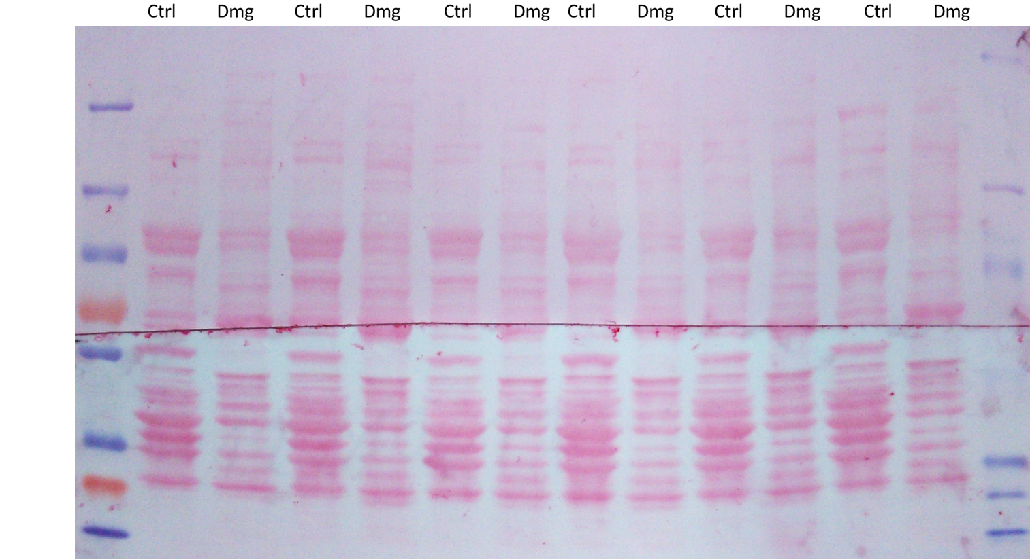

**Supplementary Figure 2.** Representative Ponceau S staining of a membrane which was used for western blot analysis.



**Supplementary Figure 3.** Clustered fiber type analysis. *N*=5 animals, counted were 10-50 fibers per slide depending on the quality of the Toluidine blue staining.



**Supplementary Figure 4.** Intraindividual comparison of myofibrillar protein synthesis rates of the TA in the contralateral control leg compared to the nerve damaged leg (*n*=10). The dashed lines connect the values of the contralateral TA (control) with the nerve damaged TA (damaged) of the same animal.

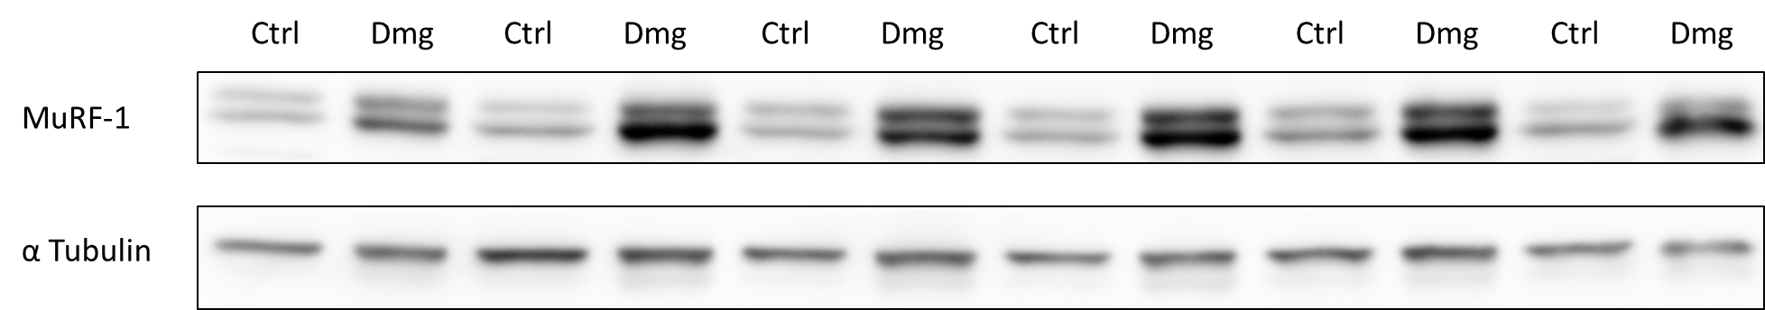

**Supplementary Figure 5.** Protein expression of MuRF-1 and Alpha Tubulin in the contralateral control TA (Ctrl) next to the nerve damaged TA (Dmg) of the same animal (*n*=6).

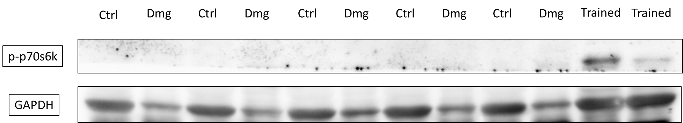

**Supplementary Figure 6.** Protein expression of phosphorylated p70s6k1 in the contralateral control TA (Ctrl) next to the nerve damaged TA (Dmg) of the same animal (*n*=5), as well as compared to a positive control (exercised rat TA (Trained)) (*n*=2).



**Supplementary Figure 7.** Change in bodyweight over the course of the 4 week experiment (*n*=8).



**Supplementary Figure 8.** Correlation between myofibrillar protein synthesis (FSR) and p70s6k1 expression under baseline conditions. Only within the contralateral control TA (*n*=6).

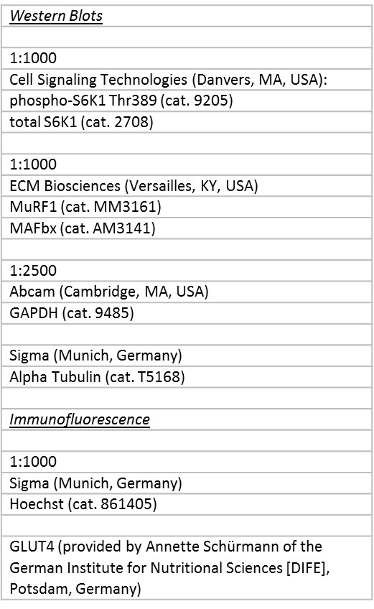

**Supplementary Figure 9.** List of antibodies and dilutions.