Supplementary Materials: S1P signalling differentially affects migration of peritoneal B cell populations in vitro and influences the production of intestinal IgA in vivo
Annabel Kleinwort, Felix Lührs, Claus-Dieter Heidecke, Martin Lipp and Tobias Schulze
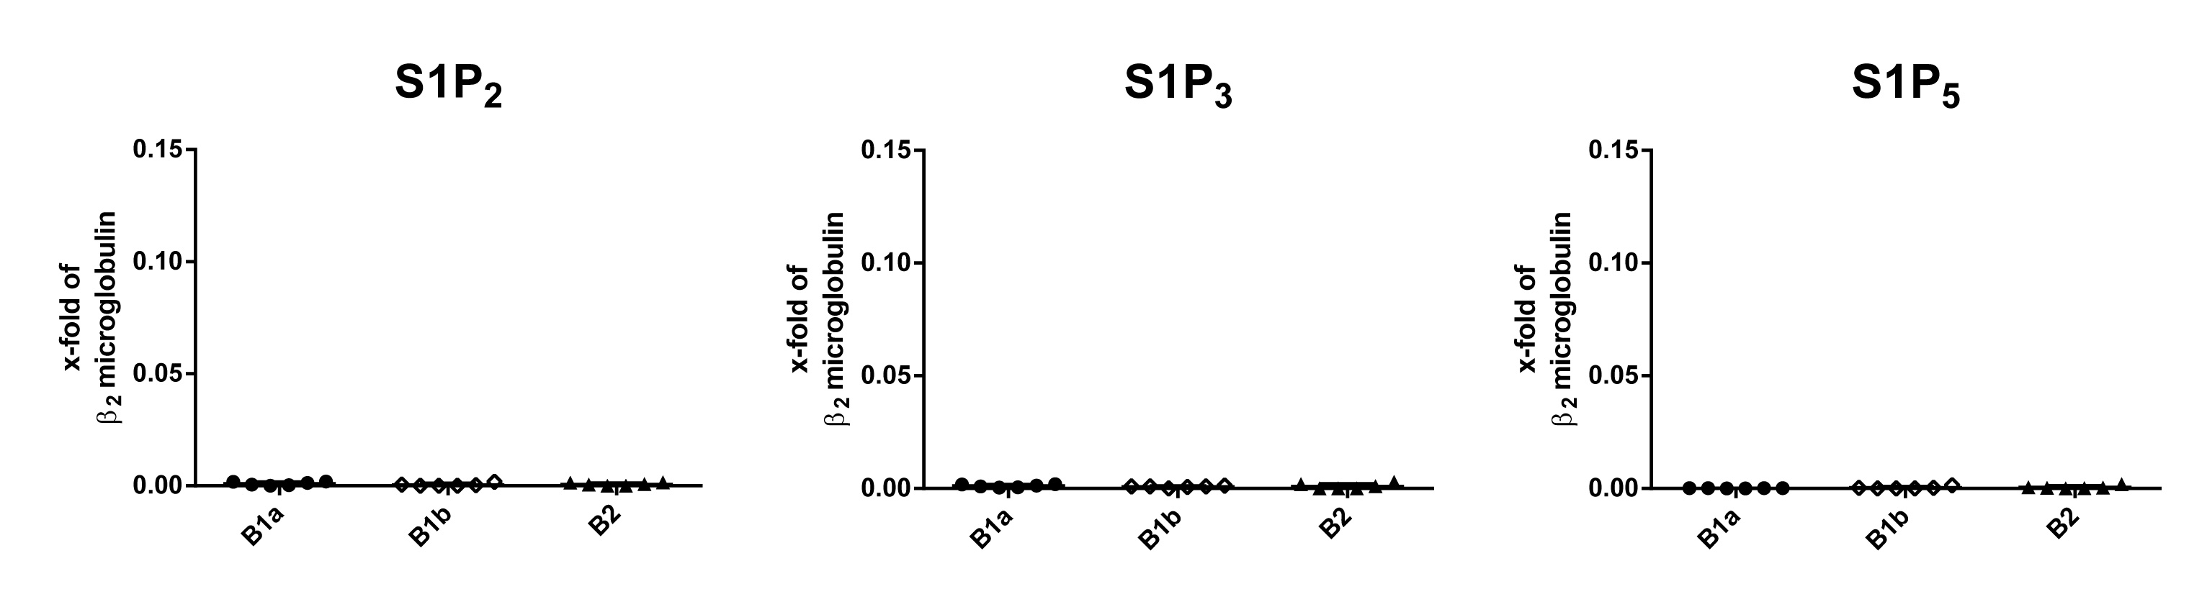
Figure S1. Expression of sphingosine-1-phosphate (S1P) receptor subtypes S1P₂, S1P₃ and S1P₅ in peritoneal B cell subpopulations.
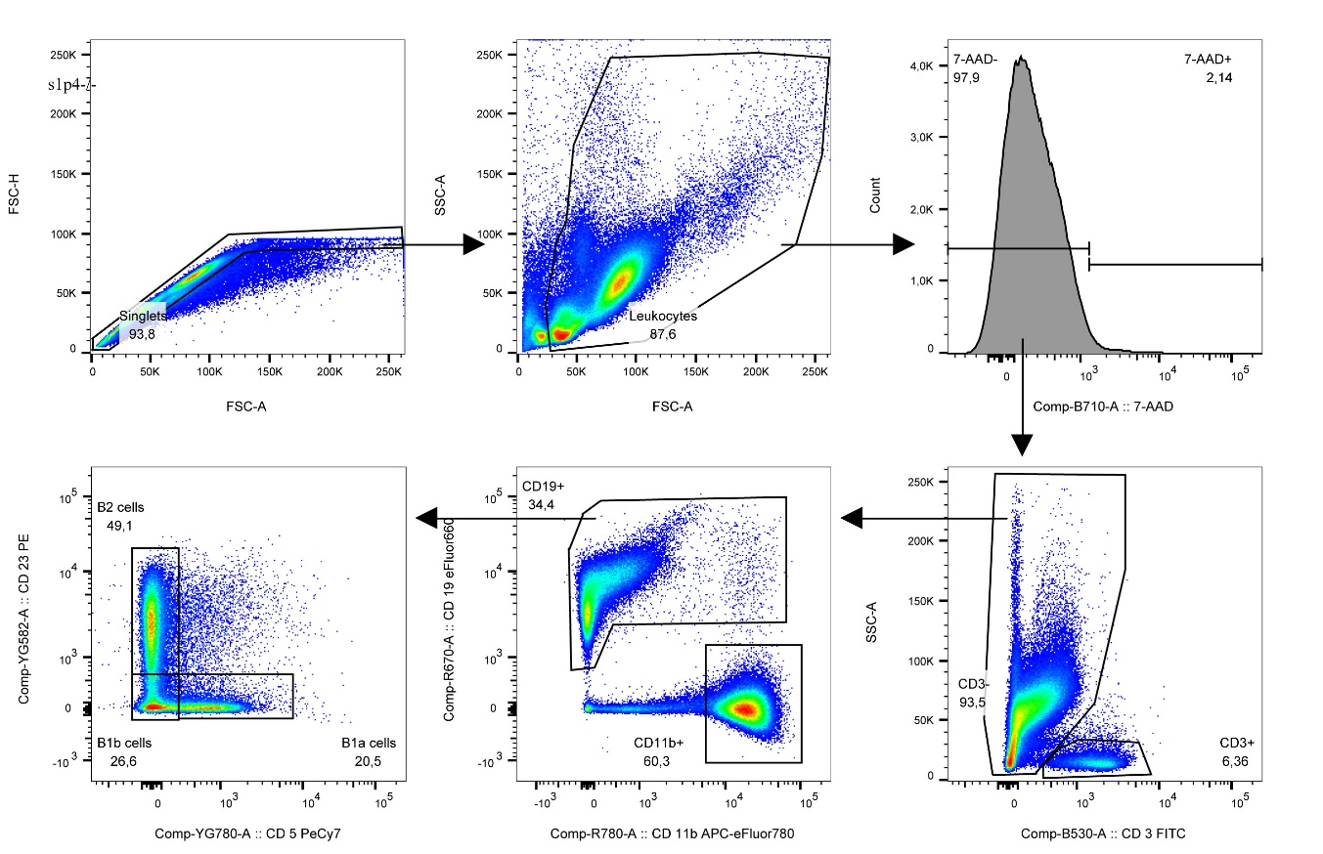
Figure S2. Gating strategy for identification of B1a B cells, B1b B cells and B2 B cells in the peritoneal cell population.

