Supplementary Material

Genetic tracing of Ca_{v}3.2 T-type calcium channel expression in the peripheral nervous system
Yinth Andrea Bernal Sierra, Julia Haseleu, Alexey Kozlenkov, Valérie Bégay, Gary R. Lewin
* Correspondence: Gary R. Lewin: glewin@mdc-berlin.de

Supplementary Figures

Supplementary Figure 1

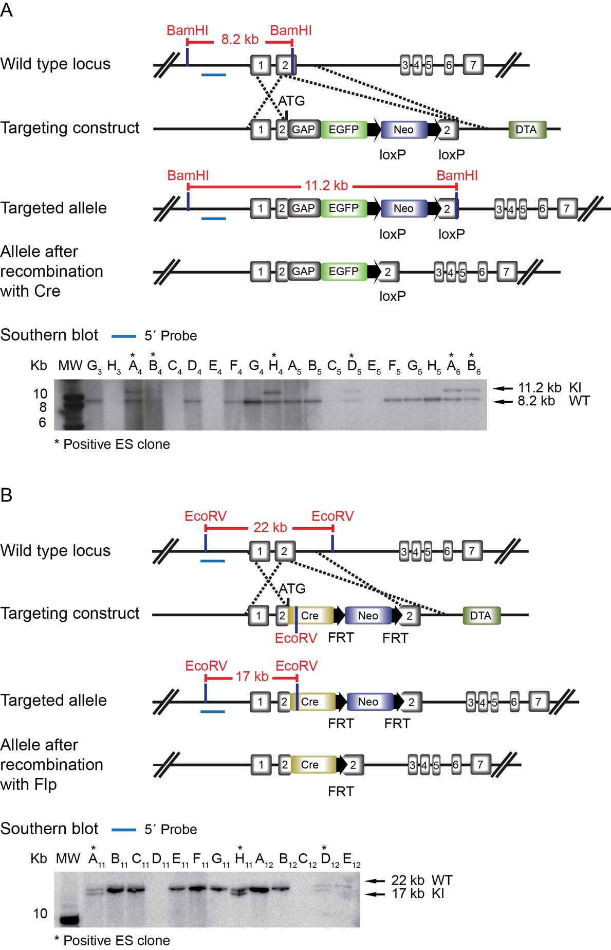
Supplementary Figure 1. Generation of Ca_{v}3.2^{eGFP} and Ca_{v}3.2^{Cre} knockin mice. (A) Schematic representation of the Ca_{v}3.2 locus, the targeting vector and the mutated Ca_{v}3.2^{EGFP} allele. In the targeting vector, the EGFP cassette containing the palmitoylation site of GAP43 (GAP) is inserted after the ATG initiation codon located in the second exon of the Ca_{v}3.2 gene, and is followed by a neomycin (Neo) cassette flanked by loxP sequences. A MC-1 diphteria toxin A (DTA) cassette located at the 3’ end of the vector was used for negative selection. At the bottom of (A), a Southern blot analysis of BamH1 digested tail genomic DNA is shown. The 5’ end probe (blue line) shows a 8.2 kb band (red line) from the wild type locus and a 11.2 kb band (red line) from the targeted allele. *, Ca_{v}3.2^{EGFP} positive clone. (B) Schematic representation of the Ca_{v}3.2 locus, the targeting vector, and the mutated Ca_{v}3.2^{Cre} allele. In the targeting vector, a Cre recombinase cassette followed by a FRT-flanked Neo cassette is inserted in the second exon as described above. A DTA cassette was inserted at the 3’ end of the vector and was used for negative selection. At the bottom of (B), a Southern Blot analysis of EcoRV digested tail genomic DNA is shown. The 5’ end probe (blue line) shows a 22 kb band (red line) from the wild type locus and a 17 kb band (red line) from the targeted allele. *, Ca_{v}3.2^{Cre} positive clone. Note that the schemes are not in scale.

Supplementary Figure 2

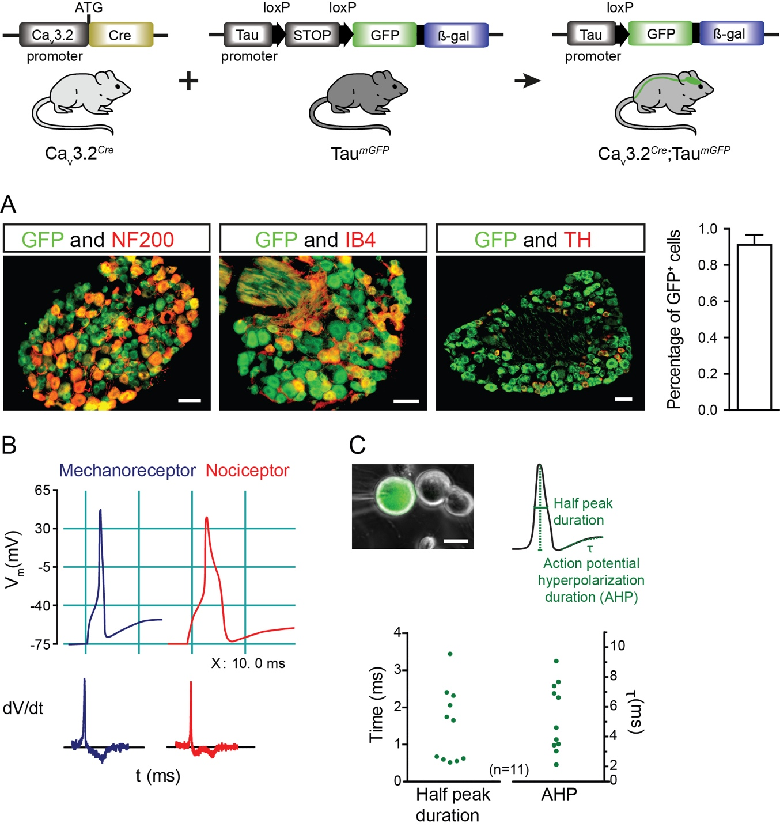
Supplementary Figure 2. Characterization of GFP positive cells in the DRG of Ca_{v}3.2^{Cre}; Tau^{mGFP} adult mice. (A) Double immunostaining of GFP and NF200 for identification of Aß- and Aδ-myelinated afferents, GFP and IB4 for identification of nonpeptidergic unmyelinated nociceptors, and GFP and TH for identification of nonpeptidergic C-LTMRs. On the left, a quantification of GFP⁺ cells is shown. Scale bars: 50 µm. (B) Examples of the action potential shape of mechanoreceptors and nociceptors. Below, schemes of the first derivate dV/dt which show the presence of one minimum for mechanoreceptors and two minimums for nociceptors are shown. (C) In the upper left, an example of a GFP⁺ cell in culture is shown. Scale bar: 20 µm. In the upper right, an illustration of the measured action potential variables is shown. In the dotplot graph, electrophysiological parameters of action potentials recorded in cultured GFP⁺ DRG cells from Ca_{v}3.2^{Cre};Tau^{mGFP} mice are quantified. Cells with a half peak duration of less than 1 ms were classified as mechanoreceptors.

Supplementary Figure 3

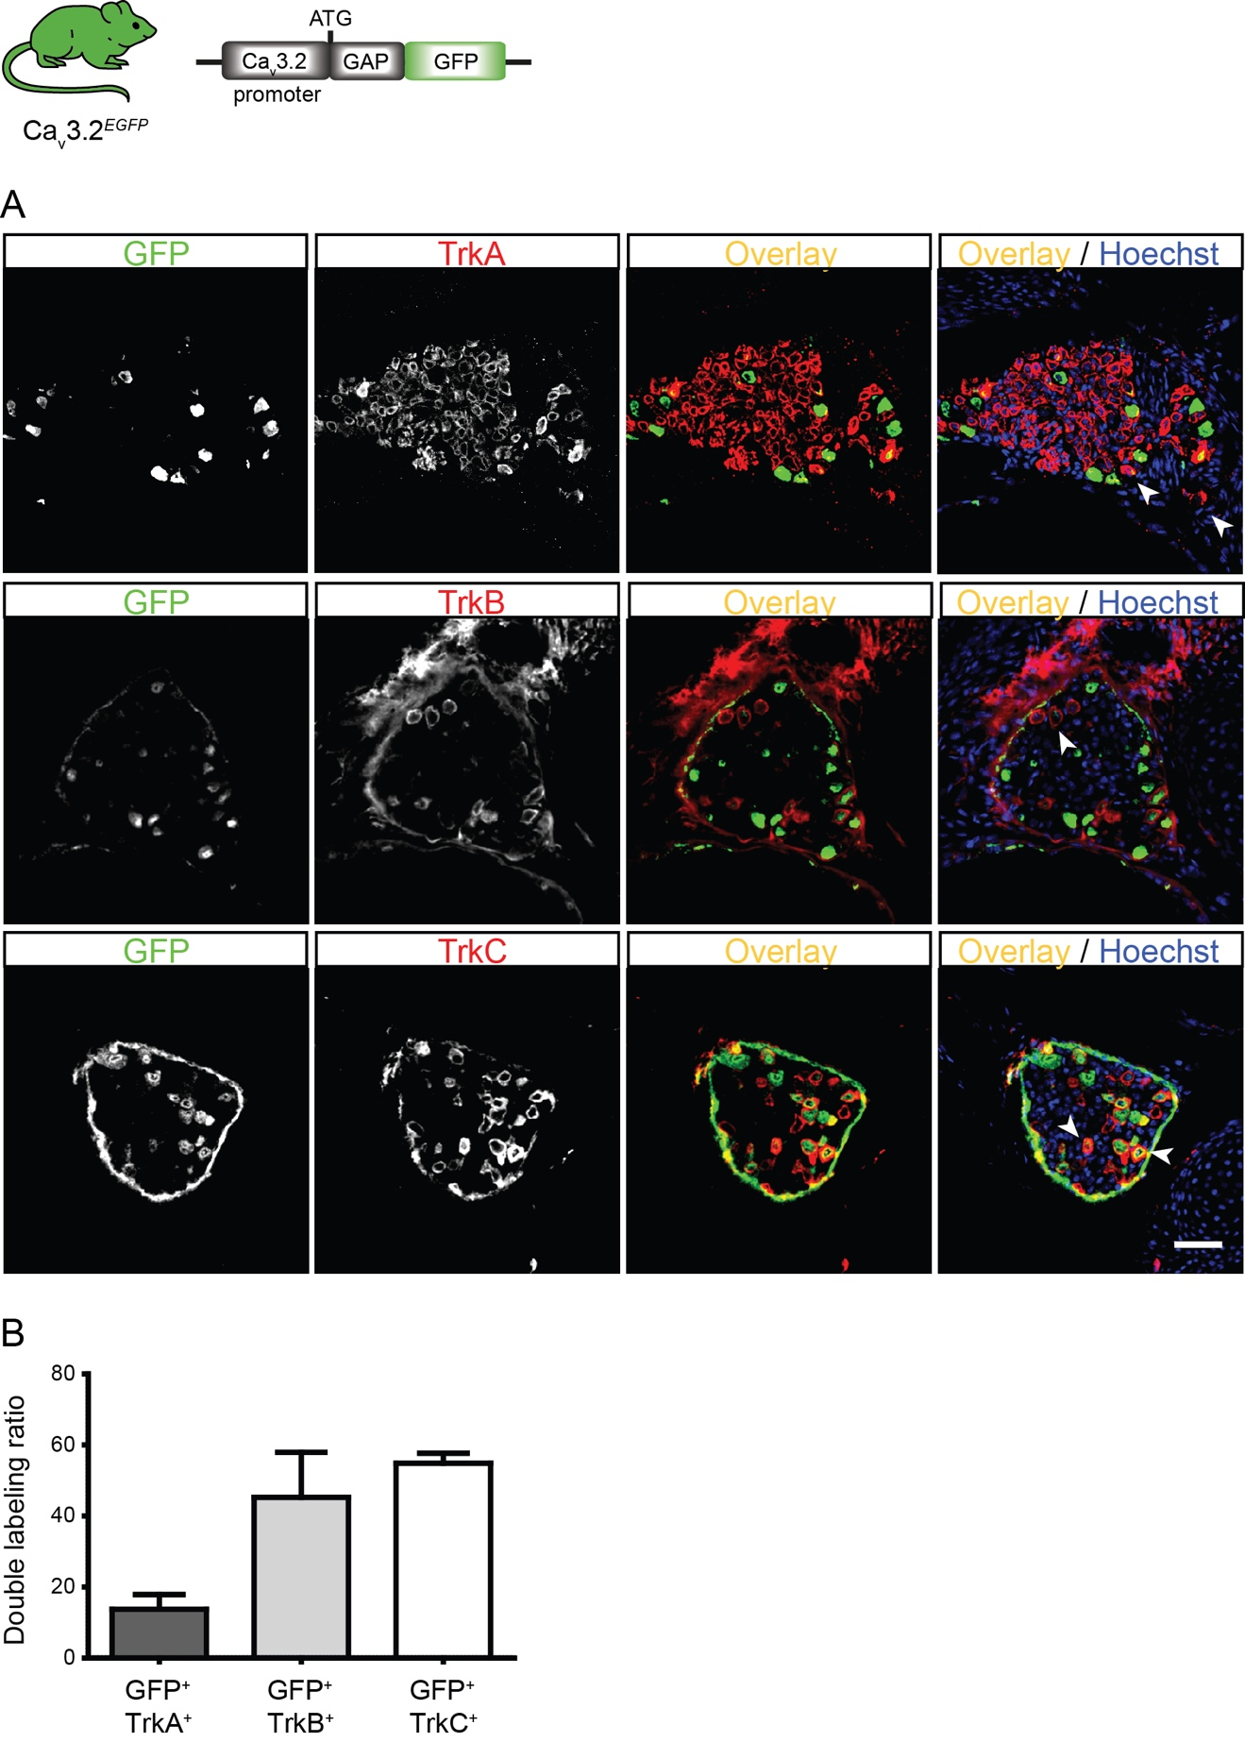
Supplementary Figure 3. Characterization of eGFP⁺ cells in the DRG of Ca_{v}3.2^{eGFP} knockin mice. (A) DRG double immunostaining of eGFP and TrkA, eGFP and TrkB, and eGFP and TrkC in embryos at E18.5. Cell nuclei are labelled with Hoechst (blue). Arrowheads indicate examples of double-positive neurons. Scale bars: 50 µm. (B) In the bar plot double immunostainings are quantified. The ordinate represents the percentage of eGFP⁺ cells co-expressing one of the molecular markers. Data presented as mean + SD. N=3 animals, 3 DRGs were examined per animal.

Supplementary Figure 4

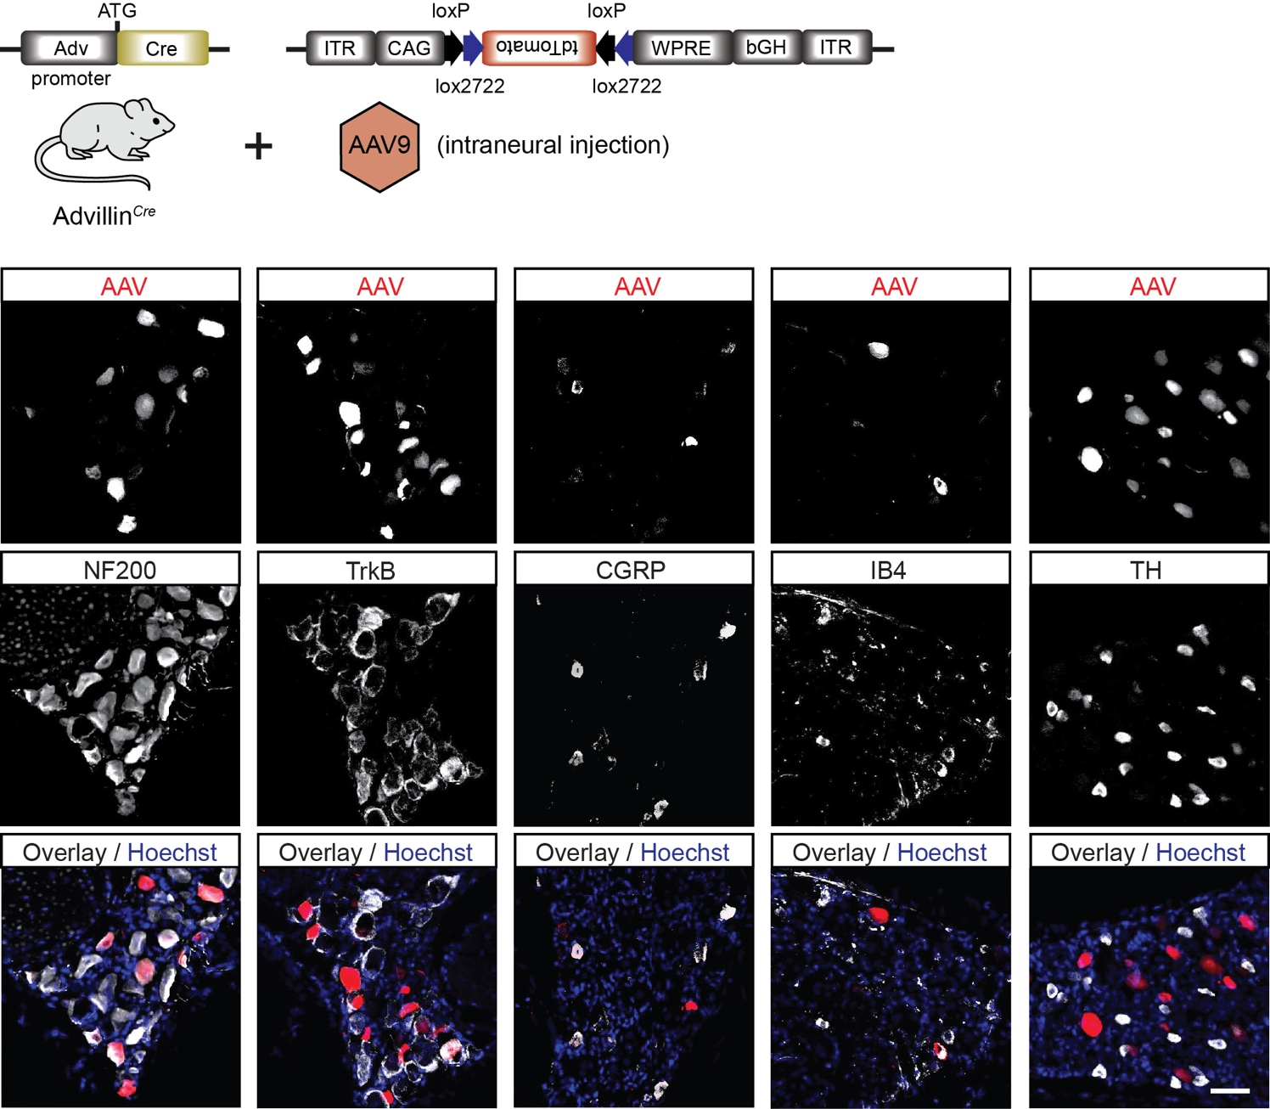
Supplementary Figure 4. Immunostainings for characterization of tdTomato positive cells in the DRG of virally transduced Advillin^{Cre} mice. Representative images of immunostainings of tdTomato⁺ cells with markers for sensory neuron subtypes, i.e. NF200, TrkB, CGRP, IB4, and TH. Scale bar: 50 µm.

Supplementary Figure 5

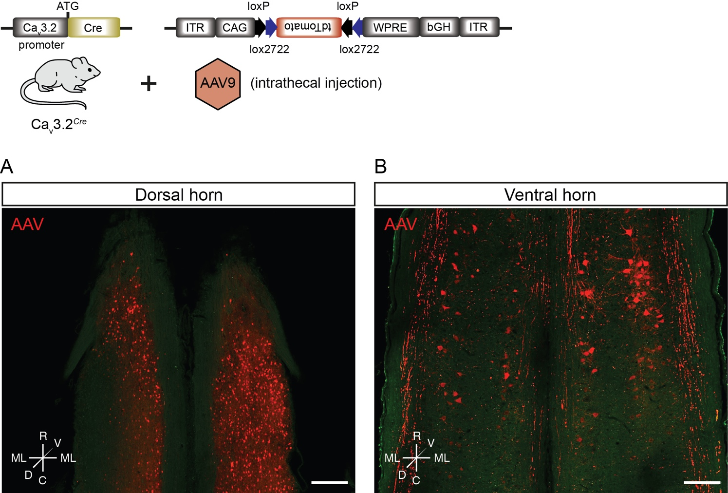

Supplementary Figure 5. Virally transduced spinal cord cells in Ca_{v}3.2^{Cre} mice after intrathecal AAV injections. TdTomato⁺ cells in the spinal cord (A) dorsal horn and (B) ventral horn. Scale bar: 200 µm.

