J Mol Med 2016

Electronic Supplemental Material

Reducing RBM20 activity improves diastolic dysfunction and cardiac atrophy

Florian Hinze^{1,4}, Christoph Dieterich^{2,5}, Michael H Radke^{1,4}, Henk Granzier³ & Michael Gotthardt^{1,4}

- Neuromuscular and Cardiovascular Cell Biology, Max-Delbrück-Center for Molecular Medicine, 13125 Berlin, Germany
- Klaus Tschira Institute for Integrative Computational Cardiology and Dept. Cardiology, Angiology, and Pneumology, Heidelberg University, 69120 Heidelberg, Germany
- Depts. of Physiology and Cellular and Molecular Medicine, University of Arizona, Tucson, AZ
- DZHK (German Centre for Cardiovascular Research), partner site Berlin, Berlin, Germany
- DZHK (German Centre for Cardiovascular Research), partner site Heidelberg, Heidelberg, Germany

Supplemental Experimental Procedures

Animal procedures
The titin N2B knockout as a model for diastolic dysfunction, as well as the RNA recognition motif knockout of RBM20 have previously been described [1, 2]. Male mice were sacrificed by cervical dislocation at 100 to 120 days of age. The hearts were rapidly excised, washed in PBS, and dissected into atria, septum, right and left ventricle. The tissue were snap frozen in liquid nitrogen and stored at -80°C. For further analyses left ventricular tissue was processed to tissue powder using liquid nitrogen cooled mortars and pestles. We evaluated the cardiac dimensions and functions by echocardiography and hemodynamic catheter analysis. For genotyping we used DNA extracted from ear tags. All experiments involving animals were carried out following institutional and US National Institutes of Health guidelines as approved by LaGeSo Berlin. Mice were age- and sex-matched for analysis.

Generation and genotyping of the splice rescue strain
The N2B splice rescue mice were generated by crossing the Ttn exon 49 (N2B exon) deletion model [1] and the Rbm20 exon 6 and 7 (RNA recognition motif) deletion model [2]. Both exonic deletions are in-frame. N2B splice rescue mice were maintained on a 129S6 background (Taconic). For genotyping, DNA was extracted from murine ear tags. The deletions of the N2B exon and Rbm20 exon 6 and 7 were confirmed by PCR. The N2B deletion were detected with N2B_f (5’- AATCTCACCACAACCTTATTCCA -3’) and N2B-WT_r (5’- GGTTAACAGCATCCCATTAAAGA -3) for the wild type allele and N2B-KO_r (5’- AGTGAATTGCGGGGAAATTATTA -3’) for the knockout allele. The exon 6 and 7 deletion of Rbm20 were detected using Rbm20_f (5’- ATATCTGCACCCATGTTTAGTTTCC -3’) and Rbm20-WT_r (5’- GAAGCCAGTGTGTTGGTATGG -3’) for the wild type allele and Rbm20-KO_r (5’- ATTTGAATGCCCCCAGAAGT -3’) for the knockout allele.

Analysis and quantification of protein expression
Proteins were extracted from left ventricular tissue powder. Tissue powder was incubated with RIPA buffer (50 mM Tris pH 8.0, 150 mM NaCl, 0.25% Na-deoxycholate, 1% NP-40, 1 mM EDTA, 1 mM EGTA) for 30 min on ice followed by sonication. Then samples were centrifuged at 13000 rpm for 20 min, flash frozen in liquid nitrogen and stored at -80°C. The proteins were separated on a SDS-PAGE gel system (Biorad) and transferred to Hybond P PVDF membranes (GE Healthcare) for 2 h with 200 mA for subsequent western blot analysis. Blocking were performed in superblotto (10 mM Tris-HCl pH 8.0, 150 mM NaCl, 0.1 % Tween 20, 0.5% BSA, 2.5 % milk powder) for 1 h at room temperature followed by the incubation with primary antibody overnight at 4°C. Antibodies were used according to manufacturer’s instructions and are listed in Supplemental Table 1. The detection was performed using horseradish peroxidase-conjugated secondary antibodies and chemiluminescence staining using ECL (Supersignal West Pico/Femto Chemiluminescence Substrate, Pierce) on a Fusion Fx7 system (PeqLab). The software AIDA v4.23 was used for quantification. Analysis of titin isoform expression was performed as described previously [3]. Tissue powder was homogenized in 40x volume sample buffer (8 M urea, 2 M thiourea, 3% SDS, 0.03% bromophenol blue, 75 mM DTT, 0.05 M Tris pH 6.8) by douncing for 30 s at 60°C. Then glycerol was added to a final concentration of 12% and the tissues were homogenized for 2 more min at room temperature, aliquoted and snap frozen in liquid nitrogen. The homogenized samples were electrophoresed on a 1% agarose gel using vertical SDS-agarose gel system (Hoefer). The gels were run at 15 mM for 4 h followed by Coomassie brilliant blue staining to visualize titin isoforms N2BA, N2B, and the proteolytic fragment T2 and MHC.

Trichrome staining
Mice at 100 to 120 days of age were weighed and sacrificed by cervical dislocation. The hearts were rapidly excised, washed in PBS and fixed with 4% PFA overnight at 4°C. The hearts were rehydrated in H₂O, subsequently dehydrated in an ascending ethanol series, embedded in paraffin, sectioned and a trichrome staining were performed. Stained sections were then imaged using a DMI 6000 B microscope (Leica, 5x magnification).

Cardiac myofiber size determination
The diameters of cardiac myofibers were determined from 20x magnified trichrome stained slices using ImageJ (Fiji).

RT-PCR and RT-qPCR
Total RNA was extracted from left ventricular tissue powder with TRIzol (Invitrogen) following the manufacturer’s protocol. At least five individual left ventricles were processed per genotype. A clean-up of the RNA was performed using RNAeasy mini spin columns (Qiagen). The RNA was reverse transcribed to cDNA using the high-capacity RNA-to-cDNA kit (Thermo Fisher Scientific). Quantitative RT-PCR was performed using TaqMan master mix (Applied Biosystems) in a 7900 HT cycler (Applied Biosystems). RT-PCR primers and TaqMan probes are listed in Supplemental Table 4. The quantification of the gene expression was performed using the ∆∆C_{T} method using Eef1a1 as the reference gene [4].

Echocardiography
For echocardiography age and sex matched mice (100-120 days old males) were anesthetized with an intermixture of oxygen and 2.5% isoflurane. The fur was removed using a hair removal cream and a shaver. Contact gel was used for an optimal imaging of the transducer. Vital parameters as cardiac and breathing frequency were measured by electrodes at the paws. The ultrasonic probe MS-400 was used to determine the cardiac parameters and the VEVO 2100 system (Visualsonics Fujifilm) for visualization as described previously [5].

Conductance catheter measurement
For the cardiac pressure and volume measurement the Millar Conductance Catheter System was used as described previously [5]. Age and sex matched mice (100-120 days old males) were anesthetized with an intermixture of oxygen and 2.5% isoflurane, orotracheally intubated and ventilated. The catheter was inserted retrogradely into the left ventricle via the arteria carotis communis to measure pressure volume relations. The artery was exposed by cervical incision between lower jaw and sternum. Blood was arrested proximal and distal of the artery. The placement of the catheter was validated by electrocardiography (Vevo2100). Pressure independent parameters were measured after a three second occlusion of the vena cava inferior. The vein was exposed by opening the peritoneum. The occlusion causes a pressure decrease and reduction of the left ventricular volume.

RNAseq library prep and analysis of RNAseq data
RNA from three left ventricles was isolated using TRIzol followed by a clean-up with the QIAGEN RNA micro kit. The cDNA libraries were generated using the Illumina TruSeq Stranded mRNA Sample Prep Kit and 2x101 paired end sequenced on HiSeq2000. The reads were trimmed and quality clipped with Flexbar [6]. All remaining reads greater 18bp were mapped to the murine genome (assembly EnsEMBL 84) with the splice-aware STAR aligner [7]. Subsequent transcriptome analyses on differential gene and isoform abundance were carried out with cuffdiff [8]. The differentially expressed and differentially spliced genes (P < 0.05) were analyzed and clustered by their biological processes, molecular function and biological component Cytoscape v3.3.0 and the plug-in ClueGO v 2.2.5.

Global splicing analysis
We tested for differential exon usage in pair-wise comparisons for RBM20-HET, N2B-KO and splice-rescue mice compared to WT to identify exons regulated by Rbm20. Percentage spliced in values were computed as conceptually outlined in Schäfer et al. [9]. However, we used the more recent StringTie software [10] to re-annotate the reference transcriptome and to compute splice junction read counts. Custom PERL and R scripts were employed to integrate the relevant junction and exonic read counts to arrive at a final list of PSI values.

Supplemental Figures

Figure S1

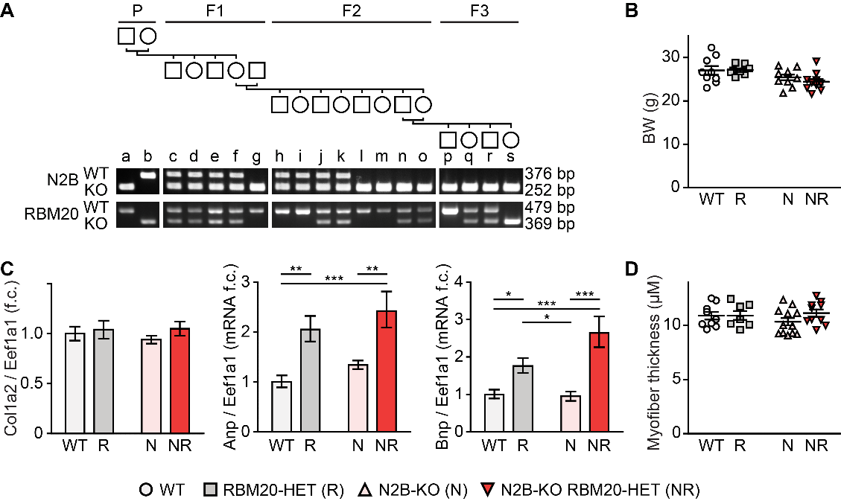

Supplemental Figure 1: Generation and validation of N2B splice rescue model. (A) Breeding scheme with genotypes. Genotyping PCRs for N2B and RBM20 generated a short fragment for knockout allele and a longer for the wildtype allele. (B) Body weight of each mouse strain. (C) Quantification of Col1a2, Anp, and Bnp mRNA levels by TaqMan normalized to Eef1a1 (n = 5 for WT; n = 6 for other groups). (D) Diameter of cardiac myofibers.

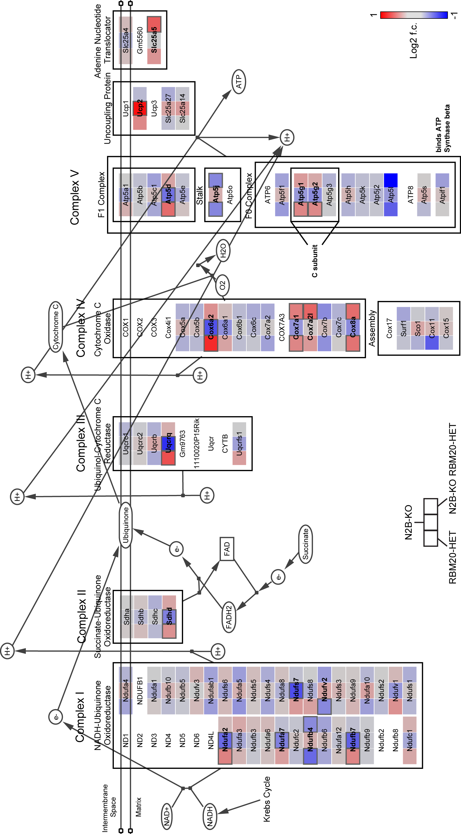
Figure S2

Supplemental Figure 2: Restored expression of genes related to oxidative phosphorylation (RNAseq data overlaid on the WIKIpathway electron transport chain). The color code defines gene expression relations to WT mice in Log2 fold change ranging from 1 to -1 (red: upregulated, blue: downregulated). Each box representing a gene is split in three squares to indicate the regulation in RBM20-HET, N2B-KO and N2B splice rescue vs. WT (left to right). Genes significantly regulated vs. WT (P < 0.05) are framed in dark grey and bold.

Figure S3

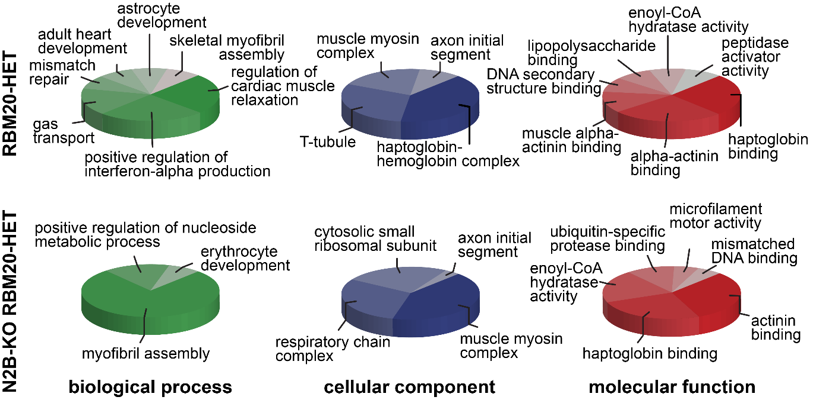

Supplemental Figure 3: Gene ontology classification of differentially spliced genes. Transcripts differentially spliced between RBM20-HET (top) and N2B splice rescue mice (bottom) as compared to WT mice were classified by gene ontology analysis (biological process, cellular component, and molecular function).

Figure S4
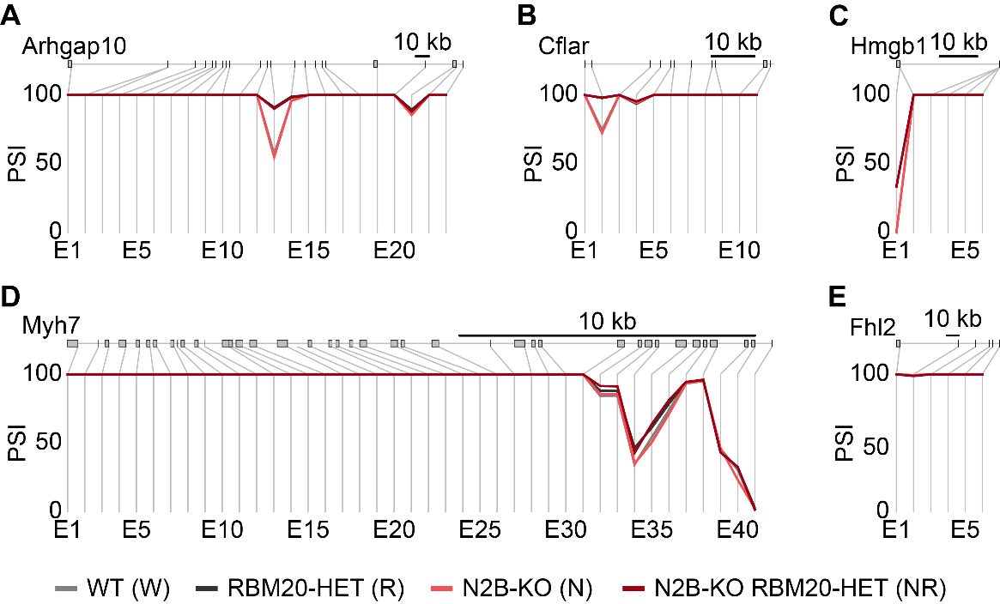

Supplemental Figure 4: RBM20-dependent isoform expression (cont. from Fig. 5). Genotype dependent isoform expression of Arhgap (A), Cflar (B), Hmgb1 (C), Myh7 (D), and Fhl2 (E). PSI scores (percentage spliced in) are indicated on the Y axis (n = 2 for N2B-KO, n = 3 for other groups). Exon labels are below; size bar (10 kb).

Figure S5

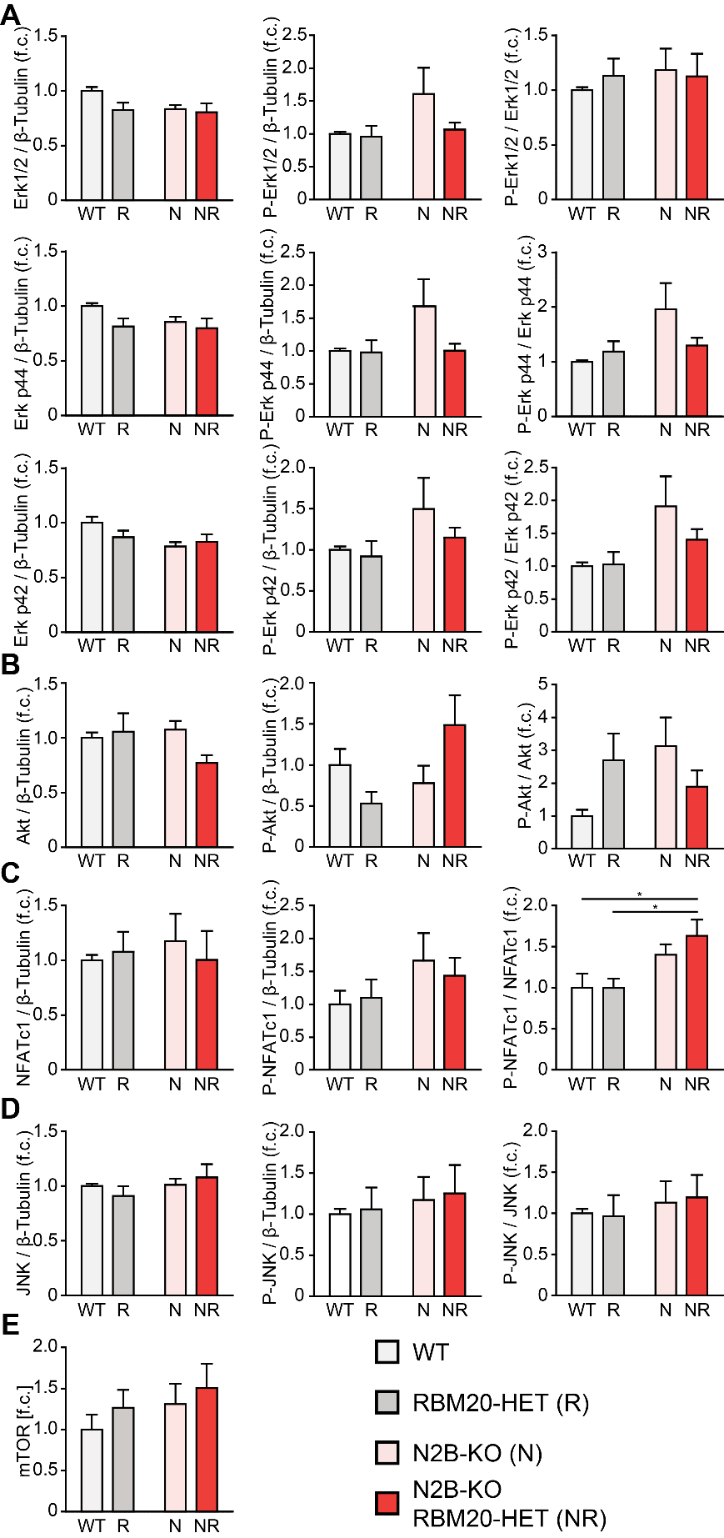

Supplemental Figure 5: Total and phospho protein levels of Erk1/2 and Akt. (A-E) Quantification of total- and phospho-protein normalized to beta-Tubulin, and the ratio of phospho to total protein levels of Erk1/2 (A), Akt (B), NFATc1 (C), JNK (D) and mTOR (E).

Figure S6

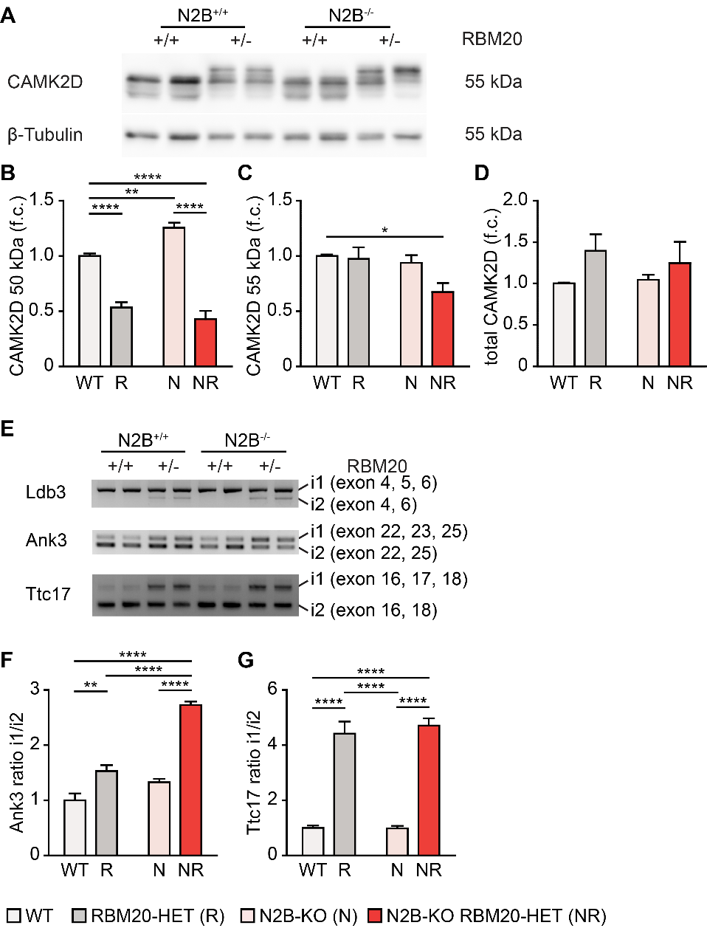

Supplemental Figure 6: Validation of differential isoform expression. (A) Genotype dependent isoform expression of Camk2d validated by western blot (n = 6 per group). (B-D) Quantification of Camk2d isoform expression normalized to WT and the house keeping gene β-tubulin. (E) Validation of RBM20-dependent isoform expression of Ank3, Ldb3, and Ttc17 by RT-PCR. (n = 4-6 per group). (F, G) Quantification of RBM20-dependent Ank3 and Ttc17 isoform expression.

Supplemental Tables

Supplemental Table 1: Antibodies

Antibodies | Order no | Supplier
Akt | 4691 | Cell Signaling
Phospho-Akt | 4060 | Cell Signaling
β-Tubulin | 2146 | Cell Signaling
CAMK2D | ab181052 | Abcam
Erk1/2 | 9102 | Cell Signaling
Phospho-Erk1/2 | Sc-7383 | Santa Cruz
FHL1 | 58067 | Abcam
FHL2 | K0055-3 | MBL
JNK | 9252 | Cell Signaling
P-JNK | 9255 | Cell Signaling
mTOR | 2983 | Cell Signaling
NFATc1 | sc-13033 | Santa Cruz
Phospho-NFATc1 | sc-32979 | Santa Cruz
RBM20 | custom | Eurogentec [11]

Supplemental Table 2: PCR primers and TaqMan probesets

Primer | Sequence
Ank3_E22_f | CATCACGGAGAAGCACAAAA
Ank3_E25_r | GGCTCCAAGACTGAAGCCTA
Ldb3_E3_fw | CCTATTCCCATCTCCACGAC
Ldb3_E7_rev | GAGACTGCAGGTTGGAGGAC
Ttc17_E16_fw | CTTCAGACAGGCCTTGAAGC
Ttc17_E18_rev | CTCCACCTCGTCAGAACCAT
Primer and Probes | Sequence/Applied Biosystems catalogue number
ANP | Mm01255747_g1
BNP fw | 5’-AGCTGCTGGAGCTGATAAGAGAA-3’
BNP rev | 5’-GTGAGGCCTTGGTCCTTCAA-3’
BNP probe | 6-FAM-AGTCAGAGGAAATGGCCCAGAGACAGCTA-TAMRA
Col1a2 | Mm01165187_m1
EEF1a1 | Mm01973893_g1
Fhl1 | Mm00515772_m1
Fhl2 | Mm00515781_m1
Rbm20 | Mm01264996_m1

Supplemental Table 3: Echocardiography data

 | WT | RBM20-HET | N2B-KO | N2B splice rescue
BW (g) | 24.9 ± 0.9 | 26.3 ± 1.4 | 26.4 ± 0.6 | 23.5 ± 0.4
HR (bpm) | 376 ± 22 | 432 ± 12 | 435 ± 8 | 432 ± 22
IVSd (mm) | 0.73 ± 0.03 | 0.77 ± 0.03 | 0.7 ± 0.01 | 0.75 ± 0.03
IVSs (mm) | 1.04 ± 0.05 | 1.06 ± 0.06 | 1 ± 0.02 | 1.02 ± 0.05
LVPWd (mm) | 0.73 ± 0.02 | 0.78 ± 0.03 | 0.74 ± 0.02 | 0.76 ± 0.03
LVPWs (mm) | 0.93 ± 0.03 | 1.04 ± 0.06 | 1.07 ± 0.05 | 0.98 ± 0.06
LVIDd (mm) | 4.23 ± 0.08 | 4.41 ± 0.11 | 3.68 ± 0.08** #### $$ | 4.17 ± 0.11
LVIDs (mm) | 3.3 ± 0.13 | 3.27 ± 0.13 | 2.54 ± 0.11** ## $$$ | 3.33 ± 0.16
LV FS (%) | 21.9 ± 2.3 | 25.9 ± 2.1 | 31.2 ± 1.7* $$ | 20.4 ± 1.9
LV EF (%) | 44.8 ± 4.3 | 51.1 ± 3.7 | 61 ± 2.5* $$ | 43 ± 3.6
SV (ul) | 24.1 ± 2.3 | 29.4 ± 3 | 22.1 ± 0.9 | 20.7 ± 1&
CO (ml/min) | 9.3 ± 1.2 | 12.8 ± 1.5 | 9.6 ± 0.3 | 8.9 ± 0.6&
LVw (mg) | 114.7 ± 7.3 | 132.3 ± 7.8 | 84.1 ± 5.7### $ | 116.3 ± 4.6
cHW/BW (mg/g) | 4.6 ± 0.3 | 5.1 ± 0.3 | 3.2 ± 0.2** #### $$$ | 5 ± 0.2
IVRT (ms) | 25.6 ± 2.7 | 22.9 ± 1.2 | 18.6 ± 1.4 | 25.2 ± 4.5
IVCT (ms) | 15.8 ± 1.8 | 13.4 ± 1.2 | 15.9 ± 2.6 | 17.4 ± 1.9
MVDT (ms) | 24.7 ± 2.5 | 20.1 ± 2.4 | 21.2 ± 1.1 | 23.6 ± 1.7
AET (ms) | 46.6 ± 2.4 | 42.9 ± 2.2 | 41.6 ± 1.1 | 40.9 ± 3.3
E/A | 1.76 ± 0.17 | 1.42 ± 0.08 | 2.36 ± 0.2* ### $$$ | 1.42 ± 0.13

BW, body weight; HR, heart rate; IVSd, innerventricular septum in diastole; IVSs, innerventricular septum in systole; LVPWd, left ventricular posterior wall in diastole; LVPWs, left ventricular posterior wall in systole; LVIDd, left ventricular inner diameter in diastole; LVIDs, left ventricular inner diameter in systole; LVEF, left ventricular ejection fraction; LVFS, left ventricular fractional shortening; SV, stroke volume; CO, cardiac output; LVw, left ventricular weight; cHW/BW, calculated heart to body weight ratio; IVRT, isovolumic relaxation time; IVCT, isovolumic contraction time; MVDT, mitral valve deceleration time; AET, aortic ejection time; E/A, mitral valve E-wave to A-wave ratio. N=9 for WT and N2B splice recue, n=10 for RBM20-HET and N2B-KO for BW, HR, IVSs, IVSd, LVPWd, LVPWs, LVIDd, LVIDs, LV FS, LV FS, SV, CO, LVw and HW/BW. N=9 for WT and RBM20-HET, n=10 for N2B-KO and n=8 for N2B splice rescue for E/A, MV DT. N=7 for WT, n=9 for RBM20-HET, n=10 for N2B-KO and n=5 for N2B splice rescue for IVRT, IVCT, AET. Two-way ANOVA *, p≤0.05; **, p≤0.01; ***, p≤0.001; ****, p≤0.0001
* WT vs. N2B-KO; # RBM20-HET vs N2B-KO; & RBM20-HET vs. N2B splice rescue; $ N2B splice rescue vs N2B-KO

Supplemental Table 4: Catheter data

 | WT | RBM20-HET | N2B-KO | N2B splice rescue
BW (g) | 30.0 ± 1.3 | 29.6 ± 0.9 | 28.0 ± 0.7 | 26.9 ± 0.7
HR (BPM) | 487 ± 14 | 464 ± 11 | 465 ± 15 | 473 ± 7
ESP art (mmHg) | 103.5 ± 2.8 | 106.7 ± 3.8 | 113.2 ± 2.5 | 108.0 ± 4.1
EDP art (mmHg) | 78.4 ± 4 | 80.6 ± 2.1 | 88.5 ± 1.1 | 83.3 ± 3.5
MAP (mmHg) | 86.7 ± 3.4 | 89.3 ± 2.7 | 97.4 ± 1.4* | 91.5 ± 3.6
ESP (mmHg) | 102.1 ± 3.5 | 100.9 ± 1.4 | 98.1 ± 3.7 | 99.2 ± 3.6
EDP (mmHg) | 5.9 ± 0.7 | 6.3 ± 0.8 | 9.1 ± 1.3* # $ | 5.0 ± 0.5
Pmax (mmHg) | 107.9 ± 3.5 | 105.5 ± 1.3 | 104.5 ± 2.4 | 104.6 ± 3.1
Pmin (mmHg) | 2.5 ± 0.7 | 2.5 ± 0.6 | 2.2 ± 0.5 | 2.2 ± 0.3
Pmean (mmHg) | 45.1 ± 2.1 | 45.0 ± 1.8 | 41.5 ± 1.4 | 41.1 ± 2.3
Pdev (mmHg) | 105.4 ± 3.2 | 103.1 ± 1.3 | 102.3 ± 2.3 | 102.4 ± 2.9
ESV (µL) | 22.9 ± 3.2 | 32.7 ± 6.3 | 16.6 ± 1.2 | 26.5 ± 3.6
EDV (µL) | 43.3 ± 5.6 | 55.6 ± 7.3 | 35.5 ± 2.7 | 42.1 ± 4.7
SV (µL) | 24.7 ± 2.6 | 26.2 ± 1.2 | 22.4 ± 1.6 | 22.2 ± 2
CO (ml/min) | 12.1 ± 1.5 | 11.5 ± 0.4 | 10.5 ± 1.0 | 10.4 ± 0.9
CI (ml/min/BW) | 403 ± 42 | 397 ± 17 | 374 ± 32 | 398 ± 38
Ea (mmHg/µL) | 4.5 ± 0.5 | 3.9 ± 0.2 | 4.7 ± 0.4 | 4.8 ± 0.6
TPR | 7.9 ± 1.0 | 7.7 ± 0.3 | 9.3 ± 0.6 | 9.4 ± 1.1
EF (%) | 57.4 ± 2.1 | 51.4 ± 4.5 | 65.1 ± 2.0$ | 52.9 ± 3.2
dP/dt max (mmHg/s) | 7727 ± 438 | 7392 ± 432 | 8323 ± 470 | 7320 ± 408
-dP/dt max (mmHg/s) | 9200 ± 478 | 7450 ± 584 | 9107 ± 584 | 8483 ± 514
SW (mmHg*mL) | 2.2 ± 0.3 | 2.3 ± 0.1 | 1.9 ± 0.2 | 1.8 ± 0.1
Tauω (ms) | 6.7 ± 0.3 | 7.4 ± 0.4 | 6.8 ± 0.5 | 6.8 ± 0.2
ESPVR | 3.70 ± 0.82 | 3.76 ± 1.03 | 6.53 ± 1.27 | 4.73 ± 1.09
r² (ESPVR) | 0.972 ± 0.01 | 0.968 ± 0.01 | 0.963 ± 0.008 | 0.976 ± 0.006
EDPVR | 0.132 ± 0.019 | 0.144 ± 0.023 | 0.304 ± 0.053** # $ | 0.151 ± 0.031
r² (EDPVR) | 0.919 ± 0.05 | 0.932 ± 0.024 | 0.941 ± 0.032 | 0.946 ± 0.016
PRSW | 58.4 ± 12.4 | 52.0 ± 7.2 | 73.3 ± 5.2 | 55.7 ± 6.8
r² (PRSW) | 0.941 ± 0.053 | 0.982 ± 0.009 | 0.982 ± 0.006 | 0.979 ± 0.008

BW, body weight; HR, heart rate; ESP art, arterial end-systolic pressure; EDP art, arterial end-diastolic pressure; MAP, mean arterial pressure; ESP, end-systolic pressure; EDP, end-diastolic pressure; Pmax, maximal pressure; Pmin, minimal pressure; Pmean, mean pressure; Pdev, developed pressure; ESV, end-systolic volume; EDV, end-diastolic volume; SV, stroke volume; CO, cardiac output; CI, cardiac index; Ea, arterial elastance; TPR, total peripheral resistance; EF, ejection fraction; SW, stroke work; Tauω, left ventricular relaxation time constant; ESPVR, end-systolic pressure volume relationship; r² (ESPVR), ESPVR correlation coefficient; EDPVR, end-diastolic pressure volume relationship; r² (EDPVR), EDPVR correlation coefficient; PRSW, preload recruitable stroke work; r² (PRSW), PRSW correlation coefficient. N=8 for WT, n=10 for RBM20-HET and n=9 for N2B-KO and N2B splice rescue for BW, HR, ESP art, EDP art, MAP, ESP, EDP, Pmax, Pmin, Pmean, Pdev, ESV, EDV, SV, CO, CI, Ea, TPR, EF, dP/dt max, SW, -dP/dt max and Tauω. N=6 for WT, n=9 for RBM20-HET, n=8 for N2B-KO and N2B splice rescue for ESPVR. N=6 for WT, n=9 for RBM20-HETand N2B-KO, n=8 for N2B splice rescue for PRSW. N=7 for WT, RBM20-HET and N2B-KO, n=6 for for N2B splice rescue for EDPVR. Two-way ANOVA *, p≤0.05; **, p≤0.01
* WT vs. N2B-KO; # RBM20-HET vs N2B-KO; & RBM20-HET vs. N2B splice rescue; $ N2B splice rescue vs N2B-KO

Supplemental Table 5: Rbm20-dependent isoform expression

Gene | Relevance | Alternative Exons; Domains^{C}
Ank3 | Localizes to intercalated discs and Z-disc [12] | E40-43; 2 lcr
Arhgap10 | Actin fiber formation; Z-disc after pressure overload [13] | E13-14; 1 Rho-Gap
Camk2d^{A},^{B} | Hemodynamic stress signaling [14] | E14-15; unstructured, 1 nls
Cflar | Regulates response to pressure overload [15] | E2; non coding
Fhl1 | Titin based mechanotransduction [16] | E1; start codon
Hmgb1 | Pressure overload induced cardiac hypertrophy [17, 18] | E1; non coding
Ldb3^{A},^{B} | Maintains Z-disc, cardiac hypertrophy [19] | E4-6/9; 1 ZASP-like motif, 1 lcr
Myh7^{A} | Myosin filament, hypertrophy [20] | E32-36; myosin-tail
Obscn^{A} | Sarcomere Z-disc and M-band [21] | E8-11/13-18/20-21/46; 13 IG
Ttc17 | Actin organization [22] | E17; unstructured
Ttn^{A},^{B} | Mechanotransduction, sarcomere organization [23] | I-band exons; several IG & PEVK

^{A} mRNA bound by Rbm20 [24]. ^{B} Alternatively spliced in other RBM20 deficient species[11]. ^{C} Domain annotation at http://smart.embl.de
lcr = low complexity region; nls = nuclear localization signal

Supplemental Table 6: Gene list for Figure 4C

GOterm | Associated genes
regulation of fatty acid oxidation | Dgat2, Pparg, Ppargc1a
cellular response to cAMP | Hcn1, Hcn4, Nox4
response to cold | Fos, Pparg, Ppargc1a
cellular response to fatty acid | Dgat2, Pparg, Ppargc1a
negative regulation of cellular carbohydrate metabolic process | Ppargc1a, Sik1, Sirt6

Supplemental Table 7: Gene list for Figure 4D – reverted

GOterm – biological process | Associated genes
regulation of fatty acid oxidation | Fos, Pparg, Ppargc1a, Dgat2
negative regulation of carbohydrate metabolic process | Ppargc1a, Sik1, Sirt6
skeletal muscle cell differentiation | Fos, Gpc1, Klhl40, Nr4a1
cellular response to cAMP | Hcn1, Hcn4, Nox4
positive regulation of muscle tissue development | Erbb3, Gpc1, Ppargc1a
GOterm – cellular component | Associated genes
respiratory chain | Cox6a2, Ndufb7, Ndufs7, Uqcr11, Uqcrq
oxidoreductase complex | Bckdha, Ndufb7, Ndufs7, Nox4, Uqcrq
GOterm – molecular function | Associated genes
growth factor binding | Erbb3, Gpc1, Pzp, Thbs1
amino acid binding | Aars2, Ddah2, Thbs1
oxidoreductase activity, acting on NAD(P)H | Ndufb7, Ndufs7, Nox4
steroid hormone receptor binding | Nr4a1, Pparg, Ppargc1a
modified amino acid binding | Mgst1, Nox4, Thbs1

Supplemental Table 8: Gene list for Figure 4D – misregulated

GOterm – biological process | Associated genes
cell chemotaxis | Ccl12, Ccl6, Ccl8, Cd74, Cmklr1, Cxcl14, Edn3, Fcgr3, Flt1, Itga9, Itgb2, Myo9b, Nckap1l, Ptk2b, Serpine1, Spp1, Syk, Trpv4, Ephb1, Fgf16, Hbegf, Hmgb2, Hspb1, Kdr
cardiac cell development | Agt, Alpk3, Col14a1, Fhl2, Murc, Myh11, Nppa, Nppb, Pdlim5, Pi16, Prox1, Cacna1s, Flnc, Gpx1, Lmod2, Mypn
regulation of cell-substrate adhesion | Col8a1, Egflam, Fbln1, Fbln2, Kdr, Nid1, Ninj1, Ptk2b, S100a10, Spp1, Vwc2, Acer2, Bcl6, Dlc1, Postn, Serpine1, Agt, Bcl2l11, Itga11, Itgb2, Itgb6, Sorbs1
positive regulation of epithelial cell migration | Agt, Alox12, Amot, Angpt1, Fgf16, Hspb1, Kdr, Prox1, Ptk2b, Aqp1, Hbegf, Efna1, Serpinf1
other | Acta2, Adra1a, Agt, Alox12, Amot, Angpt1, Edn3, Gpx1, Nppa, Nppb, Nts, Per2, Prkg1, Ptgs1, Snta1, Trpv4, Acer2, Adh1, Aldh1a2, Aqp1, Eln, Ptk2b, Rbp4, Ret, Serpinf1, Tfrc, Twf2, Ace, Mcpt4, Postn, Rnls, Ankrd1, Bag3, Cradd, Fas, Kcnj2, Slc38a2, Ccl12, Ccl6, Ccl8, Gbp3, Gbp6, H2-Aa, H2-Ab1, H2-Eb1, Mrc1, Btg1, Cma1, Flt1, Hspb1, Itgb2, Kdr, Ptgis, Serpine1, Abcb4, Cd74, Ctss, Fcgr3, Hfe, Unc93b1, Csf1r, Fgfr3, Inpp5d, Itga9, Pth1r, Spp1, Syk
GOterm – cellular component | Associated genes
contractile fiber | Abra, Acta2, Adra1a, Ankrd1, Bag3, Cacna1s, Cryab, Fhl2, Flnc, Hspb1, Ky, Lmod2, Murc, Myh11, Myl4, Myl7, Mypn, Pdlim5, Scn5a, Tpm2, Xirp2, Nrap, Twf2
extracellular matrix | Adamtsl2, Alpl, Angptl4, Bgn, Cilp, Clu, Cma1, Col14a1, Col1a2, Col4a4, Col4a5, Col8a1, Egflam, Eln, Fbln1, Fbln2, Fbn1, Gpc3, Lad1, Lama2, Mfap4, Mfap5, Mgp, Mmp11, Nid1, Postn, Serpine1, Serpinf1, Slc1a3, Spon2, Tgfbi, Tgm2, Tpsb2, Vwc2
membrane raft | Abcb4, Angpt1, Cd14, Dlc1, Ephb1, Fas, Inpp5d, Insr, Itgb2, Kdr, Lrp8, Myof, Ptgis, Ptk2b, Ret, S100a10, Scn5a, Sele, Sorbs1
sarcolemma | Adra1a, Alox12, Aqp1, Bgn, Cacna1s, Cacna2d1, Cacnb2, Clcn1, Dtna, Fas, Flnc, Kcnj2, Lama2, Scn5a, Slc38a2, Snta1, Trim72, Akap6, Ccdc109b, Micu1, Camk2b, Sln, Xdh, Scn4a, Scn4b
receptor complex | Acvr2b, Cd14, Cd74, Egf, Flt1, Hfe, Insr, Itga11, Itga9, Itgb2, Itgb6, Lrp8, Myh9, Plxna2, Pth1r, Ptk2b, Ptprn2, Ret, Sorbs1, Syk, Tfrc, Vwc2
other | C1qa, C1qb, C1qc, Col14a1, Col1a2, Col4a4, Col4a5, Col8a1, P4ha2, Acta2, Enah, Ephb1, Myo9b, Trpv4, Twf2, Aqp1, Clic5, Cubn, Myh11, Myh9, Pth1r, Slc11a2, Slc38a2, Ush1c, Dtna, Epn3, Gnao1, Gnb3, Ptk2b, Rgs6, S100a10, S100a6, Syk, Sytl2, Clu, Dnajb2, Gpx1, Hspb7, Mecom, Park2, Dlc1, Dstn, Hfe, Spta1, Ackr3, Ap4b1, Sele, Tfrc, Agt, Angptl4, Cfh, Tmprss13, Zbtb38, Amot, Cryab, Sorbs1, Gck, Sept6
GOterm – molecular function | Associated genes
gated channel activity | Ano10, Aqp1, Cacna1s, Cacna2d1, Cacnb2, Clcn1, Clcn6, Clic5, Cngb1, Kcnj2, Kcnn1, P2rx5, Ptk2b, Scn4a, Scn4b, Scn5a, Slc17a7, Trpv4
actin binding | Abra, Ace, Adssl1, Cnn1, Dstn, Enah, Flnc, Lmod2, Msrb1, Mtss1, Myh11, Myh9, Myl4, Myo9b, Mypn, Nrap, Park2, Pdlim5, Ppp1r42, Snta1, Spta1, Tpm2, Trpv4, Twf2, Ush1c, Xirp2
organic acid binding | Aars, Alox5ap, Fabp7, Glul, Insr, P4ha2, Pcx, Pygl, Sele, Slc1a3, Sytl2, Trim72
transmembrane receptor protein kinase activity | Acvr2b, Col1a2, Fgfr3, Flt1, Il10ra, Insr, Kdr, Scn5a, Csf1r, Ephb1, Ret
symporter activity | Slc11a2, Slc16a1, Slc16a5, Slc16a7, Slc17a7, Slc1a3, Slc1a4, Slc38a1, Slc38a2, Slc38a3
anion channel activity | Ano10, Clcn1, Clcn6, Clic5, Slc17a7, Slc1a4
other | Arntl, Dnajb2, Npas2, Park2, Pttg1, Tfrc, Ahsa1, Bag3, Dnajb4, Dnajb5, Camk2b, Cnn1, Kcnn1, Mknk2, Myh11, Myh9, Myo9b, Scn5a, Snta1, Trpv4, Abcg1, Ap4b1, Kpna2, Tomm5, Unc93b1, Fbln1, Fbn1, Itgb6, Kdr, Sema7a, Syk, Abca12, Abca4, Abcb4, Atp8a2, Plscr5, Rbp4, Aqp1, Aqp8, Slc16a1, Slc16a5, Slc16a7, Dct, Gm1840, Hsd3b3, Ptgis, Qsox1, Tmx1, Adam19, Cttnbp2, Enah, Gpx1, Inpp5d, Mypn, Sh3bgr, Aldh1a2, Cubn, Ogdhl, Opn4, P4ha2, Pcx, Pygl, Ackr3, Acvr2b, Cd74, Crlf1, Csf1r, Ifngr1, Il10ra, Gfra2, Noct

Supplemental Table 9: Gene list for Figure S3 – RBM20-HET

GOterm – biological process | Associated genes
regulation of relaxation of cardiac muscle | Camk2d, Ttn
positive regulation of interferon-alpha production | Hmgb1, Tlr4
gas transport | Hba-a1, Hba-a2
mismatch repair | Hmgb1, Msh3
adult heart development | Myh7, Ttn
astrocyte development | Lamb2, Tlr4
skeletal myofibril assembly | Cflar, Ttn
GOterm – cellular component | Associated genes
haptoglobin-hemoglobin complex | Hba-a1, Hba-a2, Rps14, Rps27a
T-tubule | Cacna2d1, Camk2d, Dysf, Micu1
muscle myosin complex | Myh7, Ttn
axon initial segment | Ank3, Camk2d
GOterm – molecular function | Associated genes
haptoglobin binding | Hba-a1, Hba-a2
alpha-actinin binding | Ldb3, Synpo2, Ttn
muscle alpha-actinin binding | Ldb3, Synpo2, Ttn
DNA secondary structure binding | Hmgb1, Msh3
lipopolysaccharide binding | Hmgb1, Tlr4
enoyl-CoA hydratase activity | Auh, Hadha
peptidase activator activity | Cflar, Vcp

Supplemental Table 10: Gene list for Figure S3 – Splice rescue

GOterm – biological process | Associated genes
myofibril assembly | Camk2d, Myh6, Myh7, Pdlim5, Ttn, Myl2, Camk2d, Tpm1, Cflar, Ldb3
positive regulation of nucleoside metabolic process | Entpd5, Park7, Vcp
erythrocyte development | Ank1, Hba-a1, Hba-a2
GOterm – cellular component | Associated genes
muscle myosin complex | Myh6, Myh7, Myl2, Obscn, Ttn, Tpm1
respiratory chain complex | Cox7b, Ndufv1, Ndufv3, Park7
cytosolic small ribosomal subunit | Hba-a1, Hba-a2, Rps14, Rps27a, Rps3a1
axon initial segment | Ank3, Camk2d
GOterm – molecular function | Associated genes
actinin binding | Obscn, Ttn, Camk2d, Ldb3, Pdlim5
haptoglobin binding | Hba-a1, Hba-a2, Park7
enoyl-CoA hydratase activity | Auh, Hadha, Park7, Ivd
ubiquitin-specific protease binding | Cflar, Park7, Vcp
microfilament motor activity | Myh6, Myh7
mismatched DNA binding | Msh3, Tdg

Supplemental References

1. Radke MH, Peng J, Wu Y, McNabb M, Nelson OL, Granzier H, Gotthardt M (2007) Targeted deletion of titin N2B region leads to diastolic dysfunction and cardiac atrophy. ProcNatlAcadSciUSA 104:3444–3449.
2. Methawasin M, Hutchinson KR, Lee E-J, Smith JE, Saripalli C, Hidalgo CG, Ottenheijm CAC, Granzier H (2014) Experimentally increasing titin compliance in a novel mouse model attenuates the Frank-Starling mechanism but has a beneficial effect on diastole. Circulation 129:1924–1936. doi: 10.1161/CIRCULATIONAHA.113.005610
3. Warren CM, Krzesinski PR, Greaser ML (2003) Vertical agarose gel electrophoresis and electroblotting of high-molecular-weight proteins. Electrophoresis 24:1695–1702.
4. Livak KJ, Schmittgen TD (2001) Analysis of relative gene expression data using real-time quantitative PCR and the 2(-Delta Delta C(T)) Method. Methods San Diego Calif 25:402–408. doi: 10.1006/meth.2001.1262
5. Granzier HL, Radke MH, Peng J, Westermann D, Nelson OL, Rost K, King NMP, Yu Q, Tschöpe C, McNabb M, et al (2009) Truncation of titin’s elastic PEVK region leads to cardiomyopathy with diastolic dysfunction. Circ Res 105:557–564. doi: 10.1161/CIRCRESAHA.109.200964
6. Dodt M, Roehr JT, Ahmed R, Dieterich C (2012) FLEXBAR-Flexible Barcode and Adapter Processing for Next-Generation Sequencing Platforms. Biology 1:895–905. doi: 10.3390/biology1030895
7. Dobin A, Davis CA, Schlesinger F, Drenkow J, Zaleski C, Jha S, Batut P, Chaisson M, Gingeras TR (2013) STAR: ultrafast universal RNA-seq aligner. Bioinforma Oxf Engl 29:15–21. doi: 10.1093/bioinformatics/bts635
8. Trapnell C, Roberts A, Goff L, Pertea G, Kim D, Kelley DR, Pimentel H, Salzberg SL, Rinn JL, Pachter L (2012) Differential gene and transcript expression analysis of RNA-seq experiments with TopHat and Cufflinks. Nat Protoc 7:562–578. doi: 10.1038/nprot.2012.016
9. Schafer S, Miao K, Benson CC, Heinig M, Cook SA, Hubner N (2015) Alternative Splicing Signatures in RNA-seq Data: Percent Spliced in (PSI). Curr Protoc Hum Genet Editor Board Jonathan Haines Al 87:11.16.1-11.16.14. doi: 10.1002/0471142905.hg1116s87
10. Pertea M, Pertea GM, Antonescu CM, Chang T-C, Mendell JT, Salzberg SL (2015) StringTie enables improved reconstruction of a transcriptome from RNA-seq reads. Nat Biotechnol 33:290–295. doi: 10.1038/nbt.3122
11. Guo W, Schafer S, Greaser ML, Radke MH, Liss M, Govindarajan T, Maatz H, Schulz H, Li S, Parrish AM, et al (2012) RBM20, a gene for hereditary cardiomyopathy, regulates titin splicing. Nat Med 18:766–773. doi: 10.1038/nm.2693
12. Yamankurt G, Wu HC, McCarthy M, Cunha SR (2015) Exon organization and novel alternative splicing of Ank3 in mouse heart. PloS One 10:e0128177. doi: 10.1371/journal.pone.0128177
13. Borges L, Bigarella CL, Baratti MO, Crosara-Alberto DP, Joazeiro PP, Franchini KG, Costa FF, Saad STO (2008) ARHGAP21 associates with FAK and PKCzeta and is redistributed after cardiac pressure overload. Biochem Biophys Res Commun 374:641–646. doi: 10.1016/j.bbrc.2008.07.085
14. Backs J, Backs T, Neef S, Kreusser MM, Lehmann LH, Patrick DM, Grueter CE, Qi X, Richardson JA, Hill JA, et al (2009) The delta isoform of CaM kinase II is required for pathological cardiac hypertrophy and remodeling after pressure overload. Proc Natl Acad Sci U S A 106:2342–2347. doi: 10.1073/pnas.0813013106
15. Giampietri C, Petrungaro S, Musumeci M, Coluccia P, Antonangeli F, De Cesaris P, Filippini A, Marano G, Ziparo E (2008) c-Flip overexpression reduces cardiac hypertrophy in response to pressure overload. J Hypertens 26:1008–1016. doi: 10.1097/HJH.0b013e3282f6a179
16. Sheikh F, Raskin A, Chu P-H, Lange S, Domenighetti AA, Zheng M, Liang X, Zhang T, Yajima T, Gu Y, et al (2008) An FHL1-containing complex within the cardiomyocyte sarcomere mediates hypertrophic biomechanical stress responses in mice. J Clin Invest 118:3870–80. doi: 10.1172/JCI34472
17. Zhu X, Messer JS, Wang Y, Lin F, Cham CM, Chang J, Billiar TR, Lotze MT, Boone DL, Chang EB (2015) Cytosolic HMGB1 controls the cellular autophagy/apoptosis checkpoint during inflammation. J Clin Invest 125:1098–1110. doi: 10.1172/JCI76344
18. Zhang L, Liu M, Jiang H, Yu Y, Yu P, Tong R, Wu J, Zhang S, Yao K, Zou Y, et al (2016) Extracellular high-mobility group box 1 mediates pressure overload-induced cardiac hypertrophy and heart failure. J Cell Mol Med 20:459–470. doi: 10.1111/jcmm.12743
19. Lin X, Ruiz J, Bajraktari I, Ohman R, Banerjee S, Gribble K, Kaufman JD, Wingfield PT, Griggs RC, Fischbeck KH, et al (2014) Z-disc-associated, alternatively spliced, PDZ motif-containing protein (ZASP) mutations in the actin-binding domain cause disruption of skeletal muscle actin filaments in myofibrillar myopathy. J Biol Chem 289:13615–13626. doi: 10.1074/jbc.M114.550418
20. Morita H, Rehm HL, Menesses A, McDonough B, Roberts AE, Kucherlapati R, Towbin JA, Seidman JG, Seidman CE (2008) Shared genetic causes of cardiac hypertrophy in children and adults. N Engl J Med 358:1899–1908. doi: 10.1056/NEJMoa075463
21. Sanger JW, Sanger JM (2001) Fishing out proteins that bind to titin. JCell Biol 154:21–24.
22. Bontems F, Fish RJ, Borlat I, Lembo F, Chocu S, Chalmel F, Borg J-P, Pineau C, Neerman-Arbez M, Bairoch A, et al (2014) C2orf62 and TTC17 are involved in actin organization and ciliogenesis in zebrafish and human. PloS One 9:e86476. doi: 10.1371/journal.pone.0086476
23. Gautel M, Djinović-Carugo K (2016) The sarcomeric cytoskeleton: from molecules to motion. J Exp Biol 219:135–145. doi: 10.1242/jeb.124941
24. Maatz H, Jens M, Liss M, Schafer S, Heinig M, Kirchner M, Adami E, Rintisch C, Dauksaite V, Radke MH, et al (2014) RNA-binding protein RBM20 represses splicing to orchestrate cardiac pre-mRNA processing. J Clin Invest 124:3419–3430. doi: 10.1172/JCI74523

