Online Supplemental Material

Amino acids, lipid metabolites and ferritin, as potential mediators linking red meat consumption to type 2 diabetes

Contents
Tables
Supplementary Table 1: Association of total red meat consumption with amino acid serum concentrations 2
Supplementary Table 2: Association of total red meat consumption with acylcarnitine serum concentrations 4
Supplementary Table 3: Association of total red meat consumption with diacyl-phosphatidylcholine serum concentrations 6
Supplementary Table 4: Association of total red meat consumption with acyl-alkyl-phosphatidylcholine serum concentrations 8
Supplementary Table 5: Association of total red meat consumption with lyso-phosphatidylcholine serum concentrations 10
Supplementary Table 6: Association of total red meat consumption with sphingomyelin serum concentrations 12
Supplementary Table 7: Association of preselected metabolites with the risk of developing type 2 diabetes 14
Supplementary Table 8: Association of total red meat consumption with serum concentrations of 126 metabolites and ferritin 16

Figures
Supplementary Figure 1: Workflow Mediation Analysis and Causal Diagram 1
Supplementary Figure 2: p-value-plot for amino acids 3
Supplementary Figure 3: p-value-plot for acylcarnitines 5
Supplementary Figure 4: p-value-plot for diacyl-phosphatidylcholines 7
Supplementary Figure 5: p-value-plot for acyl-alkyl-phosphatidylcholines 9
Supplementary Figure 6: p-value-plot for lysophosphatidylcholines 11
Supplementary Figure 7: p-value-plot for sphingomyelins 13
Supplementary Figure 8: Proportion explainable by biomarkers for subtypes of exposure (unprocessed and processed red meat) 15

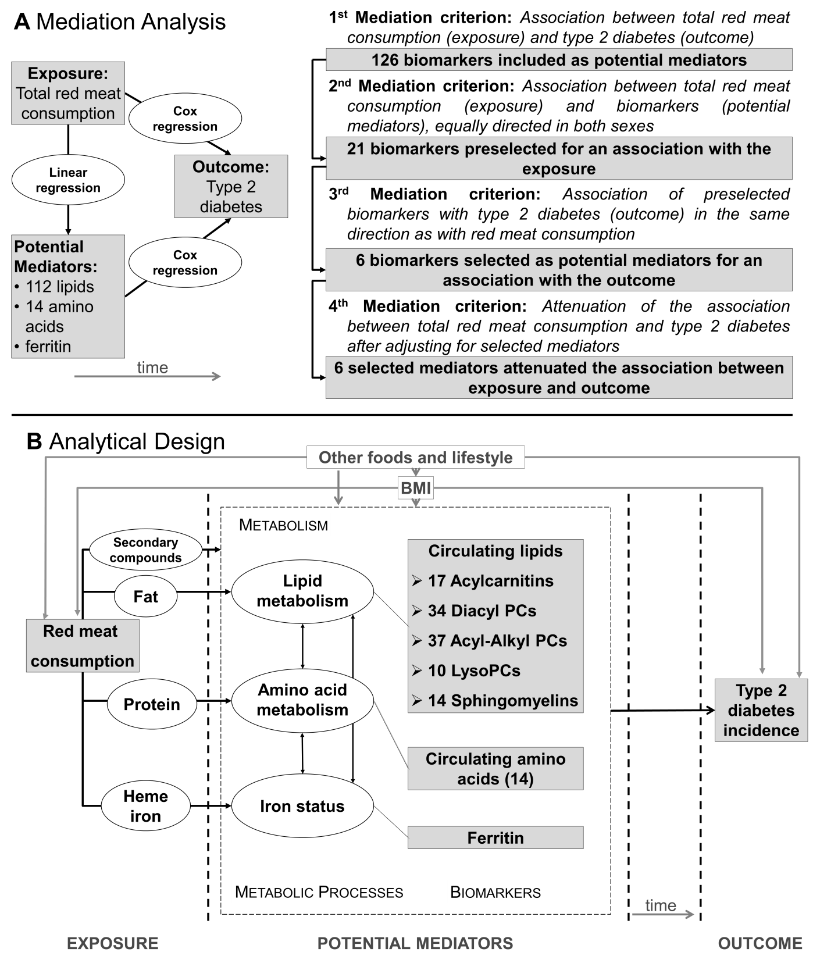
Figure 1 A (Mediation Analysis): From the initial set of biomarkers potential mediators were selected based on four prespecified mediation criteria; mediation criteria were evaluated in regression models. B (Analytical design): The specific nutrient matrix provided by total red meat consumption (exposure) was assumed to influence endogenous metabolic processes as reflected in metabolic profiles which in turn were assumed to affect the risk of type 2 diabetes; biomarkers (lipids, amino acids, and ferritin) were included based on a plausible influence of red meat intake on circulating levels
Supplementary Table 1: Association of total red meat consumption with amino acid serum concentrations
Amino Acids | F (n=1257) |  |  | M (n=790)
 | β¹ | p_{raw}² | p_{FDR}³ | β | p_{raw} | p_{FDR}
Arginine | 0.022 | 0.489 | 0.683 | -0.033 | 0.394 | 0.668
Glutamine | -0.035 | 0.263 | 0.460 | -0.059 | 0.130 | 0.364
Glycine | -0.098 | 0.001 | 0.019 | -0.099 | 0.009 | 0.067
Histidine | 0.048 | 0.118 | 0.330 | -0.046 | 0.233 | 0.465
Methionine | 0.018 | 0.555 | 0.707 | -0.094 | 0.014 | 0.067
Ornithine | 0.006 | 0.851 | 0.851 | -0.012 | 0.769 | 0.851
Phenylalanine | 0.035 | 0.256 | 0.460 | -0.017 | 0.660 | 0.840
Proline | -0.058 | 0.063 | 0.247 | -0.094 | 0.014 | 0.067
Serine | 0.028 | 0.353 | 0.548 | 0.031 | 0.429 | 0.668
Threonine | 0.056 | 0.071 | 0.247 | -0.055 | 0.157 | 0.365
Tryptophan | -0.010 | 0.749 | 0.807 | 0.007 | 0.855 | 0.855
Tyrosine | -0.015 | 0.611 | 0.713 | -0.067 | 0.075 | 0.262
Valine | 0.041 | 0.179 | 0.417 | -0.018 | 0.637 | 0.840
X-Leucine⁴ | 0.059 | 0.052 | 0.247 | -0.010 | 0.791 | 0.851
¹Standardized beta coefficients (β) for a linear association of total red meat consumption with amino acid serum concentration in the subcohort (n=2,047). Regression models were adjusted for total energy intake [MJ/d], age [years], BMI [kg/m²], sports [h/week], biking [h/week], smoking (4 stages: never smoker, former smoker, current smoker <20 Units/day, current heavy smoker >20 Units/day), education (4 stages: no vocational training or in training, vocational training, technical school, technical college or university degree), antihypertensive medication (yes/no), antidyslipidemic medication (yes/no), intake of beverages (alcohol, coffee, sugar sweetened beverages) [g/day], and of whole grain bread, refined grain bread, butter, margarine, cabbage, cooked vegetables, mushrooms, potatoes, sauce, and poultry [g/MJ].
²Raw p-values and ³false discovery rate-controlled p-values (corrected within metabolite classes) from a two-sided t-test (H₀: β=0). ⁴Sum of Leucine and Isoleucine.

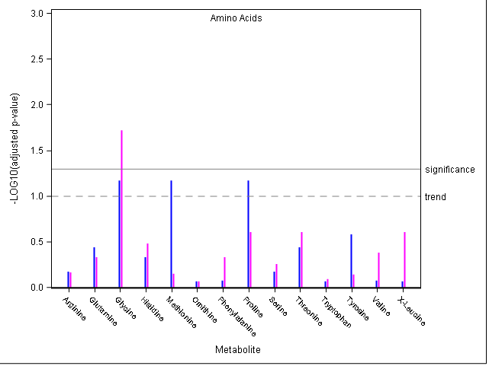Supplementary Figure 2: Manhattan-plot showing the negative decimal logarithm (-LOG10) of false discovery rate-controlled p-values for the sex-stratified association between total red meat consumption and single amino acids concentrations; blue: men; magenta: women; solid line: significance (p<0.05) after Benjamini-Hochberg-correction; dashed line: trend (p<0.1) after Benjamini-Hochberg-correction.
Supplementary Table 2: Association of total red meat consumption with acylcarnitine serum concentrations
Acylcarnitines | F (n=1257) |  |  | M (n=790)
 | β¹ | p_{raw}² | p_{FDR}³ | β | p_{raw} | p_{FDR}
C0 | 0.035 | 0.234 | 0.567 | 0.056 | 0.140 | 0.265
C10:0 | 0.002 | 0.941 | 0.941 | 0.095 | 0.013 | 0.068
C10:2 | 0.040 | 0.193 | 0.547 | 0.007 | 0.861 | 0.861
C14:1 | -0.018 | 0.547 | 0.941 | 0.047 | 0.214 | 0.330
C14:2 | 0.005 | 0.876 | 0.941 | 0.090 | 0.016 | 0.068
C16:0 | -0.007 | 0.800 | 0.941 | 0.077 | 0.036 | 0.101
C16:2 | 0.015 | 0.619 | 0.941 | 0.014 | 0.712 | 0.756
C18:0 | 0.042 | 0.162 | 0.547 | 0.133 | <0.001 | 0.007
C18:1 | 0.030 | 0.316 | 0.671 | 0.103 | 0.005 | 0.046
C18:2 | 0.008 | 0.784 | 0.941 | 0.043 | 0.248 | 0.351
C2:0 | 0.050 | 0.097 | 0.547 | 0.084 | 0.023 | 0.078
C3:0 | 0.055 | 0.068 | 0.547 | 0.024 | 0.534 | 0.647
(OH)C5_(DC)C3(M) | 0.043 | 0.168 | 0.547 | 0.064 | 0.097 | 0.236
(DC)C5_(OH)C6 | 0.005 | 0.863 | 0.941 | 0.022 | 0.571 | 0.647
(DC)C7 | 0.003 | 0.923 | 0.941 | 0.056 | 0.140 | 0.265
C8:1 | 0.061 | 0.040 | 0.547 | 0.021 | 0.560 | 0.647
C9:0 | -0.009 | 0.774 | 0.941 | -0.050 | 0.172 | 0.293
¹Standardized beta coefficients (β) for a linear association of total red meat consumption with acylcarnitine serum concentrations in the subcohort (n=2,047). Regression models were adjusted for total energy intake [MJ/d], age [years], BMI [kg/m²], sports [h/week], biking [h/week], smoking (4 stages: never smoker, former smoker, current smoker <20 Units/day, current heavy smoker >20 Units/day), education (4 stages: no vocational training or in training, vocational training, technical school, technical college or university degree), antihypertensive medication (yes/no), antidyslipidemic medication (yes/no), intake of beverages (alcohol, coffee, sugar sweetened beverages) [g/day], and of whole grain bread, refined grain bread, butter, margarine, cabbage, cooked vegetables, mushrooms, potatoes, sauce, and poultry [g/MJ].
²Raw p-values and ³false discovery rate-controlled p-values (corrected within metabolite classes) from a two-sided t-test (H₀: β=0).
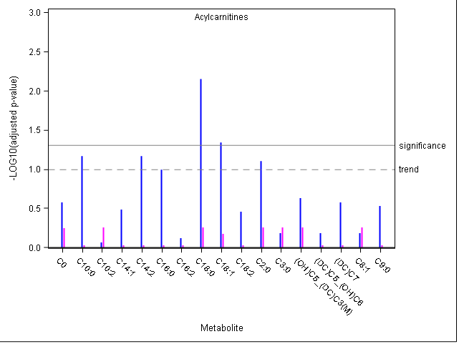Supplementary Figure 3: Manhattan-plot showing the negative decimal logarithm (-LOG10) of false discovery rate-controlled p-values for the sex-stratified association between total red meat consumption and single amino acids concentrations; blue: men; magenta: women; solid line: significance (p<0.05) after Benjamini-Hochberg-correction; dashed line: trend (p<0.1) after Benjamini-Hochberg-correction.
Supplementary Table 3: Association of total red meat consumption with diacyl-phosphatidylcholine serum concentrations
Diacyl-phosphatidylcholines | F (n=1257) |  |  | M (n=790)
 | β¹ | p_{raw}² | p_{FDR}³ | β | p_{raw} | p_{FDR}
C28:1 | -0.143 | <0.001 | <0.001 | -0.075 | 0.045 | 0.257
C30:0 | -0.113 | <0.001 | 0.001 | -0.08 | 0.030 | 0.207
C32:0 | -0.037 | 0.228 | 0.502 | 0.032 | 0.388 | 0.573
C32:1 | -0.110 | <0.001 | 0.001 | -0.001 | 0.977 | 0.977
C32:2 | -0.119 | <0.001 | 0.001 | -0.067 | 0.076 | 0.336
C32:3 | -0.065 | 0.031 | 0.096 | -0.038 | 0.316 | 0.538
C34:1 | -0.032 | 0.292 | 0.584 | 0.054 | 0.122 | 0.346
C34:2 | -0.001 | 0.974 | 0.975 | 0.047 | 0.218 | 0.462
C34:3 | -0.082 | 0.008 | 0.029 | 0.007 | 0.844 | 0.931
C34:4 | -0.007 | 0.810 | 0.895 | 0.04 | 0.275 | 0.519
C36:0 | 0.124 | <0.001 | 0.001 | 0.14 | <0.001 | 0.004
C36:1 | -0.013 | 0.655 | 0.825 | 0.042 | 0.248 | 0.495
C36:2 | 0.018 | 0.554 | 0.819 | 0.052 | 0.176 | 0.399
C36:3 | -0.026 | 0.405 | 0.689 | 0.062 | 0.102 | 0.336
C36:4 | 0.102 | 0.001 | 0.003 | 0.124 | 0.001 | 0.007
C36:5 | -0.001 | 0.975 | 0.975 | 0.002 | 0.952 | 0.977
C36:6 | -0.036 | 0.225 | 0.502 | -0.012 | 0.741 | 0.931
C38:0 | 0.148 | <0.001 | <0.001 | 0.152 | <0.001 | 0.002
C38:1 | 0.083 | 0.006 | 0.024 | 0.009 | 0.815 | 0.931
C38:3 | -0.014 | 0.626 | 0.821 | 0.029 | 0.427 | 0.605
C38:4 | 0.108 | <0.001 | 0.001 | 0.12 | 0.001 | 0.008
C38:5 | -0.008 | 0.795 | 0.895 | 0.061 | 0.098 | 0.336
C38:6 | 0.036 | 0.236 | 0.502 | 0.034 | 0.364 | 0.563
C40:2 | 0.027 | 0.374 | 0.689 | 0.058 | 0.132 | 0.346
C40:3 | 0.015 | 0.628 | 0.821 | 0.055 | 0.153 | 0.371
C40:4 | 0.023 | 0.443 | 0.717 | 0.058 | 0.109 | 0.336
C40:5 | -0.045 | 0.121 | 0.342 | 0.008 | 0.824 | 0.931
C40:6 | 0.005 | 0.867 | 0.921 | -0.01 | 0.786 | 0.931
C42:0 | -0.007 | 0.816 | 0.895 | -0.017 | 0.659 | 0.896
C42:1 | 0.007 | 0.814 | 0.895 | 0.034 | 0.358 | 0.563
C42:2 | -0.021 | 0.489 | 0.755 | -0.002 | 0.968 | 0.977
C42:4 | 0.026 | 0.396 | 0.689 | 0.068 | 0.079 | 0.336
C42:5 | 0.016 | 0.598 | 0.821 | 0.007 | 0.849 | 0.931
C42:6 | -0.037 | 0.231 | 0.502 | -0.038 | 0.315 | 0.538
¹Standardized beta coefficients (β) for a linear association of total red meat consumption with diacyl-phosphatidylcholine serum concentrations in the subcohort (n=2,047). Regression models were adjusted for total energy intake [MJ/d], age [years], BMI [kg/m²], sports [h/week], biking [h/week], smoking (4 stages: never smoker, former smoker, current smoker <20 Units/day, current heavy smoker >20 Units/day), education (4 stages: no vocational training or in training, vocational training, technical school, technical college or university degree), antihypertensive medication (yes/no), antidyslipidemic medication (yes/no), intake of beverages (alcohol, coffee, sugar sweetened beverages) [g/day], and of whole grain bread, refined grain bread, butter, margarine, cabbage, cooked vegetables, mushrooms, potatoes, sauce, and poultry [g/MJ].
²Raw p-values and ³false discovery rate-controlled p-values (corrected within metabolite classes) from a two-sided t-test (H₀: β=0).

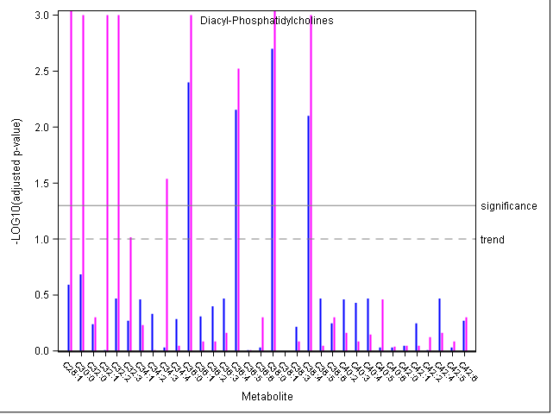
Supplementary Figure 4: Manhattan-plot of false discovery rate-corrected p-values for the sex-stratified association between total red meat consumption and single diacyl-phosphatidylcholines corrected for; blue: men; magenta: women.

Supplementary Table 4: Association of total red meat consumption with acyl-alkyl-phosphatidylcholine serum concentrations
Acyl-alkyl  phosphatidylcholines | F (n=1257) |  |  | M (n=790)
 | β¹ | p_{raw}² | p_{FDR}³ | β | p_{raw} | p_{FDR}
C30:0 | -0.120 | <0.001 | <0.001 | -0.066 | 0.063 | 0.136
C30:1 | -0.051 | 0.098 | 0.165 | -0.021 | 0.588 | 0.679
C30:2 | -0.059 | 0.046 | 0.098 | 0.014 | 0.712 | 0.798
C32:1 | -0.005 | 0.878 | 0.920 | 0.056 | 0.135 | 0.250
C32:2 | -0.031 | 0.290 | 0.370 | 0.028 | 0.447 | 0.570
C34:0 | -0.097 | 0.001 | 0.002 | -0.073 | 0.037 | 0.091
C34:1 | -0.091 | 0.002 | 0.005 | -0.039 | 0.282 | 0.417
C34:2 | 0.095 | 0.001 | 0.005 | 0.078 | 0.036 | 0.091
C34:3 | 0.066 | 0.023 | 0.064 | 0.106 | 0.004 | 0.014
C36:0 | 0.031 | 0.311 | 0.372 | 0.125 | 0.001 | 0.003
C36:1 | -0.099 | <0.001 | 0.002 | -0.079 | 0.026 | 0.080
C36:2 | -0.047 | 0.094 | 0.165 | -0.036 | 0.308 | 0.438
C36:3 | 0.127 | <0.001 | <0.001 | 0.137 | <0.001 | 0.002
C36:4 | 0.235 | <0.001 | <0.001 | 0.205 | <0.001 | <0.001
C36:5 | 0.183 | <0.001 | <0.001 | 0.225 | <0.001 | <0.001
C38:0 | -0.024 | 0.435 | 0.502 | 0.046 | 0.228 | 0.367
C38:1 | -0.039 | 0.200 | 0.274 | -0.051 | 0.185 | 0.325
C38:2 | -0.042 | 0.154 | 0.236 | 0.027 | 0.474 | 0.572
C38:3 | -0.045 | 0.131 | 0.211 | -0.010 | 0.790 | 0.836
C38:4 | 0.129 | <0.001 | <0.001 | 0.146 | <0.001 | 0.001
C38:5 | 0.211 | <0.001 | <0.001 | 0.219 | <0.001 | <0.001
C38:6 | 0.155 | <0.001 | <0.001 | 0.156 | <0.001 | <0.001
C40:1 | 0.042 | 0.159 | 0.236 | 0.121 | 0.001 | 0.005
C40:2 | -0.060 | 0.040 | 0.097 | -0.007 | 0.851 | 0.875
C40:3 | -0.082 | 0.006 | 0.019 | 0.010 | 0.791 | 0.836
C40:4 | 0.058 | 0.048 | 0.098 | 0.119 | 0.002 | 0.006
C40:5 | 0.051 | 0.088 | 0.163 | 0.042 | 0.261 | 0.402
C40:6 | 0.029 | 0.312 | 0.372 | 0.033 | 0.375 | 0.514
C42:1 | 0.041 | 0.185 | 0.263 | 0.136 | 0.000 | 0.002
C42:2 | -0.061 | 0.042 | 0.097 | 0.029 | 0.442 | 0.570
C42:3 | -0.037 | 0.213 | 0.281 | 0.078 | 0.040 | 0.091
C42:4 | 0.007 | 0.798 | 0.869 | 0.046 | 0.212 | 0.357
C42:5 | 0.062 | 0.035 | 0.093 | 0.060 | 0.110 | 0.214
C44:3 | -0.014 | 0.647 | 0.725 | 0.082 | 0.034 | 0.091
C44:4 | 0.000 | 0.993 | 0.993 | 0.026 | 0.479 | 0.572
C44:5 | 0.053 | 0.075 | 0.145 | 0.061 | 0.102 | 0.210
C44:6 | 0.004 | 0.895 | 0.920 | 0.001 | 0.987 | 0.987
¹Standardized beta coefficients (β) for a linear association of total red meat consumption with acyl-alkyl-phosphatidylcholine serum concentrations in the subcohort (n=2,047). Regression models were adjusted for total energy intake [MJ/d], age [years], BMI [kg/m²], sports [h/week], biking [h/week], smoking (4 stages: never smoker, former smoker, current smoker <20 Units/day, current heavy smoker >20 Units/day), education (4 stages: no vocational training or in training, vocational training, technical school, technical college or university degree), antihypertensive medication (yes/no), antidyslipidemic medication (yes/no), intake of beverages (alcohol, coffee, sugar sweetened beverages) [g/day], and of whole grain bread, refined grain bread, butter, margarine, cabbage, cooked vegetables, mushrooms, potatoes, sauce, and poultry [g/MJ].
²Raw p-values and ³false discovery rate-controlled p-values (corrected within metabolite classes) from a two-sided t-test (H₀: β=0).
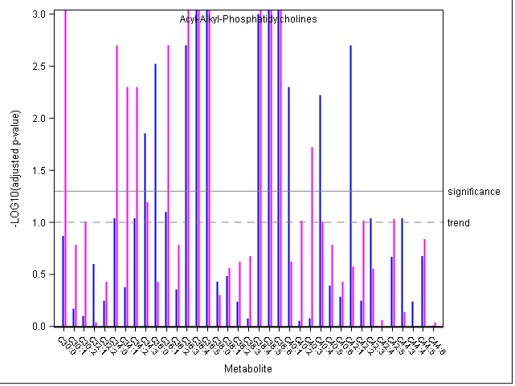 Supplementary Figure 5: Manhattan-plot of false discovery rate-corrected p-values for the sex-stratified association between total red meat consumption and single acyl-alkyl-phosphatidylcholines corrected for; blue: men; magenta: women.

Supplementary Table 5: Association of total red meat consumption with lyso-phosphatidylcholine serum concentrations
Lyso-  phosphatidylcholines | F (n=1257) |  |  | M (n=790)
 | β¹ | p_{raw}² | p_{FDR}³ | β | p_{raw} | p_{FDR}
C14:0 | -0.083 | 0.007 | 0.017 | -0.070 | 0.064 | 0.213
C16:0 | 0.009 | 0.776 | 0.780 | 0.045 | 0.233 | 0.466
C16:1 | -0.110 | <0.001 | 0.002 | -0.002 | 0.955 | 0.955
C17:0 | -0.057 | 0.043 | 0.087 | -0.098 | 0.004 | 0.019
C18:0 | 0.014 | 0.637 | 0.780 | 0.034 | 0.372 | 0.620
C18:1 | -0.008 | 0.780 | 0.780 | 0.044 | 0.224 | 0.466
C18:2 | 0.011 | 0.706 | 0.780 | -0.007 | 0.849 | 0.946
C20:3 | -0.012 | 0.696 | 0.780 | 0.023 | 0.538 | 0.768
C20:4 | 0.109 | <0.001 | 0.002 | 0.115 | 0.002 | 0.017
C28:1 | -0.105 | 0.001 | 0.002 | 0.007 | 0.851 | 0.946
¹Standardized beta coefficients (β) for a linear association of total red meat consumption with lyso-phosphatidylcholine serum concentrations in the subcohort (n=2,047). Regression models were adjusted for total energy intake [MJ/d], age [years], BMI [kg/m²], sports [h/week], biking [h/week], smoking (4 stages: never smoker, former smoker, current smoker <20 Units/day, current heavy smoker >20 Units/day), education (4 stages: no vocational training or in training, vocational training, technical school, technical college or university degree), antihypertensive medication (yes/no), antidyslipidemic medication (yes/no), intake of beverages (alcohol, coffee, sugar sweetened beverages) [g/day], and of whole grain bread, refined grain bread, butter, margarine, cabbage, cooked vegetables, mushrooms, potatoes, sauce, and poultry [g/MJ].
²Raw p-values and ³false discovery rate-controlled p-values (corrected within metabolite classes) from a two-sided t-test (H₀: β=0).

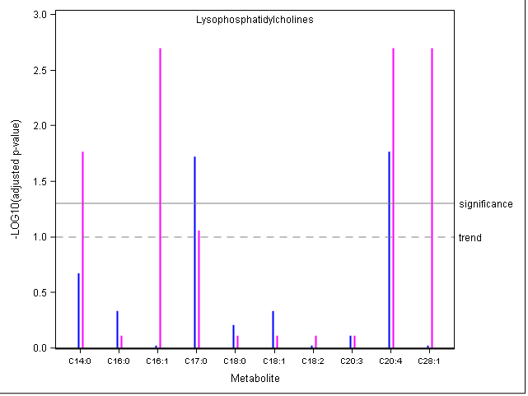
Supplementary Figure 6: Manhattan-plot of false discovery rate-corrected p-values for the sex-stratified association between total red meat consumption and single lyso-phosphatidylcholines corrected for; blue: men; magenta: women.
Supplementary Table 6: Association of total red meat consumption with sphingomyelin serum concentrations
Sphingomyelins | F (n=1257) |  |  | M (n=790)
 | β¹ | p_{raw}² | p_{FDR}³ | β | p_{raw} | p_{FDR}
Hydroxy-C14:1 | -0.121 | <0.001 | <0.001 | -0.069 | 0.053 | 0.092
Hydroxy-C16:1 | -0.071 | 0.010 | 0.040 | 0.000 | 0.998 | 0.998
Hydroxy-C22:1 | -0.038 | 0.207 | 0.415 | 0.035 | 0.359 | 0.499
Hydroxy-C22:2 | -0.040 | 0.171 | 0.399 | 0.013 | 0.725 | 0.846
Hydroxy-C24:1 | -0.073 | 0.014 | 0.040 | 0.033 | 0.392 | 0.499
C16:0 | -0.004 | 0.887 | 0.887 | 0.125 | 0.001 | 0.007
C16:1 | -0.009 | 0.756 | 0.865 | 0.091 | 0.018 | 0.035
C18:0 | 0.019 | 0.512 | 0.775 | 0.098 | 0.010 | 0.034
C18:1 | 0.032 | 0.258 | 0.451 | 0.092 | 0.016 | 0.035
C20:2 | -0.007 | 0.803 | 0.865 | -0.053 | 0.161 | 0.250
C24:0 | -0.016 | 0.609 | 0.775 | 0.109 | 0.004 | 0.020
C24:1 | 0.075 | 0.014 | 0.040 | 0.203 | <0.001 | <0.001
C26:0 | -0.078 | 0.010 | 0.040 | -0.009 | 0.809 | 0.871
C26:1 | 0.018 | 0.557 | 0.775 | 0.094 | 0.013 | 0.035
¹Standardized beta coefficients (β) for a linear association of total red meat consumption with sphingomyelin serum concentrations in the subcohort (n=2,047). Regression models were adjusted for total energy intake [MJ/d], age [years], BMI [kg/m²], sports [h/week], biking [h/week], smoking (4 stages: never smoker, former smoker, current smoker <20 Units/day, current heavy smoker >20 Units/day), education (4 stages: no vocational training or in training, vocational training, technical school, technical college or university degree), antihypertensive medication (yes/no), antidyslipidemic medication (yes/no), intake of beverages (alcohol, coffee, sugar sweetened beverages) [g/day], and of whole grain bread, refined grain bread, butter, margarine, cabbage, cooked vegetables, mushrooms, potatoes, sauce, and poultry [g/MJ].
²Raw p-values and ³false discovery rate-controlled p-values (corrected within metabolite classes) from a two-sided t-test (H₀: β=0).

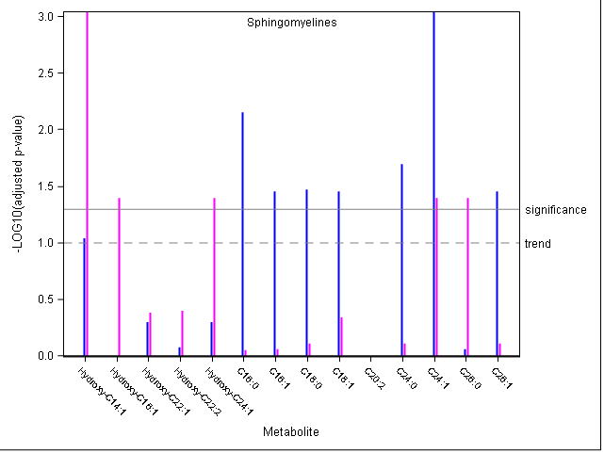
Supplementary Figure 7: Manhattan-plot of false discovery rate-corrected p-values for the sex-stratified association between total red meat consumption and single sphingomyelins corrected for; blue: men; magenta: women.
Supplementary Table 7: Association of preselected metabolites with the risk of developing type 2 diabetes
Selected Metabolites¹ | HR (95%CI)² | p_{raw}³ | p_{FDR}⁴
Glycine⁵ | 0.66 (0.57, 0.77) | <0.001 | <0.001
Diacyl PC C36:0 | 0.91 (0.82, 1.01) | 0.067 | 0.083
Diacyl PC C36:4 | 1.20 (1.07, 1.35) | 0.002 | 0.003
Diacyl PC C38:0 | 0.88 (0.79, 0.99) | 0.026 | 0.036
Diacyl PC C38:4 | 1.24 (1.12, 1.38) | <0.001 | <0.001
Acyl-Alkyl PC C34:0 | 1.03 (0.91, 1.17) | 0.600 | 0.600
Acyl-Alkyl PC C34:2 | 0.73 (0.64, 0.83) | <0.001 | <0.001
Acyl-Alkyl PC C34:3 | 0.55 (0.48, 0.64) | <0.001 | <0.001
Acyl-Alkyl PC C36:1 | 0.96 (0.84, 1.09) | 0.527 | 0.554
Acyl-Alkyl PC C36:3 | 0.78 (0.69, 0.88) | <0.001 | 0.000
Acyl-Alkyl PC C36:4 | 0.96 (0.86, 1.07) | 0.483 | 0.534
Acyl-Alkyl PC C36:5 | 0.84 (0.75, 0.94) | 0.001 | 0.003
Acyl-Alkyl PC C38:4 | 0.88 (0.78, 0.99) | 0.036 | 0.047
Acyl-Alkyl PC C38:5 | 0.84 (0.75, 0.94) | 0.003 | 0.005
Acyl-Alkyl PC C38:6 | 0.87 (0.79, 0.97) | 0.014 | 0.021
Acyl-Alkyl PC C40:4 | 0.80 (0.71, 0.91) | 0.001 | 0.002
Lyso PC C17:0 | 0.78 (0.68, 0.89) | <0.001 | 0.000
Lyso PC C20:4 | 0.95 (0.85, 1.07) | 0.428 | 0.499
Hydroxy-SM C14:1 | 0.83 (0.73, 0.94) | 0.004 | 0.007
SM C24:1 | 0.82 (0.74, 0.92) | 0.001 | 0.002
Ferritin | 1.28 (1.15, 1.42) | <0.001 | <0.001
¹Metabolites were selected based on the mediation criterion 2, i.e. a significant association with total red meat consumption in either, men or women and at least borderline-significant associated in the other.
²Diabetes-HR per SD in serum concentration; association of 21 preselected metabolites with type 2 diabetes risk was evaluated in Cox models in the case-cohort (n=2,681) adjusted for total red meat intake, total energy intake, age, BMI, sports, biking, smoking, education, antihypertensive medication, antidyslipidemic medication, intake of beverages (alcohol, coffee, sugar sweetened beverages), and consumption of whole grain bread, butter, margarine, light bread, cabbage, cooked vegetables, potatoes, and sauce.
³Raw p-values and ⁴false discovery rate-controlled p-values (corrected for the 21 tests conducted among all metabolites that fulfilled mediation criterion 2) from a two sided Wald-test.
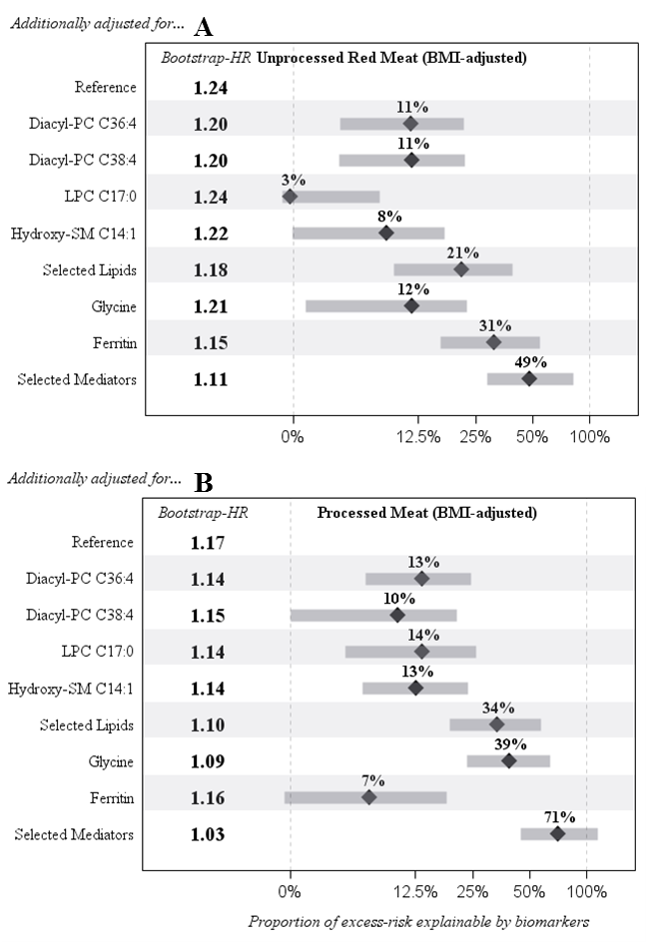
Supplementary Figure 8: Proportion explainable biomarkers of excess-risk associated with subtypes of red meat consumption. A: Unprocessed red meat consumption. B: Processed red consumption. Models were adjusted for age, sex, diet, lifestyle, and BMI. Proportion of excess-risk explainable by biomarkers was estimated as the difference of non-mediator-adjusted and mediator-adjusted HR divided by red meat-related excess diabetes risk; displayed are the median percentage, the IQR (grey box). Selected lipid-mediators: diacyl PC C38:4, lyso-PC C17:0, and hydroxy-SM C14:1; Selected mediators: lipid-mediators, ferritin, and glycine.
Supplementary Table 8: Association of total red meat consumption with serum concentrations of 126 metabolites and ferritin
 | Pooled analysis (n=2,047)
Metabolite | β¹ | p_{raw}² | p_{FDR}³ | P_{Bonferroni}⁴
Alkyl-Acyl PC C36:4 | 0.231 | 0.0001 | <0.001 | <0.001
Alkyl-Acyl PC C38:5 | 0.219 | 0.0001 | <0.001 | <0.001
Alkyl-Acyl PC C36:5 | 0.206 | 0.0001 | <0.001 | <0.001
Alkyl-Acyl PC C38:6 | 0.164 | 0.0001 | <0.001 | <0.001
Diacyl-PC C38:0 | 0.149 | 0.0001 | <0.001 | <0.001
Diacyl-PC C36:0 | 0.135 | 0.0001 | <0.001 | <0.001
Alkyl-Acyl PC C38:4 | 0.133 | 0.0001 | <0.001 | <0.001
Alkyl-Acyl PC C36:3 | 0.128 | 0.0001 | <0.001 | <0.001
SM C24:1 | 0.122 | 0.0001 | <0.001 | <0.001
Diacyl-PC C38:4 | 0.118 | 0.0001 | <0.001 | <0.001
Ferritin | 0.116 | 0.0001 | <0.001 | <0.001
LysoPC C20:4 | 0.115 | 0.0001 | <0.001 | <0.001
Diacyl-PC C36:4 | 0.111 | 0.0001 | <0.001 | <0.001
Hydroxy-SM C14:1 | -0.096 | 0.0001 | <0.001 | <0.001
Alkyl-Acyl PC C30:0 | -0.099 | 0.0001 | <0.001 | <0.001
Diacyl-PC C30:0 | -0.108 | 0.0001 | <0.001 | <0.001
Diacyl-PC C28:1 | -0.112 | 0.0001 | <0.001 | <0.001
Diacyl-PC C32:2 | -0.103 | 0.0001 | <0.001 | 0.002
Alkyl-Acyl PC C34:0 | -0.089 | 0.0001 | <0.001 | 0.0042
Alkyl-Acyl PC C36:1 | -0.085 | 0.0001 | <0.001 | 0.0068
Alkyl-Acyl PC C34:2 | 0.088 | 0.0001 | <0.001 | 0.0089
Glycine | -0.088 | 0.0002 | 0.001 | 0.0197
Alkyl-Acyl PC C34:3 | 0.078 | 0.0005 | 0.003 | 0.0545
AC C18:0 | 0.074 | 0.0009 | 0.005 | 0.0957
LysoPC C14:0 | -0.079 | 0.0009 | 0.005 | 0.0902
Alkyl-Acyl PC C40:1 | 0.078 | 0.001 | 0.005 | 0.1064
Alkyl-Acyl PC C40:4 | 0.073 | 0.0011 | 0.005 | 0.1155
Alkyl-Acyl PC C42:1 | 0.077 | 0.0013 | 0.006 | 0.1322
Alkyl-Acyl PC C34:1 | -0.070 | 0.0013 | 0.006 | 0.1335
LysoPC C17:0 | -0.068 | 0.002 | 0.009 | 0.1978
Alkyl-Acyl PC C36:0 | 0.067 | 0.0042 | 0.017 | 0.4109
Diacyl-PC C32:1 | -0.063 | 0.006 | 0.024 | 0.5764
AC C18:1 | 0.061 | 0.0063 | 0.024 | 0.5948
AC C2:0 | 0.064 | 0.0067 | 0.025 | 0.6277
LysoPC C28:1 | -0.062 | 0.0077 | 0.028 | 0.7187
Proline | -0.058 | 0.0143 | 0.051 | 1
LysoPC C16:1 | -0.057 | 0.0149 | 0.051 | 1
Alkyl-Acyl PC C42:5 | 0.054 | 0.0169 | 0.057 | 1
SM C18:1 | 0.052 | 0.0194 | 0.063 | 1
Alkyl-Acyl PC C44:5 | 0.054 | 0.0199 | 0.063 | 1
Alkyl-Acyl PC C40:3 | -0.051 | 0.021 | 0.064 | 1
Diacyl-PC C38:1 | 0.055 | 0.0211 | 0.064 | 1
Carnitine | 0.049 | 0.0231 | 0.067 | 1
Diacyl-PC C32:3 | -0.052 | 0.0232 | 0.067 | 1
AC C3:0 | 0.049 | 0.0275 | 0.078 | 1
SM C18:0 | 0.049 | 0.0352 | 0.096 | 1
Diacyl-PC C34:3 | -0.050 | 0.0361 | 0.096 | 1
Alkyl-Acyl PC C40:5 | 0.049 | 0.0368 | 0.096 | 1
SM C26:0 | -0.050 | 0.0369 | 0.096 | 1
Hydroxy-SM C16:1 | -0.043 | 0.0461 | 0.117 | 1
Alkyl-Acyl PC C30:1 | -0.047 | 0.0489 | 0.122 | 1
SM C26:1 | 0.046 | 0.0512 | 0.125 | 1
Alkyl-Acyl PC C36:2 | -0.041 | 0.0525 | 0.126 | 1
Alkyl-Acyl PC C38:1 | -0.045 | 0.0558 | 0.131 | 1
AC C8:1 | 0.043 | 0.0599 | 0.138 | 1
SM C16:0 | 0.044 | 0.064 | 0.145 | 1
Alkyl-Acyl PC C40:2 | -0.042 | 0.0654 | 0.145 | 1
AC (OH)C5_(DC)C3(M) | 0.044 | 0.0663 | 0.145 | 1
AC C14:2 | 0.039 | 0.095 | 0.204 | 1
Diacyl-PC C40:4 | 0.039 | 0.0962 | 0.204 | 1
AC C10:0 | 0.039 | 0.0993 | 0.207 | 1
Diacyl-PC C42:4 | 0.039 | 0.1022 | 0.209 | 1
Diacyl-PC C42:6 | -0.038 | 0.1094 | 0.221 | 1
X-Leucine4 | 0.036 | 0.1152 | 0.229 | 1
Diacyl-PC C40:2 | 0.037 | 0.1193 | 0.233 | 1
Diacyl-PC C38:6 | 0.036 | 0.122 | 0.235 | 1
Alkyl-Acyl PC C40:6 | 0.034 | 0.1281 | 0.243 | 1
Diacyl-PC C40:3 | 0.035 | 0.1454 | 0.271 | 1
Diacyl-PC C36:2 | 0.035 | 0.1518 | 0.279 | 1
Hydroxy-SM C24:1 | -0.033 | 0.1568 | 0.283 | 1
Glutamine | -0.034 | 0.1584 | 0.283 | 1
Alkyl-Acyl PC C38:3 | -0.031 | 0.164 | 0.289 | 1
SM C24:0 | 0.032 | 0.1752 | 0.305 | 1
LysoPC C18:0 | 0.031 | 0.1909 | 0.328 | 1
AC C10:2 | 0.031 | 0.1935 | 0.328 | 1
Alkyl-Acyl PC C30:2 | -0.029 | 0.2053 | 0.343 | 1
AC C16:0 | 0.027 | 0.2094 | 0.345 | 1
LysoPC C16:0 | 0.028 | 0.2301 | 0.375 | 1
SM C20:2 | -0.027 | 0.242 | 0.389 | 1
Tyrosine | -0.027 | 0.2483 | 0.394 | 1
SM C16:1 | 0.025 | 0.2604 | 0.408 | 1
Serine | 0.026 | 0.2643 | 0.409 | 1
AC C9:0 | -0.025 | 0.2804 | 0.429 | 1
AC (DC)C7 | 0.024 | 0.2997 | 0.453 | 1
Valine | 0.023 | 0.3126 | 0.46 | 1
Alkyl-Acyl PC C42:2 | -0.024 | 0.3147 | 0.46 | 1
Diacyl-PC C36:6 | -0.024 | 0.3149 | 0.46 | 1
AC C18:2 | 0.022 | 0.3214 | 0.464 | 1
Diacyl-PC C38:5 | 0.022 | 0.3394 | 0.48 | 1
Hydroxy-SM C22:2 | -0.021 | 0.3399 | 0.48 | 1
Diacyl-PC C40:5 | -0.020 | 0.3823 | 0.531 | 1
LysoPC C18:1 | 0.020 | 0.3847 | 0.531 | 1
Threonine | 0.020 | 0.4081 | 0.554 | 1
Diacyl-PC C34:2 | 0.020 | 0.4102 | 0.554 | 1
Alkyl-Acyl PC C38:2 | -0.018 | 0.4304 | 0.575 | 1
Alkyl-Acyl PC C44:3 | 0.018 | 0.4576 | 0.6 | 1
Histidine | 0.018 | 0.4599 | 0.6 | 1
Methionine | -0.018 | 0.4632 | 0.6 | 1
AC C16:2 | 0.015 | 0.5261 | 0.675 | 1
Diacyl-PC C42:1 | 0.014 | 0.5381 | 0.676 | 1
Diacyl-PC C32:0 | -0.014 | 0.5414 | 0.676 | 1
Alkyl-Acyl PC C42:4 | 0.013 | 0.547 | 0.676 | 1
Diacyl-PC C42:0 | -0.014 | 0.5488 | 0.676 | 1
Diacyl-PC C42:2 | -0.014 | 0.5536 | 0.676 | 1
Alkyl-Acyl PC C32:1 | 0.013 | 0.5652 | 0.684 | 1
Hydroxy-SM C22:1 | -0.013 | 0.5734 | 0.687 | 1
Ornithine | 0.012 | 0.6035 | 0.716 | 1
Diacyl-PC C42:5 | 0.012 | 0.6142 | 0.722 | 1
Phenylalanine | 0.011 | 0.6399 | 0.746 | 1
Diacyl-PC C36:1 | 0.010 | 0.6791 | 0.784 | 1
LysoPC C20:3 | 0.008 | 0.72 | 0.798 | 1
AC (DC)C5_(OH)C6 | 0.009 | 0.7206 | 0.798 | 1
Alkyl-Acyl PC C32:2 | -0.008 | 0.7267 | 0.798 | 1
Alkyl-Acyl PC C38:0 | 0.008 | 0.7283 | 0.798 | 1
Diacyl-PC C34:4 | 0.008 | 0.7312 | 0.798 | 1
Diacyl-PC C36:3 | 0.008 | 0.7319 | 0.798 | 1
Arginine | 0.008 | 0.7356 | 0.798 | 1
AC C14:1 | 0.008 | 0.7479 | 0.801 | 1
Diacyl-PC C38:3 | 0.007 | 0.7508 | 0.801 | 1
LysoPC C18:2 | 0.007 | 0.7735 | 0.819 | 1
Alkyl-Acyl PC C42:3 | 0.006 | 0.7928 | 0.832 | 1
Diacyl-PC C34:1 | 0.005 | 0.8341 | 0.868 | 1
Diacyl-PC C36:5 | 0.003 | 0.884 | 0.913 | 1
Diacyl-PC C40:6 | 0.003 | 0.897 | 0.919 | 1
Alkyl-Acyl PC C44:4 | 0.002 | 0.915 | 0.93 | 1
Tryptophan | 0.002 | 0.9286 | 0.936 | 1
Alkyl-Acyl PC C44:6 | 0.000 | 0.9956 | 0.996 | 1
¹Standardized beta coefficients (β) for a linear association of total red meat consumption with serum concentrations of metabolites and ferritin in the subcohort (n=2,047). Regression models were adjusted for total energy intake [MJ/d], age [years], BMI [kg/m²], sports [h/week], biking [h/week], smoking (4 stages: never smoker, former smoker, current smoker <20 Units/day, current heavy smoker >20 Units/day), education (4 stages: no vocational training or in training, vocational training, technical school, technical college or university degree), antihypertensive medication (yes/no), antidyslipidemic medication (yes/no), intake of beverages (alcohol, coffee, sugar sweetened beverages) [g/day], and of whole grain bread, refined grain bread, butter, margarine, cabbage, cooked vegetables, mushrooms, potatoes, sauce, and poultry [g/MJ].
²Raw p-values; ³false discovery rate-controlled p-values; ³Bonferroni-corrected p-values; p-values from a two-sided t-test (H₀: β=0) corrected over all metabolites and ferritin (127 tests). Bold: metabolites that were selected as mediators in the main analysis. Metabolites were ordered according to raw p-values.

