SUPPLEMENTARY FIG. S1.
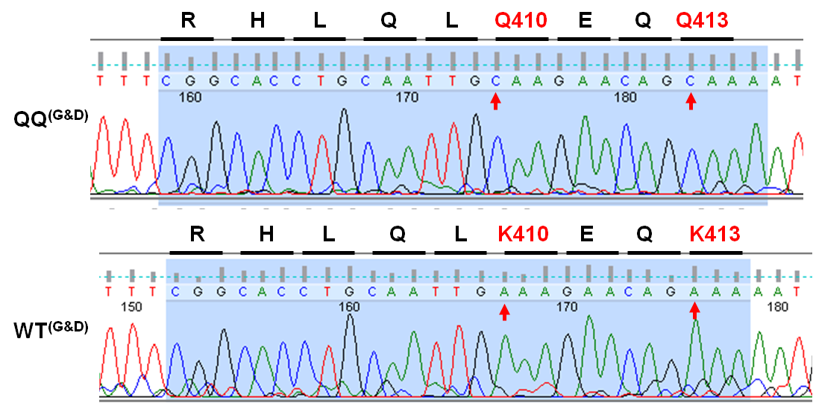
A

B
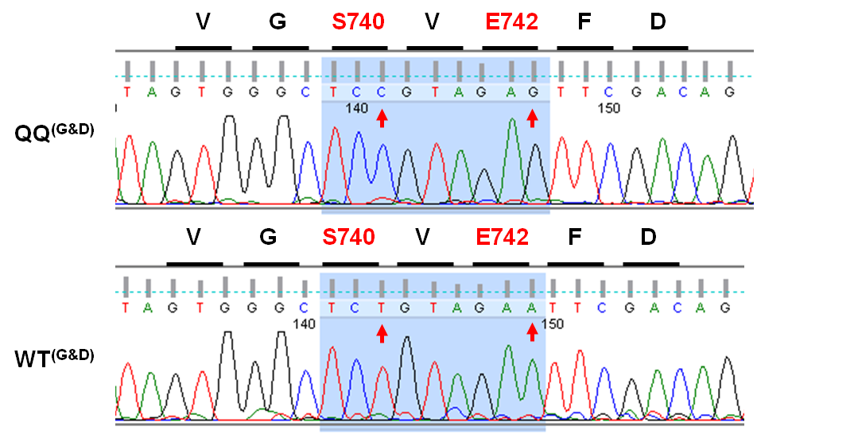

Sequencing results with constructs used in publications (22, 23) encoding wild type STAT1 (WT^{G&D}) and the acetylation-mimicking KK410/413QQ mutant (QQ^{G&D}), as provided by Dr. Heinzel.

