Supplements

Supplement 1. Flow diagram of the NAKO cohort study

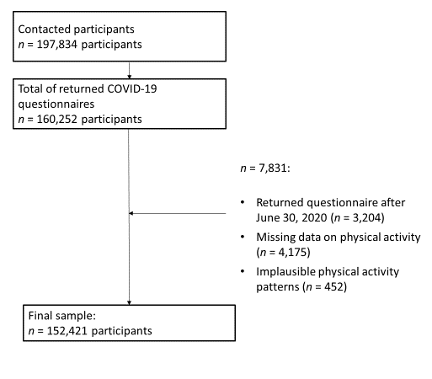

Supplement 2. Frequency of missing data

 | Missing |  |  | Complete
 | n | % |  | n | %
Self-reported PA change scores (COVID-19 survey) | 0 | 0 |  | 152,421 | 100
Following PA guidelines (COVID-19 survey)
Before COVID-19 restrictions | 4,436 | 2.9 |  | 147,985 | 97.1
With the onset of the restrictions | 5,385 | 3.5 |  | 147,036 | 96.5
GPAQ (baseline survey) | 1,969 | 1.3 |  | 150,452 | 98.7
Age (COVID-19 survey) | 9 | 0.0 |  | 152,412 | 100.0
Sex (baseline survey) | 4 | 0.0 |  | 152,408 | 100.0
Education (baseline survey) | 9 | 0.0 |  | 152,412 | 100.0
Migrant background (baseline survey) | 9 | 0.0 |  | 152,412 | 100.0
Altered working condition (COVID-19 survey) | 9 | 0.0 |  | 152,412 | 100.0
Self-rated health (COVID-19 survey) | 736 | 0.5 |  | 151,685 | 99.5
Changes in self-rated health (COVID-19 survey) | 716 | 0.5 |  | 151,705 | 99.5
Anxiety (COVID-19 survey) | 492 | 0.3 |  | 151,929 | 99.7
Depression (baseline survey) | 549 | 0.4 |  | 151,872 | 99.6
Depression (COVID-19 survey) | 549 | 0.4 |  | 151,872 | 99.6
Household with children (COVID-19 survey) | 9 | 0.0 |  | 152,412 | 100.0
Feeling of loneliness (COVID-19 survey) | 352 | 0.2 |  | 152,069 | 99.8
Member of a sports club (COVID-19 survey) | 9 | 0.0 |  | 152,412 | 100.0
Living alone | 9 | 0.0 |  | 152,412 | 100.0
Notes. n = number of respondents; GPAQ= Global physical activity questionnaire;

Supplement 3. Changes in sedentary behavior and physical activity domains

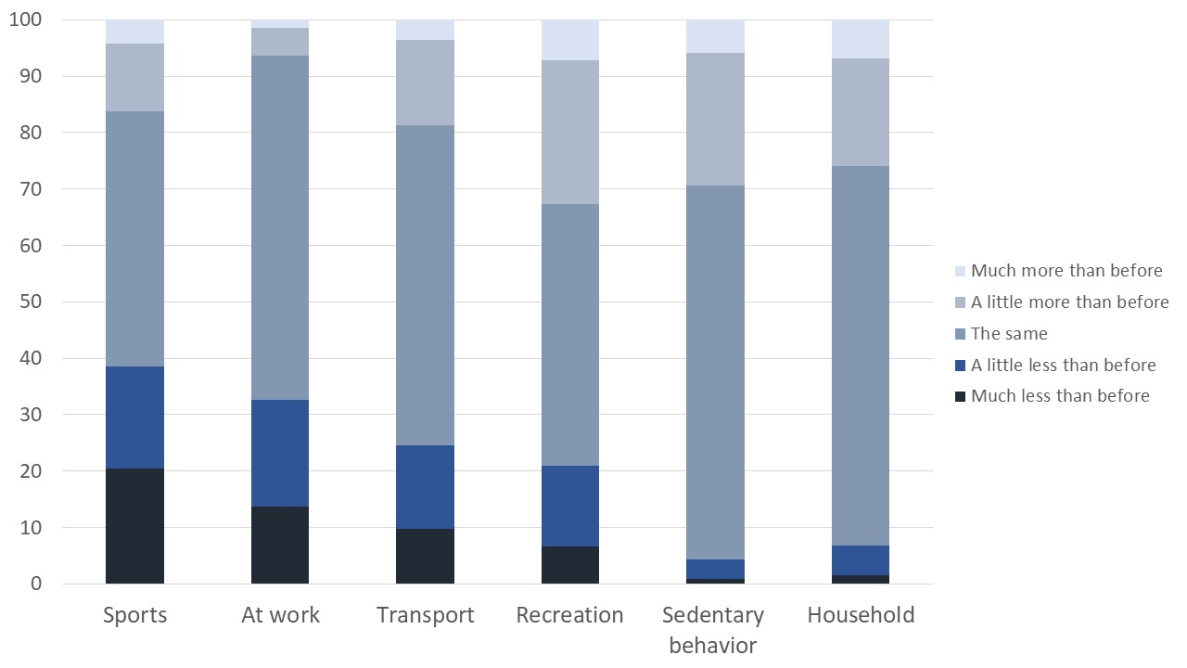
Supplement 4. Interaction between age and the development of depressive symptoms on the change of physical activity and sedentary behavior at the onset of the COVID-19 restrictions
 | Sports |  |  |  |  | At work |  |  |  |  | Transport |  |  |  |  | Recreation |  |  |  |  | Sedentary behavior |  |  |  |  | Household
 | β | 95%-CI |  |  |  | β | 95%-CI |  |  |  | β | 95%-CI |  |  |  | β | 95%-CI |  |  |  | β | 95%-CI |  |  |  | β | 95%-CI
Age | -0.05 | (-.054 | -.042 | ) |  | 0.04 | (.037 | .048 | ) |  | 0.00 | (-.009 | .003 | ) |  | -0.03 | (-.033 | -.02 | ) |  | -0.07 | (-.073 | -.062 | ) |  | -0.08 | (-.081 | -.069 | )
Δ depression (T2-T1) | -0.06 | (-.065 | -.053 | ) |  | -0.09 | (-.092 | -.08 | ) |  | -0.07 | (-.076 | -.064 | ) |  | -0.07 | (-.081 | -.069 | ) |  | 0.06 | (.058 | .07 | ) |  | -0.02 | (-.024 | -.012 | )
Interaction | 0.00 | (-.006 | .004 | ) |  | 0.00 | (-.004 | .005 | ) |  | 0.00 | (-.001 | .009 | ) |  | 0.00 | (-.004 | .006 | ) |  | -0.02 | (-.027 | -.017 | ) |  | 0.00 | (-.008 | .002 | )
Age * Δ depression (T2-T1)
Notes. N = 152,421; values of changes in sedentary behavior and all physical activity domains ranged from -2 to 2; additionally, adjusted for education, altered working conditions, self-rated health, anxiety, depression at baseline, living alone, feeling of loneliness, member of a sports club, physical activity at baseline, high regional number of COVID-19-cases, month of interview

