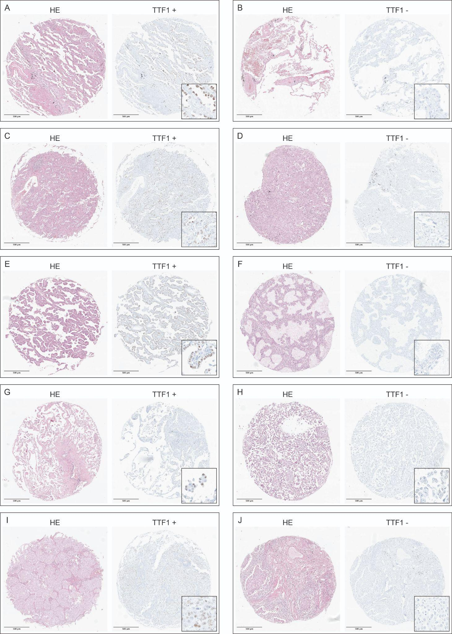
Supplementary Figure 1: Exemplary images of the growth patterns and positive as well as negative TTF-1 staining.
Representative hematoxylin and eosin–stained tumor spots of (A + B) lepidic, (C + D) acinar, (E + F) papillary, (G + H) micropapillary, and (I + J) solid-predominant pulmonary adenocarcinomas and (A, C, E, G, I) spot-related TTF-positive and (B, D, F, H, J) -negative stainings.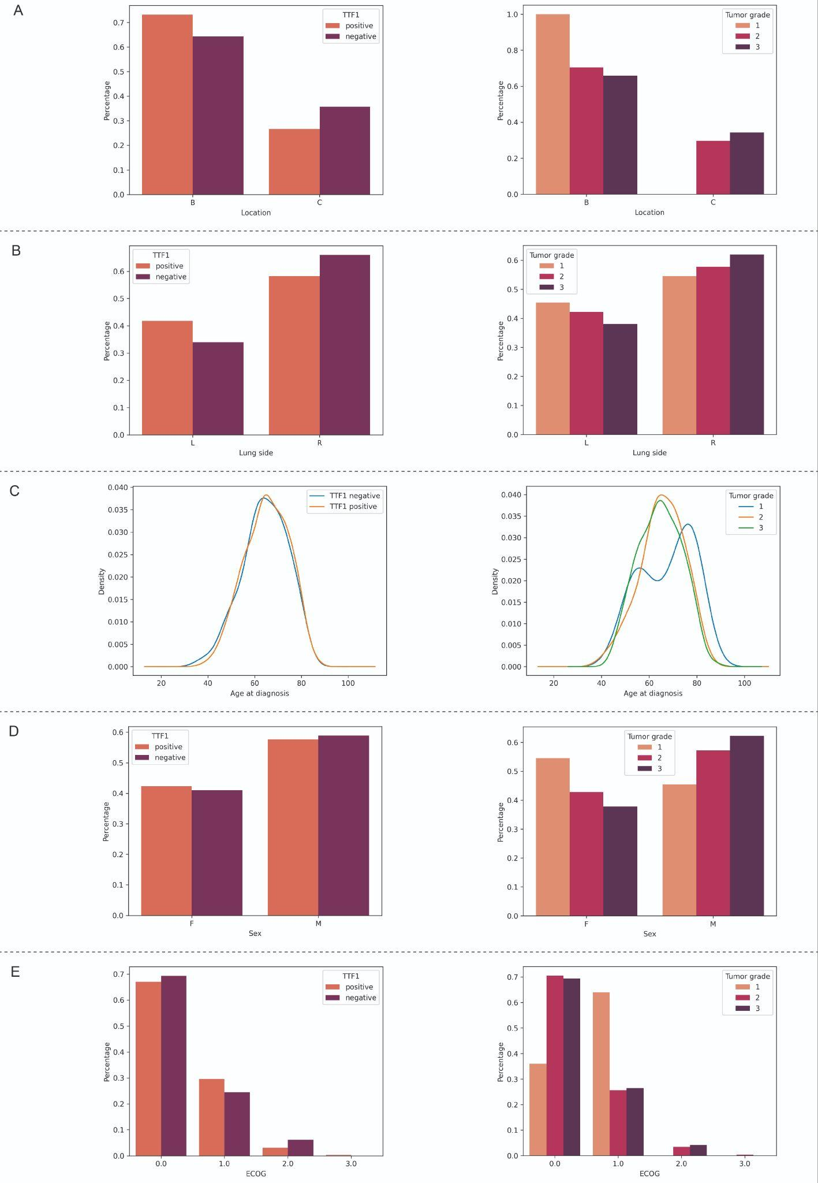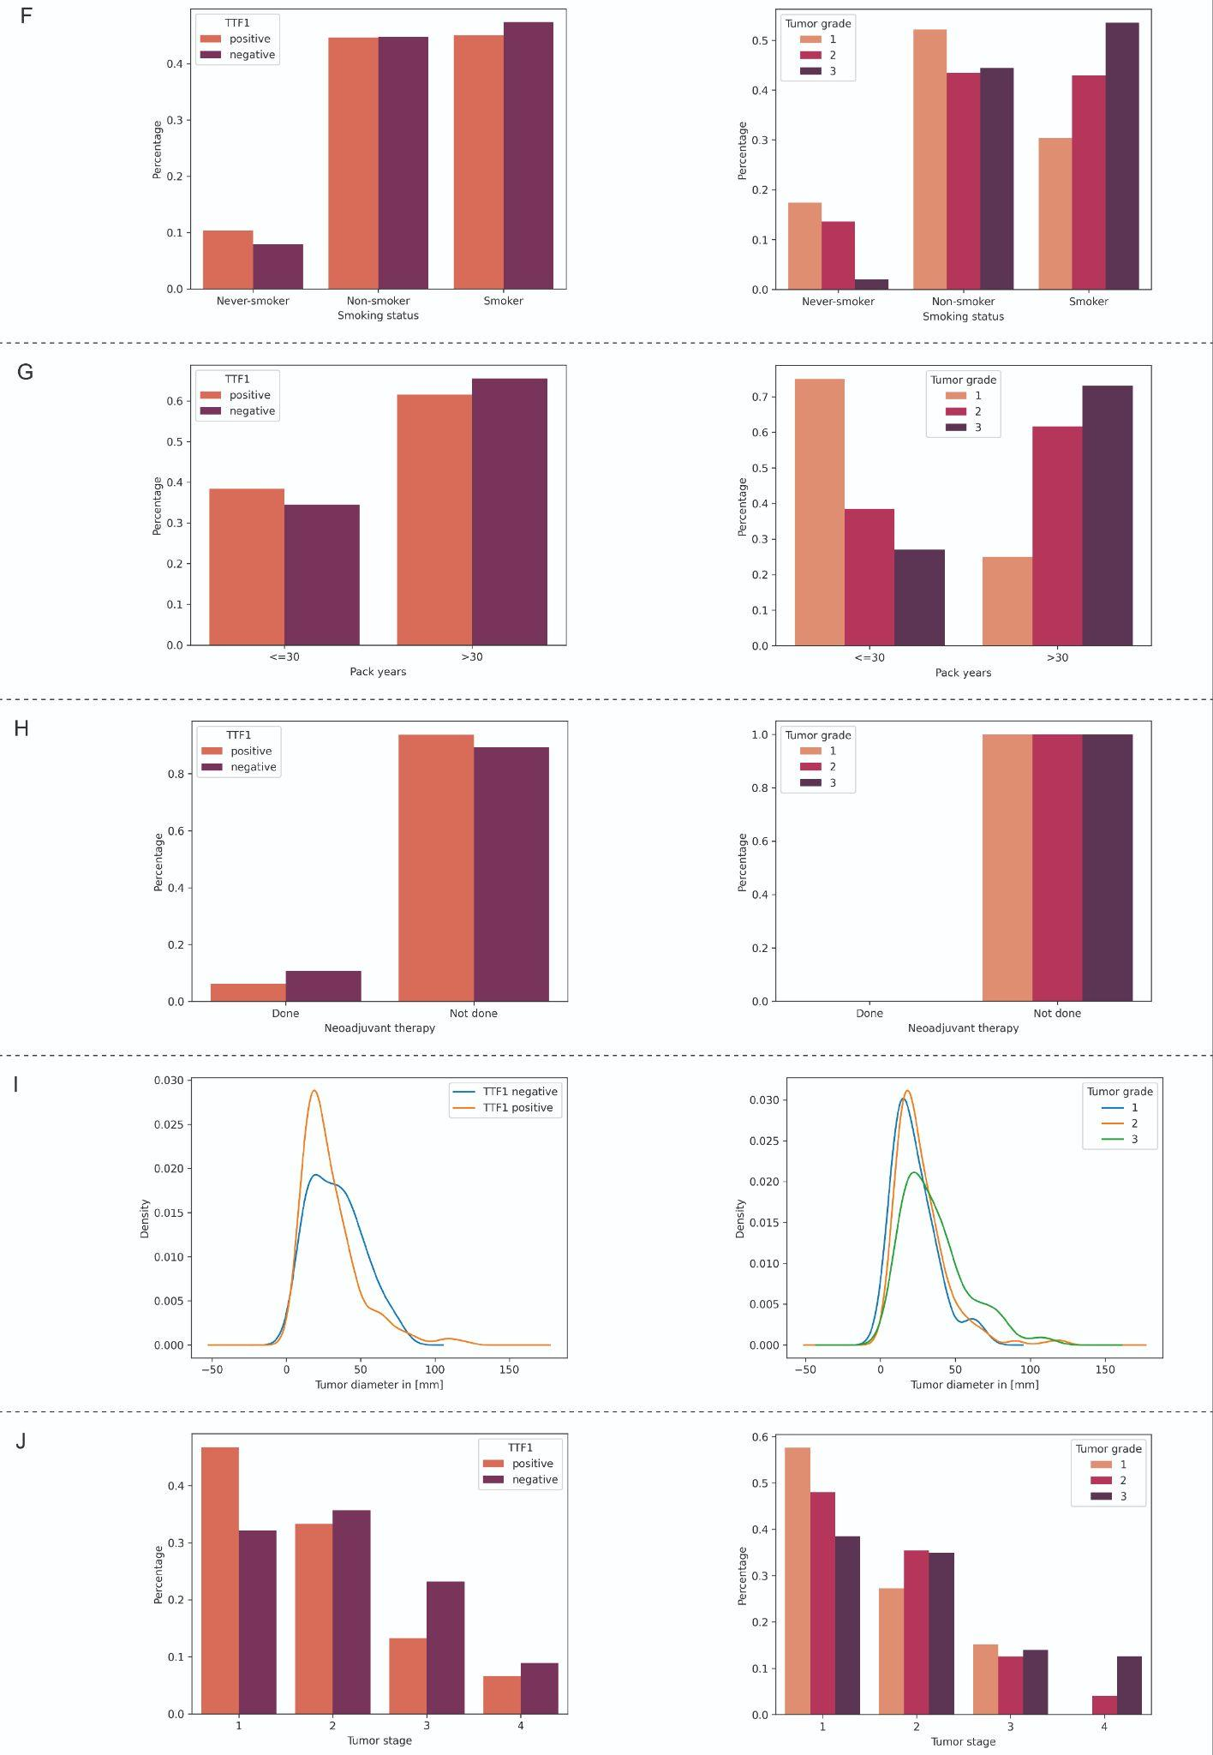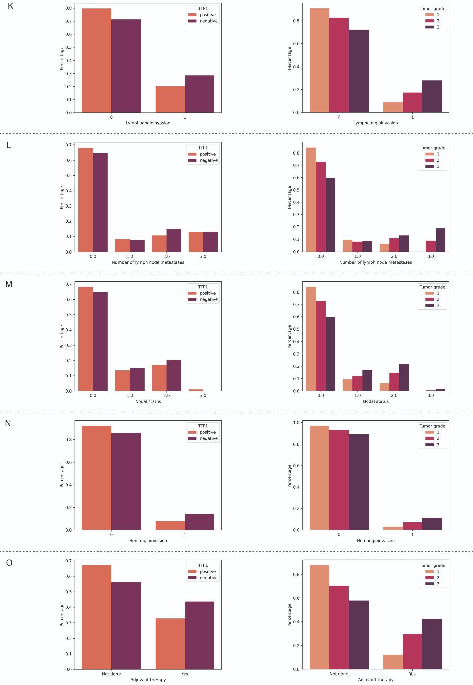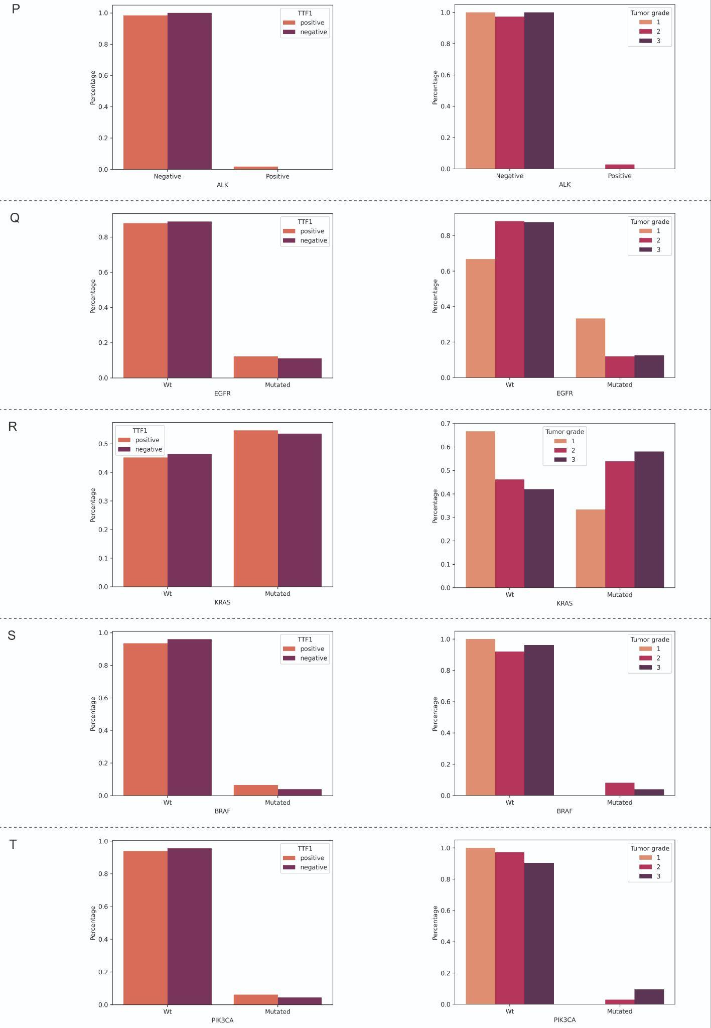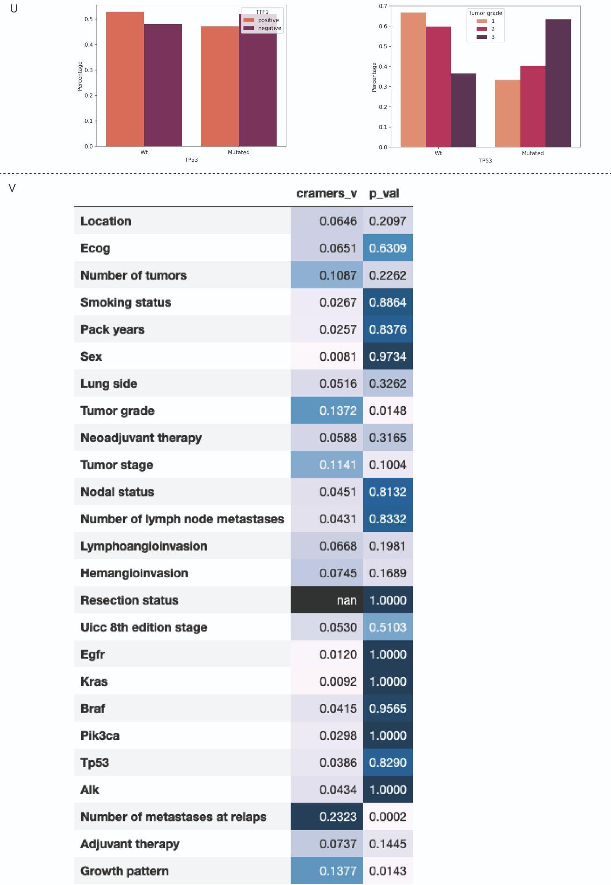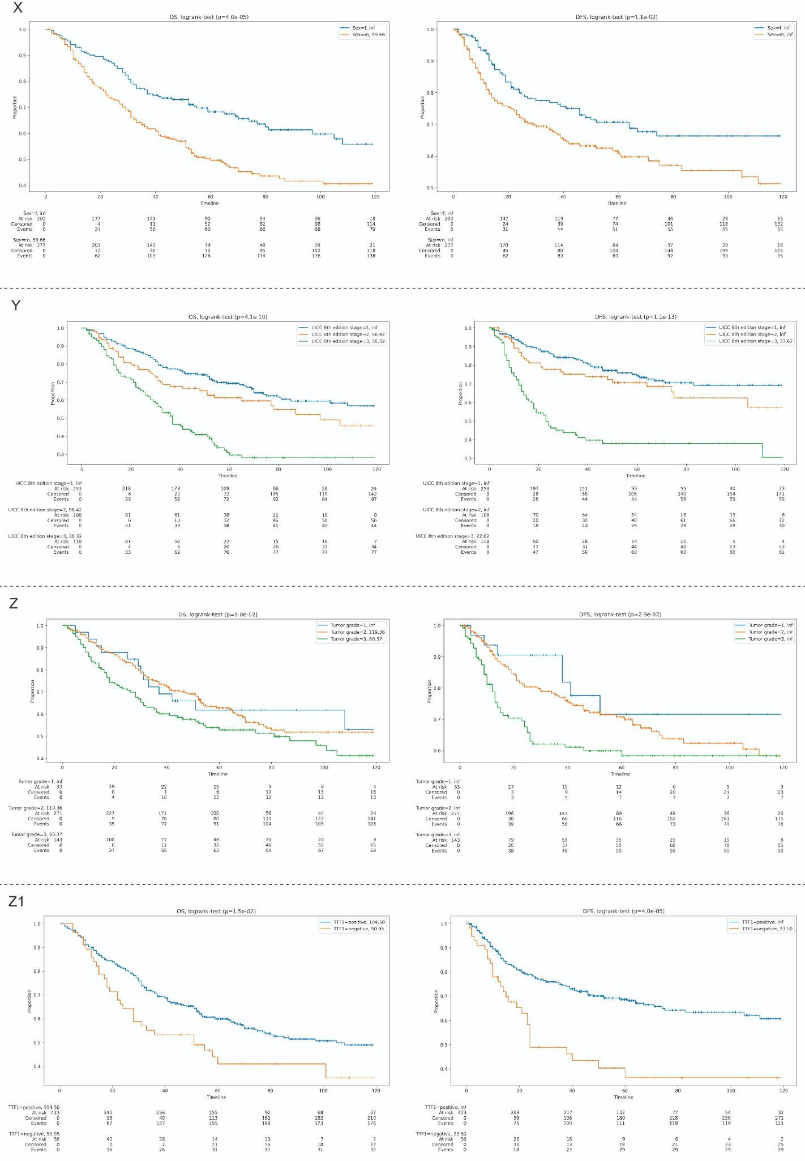

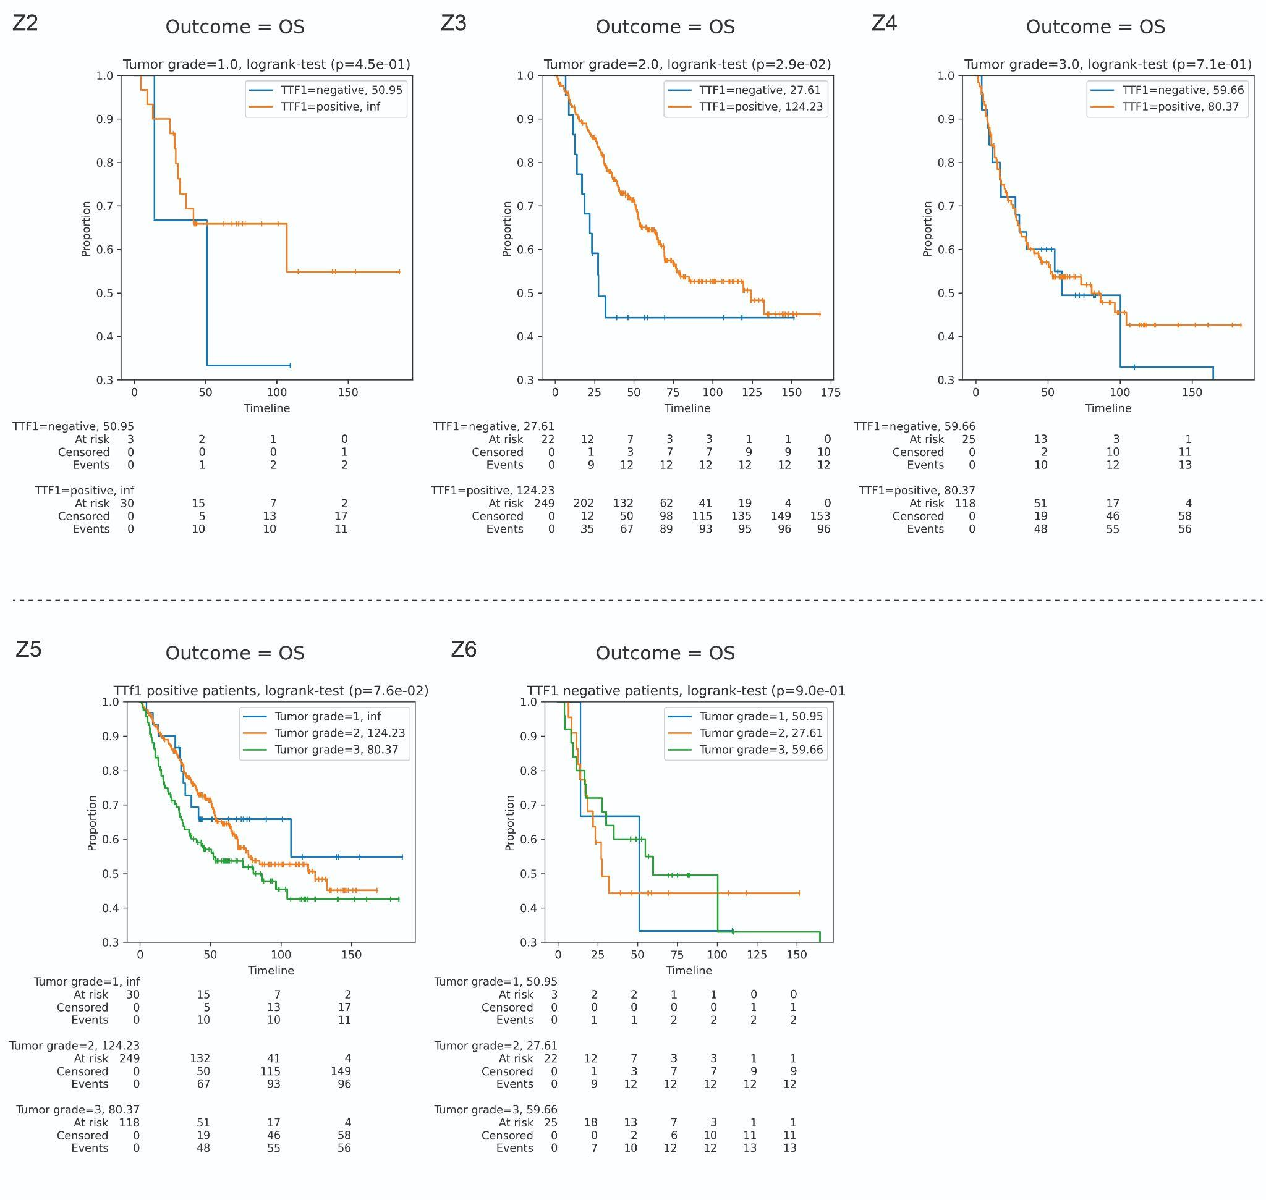
Supplementary Figure 2: Association of TTF-1-status and tumor grade with clinicopathologic parameters and DFS: Histograms and kernel density plots reveal the correlation of TTF-1 status (left side) and tumor grading (right side) with clinicopathological characteristics ((A) treatment center, (B) affected lung side, (C) age of diagnosis, (D) sex, (E) ECOG, (F) smoking status, (G) pack years, (H) neoadjuvant therapy, (I) tumor diameter, (J) tumor stage, (K) lymphangioinvasion, (L) number of lymph node metastases, (M) nodal status, (N) hemangioinvasion, (O) adjuvant therapy), genomic alterations ((P) ALK, (Q) EGFR, (R) KRAS, (S) BRAF, (T) PIK3CA, (U) TP53) and (V) UICC stage, respectively. (W) Paired sample permutation test showing statistic correlations between TTF-1 status, clinicopathological characteristics, and genomic alterations. Kaplan-Meier-curves reveal overall survival OS (left side) and DFS (right side) regarding (X) sex, (Y) UICC stage, (Z) tumor grading, and (Z1) TTF-1 status. Kaplan-Meier curves show a comparison of (Z2-Z4) TTF-1 status and tumor grading and (Z5-Z6) vice versa, regarding OS. Numbers in the upper right corner indicate the median survival time in months.

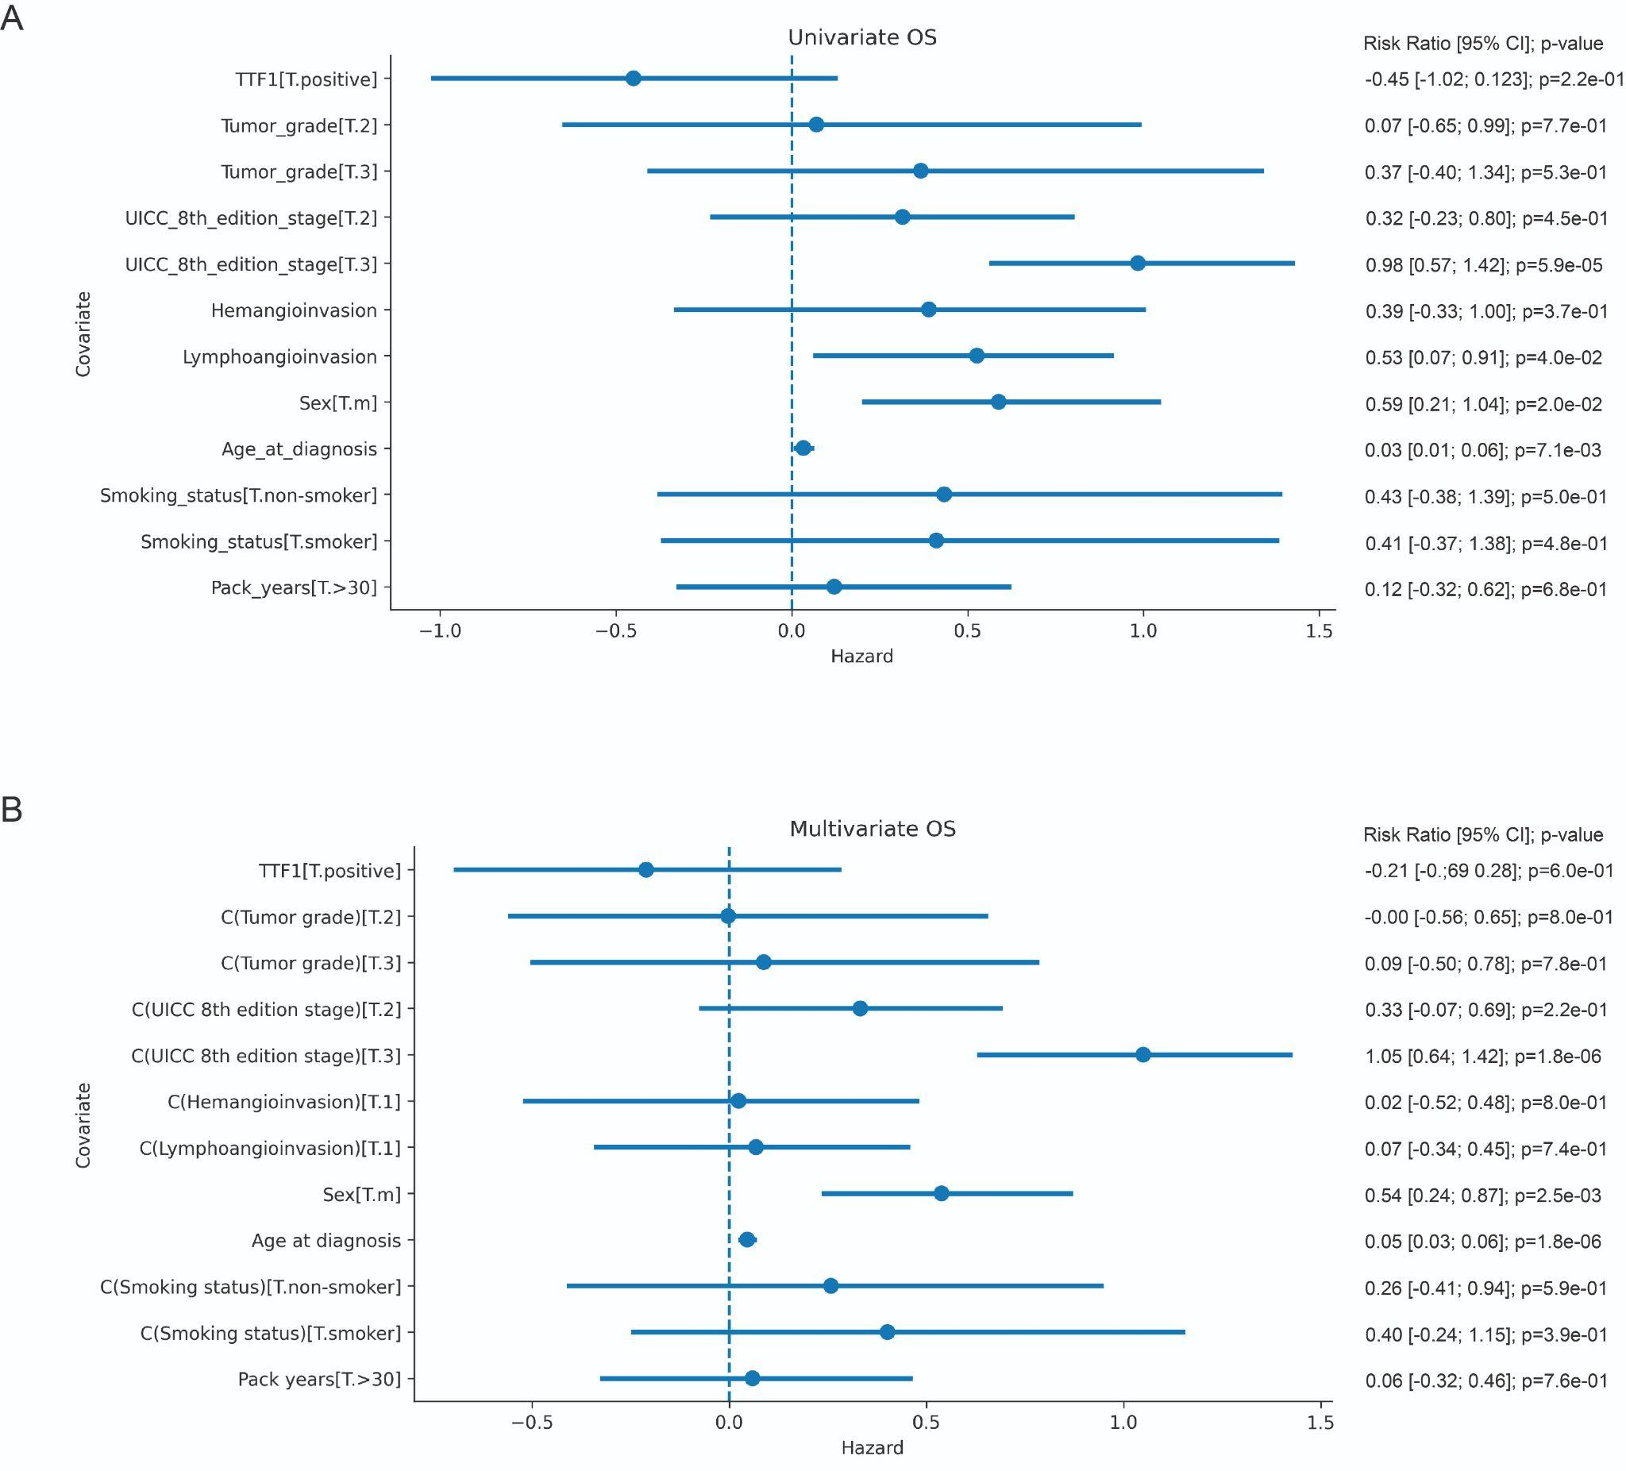
Supplementary Figure 3: Effect of TTF-1, tumor grade, and clinicopathologic parameters on OS by univariate and multivariate analyses. (A) OS Univariate analysis and (B) multivariate analysis of TTF-1 status, tumor grade, sex, UICC stage, smoking status, pack-years, lymphangioinvasion, hemangioinvasion, and age at diagnosis.
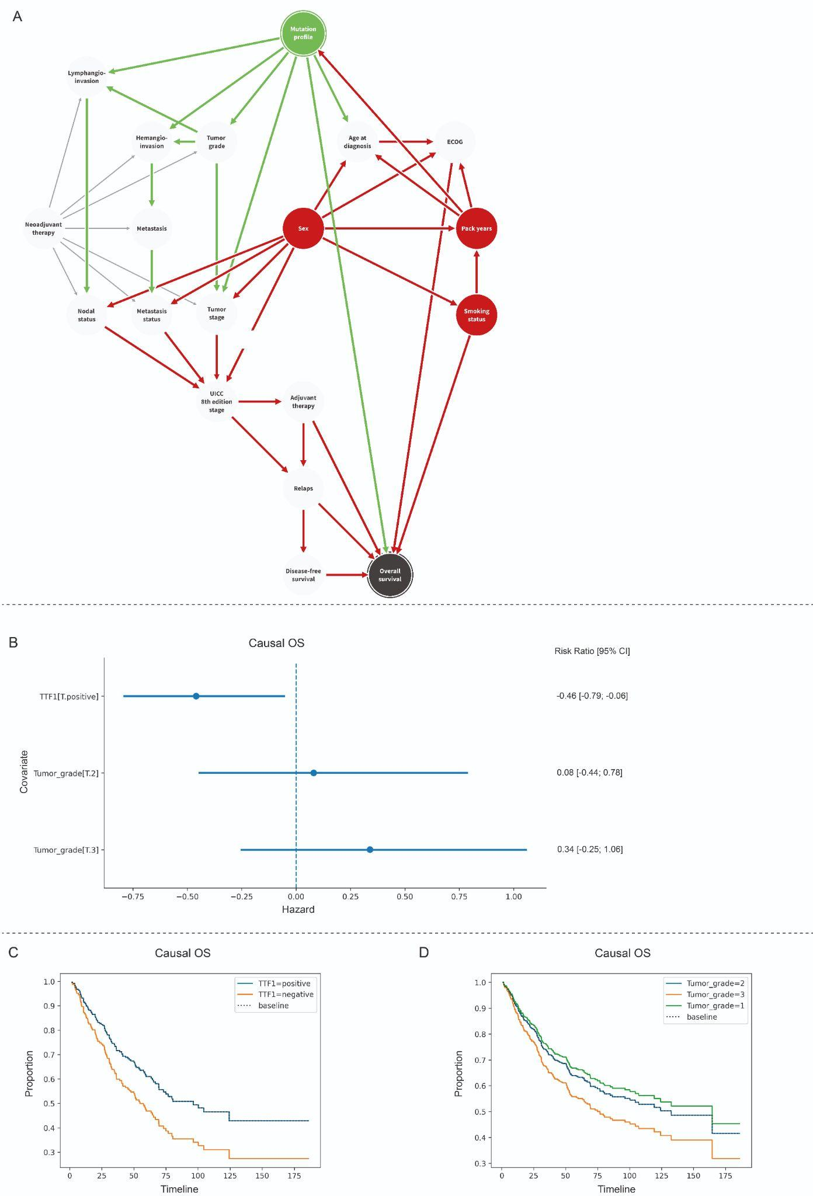
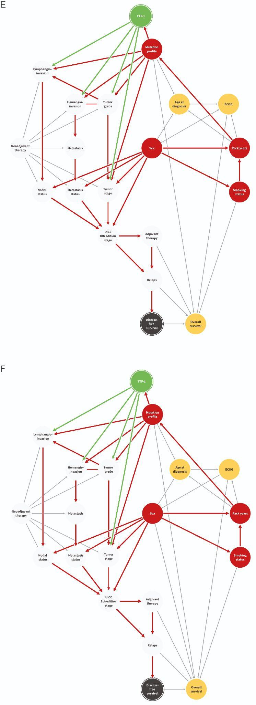
Supplementary Figure 4A-H: Evaluation of the true effect size of TTF-1 on OS and comparison with grading by causal effect estimation: (A) Bayesian network displaying the conditional probabilities for the corresponding variables. The mutation profile, including TTF-1 status, is defined as exposure and OS as outcome, respectively. Green circles represent ancestors of exposure, light gray circles ancestors of the outcome, red circles ancestors of exposure and outcome, green arrows causal pathways, and red arrows biasing pathways, respectively. (B) Forrest plot showing the computed effects of TTF-1 status and tumor grade on OS. Computed survival curves visualize the effects of (C) TTF-1 and (D) tumor grading. (E-H) Bayesian networks, in which TTF-1 status and mutation profile are separated, determine the mutation profile as another ancestor of exposure and outcome. This does not affect the computed effects of TTF-1 status and tumor grade on DFS and OS.

Patients |  | Method # | EGFR |  |  | ALK |  |  | KRAS |  |  | BRAF |  |  | PIK3CA |  |  | TP53 |  |  | Other genes
No. | % |  | WT | Mut. | n.d. | Negative | Positive | n.d. | WT | Mut. | n.d. | WT | Mut. | n.d. | WT | Mut. | n.d. | WT | Mut. | n.d.
46 | 10,3 | Sanger 1 | 36 | 10 | 0 | 0 | 0 | 46 | 0 | 0 | 46 | 0 | 0 | 46 | 0 | 0 | 46 | 0 | 0 | 46 | 0
8 | 1,8 | Sanger 2 | 6 | 2 | 0 | 0 | 0 | 8 | 0 | 0 | 8 | 0 | 0 | 8 | 0 | 0 | 8 | 0 | 0 | 8 | 0
4 | 0,9 | Sanger 3 | 4 | 0 | 0 | 0 | 0 | 4 | 4 | 0 | 0 | 0 | 0 | 4 | 0 | 0 | 4 | 0 | 0 | 4 | 0
2 | 0,4 | Sanger 4 | 2 | 0 | 0 | 0 | 0 | 2 | 0 | 0 | 2 | 2 | 0 | 0 | 0 | 0 | 2 | 0 | 0 | 2 | 0
1 | 0,2 | Sanger 5 | 1 | 0 | 0 | 0 | 0 | 1 | 1 | 0 | 0 | 1 | 0 | 0 | 0 | 0 | 1 | 0 | 0 | 1 | 0
17 | 3,8 | Sanger ext. | 3 | 3 | 11 | 0 | 0 | 11 | 5 | 8 | 4 | 10 | 0 | 7 | 10 | 2 | 5 | 0 | 0 | 11 | 0
31 | 6,7 | LUN3 | 28 | 3 | 0 | 0 | 0 | 31 | 17 | 14 | 0 | 26 | 5 | 0 | 30 | 1 | 0 | 14 | 15 | 2 | 27 x WT; 2x PTEN mut.; 1 x MET mut.;
44 | 9,8 | LUN4 | 41 | 3 | 0 | 0 | 0 | 44 | 16 | 27 | 1 | 43 | 1 | 0 | 44 | 0 | 0 | 23 | 21 | 0 | 26 x WT; 9 x KEAP1 mut.; 1 x CTNNB1 mut.; 4 x DDR2 mut.; 2 x FGFR2 mut.; 1 x NRAS mut.; 1 x PTEN mut.
11 | 2,5 | LUN5 | 10 | 1 | 0 | 0 | 0 | 11 | 4 | 7 | 0 | 11 | 0 | 0 | 10 | 1 | 0 | 7 | 4 | 0 | 8 x WT; 1 x ROS1 mut.; 1 x MET mut.; 1 x SMARCA4 mut.
33 | 7,8 | nNGM 1.0 | 31 | 2 | 0 | 0 | 0 | 33 | 15 | 17 | 1 | 30 | 3 | 0 | 10 | 1 | 22 | 15 | 14 | 4 | 25 x WT; 1 x CTNNB1 mut.; 1 x STK11 mut.
9 | 2,0 | nNGM 2.0 | 8 | 1 | 0 | 0 | 0 | 9 | 3 | 6 | 0 | 9 | 0 | 0 | 6 | 1 | 2 | 5 | 4 | 0 | 5 x WT, 2 x STK11 mut.; 1 x MAPK mut.; 1 x NTRK2 mut.
107 | 23,9 | FISH | 0 | 0 | 107 | 105 | 2 | 0 | 0 | 0 | 107 | 0 | 0 | 107 | 0 | 0 | 107 | 0 | 0 | 107 | 0
185 | 41,4 | IHC | 0 | 0 | 185 | 181 | 4 | 0 | 0 | 0 | 185 | 0 | 0 | 185 | 0 | 0 | 185 | 0 | 0 | 185 | 0

Abbreviations: No., Absolute number of patients; %, percentage of patients refers to all patients; Sanger, Sanger sequencing; ext., external analysis; EGFR, Epidermal Growth Factor Receptor; ALK, Anaplastic Lymphoma Kinase; KRAS, Kirsten RAt Sarcoma virus; BRAF, proto-oncogene B-Raf; PIK3CA, Phosphatidylinositol-4,5-bisphosphate 3-kinase, catalytic subunit alpha; TP53, Tumor Suppressor P53; WT, wildtype; Mut., mutated; n.d., not done; PTEN, Phosphatase and tensin homolog; MET, Hepatocyte growth factor receptor; KEAP1, Kelch-like ECH-associated protein 1; CTNNB1, Catenin beta-1; DDR2, Discoidin domain-containing receptor 2; FGFR2, Fibroblast growth factor receptor 2; NRAS, Neuroblastoma RAS viral oncogene homolog; ROS1, Proto-oncogene tyrosine-protein kinase; SMARCA4, Transcription activator BRG1 ; STK11, Serine/threonine kinase 11; MAPK, mitogen-activated protein kinase; NTRK2, Tropomyosin receptor kinase B; FISH, Fluorescence in situ hybridization; IHC, Immunohistochemistry.
#For detailed description of the different gene panels see supplementary table 2A-J
Supplementary Table 1: Distribution of patient mutation status according to the used methods.

Gene | Exon
EGFR | 18, 19, 21
Supplementary Table 2A: Sanger 1.

Gene | Exon
EGFR | 18-21
Supplementary Table 2B: Sanger 2.

Gene | Exon
EGFR | 18-21
KRAS | 2-4
Supplementary Table 2C: Sanger 3.

Gene | Exon
EGFR | 18-21
BRAF | 15
Supplementary Table 2D: Sanger 4.

Gene | Exon
EGFR | 18-21
KRAS | 2-4
NRAS | 2, 3
Supplementary Table 2E: Sanger 5.

Gene | Exon
AKT1 | 4
ALK | 21 - 25
BRAF | 11, 15
CTNNB1 | 3
DDR2 | 3 - 18
EGFR | 18-21
ERBB2 | 19, 20
KRAS | 2, 3
MAP2K1 | 2
MET | 14
NRAS | 2, 3
PIK3CA | 10, 21
PTEN | 1 - 8
TP53 | 5 - 8
Supplementary Table 2F: Sequencing panel LUN3.

Gene | Exon
ARAF | 7, 10, 15
BRAF | 11, 15
CTNNB1 | 3
DDR2 | 4 -19
EGFR | 18 - 21
ERBB2 | 19, 20
FGFR2 | 8 - 10, 12, 17, 20
FGFR3 | 7, 10, 15
KEAP1 | 2 - 6
KRAS | 2 - 4
MAP2K1 | 2
MET | 14, 16 - 19
NFE2L2 | 2
NRAS | 2 - 4
PIK3CA | 10, 21
PTEN | 1 - 8
TP53 | 5 - 8
Supplementary Table 2G: Sequencing panel LUN4.

Gene | Exon
ALK | 22 - 25
BRAF | 11, 15
CTNNB1 | 3
EGFR | 18 - 21
ERBB2 | 8, 19, 20
FGFR1 | 4 - 7, 10, 12 - 15
FGFR2 | 6 - 15, 18 (8 – NM_022970)
FGFR3 | 3, 7, 9, 10, 12 (Codon 512-529), 14, 16, 18 (Codon 769-807)
FGFR4 | 3, 6, 9, 12, 13 (Codon 556-607), 15, 16
IDH1 | 4
IDH2 | 4
KRAS | 2 - 4
MAP2K1 | 2, 3
MET | 14, 16 - 19
NRAS | 2 - 4
PIK3CA | 10, 21
PTEN | 1 - 8
ROS1 | 34 - 41
TP53 | 4 (Codon 97-125), 5, 6, 7, 8
Supplementary Table 2H: Sequencing panel LUN5

Gene | Exon
ALK | 22-25
BRAF | 11, 15
CTNNB1 | 3
EGFR | 18-21
ERBB2 | 8, 19, 20
FGFR1 | 4, 5, 6, 7, 10-15
FGFR2 | 6-15, 18
FGFR3 | 3, 6, 7, 9, 10, 12, 14, 16, 18
FGFR4 | 3, 6, 9, 10*, 12, 13, 15, 16
IDH1 | 4
IDH2 | 4
KRAS | 2-4
MAP2K1 | 2, 3
MET | 13, 14, 16-19
NRAS | 2-4
PIK3CA | 10, 21
PTEN | 1-7, 8
ROS1 | 34-41
TP53 | 4-8
Supplementary Table 2I: Sequencing panel nNGM 1.0.

Gene | Exon
ALK | 22, 23, 24, 25
BRAF | 11, 15
CTNNB1 | 3
EGFR | 18, 19, 20, 21
ERBB2 | 8, 19, 20
FGFR1 | 4, 5, 6, 7, 10, 11, 12, 13, 14, 15
FGFR2 | 6, 7, 8, 9, 10, 11, 12, 13, 14,15, 18
FGFR3 | 3, 6, 7, 9, 10, 12, 14, 16, 18
FGFR4 | 3, 6, 9, 10, 12, 13, 15, 16
HRAS | 2, 3, 4
IDH1 | 4
IDH2 | 4
KEAP1 | 2, 3, 4, 5, 6
KRAS | 2, 3, 4
MAP2K1 | 2, 3
MET | 13, 14, 16, 17, 18, 19
NRAS | 2, 3, 4
NTRK1 | 13, 14, 15, 16, 17
NTRK2 | 14, 15, 16, 17, 18, 19
NTRK3 | 15, 16, 17, 18, 19, 20
PIK3CA | 10, 21
PTEN | 1, 2, 3, 4, 5, 6, 7, 8
RET | 10, 11, 12, 13*, 14, 15, 16, 17, 18
ROS1 | 34, 35, 36, 37, 38, 39, 40, 41
STK11 | 1, 2, 3, 4, 5, 6, 7, 8, 9
TP53 | 4, 5, 6, 7, 8
Supplementary Table 2J: Sequencing panel nNGM 2.0.

