Supplemental Figure 1: Receiver Operator characteristics curve
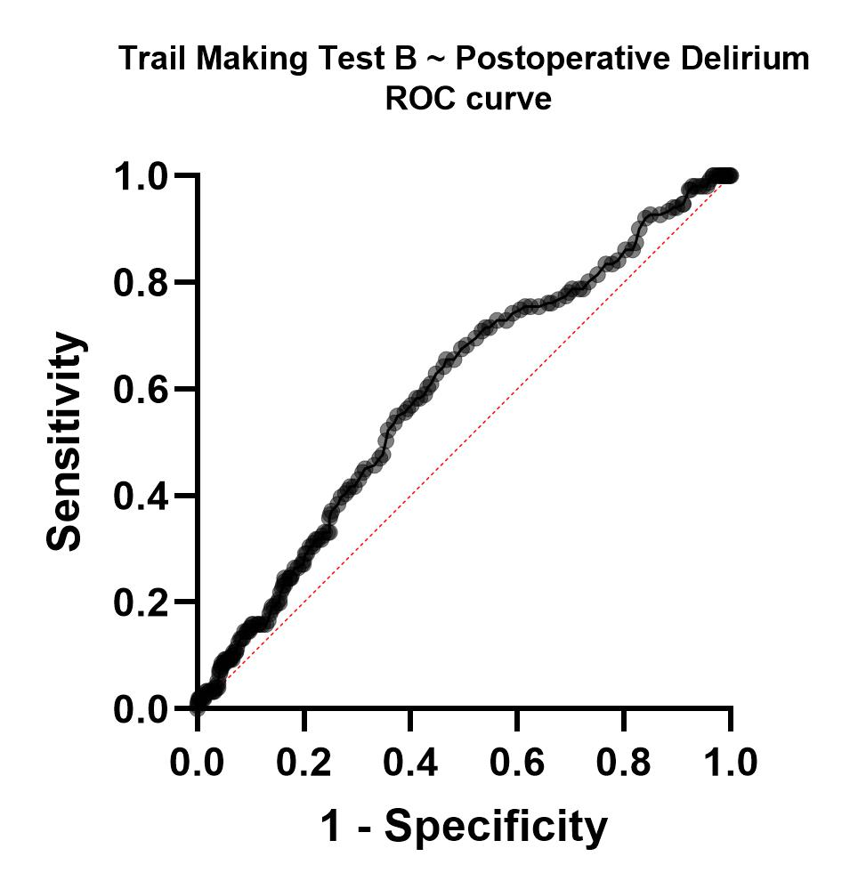
Note: Receiver Operator Characteristics curve showing the performance of preoperative Trail Making Test B scores predicting postoperative delirium. The area under the curve is 0.60 [(95% CI 0.55 – 0.64) p< 0.001] for n = 841.

Supplemental Table 1: Summary of Missing Data

Variable | Number of Missing Data
Age | 0
Sex | 0
ISCED | 77
Preoperative Charlson Comorbidity Index | 4
GDS | 117
Frailty | 223
Sum of taken drugs | 91

 | Trail Making Test B score (in seconds)
1 | 288
2 | 253
3 | 256
4 | 268
5 | 245
6 | 248
7 | 250
8 | 270
9 | 268
10 | 291
11 | 252
12 | 284
13 | 256
14 | 294
15 | 298
16 | 264
17 | 260
18 | 259
19 | 270
20 | 271
21 | 295

Supplemental Table 2: Outlier and respective Trail Making Test B scores

