SUPPLEMENTAL MATERIAL
Autoantibodies against the chemokine receptor 3 predict cardiovascular risk

Felix S. Müller^{1,2,3,4}, Zouhair Aherrahrou^{5,6}; Hanna Grasshoff⁷; Marc W. Heidorn^{1,2,3,4}, Jens Y. Humrich⁷, Laurence Johanson⁷, Redouane Aherrahrou^{8,5,6}, Tobias Reinberger^{5,6}, Andreas Schulz^{1,2}, Vincent ten Cate^{1,2,3,9}, Alejandro Pallares Robles^{1,2,9}, Thomas Koeck^{1,2,3}, Steffen Rapp^{1,2,3}, Tanja Lange^{7,10}, Lukas Brachaczek⁷, Finn Luebber^{7,11}, Jeanette Erdmann^{5,6†}, Harald Heidecke¹², Kai Schulze-Forster¹², Ralf Dechend^{12,13,14}, Karl J. Lackner^{15,3}, Norbert Pfeiffer¹⁶, Jasmin Ghaemi Kerahrodi¹⁷, Oliver Tüscher^{18,19}, Andreas Schwarting²⁰, Konstantin Strauch²¹, Thomas Münzel^{4,3,9}, Jürgen H. Prochaska^{1,2,3,9}, Gabriela Riemekasten^{7, 22‡}, and Philipp S. Wild^{1,2,3,9,23*‡}

¹ Preventive Cardiology and Preventive Medicine, Department of Cardiology, University Medical Center of the Johannes Gutenberg-University Mainz, Langenbeckstr. 1, 55131 Mainz, Germany;
² Clinical Epidemiology and Systems Medicine, Center for Thrombosis and Hemostasis, University Medical Center of the Johannes Gutenberg-University Mainz, Langenbeckstr. 1, 55131 Mainz, Germany;
³ DZHK (German Centre for Cardiovascular Research), partner site RhineMain, Mainz, Langenbeckstr. 1, 5513, Germany
⁴ Department of Cardiology, University Medical Center of the Johannes Gutenberg-University Mainz, Mainz, Langenbeckstr. 1, 55131, Germany
⁵ Institute for Cardiogenetics, University of Lübeck, Lübeck, Germany
⁶ DZHK (German Centre for Cardiovascular Research), partner site Hamburg/Kiel/Lübeck, Lübeck, Germany
⁷ Department of Rheumatology and Clinical Immunology, University Medical Center Schleswig-Holstein Campus Lübeck, Lübeck, Germany
⁸ A.I. Virtanen Institute for Molecular Sciences, University of Eastern Finland, Kuopio, Finland
⁹ Center for Thrombosis and Hemostasis, University Medical Center of the Johannes Gutenberg-University Mainz, Langenbeckstr. 1, 55131, Germany
¹⁰ Center of Brain, Behavior, and Metabolism (CBBM), University of Lübeck, Lübeck, Germany
¹¹ Social Neuroscience Lab, Department of Psychiatry and Psychotherapy, University of Lübeck, Lübeck, Germany
¹² CellTrend Gesellschaft mit beschränkter Haftung (GmbH), Luckenwalde, Germany
¹³ Experimental and Clinical Research Center, a cooperation of Charité - Universitätsmedizin Berlin and Max Delbrück Center for Molecular Medicine, Berlin, Germany
¹⁴ HELIOS Klinikum Berlin Buch, Department of Cardiology and Nephrology, Berlin, Germany
¹⁵Institute for Clinical Chemistry and Laboratory Medicine, University Medical Center of the Johannes Gutenberg-University Mainz, Mainz, Germany
¹⁶ Department of Ophthalmology University Medical Center of the Johannes Gutenberg-University Mainz, Mainz, Germany
¹⁷ Department of Psychosomatic Medicine and Psychotherapy, University Medical Center of the Johannes Gutenberg University Mainz, Mainz, Germany
¹⁸ Department of Psychiatry and Psychotherapy, University Medical Center of the Johannes Gutenberg-University Mainz, Mainz, Germany
¹⁹ Institute for Molecular Biology (IMB), Working Group Neurocognitive Mechanism of Mental Resilience, Ackermannweg 4, 55128 Mainz, Germany
²⁰ Department of Internal Medicine I, University Medical Center Mainz, Mainz, Germany
²¹ Institute of Medical Biostatistics, Epidemiology and Informatics (IMBEI), University Medical Center of the Johannes Gutenberg University Mainz, Mainz, Germany
²² Centre for Infection and Inflammation Lübeck (ZIEL), University Medical Center Schleswig-Holstein Campus Lübeck, Lübeck, Germany
²³ Institute for Molecular Biology (IMB), Working Group Systems Medicine, Ackermannweg 4, 55128 Mainz, Germany

† Deceased
‡ The last two authors share senior authorship.

* Corresponding author
Philipp S. Wild, MD, MSc
Professor of Clinical Epidemiology
University Medical Center Mainz of the Johannes Gutenberg University Mainz
Langenbeckstr. 1, 55131 Mainz, Germany
Phone: +49 6131 17-7163
Fax: +49 6131 17-8460
Email: philipp.wild@unimedizin-mainz.de
Table of contents
Page
- Text Supplement ……………………………………………………………………... 5
  - Handling of human biomaterial.
  - Further characterization of the anti-CXCR3 autoantibody assay.
  - Definition of cardiovascular risk factors.
  - Acquisition of data on individual medication.
  - Echocardiography.
  - Induction of atherosclerosis in ApoE knockout mice.
  - Histological analysis of atherosclerosis burden in ApoE knockout mice.
  - Statistical analysis – descriptive part.
  - Statistical analysis – bioinformatic part.
  - Software, scripts and databases used in the analysis.

- Supplemental Tables …………………………………………………………………. 9
  - Supplemental Table S1. Anti-CXCR3 autoantibody assay procedure.
  - Supplemental Table S2. Concentrations of anti-CXCR3 autoantibodies according to the number of freeze/thaw cycles in four different human samples.
  - Supplemental Table S3. Serial measurements of anti-CXCR3-autoantibodies using a monoclonal antibody as standard curve and a positive control serum.
  - Supplemental Table S4. Proteins measured by targeted proximity extension assay technology.
  - Supplemental Table S5. Additional clinical characteristics of the analysis sample according to quartiles of anti-CXCR3 autoantibodies.
  - Supplemental Table S6. Clinical characteristics of the reference sample.
  - Supplemental Table S7. Age- and sex-specific distribution of anti-CXCR3-autoantibodies in the reference sample.
  - Supplemental Table S8. Clinical determinants of anti-CXCR3-autoantibodies (multivariable regression).
  - Supplemental Table S9. Relationship of anti-CXCR3-autoantibodies with history of atherosclerotic events and prevalent renal disease.
  - Supplemental Table S10: Concentrations of anti-CXCR3-autoantibodies (analyzed per standard deviation increase) and clinical outcome.
  - Supplemental Table S11. Anti-CXCR3 autoantibodies, C-reactive protein, and clinical outcome.
  - Supplemental Table S12. Anti-CXCR3 autoantibodies, time from blood draw to analysis, and clinical outcome.
  - Supplemental Table S13. Full list of variables selected by least absolute shrinkage and selection operator analysis.

- Supplemental Figures ………………………………………………………………. 25
  - Supplemental Figure S1. Distribution of autoimmune disease across the first 5,000 participants of the Gutenberg Health Study.
  - Supplemental Figure S2. Study Flow.
  - Supplemental Figure S3. Distribution of concentrations of anti-CXCR3-autoantibodies in the analysis sample.
  - Supplemental Figure S4. Derivation of the reference sample for anti-CXCR3-autoantibody concentrations.
  - Supplemental Figure S5. Influence of medication on anti-CXCR3-autoantibody concentrations.
  - Supplemental Figure S6. Relationship of concentrations of anti-CXCR3-autoantibodies with all-cause mortality.
  - Supplemental Figure S7. Relationship of concentrations of anti-CXCR3-autoantibodies with cardiac death and MACE.
  - Supplemental Figure S8. Relationship of concentrations of anti-CXCR3- autoantibodies with incident heart failure.
  - Supplemental Figure S9. Association of log-transformed concentrations of anti-CXCR3 autoantibodies with clinical outcome
  - Supplemental Figure S10: Association of anti-CXCR3 autoantibodies with CXCR3 ligands or modulators of CXCR3 activity.
  - Supplemental Figure S11: Cross-sectional analysis of the aortic root in mice immunized against CXCR3 versus controls.

  - Supplemental Figure S12: Concentrations of cholesterol and triglycerides according to diet and CXCR3 immunization status.

  - Supplemental Figure S13: Granulocyte-to-lymphocyte ratio in mice immunized against CXCR3 versus controls.

  - Supplemental Figure S14: Pulmonary expression of CXCR3 mRNA and lung infiltration according to CXCR3 immunization status.

- Supplemental references…………………………………………………………… 37
- Text supplement

- Handling of human biomaterial and characterization of the anti-CXCR3 autoantibody assay.
Human blood samples were collected from antecubital veins by specifically trained study nurses of the Gutenberg Health Study according to a standard operating procedure (SOP). Samples were processed according to a predefined SOP immediately after collection in a processing laboratory (20 metres from the collection site) and immediately centrifuged at 2,500 rpm for 10 minutes by laboratory technicians of the Biobank of the University Medical Center Mainz (BBM) and frozen in 300ul portions in a 96-well format at -80°C. The serum samples underwent one freeze/thaw cycle for this analysis (water bath at 30°C for 10 minutes). The average time from blood collection to laboratory analysis of anti-CXCR3 aAbs was 12 ± 0.4 years.
- Further characterization of the anti-CXCR3 autoantibody assay.
The intra-assay precision (n=10) was 4.7% (at a concentration of 14.2 U/ml) and the inter-assay precision (n=20) was 6.1% (at a concentration of 14.8 U/ml). Single procedural steps are detailed in Supplemental Table S1. A weak positive correlation was found between the time to analysis and the log-transformed concentrations of anti-CXCR3 aAbs (r=0.12). Consistent with this result, time to analysis was shortest in the first quartile (11.9 ± 0.4 years) and longest in the fourth quartile of anti-CXCR3 aAb concentrations (p for trend <0.001). However, analysis with adjustment for this parameter showed no relevant change in the results (see below, Supplemental Table S12).
To address the issue of possible variation in concentrations of anti-CXCR3 aAbs due to the number of freeze/thaw cycles, serial measurements on four independent samples after four consecutive freeze/thaw cycles were performed. As shown in Supplemental Table S2, the concentrations generally remain constant within an acceptable range of variation.
In a second set of experiments, we used a monoclonal antibody as standard curve and a positive control serum all tested once a week over a period of 6 weeks. The material was stored at 4°C between the analyses. Again, the results were consistent, demonstrating low inter- and intraindividual variability (Supplemental Table S3).
- Definition of cardiovascular risk factors.
Cardiovascular risk factors were defined as follows: Smoking was dichotomized into nonsmokers (never smokers and former smokers) and smokers (occasional smoker, i.e. < 1 cigarette/day, and smoker, i.e. ≥1 cigarette/day). Obesity was defined as a body-mass index ≥30 m²/kg. Diabetes mellitus was defined in individuals with a definite diagnosis of diabetes by a physician or a blood glucose level of ≥126mg/dl in the baseline examination after an overnight fast of at least 8 hours or a blood glucose level of ≥200mg/dl in the baseline examination after a fasting period <8 hours. Dyslipidemia was defined as a definite diagnosis of dyslipidemia by a physician or a LDL/HDL-ratio of >3.5. Hypertension was diagnosed, if antihypertensive drugs were taken, or a mean systolic blood pressure of ≥140mmHg or a mean diastolic blood pressure of ≥90mmHg (in the 2nd and 3rd standardized measurement after 8 and 11 minutes of rest). A positive family history was defined as history of myocardial infarction or stroke in a female first-degree relative ≤65 years or a male first-degree relative ≤60 years.
- Acquisition of data on individual medication.
Current medication use including medication on demand was recorded digitally by scanning the drug identification bar code from drug packages or alternatively established on the basis of self-reported information from participants (e.g., prescription plan). History of drug intake and the type of prescription (self-medication vs. prescription by a physician) were recorded for the medication. Central pharmaceutical numbers were translated into the Anatomical Therapeutic Chemical (ATC) code of the current pharmaceutical index.
- Echocardiography.
All subjects underwent transthoracic echocardiography performed on an iE33 echocardiography system utilizing a S5–1 sector array transducer (Philips Healthcare, Hamburg, Germany). Images were digitally transferred into an image archiving and communication system for offline analysis (Xcelera version R4.1L1-SP1 Philips Healthcare, Hamburg, Germany). Measurements of cardiac structure and function, i.e., left ventricular mass indexed to height^{2.7} (LVMi), relative left ventricular wall thickness (RWT), left ventricular ejection fraction (LVEF), and E/E’-ratio were performed according to current European and American recommendations¹. LVM was calculated via linear method utilizing the cube formula in 2D or M-Mode imaging in the parasternal long axis at end-diastole. Measurements of cardiac function were obtained from the apical four-chamber view. LVEF was determined via Simpson´s modified method. Diastolic function was described by E/E’-ratio. Peak early diastolic velocity (E) was measured via pulsed wave doppler imaging by placing the sample volume between the open mitral leaflet tips. Peak longitudinal early diastolic velocity (E’) was measured in pulsed wave tissue doppler imaging recordings at the lateral mitral annulus.
- Induction of atherosclerosis in ApoE knockout mice.

At the age of 10 weeks, mice were fed a western-type diet (WTD, WD, EF TD88137 mod. + 1.25% cholesterol, ssniff Spezialdiäten GmbH, Soest, Germany², for an additional 90 days. All mice were kept under controlled conditions: temperature (23 °C), humidity (40–60%), and lighting (12 h/12 h light/dark cycle). At the end of the experiment, mice were euthanized by inhalation of an overdose of isoflurane. After retrobulbar blood drain, whole aortas (to the iliac bifurcation) and hearts were removed and fixed in 4% paraformaldehyde solution for histological analysis. Additional organs were harvested and stored for future studies.
- Histological analysis of atherosclerotic burden in ApoE knockout mice.

To analyze atherosclerotic lesions in mice, atherosclerotic deposits were quantified in the aortic root and whole aorta, including the aortic arch and the descending thoracic aorta as reported previously^{3,4}. All atherosclerotic plaque analyses were performed blind to the treatment. Aortas were dissected and cleaned of fat and connective tissue, followed by removal of the adventitia. Aortas were stained using Oil Red O (ORO) to detect atherosclerotic deposits. Images were acquired using a Keyence microscope (BZ-X800) and processed using GIMP. Areas of lesions and ORO-positive regions were determined by a blinded investigator using an in-house Python script (available on request). In brief, the Python package OpenCV (https://pypi.org/project/opencv-python/) was utilized to process images and to determine lesions based on color thresholds (e.g., red pixel for ORO). The ratio of ORO-positive lesions in each animal was defined as the percentage of lesion area normalized to the total area of the aorta. Groups were compared using unpaired Student’s t-test. utilizing GraphPad (Prism 9). A two-sided p-value of 0.05 was defined as threshold for statistical significance (*P<0.05).

- Statistical analysis – descriptive part.
Discrete variables were reported by relative and absolute frequencies, continuous variables were described by mean and standard deviation (SD) or median and interquartile range (IQR) as statistically appropriate. Distribution of anti-CXCR3-aAb in the study sample was depicted by age- and sex-stratified median (IQR) and percentiles. Reference ranges were defined as 5th to 95th percentile of a subsample derived as shown in Supplemental Figure S4.

- Statistical analysis – bioinformatic part.
Fractional polynomials were introduced to account for non-linear relationships between covariates and dependent variable. The optimal regularization parameter lambda (λ) was selected using 10-fold cross-validation. The lambda ratio (LR), a scale-invariant measure to grade the robustness of association between covariates and anti-CXCR3 aAbs, was calculated by dividing the λ at which a variable was eliminated from the model by the optimal λ selected by cross-validation. The 10-fold cross validated coefficient of determination (R²) was calculated to assess generalizability. The proteins selected by regularized regression served as input variables for pathway and process enrichment analysis using Metascape⁵. Protein-protein interaction networks were derived from this analysis and modeled using Cytoscape⁶ (V 3.9.1).

- Software, scripts and databases used in the analysis.
As for the epidemiological part of the study, the Gutenberg Health Study served as exclusive database.⁷ According to the GHS data use and access policy, all clinical data can be assessed onsite upon reasonable request to the study steering committee.
Data on CXCR3 expression in human samples were obtained by RNA sequencing using two publicly available human datasets: 1) human stable and unstable atherosclerotic plaques of carotid arteries (GEO accession number GSE120521⁸), and 2) early and advanced human atherosclerotic lesions of carotid arteries (GSE28829⁹). Paired Student t-test was applied to compare stable and unstable atherosclerotic plaques in the carotid arteries of the same donors. Unpaired Student's t-tests were performed to compare early and advanced human atherosclerotic lesions of carotid arteries, *p<0.05 was considered statistically significant.
In the proteomics part, protein-protein interaction and pathway enrichment analysis was performed using metascape⁵ using STRING, BioGrid, OmniPath, and InWeb_IM. Pathway analysis based on KEGG Pathway, GO Biological Processes, Reactome Gene Sets, Canonical Pathways, Cell Type Signatures, CORUM, TRRUST, DisGeNET, PaGenBase, Transcription Factor Targets, WikiPathways, PANTHER Pathway, and COVID as ontology sources, outlined in the figure legend to Figure 3 in the main manuscript.
All statistical analyses were conducted using R (version 4.2.1) and GraphPad Prism 7 software. R was used to analyze clinical data, the R code can be shared upon request. The following packages were used for statistical analysis:
- Clinfun (https://CRAN.R-project.org/package=clinfun)
- Cmprsk (https://CRAN.R-project.org/package=cmprsk
- Coin (Hothorn T, Hornik K, van de Wiel MA, Zeileis A (2006). “A Lego system for conditional inference.” The American Statistician, 60(3), 257–263. doi:10.1198/000313006X118430.)
- compareC (Kang L, Chen W, Petrick NA, Gallas BD (2015). “Comparing two correlated C indices with right-censored survival outcome: a one-shot nonparametric approach.” Statistics in Medicine, 34(4), 685-703. https://doi.org/10.1002/sim.6370)
- Corrgram (https://CRAN.R-project.org/package=corrgram)
- Epade (https://CRAN.R-project.org/package=epade)
- Etable (https://CRAN.R-project.org/package=etable)
- Forplo (https://cran.r-project.org/web/packages/forplo/index.html)
- Glmnet (Friedman J, Tibshirani R, Hastie T (2010). “Regularization Paths for Generalized Linear Models via Coordinate Descent.” Journal of Statistical Software, 33(1), 1–22. doi:10.18637/jss.v033.i01)
- Survival (Therneau T (2023). A Package for Survival Analysis in R. R package version 3.5-5, https://CRAN.R-project.org/package=survival.)

- Supplemental Tables
- Supplemental Table S1. Anti-CXCR3 autoantibody assay procedure.
Step | Amount of material used | Condition
Incubation of samples, standards, and controls | 100 μl | 2h, 4°C
Wash
Incubation of detection antibody | 100 μl | 1h, room temperature
Substrate incubation | 100 ul/well | 20 min, room temperature
Stop solution
Read at 450 nm

- Supplemental Table S2. Concentrations of anti-CXCR3 autoantibodies according to the number of freeze/thaw cycles in four different human samples.
Number of Freeze/Thaw cycles | Mean concentration [U/ml] | Sample 1 [U/ml] | Sample 2 [U/ml] | Sample 3 [U/ml] | Sample 4 [U/ml]
1 | 25.3 | 26.3 | 28.0 | 23.2 | 23.8
2 | 27.8 | 26.2 | 29.9 | 28.5 | 26.5
3 | 28.4 | 36.3 | 28.1 | 23.5 | 25.8
4 | 25.7 | 21.1 | 35.0 | 21.6 | 24.8

- Supplemental Table S3. Serial measurements of anti-CXCR3-autoantibodies using a monoclonal antibody as standard curve and a positive control serum.
CXCR3 | Value 1  Optical density | Value 2  Optical density | Mean  [OD] |  | Value 1 [U/ml] | Value 2 [U/ml] | Mean [U/ml]
1st measurement
80 Units | 1.207 | 1.031 | 1.119 |  | >Max | 63.83 | 63.83
40 Units | 0.845 | 0.830 | 0.837 |  | 39.38 | 38.00 | 38.69
20 Units | 0.568 | 0.583 | 0.576 |  | 19.67 | 20.50 | 20.09
10 Units | 0.324 | 0.354 | 0.339 |  | 9.24 | 10.33 | 9.78
5 Units | 0.203 | 0.200 | 0.201 |  | 5.30 | 5.23 | 5.26
2.5 Units | 0.106 | 0.115 | 0.110 |  | 2.49 | 2.74 | 2.61
control | 1.063 | 1.031 | 1.047 |  | 70.00 | 63.83 | 66.92
LW | 0.015 | 0.017 | 0.016 |  | <Min | <Min | 0.00
2ndmeasurement
80 Units | 1.219 | 1.299 | 1.259 |  | 70.27 | >Max | 70.27
40 Units | 1.178 | 0.882 | 1.030 |  | 62.42 | 31.55 | 46.98
20 Units | 0.562 | 0.630 | 0.596 |  | 16.28 | 18.86 | 17.57
10 Units | 0.367 | 0.363 | 0.365 |  | 10.01 | 9.90 | 9.96
5 Units | 0.244 | 0.217 | 0.230 |  | 6.58 | 5.84 | 6.21
2.5 Units | 0.107 | 0.109 | 0.108 |  | 2.81 | 2.89 | 2.85
control | 0.765 | 0.783 | 0.774 |  | 24.88 | 25.79 | 25.34
LW | 0.027 | 0.017 | 0.022 |  | <Min | <Min | 0.00
3rd measurement
80 Units | 1.421 | 1.302 | 1.362 |  | >Max | 74.79 | 74.79
40 Units | 0.972 | 0.951 | 0.961 |  | 36.48 | 35.01 | 35.75
20 Units | 0.723 | 0.677 | 0.700 |  | 22.21 | 20.19 | 21.20
10 Units | 0.375 | 0.369 | 0.372 |  | 9.56 | 9.37 | 9.47
5 Units | 0.228 | 0.223 | 0.225 |  | 5.45 | 5.32 | 5.39
2.5 Units | 0.120 | 0.120 | 0.120 |  | 2.61 | 2.62 | 2.61
control | 1.252 | 1.150 | 1.201 |  | 66.16 | 52.63 | 59.39
LW | 0.029 | 0.021 | 0.025 |  | <Min | <Min | 0.00
4th measurement
80 Units | 1.121 | 1.207 | 1.164 |  | 78.26 | >Max | 78.26
40 Units | 0.775 | 0.792 | 0.783 |  | 34.96 | 36.28 | 35.62
20 Units | 0.594 | 0.492 | 0.543 |  | 22.97 | 17.71 | 20.34
10 Units | 0.331 | 0.318 | 0.324 |  | 10.74 | 10.25 | 10.49
5 Units | 0.178 | 0.179 | 0.178 |  | 5.21 | 5.24 | 5.23
2.5 Units | 0.100 | 0.094 | 0.097 |  | 2.60 | 2.42 | 2.51
control | 0.690 | 0.724 | 0.707 |  | 28.86 | 31.18 | 30.02
LW | 0.023 | 0.028 | 0.025 |  | <Min | 0.06 | 0.06
5th measurement
80 Units | 1.428 | 1.300 | 1.364 |  | 80.00 | 65.56 | 72.78
40 Units | 1.122 | 1.088 | 1.105 |  | 41.25 | 38.21 | 39.73
20 Units | 0.881 | 0.668 | 0.774 |  | 24.88 | 16.28 | 20.58
10 Units | 0.449 | 0.427 | 0.438 |  | 9.95 | 9.42 | 9.68
5 Units | 0.244 | 0.235 | 0.239 |  | 5.20 | 5.01 | 5.10
2.5 Units | 0.129 | 0.133 | 0.131 |  | 2.71 | 2.80 | 2.75
control | 0.992 | 1.068 | 1.030 |  | 31.13 | 36.57 | 33.85
LW | 0.024 | 0.018 | 0.021 |  | <Min | <Min | 0.00
Serial measurements of anti-CXCR3-autoantibodies using a monoclonal antibody as standard curve and a positive control serum, analysed by optical density (OD, left columns) or directly measuring concentrations (right columns). All samples were tested once a week over a period of 6 weeks. The material was stored at 4°C between the analyses.

- Supplemental Table S4. Proteins measured by targeted proximity extension assay technology.
Adenosine Deaminase (ADA) | Interleukin-17A (IL-17A)
Artemin (ARTN) | Interleukin-17C (IL-17C)
Axin-1 (AXIN1) | Interleukin-18 (IL-18)
Beta-nerve growth factor (Beta-NGF) | Interleukin-18 receptor 1 (IL-18R1)
Caspase 8 (CASP-8 ) | Interleukin-20 (IL-20)
C-C motif chemokine 4 (CCL4 ) | Interleukin-20 receptor subunit alpha (IL-20RA)
C-C motif chemokine 19 (CCL19) | Interleukin-22 receptor subunit alpha-1 (IL-22 RA1)
C-C motif chemokine 20 (CCL20) | Interleukin-24 (IL-24)
C-C motif chemokine 23 (CCL23) | Interleukin-33 (IL-33)
C-C motif chemokine 25 (CCL25) | Latency-associated peptide transforming growth factor beta 1 (LAP TGF-beta-1)
C-C motif chemokine 28 (CCL28) | Leukemia inhibitory factor (LIF)
CD40L receptor (CD40) | Leukemia inhibitory factor receptor (LIF-R)
CUB domain-containing protein 1 (CDCP1) | Macrophage colony-stimulating factor 1 (CSF-1)
C-X-C motif chemokine 1 (CXCL1) | Macrophage inflammatory protein 1-alpha (CCL3)
C-X-C motif chemokine 5 (CXCL5) | Matrix metalloproteinase-1 (MMP-1)
C-X-C motif chemokine 6 (CXCL6) | Matrix metalloproteinase-10 (MMP-10)
C-X-C motif chemokine 9 (CXCL9 ) | Monocyte chemotactic protein 1 (MCP-1)
C-X-C motif chemokine 10 (CXCL10) | Monocyte chemotactic protein 2 (MCP-2)
C-X-C motif chemokine 11 (CXCL11) | Monocyte chemotactic protein 3 (MCP-3)
Cystatin D (CST5) | Monocyte chemotactic protein 4 (MCP-4)
Delta and Notch-like epidermal growth factor related receptor (DNER) | Natural killer cell receptor 2B4 (CD244)
Eotaxin-1 (CCL11) | Neurotrophin-3 (NT-3)
Eukaryotic translation initiation factor 4E-binding protein 1 (4E-BP1) | Neurturin (NRTN)
Fibroblast growth factor 5 (FGF-5) | Oncostatin-M (OSM)
Fibroblast growth factor 19 (FGF-19) | Osteoprotegerin (OPG)
Fibroblast growth factor 21 (FGF-21) | Programmed cell death 1 ligand 1 (PD-L1)
Fibroblast growth factor 23 (FGF-23) | Protein S100-A12 (EN-RAGE )
Fms-related tyrosine kinase 3 ligand (Flt3L) | Signaling lymphocytic activation molecule (SLAMF1)
Fractalkine (CX3CL1 ) | SIR2-like protein 2 (SIRT2)
Glial cell line-derived neurotrophic factor (GDNF) | STAM-binding protein (STAMPB)
Hepatocyte growth factor (HGF) | Stem cell factor (SCF)
Interferon gamma (IFN-gamma) | Sulfotransferase 1A1 (ST1A1)
Interleukin-1 alpha (IL-1 alpha) | T-cell surface glycoprotein CD5 (CD5)
Interleukin-2 (IL-2) | T-cell surface glycoprotein CD6 isoform (CD6)
Interleukin-2 receptor subunit beta (IL-2RB) | T-cell surface glycoprotein CD8 alpha chain (CD8A)
Interleukin-4 (IL-4) | Thymic stromal lymphopoietin (TSLP)
Interleukin-5 (IL-5) | TNF-beta (TNFB)
Interleukin-6 (IL-6) | TNF-related activation-induced cytokine (TRANCE)
Interleukin-7 (IL-7) | TNF-related apoptosis-inducing ligand (TRAIL)
Interleukin-8 (IL-8) | Transforming growth factor alpha (TGF-alpha)
Interleukin-10 (IL-10) | Tumor necrosis factor (Ligand) superfamily, member 12 (TWEAK)
Interleukin-10 receptor subunit alpha (IL-10RA) | Tumor necrosis factor (TNF)
Interleukin-10 receptor subunit beta (IL-10RB) | Tumor necrosis factor ligand superfamily member 14 (TNFSF14)
Interleukin-12 subunit beta (IL-12B) | Tumor necrosis factor receptor superfamily member 9 (TNFRSF9)
Interleukin-13 (IL-13) | Urokinase-type plasminogen activator (uPA)
Interleukin-15 receptor subunit alpha (IL-15RA) | Vascular endothelial growth factor A (VEGF-A)

- Supplemental Table S5. Additional clinical characteristics of the analysis sample.
 | Full analysis sample | 1st quartile of  anti-CXCR3 aAbs  (≤4.5 U/ml) | 2nd quartile of  anti CXCR3 aAbs  (>4.5; ≤6.4 U/ml) | 3rd quartile of  anti-CXCR3 aAbs  (>6.4; ≤10.1 U/ml) | 4th quartile of  anti-CXCR3 aAbs  (>10.1 U/ml)
Cardiovascular risk factors
Alcohol intake [g/d] | 5.03 (0/18.43) | 5.03 (0/17.83) | 5.03 (0/18.86) | 5.03 (0/17.60) | 5.03 (0/18.86)
Body mass index [kg/m²] | 26.6 (24.0/29.9) | 26.4 (23.8/29.6) | 26.5 (23.9/29.6) | 26.6 (24.0/29.9) | 26.9 (24.1/30.5)
Diastolic blood pressure [mmHg] | 83.1 +/- 9.5 | 83.1 +/- 9.5 | 82.9 +/- 9.5 | 83.0 +/- 9.5 | 83.2 +/- 9.6
Exercise (SQUASH age-independent activity score per week, without sitting) | 7020.00 (4798.67/9300.00) | 7200.00 (4980.00/9391.67) | 7027.50 (4870.00/9376.67) | 6942.50 (4589.58/9092.50) | 6900.00 (4735.00/9260.00)
Heart rate [bpm] | 68.7 +/- 10.9 | 68.6 +/- 11.3 | 68.7 +/- 10.4 | 68.5 +/- 10.8 | 69.2 +/- 11.0
Metabolic syndrome | 13.4% (560) | 15.1% (158) | 12.6% (132) | 12.5% (129) | 13.3% (141)
Systolic blood pressure [mmHg] | 132.8 +/- 17.7 | 132.7 +/- 17.5 | 132.2 +/- 17.3 | 132.7 +/- 18.3 | 133.7 +/- 17.8
Waist-to-hip ratio | 0.93 +/- 0.09 | 0.92 +/- 0.09 | 0.93 +/- 0.09 | 0.92 +/- 0.09 | 0.93 +/- 0.09
Comorbidities
Anemia | 3.8% (160) | 4.4% (46) | 3.0% (32) | 4.0% (41) | 3.9% (41)
Ankle Brachial Index <0.9 | 20.4% (853) | 19.1% (200) | 18.7% (196) | 20.1% (207) | 23.6% (250)
Carotid artery disease | 38.3% (1606) | 37.2% (389) | 37.5% (395) | 37.3% (385) | 41.1% (437)
Interventionally treated carotid artery disease | 0.5% (19) | 0.7% (7) | 0.2% (2) | 0.7% (7) | 0.3% (3)
Family history of myocardial infarction or stroke | 23.0% (964) | 22.7% (238) | 22.7% (239) | 22.6% (233) | 23.9% (254)
Fatty liver index | 47.33 +/- 30.06 | 45.73 +/- 29.75 | 46.08 +/- 29.67 | 47.19 +/- 30.43 | 50.29 +/- 30.23
Gout | 10.1% (417) | 8.9% (92) | 9.3% (96) | 10.2% (104) | 12.0% (125)
History of cancer (> 5 years before enrolment) | 5.3% (223) | 5.7% (60) | 4.6% (49) | 4.8% (49) | 6.1% (65)
History of depression | 10.8% (454) | 11.8% (123) | 9.8% (103) | 10.8% (111) | 11.0% (117)
History of mental disorder | 13.4% (560) | 15.1% (158) | 12.6% (132) | 12.5% (129) | 13.3% (141)
History of Panic disorder | 6.4% (266) | 7.5% (78) | 6.1% (64) | 5.4% (56) | 6.4% (68)
Hypothyroidism | 11.1% (467) | 11.8% (123) | 10.7% (113) | 10.7% (110) | 11.4% (121)
NAFLD score | -2.43 +/- 1.39 | -2.49 +/- 1.35 | -2.48 +/- 1.31 | -2.48 +/- 1.37 | -2.27 +/- 1.51
Peripheral artery disease | 3.9% (162) | 3.2% (33) | 3.6% (38) | 4.2% (43) | 4.5% (48)
Valvular disease (i.e., history of valve repair or replacement) | 0.4% (16) | 0.5% (5) | 0.2% (2) | 0.3% (3) | 0.6% (6)
Echocardiography
E [cm/s] | 76.2 (65.8/87.7) | 77.0 (66.8/88.4) | 76.5 (65.8/87.7) | 76.0 (65.8/88.3) | 75.7 (65.3/86.6)
A [cm/s] | 74.8 +/- 18.5 | 75.1 +/- 17.7 | 74.3 +/- 18.1 | 74.1 +/- 18.2 | 75.7 +/- 20.0
E‘ lateral [cm/s] | 11.24 +/- 3.43 | 11.14 +/- 3.31 | 11.24 +/- 3.45 | 11.40 +/- 3.44 | 11.19 +/- 3.52
E/A | 1.05 (0.83/1.29) | 1.04 (0.84/1.29) | 1.08 (0.84/1.29) | 1.06 (0.84/1.31) | 1.04 (0.80/1.27)
E/E‘-ratio | 6.97 (5.71/8.64) | 7.05 (5.87/8.72) | 6.97 (5.67/8.69) | 6.95 (5.64/8.47) | 6.85 (5.62/8.63)
Mitral valve deceleration time [ms] | 0.23 +/- 0.05 | 0.23 +/- 0.05 | 0.22 +/- 0.05 | 0.23 +/- 0.05 | 0.23 +/- 0.05
LV mass / BSA [g/m²] | 80.3 (68.7/93.4) | 79.0 (68.0/91.2) | 80.7 (68.7/93.3) | 79.5 (68.5/92.9) | 81.8 (69.5/95.8)
LV mass / height [g/m^{2.7}] | 36.0 (30.5/42.9) | 35.4 (30.0/42.3) | 36.1 (30.7/42.4) | 35.9 (30.4/42.6) | 36.9 (30.8/44.1)
Left atrial volume index [ml/m²] | 28.6 (24.4/33.7) | 28.1 (23.7/33.0) | 28.6 (24.6/33.9) | 28.9 (24.6/33.6) | 28.7 (24.6/34.7)
LV inner diameter diastolic [cm] | 4.51 +/- 0.49 | 4.49 +/- 0.47 | 4.52 +/- 0.48 | 4.50 +/- 0.49 | 4.54 +/- 0.51
LV inner diameter systolic [cm] | 2.81 (2.54/3.10) | 2.80 (2.51/3.10) | 2.82 (2.54/3.13) | 2.80 (2.51/3.10) | 2.83 (2.57/3.14)
LV geometric phenotype
Normal LV geometry | 35.0% (1468) | 36.5% (382) | 35.2% (370) | 34.5% (356) | 33.9% (360)
Concentric LV Remodeling | 54.0% (2263) | 54.0% (565) | 53.5% (563) | 54.9% (566) | 53.6% (569)
Concentric LV Hypertrophy | 8.8% (367) | 7.6% (79) | 9.0% (95) | 8.8% (91) | 9.6% (102)
Eccentric LV Hypertrophy | 2.2% (93) | 1.9% (20) | 2.3% (24) | 1.7% (18) | 2.9% (31)
Systolic dysfunction
None | 92.9% (3892) | 93.5% (978) | 94.2% (991) | 91.8% (945) | 92.0% (978)
Mild | 6.0% (251) | 5.6% (59) | 4.5% (47) | 7.4% (76) | 6.5% (69)
Moderate | 0.8% (34) | 0.7% (7) | 1.0% (11) | 0.8% (8) | 0.8% (8)
Severe | 0.3% (13) | 0.2% (2) | 0.3% (3) | 0% (0) | 0.8% (8)
Laboratory parameters
Fasting glucose [mg/dl] | 91.2 (86.0/98.2) | 91.0 (85.0/97.2) | 91.1 (85.2/98.0) | 91.2 (86.0/98.2) | 92.2 (86.2/99.2)
Hemoglobin | 14.53 +/- 1.21 | 14.47 +/- 1.19 | 14.59 +/- 1.18 | 14.51 +/- 1.23 | 14.55 +/- 1.24
Lipids
Cholesterol [mg/dl] | 223.9 +/- 41.5 | 224.5 +/- 41.6 | 222.2 +/- 40.9 | 224.1 +/- 40.7 | 224.8 +/- 42.7
Non-HDL cholesterol [mg/dl] | 167.6 +/- 39.8 | 167.4 +/- 40.1 | 166.6 +/- 39.2 | 167.3 +/- 39.9 | 169.1 +/- 40.0
LDL [mg/dl] | 142.7 +/- 35.5 | 142.9 +/- 36.0 | 142.0 +/- 34.8 | 141.9 +/- 35.4 | 143.7 +/- 35.9
HDL [mg/dl] | 56.3 +/- 15.6 | 57.1 +/- 15.4 | 55.6 +/- 15.4 | 56.7 +/- 15.8 | 55.8 +/- 15.6
LDL/HDL-ratio | 2.69 +/- 0.94 | 2.65 +/- 0.93 | 2.72 +/- 0.94 | 2.67 +/- 0.97 | 2.73 +/- 0.93
Triglycerides [mg/dl] | 107.0 (80.0/150.0) | 104.0 (78.0/146.4) | 105.4 (77.0/146.0) | 107.0 (80.1/152.4) | 111.4 (83.4/154.9)
Platelet count [x109/l] | 265.0 (226.0/310.0) | 268.0 (226.0/313.0) | 268.0 (229.0/311.0) | 264.0 (230.0/310.0) | 261.5 (222.0/306.0)
Medication
Platelet aggregation inhibitors (ATC B01AC) | 10.8% (453) | 10.5% (110) | 10.3% (109) | 11.3% (116) | 11.1% (118)

Additional sample characteristics according to quartiles of anti-CXCR3 autoantibodies (aAbs). Data on liver steatosis and cirrhosis was estimated by computing the Non-Alcoholic Fatty Liver Disease (NAFLD) fibrosis score¹⁰ and the fatty liver index¹¹. Physical activity was expressed by the SQUASH (Short Questionnaire to Assess Health-enhancing physical activitiy) age-independent activity score per week, without sitting. Abbreviations: LV denotes left ventricular, HDL high-density lipoprotein, and LDL low-density lipoprotein.

- Supplemental Table S6. Clinical characteristics of the reference sample.
 | Reference sample
Anti-CXCR3 autoantibodies [U/ml] | 6.16 (4.3/9.48)
Sample size | N=989
Age [years] | 56.9 +/- 10.2
Sex (Women), % (n) | 46.0% (455)
Traditional cardiovascular risk factors, % (n)
Arterial Hypertension | 64 (641)
Diabetes | 0 (0)
Dyslipidemia | 29.3 (290)
FH of MI/Stroke | 22.0 (218)
Obesity | 0 (0)
Smoking | 0 (0)
Comorbidities, % (n)
Allergic rhinits | 16.8 (166)
Asthma | 0 (0)
Arthritis | 0 (0)
Atopic dermatitis | 0 (0)
Atrial fibrillation | 0 (0)
Chronic kidney disease | 0 (0)
Chronic liver disease | 0 (0)
COPD | 0 (0)
Coronary artery disease | 0 (0)
Heart failure | 0 (0)
History of myocardial infarction | 0 (0)
History of stroke | 0 (0)
Peripheral artery disease | 0 (0)
Clinical parameters
Left ventricular ejection fraction [%] | 64.2 +/- 6.6
E/E‘ ratio | 6.98 (5.71/8.56)
Left ventricular mass index [g/m^{2.7}] | 35.1 (29.8/41.1)
Intima media thickness [mm] | 0.66 +/- 0.12
Laboratory parameters
C-reactive protein [mg/l] | 1.40 (0.50/2.40)
Estimated glomerular filtration rate [ml/min/1.73m²] | 84.83 +/- 11.84
NT-proBNP [pg/ml] | 70.82 (30.62/141.66)

Data are presented as mean (+/- standard deviation), median (interquartile range) or relative and absolute frequencies. Chronic kidney disease was defined as estimated glomerular filtration rate <60 ml/min/1.73m². Abbreviations: ab denotes autoantibodies, COPD chronic obstructive pulmonary disease, FH family history, MI myocardial infarction, NTproBNP, N-terminal pro-brain natriuretic peptide.
- Supplemental Table S7. Age- and sex-specific distribution of anti-CXCR3 autoantibodies in the reference sample.
 |  | No. of individuals | Mean (SD) | Median (Q1/Q3) | 5th/95th Percentile
Men | 35-44 years | 62 | 8.89 (11.3) | 6.26 (4.42/8.19) | 3.03/25.1
 | 45-54 years | 175 | 9.54 (11.3) | 5.89 (4.15/9.89) | 2.86/33.8
 | 55-64 years | 164 | 11.0 (16.1) | 5.79 (3.97/9.59) | 2.77/49.5
 | 65-74 years | 133 | 9.34 (12.6) | 6.59 (4.27/9.36) | 2.66/20.9
Women | 35-44 years | 79 | 8.17 (6.43) | 6.00 (4.13/9.28) | 2.63/22.5
 | 45-54 years | 104 | 9.40 (11.9) | 6.03 (4.12/8.48) | 2.92/30.4
 | 55-64 years | 146 | 10.8 (13.7) | 6.63 (4.69/10.1) | 3.00/40.1
 | 65-74 years | 126 | 11.3 (17.0) | 6.31 (4.75/9.86) | 3.31/47.5
Total | 35-44 years | 141 | 8.49 (8.87) | 6.18 (4.31/9.23) | 2.72/22.4
 | 45-54 years | 279 | 9.49 (11.5) | 5.90 (4.13/9.36) | 2.86/33.1
 | 55-64 years | 310 | 10.9 (15.0) | 6.23 (4.38/9.82) | 2.85/47.1
 | 65-74 years | 259 | 10.3 (14.9) | 6.34 (4.57/9.55) | 3.02/26.6
Abbreviations: No = number, IQR = interquartile range, SD = standard deviation.
- Supplemental Table S8. Clinical determinants of anti-CXCR3 autoantibodies.

 | Multivariable regression model*
 | β-estimate [95% CI] | P-value
Age [10 years] | -0.0183 (-0.0489, 0.0122) | 0.24
Sex [female] | -0.0200 (-0.0730, 0.0331) | 0.46
Cardiovascular risk factors
Blood pressure [mmHg] per SD
Diastolic blood pressure | -0.0170 (-0.0521, 0.0180) | 0.34
Systolic blood pressure | 0.0162 (-0.0214, 0.0537) | 0.4
Body mass index [kg/m²] per SD | 0.0106 (-0.0177, 0.0389) | 0.46
HbA_{1c} [%] per SD | 0.019 (-0.00657, 0.0447) | 0.15
Lipids per SD
High-density lipoprotein [mg/dl] | -0.00494 (-0.0352, 0.0253) | 0.75
Low-density lipoprotein [mg/dl] | -0.000509 (-0.0253, 0.0243) | 0.97
Log(Triglycerides [mg/dl]) | 0.0182 (-0.0123, 0.0486) | 0.24
Smoking pack years | -0.00172 (-0.0255, 0.0221) | 0.89
Clinical profile
Cardiovascular disease | 0.135 (0.0567, 0.213) | <0.001
Chronic obstructive pulmonary disease | 0.0771 (-0.0374, 0.192) | 0.19
Log(C-reactive protein [mg/l]) per SD | -0.000718 (-0.0260, 0.0245) | 0.96
Estimated glomerular filtration rate [ml/min/1.73m²] | -0.0610 (-0.0894, -0.0327) | <0.001
Family history of myocardial infarction/stroke | 0.0209 (-0.0332, 0.0750) | 0.45
Inflammatory disease | 0.0245 (-0.0247, 0.0738) | 0.33

Presented are estimates of multivariable regression analyses with anti-CXCR autoantibodies as dependent variable and continuous or categorical clinical traits as independent variables, expressed by β-estimate and corresponding 95%-confidence interval (CI). Continuous traits were analyzed per standard deviation. Full model includes listed variables and adjustment for medication, comprising statins (ATC code C10AA, antiinflammatory agents (M01A), Betablockers (C07), calcium channel blockers (C08), diuretics (C03), and agents acting on the renin-angiotensin-aldosterone-system (C09). None of the agents adjusted for displayed a relevant association with anti-CXCR3 autoantibodies as dependent variable. Cardiovascular disease comprised prevalent atrial fibrillation, coronary artery disease, heart failure, history of myocardial infarction and/or stroke, and peripheral artery disease. Inflammatory disease comprised osteoarthritis, asthma, allergic rhinitis, upper respiratory tract infection <14d prior baseline examination at concentrations of C-reactive protein <10 mg/l, and atopic dermatitis. Abbreviations: HbA_{1c} denotes hemoglobin A_{1c}.

- Supplemental Table S9. Relationship of anti-CXCR3-autoantibodies with history of atherosclerotic events and prevalent kidney disease.

 | Single regression models adjusted for age and sex |  | Additional adjustment for eGFR and traditional cardiovascular risk factors**
Dependent variables | Odds Ratio per SD increase in log(anti-CXCR3 aAbs) [95% CI] | P-value | Odds Ratio per SD increase in log(anti-CXCR3 aAbs) [95% CI] | P-value
History of myocardial infarction | 1.13 [0.96; 1.33] | 0.14 | 1.11 [0.93; 1.31] | 0.24
History of Stroke | 1.33 [1.09; 1.6] | 0.004 | 1.3 [1.06; 1.58] | 0.01
Prevalent chronic kidney disease | 1.23 [1.06; 1.43] | 0.006 | 1.28 [1.05; 1.42] | 0.008

Presented are the results of linear regression analysis log(anti-CXCR3 autoantibodies) as independent variable, expressed by odds ratio and corresponding 95%-confidence interval (CI). Each line represents a separate model. Traditional cardiovascular risk factors comprised arterial hypertension, diabetes mellitus, dyslipidemia, family history of myocardial infarction or stroke, obesity, and smoking. Abbreviations: aAbs denotes autoantibodies, eGFR estimated glomerular filtration rate.

- Supplemental Table S10: Concentrations of anti-CXCR3-autoantibodies (analyzed per standard deviation increase) and clinical outcome.
 | Adjustment for age and sex |  | Additional adjustment for traditional cardiovascular risk factors and eGFR
 | Hazard ratio per SD increase in log(anti-CXCR3 aAbs) [95%CI] | P-value | Hazard ratio per SD increase in log(anti-CXCR3 aAbs) [95%CI] | P-value
All-cause death | 1.06 [0.97; 1.16] | 0.17 | 1.05 [0.97; 1.15] | 0.24
Cardiac death | 1.44 [1.16; 1.79] | <0.001 | 1.43 [1.15; 1.79] | 0.001
Heart failure | 1.26 [1.02; 1.56] | 0.03 | 1.24 [1.0; 1.55] | 0.056
MACE | 1.13 [0.99; 1.3] | 0.075 | 1.12 [0.97; 1.29] | 0.13
Myocardial infarction | 1.22 [0.95; 1.57] | 0.12 | 1.24 [0.96; 1.61] | 0.10
Stroke | 1.01 [0.82; 1.25] | 0.91 | 1.00 [0.81; 1.26] | 0.94

Cox regression models (all-cause mortality) and Cox proportional hazard models (other endpoints) with competing risk analysis for death and adjustment for potential effect mediators or confounders were analyzed. Results are presented as hazard ratio and corresponding 95%-confidence interval (CI). MACE (major adverse cardiac events) comprised incident coronary artery disease, myocardial infarction or cardiac death. Traditional cardiovascular risk factors comprised arterial hypertension, diabetes mellitus, dyslipidemia, family history of myocardial infarction or stroke, obesity, and smoking. Abbreviations: aAbs denotes autoantibodies, eGFR estimated glomerular filtration rate, SD standard deviation.

- Supplemental Table S11. Anti-CXCR3 autoantibodies, C-reactive protein, and clinical outcome.
 | Adjustment for age, sex, and log(C-reactive protein)
 | HR anti-CXCR3 aAbs >75th percentile (95%-CI) | P-Value | HR per SD increase of log(anti-CXCR3 aAbs) (95%-CI) | P-Value
All-cause death | 1.25 (1.03; 1.52) | 0.026 | 1.06 (0.97: 1.15) | 0.18
Cardiac death | 2.44 (1.17; 5.12) | 0.018 | 1.43 (1.15; 1.78) | 0.0014
Heart failure | 1.54 (0.93; 2.55) | 0.097 | 1.26 (1.02; 1.55) | 0.036
MACE | 1.39 (0.98; 1.97) | 0.063 | 1.13 (0.98; 1.29) | 0.088

Cox proportional hazard models with competing risk analysis for death and adjustment for age, sex, and log-transformed C-reactive protein. Results are presented as hazard ratio (HR) and corresponding 95%-confidence interval (CI). MACE (major adverse cardiac events) comprised incident coronary artery disease, myocardial infarction, or cardiac death. Abbreviations: aAbs denotes autoantibodies, SD standard deviation.

- Supplemental Table S12. Anti-CXCR3 autoantibodies, time from blood draw to analysis, and clinical outcome.
 | Adjustment for age, sex, and time to analysis
 | HR anti-CXCR3 aAb >75th percentile (95%-CI) | P-Value | HR per SD increase of log(anti-CXCR3 aAb) (95%-CI) | P-Value
All-cause death | 1.28 (1.05; 1.55) | 0.014 | 1.07 (0.98; 1.16) | 0.13
Cardiac death | 2.55 (1.23; 5.30) | 0.012 | 1.45 (1.17; 1.80) | 0.0007
Heart failure | 1.53 (0.92; 2.5) | 0.10 | 1.24 (1.01; 1.54) | 0.043
MACE | 1.41 (1.0; 2.0) | 0.052 | 1.13 (0.99; 1.30) | 0.079

Cox proportional hazard models with competing risk analysis for death and adjustment for age, sex, and time to analysis, defined as time from blood sampling until quantification of anti-CXCR3 aAb concentrations. Results are presented as hazard ratio (HR) and corresponding 95%-confidence interval (CI). MACE (major adverse cardiac events) comprised incident coronary artery disease, myocardial infarction, or cardiac death. Abbreviations: aAb denotes autoantibody, SD standard deviation.

- Supplemental Table S13. Full list of variables selected by least absolute shrinkage and selection operator analysis.

Variable (Uniprot ID / name) | Lambda ratio | Transformation | Direction | Association
Q07011 (TNFRSF9) | 6.62 | ^1 | + | positive
Q13291 (SLAMF1) | 5.50 | ^1, ^3 | +, + | positive
Q13541 (X4E BP1) | 3.99 | ^1 | + | positive
Q14790 (CASP 8) | 3.44 | ^1 | + | positive
Q8NFT8 (DNER) | 3.20 | ^1 | - | negative
eGFR [ml/min/1.73m²] | 3.05 | ^-0.5, ^1 | +, - | negative
O14788 (TRANCE) | 2.58 | ^1 | + | positive
P01732 (CD8A) | 2.47 | ^1 | + | positive
Q9UHF4 (IL 20RA) | 2.45 | ^-2 | + | negative
Q9NSA1 (FGF 21) | 2.31 | ^0.5, ^1 | -, - | negative
P10145 (IL8) | 2.17 | ^-2, ^-1, ^-0.5 | +, +, + | negative
Q99731 (CCL19) | 2.03 | ^-2, ^1 | +, + | positive
P60568 (IL2) | 2.00 | ^1, ^3 | -, - | negative
Q13261 (IL 15RA) | 1.96 | ^-2 | + | negative
P00813 (ADA) | 1.94 | log, ^1 | +, + | positive
P01375 (TNF) | 1.71 | ^0.5 | + | positive
P78556 (CCL20) | 1.71 | ^1 | + | positive
O95760 (IL33) | 1.71 | ^3 | + | positive
P00749 (uPA) | 1.68 | ^3 | + | positive
Q14116 (IL18) | 1.59 | ^3 | + | positive
P21583 (SCF) | 1.56 | ^0.5 | - | negative
P05113 (IL5) | 1.51 | log, ^1 | +, + | positive
P42830 (CXCL5) | 1.47 | ^1 | + | positive
P14784 (IL 2RB) | 1.45 | ^2 | + | positive
O95630 (STAMPB) | 1.38 | log | + | positive
P80075 (MCP 2) | 1.32 | log | + | positive
P01137 (LAP TGF beta 1) | 1.28 | ^-0.5, log | +, - | negative
P35225 (IL13) | 1.26 | ^-2 | + | negative
Q99748 (NRTN) | 1.25 | ^0.5 | - | negative
P10147 (CCL3) | 1.18 | ^1 | + | positive
P80511 (EN RAGE) | 1.17 | ^1 | + | positive
P01135 (TGF alpha) | 1.17 | ^3 | - | negative
P05112 (IL4) | 1.15 | log | - | negative
O14625 (CXCL11) | 1.14 | ^1 | + | positive
Q9NYY1 (IL 20) | 1.14 | ^1 | + | positive
Q13478 (IL 18R1) | 1.09 | log | + | positive
Q13007 (IL 24) | 1.08 | ^1, ^3 | +, + | positive

- Supplemental Figures
- Supplemental Figure S1. Distribution of autoimmune disease across the first 5,000 participants of the Gutenberg Health Study.
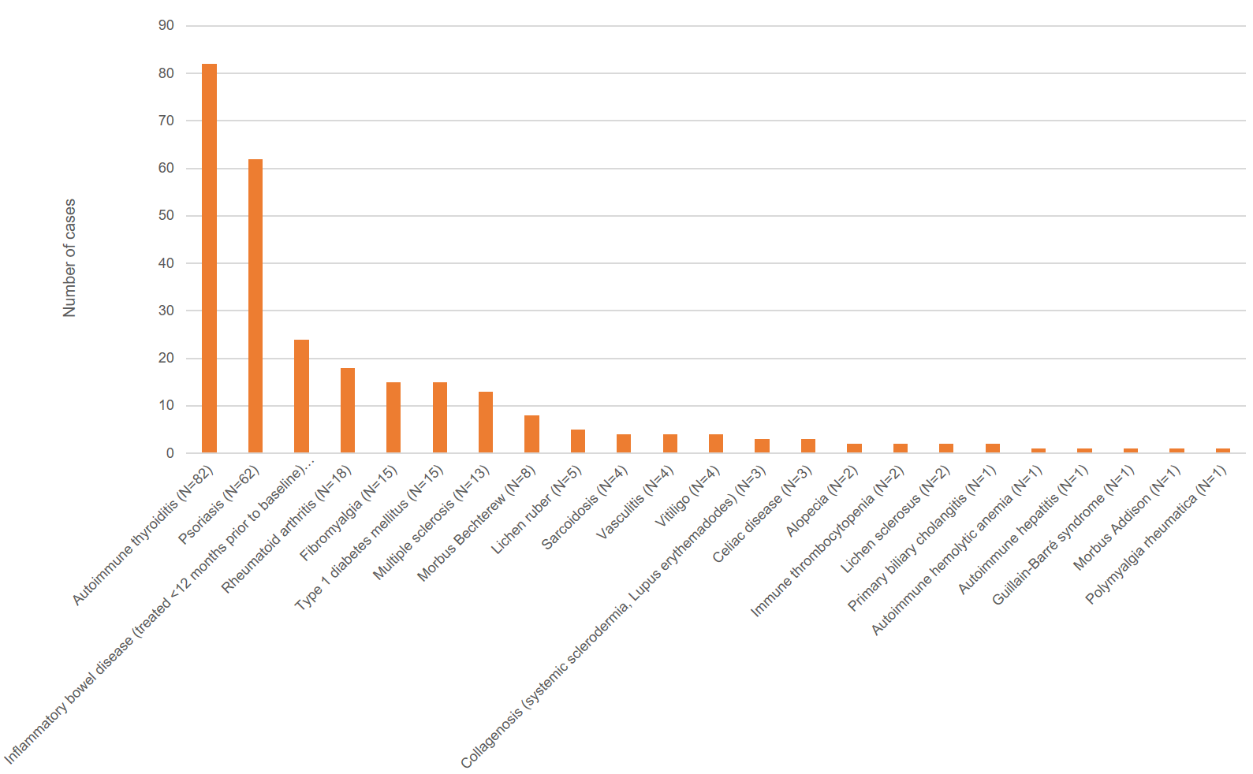

- Supplemental Figure S2. Study Flow.
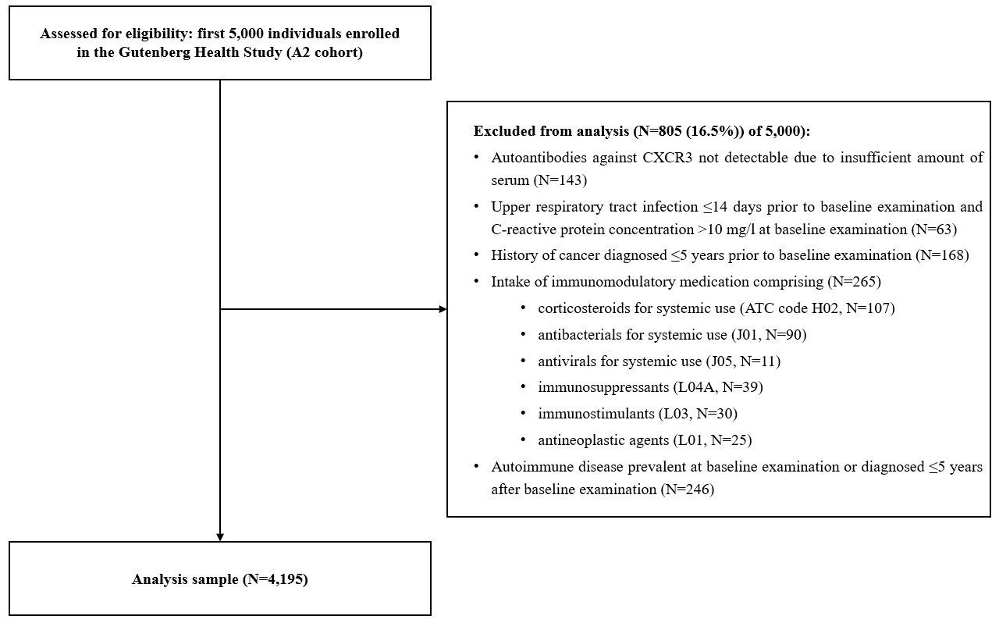

Supplemental Figure S3. Distribution of concentrations of anti-CXCR3-autoantibodies in the analysis sample.

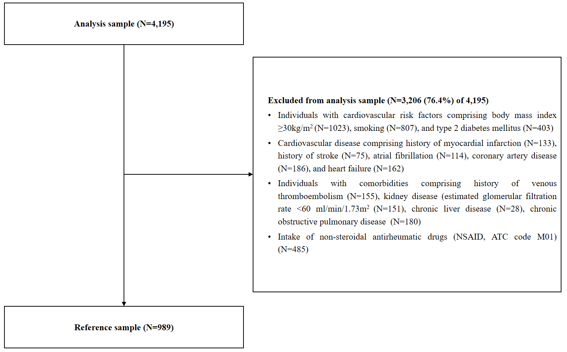
- Supplemental Figure S4. Derivation of the reference sample for anti-CXCR3-autoantantibody concentrations.
ATC denotes anatomical therapeutic chemical classification system.

- Supplemental Figure S5. Influence of medication on anti-CXCR3 autoantibody concentrations.
Presented are the results of multivariable regression analysis for log(anti-CXCR3 autoantibodies) as dependent variable and 4-digit ATC-coded medication classes (in parentheses) as independent variables. The top 20 medication classes according to level of statistical significance (p-value) are shown. Applying Bonferroni correction for multiple testing, no medication class met the Bonferroni threshold (p=0.00051). Abbreviations: β denotes β-estimate, 95% CI 95%-confidence interval.

- Supplemental Figure S6. Relationship of concentrations of anti-CXCR3 autoantibodies with all-cause mortality.
Cumulative incidence of all-cause death during a mean follow up of 12.9 years by quartiles of concentrations of anti-CXCR3 aAbs. Log-rank test was used to assess inter-group differences. Abbreviations: No denotes number.
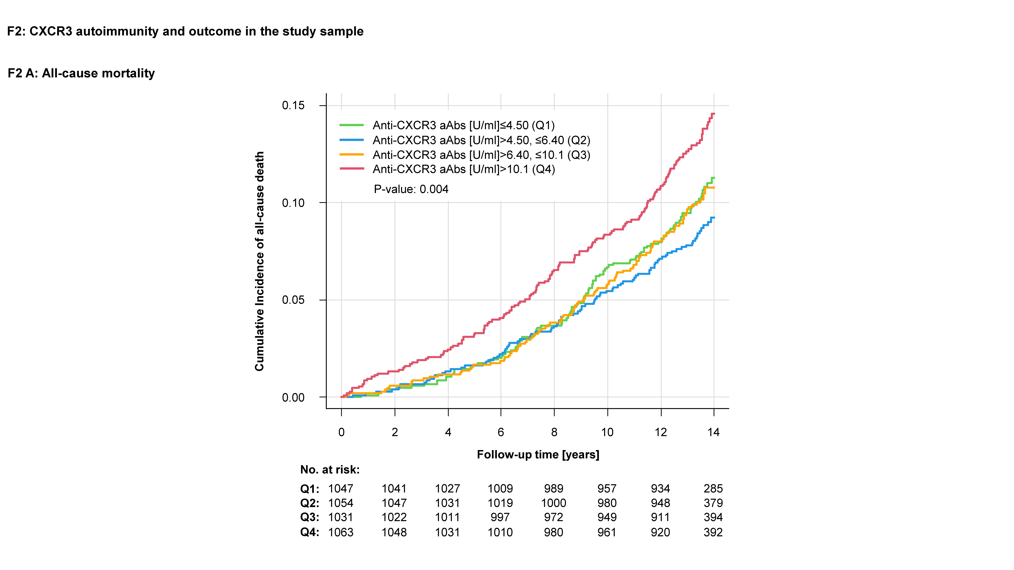

- Supplemental Figure S7. Relationship of concentrations of anti-CXCR3-autoantibodies with cardiac death and major adverse cardiac events.
Cumulative incidence of cardiac death during a mean follow up of 4.85 years (left bar) and MACE during a mean follow up of 4.79 years by quartiles of concentrations of anti-CXCR3 aAbs (right bar). Gray’s-test was used to assess inter-group differences. Abbreviations: MACE denotes major adverse cardiac events (comprising incident coronary artery disease, myocardial infarction, and cardiac death), No number.
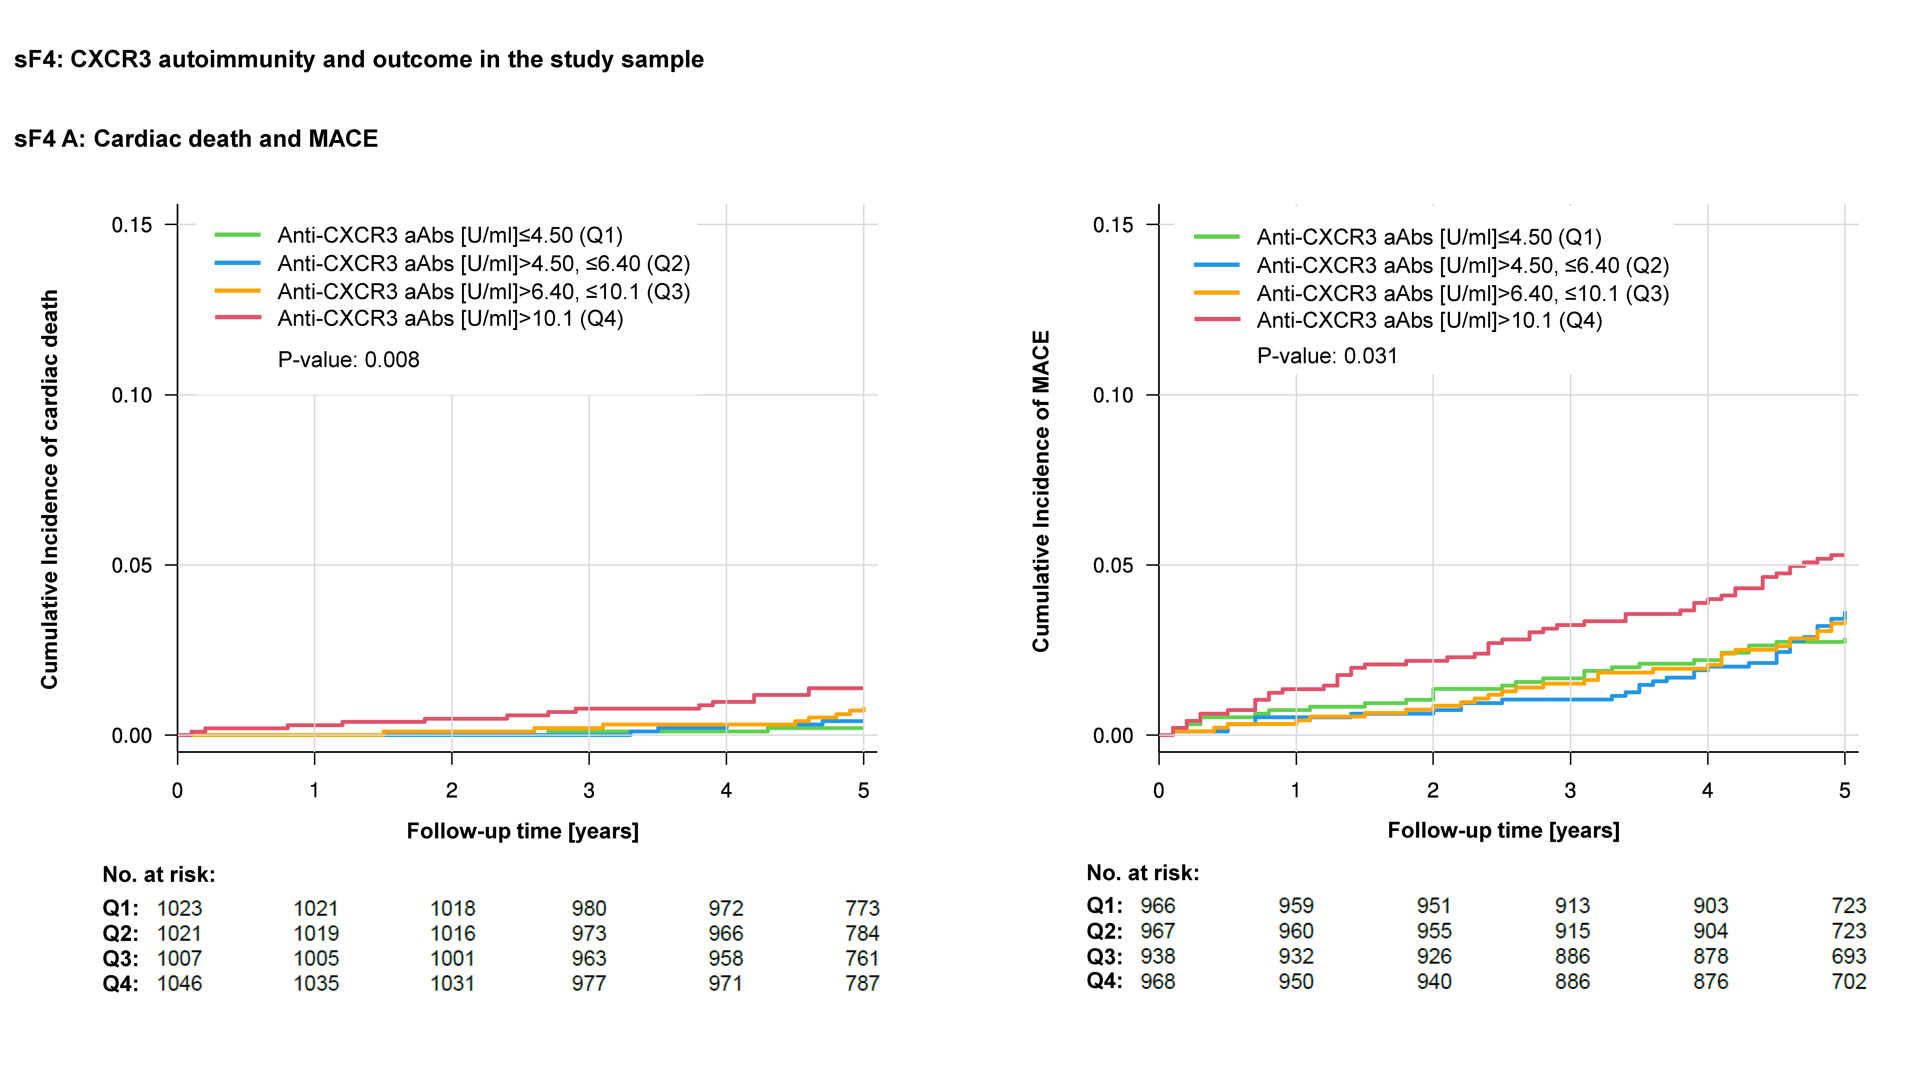

- Supplemental Figure S8. Relationship of concentrations of anti-CXCR3-autoantibodies with incident heart failure.
Cumulative incidence of heart failure during a mean follow up of 4.82 years by concentrations of anti-CXCR3-aAb above and below the 75th percentile (right bar) and by quartiles of concentrations of CXCR3 aAbs (left bar). Gray’s-test was used to assess inter-group differences. Abbreviations: No denotes number, pct percentile.
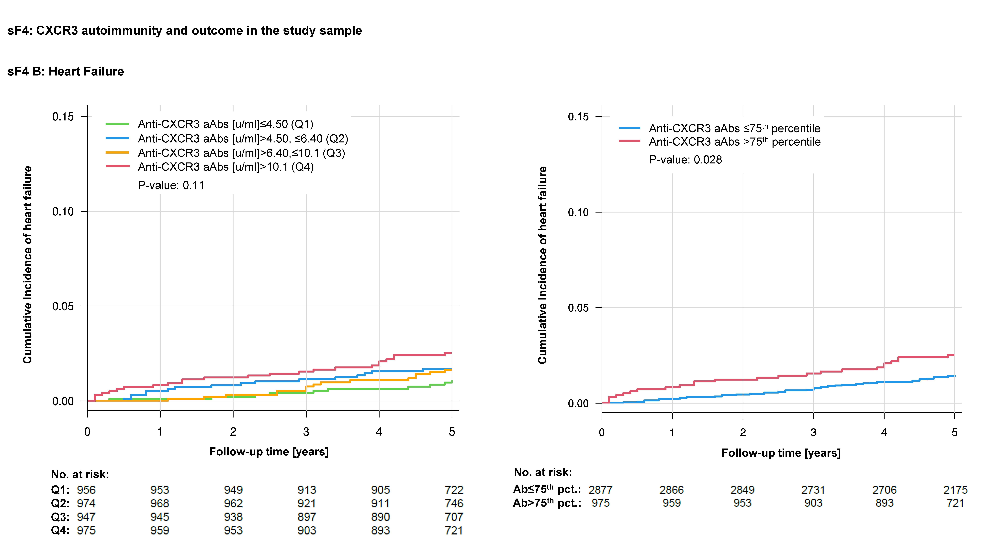

- Supplemental Figure S9: Association of log-transformed concentrations of anti-CXCR3 autoantibodies with clinical outcome
Depicted are results from spline regression models for log-transformed concentrations of anti-CXCR3 autoantibodies (aAbs) as independent variables and the outcome variables all-cause death (upper left), cardiac death (upper right), major adverse cardiac events (MACE, comprising incident myocardial infarction, coronary artery disease, or cardiac death, lower left), and heart failure (HF, lower right). Dotted red lines depict 95% confidence intervals, the vertical dotted blue line marks the 75th percentile of autoantibody concentrations. Further abbreviations: aAbs denotes autoantibodies, HR hazard ratio.
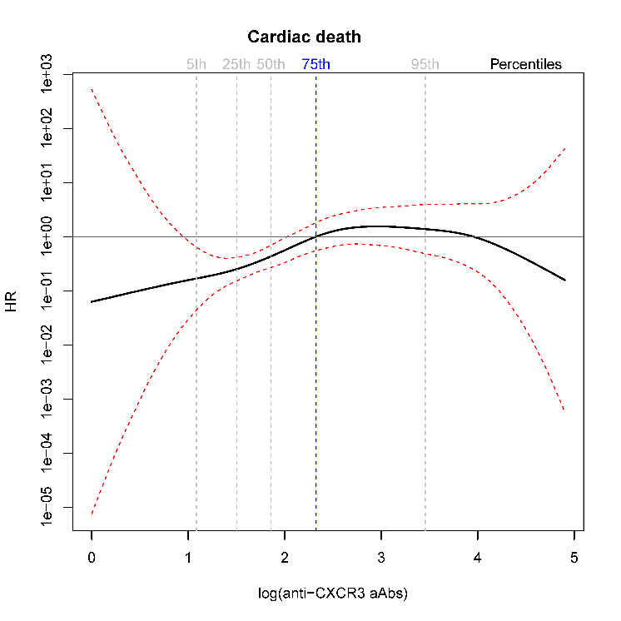
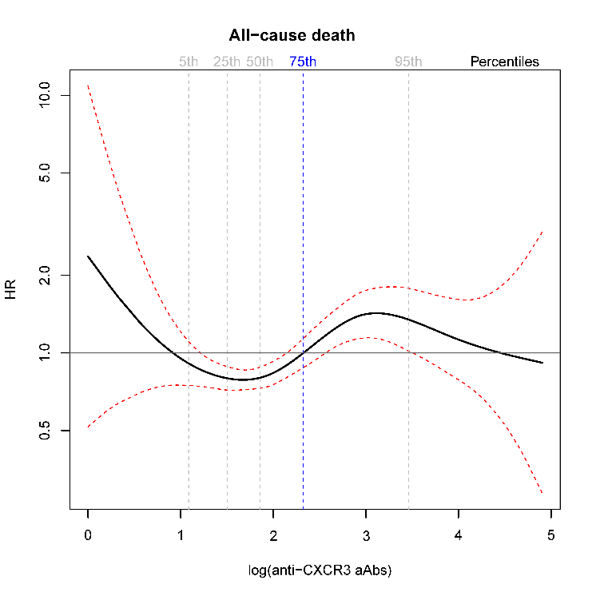
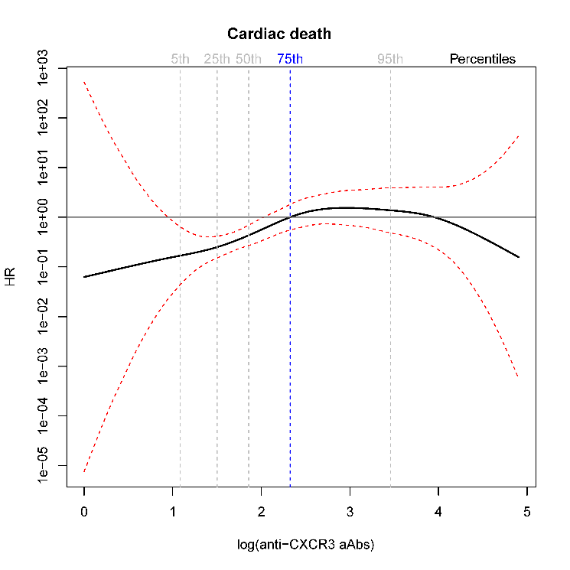
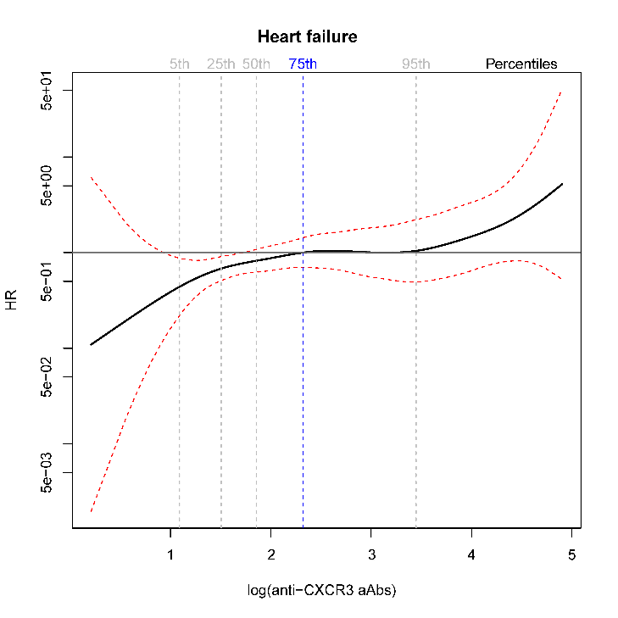
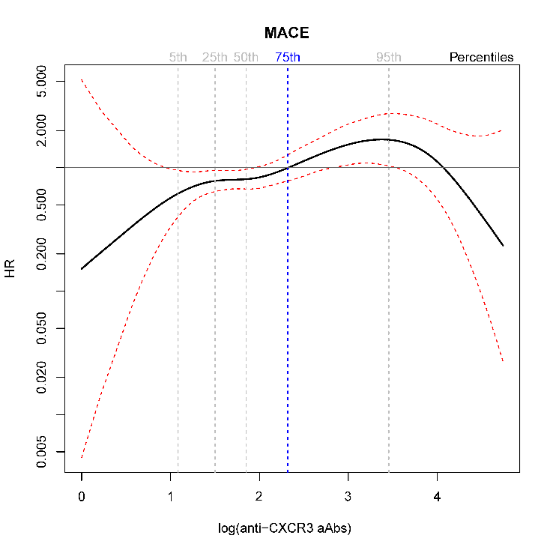

- Supplemental Figure S10: Association of anti-CXCR3 autoantibodies with CXCR3 ligands or modulators of CXCR3 activity.
Correlation matrix of log(anti-CXCR3 autoantibodies) with ligands as well as modulators of CXCR3 activity as measured with the Olink® inflammation panel. Numbers denote correlation coefficients with 95%-confidence interval, colors display strength of correlation, ranging from pale (weak positive) to strong red (strongly positive). Negative correlations are displayed in grey. Upwards striping reflects positive associations. On the diagonal, the distribution of each parameter is shown. Of note, all variables except anti-CXCR3 aAbs were measured with proximity extension assay technology, expressed as relative concentrations by normalized protein expression values.

- Supplemental Figure S11: Cross-sectional analysis of the aortic root in mice immunized against CXCR3 versus controls.
Cross-sectional analysis at the aortic root as determined by histological evaluation to assess plaque content and area and collagen content.
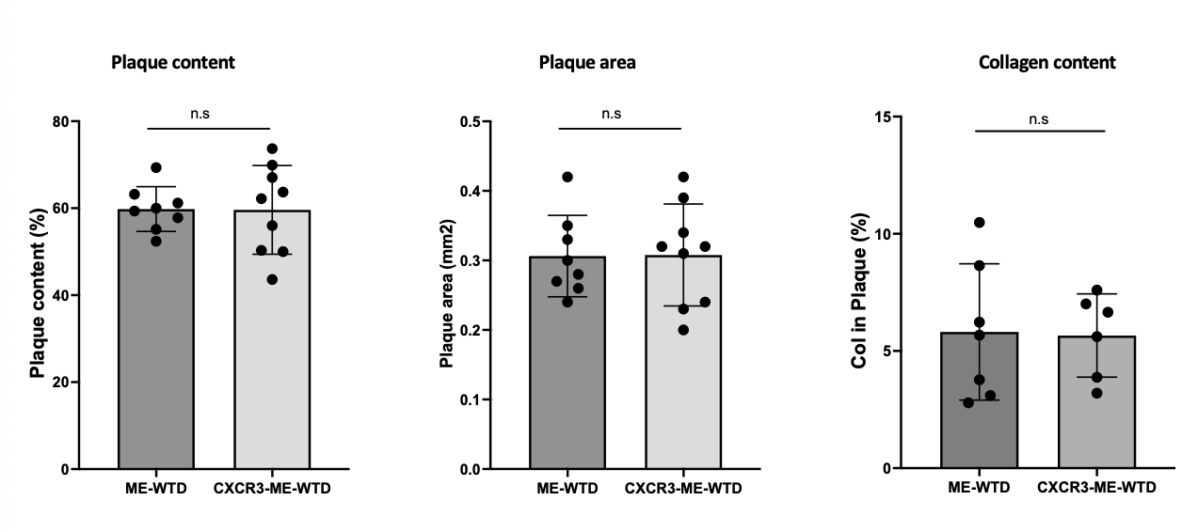
- Supplemental Figure S12: Concentrations of cholesterol and triglycerides according to diet and CXCR3 immunization status.
Total cholesterol concentrations in according to diet (left panel) and CXCR3 immunization status (middle panel) as well as triglyceride concentrations according to CXCR3 immunization status (right panel). Abbreviations: TC denotes total cholesterol, TG triglycerides.
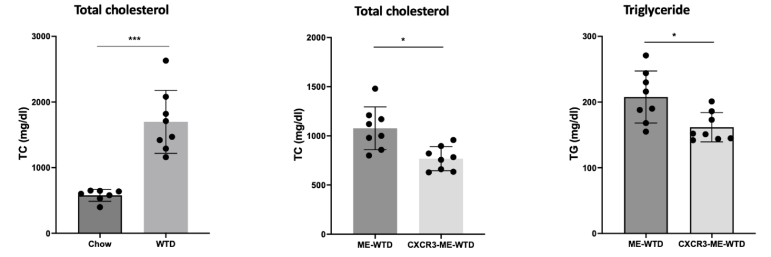
- Supplemental Figure S13: Granulocyte-to-lymphocyte ratio in mice immunized against CXCR3 versus controls.
Granulocyte-lymphocyte ratio in mice not immunized with CXCR3 (left, membrane extract [ME] + high fat diet [HFD]) versus immunized mice (right, p for difference <0.05).

- Supplemental Figure S14: Pulmonary expression of CXCR3 mRNA and lung infiltration according to CXCR3 immunization status.
Increased CXCR3 mRNA expression (A) as well as inflammation (B) in the lung of CXCR3 immunized mice versus mice immunized with the control (empty membrane extracts (ME). Further abbreviations: HFD denotes high-fat diet.

- Supplemental references

1. Lang RM, Badano LP, Mor-Avi V, Afilalo J, Armstrong A, Ernande L, et al. Recommendations for cardiac chamber quantification by echocardiography in adults: an update from the American Society of Echocardiography and the European Association of Cardiovascular Imaging. Eur Heart J Cardiovasc Imaging 2015;16:233-270. doi: 10.1093/ehjci/jev014
2. Achner L, Klersy T, Fels B, Reinberger T, Schmidt CX, Gross N, et al. AFM-based nanoindentation indicates an impaired cortical stiffness in the AAV-PCSK9(DY) atherosclerosis mouse model. Pflugers Arch 2022;474:993-1002. doi: 10.1007/s00424-022-02710-x
3. Segura-Puimedon M, Mergia E, Al-Hasani J, Aherrahrou R, Stoelting S, Kremer F, et al. Proatherosclerotic Effect of the alpha1-Subunit of Soluble Guanylyl Cyclase by Promoting Smooth Muscle Phenotypic Switching. Am J Pathol 2016;186:2220-2231. doi: 10.1016/j.ajpath.2016.04.010
4. Vedder VL, Aherrahrou Z, Erdmann J. Dare to Compare. Development of Atherosclerotic Lesions in Human, Mouse, and Zebrafish. Front Cardiovasc Med 2020;7:109. doi: 10.3389/fcvm.2020.00109
5. Zhou Y, Zhou B, Pache L, Chang M, Khodabakhshi AH, Tanaseichuk O, et al. Metascape provides a biologist-oriented resource for the analysis of systems-level datasets. Nat Commun 2019;10:1523. doi: 10.1038/s41467-019-09234-6
6. Shannon P, Markiel A, Ozier O, Baliga NS, Wang JT, Ramage D, et al. Cytoscape: a software environment for integrated models of biomolecular interaction networks. Genome Res 2003;13:2498-2504. doi: 10.1101/gr.1239303
7. Wild PS, Zeller T, Beutel M, Blettner M, Dugi KA, Lackner KJ, et al. [The Gutenberg Health Study]. Bundesgesundheitsblatt Gesundheitsforschung Gesundheitsschutz 2012;55:824-829. doi: 10.1007/s00103-012-1502-7
8. Mahmoud AD, Ballantyne MD, Miscianinov V, Pinel K, Hung J, Scanlon JP, et al. The Human-Specific and Smooth Muscle Cell-Enriched LncRNA SMILR Promotes Proliferation by Regulating Mitotic CENPF mRNA and Drives Cell-Cycle Progression Which Can Be Targeted to Limit Vascular Remodeling. Circ Res 2019;125:535-551. doi: 10.1161/CIRCRESAHA.119.314876
9. Doring Y, Manthey HD, Drechsler M, Lievens D, Megens RT, Soehnlein O, et al. Auto-antigenic protein-DNA complexes stimulate plasmacytoid dendritic cells to promote atherosclerosis. Circulation 2012;125:1673-1683. doi: 10.1161/CIRCULATIONAHA.111.046755
10. Angulo P, Hui JM, Marchesini G, Bugianesi E, George J, Farrell GC, et al. The NAFLD fibrosis score: a noninvasive system that identifies liver fibrosis in patients with NAFLD. Hepatology 2007;45:846-854. doi: 10.1002/hep.21496
11. Bedogni G, Bellentani S, Miglioli L, Masutti F, Passalacqua M, Castiglione A, et al. The Fatty Liver Index: a simple and accurate predictor of hepatic steatosis in the general population. BMC Gastroenterol 2006;6:33. doi: 10.1186/1471-230X-6-33

