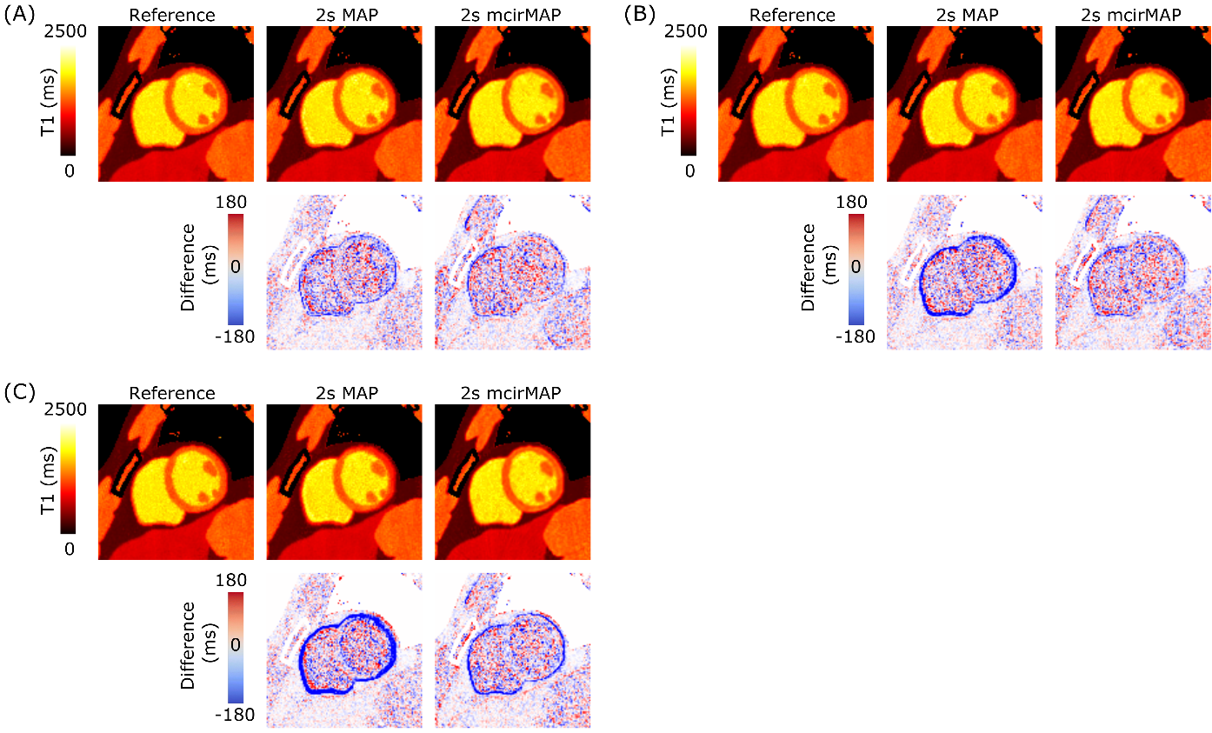

Supporting Figure S1: (A) Results of the numerical simulations for a heartrate of (A) 50 bpm, (B) 80 bpm and (C) 100 bpm, showing T1 maps estimated without motion (Reference), without 30% of systolic tune frames (2s MAP) and using the proposed motion-corrected MAP approach (2s mcirMAP) without 20% of systolic time frames. In addition, pixel-wise differences to the reference are shown.

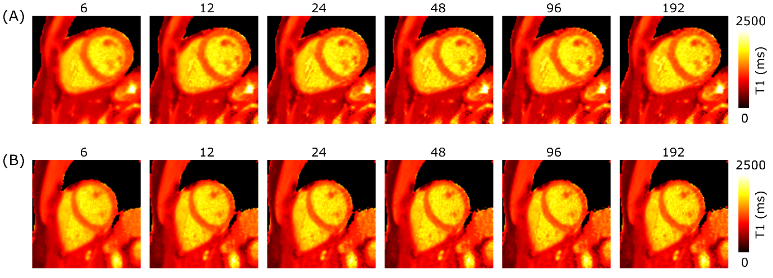

Supporting Figure S2: Proposed motion-corrected MAP reconstruction (2s mcirMAP) for different numbers of iterations, ranging from 6 to 192 for two volunteers (A) and (B). Blurring is visible for a low number of iterations (6). Higher numbers of iterations lead to an increase in noise. Here, 24 iterations were chosen, which led to robust reconstructions.

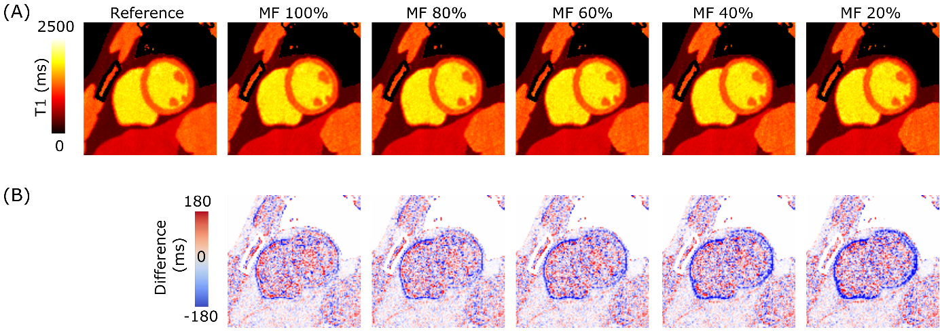

Supporting Figure S3: (A) Proposed motion-corrected MAP reconstruction (2s mcirMAP) for different scales of motion field amplitudes. 100% corresponds to the estimated motion amplitude. 20% corresponds to a motion field that was scaled by 0.2, describing an underestimation of the cardiac motion. (B) Difference images show increasing errors with decreasing motion amplitudes.

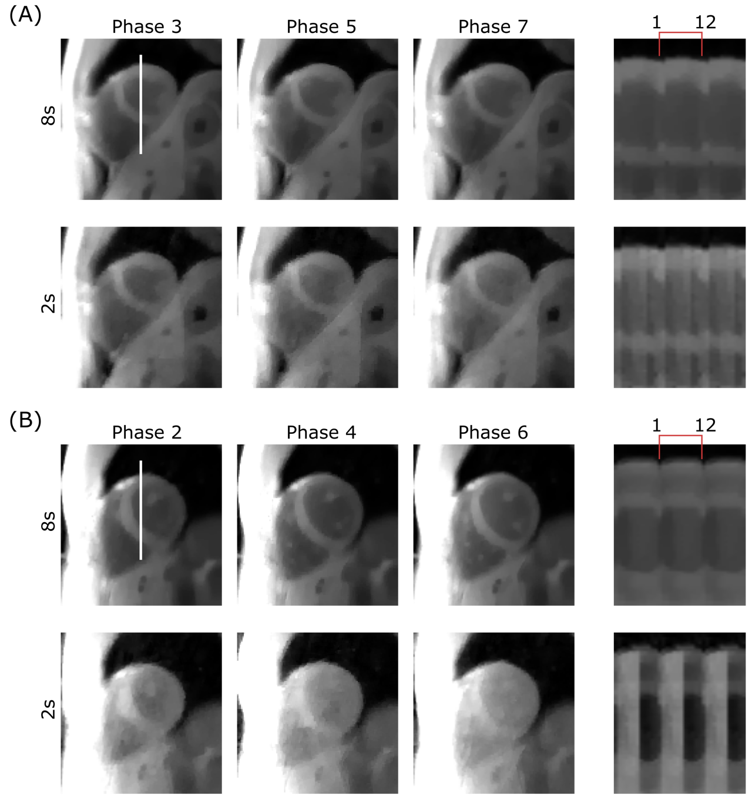

Supporting Figure S4: Cardiac motion resolved images reconstructed for two different subjects (A and B) using the approach described in [10]. For a total scan time of 8s, this approach yields motion-resolved images with stable contrast. Reducing the scan time to 2.3s leads to contrast variations between different cardiac phases and, in some cases, to a strongly reduced contrast between blood and myocardium which does not allow for accurate cardiac motion estimation. For better visualisation, the temporal profiles (indicated by the white line in Phase 3 and 2, respectively) are shown over three cardiac cycles. Each cardiac cycle is resolved with 12 images.

Vial number | IR-SE  Reference | 16s MAP | 2s MAP  80 bpm | 2s MAP  50 bpm
1 | 255 ± 5 | 280 ± 14 | 274 ± 11 | 274 ± 11
2 | 1900 ± 38 | 1978 ± 81 | 2000 ± 73 | 1981 ± 75
3 | 457 ± 5 | 489 ± 19 | 472 ± 21 | 474 ± 35
4 | 979 ± 18 | 982 ± 41 | 974 ± 16 | 972 ± 14
5 | 1447 ± 19 | 1443 ± 71 | 1449 ± 36 | 1454 ± 34
6 | 1220 ± 14 | 1215 ± 65 | 1213 ± 34 | 1212 ± 26
7 | 283 ± 7 | 307 ± 15 | 298 ± 11 | 300 ± 14
8 | 528 ± 5 | 558 ± 29 | 537 ± 13 | 543 ± 26
9 | 403± 6 | 421 ± 23 | 417 ± 15 | 417 ± 18

Supporting Information Table S1: T1 times in the phantom for the IR-SE reference, 16s MAP and 2s MAP for simulated heart rates of 50 bpm and 80 bpm. No significant differences were found between reference and 2s MAP for both heartrates. Values are shown as mean ± SD.

