- Supplementary data -
Grip strength values and cut-off points based on over 200,000 adults of the German National Cohort - a comparison to the EWGSOP2 cut-off points

Contents
Details regarding the study sample 2
Grip strength measurement 2
Description of the covariates 3
Statistical analysis 4
Supplementary Table S1: Grip strength stratified by age and sex in the NAKO sample 6
Supplementary Figure S1: Mean (± standard deviation) of grip strength across age in the NAKO sample 9
Supplementary Table S2: Characteristics of the study participants in the KORA-Age sample 10
Supplementary Figure S2: Prevalence of low grip strength based on the NAKO-derived and EWGSOP2 cut-off points stratified for age groups in the KORA-Age sample 11
Supplementary Table S3: T-scores based on data from the NAKO sample and resulting prevalence of low grip strength in the KORA-Age sample 12
Supplementary Figure S3: Density plot of grip strength in the KORA-Age sample 13
Supplementary Table S4: Hazard ratios for the association of grip strength (continuous variable) with all-cause mortality in the KORA-Age sample 14
Supplementary Table S5: Hazard ratios for the association of low grip strength with all-cause mortality in the KORA-Age sample 15
References 16

Details regarding the study sample
German National Cohort (NAKO)
The response proportion was 17 % for the whole NAKO sample (9 %–32 % for the individual study centers) [1]. To ensure standardized measurement procedures, examiners from all study centers were trained and certified before and during the study in joint sessions. Additionally, monitoring of examiners was conducted during the study in the individual study centers by internal and external quality control [2].
Cooperative Health Research in the Region of Augsburg (KORA)-Age
The KORA-Age participants were recruited from the group of participants born in 1943 or earlier that took part in one of the three Monitoring of Trends and Determinants in Cardiovascular Disease (MONICA) Augsburg studies S1, S2, and S3 conducted between 1984–1995 or the KORA S4 study conducted between 1999–2001 [3].

Grip strength measurement
NAKO
Details regarding grip strength measurements during the NAKO examinations including calibration and quality control have been reported before [4]. Briefly, the maximum isometric handgrip strength was measured using Jamar Plus+ hand dynamometer (Sammons Preston, Rolyon, Bolingbrook, IL, USA). Every study center used several devices of exactly the same device type. The manufacturer calibrated the hand dynamometers every two years. Additionally, the measurement accuracy was tested in the study centers using standard weights every six weeks. Data collection protocols were the same for all study centers. Influences of examiners and devices on results were tested frequently and in case of any irregularities, examiners received further training, while measurement devices were tested for measurement accuracy and if applicable calibrated or replaced. During handgrip measurement, participants were in seating position on a chair without armrests, placed their feet on the ground and remained their shoulders and forearm in neutral position, while the elbow was flexed approximately 90°. The hand dynamometer was set to the grip width 2 for all participants. The measurement was performed three times with each hand, alternating. Participants were excluded from performing the handgrip measurement if they had acute injury or operation at both hands or amputation or paralysis of both arms. For this article, we used the maximum grip strength value of all available measurements (both hands) if minimum two measurement values were available for at least one hand [4].

KORA-Age
In KORA-Age, the handgrip strength was measured with a Jamar dynamometer (SAEHAN Corporation, Masan, Korea). The maximum value of three measurements of the dominant hand with short breaks in between [5] was used for analysis. The dominant hand was identified as the hand that is used to cut with a scissor or to hold a knife cutting bread. The measurement was conducted in standing position (if impossible in upright seating position) and the participants were instructed to hold their upper arm against their body, while holding their elbow approximately 90° flexed. The handle of the dynamometer was adjusted to fit the hand of the participants.

Description of the covariates
Covariates for the cut-off point calculation with the NAKO data comprised sex (women / men) and age (years) at the examination date.
Covariates for the Cox regression analyses with KORA-Age data included age at reference date (December 31, 2008) (years), sex (women / men), physical activity scale for the elderly (PASE): total score, smoking (never / former / current), education (> 10 years / ≤ 10 years), body mass index (BMI) (kg/m²), estimated glomerular filtration rate (eGFR) (ml/min/1.73 m²), albumin (g/dl), lung disease (asthma, emphysema, COPD) (no / yes), cancer within the last three years (no / yes), diabetes mellitus (no / yes), heart problems or disease (e.g. angina, congestive heart disease, coronary heart disease, myocardial infarction, bypass, stent) (no / yes), and neurological disease (without stroke) (no / yes).
The continuous score PASE: total score was calculated based on the publication of Washburn et al. from 1993 [6] using interview questions regarding leisure, household, and work physical activities [7]. Smoking status was assessed based on interview questions. Smoking status “never” was defined as having smoked ≤ 100 cigarettes in life (yes or no question) and smoking status “former” as having smoked > 100 cigarettes in life and not smoking cigarettes currently. Smoking status “current” was defined as smoking regularly and occasionally [8]. For assessing the education, the highest level of vocational training and the highest level of school graduation were combined and assessed based on prior data from the studies S1, S2, S3, and S4 [8]. We categorized the variable education into > 10 years and ≤ 10 years.
Self-reported diseases (lung disease, cancer within the last three years, diabetes mellitus, heart problems or disease, and neurological disease) were assessed during a telephone interview in the KORA-Age study [8].
In KORA-Age, Albumin was measured in serum with modified bromocresol purple (BCP) dye-binding method using Dimension® Flex® reagent cartridge ALB (Siemens Healthcare Diagnostics Inc.). eGFR was calculated with serum creatinine according to Inker et al. (2012) [9]. Creatinine was measured in serum with modified kinetic Jaffe reaction using Dimension® Flex® reagent cartridge CREA (Siemens Healthcare Diagnostics Inc.).

Statistical analysis
Description of the selection of covariates in the KORA-Age sample
Covariates for Cox regression models were chosen based on stepwise backward model selection by Akaike information criterion (AIC) in a preliminary data set of 1,003 participants (smaller sample size compared to the final data set due to more exclusions based on missing values for any of the tested variables). The variables that were available for selection included: age, sex, PASE: total score, smoking, education, BMI, eGFR, albumin, lung disease, cancer within the last three years, diabetes mellitus, heart problems or disease, neurological disease without stroke (all chosen by the model selection with grip strength as a continuous variable and low grip strength defined by European Working Group on Sarcopenia in Older People (EWGSOP) 2 cut-off points and NAKO-derived cut-off points), nutrition score, number of medication without plant-based and homeopathic, high sensitivity C-reactive protein (mg/l) (transformed by natural logarithm), alcohol intake (0 g/day / men 0.1–39.9 g/day and women 0.1–19.9 g/day / men ≥ 40 g/day and women ≥ 20 g/day), arthritis or rheumatic disease or arthrosis (no / yes), and stroke (no / yes) (all not chosen by the model selection).
All continuous covariates were tested prior to the model selection individually for linear and non-linear association with all-cause mortality using Cox regression models adjusted for age and sex with the tested variables as a penalized spline term. To identify non-linearity of the associations, we used graphical representations of the Cox regression models and in a second step significance of the p-values for the linear and non-linear terms in the Cox regression models. If both (linear and non-linear) p-values were significant, we chose the term with the higher portion (lower p-value). Based on these analyses, only BMI showed a non-linear association with all-cause mortality. Therefore, the only covariate included as a penalized spline term for all following Cox regression models was BMI.
After testing for linear and non-linear association of all continuous covariates with all-cause mortality, we calculated the stepwise backward model selection by AIC to choose the covariates. We calculated three Cox regression models (function “coxph” of R package “survival” [10, 11]) with grip strength as a continuous variable or low grip strength defined by EWGSOP2 cut-off points or NAKO-derived cut-off points plus all variables available for selection including BMI as a penalized spline term with function “pspline” of R package “survival” [10, 11]. Number of degrees of freedom for the penalized spline term was chosen by AIC corrected with the method of Hurvich et al. [12]. A stepwise backward model selection by AIC was performed for each of the three models (with either of the three grip strength outcomes) using the “stepAIC” function from the R package “MASS” [13]. The variables listed in the section “Description of the covariates” are the covariates that were selected by this method for all three models.
R packages used in the statistical analysis
Figure 1: Percentile curves were created using the function “lms” from the R package “gamlss” [14]. For both graphs (men and women), the “BCTo” method with fitting method Rigby and Stasinopoulos algorithm was chosen by the “lms” function to fit the curves. The percentiles were plotted using the “centiles” function of the “gamlss” R package [14].
Table 2: We calculated the directly age-standardized prevalence of low grip strength with the R function “dsr” and the rate ratio of NAKO-derived to EWGSOP2 prevalence (EWGSOP2 as the reference) with the function “dsrr” of the R package “dsr” [15].
Figure 2: We calculated the Cox models with grip strength as a penalized spline term, stratified for sex and adjusted for BMI (penalized spline term) and all other covariates chosen by the model selection as described above. We therefore used the functions “coxph” and “pspline” of the R package “survival” [10, 11]. We used the function “dfmacox” of the R package “smoothHR” [16, 17] to calculate the number of degrees of freedom by AIC corrected with the method of Hurvich et al. [12]. The “dfmacox” function enabled the calculation of the optimal degrees of freedom for a model with multiple nonlinear covariate effects [16] (here: grip strength and BMI). The function “termplot” from the R package “stats” [18] was used to calculate the data from the Cox regression models for plotting. We centered the plot to the median of the grip strength (women: 22 kg, men: 36 kg) as the reference (hazard ratio = 1). Curves were plotted with the function “matplot” from the R package “graphics” [18].
Table 3: Time-dependent sensitivity and specificity of the EWGSOP2 and NAKO-derived cut-off points for the time points 3-year (1,095 days) and 6-year (2,190 days) survival were calculated using the R package “tdROC” [19] with the function “tdROC”. (The confidence intervals of sensitivity and specificity were calculated within the same function with 100x bootstrapping.) The differences (and corresponding confidence intervals) in sensitivity and specificity between the two cut-off points were calculated with the R package “DTComPair” [20] using the function “sesp.diff.ci”.
Supplementary Table S4 and S5: Cox proportional hazards regression models were calculated using the function “coxph” of the R package “survival” [10, 11]. BMI was included as a penalized spline term using the function “pspline” of the R package “survival” [10, 11]. To calculate the spline term’s number of degrees of freedom by AIC corrected with the method of Hurvich et al. [12], we used the “caic = T” specification within the “pspline” function.

Supplementary Table S1: Grip strength stratified by age and sex in the NAKO sample
Age | n | Grip strength (kg)
 |  | Percentiles
 |  | 5th | 10th | 25th | 50th | 75th | 90th | 95th | Mean (SD)
Men
19* | 3 | - | - | - | - | - | - | - | -
20 | 118 | 33.7 | 36.4 | 40.4 | 46.2 | 52.3 | 57.7 | 60.7 | 46.5 (8.5)
21 | 468 | 31.2 | 36.2 | 41.5 | 46.5 | 51.9 | 59.1 | 62.1 | 46.7 (9.2)
22 | 733 | 32.1 | 34.8 | 40.5 | 46.6 | 53.7 | 59.3 | 63.6 | 47.1 (9.7)
23 | 879 | 32.6 | 35.8 | 42.0 | 47.6 | 53.4 | 58.5 | 63.1 | 47.7 (9.1)
24 | 939 | 33.9 | 36.5 | 42.2 | 48.1 | 54.7 | 60.8 | 65.1 | 48.5 (9.5)
25 | 1,055 | 34.3 | 37.3 | 42.2 | 48.0 | 54.3 | 60.4 | 64.0 | 48.5 (9.2)
26 | 1,150 | 34.2 | 37.9 | 42.3 | 48.3 | 55.3 | 61.5 | 64.8 | 49.0 (9.5)
27 | 1,331 | 34.7 | 38.3 | 43.5 | 49.4 | 55.7 | 62.0 | 66.0 | 49.7 (9.4)
28 | 1,537 | 35.2 | 38.0 | 43.3 | 49.1 | 55.6 | 61.6 | 64.9 | 49.5 (9.4)
29 | 1,542 | 34.4 | 38.6 | 44.2 | 49.7 | 56.2 | 62.0 | 65.5 | 50.1 (9.4)
30 | 1,336 | 35.7 | 38.8 | 44.7 | 50.2 | 56.2 | 61.7 | 65.3 | 50.4 (9.0)
31 | 1,129 | 34.4 | 38.6 | 44.5 | 50.6 | 56.7 | 62.8 | 65.7 | 50.5 (9.5)
32 | 1,036 | 35.8 | 39.0 | 44.8 | 51.1 | 56.8 | 63.3 | 66.8 | 51.0 (9.6)
33 | 1,006 | 37.1 | 40.7 | 45.9 | 51.2 | 56.8 | 62.2 | 65.9 | 51.3 (9.0)
34 | 1,000 | 36.1 | 40.1 | 45.4 | 51.5 | 57.4 | 62.7 | 65.8 | 51.4 (9.2)
35 | 1,011 | 36.6 | 39.5 | 45.1 | 51.6 | 57.5 | 62.7 | 66.5 | 51.3 (9.2)
36 | 1,047 | 36.5 | 40.0 | 45.1 | 51.6 | 57.7 | 63.1 | 65.9 | 51.5 (9.2)
37 | 1,008 | 36.1 | 40.4 | 46.0 | 51.8 | 57.9 | 62.9 | 66.5 | 51.8 (9.1)
38 | 984 | 37.3 | 40.4 | 46.2 | 51.8 | 58.2 | 63.8 | 68.1 | 52.1 (9.2)
39 | 991 | 37.9 | 40.6 | 45.8 | 51.7 | 57.6 | 63.0 | 66.6 | 51.7 (8.9)
40 | 1,435 | 37.6 | 41.2 | 46.0 | 51.6 | 57.7 | 63.5 | 66.4 | 51.9 (8.9)
41 | 2,022 | 36.1 | 40.5 | 45.7 | 51.5 | 57.6 | 62.9 | 66.2 | 51.6 (9.1)
42 | 2,378 | 36.8 | 40.1 | 45.6 | 51.5 | 57.3 | 63.0 | 66.7 | 51.4 (9.2)
43 | 2,382 | 37.4 | 40.4 | 45.6 | 51.0 | 57.0 | 62.8 | 66.0 | 51.3 (8.8)
44 | 2,453 | 36.8 | 40.5 | 45.8 | 51.3 | 57.2 | 62.6 | 65.9 | 51.4 (9.0)
45 | 2,677 | 36.4 | 40.4 | 45.9 | 51.5 | 57.3 | 62.4 | 66.0 | 51.5 (9.0)
46 | 2,878 | 36.5 | 40.4 | 45.5 | 50.8 | 56.2 | 61.4 | 64.8 | 50.8 (8.7)
47 | 3,032 | 36.2 | 39.7 | 45.1 | 50.6 | 56.4 | 61.2 | 64.7 | 50.6 (8.7)
48 | 3,290 | 36.4 | 39.5 | 44.9 | 50.9 | 56.5 | 61.7 | 65.2 | 50.7 (8.7)
49 | 3,461 | 36.4 | 39.5 | 44.8 | 50.2 | 55.7 | 60.8 | 63.8 | 50.2 (8.6)
50 | 3,257 | 36.4 | 39.5 | 44.6 | 50.0 | 55.6 | 60.6 | 64.1 | 50.1 (8.6)
51 | 2,999 | 35.3 | 39.1 | 44.3 | 49.7 | 55.4 | 60.5 | 63.7 | 49.7 (8.6)
52 | 2,808 | 35.6 | 39.0 | 44.0 | 49.2 | 54.7 | 60.2 | 63.3 | 49.3 (8.6)
53 | 2,752 | 35.0 | 37.9 | 43.4 | 48.8 | 54.3 | 59.7 | 62.4 | 48.8 (8.5)
54 | 2,540 | 34.7 | 37.7 | 43.5 | 48.6 | 54.2 | 59.3 | 61.8 | 48.7 (8.5)
55 | 2,536 | 34.0 | 37.3 | 42.8 | 48.1 | 53.3 | 58.4 | 61.7 | 48.0 (8.5)
56 | 2,454 | 34.2 | 37.5 | 42.6 | 48.2 | 53.4 | 58.0 | 60.4 | 47.9 (8.2)
57 | 2,466 | 33.0 | 36.6 | 42.0 | 47.6 | 53.1 | 57.9 | 60.5 | 47.4 (8.5)
58 | 2,387 | 34.2 | 37.0 | 42.0 | 47.2 | 52.4 | 57.6 | 60.2 | 47.2 (8.2)
59 | 2,324 | 32.4 | 35.7 | 41.4 | 46.5 | 51.8 | 56.7 | 60.4 | 46.4 (8.4)
60 | 2,233 | 32.6 | 35.8 | 40.5 | 45.8 | 51.5 | 56.7 | 59.7 | 46.0 (8.3)
61 | 2,373 | 33.4 | 36.4 | 40.9 | 46.2 | 51.6 | 56.4 | 59.5 | 46.3 (8.2)
62 | 2,515 | 31.4 | 34.7 | 39.8 | 45.2 | 50.0 | 54.6 | 57.0 | 44.9 (8.0)
63 | 2,784 | 32.2 | 34.9 | 39.7 | 44.9 | 50.1 | 54.9 | 58.0 | 44.9 (8.0)
64 | 2,693 | 31.5 | 34.5 | 39.3 | 44.4 | 49.7 | 54.0 | 57.1 | 44.4 (7.8)
65 | 2,739 | 31.9 | 34.6 | 39.1 | 44.3 | 49.1 | 54.1 | 57.3 | 44.2 (7.9)
66 | 2,602 | 31.5 | 34.2 | 38.7 | 43.7 | 48.5 | 53.4 | 56.1 | 43.6 (7.6)
67 | 2,438 | 30.5 | 33.4 | 38.1 | 43.2 | 48.1 | 52.5 | 55.3 | 43.1 (7.7)
68 | 2,308 | 29.9 | 32.9 | 37.4 | 42.7 | 47.7 | 52.0 | 54.9 | 42.5 (7.7)
69 | 2,019 | 30.0 | 32.9 | 37.4 | 42.1 | 47.0 | 51.5 | 54.0 | 42.2 (7.3)
70 | 1,358 | 29.6 | 32.2 | 36.6 | 41.5 | 46.6 | 50.6 | 53.6 | 41.5 (7.4)
71 | 629 | 29.0 | 31.8 | 36.0 | 41.4 | 46.2 | 50.9 | 53.5 | 41.2 (7.5)
72 | 183 | 28.5 | 31.3 | 35.9 | 40.6 | 46.0 | 51.3 | 54.0 | 40.9 (7.7)
73* | 29 | - | - | - | - | - | - | - | -
74* | 9 | - | - | - | - | - | - | - | -
75* | 3 | - | - | - | - | - | - | - | -
Women
19* | 6 | - | - | - | - | - | - | - | -
20 | 126 | 18.8 | 21.1 | 24.3 | 28.8 | 33.1 | 37.0 | 39.2 | 29.0 (6.1)
21 | 466 | 20.8 | 23.3 | 26.7 | 29.8 | 33.5 | 37.2 | 39.4 | 30.1 (5.6)
22 | 862 | 21.2 | 23.4 | 26.6 | 30.4 | 34.3 | 37.7 | 40.0 | 30.4 (5.8)
23 | 1,008 | 22.2 | 23.5 | 27.1 | 30.8 | 34.0 | 37.5 | 39.6 | 30.6 (5.4)
24 | 1,008 | 21.0 | 23.4 | 27.2 | 30.7 | 34.2 | 37.6 | 39.5 | 30.6 (5.7)
25 | 1,174 | 22.0 | 24.0 | 27.3 | 31.0 | 34.5 | 38.2 | 40.8 | 31.1 (5.7)
26 | 1,186 | 21.7 | 24.4 | 27.6 | 30.9 | 34.7 | 38.6 | 40.9 | 31.1 (5.7)
27 | 1,379 | 22.1 | 24.4 | 27.4 | 30.7 | 34.7 | 38.3 | 40.5 | 31.0 (5.6)
28 | 1,421 | 22.1 | 24.1 | 27.5 | 31.0 | 34.8 | 38.5 | 40.7 | 31.2 (5.7)
29 | 1,352 | 22.3 | 24.3 | 27.4 | 31.3 | 35.1 | 38.4 | 40.6 | 31.3 (5.6)
30 | 1,301 | 22.2 | 24.4 | 28.1 | 31.5 | 35.5 | 39.1 | 41.2 | 31.6 (5.8)
31 | 1,105 | 22.6 | 24.6 | 27.8 | 31.7 | 35.2 | 38.5 | 40.4 | 31.5 (5.6)
32 | 1,051 | 22.2 | 24.5 | 28.0 | 31.8 | 35.5 | 38.8 | 41.0 | 31.7 (5.7)
33 | 1,043 | 23.1 | 25.4 | 28.5 | 32.0 | 35.8 | 39.2 | 41.8 | 32.2 (5.7)
34 | 1,072 | 22.5 | 25.0 | 28.3 | 32.3 | 36.2 | 39.5 | 42.2 | 32.3 (6.0)
35 | 1,105 | 22.3 | 24.6 | 28.3 | 32.3 | 35.9 | 38.9 | 40.4 | 32.0 (5.6)
36 | 1,024 | 22.7 | 24.9 | 28.4 | 32.2 | 35.8 | 39.4 | 41.5 | 32.2 (5.8)
37 | 1,045 | 23.3 | 25.4 | 28.8 | 32.6 | 36.0 | 39.7 | 41.9 | 32.5 (5.8)
38 | 1,012 | 23.3 | 25.3 | 28.8 | 32.6 | 36.3 | 39.9 | 41.6 | 32.5 (5.7)
39 | 1,014 | 23.3 | 25.2 | 28.8 | 32.5 | 36.3 | 39.7 | 41.8 | 32.5 (5.7)
40 | 1,393 | 23.2 | 25.4 | 28.8 | 32.2 | 36.0 | 39.6 | 41.8 | 32.5 (5.8)
41 | 1,777 | 23.1 | 25.2 | 28.4 | 32.2 | 36.3 | 39.7 | 41.4 | 32.3 (5.7)
42 | 2,249 | 23.0 | 25.3 | 28.5 | 32.3 | 36.1 | 39.8 | 42.0 | 32.4 (5.8)
43 | 2,450 | 23.2 | 25.3 | 28.7 | 32.5 | 36.0 | 39.4 | 41.6 | 32.4 (5.6)
44 | 2,566 | 23.1 | 25.3 | 28.6 | 32.3 | 36.1 | 39.6 | 41.5 | 32.3 (5.7)
45 | 2,638 | 23.2 | 25.4 | 28.6 | 32.2 | 35.9 | 39.4 | 41.6 | 32.3 (5.7)
46 | 2,991 | 22.5 | 24.7 | 28.4 | 32.0 | 35.6 | 39.1 | 41.2 | 32.0 (5.7)
47 | 3,180 | 22.9 | 25.0 | 28.4 | 31.9 | 35.4 | 39.0 | 41.1 | 31.9 (5.7)
48 | 3,370 | 22.4 | 24.6 | 28.2 | 31.9 | 35.6 | 39.0 | 41.0 | 31.8 (5.8)
49 | 3,527 | 22.7 | 24.9 | 28.1 | 31.6 | 35.2 | 38.6 | 40.8 | 31.7 (5.6)
50 | 3,251 | 22.1 | 24.1 | 27.6 | 31.3 | 35.0 | 38.3 | 40.8 | 31.3 (5.8)
51 | 2,944 | 21.6 | 23.6 | 27.5 | 31.0 | 34.7 | 37.9 | 40.0 | 31.0 (5.7)
52 | 2,848 | 21.4 | 23.4 | 27.2 | 30.6 | 34.3 | 37.5 | 39.7 | 30.6 (5.6)
53 | 2,986 | 20.8 | 23.2 | 26.7 | 30.3 | 33.7 | 37.0 | 39.1 | 30.1 (5.6)
54 | 2,717 | 20.7 | 22.8 | 26.2 | 29.9 | 33.4 | 36.6 | 38.8 | 29.8 (5.6)
55 | 2,731 | 20.9 | 22.9 | 26.3 | 29.7 | 33.1 | 36.2 | 38.0 | 29.6 (5.5)
56 | 2,513 | 21.0 | 23.2 | 26.3 | 29.5 | 32.7 | 35.9 | 37.8 | 29.4 (5.2)
57 | 2,505 | 20.5 | 22.6 | 26.0 | 29.3 | 32.5 | 35.8 | 37.8 | 29.2 (5.4)
58 | 2,352 | 20.6 | 22.6 | 25.7 | 28.9 | 32.3 | 35.4 | 37.3 | 28.9 (5.2)
59 | 2,300 | 20.4 | 22.3 | 25.4 | 28.9 | 32.3 | 35.4 | 37.2 | 28.9 (5.3)
60 | 2,332 | 20.0 | 22.0 | 25.2 | 28.5 | 31.9 | 35.1 | 37.0 | 28.5 (5.3)
61 | 2,470 | 19.9 | 22.0 | 25.1 | 28.2 | 31.6 | 34.4 | 36.5 | 28.2 (5.1)
62 | 2,586 | 19.9 | 21.7 | 24.7 | 28.0 | 31.2 | 34.2 | 35.9 | 27.9 (5.0)
63 | 2,792 | 19.8 | 21.8 | 24.7 | 27.8 | 31.1 | 34.3 | 36.4 | 27.9 (5.2)
64 | 2,784 | 19.8 | 21.5 | 24.3 | 27.7 | 30.9 | 33.9 | 35.6 | 27.6 (4.9)
65 | 2,725 | 19.3 | 21.3 | 24.1 | 27.4 | 30.4 | 33.4 | 35.2 | 27.3 (4.9)
66 | 2,580 | 18.8 | 20.8 | 23.9 | 26.9 | 30.1 | 33.1 | 35.2 | 27.0 (5.0)
67 | 2,446 | 19.2 | 20.9 | 23.8 | 27.1 | 30.1 | 32.8 | 34.8 | 26.9 (4.8)
68 | 2,175 | 18.3 | 20.4 | 23.2 | 26.4 | 29.7 | 32.4 | 34.1 | 26.4 (4.9)
69 | 1,704 | 18.4 | 20.2 | 23.1 | 26.1 | 29.1 | 32.3 | 33.8 | 26.1 (4.6)
70 | 1,231 | 18.2 | 19.8 | 23.2 | 26 | 28.9 | 31.4 | 33.0 | 25.9 (4.5)
71 | 574 | 18.3 | 20.1 | 22.7 | 25.5 | 28.8 | 31.2 | 33.3 | 25.6 (4.7)
72 | 172 | 18.4 | 19.4 | 21.8 | 24.9 | 28.0 | 30.6 | 32.3 | 25.0 (4.4)
73* | 19 | - | - | - | - | - | - | - | -
74* | 2 | - | - | - | - | - | - | - | -
Bold font indicates the highest mean of all ages.
* Not enough participants to calculate valid descriptive statistics.
n: number of participants, SD: standard deviation.

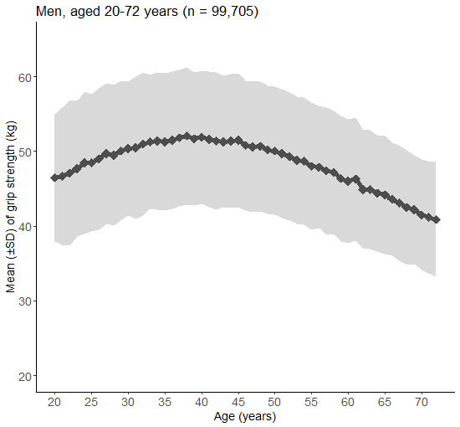
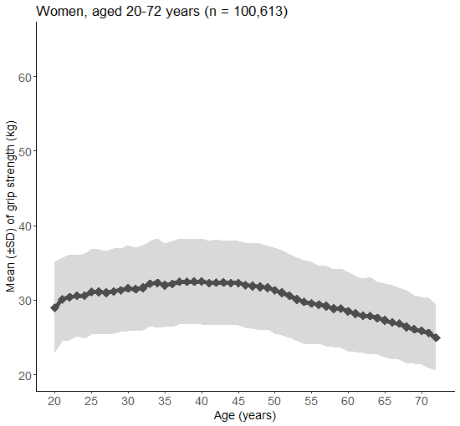

Supplementary Figure S1: Mean (± standard deviation) of grip strength across age in the NAKO sample
Dark grey line indicates the mean and surrounding light grey area indicates the standard deviation.
n: number of participants, SD: standard deviation.

Supplementary Table S2: Characteristics of the study participants in the KORA-Age sample
Characteristic | N = 1,012
Age (years) ª | 75.7 ± 6.5
Sex, n (%)
Female | 499 (49.3)
Male | 513 (50.7)
Physical activity scale for the elderly: total score ª | 117.9 ± 56.0
Smoking, n (%)
Never | 577 (57.0)
Former | 388 (38.3)
Current | 47 (4.6)
Education, n (%)
> 10 years | 372 (36.8)
≤ 10 years | 640 (63.2)
Body mass index (kg/m²) ª | 28.5 ± 4.3
eGFR (ml/min/1.73 m²) ª | 67.7 ± 17.2
Albumin (g/dl) ª | 3.8 ± 0.3
Lung disease (asthma, emphysema, COPD), n (%)
No | 907 (89.6)
Yes | 105 (10.4)
Cancer within the last three years, n (%)
No | 972 (96.0)
Yes | 40 (4.0)
Diabetes mellitus, n (%)
No | 834 (82.4)
Yes | 178 (17.6)
Heart problems or disease, n (%)
No | 700 (69.2)
Yes | 312 (30.8)
Neurological disease (without stroke), n (%)
No | 978 (96.6)
Yes | 34 (3.4)
Maximum grip strength (kg) ª | 28.3 ± 9.8
ª Continuous variables are listed as arithmetic mean ± standard deviation.
COPD: chronic obstructive pulmonary disease, eGFR: estimated glomerular filtration rate, n: number of participants.

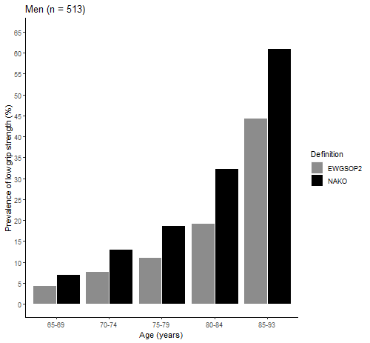
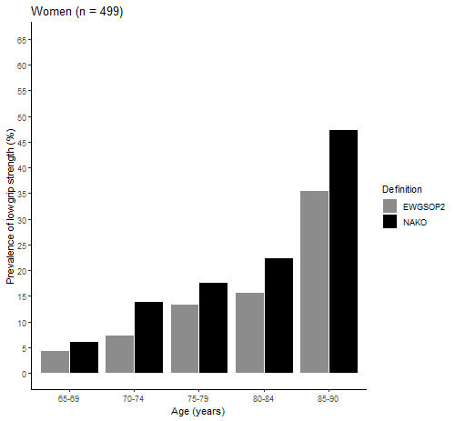

Supplementary Figure S2: Prevalence of low grip strength based on the NAKO-derived and EWGSOP2 cut-off points stratified for age groups in the KORA-Age sample
Low grip strength defined based on NAKO-derived cut-off points: < 29 kg for men and < 18 kg for women.
Low grip strength defined based on EWGSOP2 cut-off points: < 27 kg for men and < 16 kg for women [21].
EWGSOP2: European Working Group on Sarcopenia in Older People 2, n: number of participants, NAKO: German National Cohort.

Supplementary Table S3: T-scores based on data from the NAKO sample and resulting prevalence of low grip strength in the KORA-Age sample
T-score calculation | Men  (n = 513) |  | Women  (n = 499) |  | All  (n = 1,012)
 | T-score low grip strength (kg) | Prevalence of low grip strength (%) | T-score low grip strength (kg) | Prevalence of low grip strength (%) | Prevalence of low grip strength (%)
EWGSOP2 low grip strength cut-off points
peak mean - 2.5 x SD | 27 | 14.2 | 16 | 13.2 | 13.7
NAKO-derived low grip strength cut-off points
peak mean - 1 x SD | 43 | 83.0 | 27 | 85.2 | 84.1
peak mean - 1.5 x SD | 38 | 60.0 | 24 | 62.5 | 61.3
peak mean - 2 x SD | 34 | 40.7 | 21 | 45.3 | 43.0
peak mean - 2.5 x SD | 29 | 22.4 | 18 | 18.8 | 20.7
peak mean - 3 x SD | 25 | 9.4 | 15 | 12.8 | 11.1
EWGSOP2: European Working Group on Sarcopenia in Older People 2, n: number of participants, NAKO: German National Cohort.

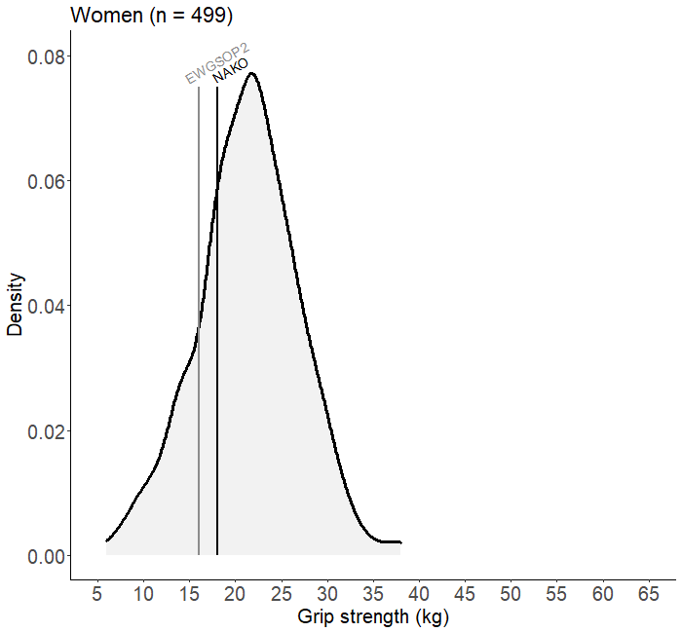
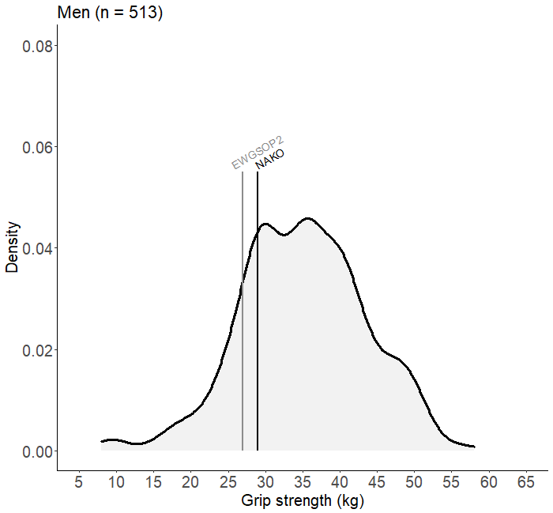

Supplementary Figure S3: Density plot of grip strength in the KORA-Age sample
Grey vertical line shows the cut-off point of the EWGSOP2 sarcopenia definition for low grip strength (men: 27 kg and women: 16 kg [21]) and black vertical line represents the cut-off point for low grip strength calculated based on the NAKO data (men: 29 kg and women: 18 kg).
EWGSOP2: European Working Group on Sarcopenia in Older People 2, n: number of participants, NAKO: German National Cohort.

Supplementary Table S4: Hazard ratios for the association of grip strength (continuous variable) with all-cause mortality in the KORA-Age sample
 | HR (95 % CI)
Men (n = 513)
Model 1 | 0.93 (0.91, 0.95)
Model 2 | 0.95 (0.93, 0.98)
Model 3 | 0.96 (0.94, 0.99)
Model 4 | 0.97 (0.94, 0.99)
Women (n = 499)
Model 1 | 0.89 (0.86, 0.93)
Model 2 | 0.95 (0.91, 0.99)
Model 3 | 0.95 (0.90, 0.99)
Model 4 | 0.96 (0.92, 1.01)
HRs are shown for a 1-kg increase in grip strength.
Model adjustments:
Model 1: crude model
Model 2: age
Model 3: model 2 + physical activity scale for the elderly: total score, smoking, education, and body mass index (as penalized spline term)
Model 4: model 3 + estimated glomerular filtration rate, albumin, lung disease (asthma, emphysema, COPD), cancer within the last three years, diabetes mellitus, heart problems or disease, and neurological disease (without stroke)
CI: confidence interval, COPD: chronic obstructive pulmonary disease, HR: hazard ratio, n: number of participants.

Supplementary Table S5: Hazard ratios for the association of low grip strength with all-cause mortality in the KORA-Age sample
 | EWGSOP2  low grip strength cut-off points | NAKO-derived  low grip strength cut-off points
 | HR (95 % CI) | HR (95 % CI)
All (n = 1,012)
Model 1 | 3.07 (2.31, 4.08) | 3.33 (2.56, 4.33)
Model 2 | 1.85 (1.37, 2.50) | 2.03 (1.53, 2.68)
Model 3 | 1.65 (1.22, 2.24) | 1.85 (1.40, 2.45)
Model 4 | 1.40 (1.02, 1.92) | 1.72 (1.29, 2.30)
Men (n = 513)
Model 1 | 3.05 (2.11, 4.40) | 3.24 (2.31, 4.53)
Model 2 | 1.96 (1.33, 2.88) | 2.10 (1.47, 3.00)
Model 3 | 1.67 (1.13, 2.49) | 1.86 (1.29, 2.67)
Model 4 | 1.64 (1.08, 2.47) | 1.93 (1.32, 2.82)
Women (n = 499)
Model 1 | 3.06 (1.94, 4.83) | 3.32 (2.18, 5.06)
Model 2 | 1.63 (1.01, 2.64) | 1.86 (1.19, 2.91)
Model 3 | 1.76 (1.08, 2.88) | 2.02 (1.28, 3.18)
Model 4 | 1.44 (0.86, 2.41) | 1.87 (1.17, 3.02)
Model adjustments:
Model 1: crude model
Model 2: sex (only in the models with all participants), age
Model 3: model 2 + physical activity scale for the elderly: total score, smoking, education, and body mass index (as penalized spline term)
Model 4: model 3 + estimated glomerular filtration rate, albumin, lung disease (asthma, emphysema, COPD), cancer within the last three years, diabetes mellitus, heart problems or disease, and neurological disease (without stroke)
CI: confidence interval, COPD: chronic obstructive pulmonary disease, EWGSOP2: European Working Group on Sarcopenia in Older People 2, HR: hazard ratio, n: number of participants, NAKO: German National Cohort.

References
1. Peters A, Greiser KH, Göttlicher S et al. Framework and baseline examination of the German National Cohort (NAKO). Eur J Epidemiol 2022; 37: 1107–1124. https://doi.org/10.1007/s10654-022-00890-5
2. Schipf S, Schöne G, Schmidt B et al. The baseline assessment of the German National Cohort (NAKO Gesundheitsstudie): participation in the examination modules, quality assurance, and the use of secondary data (German). Bundesgesundheitsbl 2020; 63: 254-66. https://doi.org/10.1007/s00103-020-03093-z.
3. Peters A, Döring A, Ladwig KH et al. Multimorbidity and successful aging (German). Z Gerontol Geriatr 2011; 44: 41-54. https://doi.org/10.1007/s00391-011-0245-7.
4. Kluttig A, Zschocke J, Haerting J et al. Measuring physical fitness in the German National Cohort—methods, quality assurance, and first descriptive results (German). Bundesgesundheitsbl 2020; 63: 312-21. https://doi.org/10.1007/s00103-020-03100-3.
5. Arvandi M, Strasser B, Meisinger C et al. Gender differences in the association between grip strength and mortality in older adults: results from the KORA-age study. BMC Geriatr 2016; 16: 1-8. https://doi.org/10.1186/s12877-016-0381-4.
6. Washburn RA, Smith KW, Jette AM, Janney CA. The Physical Activity Scale for the Elderly (PASE): development and evaluation. J Clin Epidemiol 1993; 46: 153-62. https://doi.org/10.1016/0895-4356(93)90053-4.
7. Autenrieth CS, Kirchberger I, Heier M et al. Physical activity is inversely associated with multimorbidity in elderly men: results from the KORA-Age Augsburg Study. Prev Med 2013; 57: 17-9. http://dx.doi.org/10.1016/j.ypmed.2013.02.014.
8. Strobl R, Müller M, Emeny R, Peters A, Grill E. Distribution and determinants of functioning and disability in aged adults - results from the German KORA-Age study. BMC Public Health 2013; 13: 137. https://doi.org/10.1186/1471-2458-13-137.
9. Inker LA, Schmid CH, Tighiouart H et al. Estimating glomerular filtration rate from serum creatinine and cystatin C. N Engl J Med 2012; 367: 20-9. https://dx.doi.org/10.1056%2FNEJMoa1114248.
10. Therneau TM. A Package for Survival Analysis in R. R package version 3.2-11. 2021. https://CRAN.R-project.org/package=survival.
11. Therneau TM, Grambsch PM. Modeling Survival Data: Extending the Cox Model. New York: Springer, 2000. ISBN 0-387-98784-3.
12. Hurvich CM, Simonoff JS, Tsai C-L. Smoothing parameter selection in nonparametric regression using an improved Akaike information criterion. J R Stat Soc Series B Stat Methodol 1998; 60: 271–93. https://doi.org/10.1111/1467-9868.00125.
13. Venables WN, Ripley BD. Modern Applied Statistics with S. Fourth Edition. New York: Springer, 2002. ISBN 0-387-95457-0. https://www.stats.ox.ac.uk/pub/MASS4/.
14. Rigby RA, Stasinopoulos DM. Generalized additive models for location, scale and shape. Appl Statist 2005; 54: 507-54. https://doi.org/10.1111/j.1467-9876.2005.00510.x.
15. Kumar M. dsr: Compute Directly Standardized Rates, Ratios and Differences. R package version 0.2.2. 2019. https://CRAN.R-project.org/package=dsr.
16. Meira-Machado L, Cadarso-Suárez C, Gude F, Araújo A. smoothHR: An R Package for Pointwise Nonparametric Estimation of Hazard Ratio Curves of Continuous Predictors. Comput Math Methods Med 2013; 2013: 745742. https://doi.org/10.1155/2013/745742.
17. Araújo A, Meira-Machado L. smoothHR: Smooth Hazard Ratio Curves Taking a Reference Value. R package version 1.0.3. 2021. https://CRAN.R-project.org/package=smoothHR.
18. R Core Team; R: A language and environment for statistical computing. R Foundation for Statistical Computing, Vienna, Austria. 2021. https://www.R-project.org/.
19. Li L, Wu C. tdROC: nonparametric estimation of time-dependent ROC curve from right censored survival data. R package version 1.0. 2016. https://CRAN.R-project.org/package=tdROC.
20. Stock C, Hielscher T. DTComPair: comparison of binary diagnostic tests in a paired study design. R package version 1.0.3. 2014. http://CRAN.R-project.org/package=DTComPair.
21. Cruz-Jentoft AJ, Bahat G, Bauer J et al. Sarcopenia: revised European consensus on definition and diagnosis. Age Ageing 2019; 48: 16-31. https://doi.org/10.1093/ageing/afy169.

