Supplemental Material to
Epidemiological, genetic and clinical characterization of newly diagnosed acute myeloid leukemia based on an academic population-based registry study (AMLSG BiO)
Nagel G¹, Weber D², Fromm E¹, Erhardt S¹, Lübbert M³, Fiedler W⁴, Kindler T⁵, Krauter J⁶, Brossart P⁷, Kündgen A⁸, Salih HR⁹, Westermann J¹⁰, Wulf G¹¹, Hertenstein B¹², Wattad M¹³, Götze K¹⁴, Kraemer D¹⁵, Fischer T¹⁶, Girschikofsky M¹⁷, Derigs HG¹⁸, Horst HA¹⁹, Rudolph C², Heuser M²⁰, Göhring G²¹, Teleanu V², Bullinger L², Thol F²⁰, Gaidzik VI², Paschka P², Döhner K², Ganser A²⁰, Döhner H², Schlenk RF^{2,22}, German-Austrian AML Study Group (AMLSG)

Supplemental Figure 1: Recruitment in the AMLSG BiO registry in Austria (N= 270)*

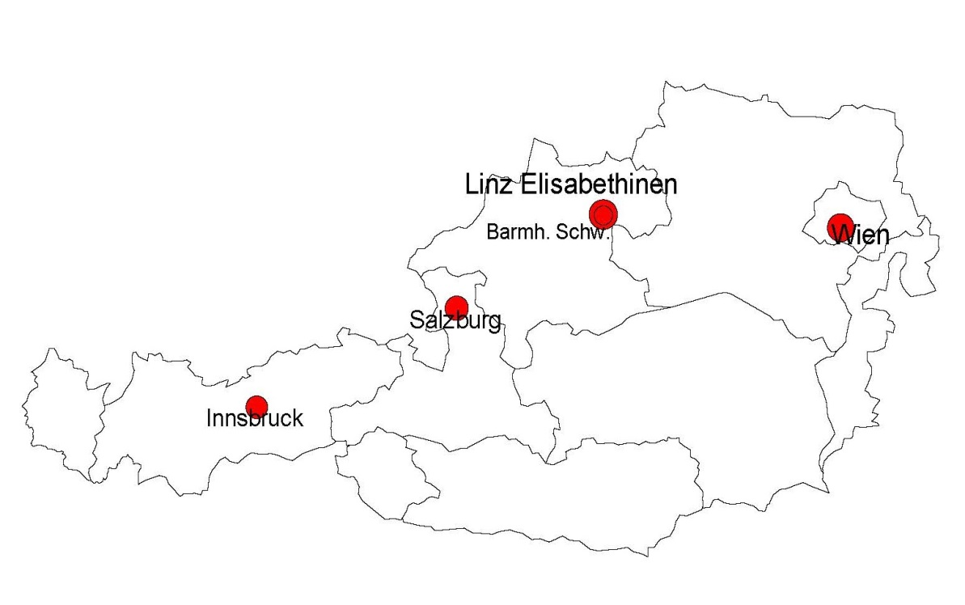
*Size of the dots corresponds to the number of reported cases of AML

Supplemental Figure 2: Recruitment in the AMLSG BiO registry in Germany (N=3,251)

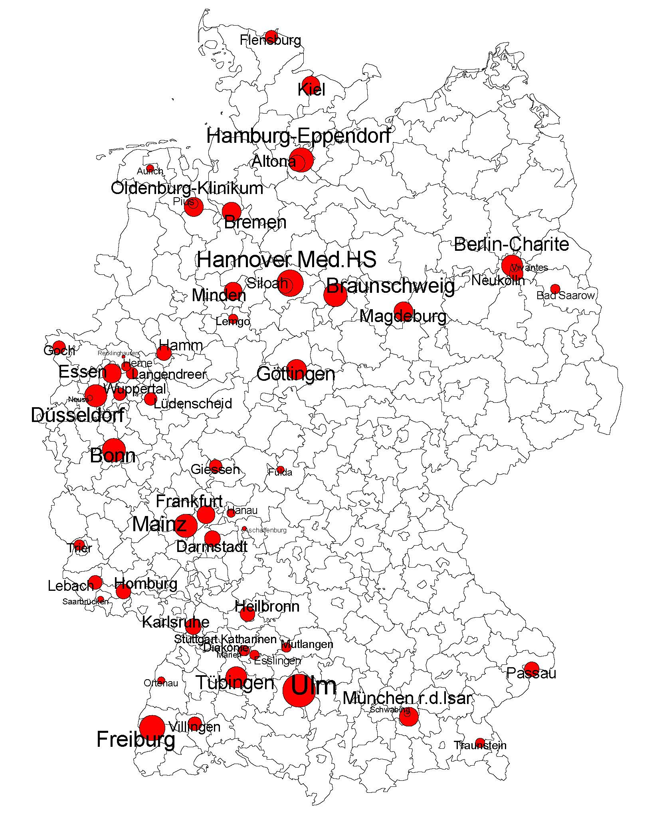
*Size of the dots corresponds to the number of reported cases of AML

Supplemental Table 1: Study population AMLSG BiO registry 2012-2014 in the multivariate model
Covariate |  |  | Total  N=2,336 | Men  N=1,273 | Women  N=1,063
 |  |  | Median (Q1;Q3) | Median (Q1;Q3) | Median (Q1;Q3)
Age (years) |  |  | 66 (55;74) | 68 (57;74) | 65 (53;74)
BMI (kg/m²) |  |  | 26 (23;29) | 26 (24;29) | 25 (23;29)
 |  |  | N (%) | N (%) | N (%)
Age classes (years) | < 59 |  | 770 (32.96) | 372 (48.31) | 398 (51.69)
60 - 69 |  |  | 608 (26.03) | 349 (57.40) | 259 (42.60)
≥70 |  |  | 958 (41.01) | 552 (57.62) | 406 (42.38)
Prevalence of FLT3-ITD |  |  | 457 (19.56) | 200 (43.76) | 257 (56.24)
Prevalence of FLT3-TKD mutation |  |  | 138 (5.91) | 72 (52.17) | 66 (47.83)
Prevalence of NPM1 mutation |  |  | 650 (27.83) | 287 (44.15) | 363 (55.85)
Prevalence of CEBPA mutation |  |  | 136 (5.83) | 70 (51.47) | 66 (48.53)
2010 ELN classification |  | Favorable | 479 (20.51) | 250 (52.19) | 229 (47.81)
 |  | Intermediate-1 | 722 (30.91) | 393 (54.43) | 329 (45.57)
 |  | Intermediate-2 | 652 (27.91) | 361 (55.37) | 291 (44.63)
 |  | Adverse | 483 (20.68) | 269 (55.69) | 214 (44.31)
HCT-Comorbidity index |  | 0 | 920 (39.38) | 480 (52.17) | 440 (47.83)
 |  | 1-2 | 787 (33.69) | 425 (54.00) | 362 (46.00)
 |  | ≥ 3 | 629 (26.93) | 368 (58.51) | 261 (41.49)
ECOG |  | 0-1 | 1,957 (83.78) | 1,060 (54.16) | 897 (45.84)
 |  | 2-4 | 379 (16.22) | 213 (56.20) | 166 (43.80)
Therapy |  | Intensive | 1,663 (71.19) | 888 (53.40) | 775 (46.60)
 |  | BSC | 211 (9.03) | 124 (58.77) | 87 (41.23)
 |  | Non-intensive* | 462 (19.78) | 261 (56.49) | 201 (43.51)
Abbreviations: BMI, body mass index; BSC, best supportive care; ECOG, Eastern Cooperative Oncology Group performance status; ELN, European LeukemiaNet ; HCT, Hematopoietic cell transplantation; N, number of patients; Q, quartile.
*Including azacitidine, decitabine, and low-dose cytarabine

Supplemental Figure 3: Frequency of NPM1 mutation by age groups

