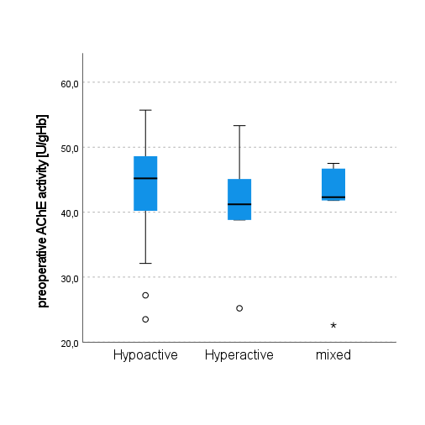
Additional Figure 1: Preoperative AChE activity regarding POD subtypes.
Differences were calculated using the Kruskal-Wallis-Test.
AChE – acetylcholine esterase, POD – postoperative delirium

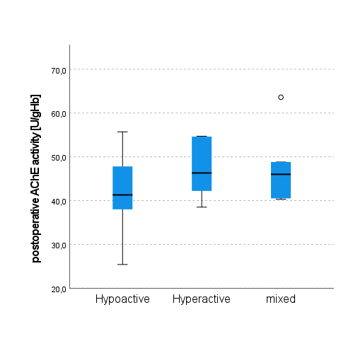
Additional Figure 2: Postoperative AChE activity regarding POD subtypes.
Differences were calculated using the Kruskal-Wallis-Test.
AChE – acetylcholine esterase, POD – postoperative delirium
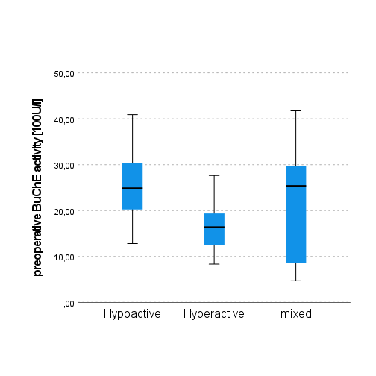
Additional Figure 3: Preoperative BuChE activity regarding POD subtypes.
Differences were calculated using the Kruskal-Wallis-Test.
BuChE – butyrylcholine esterase, POD – postoperative delirium
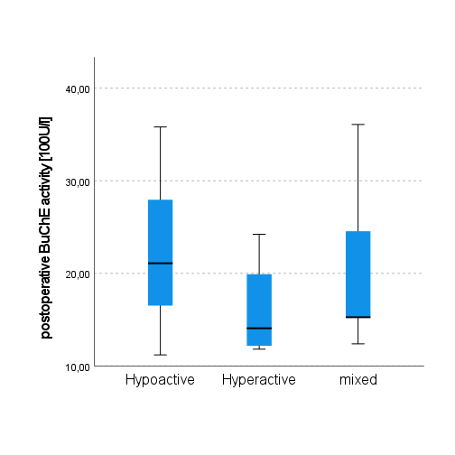
Additional Figure 4: Postoperative BuChE activity regarding POD subtypes.
Differences were calculated using the Kruskal-Wallis-Test.
BuChE – butyrylcholine esterase, POD – postoperative delirium

