SUPPLEMENTARY MATERIAL
Supplemental Table 1
Mean arterial blood pressure (mmHg; mean±SEM)
Intervention | baseline | end of observation period | n
Aortic occlusion | 81±3 | 84±4 | 13
Venous occlusion | 83±4 | 79±4 | 12
Combined occlusion | 80±4 | 87±4 | 10
Hypoxaemia | 85±5 | 79±5 | 11
X-ray CM Iodixanol | 87±6 | 91±6 | 8
Furosemide | 89±4 | 90±4 | 5

Figures S1 – S6 correspond to Figures 1 – 6 in the manuscript showing the time courses obtained upon the six interventions (green area). Figures S1 – S6 depict the individual rats’ time courses and, by the thick black lines, their mean time course (which is also shown together with the SEM in in Figures 1 – 6 in the manuscript). Data are given as percentage changes related to the respective baseline values. Left panels depict data obtained by T₂ mapping, right panels data obtained by T₂* mapping.

Figure S1

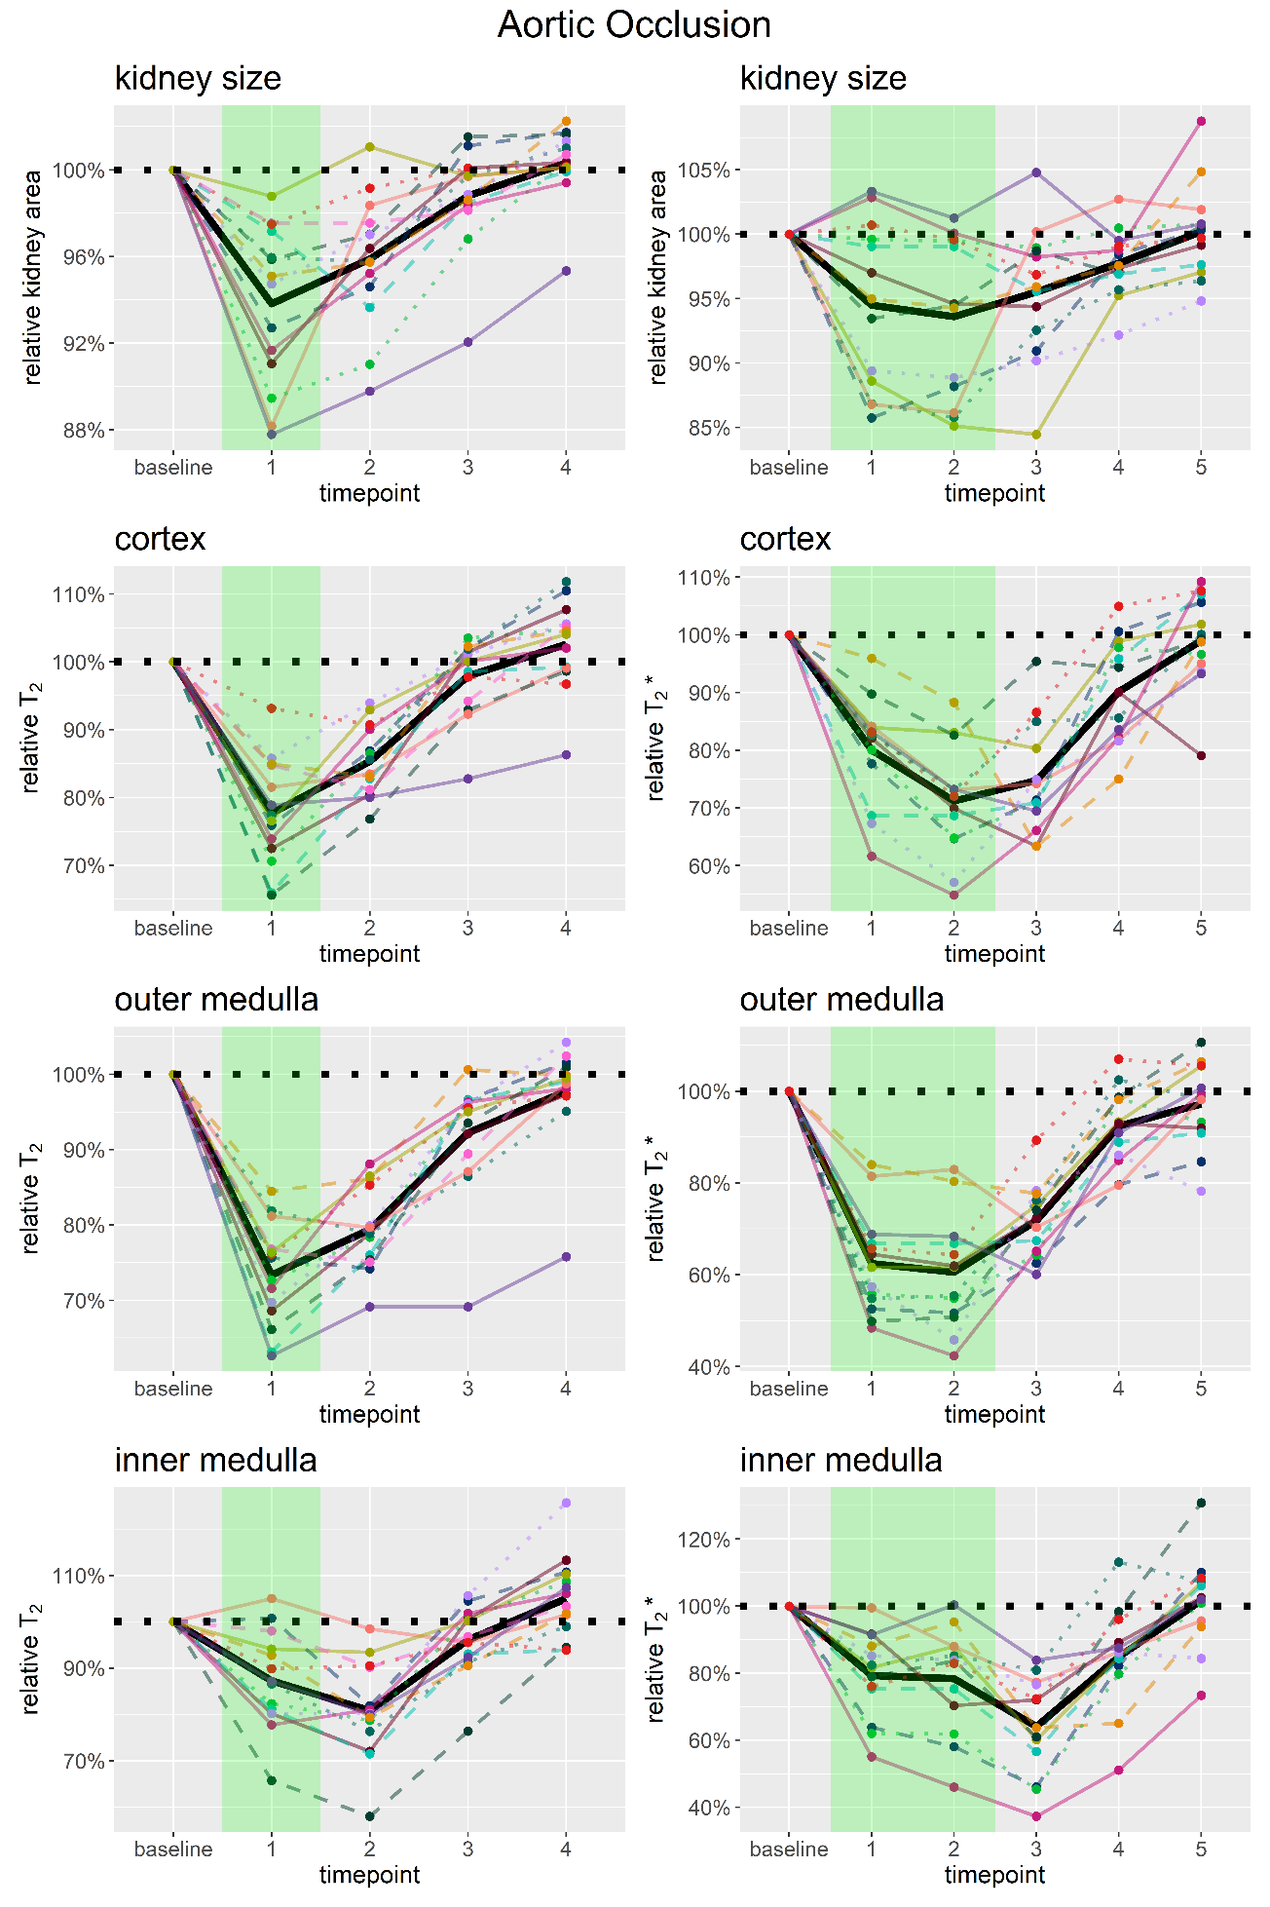

Figure S2

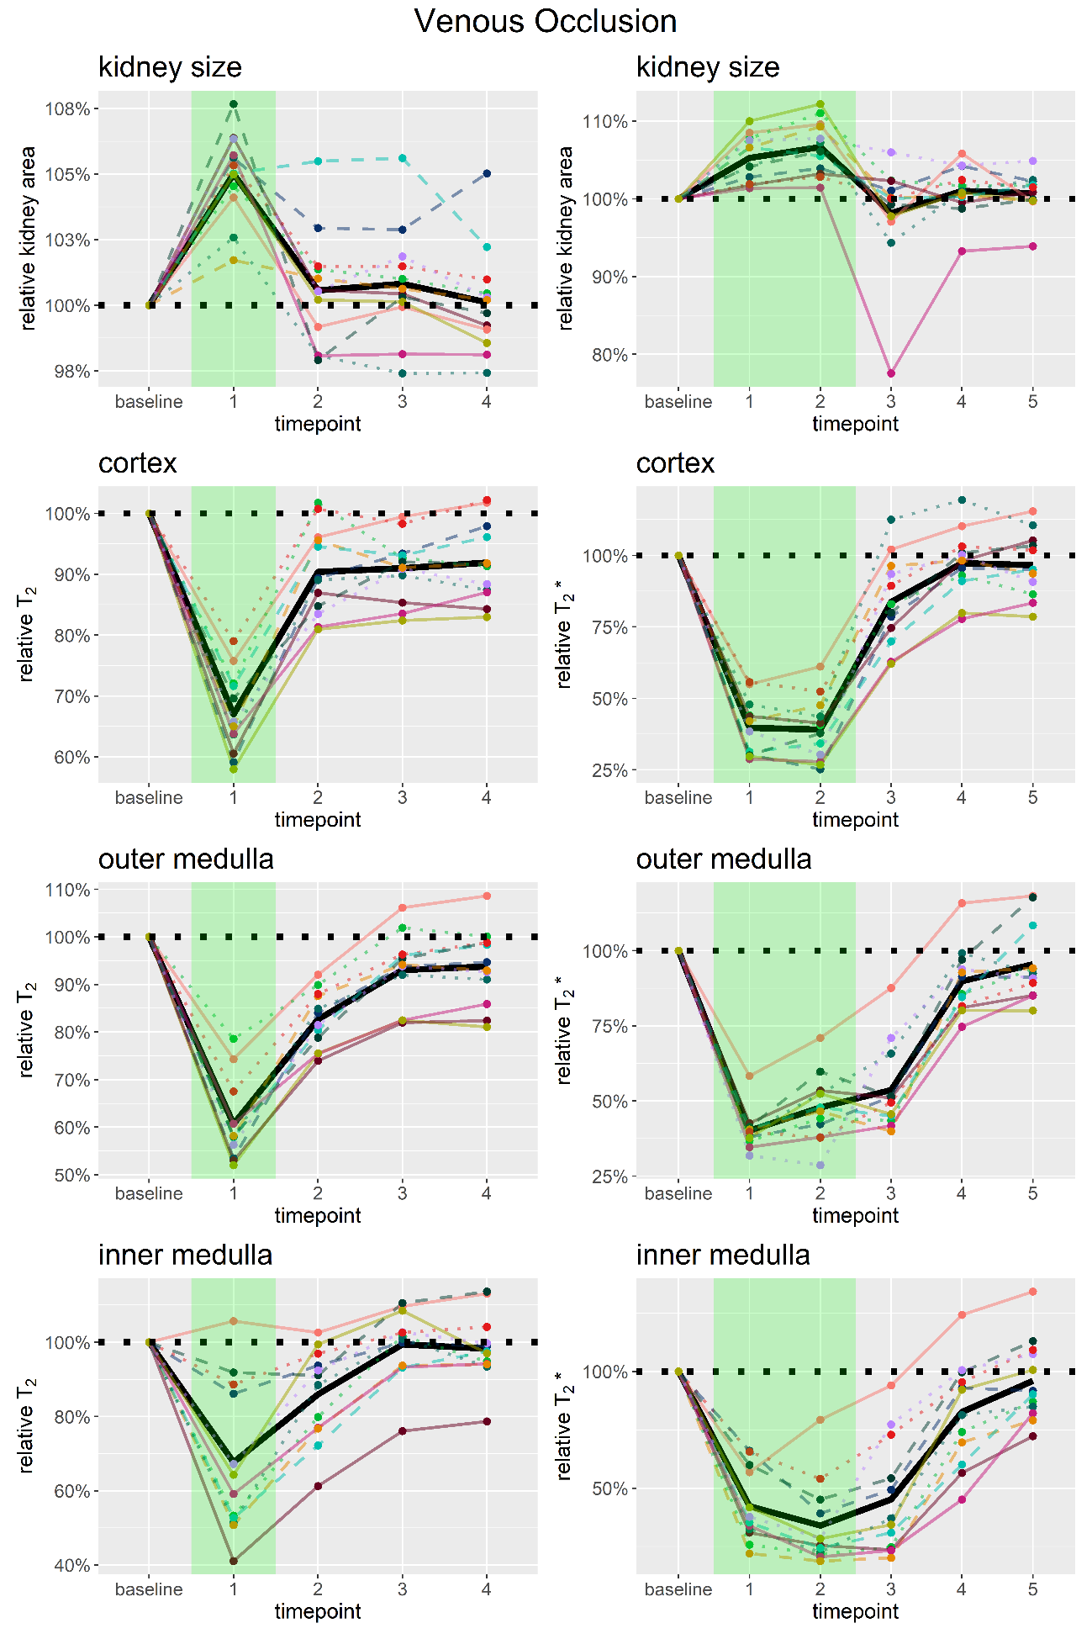

Figure S3

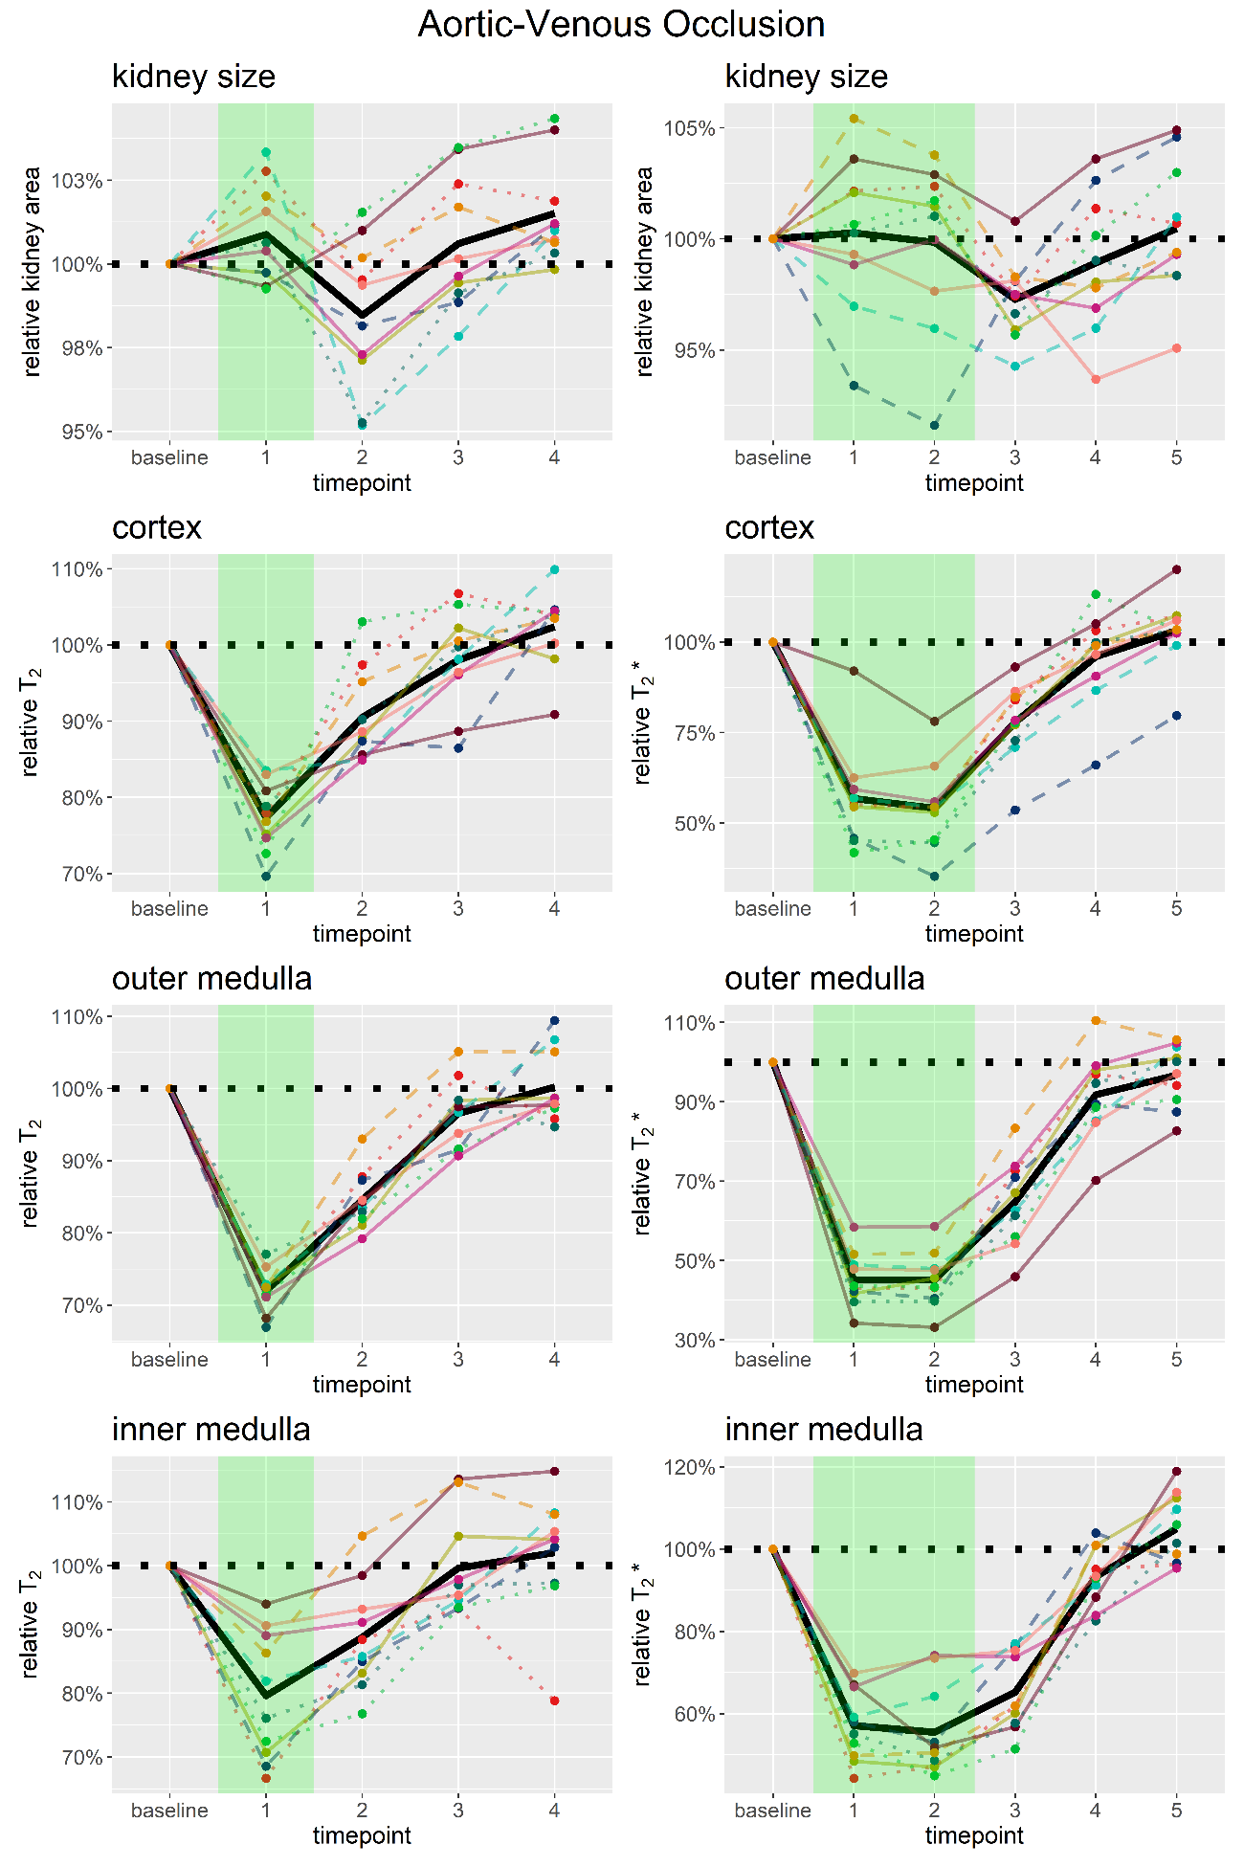

Figure S4

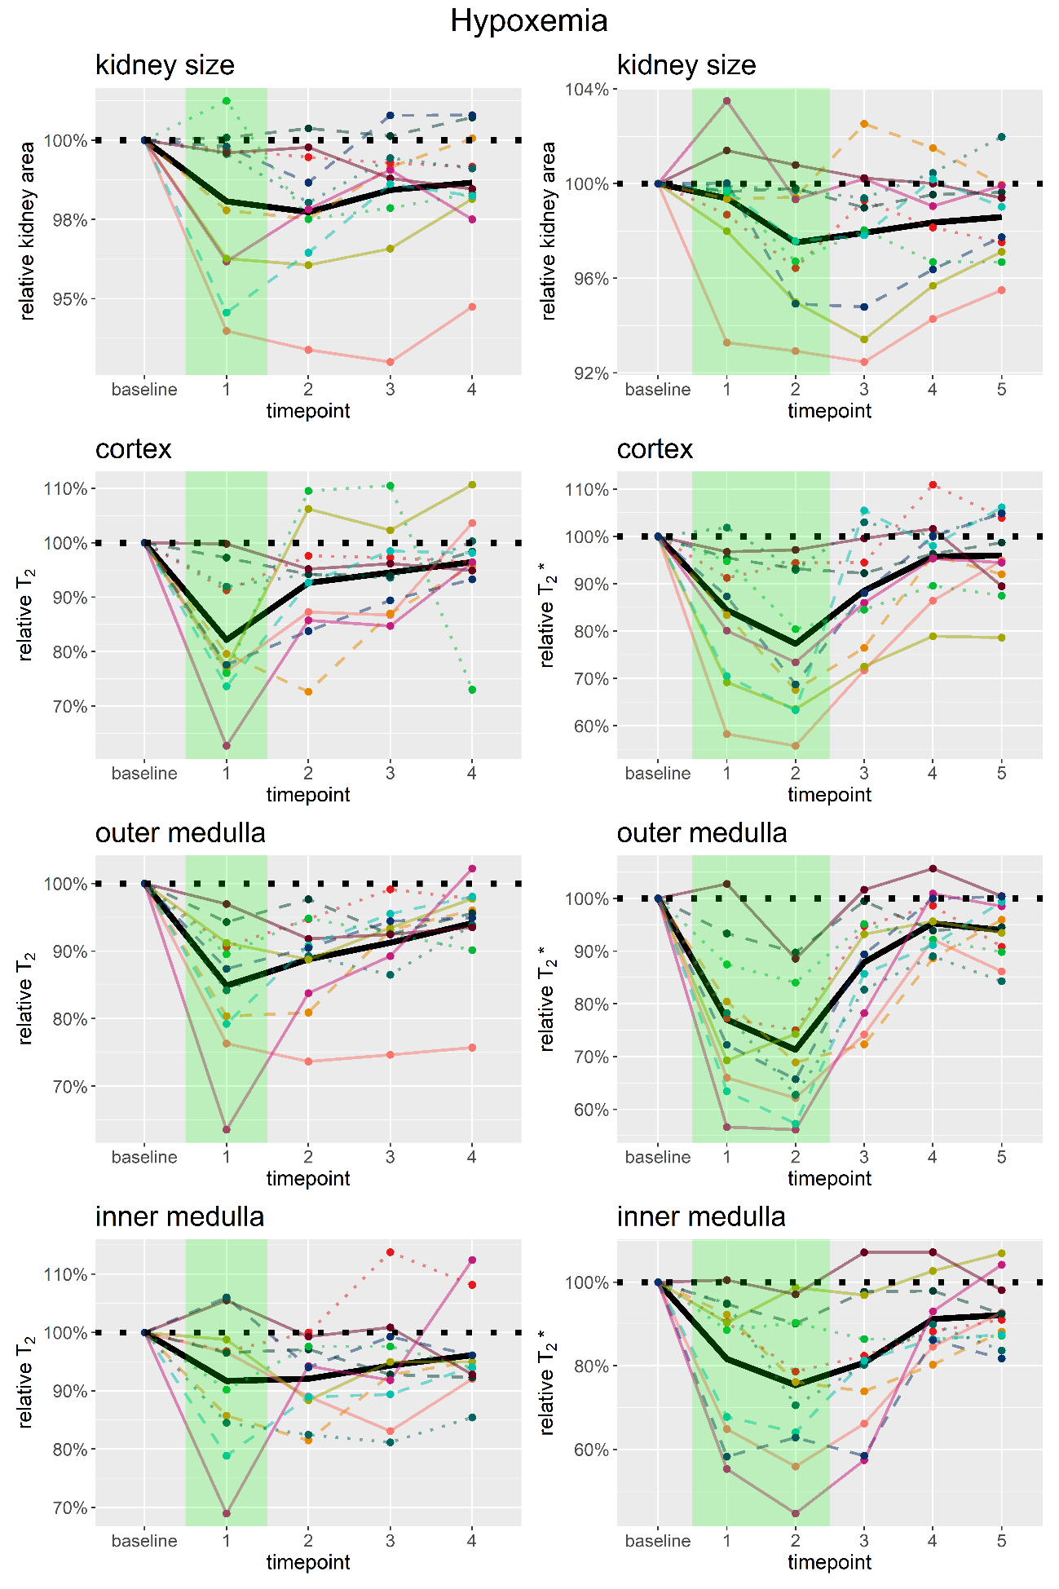

Figure S5

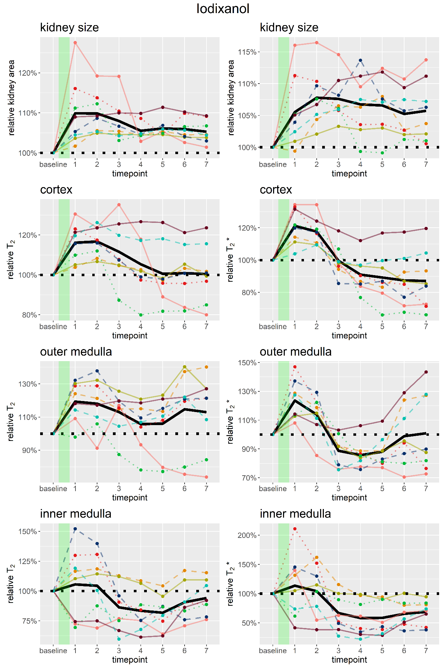

Figure S6

